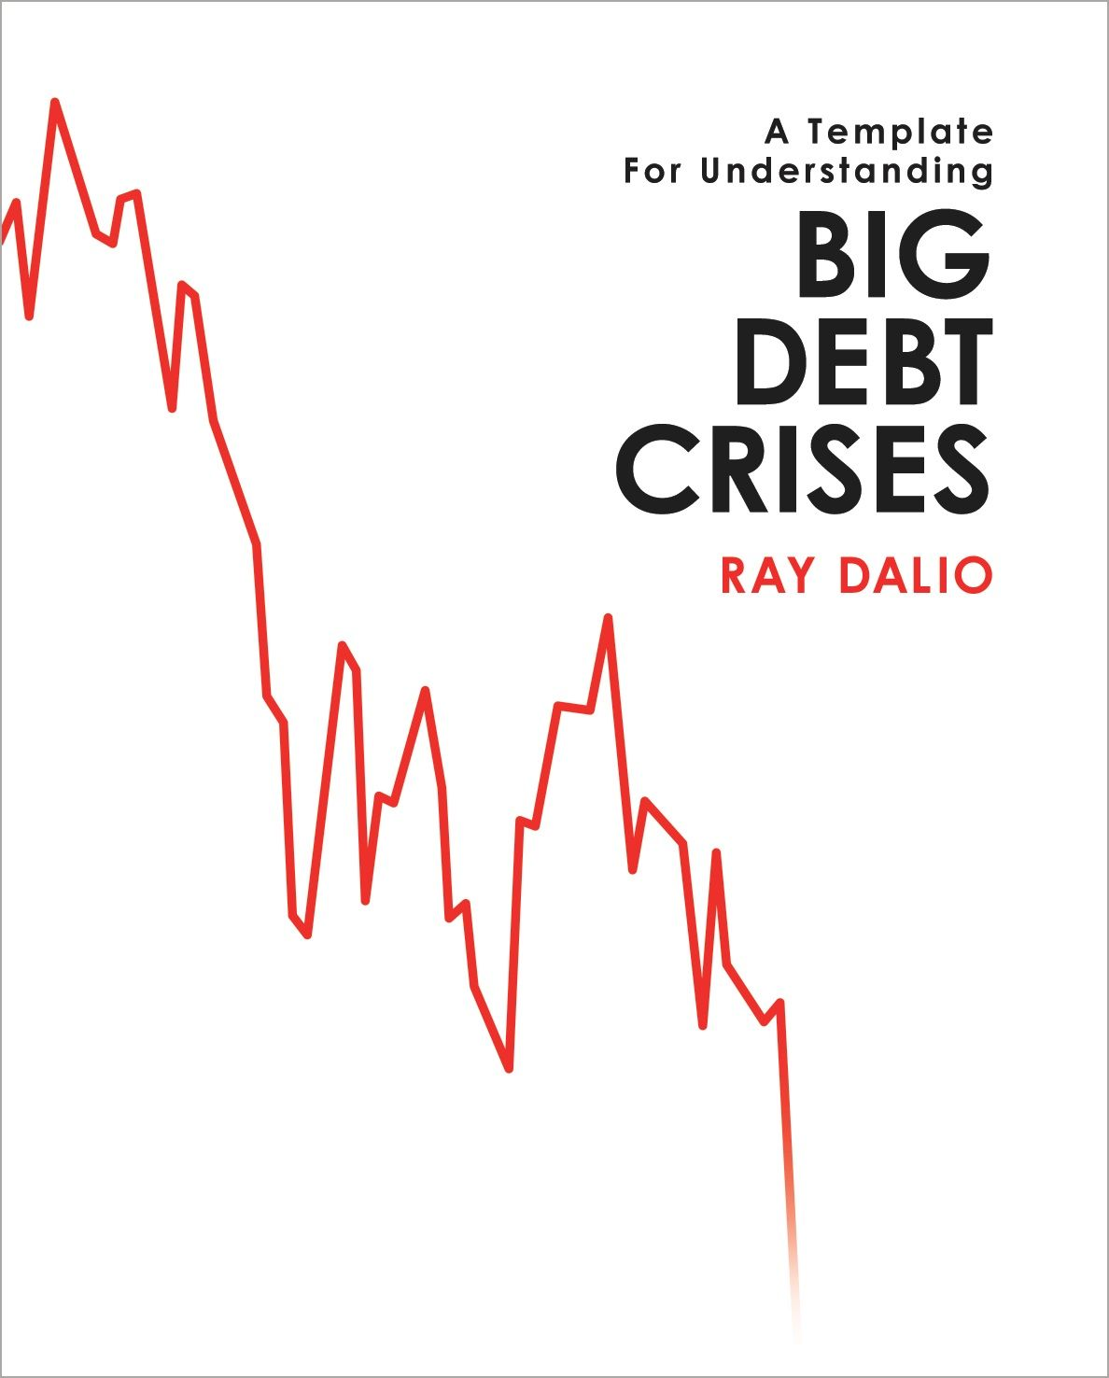

# Table of Contents

A Template for Understanding Big Debt Crises

Acknowledgements

Introduction

PART 1: The Archetypal Big Debt Cycle

How I Think about Credit and Debt

The Template for the Archetypal Long-Term/Big Debt Cycle

Our Examination of the Cycle

The Phases of the Classic Deflationary Debt Cycle

The Early Part of the Cycle

The Bubble

The Top

The “Depression”

The “Beautiful Deleveraging”

“Pushing on a String”

Normalization

Inflationary Depressions and Currency Crises

The Phases of the Classic Inflationary Debt Cycle

The Early Part of the Cycle

The Bubble

The Top and Currency Defense

The Depression (Often When the Currency Is Let Go)

Normalization

The Spiral from a More Transitory Inflationary Depression to Hyperinflation

War Economies

In Summary

PART 2: Detailed Case Studies

German Debt Crisis and Hyperinflation (1918-1924)

US Debt Crisis and Adjustment (1928–1937)

US Debt Crisis and Adjustment (2007–2011)

PART 3: Compendium of 48 Case Studies

Glossary of Key Economic Terms

Primarily Domestic Currency Debt Crises

Non-Domestic Currency Debt Crises

Appendix: Macroprudential Policies

# A Template for Understanding BIG DEBT CRISES

Ray Dalio

Table of Contents

A Template for Understanding Big Debt Crises

Acknowledgements

Introduction

PART 1: The Archetypal Big Debt Cycle

How I Think about Credit and Debt

The Template for the Archetypal Long-Term/Big Debt Cycle

Our Examination of the Cycle

The Phases of the Classic Deflationary Debt Cycle

The Early Part of the Cycle

The Bubble

The Top

The “Depression”

The “Beautiful Deleveraging”

“Pushing on a String”

Normalization

Inflationary Depressions and Currency Crises

The Phases of the Classic Inflationary Debt Cycle

The Early Part of the Cycle

The Bubble

The Top and Currency Defense

The Depression (Often When the Currency Is Let Go)

Normalization

The Spiral from a More Transitory Inflationary Depression to Hyperinflation

War Economies

In Summary

PART 2: Detailed Case Studies

German Debt Crisis and Hyperinflation (1918-1924)

US Debt Crisis and Adjustment (1928–1937)

US Debt Crisis and Adjustment (2007–2011)

PART 3: Compendium of 48 Case Studies

Glossary of Key Economic Terms

Primarily Domestic Currency Debt Crises

Non-Domestic Currency Debt Crises

Appendix: Macroprudential Policies

# Acknowledgements

I cannot adequately thank the many people at Bridgewater who have shared, and continue to share, my mission to understand the markets and to test that understanding in the real world. I celebrate the meaningful work and meaningful relationships that we have had and that have led to the understandings and principles that have enriched us in the most profound ways.

The list of great partners includes Bob Prince, Greg Jensen and Dan Bernstein, who have worked with me over decades, my current investment research team (especially Steven Kryger, Gardner Davis, Bill Longfield, Anser Kazi, Danny Newman, Michael Savarese, and Elena Gonzalez Malloy), members of my past research teams (especially Brian Gold, Claude Amadeo, Bob Elliott, Mark Dinner, Brandon Rowley, and Jason Rogers), and many others who have worked with me on research over the years. I’m also indebted to the many other leaders in Bridgewater research, including Jason Rotenberg, Noah Yechiely, Larry Cofsky, Ramsen Betfarhad, Karen Karniol-Tambour, Kevin Brennan, Kerry Reilly, Jacob Kline, Avraam Sidiropoulos, Amit Srivastava, and our treasured former colleague Bruce Steinberg, who we tragically lost last year.

# Introduction

I am writing this on the tenth anniversary of the 2008 financial crisis in order to offer the perspective of an investor who navigated that crisis well because I had developed a template for understanding how all debt crises work. I am sharing that template here in the hope of reducing the likelihood of future debt crises and helping them be better managed.

As an investor, my perspective is different from that of most economists and policy makers because I bet on economic changes via the markets that reflect them, which forces me to focus on the relative values and flows that drive the movements of capital. Those, in turn, drive these cycles. In the process of trying to navigate them, I’ve found there is nothing like the pain of being wrong or the pleasure of being right as a global macro investor to provide the practical lessons about economics that are unavailable in textbooks.

After repeatedly being bit by events I never encountered before, I was driven to go beyond my own personal experiences to examine all the big economic and market movements in history, and to do that in a way that would make them virtual experiences—i.e., so that they would show up to me as though I was experiencing them in real time. That way I would have to place my market bets as if I only knew what happened up until that moment. I did that by studying historical cases chronologically and in great detail, experiencing them day by day and month by month. This gave me a much broader and deeper perspective than if I had limited my perspective to my own direct experiences. Through my own experience, I went through the erosion and eventual breakdown of the global monetary system (“Bretton Woods”) in 1966–1971, the inflation bubble of the 1970s and its bursting in 1978–82, the Latin American inflationary depression of the 1980s, the Japanese bubble of the late 1980s and its bursting in 1988–1991, the global debt bubbles that led to the “tech bubble” bursting in 2000, and the Great Deleveraging of 2008. And through studying history, I experienced the collapse of the Roman Empire in the fifth century, the United States debt restructuring in 1789, Germany’s Weimar Republic in the 1920s, the global Great Depression and war that engulfed many countries in the 1930–45 period, and many other crises.

My curiosity and need to know how these things work in order to survive them in the future drove me to try to understand the cause-effect relationships behind them. I found that by examining many cases of each type of economic phenomenon (e.g., business cycles, deleveragings) and plotting the averages of each, I could better visualize and examine the cause-effect relationships of each type. That led me to create templates or archetypal models of each type—e.g., the archetypal business cycle, the archetypal big debt cycle, the archetypal deflationary deleveraging, the archetypal inflationary deleveraging, etc. Then, by noting the differences of each case within a type (e.g., each business cycle in relation to the archetypal business cycle), I could see what caused the differences. By stitching these templates together, I gained a simplified yet deep understanding of all these cases. Rather than seeing lots of individual things happening, I saw fewer things happening over and over again, like an experienced doctor who sees each case of a certain type of disease unfolding as “another one of those.”

I did the research and developed this template with the help of many great partners at Bridgewater Associates. This template allowed us to prepare better for storms that had never happened to us before, just as one who studies 100-year floods or plagues can more easily see them coming and be better prepared. We used our understanding to build computer decision-making systems that laid out in detail exactly how we’d react to virtually every possible occurrence. This approach helped us enormously. For example, eight years before the financial crisis of 2008, we built a “depression gauge” that was programmed to respond to the developments of 2007–2008, which had not occurred since 1929–32. This allowed us to do very well when most everyone else did badly.

While I won’t get into Bridgewater’s detailed decision making systems, in this study I will share the following: 1) my template for the “Archetypal Big Debt Cycle;” 2) “Three Iconic Case Studies” examined in detail (the US in 2007–2011, which includes the “Great Recession;” the US in 1928–1937, which covers a deflationary depression; and Germany in 1918–1924, which examines an inflationary depression), and 3) a “Compendium of 48 Case Studies,” which includes most of the big debt crises that happened over the last 100 years.* I guarantee that if you take the trouble to understand each of these three perspectives, you will see big debt crises very differently than you did before.

To me, watching the economy and markets, or just about anything else, on a day-to-day basis is like being in an evolving snowstorm with millions of bits and pieces of information coming at me that I have to synthesize and react to well. To see what I mean by being in the blizzard versus seeing what’s happening in more synthesized ways, compare what’s conveyed in Part 1 (the most synthesized/template version) with Part 2 (the most granular version), and Part 3 (the version that shows the 48 cases in chart form). If you do that, you will note how all of these cases transpire in essentially the same way as described in the archetypal case while also noting their differences, which will prompt you to ponder why these differences exist and how to explain them, which will advance your understanding. That way, when the next crisis comes along, you will be better prepared to deal with it.

To be clear, I appreciate that different people have different perspectives, that mine is just one, and that by putting our perspectives out there for debate we can all advance our understandings. I am sharing this study to do just that.

* There is also a glossary of economic terms at the start of Part 3, and for a general overview of many of the concepts contained in this study, I recommend my 30-minute animated video, “How the Economic Machine Works,” which can be accessed at www.economicprinciples.org.

# PART 1: The Archetypal Big Debt Cycle

How I Think about Credit and Debt

The Template for the Archetypal Long-Term/Big Debt Cycle

Our Examination of the Cycle

The Phases of the Classic Deflationary Debt Cycle

The Early Part of the Cycle • The Bubble • The Top • The “Depression” • The “Beautiful Deleveraging” • “Pushing on a String” • Normalization

Inflationary Depressions and Currency Crises

The Phases of the Classic Inflationary Debt Cycle

The Early Part of the Cycle • The Bubble • The Top and Currency Defense • The Depression (Often When the Currency Is Let Go) • Normalization

The Spiral from a More Transitory Inflationary Depression to Hyperinflation

War Economies

In Summary

## How I Think about Credit and Debt

Since we are going to use the terms “credit” and “debt” a lot, I’d like to start with what they are and how they work.

Credit is the giving of buying power. This buying power is granted in exchange for a promise to pay it back, which is debt. Clearly, giving the ability to make purchases by providing credit is, in and of itself, a good thing, and not providing the power to buy and do good things can be a bad thing. For example, if there is very little credit provided for development, then there is very little development, which is a bad thing. The problem with debt arises when there is an inability to pay it back. Said differently, the question of whether rapid credit/debt growth is a good or bad thing hinges on what that credit produces and how the debt is repaid (i.e., how the debt is serviced).

Almost by definition, financially responsible people don’t like having much debt. I understand that perspective well because I share it.1 For my whole life, even when I didn’t have any money, I strongly preferred saving to borrowing, because I felt that the upsides of debt weren’t worth its downsides, which is a perspective I presume I got from my dad. I identify with people who believe that taking on a little debt is better than taking on a lot. But over time I learned that that’s not necessarily true, especially for society as a whole (as distinct from individuals), because those who make policy for society have controls that individuals don’t. From my experiences and my research, I have learned that too little credit/debt growth can create as bad or worse economic problems as having too much, with the costs coming in the form of foregone opportunities.

Generally speaking, because credit creates both spending power and debt, whether or not more credit is desirable depends on whether the borrowed money is used productively enough to generate sufficient income to service the debt. If that occurs, the resources will have been well allocated and both the lender and the borrower will benefit economically. If that doesn’t occur, the borrowers and the lenders won’t be satisfied and there’s a good chance that the resources were poorly allocated.

In assessing this for society as a whole, one should consider the secondary/indirect economics as well as the more primary/direct economics. For example, sometimes not enough money/credit is provided for such obviously cost-effective things as educating our children well (which would make them more productive, while reducing crime and the costs of incarceration), or replacing inefficient infrastructure, because of a fiscal conservativism that insists that borrowing to do such things is bad for society, which is not true.

I want to be clear that credit/debt that produces enough economic benefit to pay for itself is a good thing. But sometimes the trade-offs are harder to see. If lending standards are so tight that they require a near certainty of being paid back, that may lead to fewer debt problems but too little development. If the lending standards are looser, that could lead to more development but could also create serious debt problems down the road that erase the benefits. Let’s look at this and a few other common questions about debt and debt cycles.

How Costly Is Bad Debt Relative to Not Having the Spending that the Debt Is Financing?  
 Suppose that you, as a policy maker, choose to build a subway system that costs $1 billion. You finance it with debt that you expect to be paid back from revenue, but the economics turn out to be so much worse than you expected that only half of the expected revenues come in. The debt has to be written down by 50 percent. Does that mean you shouldn’t have built the subway?

Rephrased, the question is whether the subway system is worth $500 million more than what was initially budgeted, or, on an annual basis, whether it is worth about 2 percent more per year than budgeted, supposing the subway system has a 25-year lifespan. Looked at this way, you may well assess that having the subway system at that cost is a lot better than not having the subway system.

To give you an idea of what that might mean for an economy as a whole, really bad debt losses have been when roughly 40 percent of a loan’s value couldn’t be paid back. Those bad loans amount to about 20 percent of all the outstanding loans, so the losses are equal to about 8 percent of total debt. That total debt, in turn, is equal to about 200 percent of income (e.g., GDP), so the shortfall is roughly equal to 16 percent of GDP. If that cost is “socialized” (i.e., borne by the society as a whole via fiscal and/or monetary policies) and spread over 15 years, it would amount to about 1 percent per year, which is tolerable. Of course, if not spread out, the costs would be intolerable. For that reason, I am asserting that the downside risks of having a significant amount of debt depends a lot on the willingness and the ability of policy makers to spread out the losses arising from bad debts. I have seen this in all the cases I have lived through and studied. Whether policy makers can do this depends on two factors: 1) whether the debt is denominated in the currency that they control and 2) whether they have influence over how creditors and debtors behave with each other.

Are Debt Crises Inevitable?  
 Throughout history only a few well-disciplined countries have avoided debt crises. That’s because lending is never done perfectly and is often done badly due to how the cycle affects people’s psychology to produce bubbles and busts. While policy makers generally try to get it right, more often than not they err on the side of being too loose with credit because the near-term rewards (faster growth) seem to justify it. It is also politically easier to allow easy credit (e.g., by providing guarantees, easing monetary policies) than to have tight credit. That is the main reason we see big debt cycles.

Why Do Debt Crises Come in Cycles?  
 I find that whenever I start talking about cycles, particularly big, long-term cycles, people’s eyebrows go up; the reactions I elicit are similar to those I’d expect if I were talking about astrology. For that reason, I want to emphasize that I am talking about nothing more than logically-driven series of events that recur in patterns. In a market-based economy, expansions and contractions in credit drive economic cycles, which occur for perfectly logical reasons. Though the patterns are similar, the sequences are neither pre-destined to repeat in exactly the same ways nor to take exactly the same amount of time.

To put these complicated matters into very simple terms, you create a cycle virtually anytime you borrow money. Buying something you can’t afford means spending more than you make. You’re not just borrowing from your lender; you are borrowing from your future self. Essentially, you are creating a time in the future in which you will need to spend less than you make so you can pay it back. The pattern of borrowing, spending more than you make, and then having to spend less than you make very quickly resembles a cycle. This is as true for a national economy as it is for an individual. Borrowing money sets a mechanical, predictable series of events into motion.

If you understand the game of Monopoly®, you can pretty well understand how credit cycles work on the level of a whole economy. Early in the game, people have a lot of cash and only a few properties, so it pays to convert your cash into property. As the game progresses and players acquire more and more houses and hotels, more and more cash is needed to pay the rents that are charged when you land on a property that has a lot of them. Some players are forced to sell their property at discounted prices to raise that cash. So early in the game, “property is king” and later in the game, “cash is king.” Those who play the game best understand how to hold the right mix of property and cash as the game progresses.

Now, let’s imagine how this Monopoly® game would work if we allowed the bank to make loans and take deposits. Players would be able to borrow money to buy property, and, rather than holding their cash idly, they would deposit it at the bank to earn interest, which in turn would provide the bank with more money to lend. Let’s also imagine that players in this game could buy and sell properties from each other on credit (i.e., by promising to pay back the money with interest at a later date). If Monopoly® were played this way, it would provide an almost perfect model for the way our economy operates. The amount of debt-financed spending on hotels would quickly grow to multiples of the amount of money in existence. Down the road, the debtors who hold those hotels will become short on the cash they need to pay their rents and service their debt. The bank will also get into trouble as their depositors’ rising need for cash will cause them to withdraw it, even as more and more debtors are falling behind on their payments. If nothing is done to intervene, both banks and debtors will go broke and the economy will contract. Over time, as these cycles of expansion and contraction occur repeatedly, the conditions are created for a big, long-term debt crisis.

Lending naturally creates self-reinforcing upward movements that eventually reverse to create self-reinforcing downward movements that must reverse in turn. During the upswings, lending supports spending and investment, which in turn supports incomes and asset prices; increased incomes and asset prices support further borrowing and spending on goods and financial assets. The borrowing essentially lifts spending and incomes above the consistent productivity growth of the economy. Near the peak of the upward cycle, lending is based on the expectation that the above-trend growth will continue indefinitely. But, of course, that can’t happen; eventually income will fall below the cost of the loans.

Economies whose growth is significantly supported by debt-financed building of fixed investments, real estate, and infrastructure are particularly susceptible to large cyclical swings because the fast rates of building those long-lived assets are not sustainable. If you need better housing and you build it, the incremental need to build more housing naturally declines. As spending on housing slows down, so does housing’s impact on growth. Let’s say you have been spending $10 million a year to build an office building (hiring workers, buying steel and concrete, etc.). When the building is finished, the spending will fall to $0 per year, as will the demand for workers and construction materials. From that point forward, growth, income, and the ability to service debt will depend on other demand. This type of cycle—where a strong growth upswing driven by debt-financed real estate, fixed investment, and infrastructure spending is followed by a downswing driven by a debt-challenged slowdown in demand—is very typical of emerging economies because they have so much building to do.

Contributing further to the cyclicality of emerging countries’ economies are changes in their competitiveness due to relative changes in their incomes. Typically, they have very cheap labor and bad infrastructure, so they build infrastructure, have an export boom, and experience rising incomes. But the rate of growth due to exports naturally slows as their income levels rise and their wage competitiveness relative to other countries declines. There are many examples of these kinds of cycles (i.e., Japan’s experience over the last 70 years).

In “bubbles,” the unrealistic expectations and reckless lending results in a critical mass of bad loans. At one stage or another, this becomes apparent to bankers and central bankers and the bubble begins to deflate. One classic warning sign that a bubble is coming is when an increasing amount of money is being borrowed to make debt service payments, which of course compounds the borrowers’ indebtedness.

When money and credit growth are curtailed and/or higher lending standards are imposed, the rates of credit growth and spending slow and more debt service problems emerge. At this point, the top of the upward phase of the debt cycle is at hand. Realizing that credit growth is dangerously fast, the central banks tighten monetary policy to contain it, which often accelerates the decline (though it would have happened anyway, just a bit later). In either case, when the costs of debt service become greater than the amount that can be borrowed to finance spending, the upward cycle reverses. Not only does new lending slow down, but the pressure on debtors to make their payments is increased. The clearer it becomes that debtors are struggling, the less new lending there is. The slowdown in spending and investment that results slows down income growth even further, and asset prices decline.

When borrowers cannot meet their debt service obligations to lending institutions, those lending institutions cannot meet their obligations to their own creditors. Policy makers must handle this by dealing with the lending institutions first. The most extreme pressures are typically experienced by the lenders that are the most highly leveraged and that have the most concentrated exposures to failed borrowers. These lenders pose the biggest risks of creating knock-on effects for credit worthy buyers and across the economy. Typically, they are banks, but as credit systems have grown more dynamic, a broader set of lenders has emerged, such as insurance companies, non-bank trusts, broker-dealers, and even special purpose vehicles.

The two main long-term problems that emerge from these kinds of debt cycles are:

1. The losses arising from the expected debt service payments not being made. When promised debt service payments can’t be made, that can lead to either smaller periodic payments and/or the writing down of the value of the debt (i.e., agreeing to accept less than was owed.) If you were expecting an annual debt service payment of 4 percent and it comes in at 2 percent or 0 percent, there is that shortfall for each year, whereas if the debt is marked down, that year’s loss would be much bigger (e.g., 50 percent).
2. The reduction of lending and the spending it was financing going forward. Even after a debt crisis is resolved, it is unlikely that the entities that borrowed too much can generate the same level of spending in the future that they had before the crisis. That has implications that must be considered.

Can Most Debt Crises Be Managed so There Aren’t Big Problems?  
 Sometimes these cycles are moderate, like bumps in the road, and sometimes they are extreme, ending in crashes. In this study we examine ones that are extreme—i.e., all those in the last 100 years that produced declines in real GDP of more than 3 percent. Based on my examinations of them and the ways the levers available to policy makers work, I believe that it is possible for policy makers to manage them well in almost every case that the debts are denominated in a country’s own currency. That is because the flexibility that policy makers have allows them to spread out the harmful consequences in such ways that big debt problems aren’t really big problems. Most of the really terrible economic problems that debt crises have caused occurred before policy makers took steps to spread them out. Even the biggest debt crises in history (e.g., the 1930s Great Depression) were gotten past once the right adjustments were made. From my examination of these cases, the biggest risks are not from the debts themselves but from a) the failure of policy makers to do the right things, due to a lack of knowledge and/or lack of authority, and b) the political consequences of making adjustments that hurt some people in the process of helping others. It is from a desire to help reduce these risks that I have written this study.

Having said that, I want to reiterate that 1) when debts are denominated in foreign currencies rather than one’s own currency, it is much harder for a country’s policy makers to do the sorts of things that spread out the debt problems, and 2) the fact that debt crises can be well-managed does not mean that they are not extremely costly to some people.

The key to handling debt crises well lies in policy makers’ knowing how to use their levers well and having the authority that they need to do so, knowing at what rate per year the burdens will have to be spread out, and who will benefit and who will suffer and in what degree, so that the political and other consequences are acceptable.

There are four types of levers that policy makers can pull to bring debt and debt service levels down relative to the income and cash flow levels that are required to service them:

1. Austerity (i.e., spending less)
2. Debt defaults/restructurings
3. The central bank “printing money” and making purchases (or providing guarantees)
4. Transfers of money and credit from those who have more than they need to those who have less

Each one of their levers has different impacts on the economy. Some are inflationary and stimulate growth (e.g., “printing money”), while others are deflationary and help reduce debt burdens (e.g., austerity and defaults). The key to creating a “beautiful deleveraging” (a reduction in debt/income ratios accompanied by acceptable inflation and growth rates, which I explain later) lies in striking the right balance between them. In this happy scenario, debt-to-income ratios decline at the same time that economic activity and financial asset prices improve, gradually bringing the nominal growth rate of incomes back above the nominal interest rate.

These levers shift around who benefits and who suffers, and over what amount of time. Policy makers are put in the politically difficult position of having to make those choices. As a result, they are rarely appreciated, even when they handle the debt crisis well.

## The Template for the Archetypal Long-Term/Big Debt Cycle

The template that follows is based on my examination of 48 big debt cycles, which include all of the cases that led to real GDP falling by more than 3 percent in large countries (which is what I will call a depression). For clarity, I divided the affected countries into two groups: 1) Those that didn’t have much of their debt denominated in foreign currency and that didn’t experience inflationary depressions, and 2) those that had a significant amount of their debt denominated in foreign currency and did experience inflationary depressions. Since there was about a 75 percent correlation between the amounts of their foreign debts and the amounts of inflation that they experienced (which is not surprising, since having a lot of their debts denominated in foreign currency was a cause of their depressions being inflationary), it made sense to group those that had more foreign currency debt with those that had inflationary depressions.

Typically debt crises occur because debt and debt service costs rise faster than the incomes that are needed to service them, causing a deleveraging. While the central bank can alleviate typical debt crises by lowering real and nominal interest rates, severe debt crises (i.e., depressions) occur when this is no longer possible. Classically, a lot of short-term debt cycles (i.e., business cycles) add up to a long-term debt cycle, because each short-term cyclical high and each short-term cyclical low is higher in its debt-to-income ratio than the one before it, until the interest rate reductions that helped fuel the expansion in debt can no longer continue. The chart below shows the debt and debt service burden (both principal and interest) in the US since 1910. You will note how the interest payments remain flat or go down even when the debt goes up, so that the rise in debt service costs is not as great as the rise in debt. That is because the central bank (in this case, the Federal Reserve) lowers interest rates to keep the debt-financed expansion going until they can’t do it any more (because the interest rate hits 0 percent). When that happens, the deleveraging begins.

While the chart gives a good general picture, I should make clear that it is inadequate in two respects: 1) it doesn’t convey the differences between the various entities that make up these total numbers, which are very important to understand, and 2) it just shows what is called debt, so it doesn’t reflect liabilities such as pension and health care obligations, which are much larger. Having this more granular perspective is very important in gauging a country’s vulnerabilities, though for the most part such issues are beyond the scope of this book.

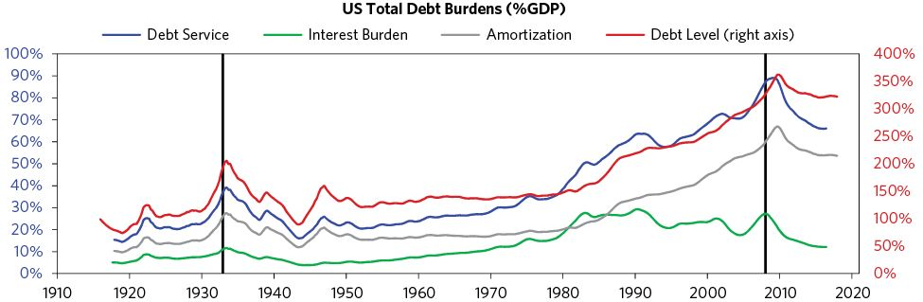

## Our Examination of the Cycle

In developing the template, we will focus on the period leading up to the depression, the depression period itself, and the deleveraging period that follows the bottom of the depression. As there are two broad types of big debt crises—deflationary ones and inflationary ones (largely depending on whether a country has a lot of foreign currency debt or not)—we will examine them separately.

The statistics reflected in the charts of the phases were derived by averaging 21 deflationary debt cycle cases and 27 inflationary debt cycle cases, starting five years before the bottom of the depression and continuing for seven years after it.

Notably long-term debt cycles appear similar in many ways to short-term debt cycles, except that they are more extreme, both because the debt burdens are higher and the monetary policies that can address them are less effective. For the most part, short-term debt cycles produce bumps—mini-booms and recessions—while big long-term ones produce big booms and busts. Over the last century, the US has gone through a long-term debt crisis twice—once during the boom of the 1920s and the Great Depression of the 1930s, and again during the boom of the early 2000s and the financial crisis starting in 2008.

In the short-term debt cycle, spending is constrained only by the willingness of lenders and borrowers to provide and receive credit. When credit is easily available, there’s an economic expansion. When credit isn’t easily available, there’s a recession. The availability of credit is controlled primarily by the central bank. The central bank is generally able to bring the economy out of a recession by easing rates to stimulate the cycle anew. But over time, each bottom and top of the cycle finishes with more economic activity than the previous cycle, and with more debt. Why? Because people push it—they have an inclination to borrow and spend more instead of paying back debt. It’s human nature. As a result, over long periods of time, debts rise faster than incomes. This creates the long-term debt cycle.

During the upswing of the long-term debt cycle, lenders extend credit freely even as people become more indebted. That’s because the process is self-reinforcing on the upside—rising spending generates rising incomes and rising net worths, which raises borrowers’ capacities to borrow, which allows more buying and spending, etc. Most everyone is willing to take on more risk. Quite often new types of financial intermediaries and new types of financial instruments develop that are outside the supervision and protection of regulatory authorities. That puts them in a competitively attractive position to offer higher returns, take on more leverage, and make loans that have greater liquidity or credit risk. With credit plentiful, borrowers typically spend more than is sustainable, giving them the appearance of being prosperous. In turn, lenders, who are enjoying the good times, are more complacent than they should be. But debts can’t continue to rise faster than the money and income that is necessary to service them forever, so they are headed toward a debt problem.

When the limits of debt growth relative to income growth are reached, the process works in reverse. Asset prices fall, debtors have problems servicing their debts, and investors get scared and cautious, which leads them to sell, or not roll over, their loans. This, in turn, leads to liquidity problems, which means that people cut back on their spending. And since one person’s spending is another person’s income, incomes begin to go down, which makes people even less creditworthy. Asset prices fall, further squeezing banks, while debt repayments continue to rise, making spending drop even further. The stock market crashes and social tensions rise along with unemployment, as credit and cash-starved companies reduce their expenses. The whole thing starts to feed on itself the other way, becoming a vicious, self-reinforcing contraction that’s not easily corrected. Debt burdens have simply become too big and need to be reduced. Unlike in recessions, when monetary policies can be eased by lowering interest rates and increasing liquidity, which in turn increase the capacities and incentives to lend, interest rates can’t be lowered in depressions. They are already at or near zero and liquidity/money can’t be increased by ordinary measures.

This is the dynamic that creates long-term debt cycles. It has existed for as long as there has been credit, going back to before Roman times. Even the Old Testament described the need to wipe out debt once every 50 years, which was called the Year of Jubilee. Like most dramas, this one both arises and transpires in ways that have reoccurred throughout history.

Remember that money serves two purposes: it is a medium of exchange and a store hold of wealth. And because it has two purposes, it serves two masters: 1) those who want to obtain it for “life’s necessities,” usually by working for it, and 2) those who have stored wealth tied to its value. Throughout history these two groups have been called different things—e.g., the first group has been called workers, the proletariat, and “the have-nots,” and the second group has been called capitalists, investors, and “the haves.” For simplicity, we will call the first group proletariat-workers and the second group capitalists-investors. Proletariat-workers earn their money by selling their time and capitalists-investors earn their money by “lending” others the use of their money in exchange for either a) a promise to repay an amount of money that is greater than the loan (which is a debt instrument), or b) a piece of ownership in the business (which we call “equity” or “stocks”) or a piece of another asset (e.g., real estate). These two groups, along with the government (which sets the rules), are the major players in this drama. While generally both groups benefit from borrowing and lending, sometimes one gains and one suffers as a result of the transaction. This is especially true for debtors and creditors.

One person’s financial assets are another’s financial liabilities (i.e., promises to deliver money). When the claims on financial assets are too high relative to the money available to meet them, a big deleveraging must occur. Then the free-market credit system that finances spending ceases to work well, and typically works in reverse via a deleveraging, necessitating the government to intervene in a big way as the central bank becomes a big buyer of debt (i.e., lender of last resort) and the central government becomes a redistributor of spending and wealth. At such times, there needs to be a debt restructuring in which claims on future spending (i.e., debt) are reduced relative to what they are claims on (i.e., money).

This fundamental imbalance between the size of the claims on money (debt) and the supply of money (i.e., the cash flow that is needed to service the debt) has occurred many times in history and has always been resolved via some combination of the four levers I previously described. The process is painful for all of the players, sometimes so much so that it causes a battle between the proletariat-workers and the capitalist-investors. It can get so bad that lending is impaired or even outlawed. Historians say that the problems that arose from credit creation were why usury (lending money for interest) was considered a sin in both Catholicism and Islam.2

In this study we will examine big debt cycles that produce big debt crises, exploring how they work and how to deal with them well. But before we begin, I want to clarify the differences between the two main types: deflationary and inflationary depressions.

* In deflationary depressions, policy makers respond to the initial economic contraction by lowering interest rates. But when interest rates reach about 0 percent, that lever is no longer an effective way to stimulate the economy. Debt restructuring and austerity dominate, without being balanced by adequate stimulation (especially money printing and currency depreciation). In this phase, debt burdens (debt and debt service as a percent of income) rise, because incomes fall faster than restructuring, debt paydowns reduce the debt stock, and many borrowers are required to rack up still more debts to cover those higher interest costs. As noted, deflationary depressions typically occur in countries where most of the unsustainable debt was financed domestically in local currency, so that the eventual debt bust produces forced selling and defaults, but not a currency or a balance of payments problem.
* Inflationary depressions classically occur in countries that are reliant on foreign capital flows and so have built up a significant amount of debt denominated in foreign currency that can’t be monetized (i.e., bought by money printed by the central bank). When those foreign capital flows slow, credit creation turns into credit contraction. In an inflationary deleveraging, capital withdrawal dries up lending and liquidity at the same time that currency declines produce inflation. Inflationary depressions in which a lot of debt is denominated in foreign currency are especially difficult to manage because policy makers’ abilities to spread out the pain are more limited.

We will begin with deflationary depressions.

1. I’m so debt adverse that I’ve hardly had any debt in any form, even when I bought my first house. When I built Bridgewater, it was without debt, and I’m still a keen saver.

2. Throughout the Middle Ages, Christians could generally not legally charge interest to other Christians. This is one reason why Jews played a large part in the development of trade, as they lent money for business ventures and financed voyages. But Jews were also the holders of the loans that debtors sometimes could not repay. Many historical instances of violence against Jews were driven by debt crises.

## The Phases of the Classic Deflationary Debt Cycle

The chart below illustrates the seven stages of an archetypal long-term debt cycle, by tracking the total debt of the economy as a percentage of the total income of the economy (GDP) and the total amount of debt service payments relative to GDP over a period of 12 years.

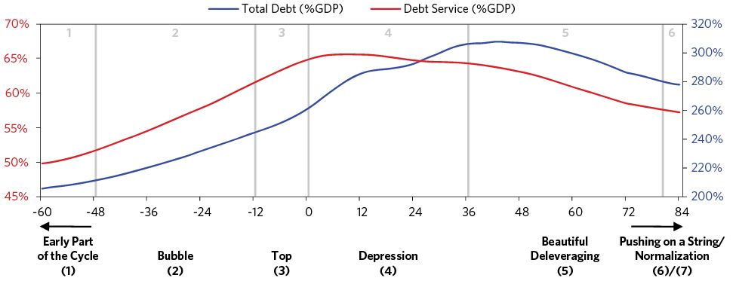

Throughout this section, I’ll include similar “archetype” charts that are built by averaging the deflationary deleveraging cases.3

### 1) The Early Part of the Cycle

In the early part of the cycle, debt is not growing faster than incomes, even though debt growth is strong. That is because debt growth is being used to finance activities that produce fast income growth. For instance, borrowed money may go toward expanding a business and making it more productive, supporting growth in revenues. Debt burdens are low and balance sheets are healthy, so there is plenty of room for the private sector, government, and banks to lever up. Debt growth, economic growth, and inflation are neither too hot nor too cold. This is what is called the “Goldilocks” period.

### 2) The Bubble

In the first stage of the bubble, debts rise faster than incomes, and they produce accelerating strong asset returns and growth. This process is generally self-reinforcing because rising incomes, net-worths, and asset values raise borrowers’ capacities to borrow. This happens because lenders determine how much they can lend on the basis of the borrowers’ 1) projected income/cash flows to service the debt, 2) net worth/collateral (which rises as asset prices rise), and 3) their own capacities to lend. All of these rise together. Though this set of conditions is not sustainable because the debt growth rates are increasing faster than the incomes that will be required to service them, borrowers feel rich, so they spend more than they earn and buy assets at high prices with leverage. Here’s one example of how that happens:

Suppose you earn $50,000 a year and have a net worth of $50,000. You have the capacity to borrow $10,000 per year, so you could spend $60,000 per year for a number of years, even though you only earn $50,000. For an economy as a whole, increased borrowing and spending can lead to higher incomes, and rising stock valuations and other asset values, giving people more collateral to borrow against. People then borrow more and more, but as long as the borrowing drives growth, it is affordable.

In this up-wave part of the long-term debt cycle, promises to deliver money (i.e., debt burdens) rise relative to both the supply of money in the overall economy and the amount of money and credit debtors have coming in (via incomes, borrowing, and sales of assets). This up-wave typically goes on for decades, with variations primarily due to central banks’ periodic tightenings and easings of credit. These are short-term debt cycles, and a bunch of them generally add up to a long-term debt cycle.

A key reason the long-term debt cycle can be sustained for so long is that central banks progressively lower interest rates, which raises asset prices and, in turn, people’s wealth, because of the present value effect that lowering interest rates has on asset prices. This keeps debt service burdens from rising, and it lowers the monthly payment cost of items bought on credit. But this can’t go on forever. Eventually the debt service payments become equal to or larger than the amount debtors can borrow, and the debts (i.e., the promises to deliver money) become too large in relation to the amount of money in existence there is to give. When promises to deliver money (i.e., debt) can’t rise any more relative to the money and credit coming in, the process works in reverse and deleveraging begins. Since borrowing is simply a way of pulling spending forward, the person spending $60,000 per year and earning $50,000 per year has to cut his spending to $40,000 for as many years as he spent $60,000, all else being equal.

Though a bit of an oversimplification, this is the essential dynamic that drives the inflating and deflating of a bubble.

#### The Start of a Bubble: The Bull Market

Bubbles usually start as over-extrapolations of justified bull markets. The bull markets are initially justified because lower interest rates make investment assets, such as stocks and real estate, more attractive so they go up, and economic conditions improve, which leads to economic growth and corporate profits, improved balance sheets, and the ability to take on more debt—all of which make the companies worth more.

As assets go up in value, net worths and spending/income levels rise. Investors, business people, financial intermediaries, and policy makers increase their confidence in ongoing prosperity, which supports the leveraging-up process. The boom also encourages new buyers who don’t want to miss out on the action to enter the market, fueling the emergence of a bubble. Quite often, uneconomic lending and the bubble occur because of implicit or explicit government guarantees that encourage lending institutions to lend recklessly.

As new speculators and lenders enter the market and confidence increases, credit standards fall. Banks lever up and new types of lending institutions that are largely unregulated develop (these non-bank lending institutions are referred to collectively as a “shadow banking” system). These shadow banking institutions are typically less under the blanket of government protections. At these times, new types of lending vehicles are frequently invented and a lot of financial engineering takes place.

The lenders and the speculators make a lot of fast, easy money, which reinforces the bubble by increasing the speculators’ equity, giving them the collateral they need to secure new loans. At the time, most people don’t think that is a problem; to the contrary, they think that what is happening is a reflection and confirmation of the boom. This phase of the cycle typically feeds on itself. Taking stocks as an example, rising stock prices lead to more spending and investment, which raises earnings, which raises stock prices, which lowers credit spreads and encourages increased lending (based on the increased value of collateral and higher earnings), which affects spending and investment rates, etc. During such times, most people think the assets are a fabulous treasure to own—and consider anyone who doesn’t own them to be missing out. As a result of this dynamic, all sorts of entities build up long positions. Large asset-liability mismatches increase in the forms of a) borrowing short-term to lend long-term, b) taking on liquid liabilities to invest in illiquid assets, and c) investing in riskier debt or other risky assets with money borrowed from others, and/or d) borrowing in one currency and lending in another, all to pick up a perceived spread. All the while, debts rise fast and debt service costs rise even faster. The charts below paint the picture.

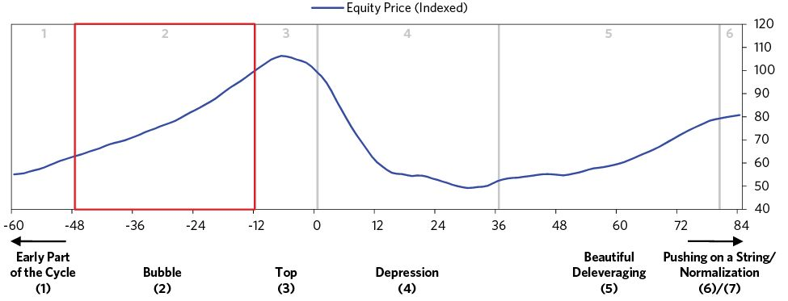

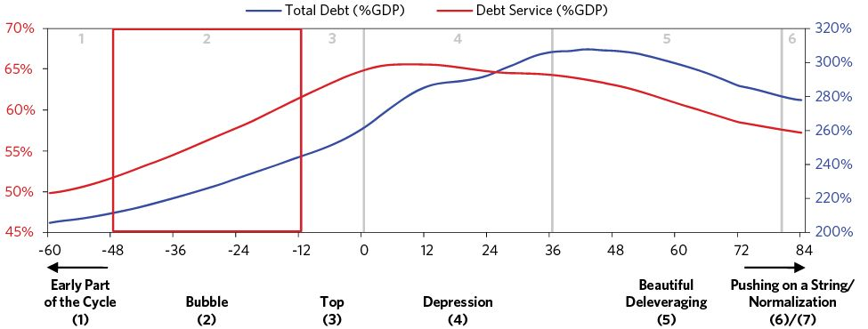

In markets, when there’s a consensus, it gets priced in. This consensus is also typically believed to be a good rough picture of what’s to come, even though history has shown that the future is likely to turn out differently than expected. In other words, humans by nature (like most species) tend to move in crowds and weigh recent experience more heavily than is appropriate. In these ways, and because the consensus view is reflected in the price, extrapolation tends to occur.

At such times, increases in debt-to-income ratios are very rapid. The above chart shows the archetypal path of debt as a percent of GDP for the deflationary deleveragings we averaged. The typical bubble sees leveraging up at an average rate of 20 to 25 percent of GDP over three years or so. The blue line depicts the arc of the long-term debt cycle in the form of the total debt of the economy divided by the total income of the economy as it passes through its various phases; the red line charts the total amount of debt service payments relative to the total amount of income.

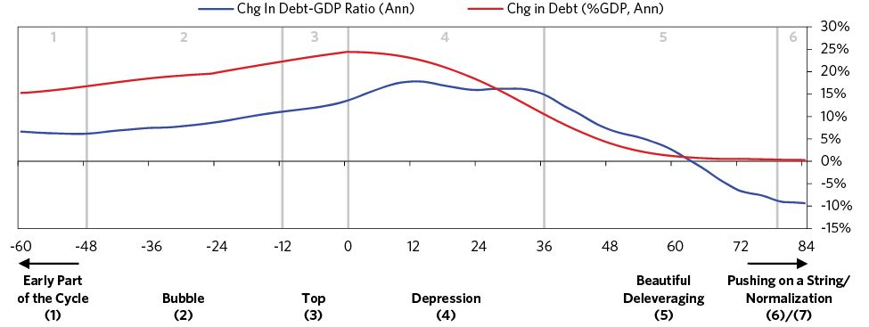

Bubbles are most likely to occur at the tops in the business cycle, balance of payments cycle, and/or long-term debt cycle. As a bubble nears its top, the economy is most vulnerable, but people are feeling the wealthiest and the most bullish. In the cases we studied, total debt-to-income levels averaged around 300 percent of GDP. To convey a few rough average numbers, below we show some key indications of what the archetypal bubble looks like:

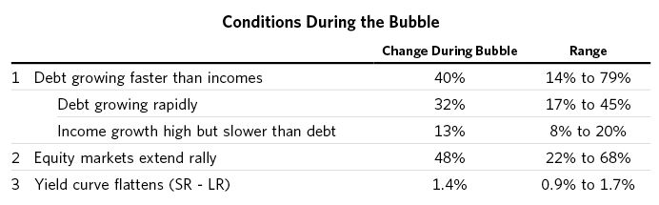

#### The Role of Monetary Policy

In many cases, monetary policy helps inflate the bubble rather than constrain it. This is especially true when inflation and growth are both good and investment returns are great. Such periods are typically interpreted to be a productivity boom that reinforces investor optimism as they leverage up to buy investment assets. In such cases, central banks, focusing on inflation and growth, are often reluctant to adequately tighten money. This is what happened in Japan in the late 1980s, and in much of the world in the late 1920s and mid-2000s.

This is one of the biggest problems with most central bank policies—i.e., because central bankers target either inflation or inflation and growth and don’t target the management of bubbles, the debt growth that they enable can go to finance the creation of bubbles if inflation and real growth don’t appear to be too strong. In my opinion it’s very important for central banks to target debt growth with an eye toward keeping it at a sustainable level—i.e., at a level where the growth in income is likely to be large enough to service the debts regardless of what credit is used to buy. Central bankers sometimes say that it is too hard to spot bubbles and that it’s not their role to assess and control them—that it is their job to control inflation and growth.4 But what they control is money and credit, and when that money and credit goes into debts that can’t be paid back, that has huge implications for growth and inflation down the road. The greatest depressions occur when bubbles burst, and if the central banks that are producing the debts that are inflating them won’t control them, then who will? The economic pain of allowing a large bubble to inflate and then burst is so high that it is imprudent for policy makers to ignore them, and I hope their perspective will change.

While central banks typically do tighten money somewhat and short rates rise on average when inflation and growth start to get too hot, typical monetary policies are not adequate to manage bubbles, because bubbles are occurring in some parts of the economy and not others. Thinking about the whole economy, central banks typically fall behind the curve during such periods, and borrowers are not yet especially squeezed by higher debt-service costs. Quite often at this stage, their interest payments are increasingly being covered by borrowing more rather than by income growth—a clear sign that the trend is unsustainable.

All this reverses when the bubble pops and the same linkages that inflated the bubble make the downturn self-reinforcing. Falling asset prices decrease both the equity and collateral values of leveraged speculators, which causes lenders to pull back. This forces speculators to sell, driving down prices even more. Also, lenders and investors “run” (i.e., withdraw their money) from risky financial intermediaries and risky investments, causing them to have liquidity problems. Typically, the affected market or markets are big enough and leveraged enough that the losses on the accumulated debt are systemically threatening, which is to say that they threaten to topple the entire economy.

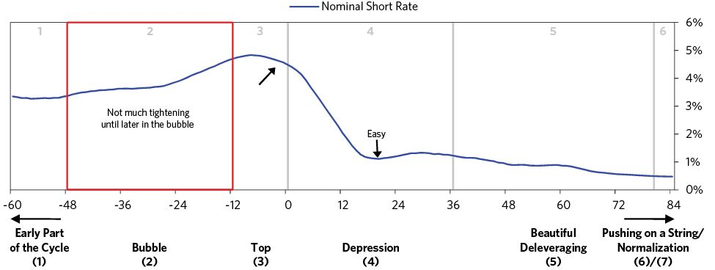

#### Spotting Bubbles

While the particulars may differ across cases (e.g., the size of the bubble; whether it’s in stocks, housing, or some other asset5; how exactly the bubble pops; and so on), the many cases of bubbles are much more similar than they are different, and each is a result of logical cause-and-effect relationships that can be studied and understood. If one holds a strong mental map of how bubbles form, it becomes much easier to identify them.

To identify a big debt crisis before it occurs, I look at all the big markets and see which, if any, are in bubbles. Then I look at what’s connected to them that would be affected when they pop. While I won’t go into exactly how it works here, the most defining characteristics of bubbles that can be measured are:

1. Prices are high relative to traditional measures
2. Prices are discounting future rapid price appreciation from these high levels
3. There is broad bullish sentiment
4. Purchases are being financed by high leverage
5. Buyers have made exceptionally extended forward purchases (e.g., built inventory, contracted for supplies, etc.) to speculate or to protect themselves against future price gains
6. New buyers (i.e., those who weren’t previously in the market) have entered the market
7. Stimulative monetary policy threatens to inflate the bubble even more (and tight policy to cause its popping)

As you can see in the table below, which is based on our systematic measures, most or all of these indications were present in past bubbles. (N/A indicates inadequate data.)

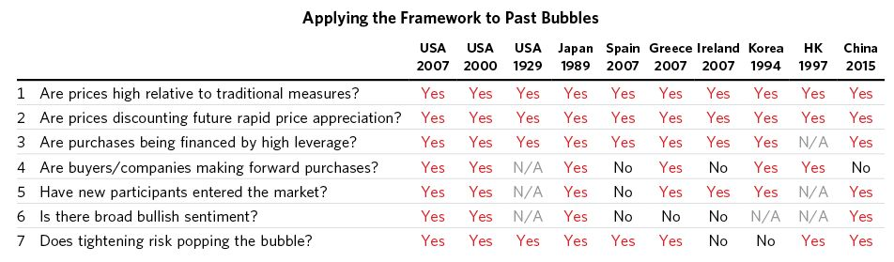

At this point I want to emphasize that it is a mistake to think that any one metric can serve as an indicator of an impending debt crisis. The ratio of debt to income for the economy as a whole, or even debt service payments to income for the economy as a whole, which is better, are useful but ultimately inadequate measures. To anticipate a debt crisis well, one has to look at the specific debt-service abilities of the individual entities, which are lost in these averages. More specifically, a high level of debt or debt service to income is less problematic if the average is well distributed across the economy than if it is concentrated—especially if it is concentrated in key entities.

### 3) The Top

When prices have been driven by a lot of leveraged buying and the market gets fully long, leveraged, and overpriced, it becomes ripe for a reversal. This reflects a general principle: When things are so good that they can’t get better—yet everyone believes that they will get better—tops of markets are being made.

While tops are triggered by different events, most often they occur when the central bank starts to tighten and interest rates rise. In some cases the tightening is brought about by the bubble itself, because growth and inflation are rising while capacity constraints are beginning to pinch. In other cases, the tightening is externally driven. For example, for a country that has become reliant on borrowing from external creditors, the pulling back of lending due to exogenous causes will lead to liquidity tightening. A tightening of monetary policy in the currency in which debts are denominated can be enough to cause foreign capital to pull back. This can happen for reasons unrelated to conditions in the domestic economy (e.g., cyclical conditions in a reserve currency country leads to a tightening in liquidity in that currency, or a financial crisis results in a pullback of capital, etc.). Also, a rise in the currency the debt is in relative to the currency incomes are in can cause an especially severe squeeze. Sometimes unanticipated shortfalls in cash flows due to any number of reasons can trigger the debt crises.

Whatever the cause of the debt-service squeeze, it hurts asset prices (e.g., stock prices), which has a negative “wealth effect”6 as lenders begin to worry that they might not be able to get their cash back from those they lent it to. Borrowers are squeezed as an increasing share of their new borrowing goes to pay debt service and/or isn’t rolled over and their spending slows down. This is classically the result of people buying investment assets at high prices with leverage, based on overly optimistic assumptions about future cash flow. Typically, these types of credit/debt problems start to emerge about half a year ahead of the peak in the economy, at first in its most vulnerable and frothy pockets. The riskiest debtors start to miss payments, lenders begin to worry, credit spreads start to tick up, and risky lending slows. Runs from risky assets to less risky assets pick up, contributing to a broadening of the contraction.

Typically, in the early stages of the top, the rise in short rates narrows or eliminates the spread with long rates (i.e., the extra interest rate earned for lending long term rather than short term), lessening the incentive to lend relative to the incentive to hold cash. As a result of the yield curve being flat or inverted (i.e., long-term interest rates are at their lowest relative to short-term interest rates), people are incentivized to move to cash just before the bubble pops, slowing credit growth and causing the previously described dynamic.

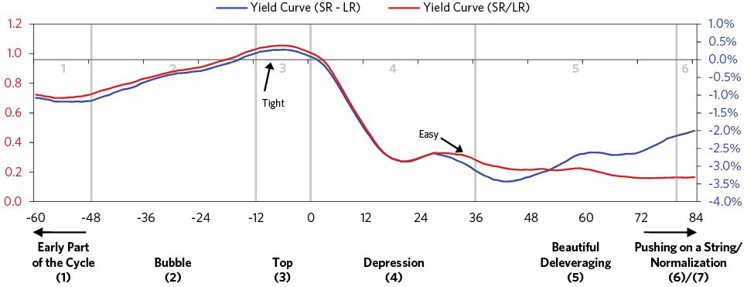

Early on in the top, some parts of the credit system suffer, but others remain robust, so it isn’t clear that the economy is weakening. So while the central bank is still raising interest rates and tightening credit, the seeds of the recession are being sown. The fastest rate of tightening typically comes about five months prior to the top of the stock market. The economy is then operating at a high rate, with demand pressing up against the capacity to produce. Unemployment is normally at cyclical lows and inflation rates are rising. The increase in short-term interest rates makes holding cash more attractive, and it raises the interest rate used to discount the future cash flows of assets, weakening riskier asset prices and slowing lending. It also makes items bought on credit de facto more expensive, slowing demand. Short rates typically peak just a few months before the top in the stock market.

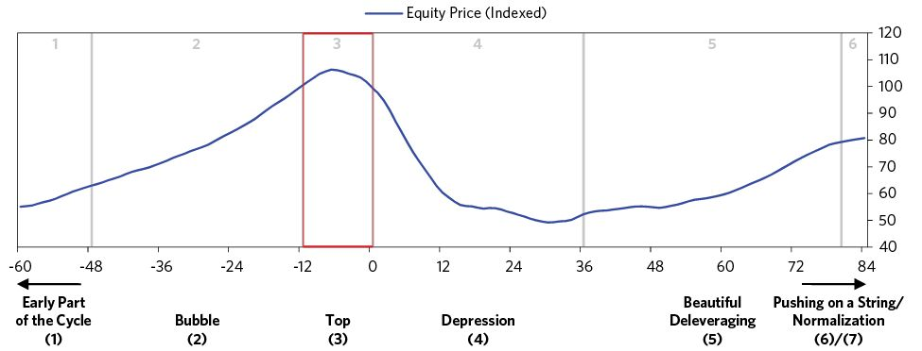

The more leverage that exists and the higher the prices, the less tightening it takes to prick the bubble and the bigger the bust that follows. To understand the magnitude of the downturn that is likely to occur, it is less important to understand the magnitude of the tightening than it is to understand each particular sector’s sensitivity to tightening and how losses will cascade. These pictures are best seen by looking at each of the important sectors of the economy and each of the big players in these sectors rather than at economy-wide averages.

In the immediate postbubble period, the wealth effect of asset price movements has a bigger impact on economic growth rates than monetary policy does. People tend to underestimate the size of this effect. In the early stages of a bubble bursting, when stock prices fall and earnings have not yet declined, people mistakenly judge the decline to be a buying opportunity and find stocks cheap in relation to both past earnings and expected earnings, failing to account for the amount of decline in earnings that is likely to result from what’s to come. But the reversal is self-reinforcing. As wealth falls first and incomes fall later, creditworthiness worsens, which constricts lending activity, which hurts spending and lowers investment rates while also making it less appealing to borrow to buy financial assets. This in turn worsens the fundamentals of the asset (e.g., the weaker economic activity leads corporate earnings to chronically disappoint), leading people to sell and driving down prices further. This has an accelerating downward impact on asset prices, income, and wealth.

### 4) The “Depression”

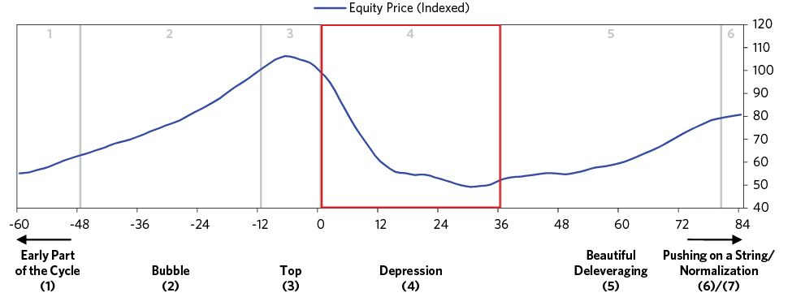

In normal recessions (when monetary policy is still effective), the imbalance between the amount of money and the need for it to service debt can be rectified by cutting interest rates enough to 1) produce a positive wealth effect, 2) stimulate economic activity, and 3) ease debt-service burdens. This can’t happen in depressions, because interest rates can’t be cut materially because they have either already reached close to 0 percent or, in cases where currency outflows and currency weaknesses are great, the floor on interest rates is higher because of credit or currency risk considerations.

This is precisely the formula for a depression. As shown, this happened in the early stage of both the 1930–32 depression and the 2008–09 depression. In well managed cases, like the US in 2007–08, the Fed lowered rates very quickly and then, when that didn’t work, moved on to alternative means of stimulating, having learned from its mistakes in the 1930s when the Fed was slower to ease and even tightened at times to defend the dollar’s peg to gold.

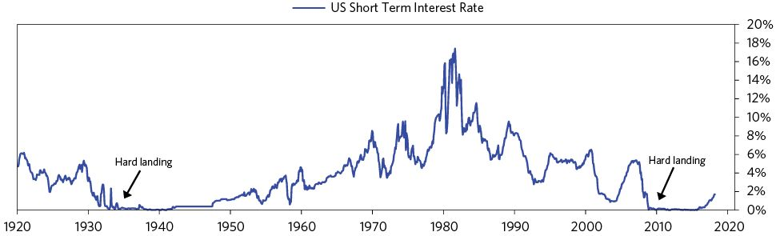

The chart below shows the sharp lowering of interest rates toward 0 percent for the average of the 21 deflationary debt crises that we looked at.

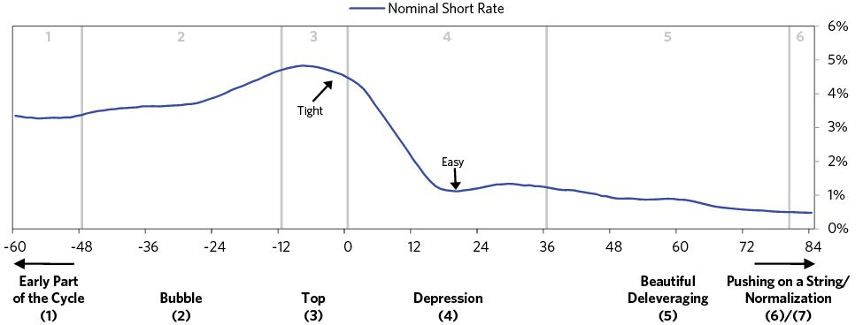

As the depression begins, debt defaults and restructurings hit the various players, especially leveraged lenders (e.g., banks), like an avalanche. Both lenders’ and depositors’ justified fears feed on themselves, leading to runs on financial institutions that typically don’t have the cash to meet them unless they are under the umbrella of government protections. Cutting interest rates doesn’t work adequately because the floors on risk-free rates have already been hit and because as credit spreads rise, the interest rates on risky loans go up, making it difficult for those debts to be serviced. Interest rate cuts also don’t do much to help lending institutions that have liquidity problems and are suffering from runs. At this phase of the cycle, debt defaults and austerity (i.e., the forces of deflation) dominate, and are not sufficiently balanced with the stimulative and inflationary forces of printing money to cover debts (i.e., debt monetization).

With investors unwilling to continue lending and borrowers scrambling to find cash to cover their debt payments, liquidity—i.e., the ability to sell investments for money—becomes a major concern. As an illustration, when you own a $100,000 debt instrument, you presume that you will be able to exchange it for $100,000 in cash and, in turn, exchange the cash for $100,000 worth of goods and services. However since the ratio of financial assets to money is high, when a large number of people rush to convert their financial assets into money and buy goods and services in bad times, the central bank either has to provide the liquidity that’s needed by printing more money or allow a lot of defaults.

The depression can come from, or cause, either solvency problems or cash-flow problems. Usually a lot of both types of problems exist during this phase. A solvency problem means that, according to accounting and regulatory rules, the entity does not have enough equity capital to operate—i.e., it is “broke” and must be shut down. So, the accounting laws have a big impact on the severity of the debt problem at this moment. A cash-flow problem means that an entity doesn’t have enough cash to meet its needs, typically because its own lenders are taking money away from it—i.e., there is a “run.” A cash-flow problem can occur even when the entity has adequate capital because the equity is in illiquid assets. Lack of cash flow is an immediate and severe problem—and as a result, the trigger and main issue of most debt crises.

Each kind of problem requires a different approach. If a solvency problem exists (i.e., the debtor doesn’t have enough equity capital), it has an accounting/regulatory problem that can be dealt with by either a) providing enough equity capital or b) changing the accounting/regulatory rules, which hides the problem. Governments can do this directly through fiscal policy or indirectly through clever monetary policies if the debt is in their own currency. Similarly, if a cash-flow problem exists, fiscal and/or monetary policy can provide either cash or guarantees that resolve it.

A good example of how these forces are relevant is highlighted by the differences between the debt/banking crises of the 1980s and 2008. In the 1980s, there was not as much mark-to-market accounting (because the crisis involved loans that weren’t traded every day in public markets), so the banks were not as “insolvent” as they were in 2008. With more mark-to-market accounting in 2008, the banks required capital injections and/or guarantees to improve their balance sheets. Both crises were successfully managed, though the ways they were managed had to be different.

Going into the “depression” phase of the cycle (by which I mean the severe contraction phase) some protections learned from past depressions (e.g., bank-deposit insurance, the ability to provide lender-of-last-resort financial supports and guarantees and to inject capital into systemically important institutions or nationalize them) are typically in place and are helpful, but they are rarely adequate, because the exact nature of the debt crisis hasn’t been well thought through. Typically, quite a lot of lending has taken place in the relatively unregulated “shadow banking system,” or in new instruments that have unanticipated risks and inadequate regulations. What happens in response to these new realities depends on the capabilities of the policy makers in the decision roles and the freedom of the system to allow them to do what is best.

Some people mistakenly think that depressions are psychological: that investors move their money from riskier investments to safer ones (e.g., from stocks and high-yield lending to government bonds and cash) because they’re scared, and that the economy will be restored if they can only be coaxed into moving their money back into riskier investments. This is wrong for two reasons: First, contrary to popular belief, the deleveraging dynamic is not primarily psychological. It is mostly driven by the supply and demand of, and the relationships between, credit, money, and goods and services—though psychology of course also does have an effect, especially in regard to the various players’ liquidity positions. Still, if everyone went to sleep and woke up with no memory of what had happened, we would be in the same position, because debtors’ obligations to deliver money would be too large relative to the money they are taking in. The government would still be faced with the same choices that would have the same consequences, and so on.

Related to this, if the central bank produces more money to alleviate the shortage, it will cheapen the value of money, making a reality of creditors’ worries about being paid back an amount of money that is worth less than what they loaned. While some people think that the amount of money in existence remains the same and simply moves from riskier assets to less risky ones, that’s not true. Most of what people think is money is really credit, and credit does appear out of thin air during good times and then disappear at bad times. For example, when you buy something in a store on a credit card, you essentially do so by saying, “I promise to pay.” Together you and the store owner create a credit asset and a credit liability. So where do you take the money from? Nowhere. You created credit. It goes away in the same way. Suppose the store owner rightly believes that you and others won’t pay the credit card company and that the credit card company won’t pay him. Then he correctly believes that the credit “asset” he has isn’t really there. It didn’t go somewhere else; it’s simply gone.

As this implies, a big part of the deleveraging process is people discovering that much of what they thought of as their wealth was merely people’s promises to give them money. Now that those promises aren’t being kept, that wealth no longer exists. When investors try to convert their investments into money in order to raise cash, they test their ability to get paid, and in cases where it fails, panic-induced “runs” and sell-offs of securities occur. Naturally those who experience runs, especially banks (though this is true of most entities that rely on short-term funding), have problems raising money and credit to meet their needs, so debt defaults cascade.

Debt defaults and restructurings hit people, especially leveraged lenders (e.g., banks), and fear cascades through the system. These fears feed on themselves and lead to a scramble for cash that results in a shortage (i.e., a liquidity crisis). The dynamic works like this: Initially, the money coming in to debtors via incomes and borrowing is not enough to meet the debtors’ obligations; assets need to be sold and spending needs to be cut in order to raise cash. This leads asset values to fall, which reduces the value of collateral, and in turn reduces incomes. Since borrowers’ creditworthiness is judged by both a) the values of their assets/collaterals in relation to their debts (i.e., their net worth) and b) the sizes of their incomes relative to the sizes of their debt-service payments, and since both their net worth and their income fall faster than their debts, borrowers become less creditworthy and lenders more reluctant to lend. This goes on in a self-reinforcing manner.

The depression phase is dominated by the deflationary forces of debt reduction (i.e., defaults and restructurings) and austerity occurring without material efforts to reduce debt burdens by printing money. Because one person’s debts are another’s assets, the effect of aggressively cutting the value of those assets can be to greatly reduce the demand for goods, services, and investment assets. For a write-down to be effective, it must be large enough to allow the debtor to service the restructured loan. If the write-down is 30 percent, then the creditor’s assets are reduced by that much. If that sounds like a lot, it’s actually much more. Since most lenders are leveraged (e.g., they borrow to buy assets), the impact of a 30 percent write-down on their net worth can be much greater. For example, the creditor who is leveraged 2:1 would experience a 60 percent decline in his net worth (i.e., their assets are twice their net worth, so the decline in asset value has twice the impact).7 Since banks are typically leveraged about 12:1 or 15:1, that picture is obviously devastating for them and for the economy as a whole.

Even as debts are written down, debt burdens rise as spending and incomes fall. Debt levels also rise relative to net worth, as shown in the chart below. As debt-to-income and debt-to-net-worth ratios go up and the availability of credit goes down, naturally the credit contraction becomes self-reinforcing on the downside.

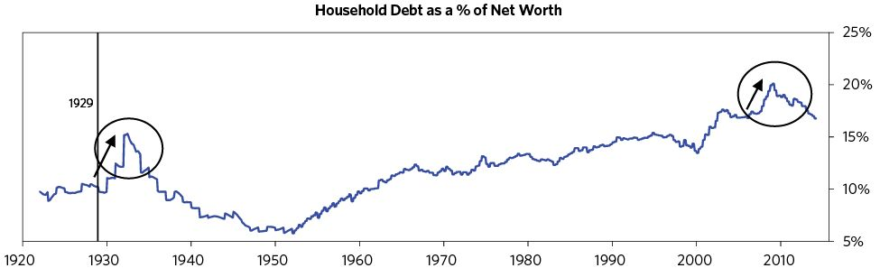

The capitalist-investor class experiences a tremendous loss of “real” wealth during depressions because the value of their investment portfolios collapses (declines in equity prices are typically around 50 percent), their earned incomes fall, and they typically face higher tax rates. As a result, they become extremely defensive. Quite often, they are motivated to move their money out of the country (which contributes to currency weakness), dodge taxes, and seek safety in liquid, noncredit-dependent investments (e.g., low-risk government bonds, gold, or cash).

Of course, the real economy as well as the financial economy suffers. With monetary policy constrained, the uncontrolled credit contraction produces an economic and social catastrophe. Workers suffer as incomes collapse and job losses are severe. Hard-working people who once were able to provide for their families lose the opportunity to have meaningful work and suddenly become either destitute or dependent. Homes are lost because owners can no longer afford to pay their mortgages, retirement accounts are wiped out, and savings for college are lost. These conditions can persist for many years if policy makers don’t offset the depression’s deflationary forces with sufficient monetary stimulation of a new form.

#### Managing Depressions

As mentioned earlier, the policies that reduce debt burdens fall under four broad categories: 1) austerity, 2) debt defaults/restructurings, 3) debt monetization/money printing, and 4) wealth transfers (i.e., from the haves to the have-nots). By using these kinds of levers well, policy makers can mitigate the worst effects of a depression and manage both the failed lenders and borrowers and the economic conditions. But it’s important to recognize that each of these levers has different impacts on the economy and creditworthiness. The key is to get the mix right, so that deflationary and depressive forces are balanced with inflationary and stimulative ones.

Policy makers typically get the mix between austerity, money printing, and redistribution wrong initially. Taxpayers are understandably angry at the debtors and at the financial institutions whose excesses caused the debt crisis, and don’t want the government (i.e., their taxes) to bail them out. And policy makers justifiably believe that debt excesses will happen again if lenders and borrowers don’t suffer the downsides of their actions (which is called the “moral hazard” problem). For all these reasons, policy makers are usually reluctant and slow to provide government supports, and the debt contraction and the agony it produces increase quickly. But the longer they wait to apply stimulative remedies to the mix, the uglier the deleveraging becomes.8 Eventually they choose to provide a lot of guarantees, print a lot of money, and monetize a lot of debt, which lifts the economy into a reflationary deleveraging. If they do these things and get the mix right quickly, the depression is much more likely to be relatively short-lived (like the short period of “depression” following the US crisis in 2008). If they don’t, the depression is usually prolonged (like the Great Depression in the 1930s, or Japan’s “lost decade” following its bubble in the late 1980s).

To reiterate, the two biggest impediments to managing a debt crisis are: a) the failure to know how to handle it well and b) politics or statutory limitations on the powers of policy makers to take the necessary actions. In other words, ignorance and a lack of authority are bigger problems than debts themselves. While being a successful investment manager is hard, it’s not nearly as hard as being a successful economic policy maker. We investors only have to understand how the economic machine works and anticipate what will happen next. Policy makers have to do that, plus make everything turn out well—i.e., they have to know what should be done while navigating through all the political impediments that make it so hard to get it done. To do that requires a lot of smarts, a willingness to fight, and political savvy—i.e., skills and heroism—and sometimes even with all those things, the constraints under which they work still prevent them from being successful.

Below I’ll walk through each of the four levers and how they are typically used in the depression phase.

#### Austerity

In the depression phase, policy makers typically try austerity because that’s the obvious thing to do. It’s natural to want to let those who got themselves and others in trouble to bear the costs. The problem is that even deep austerity doesn’t bring debt and income back into balance. When spending is cut, incomes are also cut, so it takes an awful lot of painful spending cuts to make significant reductions in the debt/income ratios.

As the economy contracts, government revenues typically fall. At the same time, demands on the government increase. As a result, deficits typically increase. Seeking to be fiscally responsible, at this point governments tend to raise taxes.

Both moves are big mistakes.

#### “Printing Money” to Stop the Bleeding and Stimulate the Economy

Quite often “runs” on lending institutions occur, especially those that aren’t protected by government guarantees. That puts the central bank and the central government in the position of having to decide which depositors/lenders should be protected from losses and which should be allowed to sustain them, and which institutions are systemically important and should be saved—and how to do these things in a way that maximizes the safety of the financial/economic system while minimizing costs to the government/taxpayers. At such times all sorts of guarantees are offered to systemically critical financial institutions—and quite often some of these institutions are nationalized. Typically there are a lot of laws and politics that affect how quickly and how well this is done. Some of the money that is needed comes from the government (i.e., it is appropriated through the budget process) and some from the central banks (by “printing”). Governments inevitably do both, though in varying degrees. In addition to providing money to some essential banks, governments also typically provide money to some nonbank entities they consider essential.

Next, they must ease the credit crunch and stimulate the overall economy. Since the government is likely having trouble raising funds through taxation and borrowing, central banks are forced to choose between “printing” still more money to buy their governments’ debts or allowing their governments and their private sector to compete for the limited supply of money, which will only tighten money further. Inevitably, they choose to print.

Typically, though not necessarily, these moves come in progressively larger doses as more modest initial attempts fail to rectify the imbalance and reverse the deleveraging process. However, those early efforts do typically cause temporary periods of relief that are manifest in bear-market rallies in financial assets and increased economic activity. During the Great Depression there were six big rallies in the stock market (of between 16 percent and 48 percent) in a bear market that declined a total of 89 percent. All of those rallies were triggered by government actions that were intended to reduce the fundamental imbalance. When they are managed well, those shifts in policies to “print money,” buy assets, and provide guarantees are what moves the debt cycle from its depression/“ugly deleveraging” phase to its expansion/“beautiful deleveraging” phase. The chart below shows how this “money printing” happened in the US in the 1930s and again after 2008.

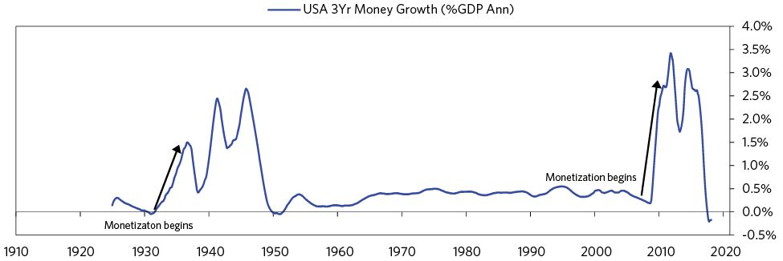

While highly stimulative monetary policy is a critical part of a deleveraging, it is typically not sufficient. When risks emerge that systemically important institutions will fail, policy makers must take steps to keep these entities running. They must act immediately to:

* Curtail panic and guarantee liabilities. Governments can increase guarantees on deposits and debt issuance. Central banks can provide systemically important institutions (i.e., institutions whose failures would threaten the ongoing operating of the financial system and/or that of the economy) with injections of money. Occasionally, governments can force liquidity to remain in the banking system by imposing deposit freezes, which is generally undesirable because it intensifies the panic, but is sometimes necessary because there is no other way of providing that money/liquidity.
* Provide liquidity. When private credit is contracting and liquidity is tight, the central bank can ensure that sufficient liquidity is provided to the financial system by lending against a widening range of collateral or to an increasingly wide range of financial institutions that are not normally considered part of their lending practices.
* Support the solvency of systemically important institutions. The first step is usually to incentivize the private sector to address the problem, often by supporting mergers between failed banks and healthy banks and by regulatory pushes to issue more capital to the private sector. In addition, accounting adjustments can be made to reduce the immediate need for capital to maintain solvency, buying more time for the institutions to earn their way out of their problems.
* Recapitalize/nationalize/cover losses of systemically important financial institutions. When the above approaches are insufficient to deal with the solvency problems of systemically important financial institutions, governments must step in to recapitalize failed banks. Moving to stabilize lenders and maintain the credit supply is critical to preventing a crisis from getting worse. Certain institutions are part of the plumbing of the system; one would hate to lose them even if they’re not making money at the moment. It would be like losing a shipping port in a depression because the port goes broke. You want the port to continue to operate and ships to come in, so you have to protect it one way or another—whether through a nationalization, loans, or capital injections.

#### Debt Defaults/Restructurings

Ultimately, the process of cleansing existing bad debts is critical for the future flow of money and credit and for a return to prosperity. The challenge for policy makers is to allow that process to work itself out in an orderly way that ensures economic and social stability. The best-managed cases are those in which policy makers a) swiftly recognize the magnitude of the credit problems; b) don’t save every institution that is expendable, balancing the benefits of allowing broke institutions to fail and be restructured with the risks that such failures can have detrimental effects on other creditworthy lenders and borrowers; c) create or restore robust credit pipes that allow for future borrowing by creditworthy borrowers; and d) ensure acceptable growth and inflation conditions while the bad debts are being worked out. Longer term, the most important decision that policy makers have to make is whether they will change the system to fix the root causes of the debt problems or simply restructure the debts so that the pain is distributed over the population and over time so that the debt does not impose an intolerable burden.

These things rarely happen right away. Policy makers typically fail to recognize the magnitude of the problem initially, instead enacting a number of one-off policies that are insufficient to move the needle. It is only after what is usually a couple of years and a lot of unnecessary economic pain that they finally act decisively. How quickly and aggressively policy makers respond is among the most important factors in determining the severity and length of the depression. And the question of exactly how these costs are divided between the government (which means the society as a whole) and the bond holders (of varying seniorities), equity holders, depositors, etc., is an important one.

Typically, nonsystemically important institutions are forced to absorb their losses, and if they fail, are allowed to go bankrupt. The resolution of these institutions can take several different forms. In many cases (about 80 percent of the cases we studied), they are merged with healthy institutions. In some other cases, the assets are liquidated or transferred to an “asset-management company” (AMC) set up by the government to be sold piecemeal.

In some cases, policy makers recognize that ensuring the viability of the whole banking system is critical and liquidity and solvency measures are taken at the banking system level. In recent years it has become common for guarantees of bank liabilities to be issued in countries in the developed world. In rare cases, government-financed bank recapitalization is done across all banks, rather than focused solely on systemically important institutions.

There are relatively clear lines for which creditors receive protections:

* Small depositors are given preference and experience minimal or no losses (in nearly every case). Often this is explicitly defined as part of a deposit insurance scheme. Coverage is usually expanded during the crisis period in order to ensure liquidity for the banks. Even in cases where there isn’t an explicit deposit insurance scheme, depositors are often prioritized. In around 30 percent of cases studied, depositors did take losses, though they were often on foreign-exchange deposits through conversion at below-market exchange rates.
* In most cases when institutions fail, equity, subordinated debt, and large depositors absorb losses regardless of whether the institution was systemically important or not. Protection of senior and subordinated debt holders, and equity recapitalizations that are simply dilutive to existing equity holders, are seen mostly in the developed world.
* Sometimes policy makers prioritize domestic creditors over foreign creditors, especially when their loans are to private-sector players and are lower down in the capital structure. This is especially true as deposit insurance programs run low on funds. But at the same time governments often end up prioritizing the payment of loans from multinational institutions like the IMF and BIS, as it’s important to maintain availability of support from these public entities, who effectively act as lenders of last resort to countries under stress.

Typically, the process of dealing with the failed lenders is accompanied by a spate of regulatory reforms. Sometimes these changes are modest and sometimes they are very large; sometimes they are for the better and sometimes they are for the worse. They range from changes in how banks operate (e.g., putting in deposit guarantees in the 1930s or Dodd-Frank and the Volcker rule in 2010 in the US) to labor market reforms, from requiring banks to improve credit standards to opening the banking system to competition (including foreign entrants) to raising capital requirements and removing protections to lenders.

Politics plays a big role in determining what reforms are made. In some cases, such reforms end up distorting private-sector market-based incentives on the flow of lending, which can limit the flow of credit to creditworthy borrowers and/or increase the risks of future credit problems emerging. In other cases, they improve the flow of credit, protect households, and reduce the risk of debt problems in the future.

There are two main ways in which failed lenders’ assets or existing lenders’ bad assets are managed: They are either a) transferred to a separate entity (an AMC) to manage the restructuring and asset disposal (about 40 percent of the cases studied) or b) they remain on the balance sheet of the original lending institution to manage (about 60 percent of cases). And there are several main levers for disposing of the nonperforming loans: a) restructuring (e.g., working out the loans through extended terms), b) debt-for-equity swaps and asset seizures, c) direct sales of the loans or assets to third parties, and d) securitizations.

The use of an AMC generally accelerates the management of the debt problem because it frees up existing banks to return to lending and helps consolidate the bad debts to a centralized entity that can manage sales and restructurings. Selling assets to AMCs also often serves as a mechanism to engage in transfers to banks by pricing them at above market prices. AMCs are typically publicly owned entities that are mandated to sell the assets within some targeted time frame (e.g., 10 years) while minimizing costs to the taxpayer and disruptions of asset markets. They do this by seeking to quickly sell off the performing assets of failed institutions and working over time to manage and sell off nonperforming assets. In some cases AMCs have explicit goals to restructure the nonperforming debts to reduce debt burdens. They are generally financed by some form of direct or pseudo-government debt issuance, and they cannot work well when legal, political, or funding constraints limit their ability to recognize bad debts and restructure them.

Allowing the original lender to manage its bad debts often occurs when the original lender is state-sponsored, which makes it closer to a public AMC. In other cases losses may be allowed to sit on the lender’s balance sheet if they are not too large, if the technical expertise to create a centralized AMC doesn’t exist, or if effective resolution mechanisms already exist.

Much as with lenders, there is usually a relatively clear distinction between how systemically or strategically important borrowers are handled and how those that aren’t are.

* For systemically important borrowers or strategically important ones, policy makers generally take steps to ensure that the businesses remain intact as entities. In general this occurs through a restructuring of the debts to make the ongoing debt service manageable. This can occur through debt-for-equity swaps, through reducing the existing debts, lowering interest rates, or terming out the borrowing. Occasionally policy makers also introduce new lending programs to these borrowers to ensure their ongoing liquidity. This process is often explicitly one of the goals of AMCs set up to manage bad debts.
* Nonsystemically important borrowers are usually left to restructure their loans with private lenders or are allowed to go bankrupt and are liquidated.
* Central governments often take steps to help reduce the debt burdens on the household sector. AMCs may also take steps to restructure debt burdens rather than foreclosing on the loans as part of their goal of maximizing recovery values.

The table below shows how frequently the previously described policy moves were deployed in our study of the 48 historical cases detailed in Part 3.

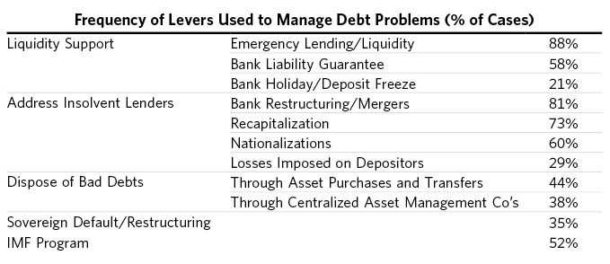

#### Redistributing Wealth

Wealth gaps increase during bubbles and they become particularly galling for the less privileged during hard times. As a general rule, if rich people share a budget with poor people and there is an economic downturn, there will be economic and political conflict. It is during such times that populism on both the left and the right tends to emerge. How well the people and the political system handle this is key to how well the economy and the society weather the period. As shown below, both inequality and populism are on the rise in the US today, much as they were in the 1930s. In both cases, the net worth of the top 0.1 percent of the population equaled approximately that of the bottom 90 percent combined.

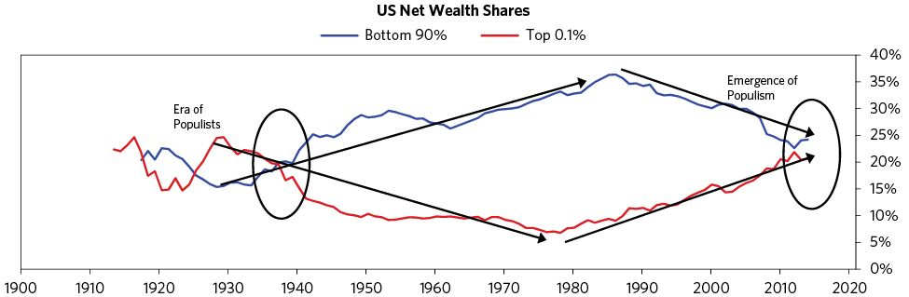

In some cases, raising taxes on the rich becomes politically attractive because the rich made a lot of money in the boom—especially those working in the financial sector—and are perceived to have caused the problems because of their greed. The central bank’s purchases of financial assets also disproportionately benefit the rich, because the rich own many more such assets. Big political shifts to the left typically hasten redistributive efforts. This typically drives the rich to try to move their money in ways and to places that provide protection, which itself has effects on asset and currency markets. It can also cause an economic “hollowing out” of those areas because the big income earners, who are also the big income taxpayers, leave, reducing overall tax revenues and leading these areas to suffer sharp declines in property values and reductions in services.

Typically, increased taxation takes the form of greater income, property, and consumption taxes because these forms of taxation are the most effective at raising revenues. Wealth and inheritance taxes are sometimes also increased,9 though these typically raise very little money because so much wealth is illiquid that it is practically difficult to collect on, and forcing the taxpayer to sell liquid assets to make their tax payments undermines capital formation. Regardless, transfers rarely occur in amounts that contribute meaningfully to the deleveraging (unless there are “revolutions” and huge amounts of property are nationalized).

### 5) The “Beautiful Deleveraging”

A “beautiful deleveraging” happens when the four levers are moved in a balanced way so as to reduce intolerable shocks and produce positive growth with falling debt burdens and acceptable inflation. More specifically, deleveragings become beautiful when there is enough stimulation (i.e., through “printing of money”/debt monetization and currency devaluation) to offset the deflationary deleveraging forces (austerity/defaults) and bring the nominal growth rate above the nominal interest rate—but not so much stimulation that inflation is accelerated, the currency is devaluated, and a new debt bubble arises.

The best way of negating the deflationary depression is for the central bank to provide adequate liquidity and credit support, and, depending on different key entities’ needs for capital, for the central government to provide that too. Recall that spending comes in the form of either money or credit. When increased spending cannot be financed with increased debt because there is too much debt relative to the amount of money there is to service the debt, increased spending and debt-service relief must come from increased money. This means that the central bank has to increase the amount of money in the system.

The central bank can do this by lending against a wider range of collateral (both of lower quality and longer maturity) and also by buying (monetizing) lower-quality and/or longer-term debt. This produces relief and, if it’s done in the right amounts, allows a deleveraging to occur with positive growth. The right amounts are those that a) neutralize what would otherwise be a deflationary credit market collapse and b) get the nominal growth rate marginally above the nominal interest rate to tolerably spread out the deleveraging process.

So, what do I mean by that? Basically, income needs to grow faster than debt. For example: Let’s assume that a country going through a deleveraging has a debt-to-income ratio of 100 percent. That means that the amount of debt it has is the same as the amount of income the entire country makes in a year. Now think about the interest rate on that debt. Let’s say it’s 2 percent. If debt is 100 and the interest rate is 2 percent, then if no debt is repaid it will be 102 after one year. If income is 100 and it grows at 1 percent, then income will be 101, so the debt burden will increase from 100/100 to 102/101. So for the burdens from existing debt not to increase, nominal income growth must be higher than nominal interest rates, and the higher the better (provided it is not so high that it produces unacceptable inflation and/or unacceptable currency declines).

People ask if printing money will raise inflation. It won’t if it offsets falling credit and the deflationary forces are balanced with this reflationary force. That’s not a theory—it’s been repeatedly proven out in history. Remember, spending is what matters. A dollar of spending paid for with money has the same effect on prices as a dollar of spending paid for with credit. By “printing money,” the central bank can make up for the disappearance of credit with an increase in the amount of money. This “printing” takes the form of central bank purchases of government securities and nongovernment assets such as corporate securities, equities, and other assets, which is reflected in money growing at an extremely fast rate at the same time as credit and real economic activity are contracting. Traditional economists see that as the velocity of money declining, but it’s nothing of the sort. What is happening at such times is that credit destruction is being offset by money creation. If the balance between replacing credit and actively stimulating the economy is right, this isn’t inflationary.

But there is such a thing as abusive use of stimulants. Because stimulants work so well relative to the alternatives, there is a real risk that they can be abused, causing an “ugly inflationary deleveraging” (like the Weimar hyperinflation of the 1920s, or those in Argentina and Brazil in the 1980s). The key is to avoid printing too much money. If policy makers achieve the right balance, a deleveraging isn’t so dramatic. Getting this balance right is much more difficult in countries that have a large percentage of debt denominated in foreign currency and owned by foreign investors (as in Weimar Germany and the South American countries) because that debt can’t be monetized or restructured as easily.

Printing money/debt monetization and government guarantees are inevitable in depressions in which interest rate cuts won’t work, though these tools are of little value in countries that are constrained from printing or don’t have assets to back printing up and can’t easily negotiate the redistributions of the debt burdens. All of the deleveragings that we have studied (which is most of those that occurred over the past hundred years) eventually led to big waves of money creation, fiscal deficits, and currency devaluations (against gold, commodities, and stocks). In different cases, policy makers have varied which exact combination of the levers they used, typically as a function of the nature of their monetary systems. The chart below conveys the archetypal path of money printing in deflationary deleveragings over the 21 cases. The money printing occurs in two classic waves—central banks first provide liquidity to stressed institutions, and then they conduct large-scale asset purchases to broadly stimulate the economy.

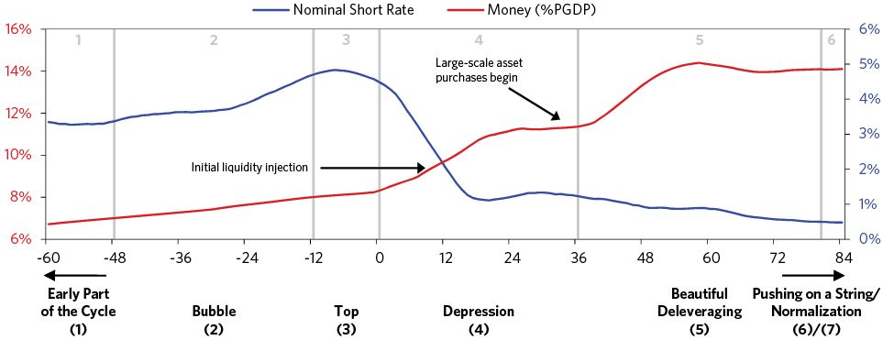

Below we show the average real exchange rate versus trade partners, which reflects the strength/weakness of a currency relative to the country’s trade partners.

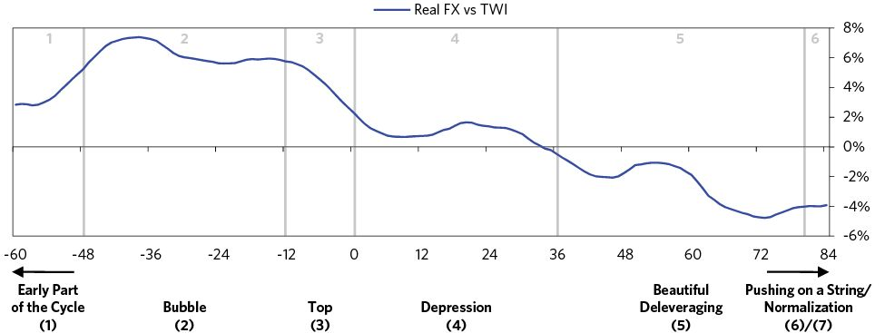

Typically, governments with gold-, commodity-, or foreign-currency-pegged money systems are forced to have tighter monetary policies to protect the value of their currency than governments with fiat monetary systems. But eventually the debt contractions become so painful that they relent, break the link, and print (i.e., either they abandon these systems or change the amount/pricing of the commodity that they will exchange for a unit of money). For example, when the value of the dollar (and therefore the amount of money) was tied to gold during the Great Depression, suspending the promise to convert dollars into gold so that the currency could be devalued and more money created was key to creating the bottoms in the stock and commodity markets and the economy. Printing money, making asset purchases, and providing guarantees were much easier to do in the 2008 financial crisis, as they didn’t require a legalized and official change in the currency regime. The chart below shows the archetypal path of gold prices. In the US Great Depression, gold rose overnight when Roosevelt broke the gold peg, and during the more recent financial crisis, Fed moves helped push down the value of the dollar versus all currencies, including gold.

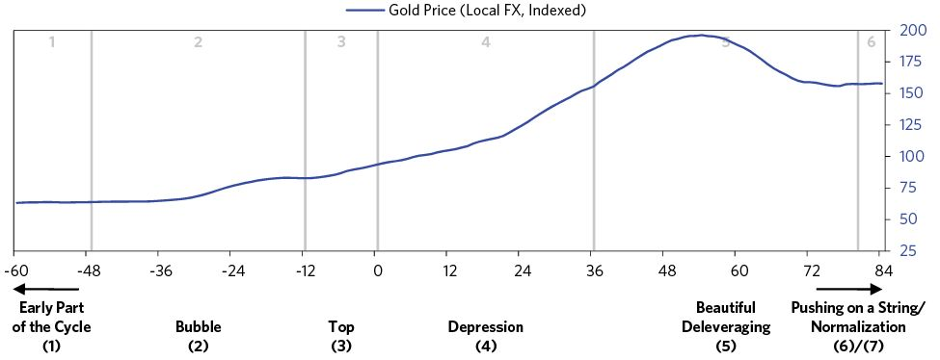

In the end, policy makers always print. That is because austerity causes more pain than benefit, big restructurings wipe out too much wealth too fast, and transfers of wealth from haves to have-nots don’t happen in sufficient size without revolutions. Also, printing money is not inflationary if the size and character of the money creation offsets the size and character of the credit contraction. It is simply negating deflation. In virtually all past deleveragings, policy makers had to discover this for themselves after they first tried other paths without satisfactory results. History has shown that those who did it quickly and well (like the US in 2008–09) have derived much better results than those who did it late (like the US in 1930–33).

The table below summarizes the typical amount of printing and currency devaluation required to create the turn from a depression to a “beautiful deleveraging.” On average the printing of money has been around 4 percent of GDP per year. There is a large initial currency devaluation of around 50 percent against gold, and deficits widen to about 6 percent of GDP. On average, this aggressive stimulation comes two to three years into the depression, after stocks have fallen more than 50 percent, economic activity has fallen about 10 percent, and unemployment has risen to around 10 to 15 percent, though there is a lot of variation.

I’m providing these numbers only as broad indicators, since circumstances vary considerably. When looking at the differences (which are very interesting but beyond the scope of this study), it is clear that when monetary and fiscal policies are rolled out faster and smarter, the results are much better than these averages.

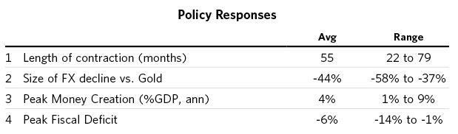

To reiterate, the key to having a beautiful deleveraging lies in balancing the inflationary forces against the deflationary ones. That’s because too much money printing can also produce an ugly inflationary deleveraging (which we will go through later). The right amounts of stimulus are those that a) neutralize what would otherwise be a deflationary credit-market collapse and b) get the nominal growth rate above the nominal interest rate by enough to relieve the debt burdens, but not by so much that it leads to a run on debt assets.

In summary, when all is said and done, only a few things distinguish whether a deleveraging is managed well or poorly. I have outlined them below. A lot of pain can be avoided if policy makers can learn from the common pitfalls and understand the policies characteristic of beautiful deleveragings.

BUBBLE

* WELL MANAGED
  + Central banks consider growth in debt and its effects on asset markets in managing policy. If they can prevent the bubble, they can prevent the bust.
  + Central banks use macroprudential policies to target restraints in debt growth where bubbles are emerging and allow debt growth where it is not excessive.
  + Fiscal policies are tightened.
* POORLY MANAGED
  + Big bubbles are fueled by speculators and lenders over-extrapolating past successes and making further debt-financed investments, and by central banks focusing just on inflation and/or growth and not considering debt bubbles in investment assets, thus keeping credit cheap for too long.

TOP

* WELL MANAGED
  + Central banks constrict the bubble either with the control of broad monetary policy or with well-chosen macroprudential policies and then ease selectively (via macroprudential policies).
* POORLY MANAGED
  + Central banks continue to tighten well after bursting the bubble.

DEPRESSION

* WELL MANAGED
  + Central banks provide ample liquidity, ease short rates quickly until they hit 0%, and then pursue aggressive monetizations, using aggressive targeted macroprudential policies.
  + Governments pursue aggressive and sustained fiscal stimulus, easing past the turn.
  + Systemically important institutions are protected.
* POORLY MANAGED
  + Central banks are slower to cut rates, provide more limited liquidity, and tighten too early. They also wait too long to pursue aggressive monetization.
  + Governments pursue austerity without adequately easing.
  + Systemically important institutions are left damaged or failed.

BEAUTIFUL DELEVERAGING

* WELL MANAGED
  + Reflations begin with aggressive monetizations through asset purchases or big currency declines, enough to bring nominal growth above nominal rates.
  + Stimulative macroprudential policies are targeted to protect systemically important entities and to stimulate high-quality credit growth.
  + Nonsystemically important institutions are allowed to fail in an orderly way.
  + Policy makers balance the depressive forces of defaults and austerity with the reflationary forces of debt monetization, currency declines, and fiscal stimulus.
* POORLY MANAGED
  + Initial monetizations stutter and start. Asset purchases are more muted and consist more of cash-like instruments rather than risky assets, so that purchases don't produce a wealth effect. Stimulation of the central bank is undermined by fiscal austerity.
  + Overindebted entities are protected even though they are not systemically important, leading to zombie banks and malaise.
  + Ugly inflationary depressions arise in cases where policy makers allow faith in the currency to collapse and print too much money.

### 6) “Pushing on a String”

Late in the long-term debt cycle, central bankers sometimes struggle to convert their stimulative policies into increased spending because the effects of lowering interest rates and central banks’ purchases of debt assets have diminished. At such times the economy enters a period of low growth and low returns on assets, and central bankers have to move to other forms of monetary stimulation in which money and credit go more directly to support spenders. When policy makers faced these conditions in the 1930s, they coined the phrase “pushing on a string.” One of the biggest risks at this stage is that if there is too much printing of money/monetization and too severe a currency devaluation relative to the amounts of the deflationary alternatives, an “ugly inflationary deleveraging” can occur.

To help understand the different kinds of monetary policies that can be used throughout a deleveraging, I think of them as coming in three different styles, each with its own effects on the economy and markets.

#### Monetary Policy 1

Interest-rate driven monetary policy (which I’ll call Monetary Policy 1) is the most effective because it has the broadest impact on the economy. When central banks reduce interest rates, they stimulate the economy by a) producing a positive wealth effect (because the lower interest rate raises the present value of most investments); b) making it easier to buy items on credit (because the monthly payments decline), raising demand—especially for interest-rate-sensitive items like durable goods and housing; and c) reducing debt-service burdens (which improves cash flows and spending). MP1 is typically the first approach to a debt crisis, but when short-term interest rates hit around 0 percent, it no longer works effectively, so central banks must go to the second type.

#### Monetary Policy 2

“Quantitative easing” (QE) as it is now called (i.e., “printing money” and buying financial assets, typically debt assets), is Monetary Policy 2. It works by affecting the behavior of investors/savers as opposed to borrowers/spenders, because it is driven by purchases of financial assets, typically debt assets that impact investors/savers the most. When the central bank buys a bond, it gives savers/investors cash, which they typically use to buy another financial asset that they think is more attractive. What they do with that money and credit makes all the difference in the world. When they invest in the sort of assets that finance spending, that stimulates the economy. When they invest in those that don’t (such as financial assets), there must be very large market gains before any money trickles down into spending—and that spending comes more from those who have enjoyed the market gains than from those who haven’t. In other words, QE certainly benefits investors/savers (i.e., those who own financial assets) much more than people who don’t, thus widening the wealth gap.

While MP2 is generally less effective than interest-rate changes, it is most effective when risk and liquidity premiums are large, because it causes those premiums to fall. When risk premiums are large, and money is added to the system, actual risks are reduced at the same time that there is more money seeking returns, which triggers purchases of riskier assets that are offering higher expected returns, driving their prices up and producing a positive wealth effect.

But over time, the use of QE to stimulate the economy declines in effectiveness because risk premiums are pushed down and asset prices are pushed up to levels beyond which they are difficult to push further, and the wealth effect diminishes. In other words, at higher prices and lower expected returns, the compensation for taking risk becomes too small to get investors to bid prices up, which would drive prospective returns down further. In fact, the reward-to-risk ratio could make those who are long a lot of assets view that terribly returning asset called cash as more appealing. As a result, QE becomes less and less effective. If they provide QE and private credit growth doesn’t pick up, policy makers feel like they are pushing on a string.

At this stage, policy makers sometimes monetize debt in even larger quantities in an attempt to compensate for its declining effectiveness. While this can help for a bit, there is a real risk that prolonged monetization will lead people to question the currency’s suitability as a store hold of value. This can lead them to start moving to alternative currencies, such as gold. The fundamental economic challenge most economies have in this phase is that the claims on purchasing power are greater than the abilities to meet them.

Think of it this way: There are only goods and services. Financial assets are claims on them. In other words, holders of investments/assets (i.e., investors/capitalists) believe that they can convert their holdings into purchasing power to get goods and services. At the same time, workers expect to be able to exchange a unit’s worth of their contribution to the production of goods and services into buying power for goods and services. But since debt/money/currency have no intrinsic value, the claims on them are greater than the value of what they are supposed to be able to buy, so they have to be devalued or restructured. In other words, when there are too many debt liabilities/assets, they either have to be reduced via debt restructurings or monetized. Policy makers tend to use monetization at this stage primarily because it is stimulative rather than contractionary. But monetization simply swaps one IOU (debt) for another (newly printed money). The situation is analogous to a Ponzi scheme. Since there aren’t enough goods and services likely to be produced to back up all the IOUs, there’s a worry that people may not be willing to work in return for IOUs forever.

Low interest rates together with low premiums on risky assets pose a structural challenge for monetary policy. With Monetary Policy 1 (interest rates) and Monetary Policy 2 (QE) at their limits, the central bank has very little ability to provide stimulus through these two channels—i.e., monetary policy has little “gas in the tank.” This typically happens in the later years of the long-term debt cycle (e.g., 1937-38 and now in the US), which can lead to “pushing on a string.” When this happens, policy makers need to look beyond QE to the new forms of monetary and fiscal policy characterized by Monetary Policy 3.

#### Monetary Policy 3

Monetary Policy 3 puts money more directly into the hands of spenders instead of investors/savers and incentivizes them to spend it. Because wealthy people have fewer incentives to spend the incremental money and credit they get than less wealthy people, when the wealth gap is large and the economy is weak, directing spending opportunities at less wealthy people is more productive.

Logic and history show us that there is a continuum of actions to stimulate spending that have varying degrees of control to them. At one end are coordinated fiscal and monetary actions, in which fiscal policy makers provide stimulus directly through government spending or indirectly by providing incentives for nongovernment entities to spend. At the other end, the central bank can provide “helicopter money” by sending cash directly to citizens without coordination with fiscal policy makers. Typically, though not always, there is a coordination of monetary policy and fiscal policy in a way that creates incentives for people to spend on goods and services. Central banks can also exert influence through macroprudential policies that help to shape things in ways that are similar to how fiscal policies might. For simplicity, I have organized that continuum and provided references to specific prior cases of each below.

* An increase in debt-financed fiscal spending. Sometimes this is paired with QE that buys most of the new issuance (e.g., in Japan in the 1930s, US during World War II, US and UK in the 2000s).
* Increase in debt-financed fiscal spending, where the Treasury isn’t on the hook for the debt, because:
  + The central bank can print money to cover debt payments (e.g., Germany in the 1930s).
  + The central bank can lend to entities other than the government that will use it for stimulus projects (e.g., lending to development banks in China in 2008).
* Not bothering to go through issuing debt, and instead giving newly printed money directly to the government to spend. Past cases have included printing fiat currency (e.g., in Imperial China, the American Revolution, the US Civil War, Germany in the 1930s, and the UK during World War I) or debasing hard currency (Ancient Rome, Imperial China, 16th-century England).
* Printing money and doing direct cash transfers to households (i.e., “helicopter money”). When we refer to “helicopter money,” we mean directing money into the hands of spenders (e.g., US veterans’ bonuses during the Great Depression, Imperial China).  
   How that money is directed could take different forms—the basic variants are either to direct the same amount to everyone or aim for some degree of helping one or more groups over others (e.g., giving money to the poor rather than to the rich). The money can be provided as a one-off or over time (perhaps as a universal basic income). All of these variants can be paired with an incentive to spend it—such as the money disappearing if it’s not spent within a year. The money could also be directed to specific investment accounts (like retirement, education, or accounts earmarked for small-business investments) targeted toward socially desirable spending/investment. Another potential way to craft the policy is to distribute returns/holdings from QE to households instead of to the government.
* Big debt write-down accompanied by big money creation (the “year of Jubilee”) as occurred in Ancient Rome, the Great Depression, and Iceland.

While I won’t offer opinions on each of these, I will say that the most effective approaches involve fiscal/monetary coordination, because that ensures that both the providing and the spending of money will occur. If central banks just give people money (helicopter money), that’s typically less adequate than giving them that money with incentives to spend it. However, sometimes it is difficult for those who set monetary policy to coordinate with those who set fiscal policy, in which case other approaches are used.

Also, keep in mind that sometimes the policies don’t fall exactly into these categories, as they have elements of more than one of them. For example, if the government gives a tax break, that’s probably not helicopter money, but it depends on how it’s financed. The government can also spend money directly without a loan financed by the central bank—that is helicopter money through fiscal channels.

While central banks influence the costs and availabilities of credit for the economy as whole, they also have powers to influence the costs and availabilities of credit for targeted parts of the financial system through their regulatory authorities. These policies, which are called macroprudential policies, are especially important when it’s desirable to differentiate entities—e.g., when it is desirable to restrict credit to an overly indebted area while simultaneously stimulating the rest of the economy, or when its desirable to provide credit to some targeted entities but not provide it broadly. Macroprudential policies take numerous forms that are valuable in different ways in all seven stages of the big debt cycle. Because explaining them here would require too much of a digression, they are explained in some depth in the Appendix.

### 7) Normalization

Eventually the system gets back to normal, though the recovery in economic activity and capital formation tends to be slow, even during a beautiful deleveraging. It typically takes roughly 5 to 10 years (hence the term “lost decade”) for real economic activity to reach its former peak level. And it typically takes longer, around a decade, for stock prices to reach former highs, because it takes a very long time for investors to become comfortable taking the risk of holding equities again (i.e., equity risk premiums are high).

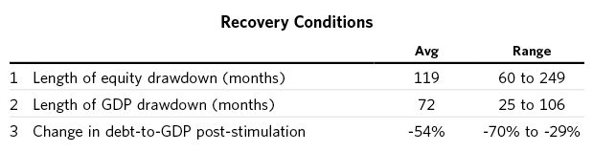

Now that you have this template for deflationary depressions in mind, I encourage you to read the detailed accounts of the US 2007–2011 and 1928–1937 big debt cycles shown in Part 2 and then look at the summary statistics and auto-text of the 21 case studies shown in Part 3.

3. Archetype charts are sensitive to outliers, especially for metrics like inflation that vary widely. For each chart, we excluded roughly the third of cases that were least related to the average.

4. In the US, the central bank doesn’t take this debt service perspective as it applies to investment assets into consideration—e.g., it’s nowhere to be found in the Taylor Rule.

5. In the 2008 crisis in the US, residential and commercial real estate, private equity, lower grade credits and, to a lesser extent, listed equities were the assets that were bought at high prices and on lots of leverage. During both the US Great Depression and the Japanese deleveraging, stocks and real estate were also the assets of choice that were bought at high prices and on leverage.

6. A negative “wealth effect” occurs when one’s wealth declines, which leads to less lending and spending. This is due to both negative psychology of worry and worse financial conditions leading to borrowers having less collateral, which leads to less lending.

7. Here’s how the math works. If you’re levered 2:1, the value of your assets is twice your net worth. To put numbers on it, say you own $100 of assets and your debts are $50. In that case, your net worth is $50. If the value of your assets falls by 30 percent, you’re left with $70 of assets and $50 of debt. Your net worth is now $20. That’s 60 percent less than the net worth of $50 you started with, even though your assets only fell 30 percent. Being levered 2:1 doubles the impact of the asset price decline on your net worth (similarly 3:1 leverage would triple it, and so on).

8. I don’t mean to convey that debt reductions and austerity don’t play beneficial roles in the deleveraging process because they do—but unless they are balanced with reflationary money printing, monetization, and guarantees, they cause a huge amount of pain while not doing enough to restore the economy.

9. The extent to which wealth taxes can be applied varies by country. For example, they have been judged to be unconstitutional in the US but have been allowed in other countries.

## Inflationary Depressions and Currency Crises

In the previous section, we looked at the archetypal deflationary debt crisis, which we created by averaging the 21 deflationary cycles you can review in Part 3. We will now look at the archetypal inflationary debt crisis, which we created by averaging the 27 worst cases of inflationary cycles (also shown in Part 3). After reviewing this template, I encourage you to read about the hyperinflation in Germany’s Weimar Republic, which is examined in depth in Part 2, to compare it to the archetypal case described here. Before we turn to the charts and other data, please remember that:

* Currency and debt serve two purposes: to be 1) mediums of exchange and 2) store holds of wealth
* Debt is one person’s asset and another’s liability
* Debt is a promise to pay in a certain type of currency (e.g., dollars, euro, yen, pesos, etc.)
* Holders of debt assets expect to convert them into money and then into goods and services down the road, so they are very conscious of the rate of its loss of purchasing power (i.e., inflation) relative to the compensation (i.e., the interest rate) they get for holding it
* Central banks can only produce the type of money and credit that they control (e.g., the Fed makes dollar denominated money and credit, the BoJ makes Japanese yen money and credit, etc.)
* Through a symbiotic relationship, over time central banks and free-market borrowers and lenders typically create bigger and bigger piles of debt assets and debt liabilities
* The bigger the pile, the greater the challenge for central bankers to balance the opposing pressures so the pile doesn’t topple over into a deflationary depression in one direction or an inflationary depression in the other
* Policy makers (those who control monetary and fiscal policies) can usually balance these opposing forces in debt crises because they have a lot of power to redistribute the burdens so they are spread out, though they can’t always balance them well
* Central banks typically relieve debt crises by “printing” a lot of the currency in which the debt is denominated, which, while stimulating spending on investment assets and the economy, also cheapens the value of the currency (all else being equal)
* If a currency falls in relation to another currency at a rate that is greater than the currency’s interest rate, the holder of the debt in the weakening currency will lose money. If investors expect that weakness to continue without being compensated with higher interest rates, a dangerous currency dynamic will develop.

That last dynamic, i.e., the currency dynamic, is what produces inflationary depressions. Holders of debt denominated in the poorly returning currency are motivated to sell it and move their assets into another currency or a non-currency store hold of wealth like gold. When there is a debt crisis and economic weakness in a country, it is typically impossible for the central bank to raise interest rates enough to compensate for the currency weakness, so the money leaves that country and currency for safer countries. When so much money leaves the country that lending dries up, the central bank is faced with the choice of letting the credit markets tighten or printing money, which produces a lot of it. While it is widely known that central banks manage the trade-offs between inflation and growth by changing interest rates and liquidity in the system, what is not widely known is that the central bank’s trade-offs between inflation and growth are easier to manage when money is flowing into a country’s currency/debt and more difficult to manage when it’s flowing out. That’s because if there is more demand for the currency/debt, that will push the currency/debt prices up, which, all else being equal, will push inflation down and growth up (assuming the central bank keeps the amount of money and credit steady); when there is less demand, the reverse will happen. How much changing demand there is for a country’s currency/debt will create changes in the currency versus changes in interest rates will depend on how the central bank moves its levers—which I’ll cover below. For now, suffice it to say that in times when money is flowing out of a currency, real interest rates need to rise less if real exchange rates fall more (and vice versa).

Capital outflows tend to happen when an environment is inhospitable (e.g., because debt, economic, and/or political problems exist), and they typically weaken the currency a lot. To make matters worse, those who fund their activities in the country that has the weaker currency by borrowing the stronger currency see their debt costs soar; that drives down the weaker currency relative to the stronger one even more. For these reasons, countries with the worst debt problems, a lot of debt denominated in a foreign currency, and a high dependence on foreign capital typically have significant currency weaknesses. The currency weakness is what causes inflation when there is a depression.

Normally this all runs its course when the currency and the debt prices go down enough to make them very cheap. More specifically, the squeeze ends when a) the debts are defaulted on and/or enough money is created to alleviate the squeeze, b) the debt service requirements are reduced in some other way (e.g., forbearance) and/or c) the currency depreciates much more than inflation picks up, so that the country’s assets and the items it sells to the world become so competitively priced that its balance of payments improves. But a lot depends on politics. If the markets are allowed to run their courses, the adjustments eventually take place and the problems are resolved, but if the politics get so bad that productivity is thrown into a self-reinforcing downward spiral, that spiral can go on for a long time.

#### Which Countries/Currencies Are Most Vulnerable to Severe Inflationary Deleveragings or Hyperinflations?

While inflationary depressions are possible in all countries/currencies, they are far more likely in countries that:

* Don’t have a reserve currency (so there is not a global bias to hold their currency/debt as a store hold of wealth)
* Have low foreign-exchange reserves (the cushion to protect against capital outflows is small)
* Have a large foreign debt (so there is a vulnerability to the cost of the debt rising via increases in either interest rates or the value of the currency the debtor has to deliver, or a shortage of the availability of dollar denominated credit)
* Have a large and increasing budget and/or current account deficit (causing the need to borrow or print money to fund the deficits)
* Have negative real interest rates (i.e., interest rates that are significantly less than inflation rates), therefore inadequately compensating lenders for holding the currency/debt
* Have a history of high inflation and negative total returns in the currency (increasing lack of trust in the value of the currency/debt)

Generally speaking, the greater the degree to which these things exist, the greater the degree of the inflationary depression. The most iconic case is the German Weimar Republic in the early 1920s, which is examined at length in Part 2. If you are interested in reviewing actual case studies showing the reasons why inflationary depressions happen rather than deflationary ones, it is worth noting the differences between the Weimar case study and the US Great Depression and 2007–2011 case studies, which are also examined in Part 2.

Can reserve-currency countries that don’t have significant foreign-currency debt have inflationary depressions? While they are much less likely to have inflationary contractions that are as severe, they can have inflationary depressions, though they emerge more slowly and later in the deleveraging process, after a sustained and repeated overuse of stimulation to reverse deflationary deleveraging. Any country, including one with a reserve currency, can experience some movement out of its currency, which changes the severity of the trade-off between inflation and growth described earlier. If a reserve-currency country permits much higher inflation in order to keep growth stronger by printing lots of money, it can further undermine demand for its currency, erode its reserve currency status (e.g., make investors view it as less of a store hold of wealth), and turn its deleveraging into an inflationary one.

## The Phases of the Classic Inflationary Debt Cycle

Classically, inflationary deleveragings follow the ebbs and flows of money and credit through five stages that mirror the stages of deflationary deleveragings, but that are different in important ways. Over the past few decades I have navigated through a number of inflationary deleveragings and researched many more. They transpire pretty much as deflationary deleveragings do up until the fourth stage, the depression.

I’ll begin this section with a look at the stages of the archetypal inflationary deleveraging, just as I did in the prior section. (This archetype was created by averaging 27 inflationary deleveragings in which there was a lot of debt denominated in foreign currencies.) Then I’ll compare the archetype to four specific hyperinflationary cases in order to highlight their differences.

### 1) The Early Part of the Cycle

In the healthy upswing, favorable capital flows are a result of good fundamentals—i.e., because the country is competitive and there is potential for productive investment. At this point, debt levels are low, and balance sheets are healthy. That stimulates export sales and hence foreign capital, which funds investments that produce good returns and yield productive growth.

Capital flows—both within countries and among them—are typically the most important flows to watch because they are the most volatile. As the cycle begins, debt and incomes rise at comparable rates and both debt and equity markets are strong, which encourages investing, often with borrowed money. The private sector, government, and banks start to borrow, which makes sense for them because incomes are rising quickly, making it easier to service the debt. These strong fundamentals and early levering up set the country up for a boom that in turn attracts more capital.

The positive, self-reinforcing cycle is enhanced when the demand for the currency is improving. If the currency is cheap enough to offer attractive opportunities to foreign investors (who will typically lend to or invest in entities that can produce inexpensively in that country and sell into export markets to earn the foreign currency to provide them with a good return), and/or the country sells more to foreigners than it buys from them, a country’s balance of payments will become favorable—i.e., the demand for its currency will be greater than its supply. This makes the central bank’s job easier—i.e., it can get more growth per unit of inflation—because the positive inflows can be used to appreciate the currency, to lower interest rates, and/or to increase reserves, depending on how the central bank chooses to handle it.

At these times of early currency strength, some central banks choose to enter the foreign-currency exchange market to sell their own currency for the incoming foreign currency in order to prevent it from rising (and to prevent the adverse economic effects of its rise). If the central bank does this, it needs to do something with that newly acquired currency, which is to buy investment assets denominated in that foreign currency (most typically bonds) and put them in an account called “foreign-exchange reserves.” Foreign-exchange reserves are like savings: They can be used to bridge imbalances between the amount of currency demanded and the amount supplied by the free market in order to cushion the movements of the currency markets. They can also be used to purchase assets that might be desirable investments or offer strategic returns. The process of accumulating reserves is stimulative to the economy because it lessens the upward pressure on their own currency, which allows a country to maintain stronger export competitiveness and puts more money in the economy. Since central banks need to create more money to buy the foreign currency, doing that increases the amount of domestic currency funds to either buy assets (causing asset prices to rise) or lend out.

At this juncture, the currency’s total return will be attractive because either a) those who want to buy what the country has to offer need to sell their own currency and buy the local currency or b) the central bank will increase the supply of its own currency and sell it for the foreign currency, which will make the country’s assets go up when measured in its own currency. So, during this time when a country has a favorable balance of payments, there is a net inflow of money that leads to the currency appreciating and/or the foreign-exchange reserves increasing. This influx of money stimulates the economy and causes that country’s markets to rise. Those invested in the country make money from the currency return (through a combination of currency price changes and asset return differences) and/or the asset appreciation. The more the currency appreciates, the less assets will appreciate.

### 2) The Bubble

The bubble emerges in the midst of a self-reinforcing virtuous cycle of strong capital flows, good asset returns, and strong economic conditions. The capital that came in during the early upswing produced good returns, as it was invested productively and led to asset price appreciation, which attracted even more capital. In the bubble phase, the prices of the currency and/or the assets get bid up and increasingly financed by debt, making the prices of these investments too high to produce adequate returns, but the borrowing and buying continues because prices are rising, and so debts rise rapidly relative to incomes.

When there is a big wave of money coming into (and/or staying in) a country/currency, typically the exchange rate is strong, foreign-exchange reserves increase, and the economy booms—or in some cases the currency rises a lot and the economy grows more slowly. This upswing tends to be self-reinforcing until it is so overdone that it reverses. It is self-reinforcing because the inflows drive up the currency, making it desirable to hold assets denominated in it (and desirable to hold liabilities denominated in other currencies), and/or produce more money creation that causes prices to rise more.

In either case, during these bubbles the total returns of these assets to foreigners (i.e., asset prices in local currency plus the currency appreciation) are very attractive. That plus that country’s hot economic activity encourage more foreign inflows and fewer domestic outflows. Over time, the country becomes the hot place to invest, and its assets become overbought so debt and stock-market bubbles emerge. Investors believe the country’s assets are a fabulous treasure to own and that anyone not in the country is missing out. Investors who were never involved with the market rush in. When the market gets fully long, leveraged, and overpriced, it becomes ripe for a reversal. In the bullets here and in the ones that follow, we show some key economic developments typically seen as the bubble inflates.

* Foreign capital flows are high (on average around 10 percent of GDP)
* The central bank is accumulating foreign-exchange reserves
* The real FX is bid up and becomes overvalued on a purchasing power parity (PPP) basis by around 15 percent
* Stocks rally (on average by over 20 percent for several years into their peak)

All sorts of entities build up structurally long currency positions because there is constant reward for doing that. Most participants are motivated to be long the currency of the country that is enjoying a sustained wave of investment into it—though they often find themselves in this position without explicitly taking it on or fully recognizing it. For example, foreign businesses that set up operations in the hot country might fund their activities with their own currency (to keep the liability in the currency that they expect will be weaker), but they might prefer to hold their deposits in the local currency, and they might not hedge the currency exposures that come from the revenues of sales in that country. Similarly, local businesses might borrow in the weaker foreign currency, which the foreign bankers are eager to lend because the market is hot. There are lots of different ways that a sustained bull market will lead to multinational entities getting long that local currency.

* The influx of foreign capital finances a boom in consumption
* Imports rise faster than exports, and the current account worsens

Meanwhile, investment in the country creates strong growth and rising incomes, which make borrowers in the country more creditworthy, and make them more willing to borrow at the same time that lenders are more willing to lend to them. High export prices, usually for commodities, increase the country’s income and incentivize investment.

As the bubble emerges, there are fewer productive investments, and at the same time there is more capital going after them. The fundamental attractiveness of the country that sparked the boom fades, in part because the rising currency is eroding the country’s competitiveness.

During this stage, growth is increasingly financed by debt rather than productivity gains, and the country typically becomes highly reliant on foreign financing. This shows up in foreign currency denominated debt rising. These emerging countries typically borrow primarily from abroad with debts denominated in foreign currencies because of a combination of factors—including the local financial system not being well developed, less faith in lending in the local currency, and a smaller stock of domestic savings available to be lent out. Asset prices rise, and the economy is strong. This creates both higher levels of spending in the economy and higher levels of obligations to pay in foreign currency in order to make debt-service payments. As with all debt cycles, the positive effects come first and the negative effects come later.

* Debt burdens rise fast. Debt to GDP rises at an annual rate of about 10 percent over three years.
* Foreign-currency debt rises (on average to around 35 percent of total debt and to around 45 percent of GDP).
* Typically, the level of economic activity (i.e., the GDP gap) is very strong and growth is well above potential, leading to tight capacity (as reflected in a GDP gap of around +4 percent).

The charts below convey what happens to debt and the current account in the average of the 27 inflationary deleveraging cases (which we call the “archetype”). Just as I did with the deflationary deleveraging archetype charts, I highlight each of the stages (with the “zero” point on the charts representing the top in economic activity). Classically, during the bubble, debt as a percentage of GDP rises from around 125 percent to about 150 percent, and the current account deteriorates by about 2 percent of GDP.

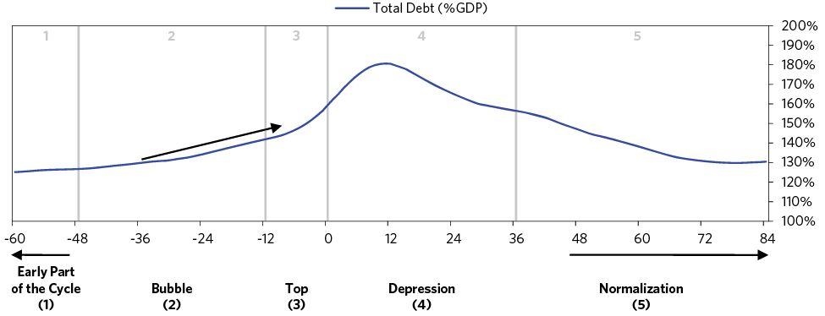

During the bubble, the gap between the country’s income and its spending widens. The country requires an increasing inflow of capital to drive continued growth in spending. But levels of economic activity can remain strong at the top of the cycle only as long as continued inflows, motivated by expectations of continued high growth, drive up asset prices and cause the currency to strengthen further. At this point, the country is increasingly fragile and even a minor event can trigger a reversal.

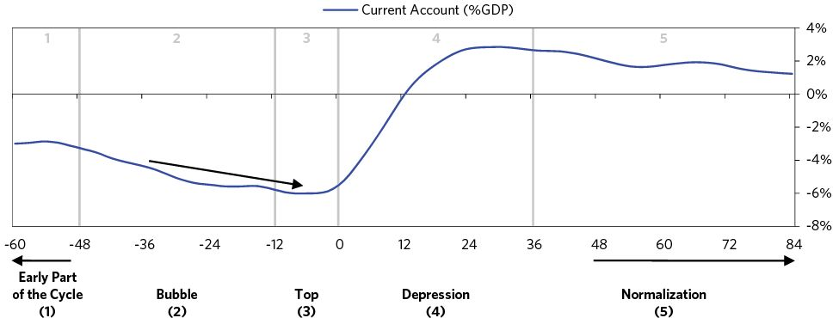

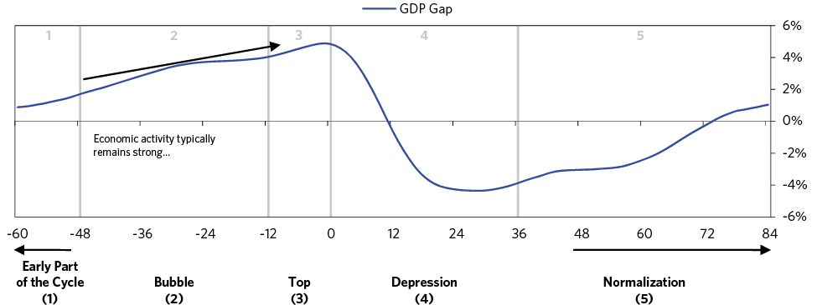

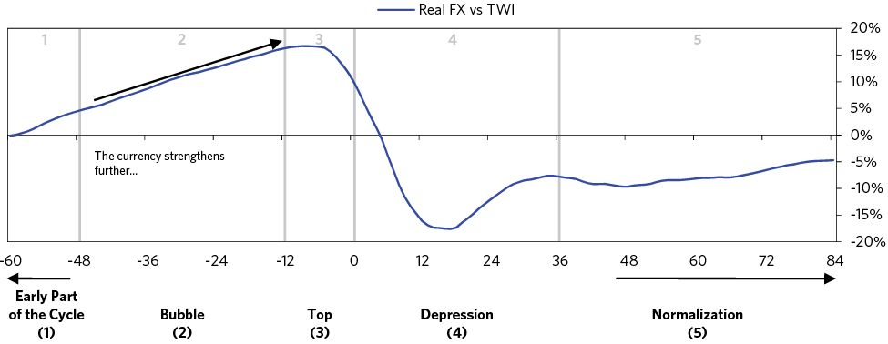

Below we summarize the conditions through the upswings that led to the 27 inflationary deleveragings we looked at. We break out the cases with higher and lower levels of foreign-denominated debt and the cases that eventually had the least and most extreme economic outcomes (as measured by most severe declines in growth and equity prices and increases in unemployment and inflation). As you will see, the countries that were most externally reliant through the upswing and experienced the biggest asset bubbles ultimately experienced the most painful outcomes.

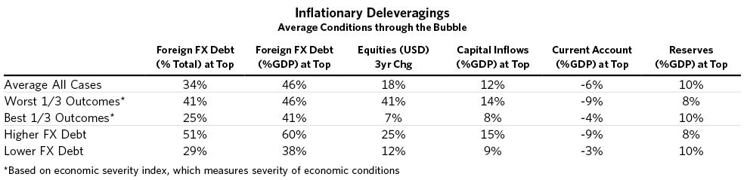

### 3) The Top and Currency Defense

The top-reversal/currency-defense occurs when the bubble bursts—i.e., when the flows that caused the bubble and the high prices of the currency level, the high asset prices and the high debt growth rates finally become unsustainable. This sets in motion a mirror-opposite cycle from what we saw in the upswing, in which weakening capital inflows and weakening asset prices cause deteriorating economic conditions, which in turn cause capital flows and asset prices to weaken further. This spiral sends the country into a balance of payments crisis and an inflationary depression.

Because at the top people are so invested in the optimistic scenario, and because that optimism is reflected in the prices, even a minor event can trigger a slowing of foreign capital inflows and an increase in domestic capital outflows. Though worsening trade balances typically play a role (usually because of the high currency level and excessive domestic consumption that led to high imports), adverse shifts in capital flows are usually more important.

The circumstances that could set off such a crisis are akin to what might set off financial difficulties for a family or individual—a loss of income or credit tightening, a big increase in costs (such as rising gasoline or heating oil prices), or having borrowed so much that repayment becomes difficult. Any one of these shocks would create a gap between the amount of money coming in and the amount of money being spent, which has to be closed somehow.

In the typical cycle, the crisis arises because the unsustainable pace of capital that drove the bubble slows, but in many cases, there is some sort of a shock (like a decline in oil prices for an oil producer). Generally the causes of the top-reversal fall into a few categories:

1. The income from selling goods and services to foreigners drops (e.g., the currency has risen to a point where it’s made the country’s exports expensive; commodity-exporting countries may suffer from a fall in commodity prices).
2. The costs of items bought from abroad or the cost of borrowing rises.
3. Declines in capital flows coming into the country (e.g., foreign investors reduce their net lending or net investment into the country). This occurs because:
   1. The unsustainable pace naturally slows,
   2. Something leads to greater worries about economic or political conditions, or
   3. A tightening of monetary policy in the local currency and/or in the currency those debts are denominated in (or in some cases, tightening abroad creates pressure for foreign capital to pull out of the country).
4. A country’s own citizens or companies want to get their money out of their country/currency.

Weakening capital flows are often the first shoe to drop in a balance of payments crisis. They directly cause growth to weaken because the investment and consumption they had been financing is reduced. This makes domestic borrowers seem less creditworthy, which makes foreigners less willing to lend and provide capital. So, the weakening is self-reinforcing.

* Growth slows relative to potential as the pace of capital inflows slows.
* Domestic capital outflows pick up a bit.
* Export earnings fall, due to falling prices or falling quantities sold. Typically exports are flat, no longer rising.

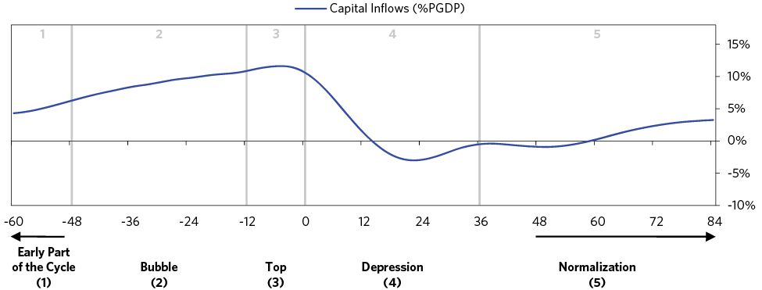

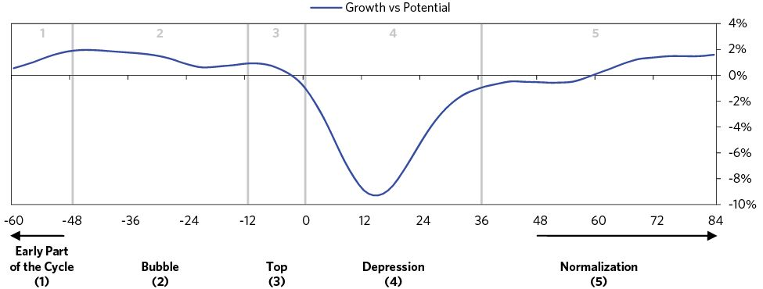

The shift in capital and income flows drives asset prices down and interest rates up, slowing the economic growth rates that were dependent on the inflows. This worsens the fundamentals of companies and further drives out capital flows. The economy suffers a debt bust—asset prices fall and banks fail.

During this stage, worry increases on the part of both asset/currency holders and the policy makers who are trying to support the currency. Asset/currency holders typically worry that policy makers will impose restrictions on their ability to get their money out of the country, which encourages them to get their money out while they still can, which further increases the balance of payments problem. Policy makers worry about capital outflows and the possibility of a currency collapse. As the balance of payments deteriorate, the central bank’s job becomes more difficult—i.e., it gets less economic growth per unit of inflation because the negative flows lead the currency to depreciate, interest rates to rise, and/or reserves to decline, depending on how the central bank chooses to handle it.

At this stage, central banks typically try to defend their currencies by a) filling the balance of payments deficit by spending down reserves and/or b) raising rates. These currency defenses and managed currency declines rarely work because the selling of reserves and/or the raising of interest rates creates more of an opportunity for sellers, while it doesn’t move the currencies and interest rates to the levels that they need to be to bring about sustainable economic conditions. Let’s look at this typical defense and why it fails.

There is a critical relationship between a) the interest rate difference and b) the spot/forward currency relationship. The amount the currency is expected to decline is priced into how much less the forward price is below the spot price. For example, if the market expects the currency to fall by 5 percent over a year, it will need that currency to yield a 5 percent higher interest rate. The math is even starker when depreciation is expected over short periods of time. If the market expects a 5 percent depreciation over a month, than it will need that currency to yield a 5 percent higher interest rate over that month—and a 5 percent monthly interest is equivalent to an annual interest rate of about 80 percent10 —a level that’s likely to produce a very severe economic contraction in an already weak economy. Because a small expected currency depreciation (say 5 to 10 percent in a year) would equal a large interest rate premium (5 to 10 percent per year higher), this path is intolerable.

Said differently, a managed currency decline accompanied by falling reserves causes the market to expect continued future currency depreciation, which pushes up domestic interest rates (as described above), acting as a tightening at a time when the economy is already weak. Also, the expectation of continued devaluation will encourage increased capital withdrawals and devaluation speculation, widening the balance of payments gap and forcing the central bank to spend down more reserves to defend the currency (or abandon the planned gradual depreciation). Also, a currency defense by spending reserves will have to stop because no sensible policy maker will want to run out of such “savings.” In such currency defenses, policy makers—especially those defending a peg—will typically make boldly confident statements vowing to stop the currency from weakening. All of these things classically happen just before the cycle moves to its next stage, which is letting the currency go.

It is typical during the currency defense to see the forward currency price decline ahead of the spot price. This is a consequence of the relationship between the interest rate differential and the spot/forward currency pricing that I discussed above. To the extent that the country tightens monetary policy to try to support the currency, they are just increasing the interest rate differential to artificially hold up the spot currency. While this supports the spot, the forward will continue to decline relative to it. As a result, what you see is essentially a whip-like effect, where the forward tends to lead the spot downward as the interest rate differential increases. The spot then eventually catches up after the currency is let go, and the fall in the spot exchange rate allows the interest differential to narrow, which mechanically causes the forward to rally relative to the spot.

At this point in the cycle, capital controls are a third (often last ditch) lever that seldom works. They can seem attractive to policy makers, since they directly cause fewer people to take their capital out of the country. But history shows that they usually fail because a) investors find ways to get around them and b) because the very act of trying to trap people leads them to want to escape. The inability to get one’s money out of a country is analogous to one’s inability to get one’s money out of a bank: fear of it can lead to a run. Still, capital controls sometimes can be a temporary fix, though in no case are they a sustained fix.

Usually, this currency defense phase of the cycle is relatively brief, in the vicinity of six months, with reserves drawn down about 10 to 20 percent before the defense is abandoned.

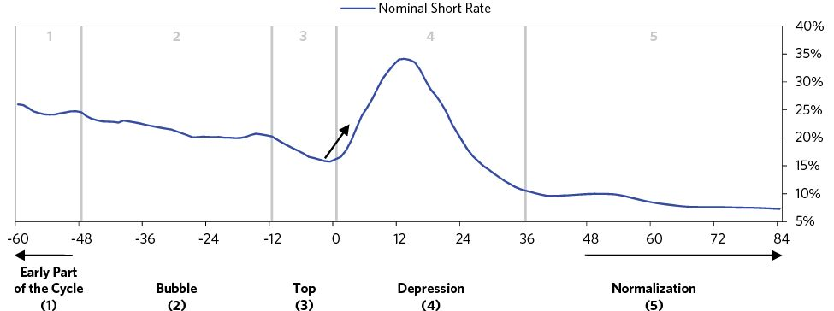

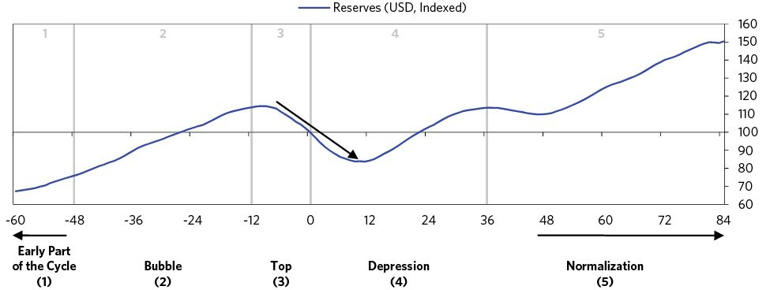

### 4) The Depression (Often When the Currency Is Let Go)

As mentioned above, a country’s inflationary deleveraging is analogous to what happens when a family has trouble making payments—with one major difference. Unlike a family, a country can change the amount of currency that exists, and hence, its value. That creates an important lever for countries to manage balance of payments pressures, and it’s why the world doesn’t have one global currency. Changing the value of the currency changes the price of a country’s goods and services for foreigners at a different rate than it does for its citizens. Think about it this way: if a family’s breadwinner lost his/her job and would have to take a 30 percent pay cut to get a new one, that would have a devastating economic effect on the family. But when a country devalues its currency by 30 percent, that paycut becomes a 30 percent pay cut only relative to the rest of the world; the wages in the currency the family cares about stay the same. In other words, currency declines allow countries to offer price cuts to the rest of the world (helping to bring in more business) without producing domestic deflation.

So after supporting the currency in unsustainable ways (i.e., expending reserves, tightening monetary policy, making very strong assurances that there will not be a devaluation of the currency, and sometimes imposing foreign exchange controls), policy makers typically stop fighting and let the currency decline (though they generally try to smooth its fall).

Here is what we typically see after policy makers let the currency go:

* The currency has a big initial depreciation, on average declining around 30 percent in real terms
* The decline in the currency is not offset by tighter short rates, so that the losses from holding the currency are significant (on average, around 30 percent in the first year)
* Because the decline is very severe, policy makers try to smooth it, leading them to continue to spend down reserves (on average, by another 10 percent for a year into the bust)

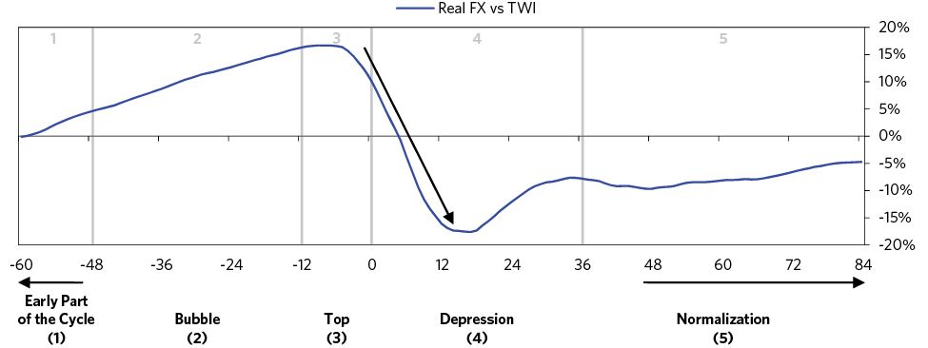

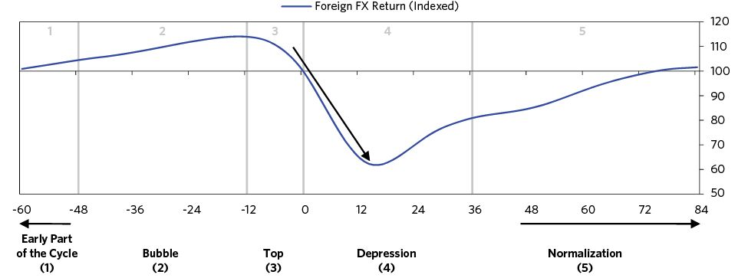

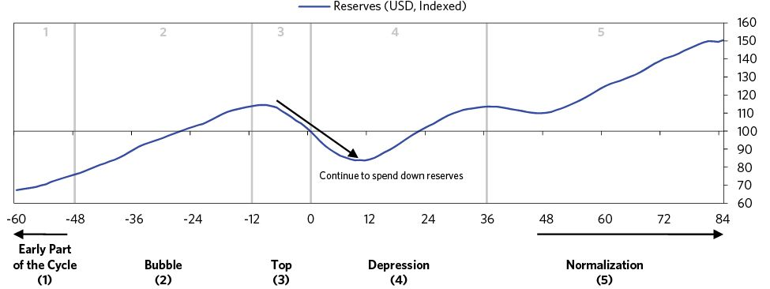

Central banks should not defend their currencies to the point of letting their reserves get too low or their interest rates too high relative to what is good for the economy because the dangers those conditions pose are greater than the dangers of devaluation. In fact, devaluations are stimulative for the economy and markets, which is helpful during the economic contraction. The currency decline tends to cause assets to rise in value measured in that weakened currency, stimulate export sales, and help the balance of payments adjustment by bringing spending back in line with income. It also lowers imports (by making them more expensive), which favors domestic producers, makes assets in that currency more competitively priced and attractive, creates better profit margins for exported goods, and sets the stage for the country to earn more income from abroad (through cheaper and more competitive exports).

But currency declines are double-edged swords; how policy makers manage them greatly impacts the amount of pain the economy must endure during the adjustment. The nature of the currency decline greatly impacts how much inflation increases and how the inflationary depression plays out. In all inflationary depressions, currency weakness translates to higher prices for imported goods, much of which is passed on to consumers, resulting in a sharp rise in inflation. A gradual and persistent currency decline causes the market to expect continued future currency depreciation, which can encourage increased capital withdrawal and speculation, widening the balance of payments gap. A continual devaluation also makes inflation more persistent, feeding an inflation psychology.

That’s why it’s generally better to have a large, one-off devaluation that gets the currency to a level where there’s a two-way market for it (i.e., where there isn’t broad expectation that the currency will continue to weaken so people are both buying and selling it). This means higher inflation is less likely to be sustained. And if the one-off devaluation isn’t expected by the market (i.e., it’s a surprise), then policy makers won’t have to spend reserves and/or allow interest rates to rise to defend the currency going into the devaluation. This is why policy makers generally say they’ll continue to defend the currency right up until the moment they stop doing it.

After policy makers first let the currency go—stinging savers and creating expectations/fears of further devaluation—people push to get out of their positions in the currency. Many people had likely acquired big asset-liability mismatches, taken on because they were profitable at the time. That makes the reversal self-sustaining, because when the currency weakens, the mismatches all of a sudden go from being profitable to unprofitable.

When the capital is no longer available, the spending is forced to stop. Even those who aren’t borrowing from abroad are impacted. Since one person’s spending is another person’s income, the effects ripple through the economy, causing job losses and still less spending. Growth grinds to a halt. Lenders, especially domestic banks, have debt problems. Foreigners become even less willing to lend and provide capital.

* Typically capital inflows dry up, falling fast (by more than 5 percent of GDP in less than 12 months)
* Capital outflows continue (at a pace of -3 to -5 percent of GDP)

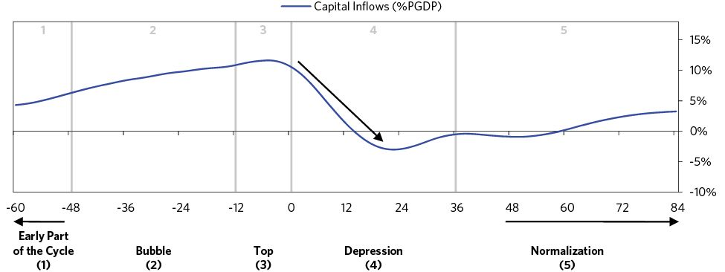

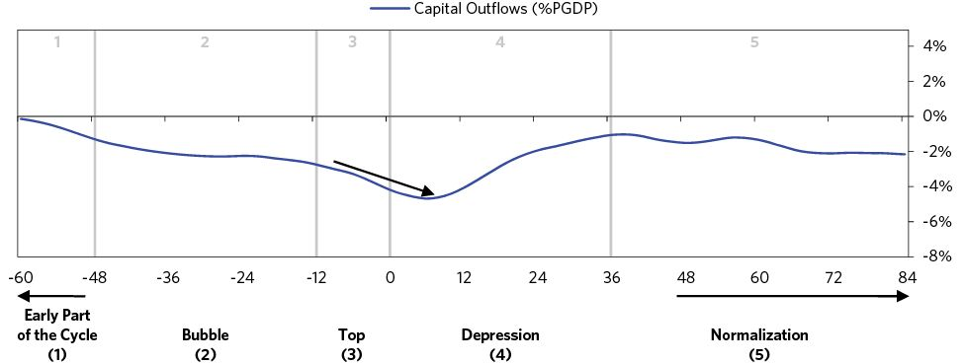

Typically the pullback in capital is not offset much by the central bank printing money, as printing risks enabling more people to get out of the currency, worsening capital flight. Weaker growth causes investors to pull their money out anyway; the assets that had been seen as a fabulous treasure a short time ago now look like trash. They quickly go from overbought to oversold and prices plummet.

* Nominal short rates rise (typically by about 20 percentage points) and the yield curve inverts.
* Printing is limited (1 to 2 percent of GDP, on average).
* Equities in local currency terms fall (on average by around 50%). They perform even worse in foreign currency terms, as the currency decline exacerbates the equity sell-off.

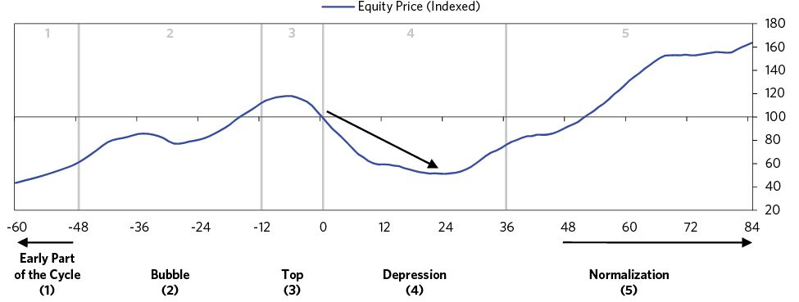

One of the most important asset/liability mismatches is foreign-denominated debt. As their local currency depreciates, debtors who owe foreign currency debt face a rising debt burden (in local currency). There is not much that borrowers can do, so they typically sell local currency to pay back debts, put on hedges, and move more savings into foreign currency, all of which contributes further to the cycle of downward pressure on the local currency.

* Debt service rises further (on average by more than 5 percent of GDP) because incomes fall and foreign currency-denominated debt service becomes higher when measured in local currency, further squeezing incomes and spending.
* FX debt burdens rise on those who borrowed in foreign currency (debt-to-GDP rises on average by about 20 percent from the decline in incomes and the currency).

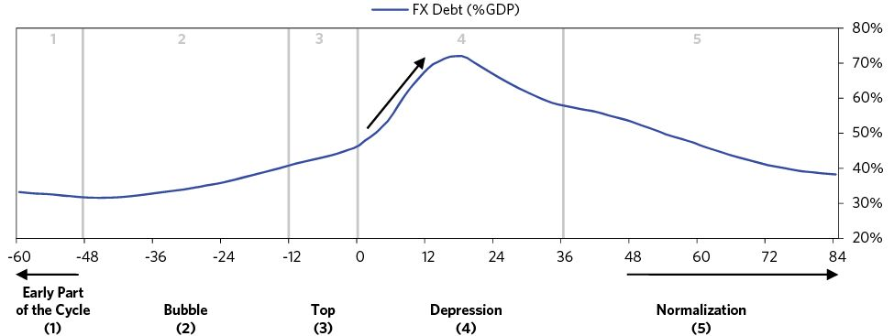

The currency declines also push up inflation as imports become more expensive.

* Inflation rises (typically by 15 percent, peaking around 30 percent).
* Inflation stays elevated for a while, on average for about two years from the top.

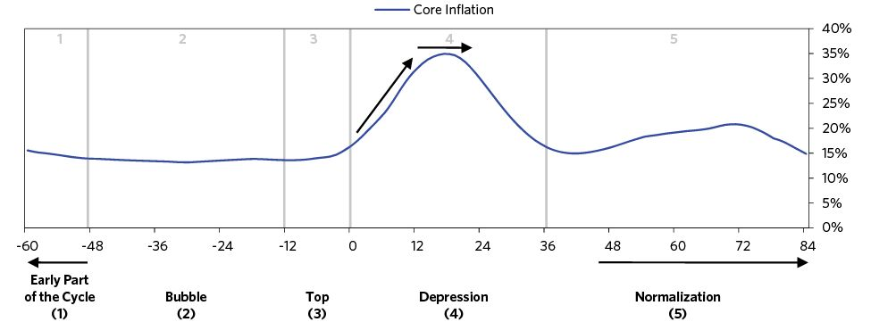

During this phase, the pendulum swings from most everything looking great to most everything looking terrible. Different types of problems—debt, economic, political, currency, etc.—reinforce each other. Hidden problems like fraudulent accounting and corruption typically come to the surface during such times. This bad environment discourages foreign money from coming in and encourages domestic investors to get their money out of the country.

This is when countries usually “hit the bottom.” The bottom is the mirror opposite of the bubble stage. While investors during the bubble are aggressively getting in, investors during the catharsis are aggressively getting out. Those losing money in asset and currency positions flee from them in a panic; those who had been thinking of getting in don’t want to go near the place—so a big supply/demand imbalance occurs in which a shortage of buyers and surplus of sellers drive prices lower. This is the most severe and painful part of inflationary deleveraging, as the downward spiral is self-reinforcing and rapid. “Hitting bottom” is typically so painful that it produces a radical metamorphosis in pricing and policies that ultimately produces the changes that are needed to turn things around. That is why I use the word “catharsis” when describing hitting bottom. In theater (or for that matter, in one’s own personal life) crisis sows the seeds for change and ultimately renewal.

Because the currency has become very cheap, spending on imports is finally cut substantially enough to restore the balance of payments. That—plus, sometimes, international aid (e.g., from the IMF, BIS, and/or other multinational organizations)—creates the necessary adjustments. Often there are big political shifts, from those who had been pursuing fundamentally bad policies to those who will pursue economically sound ones.

Here are some key economic developments that characterize this phase:

* The level of economic activity (GDP gap) falls a lot (on average by about 8 percent)
* Unemployment rises
* The bottom in activity comes after about one year, with the trough in the GDP gap typically near -4 percent

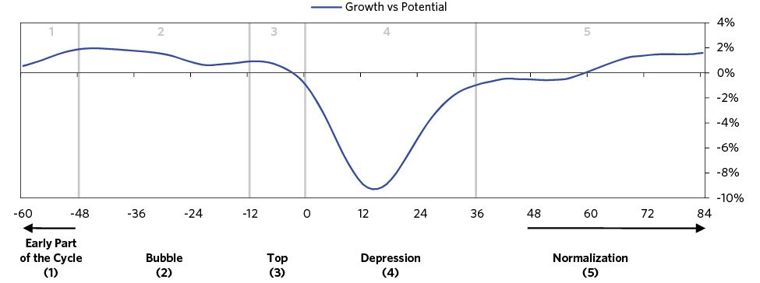

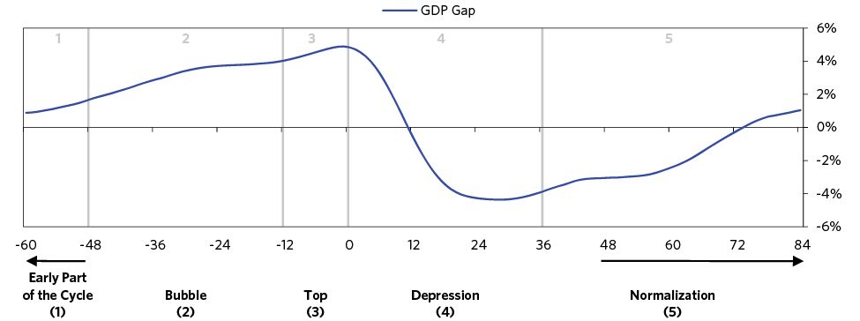

### 5) Normalization

The reversal and eventual return to normalcy comes when there is a balance between the supply and the demand for the currency relative to those of other currencies. While this balance is partially made via trade adjustments, it is typically more determined by capital flows, so it primarily comes when the central bank succeeds in making it desirable to hold the currency again, and secondarily when spending and imports have fallen sufficiently to bring about an adjustment in the balance of payments.

So how can policy makers keep capital in the country by making it desirable to be long—encouraging people to lend and save in the currency and not to borrow in it? Most importantly, they need to produce a positive total return for the currency at an acceptable interest rate (i.e., at an interest rate that isn’t too high for domestic conditions). While most people, including most policy makers, think that the best thing they can do is defend the currency during the currency defense phase, actually the opposite is true, because a currency level a) that is good for the trade balance, b) that produces a positive total return, and that c) has an interest rate that is appropriate for domestic conditions, is a low one.

As explained earlier, the best way to bring that about is to let the currency depreciate sharply and quickly. While that will hurt those who are long that currency, it will make it more attractive for investors who will get long after the devaluation, because the total return on holding the currency (i.e., the spot currency appreciation plus the interest rate difference) is more likely to be positive, and at a sharply depreciated currency level it won’t take an intolerably high interest rate to make the total return attractive. In other words, the best way to ensure that investors expect positive total returns going forward at a relatively low real interest rate (which is what the weak domestic conditions need) is to depreciate the currency enough.11

Both the balance of payments fundamentals and the central bank’s willingness to control “money printing” and currency depreciations will determine whether the total return of the currency (i.e., the currency changes plus interest rate differences) will be positive or negative, which will influence the willingness to own or be short the currency. Devaluing currencies is like using cocaine, in that it provides short-term stimulation but is ruinous when abused. It’s very important to watch what central banks do before you decide whether or not it’s prudent to take a long position. If investors are burned with negative returns for too long and the currency keeps falling, that’s frequently the break-point that determines if you’re going to have an inflationary spiral or not. The central bank’s objective should be to allow the currency to get cheap enough that it can provide the needed stimulation for the economy and the balance of payments, while running a tight enough policy to make the returns of owning the currency attractive. As you can see in the chart below, returns to holding the currency for foreigners start out negative, but then rally about a year after the devaluation.

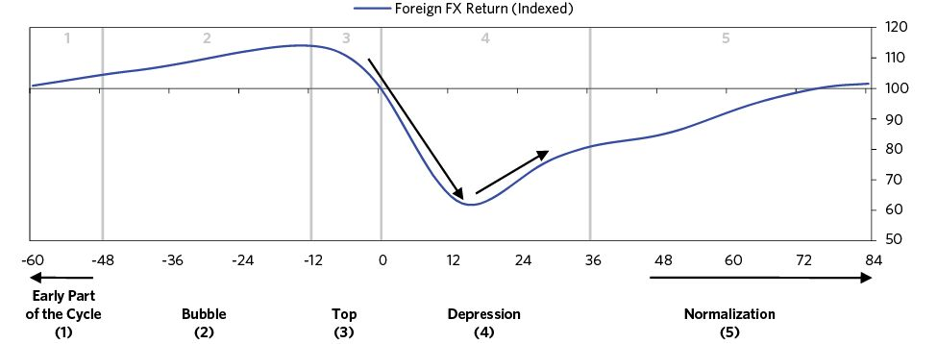

Even if the country as a whole hasn’t hit its debt limits, frequently, certain entities within the country have, and policy makers must recapitalize systemically important institutions and provide liquidity in a targeted way to manage bad debts. By providing this targeted liquidity (typically by printing money) where needed, they can help avoid a debt crisis that could be contractionary or could cause additional rounds of capital flight, but the inflationary nature of this money printing needs to be balanced carefully.

Here is what we typically see when the country reaches the bottom:

* The collapse in imports improves the current account a lot (on average by about 8 percent of GDP).
* Capital inflows stop declining and stabilize.
* Capital flight abates.
* Frequently, the country turns to the IMF or other international entities for support and a stable source of capital, especially when its reserves are limited.
* Short rates start to come down after about a year, but long rates continue to stay relatively elevated. After peaking, short rates fall back to their pre-crisis levels in around two years. The decline in short rates is stimulative.
* As interest rates come down, the forward currency price rallies relative to the spot.
* As the currency stabilizes, inflation comes down. Usually it takes nearly two years after the bottom for inflation to reach pre-crisis levels.

Of course, these are all averages, and the actual amounts depend on each country’s particular circumstances (which we will look at in the next section).

The sizable and painful decline in domestic conditions also helps to close the balance of payments gap by bringing down spending and imports. Through the crisis, the average country’s imports contract by around 10 percent as growth collapses and the equity market falls by over 50 percent. Classically, the collapse in imports brings the current account into a surplus of 2 percent of GDP, rising from a deficit of -6 percent of GDP about 18 months into the crisis. In the earlier stages of the crisis exports play a smaller role; they actually tend to contract during the worst of the crisis (as other countries are sometimes seeing economic slowdowns too). They rebound in the subsequent years.

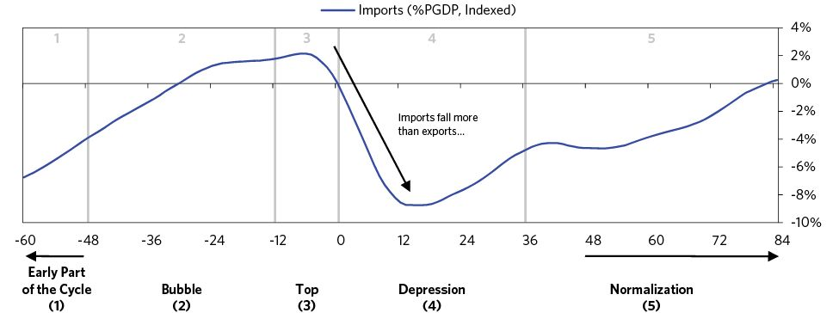

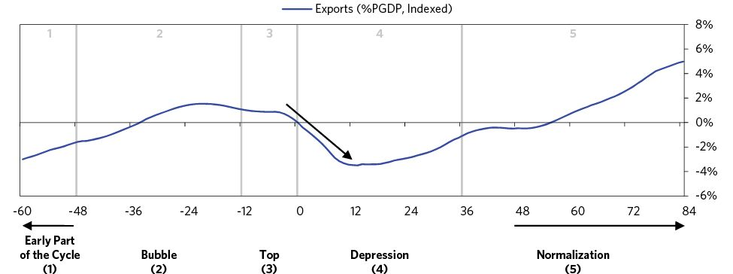

Below, we provide a summary of what well-managed and poorly managed versions of these adjustments looks like.

MANAGING THE CURRENCY

* WELL-MANAGED
  + Policy makers bluff, conveying that they will never allow the currency to weaken much. When they do devalue, it’s a surprise.
  + The devaluation is large enough that the people are no longer broadly expecting the currency weakening more (creating a two-way market).
* POORLY MANAGED
  + Policy makers are widely expected to allow a currency weakness, causing more downward pressure on the currency and higher interest rates.
  + The initial devaluation is small, and further devaluations are needed. The market expects this, causing higher interest rates and inflation expectations.

CLOSING EXTERNAL IMBALANCES

* WELL-MANAGED
  + Tight monetary policy causes domestic demand to contract in line with the fall in incomes.
  + Policy makers create incentives for investors to stay in the currency (i.e., higher interest rates that compensate for risk of currency depreciation).
* POORLY MANAGED
  + Policy makers favor domestic conditions, and monetary policy is too loose, putting off domestic pain and stoking inflation.
  + Policy makers attempt to stop the outflow of capital with capital controls or other restrictive measures.

SMOOTHING THE DOWNTURN

* WELL-MANAGED
  + Use reserves judiciously to smooth the withdrawal of foreign capital while working to close imbalances.
* POORLY MANAGED
  + Rely on reserve sales to maintain higher levels of spending.

MANAGING BAD DEBTS/DEFAULTS

* WELL-MANAGED
  + Work through debts of entities that are over-indebted, making up the gap with credit elsewhere.
* POORLY MANAGED
  + Allow disorderly defaults that lead to increased uncertainty and capital flight.

Typically it takes a few years for the country to recover. Investors who were burned on their investments from the last cycle are reluctant to return, so it can take some time before capital inflows become strongly positive. But the price of domestic goods and domestic labor fell with the currency, so the country is an attractive destination for foreign investment and the capital starts to come back. Together, higher exports and foreign direct investment kickstart growth. If policy makers protect and recapitalize critical financial institutions, the domestic financial pipelines are in place to support a recovery. The country is back to the early part of the cycle and starts a new virtuous cycle where productive investment opportunities attract capital, and capital drives up growth and asset prices, which attracts more capital.

* Incomes and spending pick up (usually after about one to two years).
* It then takes several years (usually about three) from the bottom before the level of activity is back to average.
* The real FX is undervalued (typically by around 10 percent on a PPP basis) at the start of stabilization and stays cheap.
* Exports pick up a bit (by 1 to 2 percent of GDP).
* Capital inflows start to return a few years later (on average four to five). Equities take about the same amount of time to recover in foreign currency terms.

## The Spiral from a More Transitory Inflationary Depression to Hyperinflation

While in many cases policy makers are able to engineer a recovery in which incomes and spending pick up and inflation rates return to more typical levels (transitory balance of payments crises), a subset of inflationary depressions do spiral into hyperinflations. Hyperinflations consist of extreme levels of inflation (goods and services prices more than doubling every year or worse) coupled with extreme losses of wealth and severe economic hardship. Because these cases are more common than one might think, it is worth walking through how inflationary depressions spiral into hyperinflations.

The most important characteristic of cases that spiral into hyperinflations is that policy makers don’t close the imbalance between external income, external spending, and debt service, and keep funding external spending over sustained periods of time by printing lots of money. In some cases, it’s not voluntary. Weimar Germany had a crushing external debt service burden (war reparations) that for the most part couldn’t be defaulted on. The amount of capital that needed to flow out of the country was so great that it was all but destined that Weimar would face big inflation problems (see our case study for more color). In other cases, policy makers choose to keep printing money to cover external spending—in effect, aiming to prop up growth rather than bringing spending in line with income. If this is done repeatedly over years and on a large scale, a country might face a hyperinflation that could have otherwise been avoided.

As stated earlier, contrary to popular belief, it’s not so easy to stop printing money during a crisis. Stopping printing when capital is flowing out can cause an extreme tightness of liquidity and often a deep economic contraction. And the longer the crisis goes on, the harder it becomes to stop printing money. For instance, in Weimar Germany there was literally a shortage of cash because the hyperinflation meant that the existing stock of money could buy less and less. (By late October 1923, toward the end of the crisis, Germany’s entire 1913 stock of money would have just about gotten you a one-kilo loaf of rye bread.) To stop printing would have meant there was so little cash that commerce would have virtually ground to a halt (at least until they came up with an alternate currency). In an inflation spiral, printing money can seem like the prudent choice at the time—but continuing to print money time and time again feeds the inflation spiral until there is no way out.

### How the Spiral Plays Out

Over time, as the currency declines and printing is used more and more, people begin to shift their behavior and an inflationary psychology sets in. Currency declines inspire additional capital flight, which causes an escalating feedback loop of depreciation, inflation, and money printing. Eventually, the linkages that drove growth in earlier rounds decline and money printing become less effective.

With each round of printing, more of the printed money is transferred to real or foreign assets instead of being spent on goods and services that fuel economic activity. Since investors that shorted cash and bought real/foreign assets were repeatedly better off than those who saved and invested domestically, domestic currency holders shift from investing the printed money in productive assets to real assets (like gold) and foreign currency, in order to hedge inflation and a deterioration in their real wealth. Foreign investors stay away. Because the economy is weak and investors are buying real assets, stocks suffer and no longer provide the wealth effect that drove earlier rounds of spending. The result is a currency devaluation that doesn’t stimulate growth. This dynamic is important to inflationary deleveragings, so we’ll walk through it in detail.

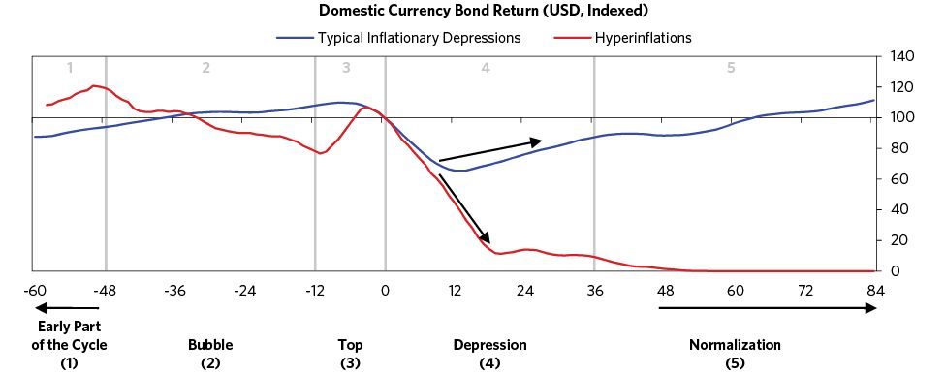

When continual currency declines lead to persistent inflation, it can become self-reinforcing in a way that nurtures inflation psychology and changes investor behavior. A key way this occurs is when inflation pressures spread to wages and produce a wage-cost spiral. Workers demand higher wages to compensate for their reduced purchasing power. Compelled to raise wages, producers increase their prices to compensate. Sometimes this happens mechanically because of wage indexing—contracts in which employers agree to increase wages with inflation. As is normal in such cases of price and wage indexing, a vicious cycle is established: the currency depreciates, internal prices rise, the increase of the quantity of paper money once more lowers the value of the currency, prices rise once more, and so on.

With each successive currency decline, savers and investors also change their behavior. Savers, who were burned before, now move to protect their purchasing power. They are quicker to short cash and buy foreign and physical assets.

As inflation worsens, bank depositors understandably want to be able to get their funds on short notice, so they shorten their lending to banks. Deposits move to short-term checking accounts rather than longer-term savings. Investors shorten the duration of their lending, or stop lending entirely, because they are worried about risks of default or getting paid back in worthless money. During inflationary deleveragings, average debt maturities always fall.

It’s also cheap to short cash, as higher inflation and money printing lowers real interest rates, so the withdrawal of capital and faster borrowing cause illiquidity in the financial system. Banks find it practically impossible to meet the demand for cash. No longer able to fulfill their contracts because of cash shortages, businesses also suffer. At this point the choice for central banks, who remember the benefits of the previous round of currency declines, is between extreme illiquidity and printing money at an accelerating rate, and the path is again obvious—i.e., to print. They provide liquidity by printing money to support the banks, and often lending directly to businesses. When interest rates are insufficient to compensate for future currency declines, this provision of liquidity provides the funds that enable investors to continue to borrow and invest abroad and in inflation hedges (like real assets or gold), which further contributes to the inflation and depreciation spiral.

Because much of the country’s debt is denominated in a foreign currency, debt burdens rise when the currency falls, which requires spending cuts and asset sales. While this effect was originally overcome by the stimulation of the falling currency, it becomes increasingly devastating as that effect fades and the debt burden grows. These higher debt burdens also mean foreign investors want higher interest rates as compensation for the risk of default. This means that currency declines and inflation often increase debt service and debt burdens, making it even harder to stimulate through the currency.

Many governments respond to rising debt burdens by raising taxes on income and wealth. With their net worths already eroding because of the bad economy and their failing investments, the wealthy desperately try to preserve their rapidly shrinking wealth at all costs. This leads to extremely high rates of tax evasion and increases the flight of capital abroad. This is typical in deleveragings.

As growth weakens further, the lack of foreign lending shuts down an important source of credit creation. And while there is a lot of domestic credit creation and borrowing, this borrowing does not result in much growth because so much of it is spent abroad on foreign assets. Of the spending that does occur locally, much of it doesn’t contribute to GDP. For example, investors buy lots of gold, factories, or imports (even rocks in the case of the Weimar Republic!) as store holds of wealth. Capital investments like machinery and tools are purchased as stores of value, not because they were needed.

It’s easy to see how these forces can create a feedback mechanism that causes inflation and currency declines to escalate until people completely lose faith in the currency. Money loses its role as a store of value (and people hold at most a few days’ reserves). The long list of zeros also makes it an impossible unit of account. Money also breaks down as a medium of exchange, because the currency instability makes producers unwilling to sell their products for domestic currency, and producers often demand payment in foreign currencies or barter. Because there is a shortage of foreign exchange, illiquidity reaches its peak and demand collapses. This form of illiquidity can’t be relieved by money printing. Stores close and unemployment rises. As the economy enters hyperinflation, it contracts rapidly because the currency declines that were once beneficial now just create chaos.

In addition to causing an economic contraction, hyperinflation wipes out financial wealth as financial assets fail to keep pace with currency depreciation and inflation. Hyperinflation also causes extreme wealth redistributions. Lenders see their wealth get inflated away, as do debtor’s liabilities. Economic contraction, extreme wealth redistributions, and chaos create political tensions and clashes. Frequently public servants like police officers go on strike because they don’t want to work for worthless paper money. Disorder, crime, looting, and violence typically reach their peak during this phase. In Weimar Germany, the government had to respond to the disorder by issuing a “state of siege,” granting military authorities greater power over domestic policies such as carrying out arrests and breaking up demonstrations.

Investing during a hyperinflation has a few basic principles: get short the currency, do whatever you can to get your money out of the country, buy commodities, and invest in commodity industries (like gold, coal, and metals). Buying equities is a mixed bag: investing in the stock market becomes a losing proposition as inflation transitions to hyperinflation. Instead of there being a high correlation between the exchange rate and the price of shares, there is an increasing divergence between share prices and the exchange rate. So, during this time gold becomes the preferred asset to hold, shares are a disaster even though they rise in local currency, and bonds are wiped out.

Once an inflationary deleveraging spirals into hyperinflation, the currency never recovers its status as a store hold of wealth. Creating a new currency with very hard backing while phasing out the old currency is the classic path that countries follow in order to end inflationary deleveragings.

10. It’s 80 percent instead of 60 percent (5 percent times 12 months) because of compounding.

11. When it comes to determining whether or not to save in a credit instrument, the motivations of domestic investors are different than those of foreign investors. Domestic investors care about the inflation rate relative to interest rates. For them, if inflation is high relative to the interest rates that they are getting to compensate them for it, they will move out of holding credit instruments to holding inflation hedge assets (and vice versa). Foreign lenders just care about the rate of change in the currency relative to the interest rate change. So for policy makers hoping to stabilize the balance of payments, inflation is a secondary consideration compared to ensuring that there are positive expected returns for saving in that currency. They have to get the currency cheap enough so that it, with the desired interest rate, will produce a positive return.

## War Economies

War economies are totally different from regular economies in terms of what happens with the production, consumption, and accounting for goods, services, and financial assets. For example, the increasing GDP arising from the greater production of armaments which get destroyed in the war, the reduced unemployment rate due to increases in military service, shifts in production and profitability arising from the top-down allocation of resources, and the nature of borrowing, lending, and other capital flows are not the same as in periods of peace so understanding these statistics requires a whole different orientation. Trying to adequately convey how war economies work would take a whole different book, so I’m not going to delve deeply into the subject now, but I will touch on them briefly because they certainly are important in understanding the big debt crises that were captured within our sampling period—and they are very important to understand if we enter another war period.

The economic/geopolitical cycle of economic conflicts leading to military conflicts both within and between emerging powerful countries and established powerful countries is obvious to anyone who studies history. It’s been well-described by historians, though those historians typically have more of a geopolitical perspective and less of an economic/market perspective than I do. In either case, it is well-recognized as classic by historians. The following sentence describes it as I see it in a nutshell:

When 1) within countries there are economic conflicts between the rich/capitalist/political right and the poor/proletariat/political left that lead to conflicts that result in populist, autocratic, nationalistic, and militaristic leaders coming to power, while at the same time, 2) between countries there are conflicts arising among comparably strong economic and military powers, the relationships between economics and politics become especially intertwined—and the probabilities of disruptive conflicts (e.g., wars) become much higher than normal.

In other words economic rivalries within and between countries often lead to fighting in order to establish which entities are most powerful. In these periods, we have war economies, and after them, markets, economies, and geopolitics all experience the hang-over effects. What happens during wars and as a result of wars have huge effects on which currencies, which debts, which equities, and which economies are worth what, and more profoundly, on the whole social-political fabric. At the most big-picture level, the periods of war are followed by periods of peace in which the dominant power/powers get to set the rules because no one can fight them. That continues until the cycle begins again (because of a rival power emerging).

Appreciating this big economic/geopolitical cycle that drives the ascendancies and declines of empires and their reserve currencies requires taking a much longer (250-year) time frame, which I will touch on briefly here and in more detail in a future report.

Typically, though not always, at times of economic rivalry, emotions run high, firebrand populist leaders who prefer antagonistic paths are elected or come to power, and wars occur. However, that is not always the case. History has shown that through time, there are two broad types of relationships, and that what occurs depends on which type of relationship exists. The two types of relationships are:

1. Cooperative-competitive relationships in which the parties take into consideration what’s really important to the other and try to give it to them in exchange for what they most want. In this type of win-win relationship, there are often tough negotiations that are done with respect and consideration, like two friendly merchants in a bazaar or two friendly teams on the field.
2. Mutually threatening relationships in which the parties think about how they can harm the other and exchange painful acts in the hope of forcing the other into a position of fear so that they will give in. In this type of lose-lose relationship, they interact through “war” rather than through “negotiation.”

Either side can force the second path (threatening war, lose-lose) onto the other side, but it takes both sides to go down the cooperative, win-win path. Both sides will inevitably follow the same approach.

In the back of the minds of all parties, regardless of which path they choose, should be their relative powers. In the first case, each party should realize what the other could force on them and appreciate the quality of the exchange without getting too pushy, while in the second case, the parties should realize that power will be defined by the relative abilities of the parties to endure pain as much as their relative abilities to inflict it. When it isn’t clear exactly how much power either side has to reward and punish the other side because there are many untested ways, the first path is the safer way. On the other hand, the second way will certainly make clear—through the hell of war—which party is dominant and which one will have to be submissive. That is why, after wars, there are typically extended periods of peace with the dominant country setting the rules and other countries following them for the time it takes for the cycle to happen all over again.

In terms of economic policy, during a war period, the most important priority is to maintain one’s access to financial and non-financial resources that are required to sustain a good war effort. Because no country has the capacity to both fund a war and sustain tolerable non-war-related spending out of current income, one must have access to borrowing and/or have very large foreign exchange reserves. The access to borrowing very much depends on each county’s creditworthiness and the development of its capital markets, especially the soundness of its own local currency debt market. Similarly, maintaining access to the critical non-financial resources that are required to sustain both the war effort and acceptable domestic economic conditions is essential during the war period.

After the war period, during the paying back period, the market consequences of the debts and the outcome of the war (whether it is won or lost) will be enormous. The worst thing a country, hence a country’s leader, could ever do is get into a lot of debt and lose a war because there is nothing more devastating. ABOVE ALL ELSE, DON’T DO THAT. Look at what it meant for Germany after World War I in the 1920s (which is explained in Part 2) and for Germany and Japan after World War II in the late 1940s and the 1950s.

The following charts show some of the typical shifts in the economy—how countries shift much of their economies to war production, borrow a lot of money to finance big fiscal deficits, and move much of their workforces to the armed services and war production. The first chart shows the rapid rise in government spending relative to private spending. The subsequent charts show the increase in military spending and the number of soldiers, averaging a number of war cases—both military spending and number of soldiers as a percent of the population increase by around five times. For instance, during World War II, 20 percent of the US workforce shifted to the military.

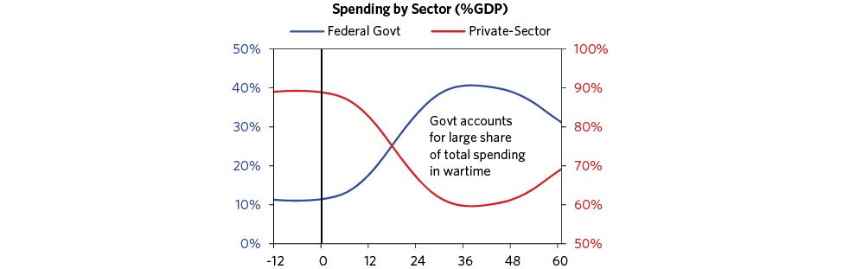

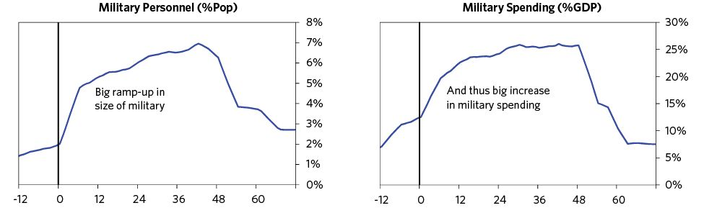

After a major war ends, all countries—both the winners and losers—are saddled with debt and the need to transition from a war-economy to a more normal economy. The big contraction of military spending usually causes a postwar recession, as factories are retooled once again and the large number of people formerly employed in the war effort need to find new jobs. Countries typically enter periods of deleveraging, working through the big war debts with the same basic dynamics visible in other depressions/deleveragings coming into play here too. However, losers of war experience significantly worse economic conditions. The following charts demonstrate this dynamic. Losers experience a much deeper depression, resort to more money printing, meaningfully spend down their savings/reserves, and see much higher inflation rates (sometimes experiencing hyperinflation).

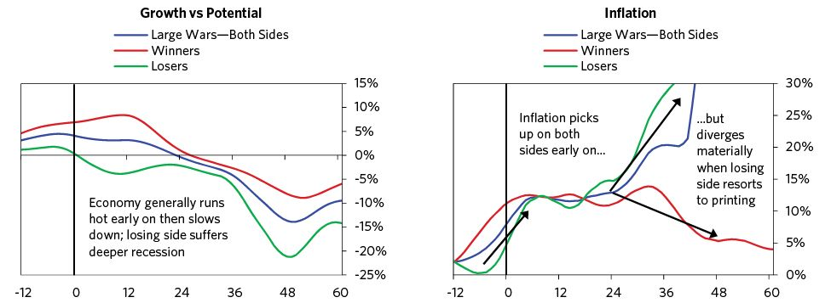

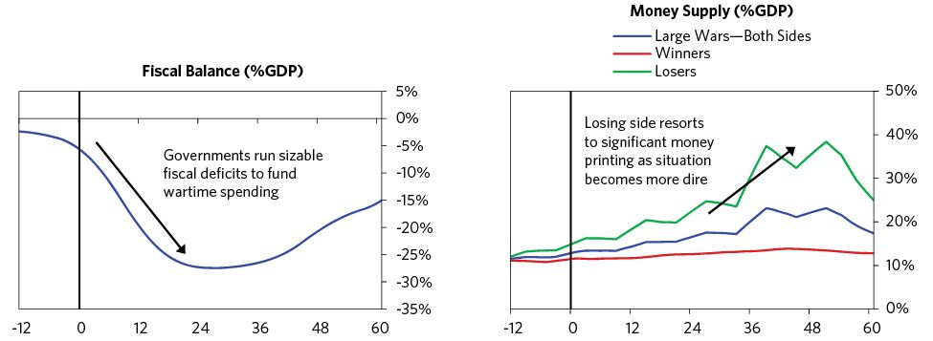

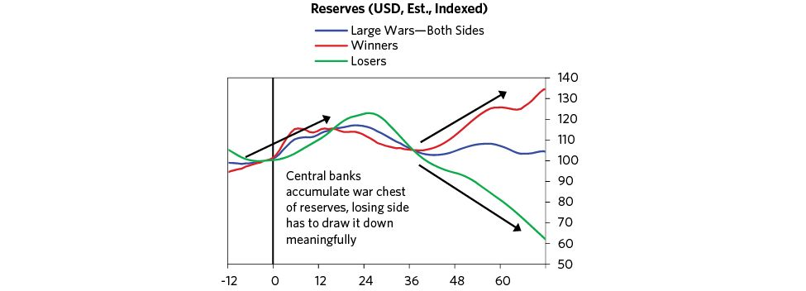

That’s all I have to convey about war economies at this stage. For more color on them, I suggest you read the Weimar Germany and US Great Depression case studies in Part 2, as the first paints a good picture of a postwar period for a war loser and the second shows how economic conflicts initiate a sequence of events that lead to shooting wars. I also suggest that you also look at the charts of the US and UK in the post-World War II periods (two examples of winners of wars). The reasons we don’t have charts for Germany, Japan, and other war losers for the post-World War II period is that the consequences for their currencies, other markets, and economies were so devastating that statistics were either ridiculously unreliable or unavailable.

## In Summary

I want to reiterate my headline: managing debt crises is all about spreading out the pain of the bad debts, and this can almost always be done well if one’s debts are in one’s own currency. The biggest risks are typically not from the debts themselves, but from the failure of policy makers to do the right things due to a lack of knowledge and/or lack of authority. If a nation’s debts are in a foreign currency, much more difficult choices have to be made to handle the situation well—and, in any case, the consequences will be more painful.

As I know from personal experience, the understandings and authorities of policy makers varies a lot across countries, which can lead to dramatically different outcomes, and they tend not to react forcefully enough until the crisis is extreme. Their authorities vary as a function of how powerful each country’s regulatory and checks-and-balance systems are. In countries where these systems are strong (which brings lots of benefits), there is also the risk that some required policy moves can’t get done because they are inconsistent with the rigid rules and agreements that are in place.

It’s impossible to write the rules well enough to anticipate all the possibilities, and even the most knowledgeable and empowered policy maker is unlikely to manage a crisis perfectly. Circumstances that weren’t foreseen must be responded to instantly, often in hours, within a legal/regulatory system that doesn’t have crystal-clear rules.

The checks and balances system—normally a critical protection from too much concentration of power—can exacerbate a crisis because it can slow decision making and allow those with narrower interests to block necessary policy moves. Policy makers who try to take the necessary bold actions are typically criticized from all sides. Politics is horrendous during debt crises, and distortions and outright misinformation are pervasive.

While these big debt crises can be devastating to some people and countries over the short- to medium-term (meaning three to ten years), in the long run they fade in importance relative to productivity, which is more forceful (though less apparent because it is less volatile). The political consequences (e.g., increases in populism) that result from these crises can be much more consequential than the debt crises themselves. The charts below show real GDP per capita and help to put these big debt crises (and the “little” ones that we call recessions) in perspective. The contractions of more than 3 percent are shown in the shaded areas. Note how the growth rates over time were far more important than the bumps along the way. The biggest bumps came more as a result of wars than the worst depressions (though a case can be made that those wars were caused by the political fallout from those depressions).

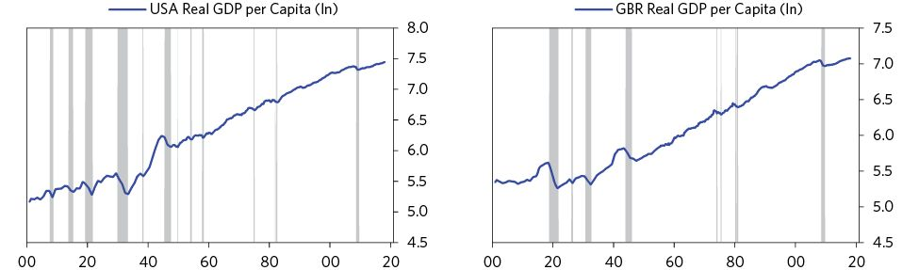

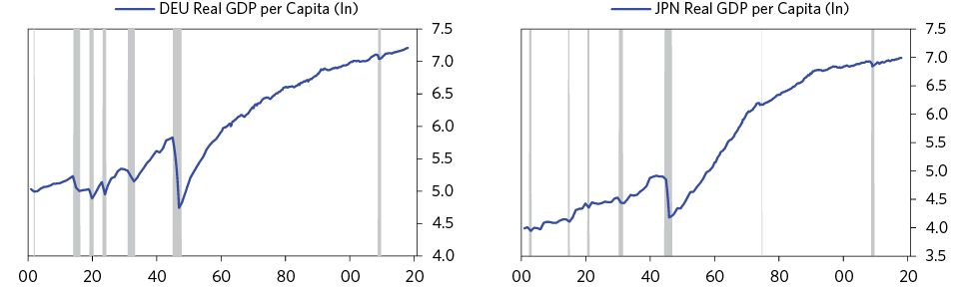

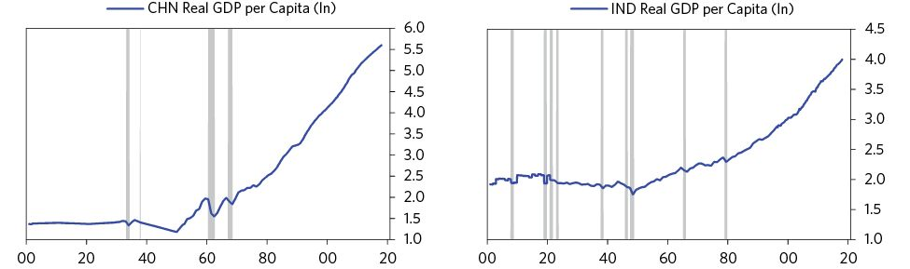

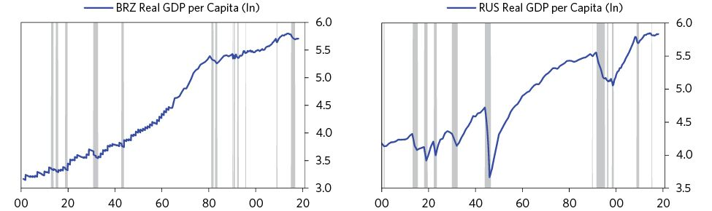

# PART 2: Detailed Case Studies

German Debt Crisis and Hyperinflation (1918–1924)

US Debt Crisis and Adjustment (1918–1924)

US Debt Crisis and Adjustment (2007–2011)

## German Debt Crisis and Hyperinflation (1918-1924)

This section provides a detailed account of the most iconic inflationary depression cycle in history—the German debt crisis and hyperinflation that followed the end of World War I and carried into the mid-1920s, which set the stage for the economic and political changes of the 1930s. Much like my accounts of the 2008 US Financial Crisis and the 1930s Great Depression, this study goes through the particulars of the case in some detail with reference to the template laid out earlier in the “Archetypal Inflationary Depression.” Although the German hyperinflation took place almost a century ago, and amid exceptional political circumstances (Germany’s defeat in the First World War and the imposition of a huge reparation burden on it by the Allies), the basic dynamic of debt cycles, economic activity, and markets described in the template drove what happened. Noting the differences between this inflationary depression case (and other inflationary depression cases) and the deflationary depression cases highlights what makes some inflationary and others deflationary. To provide a vivid sense of what was happening in real time, a newsfeed is included at the end of the chapter.

## July 1914–November 1918: World War I

World War I (July 1914–November 1918) set the stage for this big, dramatic cycle. During the war years Germany left the gold standard, accumulated a large stock of domestic and foreign debts, began the practice of money printing to finance its ever-growing fiscal deficits, and experienced its first bout of currency depreciation and inflation. Based on their experience of the Franco-Prussian War of 1870, the Germans had expected the war to be short, and they assumed it would ultimately be paid for by large indemnities levied on the defeated Allied powers. Instead it turned out to be an extremely long and expensive affair that was financed primarily through domestic debt, and Germany ended up having to pay a huge war reparation bill rather than collecting on one.

This was a classic case of war debts being built up by a country that then loses the war (though more extreme than most) and is also a classic case of a country with large foreign currency denominated debt that is held by foreign creditors. Knowing the dynamic described in the “Archetypal Inflationary Depression” section of Part 1, you should have a pretty good idea of how this story will play out.

### Background

Like most countries at the time, Germany had been on the gold standard at the beginning of the war. All paper currency, including all government debt, was convertible to gold at a fixed rate. However, by 1914, the central bank did not have enough gold to back the stock of money in circulation at the fixed price,1 as one might expect. As soon as the war broke out, smart German citizens rushed to exchange their paper money for bullion, which caused a run on the banking system. Within a matter of weeks, the central bank (the Reichsbank) and the Treasury had paid out 195 million marks’ worth of gold to the public (i.e., about 10 percent of total gold reserves).2 In order to prevent further losses, ensure liquidity in the banking system, and avoid a major contraction in the money supply, policy makers suspended the conversion of money to gold on July 31, 1914.3 The government also authorized the Reichsbank to buy short-term Treasury bills and use them, along with commercial bills, as collateral for the money it was printing.4 The pace of printing that followed was rapid: By the end of August, the quantity of Reichsbank notes in circulation (i.e., paper marks) had increased by approximately 30 percent.

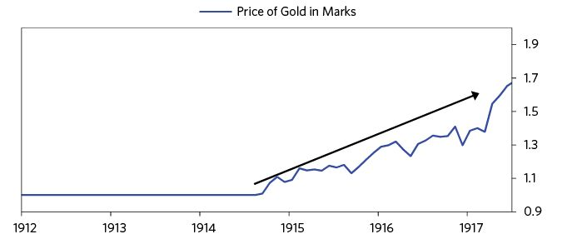

This is classic. Currency is both a medium of exchange and a store hold of wealth. When investors hold a lot of promises to deliver currency (i.e., a lot of debt denominated in a currency) and the supply of that currency is tied to something that backs it, the ability of the central bank to produce currency is limited. When investors want to convert their bonds to currency/money and spend it, that puts the central bank in the difficult position of having to choose between having a lot of debt defaults or floating a lot of currency, which can debase its value. So, whenever (a) the amount of money in circulation is much greater than the amount of gold held in reserves to back the money at the designated price of conversion, and (b) investors are rushing to convert money into gold because they are worried about the value of their money, the central bank is in the untenable position of either reducing the supply of money in circulation (i.e., tighten credit) or ending convertibility and printing more money. Central banks almost always choose suspending convertibility and printing more money versus allowing a credit contraction to take place, because it’s less painful.

Printing a lot of money and depreciating the value of a currency causes just about anything denominated in that depreciated money to go up in price, and people like it when the things they own go up in value and they have more money to spend. This is also true in times of war. Policy makers attempting to marshal the economic resources of the country toward the war effort print money to give themselves more to spend. This printing helps prevent a liquidity crisis in the banking system or an economic contraction from taking place—either of which would be very disruptive to the war effort. It is for this reason that most of the countries fighting in WWI ended up suspending the gold standard at one point or another.

Fighting the war required the German government to significantly increase expenditures (government spending as a share of GDP would increase 2.5x between 1914 and 1917). Financing this spending would mean either raising new revenues (i.e., taxation) or increasing government borrowing. As there was huge resistance to increasing taxation at home, and as Germany was mostly locked out of international lending markets, the war had to be financed by issuing domestic debt.5 In 1914, German government debt was insignificant. By 1918, Germany had amassed a total local currency debt stock of 100 billion marks, about 130 percent of German GDP.

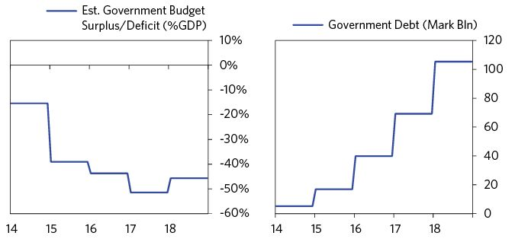

Source: Global Financial Data

Although this stock of debt was huge, prior to the German surrender and the imposition of war reparations, most of it was denominated in local currency.6 Policy makers recognized that this was a good thing. According to the Reichsbank, “the greatest weakness in the war financing of the enemies is their growing indebtedness abroad [particularly to the US],”7 as it forces them to scramble for dollars when needing to make debt-service payments. In contrast, most German debt taken on to finance the war (prior to reparations) was in local currency and financed by Germans.8

Up until the second half of 1916, the German public was both willing and able to finance the entire fiscal deficit by purchasing government debt.9 In fact, war bond issuances were regularly oversubscribed. However, as the war dragged on and inflation accelerated, the Treasury found that the public was no longer prepared to hold all the debt it was issuing. This was partly due to the size of the deficit, increasing substantially as the war progressed, but also because wartime inflation had caused real interest rates to become very negative (government war bonds paid out a fixed interest rate of 5 percent throughout the war, whereas inflation had climbed above 30% by early 1915), which resulted in lenders not being adequately compensated for holding government debt.10 The inflation was being driven by wartime disruptions and shortages, capacity constraints in key war industries, and currency weakness (the mark would fall about 25 percent against the dollar by 1916).11 While some naive lenders clung to the hope that the government would return to the gold standard at the old exchange rate once the war was over, or compensate them for any losses due to inflation, others feared they would most likely be paid in money that had lost most of its purchasing power, so they ran out of debt denominated in that currency.12

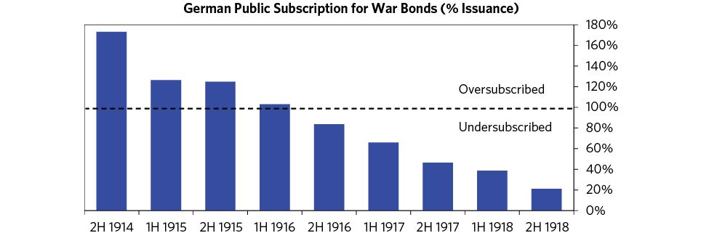

The currency remained an effective medium of exchange while losing its effectiveness as a store hold of wealth. So, the government borrowed money to pay for its war expenditures, and the Reichsbank was forced to monetize the debt as investors came up short in supplying the money. This had the effect of increasing the money supply by an amount equal to the fiscal deficit not financed by the public. As debt monetization is inflationary (there is more money in the economy chasing the same quantity of goods and services), a self-reinforcing spiral ensued—i.e., debt monetization increased inflation, which reduced real interest rates, which discouraged lending to the government, which encouraged additional debt monetization. As the deficit was huge (averaging about 40 percent of GDP between 1914 and 1918), this led to the money supply increasing by almost 300 percent over the course of the war.13

The pace of money creation accelerated after 1917 as German citizens became increasingly unwilling to purchase government debt, and the central bank was forced to monetize a growing share of the deficit.14 Although the number of marks in circulation almost doubled between mid-1917 and mid-1918, it did not cause a material decline in the currency. In fact, the mark rallied over this period as Russia’s withdrawal increased expectations of a German victory. The mark only began falling in the second half of 1918, as a German defeat began looking increasingly likely.15

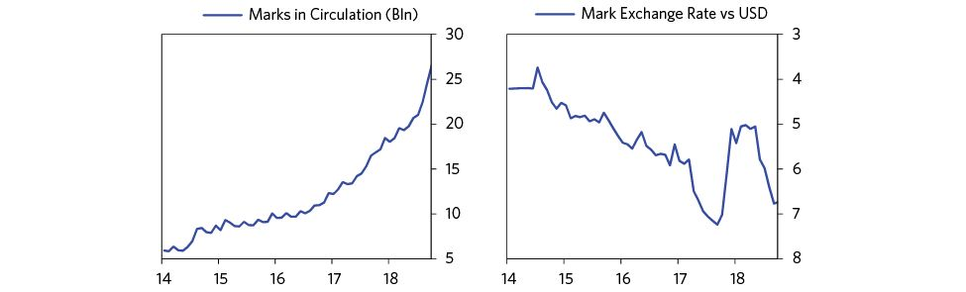

Source: Global Financial Data

In the last two years of the war, the German government began borrowing in foreign currencies because lenders were unwilling to take promises to pay in marks.16 When a country has to borrow in a foreign currency, it’s a bad sign. By 1918, the Reichsbank and private firms each owed about 2.5 billion gold marks in FX to external lenders.17 A gold mark was an artificial unit used to measure the value of a paper mark to gold. In 1914, one gold mark equaled one paper mark.18 A debt of 5 billion gold marks was therefore a debt denominated in gold, with the bill equal to the amount of gold that could be purchased by 5 billion marks in 1914.

Unlike local currency debt, hard currency (foreign currency and gold denominated) debt cannot be printed away. Debtors would have to get their hands on either gold or foreign exchange to meet these liabilities. While the hard currency debt was less than 10 percent of the total debt stock, it was still larger than the entire public gold reserves of the Reich.19 The hope was that once Germany won the war, the mark would appreciate, making those debt burdens more manageable. And, of course, the losing countries would be forced to pay for most of Germany’s foreign and domestic debts.20

Policy makers recognized that if Germany lost the war, or failed to extract large reparations, it would be extremely difficult to pay back these debts with hard money. According to the president of the Reichsbank, Rudolf Havenstein, covering those debts “will be extraordinarily difficult if we do not get a large war indemnity.”21 According to the German economist Edgar Jaffé, unless England paid between a third and a half of Germany’s war costs, the result would be the “monstrous catastrophe” of “currency collapse” once German citizens learned that domestic debts would likely be paid in depreciated money, and government agencies and private firms scrambled to get their hands on foreign exchange to pay off external liabilities.22

Breaking the peg to gold and monetizing an ever-growing fiscal deficit, combined with wartime economic disruptions and shortages, led to a declining exchange rate and a pickup in inflation. By the beginning of 1918, the mark had lost about 25 percent of its value versus the dollar and prices had tripled.

However, in the context of WWI, this was pretty typical—i.e., it’s what most countries did to fund their wars. German inflation, while high, was not significantly higher than that of other war participants, as you can see in the chart below.23 But only a few of the war’s many participants ended up with hyperinflation, for reasons I will soon explain.

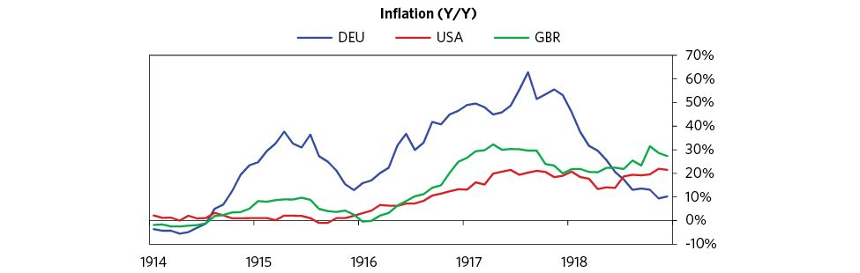

I bring up this point to underline the fact that WWI (and the accompanying monetization of debt) did not directly cause Germany’s postwar inflationary depression. As mentioned in the archetype template, while inflationary depressions are possible in all countries/currencies, they are most common in countries that:

* Don’t have a reserve currency: So there is not a global bias to hold their currency/debt as a store hold of wealth
* Have low foreign exchange reserves: So there is not much of a cushion to protect against capital outflows
* Have a large stock of foreign debt: So there is a vulnerability to the cost of debt rising via increases in either interest rates or the value of the currency the debtor has to deliver, or a shortage of available credit denominated in that currency
* Have a large and increasing budget and/or current account deficit: So there is a need to borrow or print money to fund the deficits
* Have negative real interest rates: So lenders are not adequately compensated for holding the currency/debt
* Have a history of high inflation and negative total returns in the currency: So there is a lack of trust in the value of the currency/debt

By the end of the war, the German economy met all of these conditions. Losing the war meant that the mark was not going to be the reserve currency of the postwar era. A large stock of external debts had been acquired, and it was very likely that the Allies would force Germany to pay them an additional sum in war reparations. Foreign exchange reserves were not sufficient to meet the existing stock of external debts, let alone any additional reparation payments. Real interest rates were very negative, and offered little compensation to creditors holding German currency/debt. The budget and the trade balance were also in very large deficits, meaning that Germany would remain dependent on borrowing/monetization to finance expenditures and consumption. Finally, the experience of high inflation, money printing, and negative total returns in holding the mark had begun to reduce trust in the German currency/debt as a store hold of value.

## November 1918–March, 1920: The Treaty of Versailles and the First Inflation

News of the German surrender in November 1918 was met with a wave of capital flight out of Germany. German citizens and firms rushed to convert their wealth into the currencies and assets of the victorious powers, not knowing what the terms of the peace would be or exactly how the German government would pay for its massive stock of liabilities now that it had lost the war. Over the next few months, the mark declined about 30 percent against the dollar, the German stock market lost almost half its real value, and government debt in local currency rose by about 30 percent, almost all of which had to be monetized by the central bank. As a result, the money supply grew by about 50 percent and the inflation rate climbed to 30 percent.

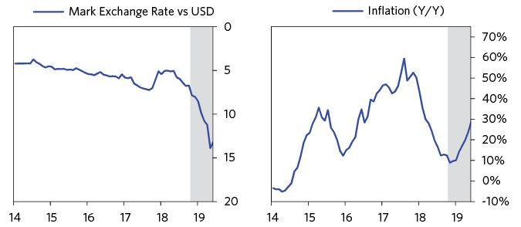

Source: Global Financial Data

This capital flight occurred despite initial optimism that the final terms of the peace would not be particularly harsh. Many members of the German negotiation team hoped that reparations would be limited to damage done in territories occupied by German forces, and would be paid primarily in goods instead of currency.24 US President Woodrow Wilson’s emphasis on self-determination also led many Germans to believe that there would be no annexations of German territory without at least a referendum. Many Germans therefore expected that their country would come out of the war with its territory and economic capacity intact, and that the reparation burden would not be too vindictive.25

When the final terms of the Treaty of Versailles were revealed, they came as a huge shock. Germany was to lose 12 percent of its territory through annexations, 10 percent of its population, 43 percent of its pig-iron capacity, and 38 percent of its steel capacity.26 Germany was also required to compensate Allied citizens for all wealth seized during the war (within Germany and in occupied territories), but it would receive no compensation for its own assets (both real and financial) that had been confiscated abroad. The German government would also have to honor all prewar debts to Allied creditors, even if they were the debts of private citizens. As for reparations, a commission was to be established in 1921 that would determine the final bill after evaluating Germany’s capacity to pay and giving its government another chance to be heard on the subject. In the interim, Germany would pay an equivalent of 20 billion marks in gold, commodities, ships, securities, and other real assets to compensate the Allies for the costs of occupation.27

Germany had no option but to agree to these terms or face total occupation. It signed the treaty on June 28, 1919. This triggered another sharp plunge in the exchange rate,28 with the mark falling 90 percent against the dollar between July, 1919 and January, 1920. Inflation surged, hitting 140 percent by the end of the year. Once again, the mark’s drop was driven primarily by German citizens rushing to get their capital out of the country because they justifiably feared that these promises to deliver currency (i.e., these debt obligations) would make it very difficult, if not impossible, for the German government to meet its liabilities with hard money. To do that, the Reich would have to levy extortionately high taxes and confiscate private wealth. As the real wealth of private citizens was at risk, getting out of the currency and the country made sense.

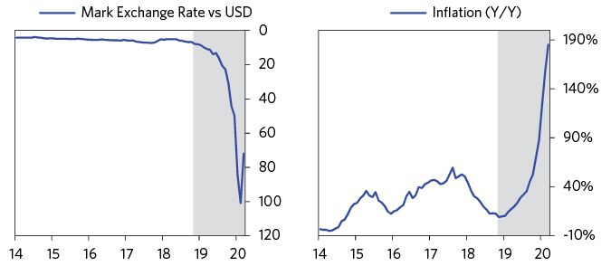

As the mark fell, German debtors with external liabilities saw the real expenses of their debts soar. They rushed to pay off as many of their foreign debts as they could, flooding the foreign exchange market. This further weakened the mark, triggering additional rounds of capital flight. This dynamic is also very common in countries with large foreign currency denominated debt during a debt/balance of payments crisis. As a prominent Hamburg industrialist noted at the time, “We are driving ourselves to destruction if everyone now…secretly sells mark notes in order to be able to meet his obligations. If things keep on this way, the mark notes will become unusable.”29

To be clear: at this point money printing was not the source of the currency weakness so much as currency weakness was the cause of money printing. In other words, capital flight from the currency and the country was driving the currency down, which in turn helped drive higher inflation. That’s classically how inflationary depressions happen.

Naturally, as money leaves a currency/debt market, that puts the central bank in the position of having to choose between a) allowing the liquidity and debt markets to tighten up a lot and b) printing money to fill in the void. Central banks typically print money to fill the void, which causes currencies to decline. While currency declines hurt importers and those with debts in foreign currencies, devaluations are stimulative for the economy and its asset markets, which is helpful during a period of economic weakness. Currency declines provide a boost to exports and profit margins, as they make a country’s goods cheaper on international markets. Simultaneously, they make imports more expensive, supporting domestic industries. Devaluations also cause assets to rise in value when measured in local currency, and they attract capital from abroad as a country’s financial assets become cheaper in global currency terms.

From July 1919 through March 1920, the decline in the mark and negative real rates provided a boost to the German economy and its equity and commodity markets.

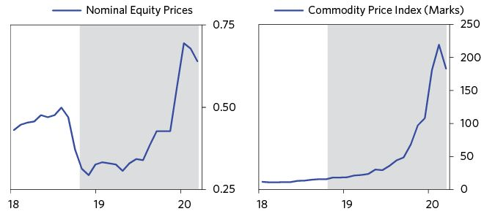

The export industry also thrived, unemployment declined, and as real wages remained low, business profitability improved. You can see the decline in unemployment and the pickup in exports in the charts below. (Note that all unemployment statistics from the time only show unemployment among trade union members, so they likely understate the true amount of unemployment and hardship in German society. However, they do show that employment conditions were improving.)

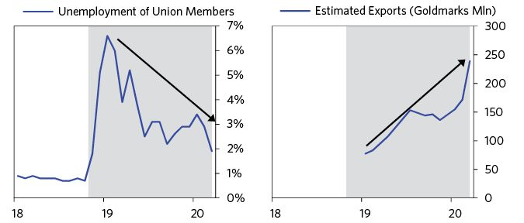

There was also the hope that by encouraging exports and discouraging imports, the mark’s decline would be a one-off and would help bring the German balance of payments into equilibrium. According to one prominent German official:

“I regard our gravely ailing currency as an admirable means of dispelling the hatred felt abroad towards Germany, and of overcoming the reluctance to trade with us by our enemies. The American who no longer gets for his dollar 4.21 marks worth of goods from us, but 6.20 marks worth, will rediscover his fondness for Germany.”30

German policy makers also began considering ways to deal with the domestic debt burden and the fiscal deficit. As one official described policy since the end of the war, “All we have done is keep printing.”31 To reduce the deficit, and raise revenues to meet debt liabilities, a comprehensive tax-reform package was proposed by finance minister Matthias Erzberger. Known as the “Erzberger Financial Reform,” the package would transfer from the “haves” to the “have-nots” by levying highly progressive taxes on income and wealth (with top rates for income approaching 60 percent, and those for wealth at 65 percent).32

Passed in December 1919, the Erzberger Reforms would go on to increase the share of the Reich’s income coming from direct taxes to 75 percent (the 1914 figure had been about 15 percent) and raise enough revenue to pay for all government expenditures except reparations by 1922.33 Prior to these reforms, the majority of the government revenue came from public enterprises (primarily railroads), as well as specific duties on exports, imports, and coal.

The beneficial results of currency weakness led many German policy makers to advocate relying on currency weakness and inflation (from rising import prices and central bank printing) as an effective alternative to “confiscatory taxation.”34 One such official was Dr. Friedrich Bendixen, who argued that “every effort to collect the monstrous sum through taxes will weaken our productivity and thus reduce receipts and drive the Reich to economic collapse…only the transformation of the war loans into money can bring salvation.”35 Inflation would “cleanse” Germany of its local currency war debts and allow it to “begin a new life on the basis of new money.” Although this program was explicitly rejected by the central bank, it recognized that things might “develop along these lines anyway.” They did: inflation climbed to almost 200 percent, and by the end of 1919 it had reduced the domestic war-debt burden to about 25 percent of its original 1918 value. As you might imagine, those with wealth scrambled to buy foreign currencies or real assets to prevent their wealth from being either inflated or taken away.36

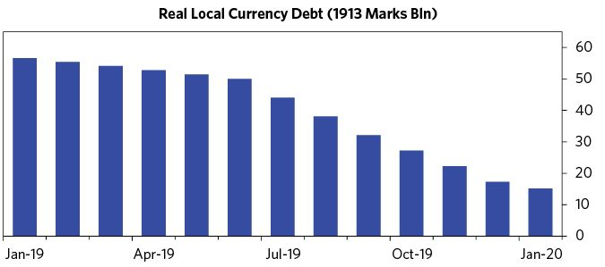

The central bank’s alternative to allowing inflation to “naturally” reduce the real debt burden was to tighten monetary policy and engineer a deflationary recession. This would allow the Reich to pay back its citizens something closer to the true value of their loaned wealth, but it would also crush domestic credit creation and demand, generating significant unemployment. Germany faced the classic dilemma: whether to help those who are long the currency (i.e., creditors who hold debt denominated in it) or those who are short it (i.e., debtors who owe it). In economic crises, policies to redistribute wealth from “haves” to “have-nots” are more likely to occur. This is because the conditions of the “have-nots” become intolerable and also because there are more “have-nots” than “haves.”

At the time, relieving debt burdens and redistributing wealth were higher priorities than preserving the wealth of creditors. Unemployment was still high, food shortages were rampant, and a large mass of returning soldiers from the front needed jobs so they could be reintegrated into the economy. Clashes between capitalists and workers, as are typical in depressions, were also happening all across Europe. There had been a Communist revolution in Russia in 1917, and Communist ideas were spreading around the world. Commenting on the choice between inflation and deflation at the time, the legendary British economist John Maynard Keynes wrote: “The inflation is unjust and deflation is inexpedient. Of the two perhaps deflation is the worse, because it is worse in an impoverished world to provoke unemployment than to disappoint the rentier [i.e., the capitalist lender].”37

Although levels of activity remained very depressed, by late 1919/early 1920 Germany had inflated away most of its domestic debt, passed a comprehensive tax-reform package to generate new revenues, and was beginning to see a pickup in economic activity. There was also some good news on the reparations front. To relieve growing tensions between Germany and the Allies, the Allies invited Germany to submit its own proposal for how much the reparation bill should be. Critics of a harsh settlement, such as John Maynard Keynes, were finding increasing sympathy in official circles abroad. The exchange rate also began to stabilize.38

However, conflicts between the Left and Right remained intense in Germany. In March 1921, right-wing nationalist groups led by Wolfgang Kapp attempted to overthrow the Weimar government and institute an autocratic monarchist regime in its place. The coup collapsed within a matter of days after workers refused to cooperate with the new government and declared a general strike.39 Although a complete failure, the “Kapp Putsch” was a reminder of how fragile the political environment remained, and was another example of how the economic pain of deleveragings/depressions can give rise to populist and reactionary leaders on both the Left and the Right. As one frustrated Berlin businessman put it:

“Just at the moment when we begin again to work more than before…when in London the recognition is mounting that through the imposition of the Versailles Treaty one has committed a fearful political stupidity, and that accordingly the exchange rate begins to improve, the military party…under the leadership of a man who is a notorious reactionary, again throws everything overboard and forces our workers into a general strike and demonstrations that are unnecessary because nothing will be achieved that way.”40

## March 1920 to May 1921: Relative Stabilization

The fourteen months between March 1920 and May 1921 were a period of “relative stabilization.”41 The mark halted its slide, prices remained stable, and the German economy outperformed the rest of the developed world. Germany wasn’t collapsing from either economic or political chaos, as many had predicted, and those shorting the mark lost considerable sums (a notable case is John Maynard Keynes, who personally lost about £13,000 on the trade).42

The global backdrop at the time was one of severe contraction, driven by tightening monetary policy in the US and UK. For example, between 1920 and 1921, industrial production fell by 20 percent in the US and 18.6 percent in the UK, while unemployment climbed to 22 percent and 11.8 percent respectively.43

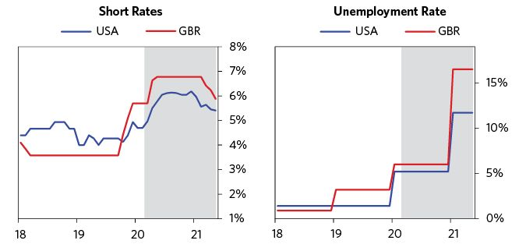

Source: Global Financial Data

In contrast to other central banks, the Reichsbank kept monetary policy very easy—the discount rate remained at 5 percent until 1922.44 The Reichsbank also regularly intervened to inject additional liquidity when credit conditions tightened. For instance, in the spring of 1921, when business liquidity tightened moderately, the Reichsbank responded by accelerating its purchases of commercial bills (from 3.1 percent to 9 percent of bills outstanding).45 Fiscal policy also remained accommodative, with real expenditures (ex-reparations) rising in 1920 and 1921.46 Although the budget deficit narrowed, it remained huge—roughly 10 percent of GDP—and continued to be financed by the issuance of floating debt.

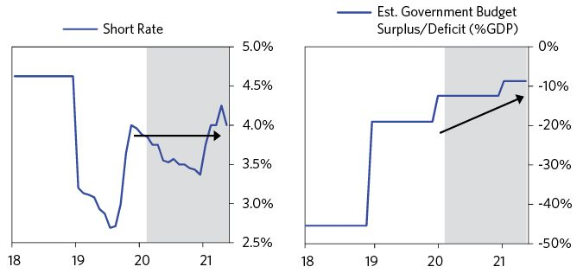

Source: Global Financial Data

The stimulative policies allowed Germany to escape the global contraction and enjoy relatively strong economic conditions. Between 1919 and 1921, industrial production increased by 75 percent! However, as you can see in the charts below, levels of economic activity remained extremely depressed (e.g., industrial production and real GDP were still well below 1913 levels), and there was considerable poverty and suffering in German society. This period should be understood as one of growth within a larger period of economic contraction.

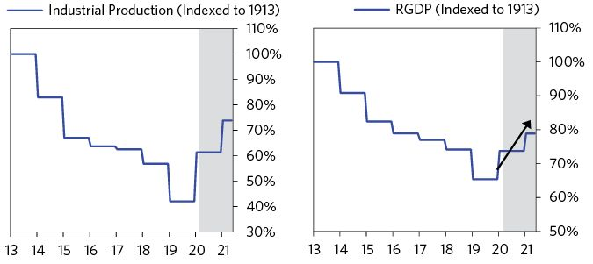

Rising economic activity and reflationary policies did not result in much inflation in Germany between March 1920 and May 1921, as domestic inflationary pressures were being offset by global deflationary forces. Import prices from the US and UK fell by about 50 percent, and rising capital flows into the outperforming German economy helped to stabilize the currency, which allowed for slower growth in the money supply. As you can see in the charts below, this was a significant turnaround. The mark rallied, inflation declined, and by early 1921 prices stopped rising for the first time since 1914.

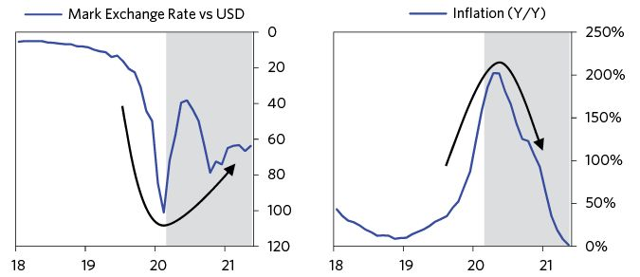

There was also considerable optimism about the German economy abroad—in fact, it became the new hot economy to invest in, as reflected by foreigners’ willingness to pour money into it, which financed an ever-growing trade deficit. In fact, some commentators at the time began referring to Germany’s surging capital inflows as a “tremendous” speculative bubble, with Keynes even calling it “the greatest ever known.” Many of those flooding the market with mark orders were new buyers, with no prior experience in the market they were trading—one of the classic signs of a bubble. According to Keynes:

“[From those] in the streets of the capital…[to] barber’s assistants in the remotest townships of Spain and South America…the argument has been the same…Germany is a great and strong country; someday she will recover; when that happens the mark will recover also, which will bring a very large profit.”47

For some perspective on the size of these inflows, by 1921 almost a third of all deposits in the seven largest German banks were foreign-owned.48 These speculative inflows supported a relative stabilization in the mark. It also made the central bank’s job much easier by reducing the inherent trade-offs between growth and inflation. As explained in my description of the archetypal template, when capital is flowing into a country, it tends to lower the country’s inflation rate and stimulate its growth rate (all other things being equal); when capital leaves, it tends to do the opposite, making the central bank’s job much more difficult.

Strong capital inflows also meant that the German economy became increasingly dependent on “hot money” (i.e., speculative investments that could be pulled out at a moment’s notice) continuing to come in, year after year, to finance fiscal and external deficits.49 As is classic in the bubble phase of any balance of payments crisis, increasing dependence on capital inflows to maintain levels of spending and economic activity made the economic recovery fragile, and sensitive to any minor event that could trigger a shift in sentiment vis-à-vis the future prospects of the German economy.

The mark’s sharp appreciation in early 1920 was an unwelcome development for policy makers because a falling mark was considered essential to maintaining German export competitiveness, supporting employment growth, and building a savings pool of hard currency earnings. It was considered the “one good fortune in the midst of misfortune,” without which Germany would lose the possibility of exports.50 The initial appreciation hit exports hard, with the chamber of commerce going as far as to say that industry had practically “ground to a halt.”51 Unemployment surged, with the number of trade union members reported as unemployed tripling. For these reasons, the economic ministry intervened between March and June 1920—aiming to deliberately depress the mark and stimulate employment. It worked. The mark fell, competitiveness returned, and unemployment once again began to decline.52

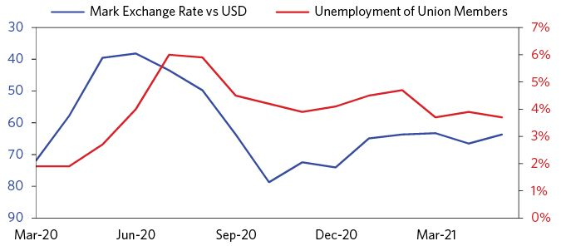

During this period, German policy makers were more concerned about deflationary forces spreading to Germany than the inflation that their stimulative policies could cause. Rising unemployment, and the potential social unrest it could cause, were considered much more menacing than the return of rising prices. As the reconstruction minister told a prominent industrialist:

“[I] am not afraid of the inflation…if the crisis which has already broken out to its full extent in England were not to come over to us, we should allow the printing press to do a bit more work and begin rebuilding the country. This activity would enable us to build a dam against the crisis.”53

Of course, the stabilization of the mark, inflation, and economic conditions remained contingent on large speculative inflows into Germany and a stable balance of payments.

## May 1921: The London Ultimatum

The arguments between Germany and the Allies over reparations came to a head with “The London Ultimatum” in May 1921, in which the Allies threatened to occupy the Ruhr Basin within six days if Germany did not accept the new reparation bill. Total reparations were set at 132 billion gold marks (about 330 percent of German GDP). Fifty billion was scheduled to be paid in quarterly installments, adding up to around 3 billion gold marks a year. This was a debt-service burden of around 10 percent of German GDP, or 80 percent of export earnings.54 Payments for the remaining 70 billion would begin whenever the Allied powers, not Germany, determined its economy capable of doing so. Not only did Germany have to service a huge hard currency debt burden, it also had to live with the threat of its debt service payments tripling at a moment’s notice.

The reparations demanded were enormous and dashed expectations that a far more conciliatory agreement would be reached. The structure of the payments was also deeply unnerving to potential investors and the German public, as it meant that debt service burdens would likely get bigger if economic conditions improved.55 For context, the chart below shows the size of the hard currency debts imposed on Germany relative to other economies prior to entering major inflationary depressions. As you can see, Weimar Germany dwarfs every other case. The second chart shows Germany’s debt as a percent of GDP between 1914 and 1922.

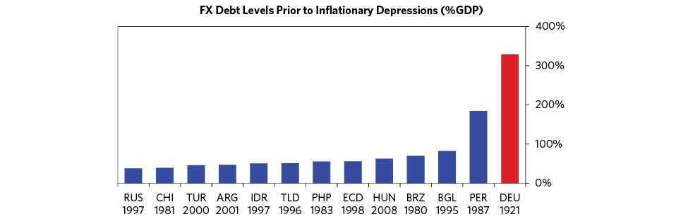

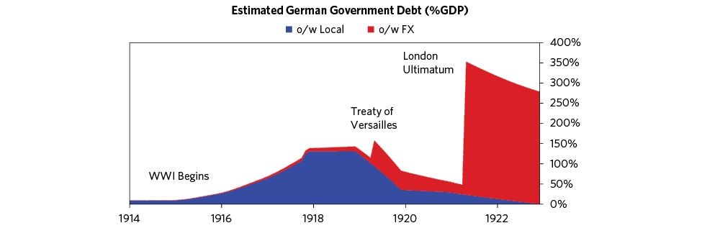

As soon as the reparation burden was announced, the mark began selling off; it declined by 75 percent by the end of the year. Inflation also returned, with prices almost doubling over the same period. For one prominent German participant at Versailles, the ultimatum fulfilled his worst fears:

“The world must be made to understand that it is impossible to burden a country with debts and at the same time to deprive it of the means of paying them…the most complete collapse of the currency…cannot…be avoided if the peace treaty is maintained in its current form.”56

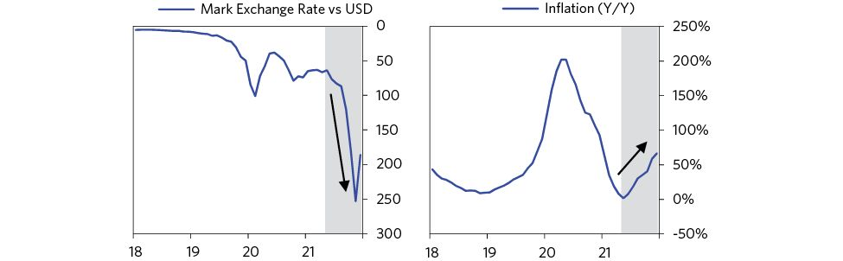

The reparation schedule created a balance of payments crisis. In many ways, a balance of payments crisis is just like any other serious problem faced by individuals, households, and corporations in making a payment. To come up with the money, a country must either 1) spend less, 2) earn more, 3) finance the payments through borrowing and/or tapping into savings, or 4) default on the debt (or convince creditors to give it relief). Unlike its domestic war loans, Germany could not print away the debt burden, as the debts were not denominated in paper marks. Policy makers would need to rely on some combination of the four levers outlined above.

Cutting Spending Would Be Extremely Painful and Politically Dangerous  
 Since about 50 percent of the German government’s total revenues would have to be spent on reparations, cuts in nonreparation expenses would need to be drastic to make a difference.57 Because most nonreparation spending was going towards essential social services—unemployment relief, subsidies for food and housing, and funding for leading public employers, such as the railways and shipyards—large spending cuts were considered “politically impossible.” With the Bolshevik Revolution in Russia and its ongoing bloody civil war, as well as the growing Communist movement in Germany, policy makers feared a potential revolution from the left. Simultaneously, the increasingly humiliating demands of the Allied powers, and the economic pain that came from meeting them, were fueling far-right nationalism. Fears of political chaos intensified as strikes, riots, and acts of political violence became increasingly common. During the summer of 1920, a state of emergency had to be declared following widespread looting;58 in March 1921, Communist groups seized control of several shipyards and factories and were only dispersed following firefights with police;59 and in October 1921, finance minister Matthias Erzberger was assassinated by ultranationalists for his role in the 1918 surrender.60 Given this context, it should not be surprising that the government refused to cut back on social spending and the Reichsbank refused to stop monetizing the deficit.

Tax Burdens Were Already Extremely High  
 While cutting spending was untenable, so was raising income by levying additional taxes. The problem was that the Erzberger reforms of 1919 (discussed above) had already raised tax burdens considerably. Increasing this burden posed the same political/social risks as cutting back on spending—i.e., any additional tax increases would not only prove immensely difficult to pass (the Erzberger reforms themselves had been watered-down significantly by opposition in the Reichstag), but would also be likely to accelerate capital flight. Commenting on the impossibility of meeting the reparation burden through taxation, Keynes wrote “the whips and scorpions of any government recorded in history [would not have been] potent enough to extract nearly half…[the required] income from a people so situated.”61

Existing Savings Were Extremely Limited and Securing Lending in Sufficient Size Was Impossible  
 There were virtually no savings to draw on to service those debts. The Treaty of Versailles had essentially seized or frozen all of Germany’s prewar foreign holdings and canceled all debts owed to Germans. Moreover, those with foreign currency savings (primarily exporters) were incentivized to keep their earnings in foreign bank accounts, precisely because they had reason to fear the reparations burden would encourage a government seizure of their wealth. As for the central bank’s gold reserves, they were not enough to cover even the first interest payment.

Further, there was little appetite internationally to extend Germany credit on a scale that would allow it to spread out its reparation burden. This was for two reasons. First, most developed world economies were burdened by war debts of their own (primarily owed to the United States) and were also in the midst of severe recessions. Second, the German government (and most Germans) weren’t creditworthy. For instance, when the head of the Reichsbank approached the Bank of England for a 500 million gold mark short-term loan to meet the second reparation installment, he was “politely refused.”62 According to the British Chancellor of the Exchequer at the time, “the difficulty was that there was a vicious circle. Germany said she could not stop the emission of paper money and repay her obligations unless she was able to raise a foreign loan, and she could not raise a foreign loan unless she could pay her obligations.”63

Of course, defaulting on the debt unilaterally was impossible, because Germany had been threatened with an invasion. Though its leaders furiously and continuously tried to renegotiate the payments, bitter feelings from the war (which had ended just a couple of years earlier) made the victors, especially France, disinclined to make concessions.

Unlike a household facing a payment problem, a country can change the amount of existing currency, and by doing so affect its value. This gives it an additional lever to manage a balance of payments crisis. While the Reichsbank could try to defend the currency by raising rates and tightening credit, which would increase the returns on holding mark denominated assets/deposits for creditors, and thereby attract more capital from abroad while discouraging capital flight at home, it would also crush domestic demand, reduce imports, and help close the trade deficit. That would require an unimaginably severe contraction in consumption, which would have been intolerable for this already impoverished and conflict-ridden society to bear.

The only remaining alternative was to allow the currency to depreciate and print money to alleviate any potential tightening in liquidity that resulted from the flight of marks abroad.

As we noted in the template, the most important characteristic of cases that spiral into hyperinflation is that policy makers don’t close the imbalance between income and spending/debt service; instead, they fund and keep funding spending over sustained periods of time by printing lots of money. Of course, some targeted money printing is typical in any balance of payments crisis—and, if not overused, is helpful, because it prevents the economic contraction from getting too severe. But when there is too much reflationary printing of money/monetization, and too severe a currency devaluation (which is reflationary) relative to the other levers for managing a deleveraging—especially the deflationary levers of austerity and debt restricting/default—the most severe inflationary depressions can and do occur.

The reparation schedule—and the extreme difficulty of using austerity, dissaving, external borrowing, and debt defaults as levers—pushed German policy makers to rely exclusively on money printing to manage the crisis. While policy makers knew this would contribute to inflation, they wagered that it would be the least terrible of their terrible choices. In my opinion, they made a mistake in not trying to achieve a better balance between deflationary forces and inflationary ones.

## June 1921–December 1921: The Emerging Inflationary Spiral

The second half of 1921 saw the classic dynamics of an inflationary spiral emerge. Germany’s impossible set of foreign debt obligations was contributing to currency declines, which caused inflation and a liquidity crisis. The central bank provided liquidity by printing money and buying debt, rather than allowing commerce to deeply contract. This, in turn, triggered further rounds of capital flight, inflation, tightening liquidity, and money printing, so the spiral accelerated. In the midst of this, the central bank depleted a substantial portion of its gold reserves to cover the first reparation payments.

The spiral was still relatively contained compared to what was to come a year later, mainly as foreigners continued to support the German balance of payments by purchasing German assets. But reparation payments and local capital flight caused the mark to decline 75 percent over the period and inflation accelerated, approaching 100 percent per annum. The sharpest declines came in October 1921, following the League of Nation’s decision to cede Upper Silesia (an important coal mining and industrial region) to Poland, despite a majority vote by its residents to remain in Germany.64

Rising inflation led to a surge in retail purchases. This pickup in demand was not a sign of increasing economic activity but rather a flight of income and savings into real goods before inflation could eat away at the purchasing power of money. The American Council of Hamburg spoke of a “vast amount of retail buying,” while the Hamburgische Correspondent referred to a “monstrous lust for goods.”65 The situation soon came to be described as one of “general liquidation,” because between foreigners buying a lot since the mark was cheap and Germans buying goods to escape inflation, the shelves in the shops were bare. A Berlin official reported shock at the “plundering of the retailers by foreigners with highly valued currencies,” while a British observer lamented that “many shops declare themselves to be sold out; others close from 1 to 4 in the afternoon, and most of them refuse to sell more than one article of the same kind to each customer…Germans [are] laying in stores for fear of a further rise in prices or a total depletion of stocks.”66

The same pressures led to a massive increase in consumer-durable and real-asset purchases. Auto sales climbed to all-time highs, the textile trade had bookings several months in advance, cotton firms refused to take new orders, and most industries found themselves operating at full capacity and having to introduce overtime to meet the growing demand for goods.67 Once again, this burst of economic activity was not a sign of economic prosperity, but a classic flight into inflation-hedge assets. According to one Bavarian official:

“The fall of the mark...has brought a real anxiety among the propertied classes. Everyone seeks to do something with their money. Everything is bought that can be bought, not only for present need, not only for future use, but in order to get rid of the paper and have objects to exchange when the time comes that it is worth absolutely nothing.”68

As the central bank kept market interest rates anchored at 5 percent (by increasing purchases when liquidity tightened), and as inflation was generally 10x higher, the real return on lending became very unattractive and the real cost of borrowing (i.e., real interest rates) plummeted.69 This led to a surge in borrowing, which became extremely attractive.70 As a result, real investment reached prewar highs71 and monthly bankruptcy rates declined by 75 percent.72 However, there was very little in this investment that was productive. Firms would push borrowed money into capital less for its “use value” than for its “intrinsic value.” Firms that did not do this, and kept most of their wealth in debt assets (such as bonds), suffered devastating losses. This time was called the “flight from the mark to the machine”; it resulted in many excessive investments that performed poorly once the inflation had passed.73 Of course, all of this accelerated inflation and reinforced the spiral.

Growing demand for real goods led to increasing employment in the industries that produced those goods.74 So unemployment fell and workers’ bargaining power increased as they pushed for wage increases and better working hours. In the summer of 1921, numerous standoffs between employers and laborers led to large nominal wage gains. However, these gains were not enough to keep up with inflation and workers still saw their real incomes fall by about 30 percent.75 This made tensions between the “haves” and the “have-nots” even worse.

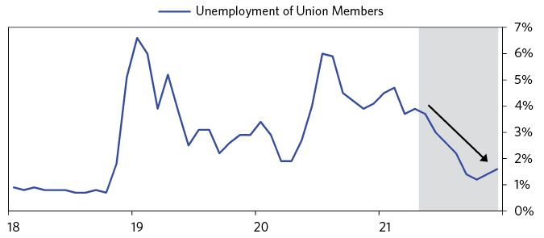

The only sector of the economy that saw some clear benefit from the collapse of the mark was the export sector. Foreign sales increased as German goods became cheaper on the international market. However, the pickup in exports was less than it ordinarily would have been, given such a large decline in the currency, for two reasons: First, there was considerable hostility to German exports abroad, even as they became cheaper, which limited the potential gains from a depreciating currency. Second, labor costs were also declining in the rest of the developed world, as a result of deflation from the severe global recession, limiting the potential competitiveness gains from the depreciating mark.

The second half of 1921 also saw what one commentator called “an orgy of speculation” in the stock market.76 Stocks nearly tripled in value over the period (in inflation-adjusted terms) and in August the Berlin stock exchange was so overloaded with orders that it was forced to shut down three times a week. By November, operating days were reduced to just one day a week and banks refused to take orders for shares after 10 a.m. According to one newspaper, “Today there is no one—from lift-boy, typist, and small landlord to the wealthy lady in high society—who does not speculate in industrial securities and who does not study the list of official quotations as if it were a most precious letter.”77

Once again, this bull market was not driven by improving economic fundamentals, or a more optimistic discounting of future economic conditions. It reflected a rush to get out of money or to get short money (i.e., borrow it) against a long “stuff” position. According to one observer:

“Stock market speculation today is the organized flight from the mark…at a time when the return on an investment diminishes in the same ratio as the value of the paper mark and when therefore even the solid capitalist, if he does not want to impoverish himself from day to day, must acquire real values. This alone has led to an extraordinary increase in the stock market business.”78

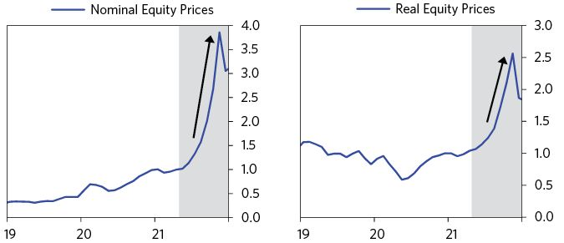

By the end of 1921, deteriorating economic conditions, the absence of faith in the mark, and rapidly rising prices began to threaten an economic and/or political collapse. At the time, the inflation rate was nearing 100 percent. The only thing preventing a total collapse was the foreigners’ willingness to continue to buy marks and fund Germany’s massive external deficit (about 10 percent of GDP). As the chart below illustrates, despite the loss of confidence in the mark at home, many foreigners kept purchasing German assets at cheap prices.

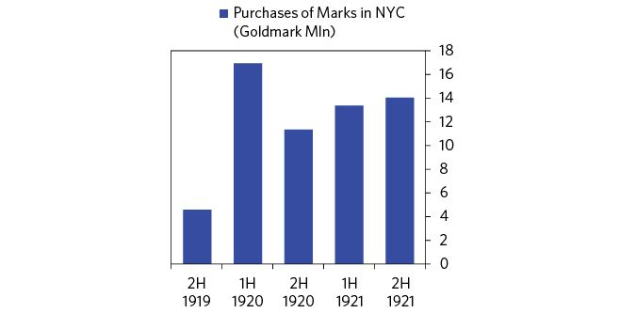

## January 1922–May 1922: Negotiating a Reparation Moratorium

Alarmed by the chaos in Germany, the Allied powers concluded that the German economy needed some relief from reparation payments.79 This was encouraging because at this stage it was the reparation debt burden that was most crushing and most inescapable. Continuing with the status quo ran the risk of a total economic collapse, which would worsen the political chaos at the heart of Europe, while making it impossible to collect any reparation payments in the future. However, there remained considerable disagreement among the Allied powers as to the extent of such relief and what, if anything, Germany should be required to give in return.

Central to the matter was a tension between the desire for vengeance and the limitation of German power, and the recognition that economic realities dictated that some compromises be made. This flavor of debtor/creditor standoff is classic during deleveragings. Naturally, the debtors (i.e., Germans) demanded as much relief as they could get and the creditors (i.e., the Allied powers) tried to get as much money back as they could without plunging the debtor economy into insolvency. The game of power brinksmanship was played by all. Commenting on the dynamics at the time, J.P. Morgan, Jr. reportedly told a confidant:

“The Allies must make up their minds as to whether they wanted a weak Germany who could not pay, or a strong Germany who could pay. If they wanted a weak Germany they must keep her economically weak; but if they wanted her to be able to pay they must allow Germany to exist in a condition of cheerfulness, which would lead to successful business. This meant, however, that you would get a strong Germany, and a Germany that was strong economically would, in a sense, be strong from a military point of view also.”80

The question of restructuring Germany’s reparation payments was discussed at a conference in Cannes, France, in January 1922. A temporary compromise was reached under which the Reparations Commission reduced the debt service bill by 75 percent for the remainder of the year, provided Germany agreed to raise new taxes (including a forced loan of a billion gold marks on its wealthy citizens), reduced spending and money printing, and granted the Reichsbank formal independence from the government.81 These concessions were mostly symbolic. The taxes agreed to were far too small to meaningfully close the budget deficit and the president of the Reichsbank, Rudolf Havenstein, said he welcomed more independence, as it would allow him to print as much money as was needed to ensure liquidity without constraints from fiscal policy makers.82

Renewed optimism about meaningful relief from reparations halted the mark’s slide. By the end of January, it had risen 30 percent from its 1921 lows, and inflation, while remaining high (about 140 percent per annum), had stopped accelerating. The inflationary spiral was halted for now, providing much-needed relief to the German economy. As negotiations progressed, German policy makers pressed the Allies for additional concessions, arguing forcefully that it was the balance of payments, and not the central bank’s money printing, that was ultimately responsible for the inflationary crisis. In a speech to the Reichstag on March 29, Foreign Minister Walter Rathenau told German lawmakers:

“Over and over again we encounter the notion that if the value of our money has been ruined this can only be because we have printed money. The recipe which we are given against this is: stop your printing press, bring your budget in order, and the misfortune is ended. A grave economic error!…[How is it possible] to make continuous gold payments without the help of foreign loans and at the same time keep the exchange rate intact? The attempt has never been made to give such a prescription and it cannot be given. For a country that does not produce gold cannot pay in gold unless it buys this gold with export surpluses [which Germany did not have] or unless it is borrowed [which Germany could not do].”83

As you can see, the mechanics of economics and markets were simple and basically the same then as they are now. While the central bank could easily extinguish its domestic currency denominated debt (in the ways previously described) it could not easily extinguish its external debts (for previously explained reasons).

From February until May, expectations surrounding the currency continued to be driven primarily by news of the reparation negotiations.84 When news suggested there would be a comprehensive agreement, the mark rallied, and inflation expectations fell.85 When new information suggested that an agreement was less likely, the mark fell and inflation expectations rose.86 The mark experienced numerous 10 to 20 percent swings on such changes of sentiment, and by the end of May was down about 40 percent versus the dollar, as the prospects of a reparation agreement deteriorated.

The chart below gives a taste of how new pieces of information on the reparation negotiations led to major swings in the mark. As you can see from the below table, the markets chopped up and down in big moves every time there was essentially any update on reparation negotiations. Imagine having to trade through such volatility!

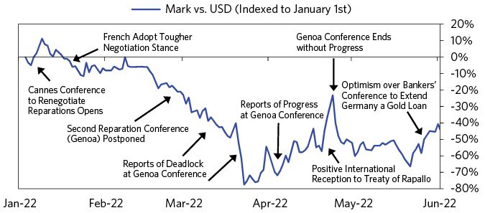

## June 1922–December 1922: Hyperinflation Begins

In June 1922, expectations of a reparation settlement collapsed, as did the mark. This was due to three interconnected events: First the French, who had always been the most reluctant among the Allied powers to reduce reparation burdens, declared they would no longer accept the conclusions of the reparations commission regarding Germany’s capacity to pay.87 Rather, France would make its own determinations on what German reparations should be, and would seize German assets, particularly some of its most productive assets (i.e., the coal mines in the Ruhr), if Germany defaulted.88 Instead of a possible moratorium, Germany would now have to pay France whatever the French thought was appropriate, or risk a sustained occupation of some of its most valuable territory.

The French declaration also undermined an additional plan to support the German economy. An international committee had been established, headed by the American financier JP Morgan, Jr., to investigate the possibility of extending Germany a gold loan to rebuild its economy and ease the burden of external debt. However, this loan was contingent on progress on a reparation moratorium, for without it such a loan could almost certainly not be paid back. Following the French declaration, the loan committee was forced to conclude that extending credit to Germany was impossible.89

Finally, on June 24, Foreign Minister Walter Rathenau was assassinated by a right wing group. Rathenau, despite some of his belligerent speeches, was one of the few German politicians who was trusted by the Allied powers and enjoyed significant support at home.90 If there was anyone who could mediate a settlement with the Reparations Commission and get it through the Reichstag, it was Rathenau. Of course, this also illustrates the threat of nationalism and extremist populism that was hanging over Germany.

Unlike earlier, foreigners now rushed to pull their capital from Germany. As noted previously, about a third of all deposits in German banks were foreign-owned, and foreign speculation had been a huge source of support for the German economy and balance of payments. Over the next few months, about two thirds of these deposits disappeared and capital inflows collapsed.91 Simultaneously, capital flight of Germans wanting to get out accelerated; well-to-do citizens rushed to get their wealth out before the confiscatory taxes agreed to in the January compromise came into effect. The mark collapsed and hyperinflation began.

The result was an acute liquidity crisis in the German banking system that led to runs on the banks. The rate of central bank printing was no longer fast enough to keep up with the flight of marks abroad and rising prices. By July, banks were forced to go on three-day work weeks, and had to inform their depositors that they did not have enough cash on hand to either honor their deposits or make weekly wage payments for their large business clients.92 Some even began printing their own marks, which was illegal. The liquidity crisis was self-reinforcing. Depositors, seeing that the banks were struggling to honor their liabilities, began withdrawing their deposits in ever-growing numbers, which only made the liquidity crisis worse.

By August 1922, the economy was on the brink of financial collapse. The central bank was forced to respond by rapidly accelerating the pace at which it was printing marks and monetizing a growing share of government debt.

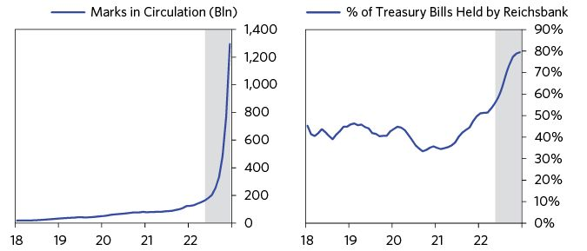

The central bank also began purchasing commercial bills en masse. As the liquidity crisis deepened in the fall, it additionally accelerated its provision of direct credits to the banking system. By the end of the year, the Reichsbank would end up holding about one third of all commercial bills in circulation and would have increased its credits to the banking system by 1,900 percent.93 Such interventions helped prevent the financial system from collapsing, and led to a ten-fold increase in the money supply.

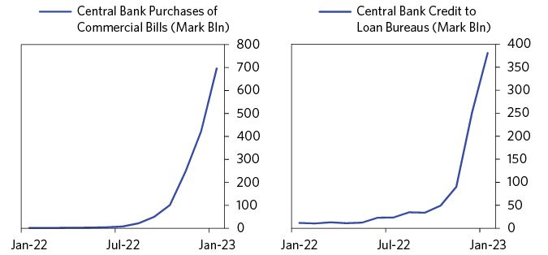

Unlike past bouts of currency depreciation and money printing, in which inflation would pick up substantially but never enter hyperinflation territory, this round of currency depreciation and money printing sent inflation skyrocketing. Part of this was due to the scale of the liquidity injection that was needed to offset the pullback in foreign capital, but part of it was also due to changing inflationary psychology. While most people had believed that inflation was being semi-managed, now most believed it was out of control.

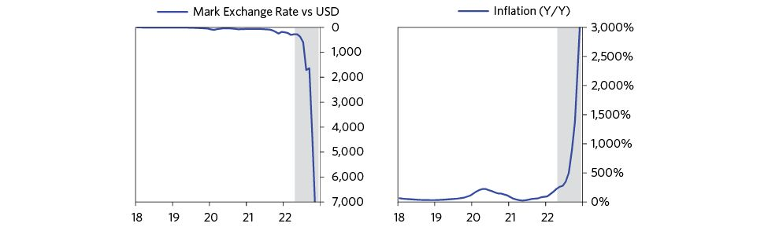

In inflationary depressions, it is classic that with each round of printing, more money leaves the currency instead of going into economic activity. As domestic currency holders see that investors that short cash (i.e., borrow in the weakening currency) and buy real/foreign assets are repeatedly better off than those who save and invest at home, they increasingly catch on and shift from investing printed money in productive assets to purchasing real assets (like gold) and foreign currency. Foreign investors no longer return because they have been repeatedly burned.

As early as August, with prices rising by over 50 percent a month and accelerating, policy makers recognized that they were approaching a hyperinflationary spiral, but they felt they had no alternative but to continue printing.94 Why didn’t they stop?

Once an inflationary depression reaches the hyperinflationary stage, it is extremely difficult to stop printing. This is because when extreme capital flight and extreme inflation feed off one another, money becomes harder to come by, even as it loses its worth. When Keynes visited Hamburg in the summer of 1922, still in the early phase of the hyperinflation, he vividly described the phenomenon:

“The prices in the shops change every hour. No one knows what this week’s wages will buy at the end of the week. The mark is at the same time valueless and scarce. On the one hand, the shops do not want to receive marks, and some of them are unwilling to sell at any price at all. On the other hand…the banks were so short of ready cash that the Reichsbank advised them to cash no checks for more than 10,000 marks…and some of the biggest institutions were unable to cash their customers’ checks for payment of weekly wages.”95

To stop printing would result in an extreme shortage of cash and bring about a total collapse of the financial system and all commerce. As one economist noted at the time:

“[To stop the printing press] would mean that in a very short time the entire public, and above all the Reich, could no longer pay merchants, employees, or workers. In a few weeks, besides the printing of notes, factories, mines, railways and post office, national and local government, in short, all national and economic life would be stopped.”96

People tend to think that hyperinflations are caused by central banks recklessly printing too much money, and all they need to do to stop it is to turn off the printing press. If it were that easy, hyperinflations would almost never occur! Instead, inflation spirals push policy makers into circumstances where printing is the least bad of several terrible options.

In the case of Weimar Germany, the cost of not printing was not only potential economic collapse, but political fragmentation. France’s repeated threats to occupy German territory if reparations were not paid made halting the printing press an invitation to a foreign invasion. It also lowered hopes for productive reparations negotiations. As one prominent industrialist put it at the time:

“The Reichsbank can no more stop inflation than the Burgermeister of Hamburg can tell the patients in the hospital to stop being ill…as long as it is possible for the French to invade Germany, there can be no talk of a stabilization of our currency.”97

By September, Germany was trapped in a classic hyperinflationary spiral. Extreme capital withdrawals and rapidly rising prices were forcing the central bank to choose between extreme illiquidity and printing money at an accelerating rate. As doing the former would result in a total collapse in business activity, there was really no choice. However, as the money supply grew, no one wanted to hold it in such a depreciating environment. The velocity of money accelerated, triggering even more capital flight, money printing, and inflation, and so on and so forth.

You can see this relationship most vividly in the chart below—which must be shown in logarithmic terms due to the exponential growth rates in inflation and the money supply. As you can see, currency weakness was leading inflation, which was leading money supply growth—not the other way around. Reckless money printing was less the cause of the hyperinflation than what was required to prevent massive deflationary defaults by banks (and just about everyone else) and a deflationary economic collapse.

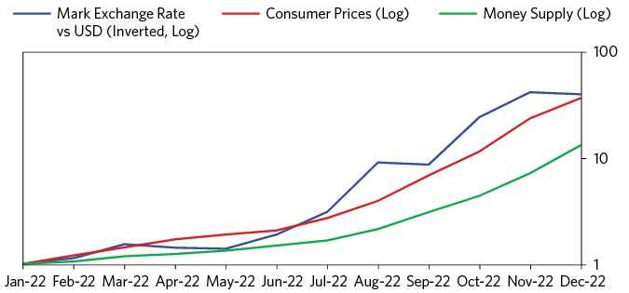

Remember that money and credit serve two purposes: As a medium of exchange and a store hold of wealth. As the spiral accelerated, the mark completely lost its status as a store hold of value. People rushed to exchange it for any available alternative—real goods, foreign exchange, and capital equipment. Very soon, exponential rates of inflation made it impractical to trade in marks, so the currency also began to lose its status as a means of exchange. Foreign currencies (especially the dollar) and even makeshift currencies became increasingly common in day-to-day transactions and price quotations. For instance, local branches of the Reichsbank found that they did not have enough actual paper notes for businesses to meet their payroll obligations.98 So, the central bank and the finance ministry allowed some large depositors to print their own currencies. These were called Notgeld—which literally means “emergency money.”99 Soon, everyone began considering whether the mark would go extinct. According to the Frankfurter Zeitung, by October 1922:

“German economic life is…dominated by a struggle over the survival of the mark: is it to remain the German currency, or is it doomed to extinction? During the past few months foreign currencies have replaced it as units of account in domestic transactions to a wholly unforeseen extent. The habit of reckoning in dollars, especially, has established itself, not only in firms’ internal accounting practice, but above all as the method of price quotation in trade, industry and agriculture.”100

In a desperate attempt to calm the inflationary spiral, on October 12 1922, the government stepped in to stop the ever-growing flight into foreign currency. Restrictions were put on German citizens purchasing foreign FX.101 Such capital controls are a classic lever to control inflationary depressions; they are rarely successful. The reasons for this are that a) capital controls have limited effectiveness at best because they are usually pretty easy to get around and b) trying to trap people typically leads them to want to escape even more. Not being able to get one’s money out of the country triggers a psychology that is analogous to the inability to get one’s money out of a bank: it produces fear that produces a run.

The stock market was one of the few remaining domestic escapes from the inflation. After declining 50 percent (in real terms) since June, stocks actually rallied in the second half of October—but like the fall of 1921, this rally had nothing to do with underlying economic conditions or the future prospects of the economy. In fact, in the fall of 1922, real profit margins were collapsing as the chaos of the hyperinflation hit productivity.102 The rally was also extremely small in the context of the overall real stock market decline during the debt crisis.

See the charts below and imagine living through these conditions.

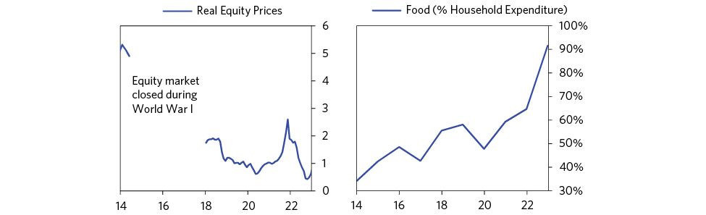

## January 1923–August 1923: The Occupation of the Ruhr and the Final Days of Inflation

In January 1923, with the economy already in chaos and prompted by Germany missing a promised delivery of timber as a reparation payment, a French-Belgian force invaded Germany and occupied the Ruhr (Germany’s primary industrial region). The French hoped that this action would pressure Germany to pay reparations more cooperatively and in the meantime allow France to extract payments in coal. The Germans responded by declaring “passive resistance.”103 Miners in the Ruhr would strike in an attempt to make the occupation as costly as possible for the French government. However, this resistance would need to be subsidized by the Reich, as both the miners and their employers would have to be paid. It also meant that about half of the country’s coal supply would need to be imported, adding additional strain on the balance of payments.104 As a result, government spending increased, the balance of payments deteriorated, liquidity shortages pushed the Reichsbank to print even more, and inflation, which was already at astronomical levels, accelerated even more.

France’s aggression left an opening for Germany in the reparation negotiations, as the occupation of a country approaching economic ruin was widely denounced. To buy time, the Reichsbank began issuing dollar denominated debt (at a considerable discount to international prices due to its credit risk) in order to buy marks—with the central bank targeting a peg against the dollar. Between January and June of 1923, the Reichsbank sold about 400 million gold marks of borrowed foreign exchange and central bank reserves to defend the mark’s peg against the dollar. The central bank also raised rates to 18 percent (but given that inflation was running at close to 10,000 percent this was mostly a symbolic move).105 According to the president of the Reichsbank:

“The intervention did not…have as its purpose the permanent and final stabilization of the mark. Such an undertaking will only become possible when the reparations problem is seriously brought to a solution. What it had as its purpose was…to recover for the German economy…as long as possible…a time of somewhat calm…to free the market from wild and unscrupulous speculation and to protect the German people from a further rapid price increase which would have exhausted it.”106

The FX intervention halted the mark’s slide (it actually appreciated by 50 percent for the first three months of the intervention) and introduced a brief period of deflation that certainly hurt the shorts.107 However, by May it became clear that the Reichsbank did not have the reserves to pay out dollar denominated principal and interest payments and maintain the peg, so the fixed exchange rate policy was abandoned six months after it was put in place and hyperinflation returned stronger than before (reaching 36,000,000,000 percent by November 1923).108

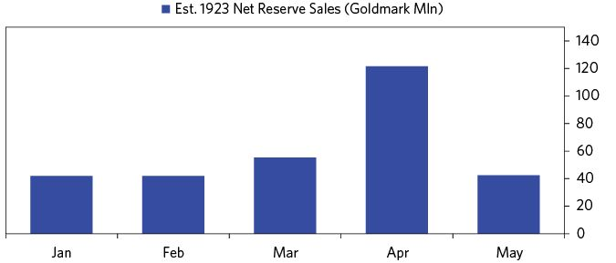

Now the German economy found itself burdened by an additional stock of hard currency debt, and the French reaffirmed their commitment to stay in the Ruhr as long as was necessary to get what they were owed. Throughout the summer, some sporadic interventions in the FX market were attempted, but none were able to curb inflation or prevent the downward spiral in the exchange rate.109 Around this time, the president of the Reich asked his finance minister to find new measures “to avert the complete collapse of our mark.” The finance minister replied “the complete collapse of the mark is already underway.”110

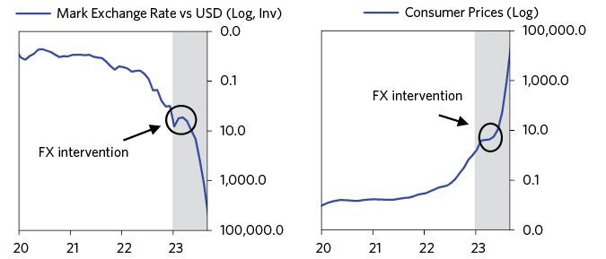

From July 1922 until November 1923 the mark depreciated by 99.99999997 percent versus the dollar (i.e., the cost of dollars increased 1570 billion percent) and prices rose by 387 billion percent! For some perspective on what these numbers mean, in 1913 a total of six billion marks circulated as currency and coin in the whole German economy. By late October 1923, the entire stock of money in 1913 would just about get you a one kilo-loaf of rye bread.111 Living through such chaos was immensely painful and traumatizing for German citizens—and experiences of the inflation would later serve to validate many of the criticisms made by Nazi politicians of the “disastrous” Weimar era.

## Late 1923 to 1924: Ending the Hyperinflation

By late 1923, the hyperinflation had created intolerably painful conditions within Germany. Unemployment was rising rapidly, inflation was well above 1,000,000 percent, real tax revenues were diminishing at an alarming rate,112 food was growing scarce, and transacting with marks had become almost impossible.113 Without an effective means of exchange, the economic machine of the nation had ground to a halt. The resulting suffering stunned people of all walks of life. As one local mayor put it, “I have never encountered such hordes of people starving and wandering about.”114 And all recognized that the crisis would soon boil over into mass riots or revolution.115 Rudolf Wissell, who would later serve as Germany’s minister of labor, captured the prevailing sentiment of the period: “The inflation in which we find ourselves at this time is murdering the Republic. It will be the gravedigger of our Republic.”116

The Allied powers concluded that without substantial reparation relief, German policy makers would remain helpless to avert a total collapse of the economy. So, in November 1923 they suspended reparations payments and reopened negotiations with the Germans on restructuring the debt.117 This gave German policy makers the breathing room they needed.

German policy makers took five crucial steps to curb inflation, each following logically from the last:

1. To offload the reparations burden that started the crisis in the first place, policy makers renegotiated payments with the Allies, eventually reducing the debt service burdens to just 1 percent of GDP. With the crippling reparation burden made more manageable…
2. …A new currency was introduced, the rentenmark, which was backed by gold-denominated assets and land and pegged to the dollar. However, as the new currency could fail if investors believed that it would be used to monetize debt payments…
3. …Strict limits were placed on the amount of rentenmarks that could be printed and the amount of debt that could be monetized. However, a central bank can only credibly avoid monetizing debt if the government can pay its bills, so…
4. …The German government took action to raise its revenues and cut its expenditures, making deep, extremely painful cuts. Similarly, the central bank capped the amount they would loan to businesses and raised borrowing rates. To further build faith in the new currency…
5. …The central bank built up large reserves of foreign currency assets. They were able to do this by borrowing foreign exchange from the Allies and encouraging German citizens who had fled the currency during the hyperinflation to repatriate their savings.

Earlier one-off measures (e.g., the short-lived currency peg, capital controls) hadn’t been enough—Germany needed a comprehensive and aggressive policy shift that abolished the currency, accepted hard backing, and placed extreme limits on monetization, credit creation, and government spending. It helped that years of economic crisis had made the public eager to find a currency that they could actually use. However, none of this would have been possible if the reparation burden was not substantially reduced. After all, why would any investor or saver want to hold German currency if they knew the government had huge external liabilities it could not pay?

Below, we walk through each of these measures in detail, moving roughly chronologically.

### 1) Restructuring the Reparations Debt

Although the process of negotiating with the Allies was slow, drawn out, and painful, some critical concessions were secured very early that provided the breathing room that was necessary to implement the policy changes that ended the hyperinflation.118 Without reparation relief, the structural drivers of the inflation would have remained intact, and it would have been highly unlikely that any new currency could have commanded faith as a store hold of wealth.

Significant progress came as early as September 1923, when German industrialists in the Ruhr began to cooperate with the Weimar government in its negotiations with the French.119 These industrial magnates had long resisted any concessions to France when it came to reparations payments, but as conditions continued to deteriorate and workers began to riot, they recognized the need for diplomacy, and eventually agreed to resume coal transfers.120 By mid-October, the Weimar government was able to completely end its financial support of “passive resistance” to the Ruhr occupation, both opening the way for progress in talks with the French and eliminating one of its largest expenses.121

The Weimar government quickly built on the progress it had made in the Ruhr. By the end of November, British and French negotiators had created a new committee—the Dawes committee—to review and potentially reduce Germany’s reparations obligations.122 Critically, the committee agreed to suspend reparations payments until it came to its final conclusions—making it far easier for Germany to balance its budget during the stabilization period.123 For the next 10 months, Germany did not have to make a single hard currency payment to the reparations commission. Moreover, when the Dawes Plan came into full force in August 1924, it significantly and permanently eased Germany’s reparations burden.124 Payments were rescheduled, and debt service costs reduced, to the point that reparations payments amounted to only one percent of German GNP in 1924 and 1925—a reduction of over 90 percent versus 1923.125

Although Germany would still have to pay the full 130 billion gold marks of reparations, payments were now so spread out that it was possible to meet them. The chart below gives some perspective on how significant this shift was by comparing what Germany could have been asked to pay at any moment between 1921 and 1923 (if the Allies had demanded Germany begin paying down the full reparation bill), what they actually had to pay between 1921 and 1923 (i.e., the London Schedule, under which some payments were suspended until the Allies thought Germany was capable of paying them), what debt service payments look like leading into the typical inflationary deleveraging, and what Germany had to pay after reparation payments were restricted in 1924 (i.e., the Dawes Plan). As you can see, the Dawes Plan dramatically reduced the FX debt service burden.

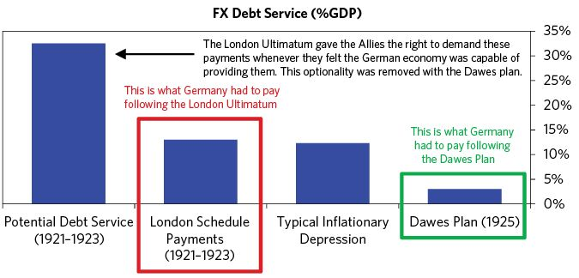

With the reparations debt service substantially reduced and the domestic debt mostly inflated away, Germany’s debt burden was largely relieved.

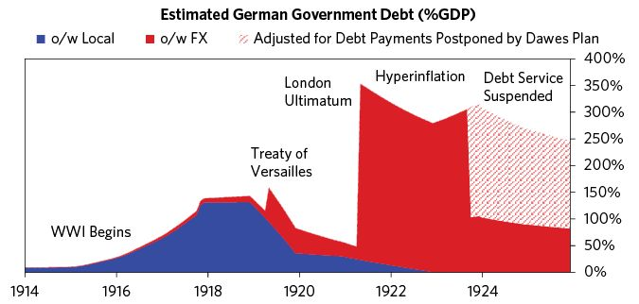

### 2) Creating a New Currency

Creating a new currency with very hard backing is the most classic path that countries suffering from inflationary deleveragings follow in order to end them. In the Weimar case, this currency replacement process came in roughly three stages, beginning in August 1923 and ending in October 1924.126

The first steps toward replacing the mark were disorganized and reactive, driven by necessity rather than by any definite plan. By the summer of 1923, transacting in the mark had become so difficult that major institutions within Germany turned to alternatives, even though these had their own flaws.127 Many resorted to using foreign exchange in place of domestic currency. From late 1922 onward, most major industries in Germany began to set prices in foreign currencies, and by 1923 much of the wholesale trade within Germany was conducted directly in dollars, francs, or florins.128 Those who could not access foreign currency turned to “emergency money” as a last resort. These emergency bills were issued by local governments, trade associations, or companies, and were usually at least theoretically backed by real assets.129 This emergency money, though often illegal, was easier to use than the paper mark, and by the fall of 1923, nearly 2,000 types of it were actively circulating in Germany.130

Recognizing the need for a currency with a stable value, the government attempted to give a stamp of authority to this informal system. Specifically, in August 1923 it began issuing very small-denomination debt, indexed to dollars, which it hoped would be used as a temporary currency until a better solution could be found.131 These “Gold Loan” bills could either be circulated directly or used as a more secure backing for other emergency currencies.132 And, though they were ultimately backed by nothing more than a stamp claiming they were “wertbestandig” (stable value) and a promise that the government could “raise supplements to the tax on capital” in order to honor them, they did retain their value.133 In fact, the public was so desperate for a reliable store of wealth that the gold loan bills tended to be hoarded rather than used, and they disappeared almost entirely from circulation shortly after being issued.134

The second phase of the transition to a new currency began on October 15, 1923, when the government announced the creation of a new national bank—the Rentenbank—and a new stable-value currency, the rentenmark, which would enter circulation on November 15.135 Unlike previous efforts to create a currency with “stable value,” the more ambitious rentenmark scheme was an immediate, “miraculous” success.136 Crucially, since rentenmarks could be exchanged for either a fixed quantity of paper marks or a fixed quantity of hard assets (and vice versa), the hard backing behind the rentenmark applied not only to newly issued bills (as had been the case with the gold loan bills), but to all of the paper marks already in circulation. Specifically, the rentenmark was pegged to the paper mark at a ratio of one to one trillion, and to the dollar at a ratio of 4.2 to one—a symbolically significant exchange rate, as it set the gold value of the rentenmark equal to that of the pre-war, peace-time mark.137

In the months that followed, both of these pegged rates held, and by December both the rentenmark and the newly-pegged paper mark were trading at par in foreign markets, while inflation had fallen to sustainable levels.138

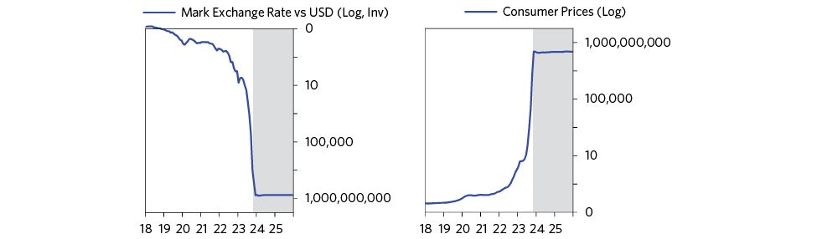

### 3) Imposing Limits on Money Printing

The key to the new currency’s lasting success was that the Rentenbank issued relatively little of it and convincingly backed its issues with real assets. At the same time, there weren’t large debts denominated in it—the total amount of credit the Rentenbank could extend was capped at 2.4 billion marks.139 And, unlike the old gold loan bills, rentenmarks were directly secured by mortgages on 5 percent of all German agricultural and industrial property (“renten” refers to the annuities paid on these mortgages).140 Even more important than this direct backing was the implicit security provided by the Reichsbank’s gold reserves. By 1923 the real value of the money supply had been so reduced by the popular flight from paper marks that it could be backed entirely by the government’s reserves.141 This reduction in the value of circulating currency was reinforced as the Reichsbank began cracking down on illegal emergency money following the introduction of the rentenmark and withdrew its gold loan bills from circulation.142

As shown on the chart below, the monetary base in dollars had fallen to equal Germany’s gold reserves by 1923.

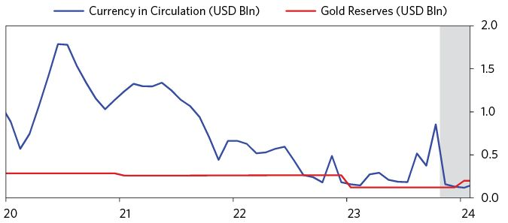

After a year of relative stability, German policy makers implemented the third phase of the currency transition. On October 11, 1924, they introduced another new hard currency (the reichsmark), which could be purchased with rentenmarks at a one to one ratio. Unlike the rentenmark, which had only been formally backed by mortgage bonds, the new reichsmark could be exchanged directly for bullion at the Reichsbank. Specifically, it could be converted into precisely the same quantity of gold as the pre-war mark.143 All remaining paper marks were withdrawn from circulation by June 5, 1925, while the old currency (the rentenmark) was gradually phased out over the next decade.144

But as we will see, it took much more than a new currency to create a lasting stabilization. The rentenmark and reichsmark were crucial pieces of the reform process, but they weren’t the only pieces. Currency depends on the credibility of the institutions issuing it. The fact that there were not a lot of promises to deliver currency (i.e., not a lot of debt denominated in the new currencies) meant that the central bank was not in the position of having to choose between inflationary monetization of debt and deflationary defaults on it. And the fact that the amount of the currency was limited to the amount of backing behind it meant it could be kept stable. The Rentenbank faced a difficult challenge as it attempted to gain credibility in the fall of 1923, but it succeeded because its fundamentals were solid.

### 4) Ending Monetization

In order to build confidence in a new currency, countries in inflationary deleveragings need to stop monetizing debt. As long as the government can force the central bank to print to cover its liabilities, there is a risk that the new currency will be debased and its supposedly hard backing abandoned. That is one of the reasons it is important that central banks be independent of the political system.

Reassurance that monetization would stop came in the form of two major announcements—one initially private and one quite public. First, on August 18, 1923, the Reichsbank informed the Weimar government that, beginning in 1924, it would not discount any additional government debt.145 Though this memo was private, it quickly circulated among the industrial elite, and it spurred policy makers to seriously reconsider the need for fiscal reforms.146 The second piece of reassuring news came on October 15, 1923, when central bank officials publicly stated that the new Rentenbank would cap total government credits (in this case at 1.2 billion rentenmarks). Additionally, its new policy would forbid the Reichsbank from monetizing any government debt after November 15.147

For a time, both the public and the government itself doubted that the central bank and the Rentenbank would honor these promises. After all, the Rentenbank lent the government the entirety of its 1.2 billion rentenmark allocation almost immediately.148 And, by December 1923, the government had already requested an additional 400 million rentenmarks.149 When officials at the Rentenbank stood firm, however, they successfully signaled the beginning of a new era of central bank independence—and the end of a long period of unchecked monetization.

### 5) Closing the Deficit

When the central bank stops monetizing debts during an inflationary deleveraging, the government can either find new creditors to finance its deficits, close those deficits, or take control over the central bank and continue monetizing debt. Since finding new creditors is usually impossible in an inflationary deleveraging, and monetizing debt only postpones the problem, the budget ultimately needs to be balanced.

By late 1923, the Weimar regime had come to the conclusion that it needed to close the deficits. There was no choice, and with the debts largely relieved, this was now possible. In the words of the German minister of finance, “If we do not succeed in cutting loose from the inflationary economy through ruthless choking off of Reich expenditures, then the only prospect we have is general chaos.”150

The government had run budget deficits since the outbreak of the war in 1914.151 However, in August 1923, the government took steps to address the problem by indexing certain taxes to inflation and passing additional emergency taxes.152 By October, it had indexed all taxes to inflation.153

Additionally, the government took aggressive measures to reduce expenses, dismissing 25 percent of its employees and cutting the salaries of the remainder by 30 percent.154 The Weimar regime ended its expensive subsidies to workers engaged in “passive resistance” in the Ruhr.155 Such austerity was extremely painful, and would have been almost impossible to stomach a year or two before. But the hyperinflation had caused so much suffering and chaos by the end of 1923 that the German public was willing to do almost anything to bring prices back under control.

Most important, though, was the effect of more gradual inflation and a more stable exchange rate on the yield of existing taxes.156 Temporary stabilization created a virtuous cycle of sorts: by reducing the rate of inflation, the stabilization increased real tax receipts, helping reduce budget strains and increasing the public’s confidence in the government’s ability to avoid future monetization. Following the introduction of the rentenmark in November, real tax receipts increased rapidly, rising from about 15 million gold marks in October 1923 to more than 300 million in December 1923.157

By January 1924, the government was running a surplus.158

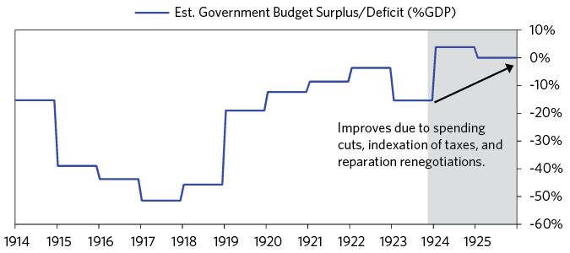

### 6) Tightening Credit

Officials decided to significantly tighten access to credit, so private credit wouldn’t add to inflationary pressures. This tightening was implemented through two channels. First, the government announced in February 1924 that it would “revalue” some privately held debts (i.e., require debtors to give creditors more than face value).159 These included mortgages, bank deposits, and industrial debentures whose values had fallen to almost nothing during the hyperinflation.160 Although the policy was implemented to appease angry creditors, it also worked as a tightening.161 Just as debt reductions have the effect of easing credit, weakening the currency, and increasing inflation, debt revaluations tighten credit, support currencies, and lower inflation.

Second—and more significantly—on April 7 1924, the Reichsbank decided to cap the total amount of credit it would extend to the private sector. It wouldn’t call back any existing debt, but it would extend new credit only as prior debts were paid off.162 This strict cap on new credit creation was painful for businesses in the short term, but it also meaningfully stabilized German inflation, which turned slightly negative in May 1924.163

### 7) Accumulating Foreign Exchange Reserves

Though all the programs, policies, and agreements described above put the German economy on progressively firmer footing, not everyone was convinced they would ensure a permanent stabilization. In fact, as Germany implemented its stabilization regime between November 1923 and October 1924, speculators continually bet against the mark.164 As long as Germany lacked a meaningful foreign exchange reserve, these speculative attacks remained a threat to its continued stability.

Two major shifts helped restore Germany’s depleted foreign exchange reserves. The first was the transfer of privately held foreign currencies to the Reichsbank. As institutions and individuals within Germany gained increasing confidence in the new rentenmark as a means of exchange, they began to convert the foreign currency they had hoarded during the hyperinflation into new bills.165 Between November 1923 and January 1924 alone, foreign exchange holdings at the Reichsbank grew from about 20 million gold marks to nearly 300 million.166 Though these foreign exchange flows paused as inflation rose in early 1924 (and individuals began accumulating foreign currencies again), they resumed once credit standards within Germany were tightened and inflation stabilized (as described above).167

The second major shift came through the Dawes Plan. In addition to reducing reparations burdens, the Dawes Committee also extended Germany a significant foreign exchange loan.168 The loan, issued in October 1924, amounted to 800 million gold marks worth of foreign currency, divided mainly between dollars, pounds, and francs.169 Though the amount was not extraordinarily large, it meaningfully improved the Reichsbank’s credibility when it came to defending against speculative attacks.170 It also sent a reassuring signal to foreign investors. In the four years following the implementation of the Dawes Plan, American investors poured money into German debt, attracted by its relatively high yields.171

By 1924, the crisis was largely over. Germany would enter a brief period of recovery before the Great Depression hit it hard a decade later. This second crisis was not only economically devastating but fueled the rise of right wing and left wing populists, Hitler’s rise to power, and all that followed. But that’s another story.

The News

All news excerpts from The New York Times.

July 29, 1914

Berlin Very Nervous: Big Banks Will Support Stocks—Keeping Gold in Vaults

“Although bankers insist that it is not justifiable to speak of a ‘financial crisis’ in Germany as a consequence of the danger of a general European war, conditions have undeniably grown graver in the last twenty-four hours. Runs on savings banks have increased in intensity, and the banks are paying out gold with the utmost reluctance.”

July 30, 1914

Berlin Bourse on Cash Basis

“Gold has become scarce to the point of invisibility. The runs on Berlin savings banks are still going on.”

August 2, 1914

German Bank Rate Up

August 3, 1914

Reichsbank Hoards Gold: Patriotic Appeal in Germany Not to Demand Coin

“Germany’s financial and economic life are naturally greatly affected. The Reichsbank has raised the bank rate to 5 per cent and the Lombard rate to 6 per cent. The demand for gold continues, but up to the present time the Reichsbank has paid out comparatively little of it.”

August 12, 1914

German Banks Helped; Financing of the Mobilization Has Been Successful

March 4, 1915

German Loan In Chicago: Bankers Ask for Subscriptions - First Offering by Belligerents

March 10, 1915

No Gold in German Banks; Patriots Urged to Exchange Hoarded Gold for War Loan Stock

April 10, 1915

Germany Faces Huge Debt; Means $500,000,000 a Year and Doubling of Taxes

“The Socialist newspaper Vorwaerts, discussing the new war budget, calculates that interest on war loans, deficit for war years, and the making good after the war will mean doubling all existing taxation. The annual increase of expenditure is figured at $625,000,000 to $730,000,000.”

September 22, 1915

Berliners Buy War Bonds; Rush for Subscriptions to Third German Loan Reported

March 12, 1916

German Food Crisis Seems Impending

“Newspapers just received from Germany contain many semi-official and seemingly inspired articles emphasizing the economic difficulties due to the Allies’ blockade and the failure of the 1915 crop.”

March 19, 1916

$10,400,000 for German War Loan

October 9, 1916

Fifth German Loan 10,590,000,000 Marks

“Berlin, announcing total, says subscriptions have exceeded the amount expected.”

February 24, 1917

German Reichstag Votes 15,000,000,000 Marks

“A new war credit of 15,000,000,000 marks was introduced in the Reichstag today...This credit of 15,000,000,000 marks brings the total credit in Germany up to 67,000,000,000 marks, or, on the basis of values before the war, $16,750,000,000.”

May 21, 1917

Germany to Borrow Bonds

“The Exchange Telegraph’s Amsterdam correspondent quotes the Berliner Tageblatt as saying that Germany’s Finance Ministry, as a preliminary step to new methods of raising money, intends to call in all Swedish, Danish, and Swiss bonds and shares owned by Germans.”

July 9, 1917

German Finance

“Saturday’s cablegrams brought the result of the sixth German loan and the announcement of the ninth German credit. The latest loan produced 13,120,000,000 marks.”

September 12, 1917

Germany Keeps Coal From Holland to Force Loan

“Germany is employing this method with a view to exerting pressure in order to induce Holland to fall in with the German desire to raise a loan here. It will be recalled that Germany put similar pressure on Switzerland a short time ago.”

November 18, 1917

Latest German Loan Was Uphill Fight

“Every power of persuasion and pressure at the disposition of the German Government was brought into play to make a success of the seventh war loan of 15,000,000,000 marks, ($3,570,000,000 at normal exchange), according to reports found in German newspapers recently reaching London.”

January 16, 1918

Berlin Food Scarcer: Population Forced to Keep to the Ration Quantity

“The population is compelled to exist almost entirely on the rationed quantities of bread, meat and potatoes.”

February 18, 1918

New Taxes in Germany to Meet Big Deficit

“Dispatches received from Berlin say that the ordinary receipts and expenditures of the German budget for 1918 balance at 7,332,000,000 marks, as compared with approximately 5,000,000,000 marks last year. The increase is said to be due mainly to the higher amount required for interest on the national debt.”

March 13, 1918

Germany Seeks New Loan

“A new German war loan of 15,000,000,000 marks will be issued soon, an Exchange Telegraph dispatch from Copenhagen says. The German war debt now amounts to 109,000,000,000 marks.”

April 21, 1918

German Loan Passes 3-Billion Mark

May 21, 1918

German Exchange Falling

“Germany, judging by foreign exchange rates, has no prospect of smashing the opposition on the west front.”

June 13, 1918

German Loan 15,001,425,000 Marks

“Subscriptions from the army to the eighth German war loan brought the total of the loan up to 15,001,425,000 marks, according to Berlin dispatches today.”

October 27, 1918

Debts Now Exceed Assets: Germany’s Financial Status as Shown in Recent Figures

October 27, 1918

Financiers Foresee Crash: Long Known Here That Germany Was Approaching Economic Abyss

November 7, 1918

Germany’s Finances Near Breaking Point

“Debt Exceeding $35,000,000,000. Has Mortgaged Two-Fifths of Her National Wealth”

November 11, 1918

Armistice Signed, End of the War! Berlin Seized by Revolutionists: New Chancellor Begs for Order; Ousted Kaiser Flees to Holland

November 12, 1918

Revolt Still Spreads Throughout Germany

November 23, 1918

Ebert and Haase Deny Banks Will Be Seized: Uphold the War Loans

“For weeks, even before the revolution, there had been a steady run on German banks all over the country, not only causing an extremely painful dearth of currency, but the banks in many cities, among them Berlin, being compelled to print so-called Notgeld.”

November 27, 1918

Firm for Forcing Germans to Repay; Allies May Occupy the Former Empire if Attempt is Made to Escape Reparation

November 30, 1918

High Mortality in Berlin: 15,397 More Deaths Than Births among Civilians Last Year

May 1, 1919

Germans Confident of Swaying Allies

May 1, 1919

Germany to Lose 70% of Iron and One-third of Her Coal

June 2, 1919

What Comes Next? Worries Germans: Allied Hostility to the Counter-proposals Causes Much Pessimism

“What is going to happen now?” That is the question everyone is asking here, and now that the almost unanimously hostile attitude of the Entente press toward the German counterproposals is known, the answer is a very pessimistic one.”

June 6, 1919

Germans Smuggle Wealth Abroad

“Some merely wish to escape the inevitably heavy taxation which must be shortly expected …the Government will not allow cash to be sent out of the country so the merchants smuggle their marks abroad and sell them at a large reduction, thereby still further reducing the value of the mark.”

June 8, 1919

If Germany Doesn’t Sign—Starvation

“Allies Are Ready to Enforce a Blockade More Rigorous Than Ever Before, Should Enemy Balk at Peace Terms”

June 15, 1919

Sees Germans Taxed $75 Each a Year

“Minister Wissell Doubts Wisdom of Importing Food to Be Paid for in Blood.”

June 28, 1919

Germans Reach Versailles, Treaty to Be Signed Today

August 3, 1919

German Resources Are in Allies’ Grip

August 9, 1919

Germans Approve Centralized Plan of Finance Minister

“This decision, which approves the Erzberger plan of unified imperial taxes, removes the rights of states to impose taxes and was bitterly contested.”

August 10, 1919

Mark Goes Still Lower

“German marks, the value of which has been steadily falling recently in neutral countries surrounding Germany, reached their lowest point in history in Switzerland yesterday, being quoted at 35 centimes instead of the peace price of 125 centimes.”

August 11, 1919

Billions in Paper in Deutsche Bank: But Report Admits Big Figures Don’t Mean Real Gain in German Business

“The management remarks: ‘It is true that the uncanny rise in the cost of operation is due to the depreciation of our money standard…but it is also materially due to the demand of the personal in connection with decreased labor output and shorter working day.’

September 7, 1919

Rigor in German Tax Hunt: Agents Empowered to Search Houses and Force Strong Boxes

September 13, 1919

German Industry Rapidly Reviving

“British observer says progress is greater than in any other country.”

September 18, 1919

Mark Touches Lowest Point in the History of Germany

“Mathias Erzberger, Minister of Finance, today convened a conference of bankers and other financiers in order to discuss the decreased value of the mark and other financial problems.”

September 26, 1919

Germans in Discord Over Heavy Taxes; Erzberger Hints at Resignation of the Government If Opposition Is Pressed

October 20, 1919

German Steel Output Up: Figures for July Show Big Gain during the Last Few Months

November 15, 1919

Won’t Take German Money; Hanover Tradesmen Refuse Cash Bought at Low Exchange Rates

“A large number of Hanover tradesmen have decided to sell nothing to foreigners who wish to pay in German money which they bought with foreign money at the present low rates of exchange. Foreign money will, however, be accepted at the ordinary peacetime rates.”

November 29, 1919

Good Market Here for German Bonds

“Imperial war loans and securities of cities attractive to American speculators.”

December 1, 1919

Germany Checks Exports Lest Country Be Stripped

“The Government’s alarm over the manner in which the process of ‘selling out Germany’ continues has finally forced it to enact temporary measures which are calculated to put a radical check on exports.”

December 5, 1919

Erzberger Offers Great Tax Budget; 60 Percent Levy on Biggest Incomes in Germany’s Postwar Financing

“Discussing Germany’s postwar economic obligations, Herr Erzberger said that the problems confronting the nation demanded the same universal solidarity among all citizens as did the responsibilities during the war. He hoped that the prospective tax reports would accelerate progress toward democracy, and contribute to the raising of a new Germany on the ruins of war.”

December 17, 1919

Germany’s Loan Falls Far Short; Only 3,800,000,000 Marks Subscribed, Instead of 5,000,000,000 Which Were Expected

“The Government is greatly disappointed by the failure of the Premium bond loan, for the preliminary figures show that it can hardly be represented as anything like the success which Erzberger and his colleagues expected.”

January 2, 1920

Berlin Bourse Becomes Lively on Expectations of Treaty

“This was due chiefly to the understanding Germany had reached with the Entente with regard to the signing of the Peace Treaty and the expectation of better conditions for exports and imports.”

January 23, 1920

Erzberger Serene Facing Many Foes

January 26, 1920

Germans Begin Evacuating Lands Lost by Treaty

“German preparations for the evacuation of Danzig, which is to become a free city under the terms of the Treaty of Versailles, had as one feature a final parade of the German troops this morning.”

January 31, 1920

Gold and Silver Bring High Prices in Berlin; Germans Pay 500 Paper Marks for 20-Mark Gold Pieces to Provide Against Collapse

“An unprecedented decrease in the German rate of exchange has caused a serious panic among business men and the public generally and has led to enormous prices being paid for gold and silver in coins, which many people seek to purchase now as a sort of an “ iron reserve “which will provide for them when the worst comes.”

February 14, 1920

French Interested in Treaty Revision: but They Would Consider None That Lightened Germany’s Burdens

“France sees in the possibility of changes opportunity of gains for herself, while the English advocates for alternations would ease the burden of Germany”.

March 14, 1920

Troops Overthrow Ebert; Kapp, Prussian Pan-German, Declares Himself German Chancellor

“Germany today is in the throes of a counterrevolutionary movement which was successful this forenoon in turning the Ebert Government out of Berlin and setting up a new Administration in the capital.”

March 28, 1920

German Rage Rises over Kapp Mutiny

“People angry over laxity in arresting and prosecuting the revolutionists. Threaten another strike; workmen demand that soldiers be withdrawn immediately from the Ruhr district.”

June 1, 1921

Germany Preparing to Pay

“Now that the period of negotiation and hoping against hope has passed for Germany, she is grappling with the financial obligations involved in making her reparations payments.”

June 20, 1921

Germany Seeking Additional Credits; Sounding Foreign Bankers on Establishment of Balances Secured by Reichsbank Silver

“Germany has used up a large proportion of her foreign credits in making the reparation payments which have already been concluded. How much in the way of credits still remains available in liquid form is a question which is causing much discussion.”

June 23, 1921

Find German Industry Making Rapid Gains

“A commercial commission which has just returned from studying conditions in Germany reports that German factories and workshops of all kinds are working with all their might and that if nothing intervenes to impede her progress Germany will before very long become commercially superior to all other European countries.”

June 23, 1921

To Tax Germans 20 Billions More; Wirth Tells National Economic Council’s Reparations Committee What Is Impending

“Chancellor Wirth’s ‘reparation Government’ is tackling the herculean task of raising funds for reparation with an intensive thoroughness and deadly earnestness commensurate with its intricate difficulties and unpopular thanklessness.”

June 25, 1921

Change in Method of German Payment

“800,000,000 marks can be turned over in European currencies instead of dollars. Countries to take risk may involve depreciation of own money, but is expected to lower rate of dollar.”

June 26, 1921

Germany Sets Pace for World’s Trade

“A reflection of the powers of recuperation of Germany has been found in statistics of the imports and exports of the United States, as compiled by the Department of Commerce. They present an excellent picture of the manner in which the German Government, importers and exporters are thrusting themselves into the forefront of foreign trade.”

June 30, 1921

Exchange Steady in German Payment

“The payment by Germany of her second instalment [sic] on her reparations bill, amounting to 44,000,000 gold marks, has been accomplished without disorganizing the foreign exchanges, as happened when the first payment was made.”

July 7, 1921

German Tax Bill 80 Billions a Year

“Wirth announces that figure in paper marks as necessary to cover obligations. The chancellor’s dilemma is if he emphasizes direct tax he alienates the bourgeois; if indirect, the proletariat.”

July 20, 1921

Mystery Cloaks Germany’s Credits

“Local bankers believe that some of present heavy withdrawals are going abroad.”

July 25, 1921

German Industries Entering on a Boom

“Artificially cheap labor and coal are basis of general revival in many branches.”

August 6, 1921

German Debt Still Rises

“Up 8,339,040,000 marks in June, making total 135,031,060,000.”

August 7, 1921

German Tax Plan Depends on Silesia

“The Wirth Government, wrestling continuously throughout the dog days with the tough problem of devising new tax schemes for saddling the additional billions on the German people needed to cover reparation charges and balance the deficit of the internal budget, has completed the first stadium of its thankless job.”

August 28, 1921

Erzberger’s Death Fires All Germany

“Responsibility for the murder attaches to the Nationalist skirts. Its effect on the radical masses is bound to assert itself.”

September 4, 1921

Sees German Crash in False Success: Fall in Mark and Increase in Issue Is inflating Prices, Says Moody

“Germany’s paper prosperity is leading to a crash,” says John Moody, President of Moody’s Investors’ Service.”

September 5, 1921

German Reds Riot in Many Places

September 30, 1921

German Food Prices Rise

“Collapse of mark exchange affects every family in country.”

October 21, 1921

Berlin and Warsaw Get Silesian Fiat: Allies Announce Adoption of League of Nations Partition of the Territory

“There will probably be a further outcry from the Germans, but with the French army on the edge of the Ruhr the Germans will accept the decision.”

November 8, 1921

3 Marks for 1 Cent in Local Market: German Bank Statement of Vast New Inflation Sends Quotations Down

“The German mark touched the lowest figure in its history.”

November 28, 1921

Germany Expects to Raise Foreign Credit

December 14, 1921

German Bank Statement: Further Increase of 1,846,000,000 Marks in First Week of December

December 17, 1921

Germany Asks for Time

December 21, 1921

Berlin Waits Result of London Conference: The Reichsbank Meanwhile Holds on to Its Reserve of Gold Marks

January 7, 1922

Rejects German Plea: Reparation Commission Refuses to Grant Delay on Next Payments

“In reply the Reparation Commission upholds its former standpoint and refuses to examine any possibility of delayed payment until Germany replies...regarding the length of postponement, what sums may be expected and what guarantees are given.”

January 10, 1922

German Delegates Start For Cannes

“Berlin has been suddenly seized with unbridled optimism over the Cannes conference, and it was reflected on the Bourse today in its effect on the paper mark.”

January 29, 1922

Germany Begs Off 1922 Cash Payment: Also Wants Allies to Reduce Money Demand and Increase Tribute in Kind

“Reply to reparations board tells of plans to re-establish financial stability: tax burden made heavier, in addition to forced levy, another internal loan is to help reduce floating debt.”

February 6, 1922

New Perplexities In German Finance

“Government may be forced to resort to direct issue of paper money.”

February 13, 1922

German Prices Up Again

“Public buying goods through fear of still further advance.”

February 27, 1922

Renewed Rise of Prices In Germany; Markets Advancing On Withdrawal Of Government Subsidies And Fixed Values

“The tendency of German commodity markets last week, independently of the mark’s movement on exchange, was toward rapidly rising prices, with renewed activity in production and trade, and with other symptoms which were shown during the great collapse of the mark in 1921.”

February 28, 1922

Genoa Prospects Depress Germans

“Gloom Over Decision of Premiers to Exclude Reparations From Conference Discussion. Mark falls still lower.”

March 2, 1922

Reparations Deal Opposed In Germany; Industrial Concerns Raise an Outcry Against Provisional Accord With Entente

“German industrials prophesy a death blow to German exports, also economic slavery and ultimate ruin, if the convention regarding material reparations, provisionally signed by representatives of the German Reconstruction Ministry...ever becomes operative.”

March 10, 1922

Reply Shatters Germany’s Hopes

“America’s participation in future conference is still looked forward to.”

March 22, 1922

Calls on Germany to Limit Paper Money: Allied Board Plans Partial Moratorium

March 25, 1922

Germany to Fight Reparation Terms

“Germany’s quietest crisis in her post-revolutionary experience is likewise her most serious. There is no excitement in Berlin today. Neither the Teuton people nor the politicians betray signs of emotion. There is only the deadly calm of utter discouragement.”

March 27, 1922

Mark’s New Decline As Seen in Germany: Financial Circles Think Stipulations for German Home Finance Impracticable

“Prices are rising again. Fall in the Mark. After the first shock produced on financial markets by the conditions laid down last week by the Reparations Commission—a shock embodied in the sharp fall of the mark to a new low level—a somewhat calmer mood has followed.”

March 30, 1922

French Are Deaf to German Pleas

“Will Not Believe Germans Cannot Pay for Restorations”

May 11, 1922

Germany Rejects Tax, Asks Loans

“Reparation reply offers to submit plan to cover expenditures and stop inflation.”

May 12, 1922

Reparation Reply Displeases French

“They call it evasive and believe that Germany is playing for more time.”

May 26, 1922

French Clear Way for German Loan; Poincare Working with Bankers Looking to Economic Settlement of Reparations

“The bankers conference is opening in conditions much more favorable than might be inferred from certain surface indications. The Poincare Government maintained a rigid stand against Lloyd George’s strategy at Genoa, and the impression went abroad that if Germany failed in the engagements of May 31 there would be a resort to the penalties by France.”

June 1, 1922

Allies Approve German Answer; Grant Moratorium

“After two days of consideration of the German reply to the demands of March 21 last, the Reparation Committee late this evening dispatched a note to the German Chancellor informing him that it was prepared to grant the partial moratorium on this year’s reparations payments which had been scheduled.”

June 25, 1922

Berlin Assassins Slay Rathenau; Minister’s Death Laid to Royalists; Germans Rally to Defend Republic

“Dr. Walter Rathenau, who was more closely identified than any other German with the efforts for the rehabilitation of his country since the war, was shot and killed.”

July 3, 1922

Mark May Go Still Lower. German Government Buys Exchange From Exporters, Who Resell Marks

“Reichsbank officials declare that next two installments of reparations payments will undoubtedly be paid. The Reichsbank is still commandeering high currency bills from exporters, who, being reimbursed in paper marks, immediately re-convert such marks into foreign currencies. That policy will inevitably bring further depreciation of the mark.”

July 26, 1922

Allied Representatives Decide Germany Must Continue to Pay 2,000,000 a Month

July 28, 1922

France Refuses Cut on Private Claims

“Germany Notified That She Will Have to Continue to Pay 2,000,000 a Month.”

July 29, 1922

Urge German Loan and Cut in Budget; Experts on Guarantees Committee Submit Their Report to Reparation Commission.

July 31, 1922

Germans Near Panic as Mark Collapses; Crowds Storm Stores in Eagerness to Buy before Prices go Higher

“The prospects are all favorable to the continued and catastrophic decline of the mark.”

August 2, 1922

The German Currency Crisis

“Practically all of Germany’s accruing foreign obligations including purchases of food and material are being paid for with paper marks. The further the mark declines, the more of such paper is required to purchase abroad a bushel of wheat or a bale of cotton, or to meet a stimulated payment in gold on reparations account.”

August 3, 1922

Hermes Asks Loan and Moratorium; Only Then Can Germany Balance Budget and Co-ordinate Her Currency

“Doctoring on symptoms is useless and senseless,” was the opinion expressed today by Dr. Andreas Hermes, Minister of Finance, in discussing Germany’s financial ills.”

August 14, 1922

Rationing Project Urged in Germany

August 20, 1922

Another Increase in German Paper Issues

“Circulation Rises 6,811,000,000 in Second Week of August, 14,900,000,000 Since July.”

August 21, 1922

Germans Selling Marks for Dollars

“Frightened Stampede of the People to Put Money into Foreign Currencies.”

August 21, 1922

Poincare Says All Germans Must Pay

“France must not listen to people who advise her to leave Germany unpunished for the wrongs of the war and forgive her the reparations she owes; France must and will find a way to make Germany pay.”

August 30, 1922

Mark Note Famine Afflicts Berlin

“The scarcity of mark notes in circulation today has reached such an acute stage that the Reichsbank paid in cash only 40 percent of the amounts demanded.”

September 2, 1922

Food Rioting Starts in Town Near Berlin; One Killed, 20 Hurt, as Police Fire on Mob

“The first blood has flowed in high cost of living riots...Other food riots have taken place in Berlin and in various other parts of Germany.”

September 7, 1922

All Records Broken by German Paper Issue

“New Currency Put Out in Closing Week of August 22,978,000,000 Marks”

September 8, 1922

Germany Prepares for Unemployment

September 11, 1922

German Prices Double in Month of August

“Increasing use of gold values in transaction of ordinary business.”

September 13, 1922

German Consumers Fight Dollar Basis; Protest to Government That Practice Undermines Confidence in the Mark.

“Dollar exchange was the subject of a concerted attack by German consumers today who protested against using the dollar as a basis for fixing domestic prices.”

September 14, 1922

14 Billions Added to the German Currency

“Increase in first week of September second largest on record.”

October 16, 1922

Will Use Foreign Money: German Business Men Mean to Continue Prices in Outside Currencies

“The basing of prices for home sales of goods upon foreign currencies is likely to continue notwithstanding the Government’s new prohibition of the practice.”

October 28, 1922

German Paper Issues Again Break Record

“New Currency Put Out in Third Week of October 35,466,969,000 Marks.”

October 30, 1922

Numerous Reasons for Fall in German Mark: Reserve Board Ascribes It to Deficit, Inflation, Reparations and Trade Balance.

“The Federal Reserve Board’s bulletin for October ascribes the greatly accelerated fall in the German mark chiefly to the German budget, to reparations, to the balance of trade and to the flight of capital from Germany.”

November 10, 1922

Berlin Once More Disappoints Allies.

“The Reparation Commission returns to Paris tomorrow empty-handed except for a brief final note from Chancellor Wirth predicating a complete moratorium and supporting action by an international financial consortium for temporary and final solution of the reparation problem and for permanent stabilization of the mark.”

November 10, 1922

France Is Prepared to Coerce Germany

“Premier Poincare, speaking before the Senate today, declared that the only hope of getting any reparation payments from Germany lay in the Brussels conference, but that if this failed France was prepared to act alone again.”

December 2, 1922

Poincare for Curb on Germany at Once

“Mark stabilization and reparations loan to follow control of German finance.”

December 4, 1922

Money Very Dear on German Market

“Private Banks Still Get 20 Per Cent Through Fees and Commissions. Bank Rate May Go Up. Currency Inflation Now Being Increased By Rediscount Of Private Bankers At Reichsbank.”

December 11, 1922

All Records Broken in German Inflation

“Paper Currency, Loans on Treasury Bills and Commercial Discounts Surpass Precedent.”

December 17, 1922

German Debt Still Grows

“Increases 123,000,000,000 Marks In First Ten Days Of December.”

December 23, 1922

German Deficit Nears One Trillion Marks

“Even ordinary expenditures are more than double the receipts from taxes.”

December 25, 1922

Wild Increase in German Inflation

“Reichsbank discounts expand 172 billions in week, currency 123 Billions.”

December 27, 1922

Germany Declared in Willful Default

“France gained an important victory in the Allied Reparation Commission today when the commission by a vote of 3 to 1 declared Germany in voluntary default in her wood deliveries for 1922.”

January 9, 1923

Germans to Offer Passive Resistance

“The Cuno Government’s immediate foreign policy will be based on the proposition that independent French occupation of the Ruhr tears up the Versailles Treaty and that consequently all reparations arrangements will be off.”

January 11, 1923

French Enter Essen Unresisted at 4:45 A.M.; Germany Recalls Envoys in Paris and Brussels; Our Troops on the Rhine are Ordered Home

“The workers are apathetic regarding the presence of the French. They declare that they know they are being exploited by their own capitalists and now are working for their bread and therefore are indifferent as to what the French do, for their situation cannot be worse.”

January 19, 1923

German Bank Rate Up From 10 Per Cent to 12; It Is Now the Highest in the World – Was 5 Percent in July

January 21, 1923

Time May Be Approaching When No One Will Buy German Paper

“It is the speculative buyer of marks, according to the year-end bulletin of the London County Westminster Parr’s Bank of London, who has enabled Germany to ‘carry on’ as long as she has. German exports being, for the period since the war, almost invariably less than German imports, it is clear that she has not been able to pay for her needs in goods, as should be the case in normal times.”

January 28, 1923

Fresh Slump in German Marks Carries Them to 28,500 to the Dollar

January 31, 1923

Paper Marks Increase 216 Billions in Week; All Records Broken by German Inflation in Third Week of January

February 12, 1923

Arrests and Riot Mark Day in Ruhr

February 12, 1923

Prices in Germany Up 248 ½ Per Cent in January; All Monthly Records of Increase Broken—7,159 Times Prewar Average

February 15, 1923

Germany Protests Ruhr Export Barrier; Tells France She Is Reducing the Means of Paying the Other Allies

February 22, 1923

45,600,000,000 Marks Paid, Germany Says; Berlin Gives Official Compilation—Says Treaty Losses, Raise Total to 56,500,000,000.

March 1, 1923

French Lift Ban on Coal to Germany; Shipments Are Allowed Subject to 40 Per Cent Tax Imposed Prior to Occupation

April 9, 1923

Americans Ask $1,187,736,867 War Damages from Germany, Including Lusitania Losses

“The United States has tentatively fixed at $1,187,736,867 the amount which it will demand from the German Government in payment of the claims of the American Government and its citizens growing out of the World War. Notice to that effect has been served on the agent of Germany in the Mixed Claims Commission organized for the purpose of adjusting the claims of each country against the other.”

April 16, 1923

Germany’s Public Deficit: Expenditure in Fiscal Year 6 1/4 Trillion Marks above Revenue

April 30, 1923

Hopes Based on New German Bank Rate; Officials Claim 18% Charge Will Check Credit and Currency Inflation

“In German official circles great hopes are being based on last week’s increase in the Reichsbank’s discount rate from 12 per cent, to 18. It is expected to be supplemented this week by a Government decree further restricting dealings in foreign currencies and requiring registration of such holdings.”

May 15, 1923

Suicides in Germany Now 80,000 Yearly; Toll Compares with 1,200 Before the War—Poverty Is Declared the Chief Cause

May 21, 1923

German Stock Exchange Now Keeps Open Only Three Days in Week

June 25, 1923

German Prices Rush Upward as Mark Falls; Rise of 41 Per Cent in Ten Days—Advance Increasingly Rapid Last Week

June 25, 1923

Effects of Germany’s Disordered Currency; Old Investments Obliterated 100 Per Cent

August 1, 1923

Printers of German Paper Marks Walk Out; Berliners Call It Meanest Strike in History

August 2, 1923

Plans Two Currencies Now For Germany: Cuno Cabinet Proposes Unlimited ‘Near Gold’ Loan, Scrip to Be Used as Money. Others Predict Failure. One Worthless Currency Is Bad Enough, Without Adding Another, They Assert

“With painful slowness and by devious ways the German Government is striving for all practical purposes to jettison the present paper mark and create a brand-new currency, which, it is hoped, will have a more confidence-inspiring character.”

August 16, 1923

Germany’s Changed Plans

“The new German Chancellor declares that his first energies must be wreaked upon domestic politics.”

August 20, 1923

German Stocks Firm Since Recovery of the Mark

August 20, 1923

Last German Gold for New Currency; Finance Minister Hilferding Decides Not to Use It in Buying Paper Marks. Plans Fixed Values Basis. Berlin Raises Street-Car Fare to 100,000 Marks, and Demands Government Aid

“Finance Minister Hilferding denies that he plans another operation to save the life of the dying mark by buying worthless paper in foreign markets for what little gold is still at the disposal of the German Government. Contrarily, he means to make that gold the slender base of a new German currency.”

August 29, 1923

Hunger-Driven Germans Die from Eating Toadstools

September 17, 1923

Basis of the Proposed New German Currency; Secured in Gold and Issued by New Bank Independent of State

September 23, 1923

Bodenmark New Unit of German Currency; Mortgages on Landed Property Throughout Country to Back Gold Bank

“Germany’s new unit of currency is to be the ‘bodenmark,’ containing .358 of a gram of fine gold and equal to 100 ‘bodenpfennigs.’ it became known today through publication of the measure providing for establishment of currency bank.”

September 26, 1923

All German States Bow to Ruhr Peace

“It was officially announced this afternoon that the Premiers of the German Federated States at their conference with Chancellor Stresemann today unanimously agreed to abandonment of the passive resistance program, but at the same time expressed determination firmly to safeguard the unity of the country.”

October 10, 1923

First Agreement in the Ruhr: Two Mine groups to Resume Work and Reparations in Kind

“The French Government today notified the Reparation Commission, the common agent for all the Allies, that General Degoutte concluded satisfactory arrangements yesterday with two Ruhr industrial groups for resumption of work and delivery of payments in kind on reparations account. He also notified that commission that other such accords would be negotiated.”

October 13, 1923

Proposals for New German Currency; London Banking House Gives Outline of the Berlin Ministry’s Proposals

“As outlined by international banking houses in London, the plan of the Stresemann Ministry for a new German currency makes the following provisions: Agriculture, industry, trade and banking shall provide means for the creation of a currency bank—‘Waehrungsbank’—which will issue the new money in form of a ‘ground-mark’ or ‘boden-mark.’”

October 15, 1923

German Stocks Rise with the Dollar; Impending Ruhr Settlement Also Stimulates Market—Bonds Also Advancing

October 16, 1923

Germany to Stop Worthless Marks

“The Cabinet tonight approved a bill granting a charter for a so-called gold annuity bank . . . the Reichsbank will cease to discount the Government’s Treasury bills, thus placing it in the position to accomplish an immediate curtailment of inflation.”

October 29, 1923

German ‘Rentenbank’ Ready for Business: First Step in the Government’s Efforts at Currency Reform

November 5, 1923

When Germany Issues Its New Currency Berlin Believes Old Paper Marks Will Disappear, New Marks Replacing Them

November 7, 1923

Must Aid Germans, Coolidge Believes; President Learns Food Situation Is Serious, Requiring Relief This Winter

“President Coolidge recognizes, as a result of official reports to the American Government brought to his attention by members of the Cabinet, that conditions in Germany are most serious, and the statement was authorized at the White House today that the President believes that the people of Germany will require relief from the outside world before the winter is over.”

November 14, 1923

Reparation Board Invites Germany; Grants Request for a Hearing on Reasons for Failure to Make Payments

November 19, 1923

Germany Puts Out the New Currency; Confusion in Financial Circles over Terms of Issue and Conversion

“With the delivery of 142,000,000 new rentenmarks on Thursday by the new bank of issue to the Government, and with cessation of Reichsbank discounting of Treasury bills and of issue of paper marks against such discounts, the new German currency experiment has at least been initiated.”

December 3, 1923

Germany’s “Real Wages”; Workingmen’s Pay Estimated in Gold 44 to 60 7/8% of Pre-War Rate

December 10, 1923

Further Decline of Prices in Germany; Social Strain Relieved, but Financial Experts Are Pessimistic of Future

“Social tension last week was considerably relieved by the heavy fall in prices, which for some goods reached 50 per cent.”

December 14, 1923

Coolidge Tells Lenroot He Approves Private Charity for German Relief

December 14, 1923

German Treasury Low; Barely Enough Money to Keep the Government Going, it Is Said

“The desperate financial situation of Germany has compelled the Government to impose extraordinary taxes on the people, and even these will hardly suffice to keep the ship of State afloat. There is barely money enough in the treasury to pay the most pressing expenses for another ten days, though the salaries of most officials and Government employees have already been greatly reduced and thousands have been dismissed.”

December 17, 1923

Many German Currencies; “ Emergency Issues” Now One-Fifth of Reichsbank Circulation

December 23, 1923

Dawes and Owen Fitted to Aid German Finance

“In selecting Charles Gates Dawes and Owen D. Young to aid in the solution of the knotty German financial problem, the Allies have chosen two Americans whose business lives exemplify success in its broadest meaning. Each is an outstanding figure in America’s commercial life.”

January 28, 1924

Berlin is Hopeful of New Gold Bank; Belief Expressed That It Will Restore International Faith in German Finance. Balanced Budget Assured; Hopes of New Plan to Check Inflation and Attract Foreign Capital

“Internal conditions in Germany are daily looking better. In the third taxation decree differences both in the Cabinet and between the republic and separate States has not appeared. It is believed the chief feature of this new legislation is the taxation away or expropriation of all gains made by paying off bonds and mortgages in paper marks.”

January 29, 1924

Germany Awaits Arrival of Experts: Books and Other Data Ready for Dawes Committee Now on the Way

“The arrival of the Dawes committee tomorrow evening is hailed as an event of historic importance.”

February 1, 1924

Germany Wipes Out Her Internal Debt; Other Drastic Steps.

“Private Bonds and Mortgages Restored to 10 Per Cent of Original Gold Value. Inflation Taxes Imposed. Independent Operation for Profit of State Railroad and Postal Services Decreed. Experts Hear Bank Plea. Schacht Urges Creation at Once of Gold Issue Institution.”

February 2, 1924

Government Bonds of German Break; Debt Program Reacts Sharply in Market Here and Excited Trading Follows

“The market for bonds of the German Government and of German cities or corporation took on exceptional activity yesterday as the result of news dispatched telling of Germany’s new program to cut down Government debts. In this program the German war loan and other issues have been scrapped and bonds of a corporate or private nature have been marked up to a value of 10 per cent of their early gold value.”

February 4, 1924

Fixing Depreciation of German Mortgages; Allotment of 10 Per Cent Valuation—Savings Deposits Wiped Out

February 4, 1924

German Trade Recovery; Some Increase In Unemployment, but Much Less Short-Time Work

February 18, 1924

Export Surplus for Germany in December; Measured in Gold Marks, Imports and Exports for 1923 Practically Balance

February 18, 1924

German Mortgages ‘Valorized’ at 15%; Had Expected Only 10%—Public Debt Repayments in Paper Marks Stopped

“The one difference in the formal decree is that mortgages are restored to 15 percent of their original value.”

February 18, 1924

German Wartime Currency to Go; “Darlehnskassen” to Be Abolished at the Beginning of Next May

“One important announcement, in line with the return to normal conditions in the German currency, is that the Darlehnskassen, which were founded in August, 1914, for the purpose of granting easy-credit, are to stop functioning altogether at the beginning of May.”

February 18, 1924

German Costs Down Again; Average Living Expenses Now 34 1/2 Per Cent Below Last November

February 20, 1924

German Revenues Increase; Surplus of Millions of Gold Marks Expected for First Time Since War

February 25, 1924

No Halt in German Trade Recovery; Continued Gradual Improvement of Industry, With ‘Boom’ in Textile Trade

“In German currency, finance and business the position continued to improve last week, the two first-mentioned gaining ground rapidly, the last more slowly, except in the textile and clothing branches. In those something of a boom is under way and manufacturers have already begun to refuse orders.”

February 26, 1924

Britain Cuts Levy on German Imports; Impost of 26 Per Cent Drops to 5 Per Cent, With Berlin Pledging Payment

February 28, 1924

League May Audit German Finances; Dawes Committee Adopts Supervision as an Indispensable Part of Experts’ Plan

March 10, 1924

Revival in German Industry Goes On; Unemployment in Labor Now Decreasing Rapidly From the Recent Figures. Steel Trade Recovering

“The trade situation throughout Germany continues to improve. One evidence is the fact that publicly supported unemployed workmen on Feb. 15 are stated to have been 1,301,270, as against 1,582,852 on Jan. 15. Even the partly unemployed decreased from 635,839 to 257,840.”

March 17, 1924

Further Improvement in Trade of Germany; Government Helped by Establishment of Nine-Hour Working Day

March 24, 1924

Continued Recovery in German Industry; Metal Prices Are Rising and Textile Industry Still Booming

April 3, 1924

German Gold Bank Ready; Will Start Business Next Week in the Reichsbank Building

April 10, 1924

Germans Criticize Terms; First Official View Is That Dawes Report Is Inacceptable as It Stands

April 10, 1924

German Resources Ample; Dawes Report Calls for Mortgage on Industry to Meet Payments. $200,000,000 Loan Proposed

“Germany’s protestations during the last four years designed to make the world believe she could not pay reparations were refuted today when the Dawes Expert Committee reported to the Reparation Commission that Germany could pay. The committee fixes the minimum normal payments at 2,500,000,000 marks annually, subject to increases according to German prosperity.”

April 15, 1924

Germany to Accept Dawes Board Plan as Basis of Parley; Reply Will Agree to Enter Negotiations for Settlement with Reparation Commission

April 16, 1924

France and Britain Approve in Full the Dawes Report; Germany’s Acceptance of It as Basis of Discussion Is on Way to Paris

April 18, 1924

Reparation Board Adopts Dawes Plan; Sets Berlin to Work; Calls on Germans to Draft Laws and Name Officials to Put It into Effect

April 21, 1924

Credit Demand in Germany; Industrial Situation Improving and Loans Doubled in a Month

April28, 1924

Germany Re-Entering Foreign Steel Trade; Large Orders Taken in Sweden—Said to Be Underbidding France and Belgium

April 28, 1924

German Surplus Revenue; Latest Period Shows 19,280,800 Marks Above Expenditure

April 29, 1924

Marx Talks of Dawes Plan; Defends Action of German Government in Accepting It.

“A speech on the Dawes report and the reasons which compelled Germany to accept it was delivered at an election meeting of the Centre Party here tonight by Dr. Marx, the German Chancellor.”

May 4, 1924

German Voters Go to Polls Today; Most Important Election Since the War Fails to Arouse Great Interest

“Thirty-five million men and women in Germany who have attained the age of 20 will have an opportunity tomorrow to give untrammeled expression to their political preferences, and upon their verdict will depend in a large measure the future of German politics and economics, as well as of the nation’s foreign relations.”

May 5, 1924

Bavarian Vote Divided: Hitler-Ludendorff Group Fails to Win Expected Victory

May 5, 1924

German Coalition for Dawes Plan Leads in Election: Despite Gains by Communists and Nationalists, Middle Parties Retain a Majority

“First returns from today’s election indicate that, though as expected the German Nationalist Party standing at the extreme right registered substantial gains, the old Coalition from which the present government was formed—the German People’s Party, the Centrum, and the Democratic Party—will form the next government, probably in conjunction with the Socialists.”

May 6, 1924

German Coalition Holds 230 Seats to Opponents’ 192; Present Cabinet Expects to Retain Office and Carry Out the Dawes Plan

“The result of German elections shows that a majority of Germans are for the ‘policy of fulfillment’ as against a definite break with the Entente, for qualified acceptance of the Dawes report as against summary rejection thereof, for continuance of the German Republic as against restoration of the German monarchy.”

June 30, 1924

Germany Accepts Military Control; Asks Month’s Delay and Limitation of Inquiry to Points Mentioned by Allies

July 31, 1924

French Ports again Open to Germans; Berlin Hears That from September Onward Ships from Fatherland Will Be Admitted

“French ports are to be thrown open to German shipping for the first time in ten years.”

August 17, 1924

Allies and Germans Sign Agreement; French Will Quit Ruhr within a Year

## Works Cited

Balderston, T. “War Finance and Inflation in Britain and Germany, 1914–1918.” The Economic History Review 42, no. 2 (May 1989): 222-244. https://doi.org/10.2307/2596203.

Bresciani-Turroni, Constantino. The Economics of Inflation: A Study of Currency Depreciation in Postwar Germany. Translated by Millicent E. Sayers. London: Allen and Unwin, Ltd., 1937.

Eichengreen, Barry. Hall of Mirrors: The Great Depression, the Great Recession, and the Uses—and Misuses—of History. New York: Oxford University Press, 2016.

Feldman, Gerald D. The Great Disorder: Politics, Economics, and Society in the German Inflation, 1914–1924. New York: Oxford University Press, 1997.

Ferguson, Niall. Paper and Iron: Hamburg Business and German Politics in the Era of Inflation, 1897–1927. Cambridge: Cambridge University Press, 1995.

Graham, Frank D. Exchange, Prices, and Production in Hyper-Inflation: Germany, 1920–1923. Princeton, NJ: Princeton University Press, 1967.

Holtfrerich, Carl-Ludwig. The German Inflation, 1914–1923. Berlin: Walter de Gruyet, 1986.

Keynes, John Maynard. The Collected Writings of John Maynard Keynes. Vol. 17, Activities 1920–1922: Treaty Revision and Reconstruction. London: Macmillan, 1977.

Peukert, Detlev J.K. The Weimar Republic: The Crisis of Classical Modernity. New York: Hill and Wang, 1993.

Rupieper, H.J. The Cuno Government and Reparations 1922–1923: Politics and Economics. The Hague, The Netherlands: Martinus Nijhoff, 1979.

Taylor, Frederick. The Downfall of Money: Germany’s Hyperinflation and the Destruction of the Middle Class. New York: Bloomsbury Press, 2013.

Webb, Steven B. Hyperinflation and Stabilization in Weimar Germany. New York: Oxford University Press, 1989.

1. Feldman, The Great Disorder, 30.

2. Feldman, 32.

3. Bresciani-Turroni, The Economics of Inflation, 23.

4. Bresciani-Turroni, 23.

5. Feldman, 38.

6. Feldman, 38.

7. Feldman, 45.

8. Feldman, 47.

9. Holtfrerich, The German Inflation, 177.

10. Feldman; 42.

11. Feldman; 52-54.

12. Taylor, The Downfall of Money, 16.

13. Bridgewater estimates. See also Bresciani-Turroni, 25; Ferguson, Paper and Iron, 118-20.

14. Holtfrerich, 117.

15. Taylor, 31.

16. Feldman, 45-46.

17. Feldman, 45.

18. Feldman, 44.

19. Bridgewater estimates. See also Feldman, 45-46.

20. Feldman, 47-49.

21. Feldman, 49.

22. Feldman, 48-49.

23. Webb, Hyperinflation and Stabilization, 4; Ferguson, 120.

24. Feldman, 146.

25. Feldman, 146.

26. Feldman, 148.

27. Feldman, 148.

28. Bresciani-Turroni, 54.

29. Feldman, 178.

30. Ferguson, 150.

31. Ferguson, 186.

32. Ferguson, 276.

33. Webb, 33, 37.

34. Holtfrerich, 132-3.

35. Feldman, 151.

36. Feldman, 152.

37. Holtfrerich, 132-3.

38. Feldman, 206.

39. Feldman, 207.

40. Feldman, 207.

41. Holtfrerich, 71.

42. Ferguson, 245.

43. Holtfrerich, 209.

44. Ferguson, 285.

45. Ferguson, 286.

46. Webb, 33.

47. Keynes, Collected Writings, 48.

48. Ferguson, 243.

49. Ferguson, 270.

50. Ferguson, 287.

51. Ferguson, 295.

52. Ferguson, 287.

53. Ferguson, 289.

54. Webb, 107.

55. See Ferguson, 311-2, for a discussion on the payments schedule.

56. Ferguson, 310.

57. Webb, 37; Ferguson, 313.

58. Ferguson, 298.

59. Ferguson, 308.

60. Ferguson, 343.

61. Keynes, 92.

62. Ferguson, 321.

63. Feldman, 445.

64. Webb, 56.

65. Ferguson, 337.

66. Feldman, 389.

67. See Bresciani-Turroni, 188-197 for more on these dynamics.

68. Quoted in Feldman, 389.

69. Bresciani-Turroni, 294.

70. Bresciani-Turroni, 294.

71. Holtfrerich, 205.

72. Graham, Exchange, Prices, and Production, 28.

73. Bresciani-Turroni, 297.

74. Bresciani-Turroni, 305-6.

75. Ferguson, 335-6.

76. Feldman, 390.

77. Bresciani-Turroni, 260.

78. Quoted in Feldman, 390.

79. Eichengreen, Hall of Mirrors, 134.

80. Quoted in Feldman, 446.

81. Balderston, “War Finance,” 21; Eichengreen, 134.

82. Feldman, 445.

83. Quoted in Feldman, 433.

84. Feldman, 505.

85. Feldman, 418.

86. Feldman, 418.

87. Webb, 56.

88. Webb, 56.

89. Ferguson, 318.

90. Webb, 57.

91. Ferguson, 338.

92. Ferguson, 383.

93. Ferguson, 341.

94. Bresciani-Turroni, 81.

95. Quoted in Ferguson, 339-340.

96. Bresciani-Turroni, 80-82.

97. Quoted in Feldman, 355.

98. Webb, 14.

99. Webb, 14.

100. Holtfrerich, 75.

101. Ferguson, 360.

102. Bresciani-Turroni, 366-7.

103. Webb, 58.

104. Rupieper, The Cuno Government, 113.

105. Feldman, 640-1.

106. Feldman, 643.

107. Ferguson, 371.

108. Ferguson, 371.

109. Webb, 60.

110. Quoted in Ferguson, 376.

111. Webb, 3.

112. Eichengreen, 146-7; Bresciani-Turroni, 368.

113. Bresciani-Turroni, 336.

114. Feldman, 768.

115. Feldman, 704.

116. Feldman, 728.

117. Eichengreen, 149.

118. For a thorough discussion of the negotiations, see Feldman, 453-507; 658-669; 698-753.

119. Eichengreen, 148.

120. Eichengreen, 148.

121. Eichengreen, 148.

122. Ferguson, 405; Eichengreen, 149.

123. Eichengreen, 149.

124. Peukert, The Weimar Republic, 286.

125. Eichengreen, 150.

126. Webb, 61; Bresciani-Turroni, 353.

127. Feldman, 784-5.

128. Bresciani-Turroni, 342-3.

129. Bresciani-Turroni, 343.

130. Bresciani-Turroni, 343.

131. Webb, 61.

132. Bresciani-Turroni, 343-4.

133. Bresciani-Turroni, 344.

134. Bresciani-Turroni, 344.

135. Bresciani-Turroni, 343; Webb 63.

136. Bresciani-Turroni, 346.

137. Bresciani-Turroni, 343.

138. Webb, 63.

139. Holtfrerich, 316.

140. Webb, 62; Feldman, 752, 787-8. Notably, even the rentenmark was not really adequately secured. Since the gold-denominated mortgage bonds that backed the rentenmark paid 5 percent, while market interest rates for stable-value loans were much higher, these mortgages traded below par. The “real” exchange value of the rentenmark, therefore, was well below its par value. The implicit backing of the Reichsbank’s gold reserves was crucial, therefore, when it came to supporting the value of the new currency. For a more detailed discussion of the rentenmark’s backing. See Bresciani-Turroni, 340-1.

141. Bresciani-Turroni, 346.

142. Bresciani-Turroni, 348-9.

143. Bresciani-Turroni, 354.

144. Bresciani-Turroni, 354.

145. Webb, 61-62.

146. Webb, 62.

147. Hotfrerich, 316-7.

148. Eichengreen, 147.

149. Eichengreen, 147.

150. Feldman, 770.

151. Bresciani-Turroni, 356.

152. Webb, 61.

153. Webb, 62.

154. Eichengreen, 146.

155. Eichengreen, 146.

156. Eichengreen, 146-7.

157. Bresciani-Turroni, 356.

158. Bresciani-Turroni, 356-7; Eichengreen, 146.

159. Bresciani-Turroni, 322.

160. Bresciani-Turroni, 322.

161. Bresciani-Turroni, 322-3.

162. Webb, 71.

163. Webb, 71; Bresciani-Turroni, 353.

164. Bresciani-Turroni, 348-351.

165. Bresciani-Turroni, 349.

166. Bresciani-Turroni, 349.

167. Bresciani-Turroni, 350-2.

168. Eichengreen, 150.

169. Eichengreen, 150.

170. Eichengreen, 150.

171. Eicehngreen, 151.

## US Debt Crisis and Adjustment (1928–1937)

This section gives a detailed account of the big US debt cycle of the 1920s and 1930s, including the Great Depression, which is probably the most iconic case of a deflationary deleveraging. It takes you through the particulars of the case with reference to the template laid out earlier in the “Archetypal Big Debt Cycle.” Though the Great Depression happened nearly a century ago, its dynamic was basically the same as what occurred in and around 2008. As with the other cases in this part, I both describe the timeline (which in this case is based on the library of books I’ve amassed on the Great Depression over the years rather than my personal experience trading through it) and provide a real-time “newsfeed” drawn from newspaper headlines and what the Federal Reserve was saying at the time that appears at the end of the chapter.

## 1927–1929: The Bubble

Following the world war and the recession of 1920 to 1921, the US economy experienced a period of rapid technology-led growth. The continuing electrification of rural and small-town America and the growth of the middle class opened up huge markets for new technologies. The radio was the new, hot technology and the number of radio sets owned grew from 60,000 in 1922 to 7.5 million in 1928.1 The automobile industry also grew rapidly and by 1929 there were 23 million cars on the road—on average, about one per every five Americans (which was nearly three times higher than in 1920).2 Technological advances also led to a productivity boom (factory worker output per hour increased 75 percent from 1922 to 1928). Technology breakthroughs filled the newspapers, driving wide-spread optimism about the economy.

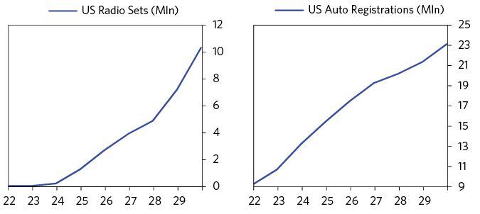

In the midst of that technology boom, the early part of the cycle (roughly from 1922 to 1927) saw strong economic growth and subdued inflation. The broader period became known as the “fat years,” as both capitalists and workers experienced significant gains.3 Corporate profits rose to postwar highs, unemployment dropped to postwar lows, and real wages rose more than 20 percent. In the pre-bubble years of 1923 to 1926, debt growth was appropriately in line with income growth because it was being used to finance activities that produced fast income growth. At the same time, the stock market roared higher while experiencing little volatility—investors in US stocks made over 150 percent between the start of 1922 and the end of 1927. The hottest tech stocks at the time—Radio Corporation of America (known to traders as “Radio”) and General Motors—led the gains.4

Then a bubble began to emerge. As is classic, the bubble had its roots in the dizzying productivity and technological gains of the period and people making leveraged bets that they would continue. One writer explained the growing belief that the economy had entered a “New Era:” “The New Era…meant permanent prosperity, an end to the old cycle of boom and bust, steady growth in the wealth and savings of the American people, [and] continuously rising stock prices.”5

The US was an extremely attractive destination for investment from abroad. The US and most of the rest of the world were on a gold standard at the time, which meant governments promised to exchange their money for gold at a fixed exchange rate in order to provide assurance to lenders that they wouldn’t just print a lot of money and devalue lenders’ claims. Gold flowed from other countries to the US, because that was effectively how investors bought dollars. This played an important role in determining how events transpired during the lead-up to the crash in 1929, but we won’t get into that now.

When other countries (France, Germany, and the UK) became worried that they were losing gold too quickly, they asked the US Federal Reserve to lower dollar interest rates to make dollars less attractive. More focused on growth and inflation than on the debt growth that was being used to buy financial assets, in the spring of 1927, the Federal Reserve Board cut its discount rate from 4 percent to 3.5 percent. This, of course, had the knock-on effect of encouraging US credit creation. This is a typical way that central banks inadvertently finance bubbles.

The economy accelerated in response to the easing, and news of the strong economy filled headlines and radio broadcasts nationwide. Over the second half of 1928, industrial production rose 9.9 percent and automobile production hit an all-time high. The boom made people euphoric. At the start of 1929, The Wall Street Journal described the pervasive strength of the US economy: “One cannot recall when a new year was ushered in with business conditions sounder than they are today… Everything points to full production of industry and record-breaking traffic for railroads.”6

The easing by the Federal Reserve also produced a bull market in stocks that showed every sign of a classic bubble. I’ll repeat my defining characteristics of a bubble:

1. Prices are high relative to traditional measures
2. Prices are discounting future rapid price appreciation from these high levels
3. There is broad bullish sentiment
4. Purchases are being financed by high leverage
5. Buyers have made exceptionally extended forward purchases (e.g., built inventory, contracted forward purchases, etc.) to speculate or protect themselves against future price gains
6. New buyers (i.e., those who weren’t previously in the market) have entered the market
7. Stimulative monetary policy helps inflate the bubble, and tight policy contributes to its popping

After prices nearly doubled over 1927 and 1928, stocks sold at extremely high multiples financed by borrowing (i.e., margin). Many stocks were valued as much as 30 times earnings.7 The popular book New Levels in the Stock Market, published in 1929 by Ohio State professor Charles Amos Dice, captured the pervasive sentiments of the bull market. He argued that the broader base of investors in the market made higher valuations more or less permanent, proclaiming, “Among the yardsticks for predicting the behavior of stocks which have been rendered obsolete…[is] the truism that what goes up must come down.”8

New buyers flooded the market, and many of them were unsophisticated investors with no prior experience with stocks, one of the classic signs of a bubble. Brokerage firms rapidly expanded to cater to aspiring speculators across the country; the number of branch offices outside of Wall Street increased by more than 50 percent between 1928 and 1929.9 “Wherever one went,” a broker declared in 1929, “one met people who told of their stock-market winnings. At dinner tables, at bridge, on golf links, on trolley cars, in country post offices, in barber shops, in factories and shops of all kinds.”10

During this period, stock purchases were financed by high and rapidly increasing leverage, and more and more of this leverage occurred outside the regulated and protected banking system. Classically, new and fast-growing lending markets where a lot of levering up occurs are symptomatic of bubbles. Often, banks are able to make these new assets seem safe to investors via guarantees, or through the way the assets are combined and packaged—and without a crisis to stress-test them, it can be hard to tell how safe they actually are. These “innovations” typically lead to the next crisis if not monitored, understood, and managed by regulators. The bankers and the speculators made a lot of fast money in a symbiotic relationship (i.e., the bankers would lend to the speculators at fat spreads and the speculators would buy stocks on leverage, pushing them up and making money). In 1929, call loans and investment trusts were the fastest-growing channels for increasing leverage outside the banking system.11

The call loan market, a relatively new innovation, developed into a huge channel through which investors could access margin debt. The terms of call loans adjusted each day to reflect market interest rates and margin requirements, and lenders could “call” the money at any time, given the one-day term. Call loans created asset/liability mismatches among lenders and borrowers, since borrowers were using short-term debt to fund the purchases of risky long-term assets, and lenders were lending to riskier borrowers who were willing to pay higher interest rates. One of the classic ingredients of a debt crisis is the squeezing of lenders and borrowers who have debt/liability mismatches that they took on during the bubble.

A new group of investors entered the call loan market to lend to the crowd of speculators. Because interest rates on call loans were higher than other short-term rates and lenders could “call” back their money on demand, call loans became popular as a safe place for companies to invest their extra cash.12 Foreign capital also poured in from places like London and Hong Kong. As a historian later described it, “A great river of gold began to converge on Wall Street, all of it to help Americans hold common stock on margin.”13 The share of funds in the call loan market that were coming from lenders outside the Federal Reserve System (i.e., non-banks and foreigners) rose from 24 percent at the start of 1928 to 58 percent in October 1929.14 This added risk to the market, since the Federal Reserve couldn’t lend to these non-banks if they needed liquidity in a squeeze.

The charts below show the explosion in margin debt through the bubble and the accompanying rise in prices.

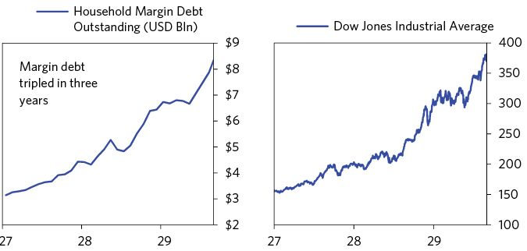

Investment trusts were another financial innovation that saw rapid growth during the bubble and helped draw new speculators into the market. First originated and popularized in Great Britain, investment trusts were companies that issued shares and invested the proceeds in the shares of other companies.15 The well-known economist Irving Fisher praised the “wide and well-managed diversification” that trusts provided investors who lacked sufficient capital to buy shares in multiple companies.16 As the stock market boomed, the number of trusts exploded. By 1929, new trusts were launching at a rate of nearly five per week, and these offerings were taking in one-third of the new capital raised.17

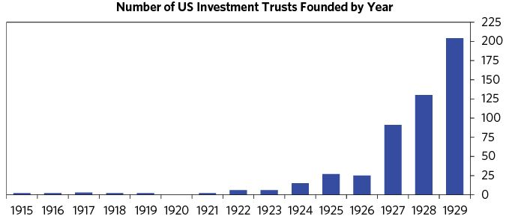

Promoters of trusts claimed that their diversification made the financial system safer. However, the use of leverage by many trusts to amplify returns in the bubble created risk for investors. And many speculators, unaware of the nature of the securities and believing that the recent past would continue, amplified this risk by taking out margin loans to lever up already-levered trust shares.18

As stock prices soared, speculators continued to lever up and make huge profits, attracting more buyers into the market to do the same. The more prices increased, the more aggressively speculators bet that they would increase still more.

At the same time, supplies of stocks were increasing as the higher prices encouraged their production.19 During this phase of the bubble, the more prices went up, the more credit standards were lowered (even though it would have been logical for the opposite to happen), as both lenders and borrowers found lending and buying stocks with borrowed money to be very profitable.

The leveraging was mostly taking place in the “shadow banking” system; banks at the time by and large did not look over-leveraged. In June 1929 banks looked much healthier than they had prior to the 1920–1921 recession: not only were they posting record earnings, their capital ratios were higher (17.2 percent versus 14.9 percent) and their liabilities were stickier, as time deposits made up a greater share of their liabilities (35.7 percent versus 23.3 percent).20 A series of large bank mergers during 1929 were viewed as a further source of strength by analysts.21 Classically, bank earnings and balance sheets look healthy during the good times because the assets are highly valued and the deposits that back them are there. It’s when there’s a run on deposits and the assets fall in value that banks have problems.

While the Federal Reserve governors debated the need to restrain the rapid lending that was fueling stock speculation, they were hesitant to raise short-term interest rates because the economy wasn’t overheating, inflation remained subdued, and higher interest rates would hurt all borrowers, not just speculators.22 Typically the worst debt bubbles are not accompanied by high and rising inflation, but by asset price inflation financed by debt growth. That is because central banks make the mistake of accommodating debt growth because they are focused on inflation and/or growth—not on debt growth, the asset inflations they are producing, and whether or not debts will produce the incomes required to service them.

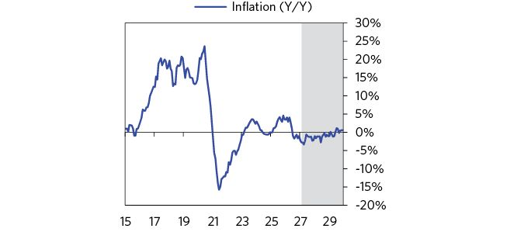

Rather than raising its discount rate, the Fed enacted macroprudential (i.e., regulatory) measures aimed at constraining the supply of credit via banks. Some of these regulatory measures included lowering the acceptance rate for loans and increasing supervision of credit facilities.23 The Fed publicly released a letter it had written to regional banks, deriding the “excessive amount of the country’s credit absorbed in speculative security loans” and threatening that banks attempting to borrow money from the Fed in order to fund such loans might be refused.24 But these policies were largely ineffective.

## Late 1929: The Top and the Crash

### Tightening Pops the Bubble

In 1928, the Fed started to tighten monetary policy. From February to July, rates had risen by 1.5 percent to five percent. The Fed was hoping to slow the growth of speculative credit, without crippling the economy. A year later, in August 1929, it raised rates again, to six percent. As short-term interest rates rose, the yield curve flattened and inverted, liquidity declined, and the return on holding short duration assets such as cash increased as their yields rose. As loans became more costly and holding cash became more attractive than holding longer duration and/or riskier financial assets (such as bonds, equities, and real estate), money moved out of financial assets, causing them to fall in value. Declining asset prices created a negative wealth effect, which fed on itself in the financial markets and fed back into the economy through declining spending and incomes. The bubble reversed into a bust.

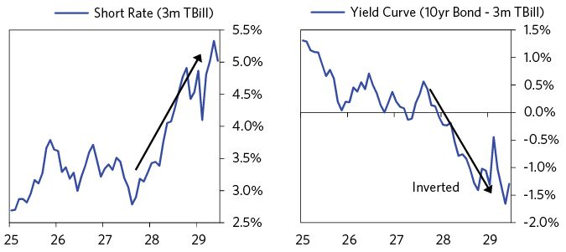

It was the tightening that popped the bubble. It happened as follows:

The first signs of trouble appeared in March 1929. News that the Federal Reserve Board in Washington was meeting daily, but not releasing details of the meetings, sparked rumors on Wall Street that a clampdown on speculative debt was coming.25 After two weeks of modest declines and reports of an unusual Saturday meeting of the Reserve Board, the stock market broke sharply lower on March 25 and then again on March 26. The Dow fell over four percent and the rate on call loans reached 20 percent as panic gripped the market. Trading volumes reached record levels.26 A wave of margin calls on small leveraged investors resulted in forced selling that exacerbated the decline. After the Federal Reserve Board chose not to act, National City Bank president Charles Mitchell (who was also a director of the New York Fed) announced that his bank stood ready to lend $25 million to the market.27 This calmed the market, rates fell, and stocks rebounded. Stocks resumed their gains, but this foreshadowed the vulnerability of stocks to tightening in the credit market.

While growth had moderated somewhat, the economy remained strong through the middle of 1929. The June Federal Reserve Bulletin showed that industrial production and factory employment remained at all-time highs through April, and that measures of construction had rebounded sharply after falling through the first quarter.28

After another short-lived sell-off in May, the rally accelerated and the bubble reached the blow-off phase. Stocks rose about 11 percent in June, five percent in July, and ten percent in August. This rally was supported by accelerating leverage, as household margin debt rose by more than $1.2 billion over the same three months.

Money continued to tighten. On August 8, the Federal Reserve Bank of New York raised its discount rate to 6 percent,29 as it became clear that macroprudential measures had failed to slow speculative lending. At the same time, concerns about the high stock prices and interest rates caused brokers to tighten their terms in the call loan market and raise margin requirements. After dropping them as low as 10 percent the previous year, margin requirements at most brokers rose to 45 to 50 percent.30

The stock market peaked on September 3 when the Dow closed at 381—a level that it wouldn’t reach again for over 25 years.

It’s important to remember that no specific event or shock caused the stock market bubble to burst. As is classic with bubbles, rising prices required buying on leverage to keep accelerating at an unsustainable rate, both because speculators and lenders were near or at their max positions and because tightening changes the economics of leveraging up.

Stocks started to decline in September and early October as a series of bad news stories eroded investor confidence. On September 5, statistician Roger Babson delivered a speech to the National Business Conference that warned about a collapse in prices due to “tight money.” A 2.6 percent sell-off followed that became known as the “Babson break.” On September 20, the collapse of Clarence Hatry’s London financial empire on fraud charges jolted markets and forced some British investors to raise funds by selling their American holdings.31 On September 26, the Bank of England raised its discount rate from 5.5 percent to an eight-year high of 6.5 percent and a few European nations followed suit.32

Together, by mid-October, these events contributed to a 10 percent sell-off in the markets from their highs. The view among investors and columnists in the major papers was largely that the worst was over and the recent volatility had been good for the market. On October 15, economist Irving Fisher proclaimed that “Stocks have reached what looks like a permanently high plateau.”33

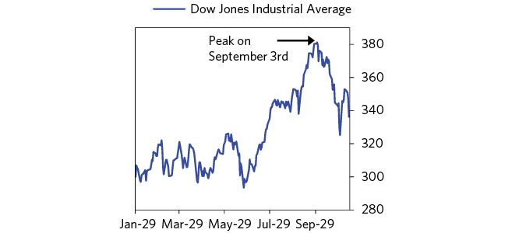

### The Stock Market Crashes

Then the bottom of the market fell out. Since so much happened each day during this period, and to give you a granular understanding, I will transition into a nearly day-by-day account, conveying it via both my own description and in the newsfeed.

Stocks fell sharply on Saturday, October 19, which saw the second-highest trading volume ever in a Saturday session and the decline became self-reinforcing on the downside. A wave of margin calls went out after the close, which required those who owned stocks on leverage to either put up more cash (which was hard to come by) or sell stocks, so they had to sell stocks.34 Sunday’s New York Times headline read, “Stocks driven down as wave of selling engulfs the market.”35 Still, traders widely expected that the market would recover when it opened again on Monday. Over the weekend, Thomas Lamont of J.P. Morgan, looking at the economy, wrote to President Herbert Hoover that the “future appears brilliant.”36

The week of October 21 began with heavier selling. One analyst described Monday’s waves of sell orders as “overwhelming and aggressive.”37 Trading volume again broke records. Another wave of margin calls went out and distressed selling among levered players was prevalent.38 But markets rallied into the end of Monday’s session, so losses were smaller on Monday than they’d been on Saturday.

Tuesday’s session saw small gains and Wednesday’s opened quietly. But any hopes that the worst had passed were shattered before the market closed on Wednesday. An avalanche of sell orders in the last hour of trading pushed stocks down sharply, which triggered a fresh round of margin calls and more forced selling.39 The Dow suffered what was then its largest one-day point loss in history, falling 20.7 points (6.3 percent) to close at 305.3.

Because the sell-off was so sharp and came so late in the day, an unprecedented number of margin calls went out that night, requiring investors to post significantly more collateral to avoid having their positions closed out when the market opened on Thursday.40 Many equity holders would be required to sell.

Everyone who worked on the exchange was alerted to be prepared for the big margin calls and sell orders that would come Thursday morning. Policemen were posted throughout the financial district in the event of trouble. New York Stock Exchange Superintendent William R. Crawford later described “electricity in the air so thick you could cut it” before the open.41 Then the collapse and panic came.

After a quieter opening, the avalanche of selling materialized and panic took hold of the market.42 Sell orders poured in from across the country, pushing down prices and generating new margin calls, which in turn pushed down prices even more. The pace of selling was so frantic that operators struggled to keep up. One exchange telephone clerk captured the scene well: “I can’t get any information. The whole place is falling apart.”43 Rumors of failures swirled and as news spread, huge crowds formed in the financial district.44 By noon of what would become known as Black Thursday, the major indices were down more than 10 percent.

Around midday, a small group of the biggest bankers met at the offices of J.P. Morgan and hatched a plan to stabilize the market. “The Bankers’ Pool,” as they were known, committed to buy $125 million in shares. Early in the afternoon, traders acting on behalf of the bankers began to place large buy orders above the most recent price.45 As news of the plan spread, other investors began to buy aggressively in response and prices rose. After hitting a low of 272 (down 33), the Dow Jones Industrial Index bounced back to close at 299, down only six points for the day.46 But as it turned out, this would just be the first of many failed attempts to bolster the market. Below is the New York Times front page from the next day:

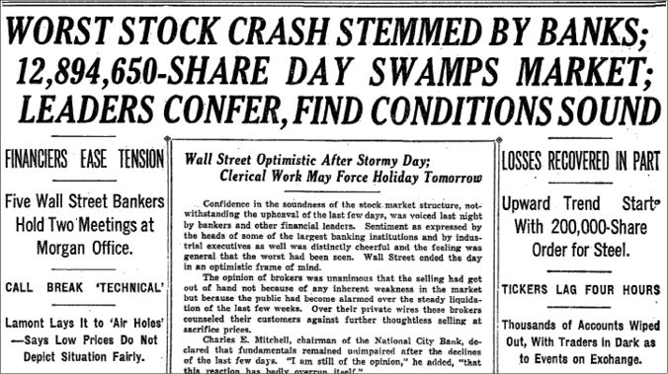

From the New York Times, 25 Oct © 1929 The New York Times. All rights reserved. Used by permission and protection by the Copyright Laws of the United States. The printing, copying redistribution, or retransmission of this Content without express written permission is prohibited.

After the market closed on Thursday, a group of about 35 brokers began organizing a second effort to stabilize the market. Believing that the worst had passed, they took out a full-page ad in the New York Times for Friday, confidently telling the public that it was time to buy.47 That same day, President Hoover declared, “The fundamental business of the country, that is, production and distribution of commodities, is on a sound and prosperous basis.”48 Stocks were steady through the rest of the week, and the Sunday papers again showed optimism that the cheapness of stocks would support a rebound in the coming week.49

But the collapse and panic resumed on Monday the 28th as a flood of sell orders came in from all types of investors. Notably, significant selling came from brokers whose loans from corporations were suddenly called amid the panic.50 Trading volume set another record as 9 million shares changed hands over the course of the day (3 million in the last hour of trading)51 and the Dow finished down 13.5 percent—its largest one-day loss in history—on what became known as Black Monday. The Bankers’ Pool met again after the market closed, stirring optimism, but announced no additional buying measures.52

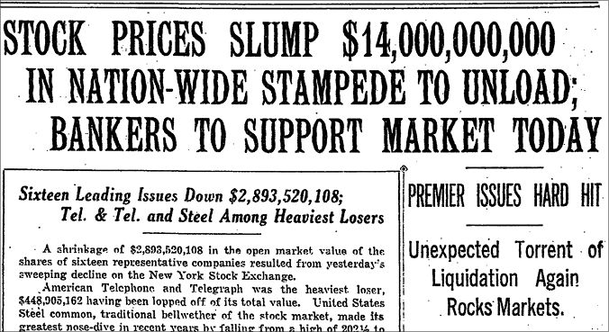

From the New York Times, 29 October © 1929 The New York Times. All rights reserved. Used by permission and protection by the Copyright Laws of the United States. The printing, copying redistribution, or retransmission of this Content without express written permission is prohibited.

Another massive wave of margin calls went out Monday night and $150 million of call loans had been pulled from the market before Tuesday’s open.53 The Federal Reserve attempted to counter the collapse in credit by providing liquidity. After a 3 a.m. meeting with his directors, New York Fed president George Harrison announced before the market opened that the Fed would inject $100 million in liquidity to ease the credit crunch in the money market by purchasing government securities. Harrison needed approval from the Fed Board in Washington, but he didn’t want to wait; instead he made the purchases outside the regular Open Market Investment Committee account.54 Classically the checks and balances designed to ensure stability during normal times are poorly suited for crisis scenarios where immediate, aggressive action is required. In the late 1920s, there were few well-established paths for dealing with the debt implosion and its domino effects.

While the Fed’s liquidity eased credit conditions and likely prevented a number of failures, it wasn’t enough to stop the stock market’s collapse on what became known as Black Tuesday. Starting at the open, large blocks of shares flooded the market and pushed prices down.55 A rumor that the Bankers’ Pool had shifted to selling fed the panic.56 The members of the New York Stock Exchange met at noon to discuss closing the exchange, before deciding against it.57 The investment trusts were hit especially hard as the leverage that buoyed returns through the bubble started to work in reverse. Goldman Sachs Trading Corporation fell 42 percent and Blue Ridge was at one point down as much as 70 percent before recovering somewhat.58 The Dow closed down 11.7 percent, the second worst one-day loss in history. The market had fallen by 23 percent over two days and problems with leveraged speculators and their lenders were already starting to emerge.

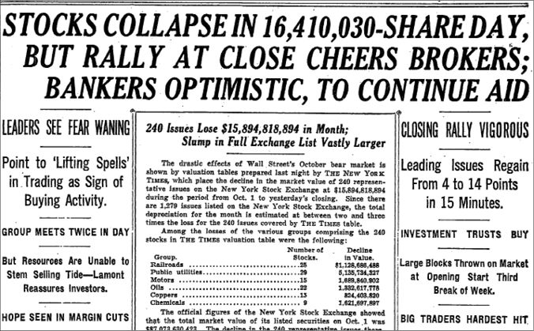

From the New York Times, 30 October © 1929 The New York Times. All rights reserved. Used by permission and protection by the Copyright Laws of the United States. The printing, copying redistribution, or retransmission of this Content without express written permission is prohibited.

Stocks snapped back on Wednesday, rising 12.3 percent in one of the sharp bear market rallies that classically occur repeatedly during the depression phases of big debt crises. Following the rally, the NYSE announced that trading would begin at noon the next day and that the exchange would be closed on the following Friday and Saturday in order to catch up on paperwork.59

Both the Fed and the Bank of England cut rates on Thursday. The Fed dropped its bank rate from 6 percent to 5 percent in coordination with the Bank of England’s move to decrease its discount rate from 6.5 percent to 6 percent.60 Traders also cheered the news that call loans outstanding had fallen by more than $1 billion from the prior week. Believing that the worst of the forced selling had passed, markets rallied again.

But speculators looking to capitalize on the prior week’s rally raced to sell when the market opened on Monday and stocks plunged again. By Wednesday, the Dow was down 15 percent on the week. Stocks continued to fall the following week as well.

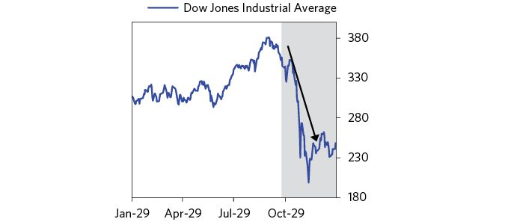

Railroad bonds and other high-grade bonds performed well during the crash, as investors sought safer investments after pulling back from stocks and call loans. At the same time, the yields between high-grade and lower-grade corporate bonds (rated BAA and below) reached their widest level in 1929, so the riskier corporate bonds were flat to down. That sort of market action—equities and bonds with credit risk falling and Treasury and other low credit risk assets rising—is typical in this phase of the cycle.

Naturally the financial and psychological impacts of the stock market plunge began to hurt the economy. As is typical, politicians and business leaders continued to talk up the strength of the economy, but stats showed weakness. Industrial production had peaked in July. More timely measures of freight car loading and steel utilization released the week of November 4 showed ongoing declines in economic activity. Sharp drops in commodity markets added to these worries. By mid-November, the Dow was down almost 50 percent from its September peak.

### Policy Responses to the Crash

Although the Hoover Administration’s handling of the market crash and economic downturn is now often criticized, its early moves were broadly praised and helped drive a meaningful stock rally. On November 13, President Hoover proposed a temporary one percent reduction in the tax rate for each income bracket and an increase to public construction spending of $175 million.61 Two days later, Hoover announced his plan to invite a “small preliminary conference of representatives of industry, agriculture and labor” to develop a plan for fighting the downturn.62 When they convened the following week, Hoover solicited pledges from business leaders to not cut spending on capital investment or wages, and from labor union leaders to not strike or demand higher wages.63 On December 5, Hoover convened a conference of 400 of the most reputable businessmen at the time, which in turn created a leadership committee of 72 of the top business tycoons of the 1920s headed by the Chairman of the US Chamber of Commerce.64 This mix of policies was successful for a time, as was Hoover’s support for the Federal Reserve System’s efforts to ease credit.

As mentioned, the New York Fed aggressively provided liquidity during the crash. Within a month, it cut its discount rate from 6 percent to 5 percent and then cut it again, to 4 ½ percent.

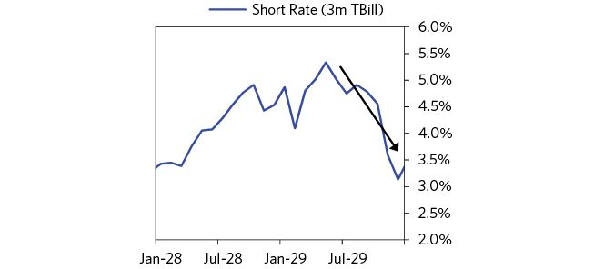

These policy moves combined with other steps by the private sector to support the stock market, most notably John D. Rockefeller’s bid for one million shares of Standard Oil Co. at $50 on November 13 (effectively flooring the price at $50).65 On November 13, the market bottomed and began what was to be a 20 percent rally going into December. A sense of optimism took hold.

## 1930–1932: Depression

By New Year’s Day of 1930 it was widely believed that the stock market’s 50 percent correction was over, which helped drive a strong rebound in the first four months of the year.66 Stocks seemed cheap because there wasn’t much evidence yet that company earnings would fall much, and investors were biased by their memories of the most recent downturns (e.g., in 1907 and 1920). In both cases, the worst was over after a correction of about 50 percent, and most assumed that events would play out similarly this time.

Helping to fuel the optimism, policy makers continued to take steps to stimulate the economy. The Fed cut rates to 3.5 percent in March, bringing the total rate cuts to 2.5 percent in just five months (sparking debate within the Fed over whether it was too much stimulation and risked weakening the dollar).67 On March 25, Congress passed two appropriation bills for state road building and construction projects, bringing the total fiscal stimulus to about 1 percent of GDP.68

The consensus among economists, including those at the American Economic Association and the Federal Reserve, was that the simulative policy moves would be enough to support an economic rebound. On January 1, the New York Times captured how sentiment had shifted since the crash, noting, “Lack of widespread commercial failures, the absence of serious unemployment, and robust recovery in the stock market have been factors calculated to dispel the gloominess.”69 As a further sign of optimism, banks were actually expanding their investments through 1930; member banks’ holdings of foreign, municipal, government, and railroad bonds all rose.70

By April 10, the Dow had rallied back above 290. But despite stimulation and general optimism, economic weakness persisted. First quarter earnings were disappointing, and stocks began to slide starting in late April. In the early stages of deleveragings, it’s very common for investors and policy makers to underestimate how much the real economy will weaken, leading to small rallies that quickly reverse, and initial policy responses that aren’t enough.

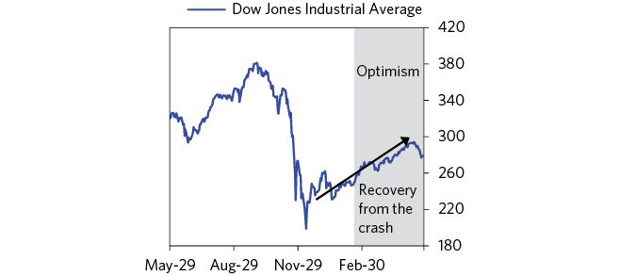

Over the second half of 1930, the economy clearly began to weaken. From May through December, department store sales fell 8 percent and industrial production fell 17.6 percent. Over the course of the year, the rate of unemployment rose by over 10 percent (to 14 percent) and capacity utilization fell by 12 percent (to 67 percent). Housing and mortgage debt collapsed. Still, at that point, the decline in the economy was more akin to a shallow recession. For example, levels of consumer spending remained above the lows of previous recessions and many industries were not yet suffering from severe declines. The charts below show how both department store sales and industrial production had slipped but had not yet collapsed to the lows of the prior recession (the gray bars highlight 1930).

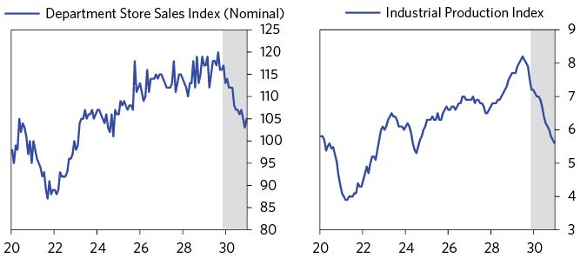

As the economy weakened, the sell-off across markets resumed. Stocks ended the period on a low note: By October of 1930, the stock market had fallen below the lows reached in November 1929. Commodities also fell sharply. Market analysts and investors alike were realizing that their hopes for a quick recovery would not materialize.71 But Hoover remained optimistic.

Although the Federal Reserve decreased interest rates and the Treasury bond market was strong, spreads continued to widen. This increased the interest rates facing most consumers and businesses. For example, rates rose on long-term mortgage loans, and the yields on municipal bonds, which had performed well following the crash, began to rise as credit anxieties developed. Some industries were hit particularly hard by the worsening credit conditions. Railroads had large amounts of debts they needed to roll, and were facing both tighter credit conditions and decreased earnings.72 Because railroads were considered a vital industry, the government wanted to support them, likely with a bailout. (The railroad industry’s circumstances in this period parallel the struggles the auto industry faced in the 2008 financial crisis.)

### Rising Protectionism

As is common in severe economic downturns, protectionist and anti-immigrant sentiment began to rise. Politicians blamed some of the weakness on anti-competitive policies by other countries, and posited that higher tariffs would help reverse the slump in manufacturing and agriculture, while restricting immigration would help the economy deal with unemployment.73

Protectionist sentiment resulted most notably in the passage of the Smoot-Hawley Tariff Act, which imposed tariffs on nearly 20,000 US imports. Investors and economists alike feared that the proposed 20 percent increase in tariffs would trigger a global trade war and cripple an already weak global economy.74 As the act neared passage in early May, a group of 1,028 economists issued an open letter to Hoover imploring him to veto the bill if it passed in Congress.75 Foreign governments also expressed opposition and hinted at retaliation.76 However, tariffs—particularly on agricultural imports—were one of Hoover’s campaign promises, so he was reluctant to renege even as the pushback against the Smoot-Hawley tariffs became more intense.77

Stocks sold off sharply as it became clear the tariff bill would pass. After falling 5 percent the previous week, the Dow dropped another 7.9 percent on June 16, the day before the tariff bill passed. The following chart shows the average tariff rate charged on US imports going back to the 1800s. While tariffs have sometimes increased during periods of economic downturn, Smoot-Hawley pushed tariffs to near-record levels.78

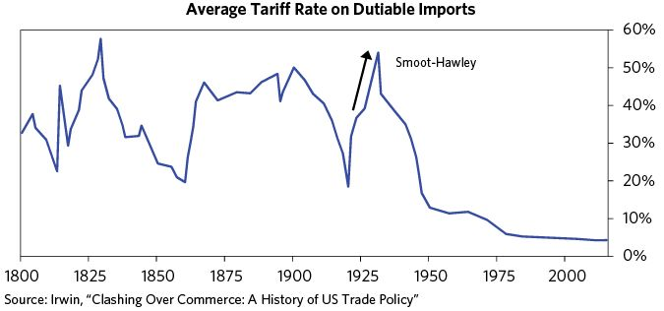

Soon the US faced a wave of retaliatory protectionist policies. The most impactful initial response came from the US’s largest trading partner, Canada, which at the time took in 20 percent of American exports. Canadian policy makers increased tariffs on 16 US goods while simultaneously lowering tariffs on imports from the British Empire.79 As similar policies piled up in the years that followed, they accelerated the collapse in global trade caused by the economic contraction.

Restricting immigration (both legal and illegal), another common protectionist response to economic weakness, was also pursued by the Hoover administration in 1930. On September 9, Hoover put a ban on immigration, allowing travel only for tourists, students, and working professionals, describing the policy as necessary to deal with unemployment. He later reflected in his memoir his view that, “directly or indirectly all immigrants were a public charge at the moment—either they themselves went on relief as soon as they landed, or if they did get jobs, they forced others onto relief.”80

### Bank Failures Begin

Banks had largely held up well following the stock market crash, but as those they lent to were hurt by the crash and the economy weakened, they began to feel it. In 1930, bank net earnings declined about 40 percent compared to the prior year, but they remained on sound footing.81 Several of the largest banks even increased their dividends. They looked strong at the time compared to the markets and the economy, and many analysts believed that they would be a source of support through the downturn.82 The majority of early failures were confined to banks in the Midwest and country banks that had a lot of money in real estate loans, and were exposed to losses from a drought.83 While the failures started small, they spread as credit problems spread.

By December, 1930 bank failures had become a meaningful risk to the broader economy. Worries about the banks led to runs on them. Runs on non-guaranteed financial institutions are classic in such depressions/deleveragings, and they can lead to their failure in a matter of days.

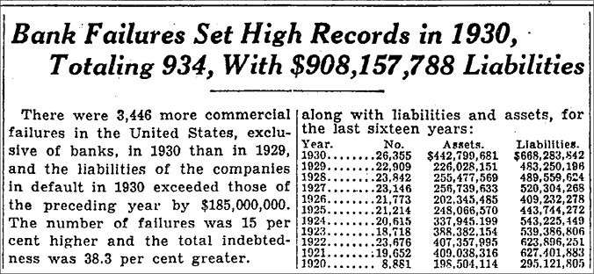

From the New York Times, 11 January © 1931 The New York Times. All rights reserved. Used by permission and protection by the Copyright Laws of the United States. The printing, copying redistribution, or retransmission of this Content without express written permission is prohibited.

Before I get into the banking failures, it’s important to discuss the gold standard, since it played an important role in determining how the 1930s debt crisis transpired. As I described in prior sections of the book, when debts are denominated in one’s own currency, deleveragings can generally be managed well. Being on a gold standard is akin to having debts denominated in a foreign currency because creditors could demand payment in gold (as was often written into contracts), and policy makers couldn’t freely print money, as too much printing would lead people to redeem their money for gold. So policy makers were working with a limited toolkit until they broke the link to gold.

The most important bank failure of this period was that of the Bank of the United States, which had some 400,000 depositors, more than any bank in the country at the time.84 The run on it began on December 10 because of a false rumor. Wall Street financiers—including the heads of J.P. Morgan and Chase—met at the New York Fed to determine whether they should provide the $30 million that was required to save the bank. Many within the group thought that the bank was insolvent, not simply illiquid, so they should let it fail.85 New York Superintendent of Banks Joseph Broderick argued that its closing “would result in the closing of at least ten other banks in the city and … it might even affect the savings banks” (e.g., it was systemically important). He also noted that he believed the bank to be solvent.86 Broderick’s colleagues ultimately did not agree with him. When the bank closed its doors the next day, it was the biggest single bank failure in history.87 The New York Times would later refer to its failure as “The First Domino In the Depression.”88 It was certainly a turning point for public confidence in the nation’s banking system.

Banks are structurally vulnerable to runs because of the liquidity mismatch between their liabilities (i.e., short-term deposits) and assets (i.e., illiquid loans and securities), so even a sound bank can fail if it can’t sell its assets fast enough to meet its liabilities. Because of the gold standard, the Federal Reserve was restricted in how much it could print money, limiting how much it could lend to a bank facing liquidity problems (i.e., act as a “lender of last resort”). There were also legal constraints. For instance, the Fed at the time was only allowed to give direct access to its credit to member banks, but only 35 percent of commercial banks were members.89 So banks would often have to borrow from the private sector and sell their assets in a “fire sale” to avoid failure.

The end of 1930 also saw the political winds beginning to shift. With the downturn playing prominently in voters’ minds, the Democrats swept Congress in the November mid-term elections. This foreshadowed FDR’s win in the presidential election two years later.90

### First Quarter, 1931: Optimism Gives Way to Gloom as Economy Continues to Deteriorate

At the start of 1931, economists, politicians, and other experts in both the US and Europe still retained hope that there would be an imminent return to normalcy because the problems still seemed manageable. The bank failures of the previous quarter were thought to be inconsequential, and not damaging to the overall financial system.

By March, all business indexes were pointing to a rise in employment, wages, and industrial production. Bank runs led to a less than 10 percent drop in deposits.91 The news reflected growing economic confidence: on March 23, the New York Times declared that the depression had bottomed, and the U.S. economy was on its way back up.92 New investment trusts were being formed to profit from the expected “long recovery.”93

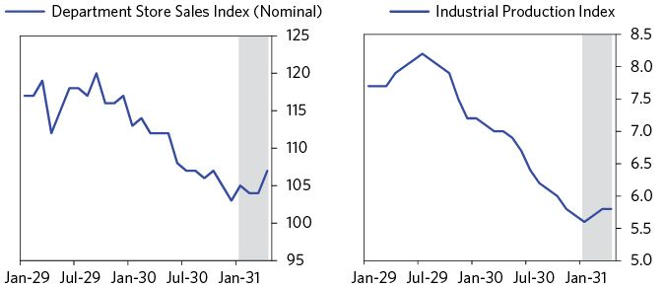

Optimism was also bolstered by the recovery of the stock market. Through the end of February, the Dow rose more than 20 percent off its December lows. The following chart illustrates the index’s rise.

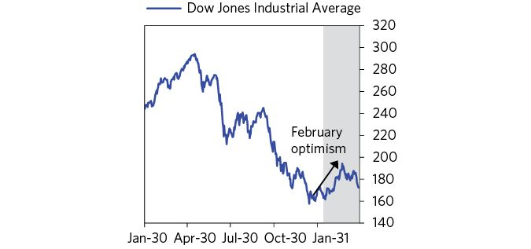

But the rally wasn’t sustained. Growing concerns over Europe and indications of weak first quarter earnings caused stock prices to slip through March and end the quarter at 172.4, down 11.3 percent from their February highs.

### The Growing Debate over Economic Policy

In a depression, the main ways that politics might play a role are by standing in the way of the implementation of sensible economic policies or by leading to extreme policies. These are important risks that can make a depression worse.

After more than a year of economic contraction, the political debate over economic policy was intensifying. By this time, more than six million people were unemployed in the United States and there was no agreement among policy makers and business leaders on how to deal with it.94 Understanding this debate is key to understanding why policy makers took certain steps that ultimately worsened the crisis. It also helps illustrate many of the classic mistakes policy makers make when handling big debt crises.

The fiscal policy debate centered on whether or not the Federal government should significantly ramp up spending to support the economy. Senate Democrats, joined by some Republicans, pushed the President to increase “direct relief” for those facing particularly difficult circumstances. That would of course mean larger deficits and more debt, and it would mean changing the rules of the game to shift wealth from one set of players to others, rather than letting the game play out in a way that would provide good lessons to help prevent such problems in the future (i.e., the moral hazard perspective). There was also a strong belief that, if this money was just given away and not turned into productivity, it would be wasted. So while the Hoover administration had supported earlier fiscal stimulus, it opposed significant direct relief from the Federal government that would “bring an inevitable train of corruption and waste such as our nation had never witnessed.” Hoover’s administration instead advocated for what he called “indirect relief”—a mix of policies that included lobbying the private sector to invest and keep employment steady, reliance on aid from state and local governments, immigration restrictions, and macroprudential policies to encourage lending.95

While concerns over budget deficits limited stimulus spending, by 1931, the federal government budget deficit grew to 3 percent of GDP. The deficit was due to falling tax revenue, which had collapsed to nearly half of 1929 levels, and an increase in social spending of about $1 billion that had been approved the previous year. Treasury Secretary Mellon believed that balancing the budget was a necessary first step to restore business confidence.96 Hoover agreed for reasons he later summarized in his memoir: “National stability required that we balance the budget.”97

Worries over the deficit and a push for austerity are classic responses to the depression phase of a big debt crisis. Austerity seems like the obvious response, but the problem is that one person’s spending is another person’s income, so when spending is cut, incomes are also cut, with the result that it takes an awful lot of painful spending cuts to make significant reductions in debt/income ratios.

For all the suffering that the Depression had caused, a sense of crisis-driven urgency hadn’t yet developed. The economy was still contracting over the first half of 1931, but at a slower rate than the year before. Hoover was certain that indirect relief was meeting the needs of the people and he did not see the need to use additional fiscal supports.98 As we’ll discuss later, this ultimately tipped the debate, and the Hoover administration to make the classic rookie mistake of leaning too heavily on austerity and other deflationary levers relative to more stimulative policies until the pain of doing these things became intolerable.

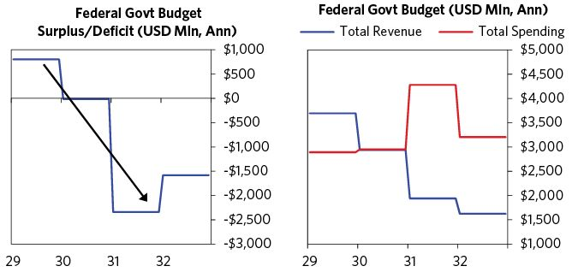

### Second Quarter, 1931: The Global Dollar Shortage Causes a Global Debt Crisis and a Strong Dollar

Because dollar-denominated credit was collapsing and a lot of dollar-denominated debt that required dollar credit to service it existed around the world, a global dollar shortage emerged during the first half of 1931. Classically, there is a squeeze in a reserve currency that is widely lent by foreign financial institutions when there is a collapse of credit creation in that currency. Although other currencies faced a shortage amid the credit crunch, the dollar was particularly impacted because of its role as a global funding currency. At the same time, falling US imports reduced foreigners’ dollar income, intensifying the squeeze. Note that virtually the same dollar squeeze dynamics occurred in the 2008 crisis for the same reasons.

As the financial markets and many other markets are global, one can’t understand all that happened by looking only at the US. What happened in the US had a big impact on what happened in Germany, which led to big political changes that were felt around the world in the 1930s and early 1940s. In 1931 Germany was the epicenter of the emerging dollar squeeze. It had previously faced great difficulty paying back the reparation debt it owed and had been forced to borrow as a result. The country had become a popular destination for the “carry trade,” in which investors would lend their dollars to Germany to earn a higher yield than they would get in dollars and Germans would borrow in dollars to get the lower interest rate. Once again, this type of behavior is classic in the “good times,” when there is little perceived risk and large cross-country credit creation, and sets up the conditions that make the “bad times” worse when the reversal happens. At the time, Germany was highly dependent on this flow of money that could easily be pulled, and by 1931, American banks and companies held about a billion dollars in short-term German bills (equal to about six percent of German GDP).99 That made both the German borrowers and the American banks and companies very vulnerable.

Also, as is typical in such times, economies and wealth disparities fuel the rise of populist and extremist leaders globally, with the ideological fight between the authoritarian left and the authoritarian right. Both the German Communist party and Hitler’s Nazi party made big electoral gains as the German economy struggled—with the Nazis going from under 3 percent support in the 1928 Reichstag elections to over 18 percent in September 1930. Meanwhile, the largest party (center left Social Democratic Party) slipped to less than a quarter of Reichstag seats.100 Together, the far right and far left parties easily had enough parliamentary support to force Germany into an unstable multi-party coalition government. Germany was essentially becoming ungovernable.

The global trade war made economic conditions and the dollar squeeze worse. The collapse in global trade depressed foreigners’ dollar income, which in turn made it harder for foreigners to service their dollar debts. As shown below, US imports in dollars had fallen by about 50 percent from 1929 to 1931.

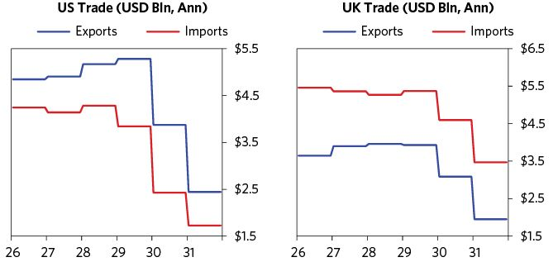

In a warning that would be echoed by global politicians and business leaders in the coming months, the president of Chase National Bank acknowledged in the August 1931 issue of Time magazine that companies’ inability to obtain enough dollars to cover their debts was heavily affecting business. As such, he stressed the necessity for the US government to reduce debts owed to them from abroad.

The shortage of dollars made borrowing more expensive, creating a liquidity squeeze in central Europe. To alleviate the liquidity squeeze and allow the continued financing of fiscal deficits, these governments naturally turned to some money printing (since the alternative of allowing the credit crunch to spiral was worse). This increased inflation, raising fears of a return to the hyperinflation of the early 1920s in Germany. In essence, Germany was facing a balance of payments crisis. On May 7, the US Ambassador to Germany, Frederic M. Sackett, told President Hoover of Germany’s economic strain, listing its pockets of weakness: capital flight, currency difficulties, unemployment, global tightening of credit, pressures for debt payments, and refusals to renew foreign held German bank accounts.101

Austria was also facing major losses. On May 8, Credit Anstalt, the oldest and largest of Austria’s banks, announced a $20 million loss resulting partially from its role in the rescue of another failing bank in 1929 that had nearly wiped out its equity.102 A run ensued and this spread to a run on the Austrian currency. When risks emerge that systemically important institutions will fail, policy makers must take steps to keep these entities running to limit the impact of their failure on other solvent institutions or the economy at large. Keeping these institutions intact is also important for keeping credit pipes in place for lending to creditworthy borrowers, particularly for financial systems with a concentrated set of lenders. But since Austria was on the gold standard, policy makers couldn’t print money to provide liquidity and other frantic attempts to secure loans to stabilize the bank failed.

Geopolitical strains made the crisis worse. France feared Austria and Germany’s increasingly close ties. In an effort to weaken those countries, the French government encouraged the Bank of France and other French banks to withdraw the short-term credit they had provided to Austria.103

Viewing the interconnectedness of global financial institutions and the weakness of Europe as potential threats to its domestic recovery, the United States began to study methods of relieving the pressure on the German economy. On May 11, President Hoover asked Treasury Secretary Mellon and Secretary of State Henry Stimson to look into relaxing Germany’s significant payments for war debts and reparations. A proposal was not put forth until early the next month.104

In the interim, bank runs spread throughout Europe. Hungary reported bank runs starting in May, leading to the imposition of a bank holiday.105 The German government nationalized Dresdner Bank, the nation’s second largest bank, by buying its preferred shares.106 Major financial institutions failed across Romania, Latvia, and Poland.107

Germany was facing capital flight. The country’s gold and foreign exchange reserves fell by a third in June, to the lowest level in five years. To stem the outflow of capital, the bank tightened monetary policy, increasing its discount rate to 15 percent and its collateralized loan rate to 20 percent.108

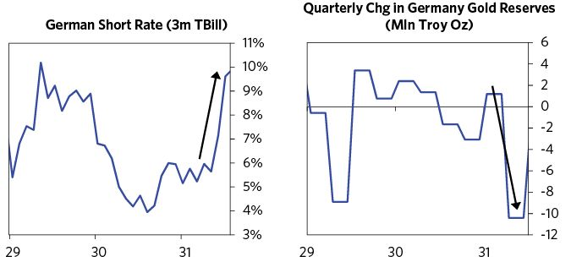

Investors took heavy losses as more and more bank failures hurt the stock market. In May, German stocks fell 14.2 percent, British stocks were down 9.8 percent and French stocks sold off 6.9 percent. In the US, the Dow sold off 15 percent in May following a 12.3 percent decline in April. The world was imploding.

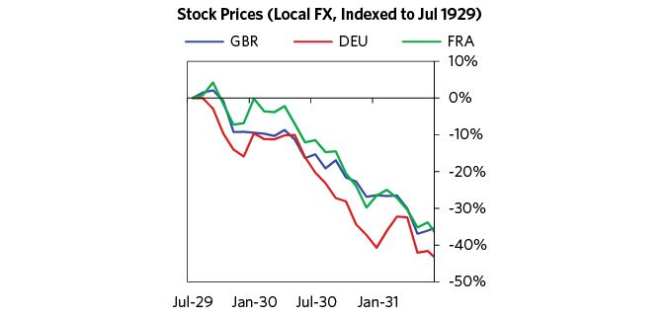

Political turmoil in Europe led funds to flow into the US, which increased demand for US Treasuries and pushed down interest rates. In an attempt to lessen the demand for dollars, the Federal Reserve reduced its discount rate to 1.5 percent.

On June 5, President Hoover suggested to his cabinet that all governments grant a moratorium of a year on all intergovernmental payments. President Paul von Hindenburg of the Weimar Republic made an appeal, stating that Germany was in danger of collapse, which helped push Hoover to swiftly adopt the plan.109 On June 20, Hoover officially announced his proposal for a moratorium on Germany’s debts for one year. Under his proposal, the US would forgo $245 million in debt service payments due over the next year from Britain, France, and other European powers. However, in order to receive these concessions, the allies had to suspend $385 million in reparations due from Germany.110

In what became known as the “moratorium rally,” the Dow rallied 12 percent in the two days following Hoover’s announcement and ended the month 23 percent above the low that it had reached on June 2. German stocks rose 25 percent on the first day of trading following the announcement. Commodity prices soared in the following weeks.

On July 6, the moratorium negotiations finally concluded. Fifteen countries agreed to it, though the share of German reparations that were suspended in the final agreement was lower than Hoover’s initial proposal. France refused to participate, but did agree to re-lend their reparations back in to Germany.111 The Dow slumped 4.5 percent on the day.

The chart below puts things in perspective; the arrow under the grey shaded area shows the moratorium rally. Notice how insignificant that 35 percent rally looks within the bigger moves. I can assure you that those sorts of moves don’t seem small when you’re going through them. Throughout the Great Depression, announcements of big policy moves like this one repeatedly produced waves of optimism and big rallies, amid a decline that totaled almost 90 percent. Investors were repeatedly disappointed when the policy moves weren’t enough and the economy continued to deteriorate. As noted earlier, bear market rallies like this are classic in a depression, since workers, investors, and policy makers have a strong tendency to exaggerate the importance of relatively small things that appear big close-up.

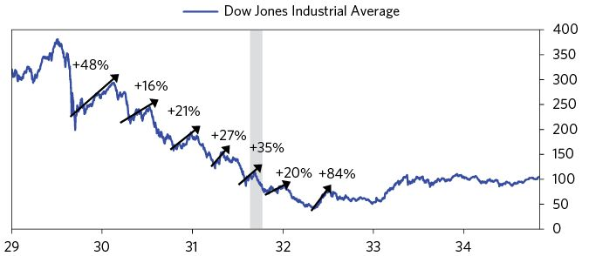

### Third Quarter, 1931: The Debt Moratorium Fails and the Run on Sterling Begins

It quickly became clear that the debt moratorium wasn’t going to be enough to save Germany. In early July, rumors circulated that one of Germany’s largest banks, Danat Bank, was on the verge of failure.112 The Reichsbank, Germany’s central bank, viewed it as systemically important and wanted to bail it out to avert the complete collapse of the German credit system, but it lacked the foreign reserves needed to do that.113

On July 8, just one day after the moratorium had been finalized, Reichsbank president Hans Luther began to reach out to policy makers from Britain to request further negotiations of Germany’s current debts and the possibility of a new loan. Luther needed a new $1 billion loan without political concessions. Policy makers from the other countries balked at this—no one wanted to lend even more to Germany.114 Hoover instead proposed a ‘standstill’ agreement, which would require all banks holding German and Central European short-term obligations to keep the credit extended, exposing them to big liquidity and potential solvency problems as they needed the cash to meet their obligations.115

Naturally, banks were opposed to the standstill agreement and Treasury Secretary Mellon implored Hoover to reconsider. Hoover would not budge. He described his reasoning in his memoir: “This was a banker-made crisis… the bankers must shoulder the burden of the solution, not our taxpayers.”116 Hoover’s instinct to have the banks bear the cost is a classic but misguided policy response to a debt crisis. Punishing the banks in a way that weakens them makes sense for a few moral and economic reasons, as mentioned in the discussion of the archetypal template, and it can be a political necessity as the public hates the bankers at such times—but it can have disastrous consequences for the financial system and markets.

Without a forceful policy response in support of the banks, the collapse continued and Germany’s depression became much worse, inciting riots across the country.117 Hitler was gearing up to run for Chancellor; he adopted the strongly populist stance of threatening to not repay the country’s reparation debts at all. When the foreign ministers met in London on July 20, plans for a new loan slowly fizzled. Ultimately they put in place a three-month extension of an earlier loan along with a standstill agreement. The result was a classic run on the currency as described in the archetypal template.

### The Run on Sterling

Germany’s problems proved to be a key source of contagion. UK banks had lots of loans to Germany, so they couldn’t get their money out; when foreign investors saw that the UK’s banks were in trouble, they began to pull their money. On July 24, France began withdrawing gold from England. This was interpreted as a lack of confidence in the pound, which prompted more countries to pull their deposits from Britain, and the run on sterling began.118

To defend the currency, the Bank of England sold its reserves (a third of them in August alone) and raised interest rates, both classic moves. Foreigners were watching the weekly declines in gold reserves, so the pressure on the pound only increased.

The Bank of England also sought loans from abroad to support the currency, but these loans effectively funded the flight out of sterling. On August 1, 1931, the Bank requested that the US government organize a loan from private US banks totaling $250 million, which Hoover urged to be done right away.119 The flight from sterling continued and the Bank of England received another loan, this time of $200 million from American banks and $200 million from French banks, which was made on August 28.120 Hoover approved of them, but acknowledged after the fact that, “Both loans, however, mostly served to create more fear.”121

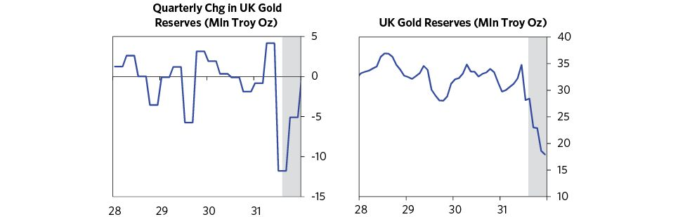

On Saturday, September 19, having exhausted all of its foreign loans and with just over £100 million in gold reserves remaining, the Bank of England stopped supporting the pound and let it fall sharply, and of course the following day, officially suspended gold payments, a de facto default.122 Initially, the public did not understand what going off the gold standard would mean for their transactions. Newspapers lamented it as the end of an era.123

Sterling fell 30 percent over the next three months. On the first trading day since gold payments had been halted, sterling dropped to $3.70, nearly 25 percent lower than its pre-default level of $4.86. British policy makers didn’t intervene in the market to slow the fall or maintain stability. Sterling exchange rates fluctuated greatly before dropping to a low of $3.23 in December. Over the same period, the UK’s equity market recovered and rose 11 percent in local currency terms.

Other countries followed the UK in abandoning gold convertibility so they could finally “print money” and devalue their currencies. Most of these devaluations were roughly 30 percent (e.g., the Nordic countries, Portugal, much of eastern Europe, New Zealand, Australia, India), in line with sterling’s devaluation. The chart, below right, shows the depreciations for a few countries.

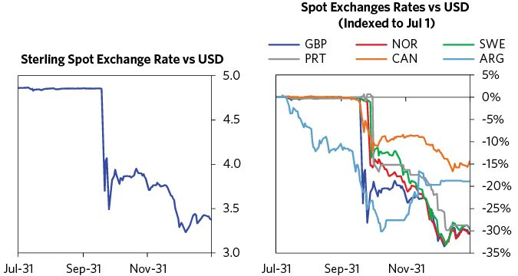

Investors feared that government bonds would be defaulted on with devalued money. This led to a run out of bonds, which raised interest rates and drove bond prices down. In the United States, the Fed raised interest rates by 2 percent in order to attract foreign capital and hold the gold peg. Each government’s bonds hit new lows in 1931. All except Switzerland’s and France’s declined at least 20 percent from their 1931 highs. Global stocks also sold off and some markets stopped trading altogether. On September 21, only the Paris Stock Exchange was open in Europe.124

UK stocks and bonds sold off during the currency defense phase and continued to weaken immediately following the devaluation, but then rebounded. Because the UK’s debt was denominated in its own currency, there wasn’t a risk that the government couldn’t pay it back. Consistent with these pressures on the bond market, the UK’s 5.5 percent bonds due in 1937 had dropped to $92 after the devaluation from $104 (as interest rates rose from 4.7 percent to 5.7 percent in December), but they moved back up to $100 by the end of the year.125

The devaluation helped stimulate the export sector of the economy and allowed the Bank of England to ease significantly, cutting rates by one percent by the end of the year. Equilibrium was reached so that, by the end of October, banks in London were receiving money again. In other words, the devaluation and money printing kicked off a beautiful deleveraging (I’ll go through this more later, when I discuss the US leaving the gold standard). Consistent with these pressures, UK stocks and bonds both rallied after selling off sharply through the currency defense phase and immediately following the devaluation. It is important to understand that these moves are very classic. Why they work as they do is explained in the archetypal template.

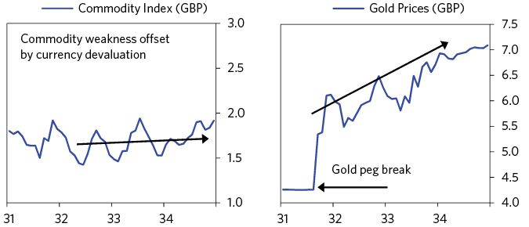

### Fourth Quarter, 1931: The International Crisis Spreads to the US and the Depression Worsens

As other currencies devalued and the dollar rose, it created more deflationary/ depressing pressures in the US. Sterling’s devaluation in September 1931 especially stunned global investors and sent shock waves through US markets. Naturally investors and savers around the world began to question whether the US was safe from either default or devaluation, so they started to sell out of their dollar debt positions. That raised interest rates and tightened liquidity, bringing on the most painful period of the depression, lasting until FDR took the US off the gold standard eighteen months later to devalue the dollar and print money.

Stocks had sold off during the run on sterling. The Dow finished September down 30.7 percent, its largest monthly loss since the crisis began. On October 5, the market fell 10.7 percent in a single day. Amid the chaos, the NYSE once again banned short selling in a classic attempt to slow the sell-off.126 While previously “safe” treasury bonds had rallied as stocks crashed in 1929 and 1930, they were now selling off along with stocks, reflecting the US balance of payments crisis. The yield on long-term US treasuries rose to 4 percent, nearly 1 percent above their midyear lows. Due to the US’s stock of debts and their rising debt service, there were concerns about the US Treasury’s ability to roll bonds that would come due in the following two years.127 The fear of devaluation led to particularly acute runs on US banks, so banks needed to sell bonds to raise cash, which contributed to rising yields.128

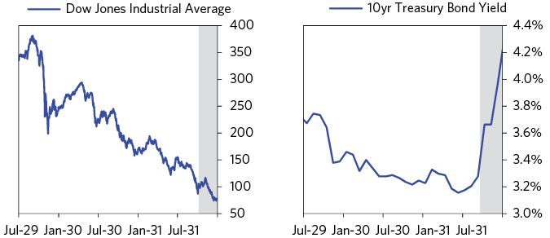

In September 1931, the dollar ceased to be a safe haven for the first time since the global debt crisis began. Gold reserves began to flow out of the US following sterling’s devaluation as central banks in France, Belgium, Switzerland, and the Netherlands all began to convert their dollars to gold. The US lost about 10 percent of its gold reserves within the three weeks following the sterling devaluation.

On October 9, in an effort to attract investors, the New York Federal Reserve Bank increased the discount rate from 1.5 percent to 2.5 percent. This was no different than tightening, which is not a path to good things in a depression. Classically, in a balance of payments crisis, interest rate increases large enough to adequately compensate holders of debt in weak currency for the currency risk are way too large to be tolerated by the domestic economy, so they don’t work. This was no exception, so a week later, the New York Fed again raised its interest rate to 3.5 percent.129 Rumors flew that the head of the New York Fed, George Harrison, had asked the French not to withdraw any more gold from the United States.130

Given the domestic difficulties, investors in the US had taken to hoarding gold and cash. This led to a series of bank runs in late 1931 that caused many banks to close and resulted in a big contraction in deposits for those remaining open. As banks’ deposits fell, they began to call their loans in order to build up their cash reserves. Homes and farms were forced into foreclosure, and several companies went bankrupt as investors did not roll loans they had previously extended.131

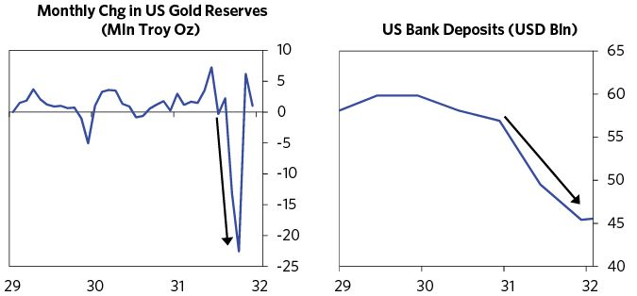

As money and credit contracted, the economy started to fall off a cliff. Over the second half of 1931, industrial production contracted by 14.3 percent and department store sales fell 12.9 percent. By the end of 1931, unemployment had reached nearly 20 percent, and domestic prices were falling 10 percent per year.

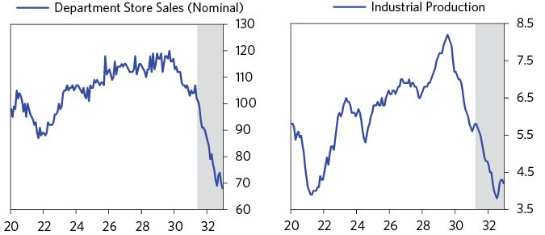

The Hoover administration took several steps to stem bank failures and stimulate the flow of credit in late 1931. The most notable among these was the creation of the National Credit Association, which provided a pool of private money that could be lent against sound collateral to provide liquidity to banks at risk of failing (i.e., a private central bank). The funds came from the banks and totaled $500 million, with the ability to borrow another billion.132

At the same time, Hoover was looking for solutions for the collapsing real estate market. To stop foreclosures on mortgages of “the homes and farms of responsible people,” he sought to create a system of Home Loan Discount Banks, which he did in 1932. In the meantime, he worked with both the insurance and real estate agencies to suspend foreclosures on farm loans by the Federal Land Banks, while providing the institution with $1 billion so that it could expand its lending.133

The policies were well received and broadly inspired confidence among investors. The stock market rallied in response, up 35 percent from its October bottom to November 9, with a jump of more than 10 percent on the day the National Credit Association was announced. The rally made some believe the worst was over, as most significant rallies do. Yet there was no significant change in the total money and credit available, so the fundamental imbalance between total debt coming due and the amount of money available to service it wasn’t resolved. As was the case with so many policy announcements throughout the depression, the rally faded as it became clear that the proposals would be too small to handle the problem. Stocks reached a new low near the end of December.

### First Half of 1932: Growing Government Intervention Unable to Halt Economic Collapse

The depression deepened in 1932, as the economy continued to plunge with deflation and credit problems worsening. An astounding number of businesses were struggling or failing—in aggregate, businesses experienced $2.7 billion in losses and bankruptcies hit record levels, with almost 32,000 failures and $928 million in liabilities.134 News of bank failures filled the newspapers. As those losses rippled through the system, imposing losses on lenders and causing other businesses to close shop, the economy contracted still more.

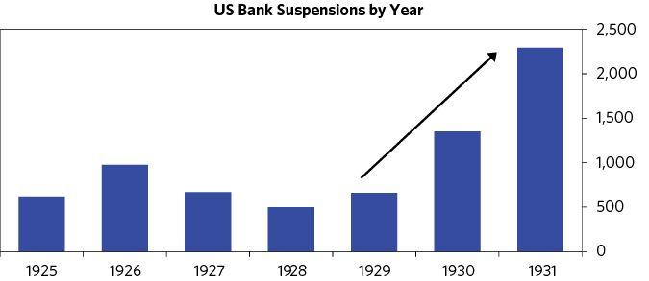

It is classic in a big debt crisis: Policy makers play around with deflationary levers to bring down debt for a couple of years but eventually wake up to the fact that the depressing effects of debt reduction and austerity are both too painful and inadequate to produce the effects that are needed. So more aggressive policies are undertaken. As it became clear that the Hoover administration hadn’t done enough to reverse the credit contraction, it announced another set of policies during the first part of 1932 in an attempt to provide liquidity to the banking system and get credit going again.

On January 23, Hoover launched the Reconstruction Finance Corporation. The RFC was funded with $500 million in capital and had the ability to borrow from the Treasury or private sources up to $3 billion; its goal was to provide liquidity to solvent banks to shore them up against failure.135 The RFC benefited from a more extensive mandate than the Federal Reserve—it was able to lend against a wider range of collateral and to a broader range of entities. It could also lend to state-chartered banks, banks in rural areas that were not a part of the Federal Reserve System (i.e., some of the banks most affected by the crisis), and railroads, which were an important industry at the time (like the auto industry in 2008).136 Lending against a widening range of collateral and to an increasingly wide range of borrowers is a classic lever that policy makers pull to ensure that sufficient liquidity gets to the financial system, sometimes provided by central banks and sometimes by central governments.

By the end of August 1932, the RFC had lent $1.3 billion to 5,520 financial institutions, helping to reduce the number of bank failures.137 But the RFC was only able to lend against “good” collateral. And so it was unable to provide sufficient support to some of the institutions that needed it the most.138

Around this time, the Fed started to experiment with money printing. Going into the crisis, the Federal Reserve was only able to lend against gold or certain forms of commercial paper. With both in short supply, policy makers were once again faced with the trade-off between further tightening and undermining the dollar’s peg to gold. The 1932 Banking Act, signed by Hoover on February 27, attempted to alleviate the liquidity squeeze while maintaining the gold standard by increasing the Federal Reserve’s ability to print money, but only to buy government bonds (which 75 years later would be called “quantitative easing”).139 This move was contentious, since it was clearly a weakening of the principles behind the gold standard, but the sense of urgency was such that the bill passed without debate.140 As Hoover framed it, the decision was “in a sense a national defense measure.”141, Later that year, Congress gave the Federal Reserve additional powers to print money and provide liquidity in an emergency.142 This provision—Section 13(3) of the Federal Reserve Act—would end up being critical to the Fed’s response to the 2008 debt crisis.

The Federal Reserve System bought nearly $50 million in government securities each week in April and nearly $100 million each week in May. By June, the system had purchased over $1.5 billion in government securities. The following chart illustrates the Federal Reserve’s purchases and holdings of government debt in 1931 and 1932.

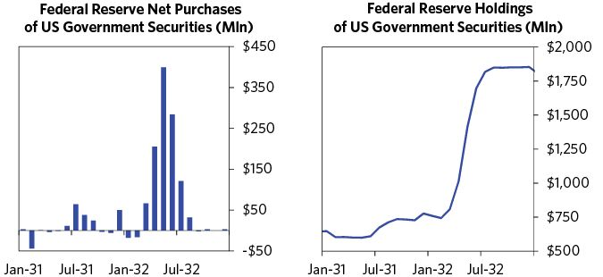

Once the Federal Reserve began purchases, yields on short-term Treasury securities fell rapidly with three month T-Bill yields falling more than two percent over the first half of the year. Fed purchases also relieved pressure in the market for longer-term treasury bonds, where the supply-demand imbalance for dollars had reached a breaking point amid large deficits and foreign reluctance to hold US assets. After rising above 4.3 percent in January, yields on ten-year treasuries fell below 3.5 percent over the next six months.

These moves ignited optimism and yet another rally, and the Dow Jones increased by 19.5 percent, reaching January’s high. It closed above 80 in February.

Policy makers also took a number of smaller steps to support the banking system during the first half of 1932. Another classic move was the abandonment of mark-to-market accounting for banks. In January, the Comptroller of the Currency instructed bank examiners to use par value as the intrinsic value of bonds held by national banks with a BAA rating or better.143 Under the prior accounting methodology, banks faced either major paper losses on the bonds they held or cash losses if they sold them. Those losses reduced their capital, forcing them to raise money or sell assets, further constraining liquidity and pushing down asset prices. The change in accounting rules relieved some of the most immediate pressure on banks.

The Hoover administration also tried to get credit going with macroprudential measures, most notably applying direct pressure on banks in an attempt to get them to lend. Hoover and Treasury Secretary Ogden Mills had blamed the banks for their inability to stimulate credit, and accused them of restricting loans and hoarding gold and cash. Hoover organized committees in the twelve Federal Reserve districts which tried to pressure large regional banks into lending, but this effort met with little success.144

Though some were helpful, none of these moves were enough to halt the economic collapse. Pressure on US gold reserves continued because foreigners worried that with the monetary expansion and the expanding deficit, the US would not be able to sustain the dollar’s conversion to gold at existing rates.145 As they rushed to make the conversion, gold left the country every month from March to June. In June net gold exports hit $206 million, a level last experienced following the depreciation of sterling.146 That produced a tightening of credit.

In March, stocks sold off and the market suffered a decline that extended through 11 weeks. The Dow Jones dropped 50 percent, from 88 on March 8 to 44 on May 31. The Dow Jones closed in May on a low for the month, and volume further declined that month to about 750,000 shares per day.147 Early in the crisis, government efforts to increase lending and spending had led to sustained rallies in asset markets. At this stage, however, investors had become disillusioned. They worried that Hoover’s programs were not making enough of a difference to make up for their vast cost, and markets continued to trend downward.

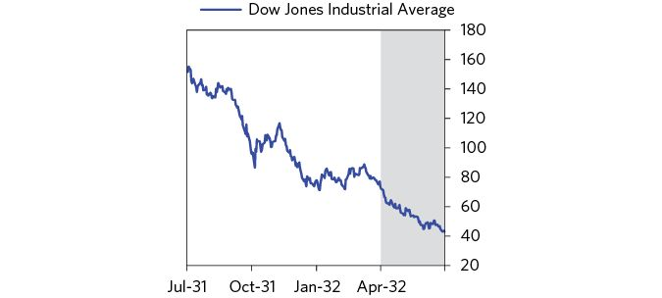

Social unrest and conflict continued to rise globally. In Germany, Hitler won the most seats in the Reichstag election. Japan slipped toward militarism, invading Manchuria in 1931 and Shanghai in 1932. In the US, strikes and protests were also increasing.148 Unemployment was approaching 25 percent, and those still employed faced wage cuts. Outside of cities, farmers faced ruin as prices fell and a drought destroyed their crops. In one dramatic expression of discontent, thousands of veterans and their families had marched on Washington in June (and stayed there) in an attempt to pressure the government to immediately pay them their veterans’ bonuses.149 On July 28, US Army troops led by General Douglas MacArthur cleared the camp with tanks and tear gas. It was at this time that conflicts both within countries and between countries intensified, sowing the seeds of populism, authoritarianism, nationalism, and militarism that at first led to economic warfare and then military warfare in Europe in September 1939 and with Japan in December 1941.

### Second Half of 1932: Further Contractions and the Election of FDR

By the summer, the big stimulation and relief to banks appeared to be helping. The downward spiral began to moderate, asset prices stabilized, and production actually increased in certain areas of the economy, like autos. From May through June, commodities, stocks, and bonds all bottomed. Markets for both stocks and bonds improved during the second half of the year. In August and September, the Dow Jones Industrial Average rallied to a peak of 80, almost double its July low. You can see trajectory of the Dow in the chart below.

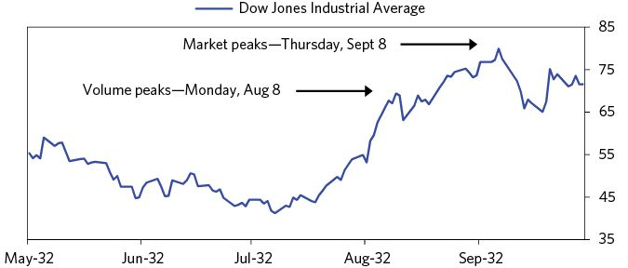

Time magazine’s August 8, 1932, edition claimed that the rally occurred because the gold outflow had finally ceased, rumors had spread about the country receiving foreign capital, and a railroad merger had been approved.

As optimism about the economy and asset markets began to increase, policy makers began to pull back on their earlier stimulative measures. Also, the RFC was weakened significantly by a scandal when it bailed out Central Republic Bank and Trust, which was headed by the previous chair of the RFC. The public was outraged—the RFC now seemed like a tool of fat-cat bankers.150 In response, Congress ordered the RFC to publish the names of all the institutions to which they had lent.151 This effectively meant that getting a loan from the RFC also required advertising that you were in trouble, which of course worsened pressure from depositor withdrawals. Borrowing from the RFC slowed, and withdrawals began to pick up pace.152

Outrage over the government’s role in “bailing out” financial institutions is one outgrowth of the “Main Street versus Wall Street,” or “workers versus investors” conflicts that classically occur during depressions. As economic pain increases, populist calls to “punish the bankers that caused this mess” make it incredibly difficult for policy makers to take the actions that are needed to save the financial system and the economy. After all, if the bankers quit in this chaos, the system would certainly shut down.

Politics also played a part in ending the Fed’s purchases of government bonds. The Banking Act passed in February had been framed as a temporary measure due to concerns that it might weaken the dollar. Members of the Federal Reserve from Chicago, Philadelphia, and Boston pushed for ending open market operations, arguing that since banks were accumulating increasing reserves but not significantly expanding credit, the program was not necessary (and the lower long-term interest rates from the program were hurting bank profitability). In July they stopped participating, and the New York Fed, unable to continue on its own, was forced to acquiesce.153

The administration was worried about the budget deficit ballooning, as receipts fell and expenditures rose.154 With almost universal support, Hoover pushed to balance the budget through a mix of tax increases and cuts to federal expenditures.155 On June 6, the Revenue Act of 1932 was signed into law. The act increased income taxes, corporation taxes, and various excise taxes. But despite these efforts, the budget deficit grew significantly relative to GDP because the austerity was contractionary and the economy shrank faster than the budget deficit did.156 As mentioned earlier, Hoover’s attempt to balance the budget through austerity was a rookie move that is classic in depressions.

As is also classic in deleveraging scenarios, the debate about what to do became antagonistically political, with strong populist overtones. Roosevelt came on the scene with what, at the time, seemed like leftist populist policies. From the outset his presidential campaign struck a strongly anti-speculator tone. It opened with a speech that railed against securities firms’ abuses and called for federal control of the stock and commodities exchanges.157 There were indications that he favored a devaluation of the dollar, which increased the pressure on the currency. To allay those fears, Roosevelt said he would not take the country off the gold standard, but investors were not convinced.158 By the way, politicians and policy makers frequently make disingenuous promises that are expedient and inconsistent with economic and market fundamentals, and such promises should never be believed.

Bank failures were ticking upward, open market operations had ended, the RFC had been neutered, government spending had been reined in, and the threat of devaluation loomed large. Gold outflows resumed and prices, which had recently begun to stabilize, started to fall. The economy’s downward trajectory steepened.

The renewed pressure on the banking sector moved into higher gear in November. Right before the election, Nevada declared the first statewide bank holiday, a classic response to widespread bank runs. Although Nevada was able to avert the failure of its main state bank, the holiday sparked a national panic.159 Fearing that their bank might be next, depositors accelerated their withdrawals. Crisis dynamics were beginning to return.

The collapse of the economy throughout 1932 was breathtaking. The charts below show some of the economic stats, highlighting the period from sterling’s devaluation until the end of 1932. Consumer spending and production fell by more than 20 percent and unemployment rose by more than 16 percent. Severe deflation had taken hold and prices were falling by almost one percent every month.

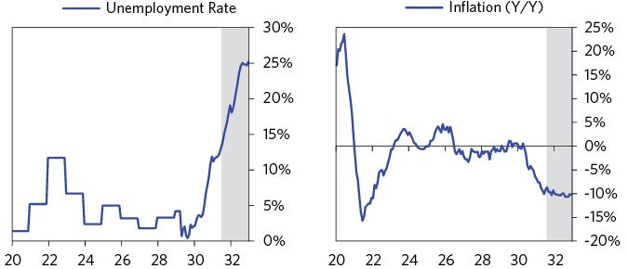

Policy makers’ reliance on the deflationary levers of debt reduction had pushed the US into a severe depression/“ugly deleveraging.” Since nominal interest rates were well above nominal growth rates, debt grew faster than income and debt burdens rose despite defaults.

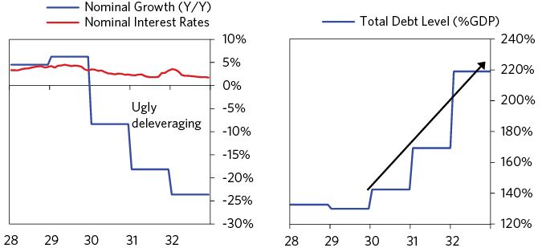

But while investors were worried about the effects of a Roosevelt presidency, the populist nature of his campaign (along with the terrible economic conditions) propelled him to victory. Roosevelt was elected in November 1932, winning 22.8 million votes against Hoover’s 15.8 million, the most popular votes ever won by a presidential candidate up to that time.

Driven by weak economic conditions, an uneven recovery (in which the elite was perceived to be prospering while the common man was still struggling), and ineffectual policy makers, populism was a global phenomenon in the interwar period (the 1920s to the 1930s), leading to regime changes not only in the United States, but also in Germany, Italy, and Spain. In the United States, inequality (in both income and wealth shares) peaked in the early 1930s, but remained high for the rest of the decade. By the time of Roosevelt’s election, the top 10 percent earned 45 percent of the income and owned 85 percent of the wealth while unemployment was over 20 percent. These conditions caused FDR to base his campaign on a “New Deal,” which promised big changes for workers, debtors, and the unemployed.160

Europe had a similar set of economic conditions. Germany had experienced both a hyperinflation and the start of the Great Depression in the prior fifteen years. Inequality was also high—the top 10 percent earned about 40 percent of the income, while unemployment was over 25 percent. This set the stage for the Nazi party’s ascent.161

### 1933: Preinauguration

Gold continued to flow out of the country in anticipation of Roosevelt’s reflationary policies, and Roosevelt now refused to reaffirm his commitment to the gold standard. Those around him attempted to persuade him to reassure the markets. Senator Carter Glass, who was Roosevelt’s likely nominee for Secretary of the Treasury, declared that he would not accept the post if Roosevelt could not guarantee the country would stay on the gold standard.162 Hoover wrote a personal letter to Roosevelt, requesting that he clarify his policies.163 European investors in the dollar were worried: From Paris, the New York Times reported that “the confusion of mind in Europe’s markets concerning the future tendency of the dollar must be ascribed to lack of information regarding the definite intentions of the new American government. Declaration by Mr. Roosevelt declaring firm resolution to maintain a sound currency would have an extremely reassuring effect.” But Roosevelt stayed silent.164

In February, the crisis deepened. Facing bankruptcy, the Guardian Detroit Union Group, the largest financial institution in Michigan, sought a loan from the RFC. The group had little good collateral, so the RFC could not, under its mandate, offer it a large loan. Perhaps more importantly, the main shareholder of the Guardian Group was auto millionaire Henry Ford. Not wanting the appearance of doing more favors for fat-cats, the RFC suggested that it could make a loan if Ford also provided some support. But Ford, recognizing that the Guardian Trust was as systemically important as the Central Republic, refused. His attempt to call the RFC’s bluff failed. The Union Guardian Trust and Guardian National Bank of Commerce, two of the Guardian Group’s banks, were allowed to go bankrupt and Michigan was forced to declare a statewide bank holiday.165

When policy makers fail to rescue systemically important institutions, the ripple effects can quickly spread to the whole system. Since Michigan was part of America’s industrial heartland, the impact on other states was especially large.166 Households and companies rushed to withdraw their savings from banks across the country. Ohio, Arkansas, and Indiana suffered bank runs. Maryland declared a bank holiday on February 25, and by March 4, there were withdrawal restrictions in over 30 states.167

The flow of gold out of the country turned into a wave. In the last two weeks of February, the New York Fed lost $250 million, almost a quarter of its gold reserves.168

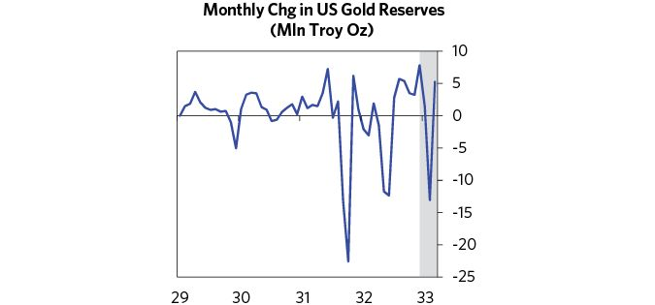

In the face of this pressure on gold reserves, Hoover attempted to invoke the War Powers Act and introduce capital controls, a classic but ineffective response to balance of payments pressures, but the Democrats would not allow it.169

The economy suffered enormously. In March, business had slowed to a shocking extent. That year, the Gross National Product hit its lowest point in the entire period of the depression at $55.6 billion, which was 31.5 percent below its 1929 level in constant dollar terms.170

## 1933–1937: The Beautiful Deleveraging

### 1933–1934: Roosevelt Leaves the Gold Standard; the Economy Moves to a Beautiful Deleveraging

On Sunday, March 5, the day after he took office, Roosevelt declared a national four-day bank holiday, suspended gold exports (effectively delinking the dollar from gold), and set a team to work on rescuing the banking system. It was a scramble to get as much done as possible in as short a time as possible.

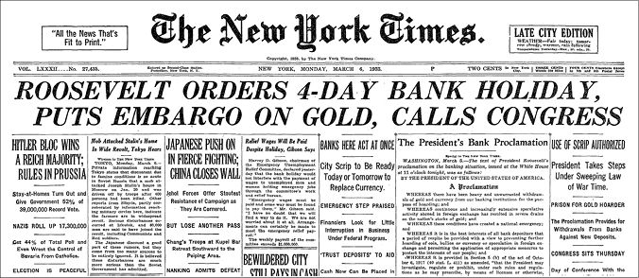

From the New York Times,6 March © 1933 The New York Times. All rights reserved. Used by permission and protection by the Copyright Laws of the United States. The printing, copying redistribution, or retransmission of this Content without express written permission is prohibited.

Before the banks were set to reopen on March 9, Congress passed the Emergency Banking Act of 1933. The act extended the bank holiday and gave the Fed and the Treasury unprecedented powers to provide liquidity and capital to the banking system. Most important, the act granted the Fed the ability to issue dollars that were backed by bank assets instead of gold, which broke the link between the dollar and gold and allowed the Fed to print money and provide the liquidity that banks desperately needed. So that the Fed could print money without facing a run on its gold reserves, Roosevelt banned gold exports under the 1917 Trading with the Enemy Act.171

Auditors began to work through the books of each US bank, starting with the largest banks and those known to be the safest. When auditors found a bank that was undercapitalized, they could either (a) recapitalize the bank by having the RFC issue preferred shares, (b) merge it with a healthier bank, or (c) close it. Systemically important banks were always supported, while smaller banks were often allowed to fail. Once auditors decided that a bank was sound, it would reopen with the ability to borrow from the Fed using any of its assets as collateral.172 As part of the Banking Act of 1933, the Treasury agreed to cover any losses the Fed incurred, effectively guaranteeing the liabilities of every bank that they chose to keep open.173

On Sunday, March 12, the night before the first wave of banks was set to reopen, Roosevelt gave a nationwide radio address explaining the plan for the banks and seeking to restore trust in the banking system:

The new law allows the twelve Federal Reserve Banks to issue additional currency on good assets and thus the banks which reopen will be able to meet every legitimate call…It is sound currency because it is backed by actual, good assets…I can assure you that it is safer to keep your money in a reopened bank than under the mattress.174

As banks in twelve cities prepared to open on Monday, policy makers and investors waited nervously to see how the public would respond. Instead of bank runs, the public proceeded to deposit more than $1 billion into the banks, which is a classic example of how debt and liquidity problems prompted by runs can be rectified by providing liquidity rather than holding it back. Banks continued to reopen in the days that followed, and within a month member banks representing 90 percent of the deposits in the system had reopened.175 When markets finally opened on Wednesday, the Dow rose 15.3 percent and commodities also soared.

To get all that money, the link to gold had to be broken. But with all that printing, the dollar’s value plunged against both other currencies and gold. This was virtually identical to what happened in August 1971, when I was clerking on the floor of the New York Stock Exchange and thought that the crisis would send the stock market and economy down. What happened was the same as what happened in 1933, and for the same reasons, but I hadn’t studied what happened in 1933, so I was painfully wrong. That was the first time that I was surprised by events that hadn’t happened in my lifetime but had happened many times in history. Being stung by these experiences drove me to try to understand all big market and economic movements in all time frames and all economies and to have timeless and universal principles for dealing with them. That saved my butt a number of times (e.g., in 2008). The events I am describing to you that happened in the 1930s have happened many times before for the exact same reasons.

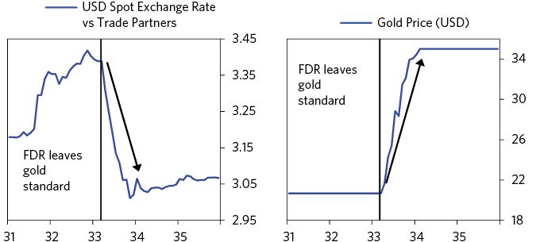

Within two weeks of leaving the gold peg, the Federal Reserve was able to decrease its liquidity injections; short-term rates decreased by one percent to two percent, bankers’ acceptance rates dropped back to two percent, and call loan rates decreased to three percent.176 The money supply increased by 1.5 percent over the next three months, and the Dow was up by almost 100 percent over the next four months. These moves ended the depression on a dime. (Most people mistakenly think that the depression lasted through the 1930s until World War II so I want to be clear on what actually happened. It is correct that it took until 1936 for GDP to match its 1929 peak. But when you look at the numbers in the charts below, you can see that leaving the gold peg was the turning point; it was exactly then that all markets and economic statistics bottomed. Still, these average numbers can be misleading because the recovery benefited the rich more than the poor, and the post-1933 period remained more difficult for a lot of people than the averages suggest, which is likely why people often think of the depression as lasting through the entire decade.)

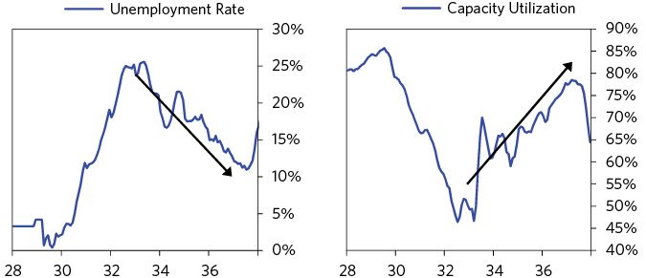

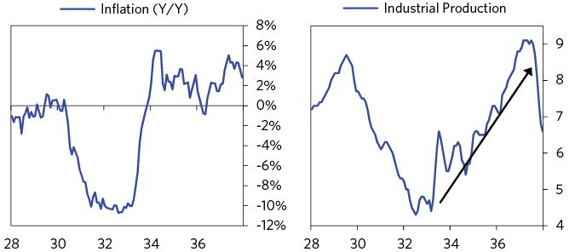

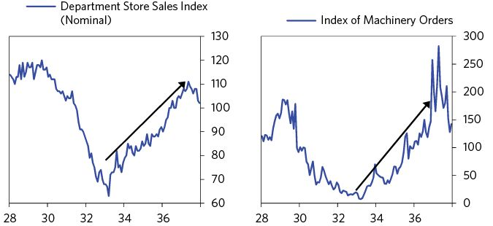

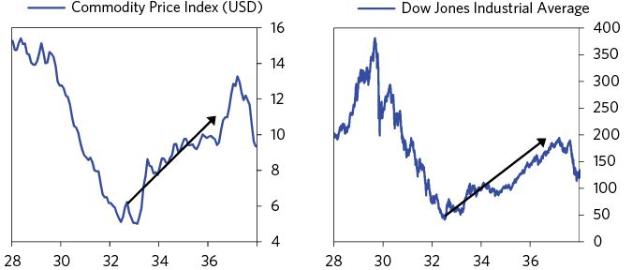

While leaving the gold standard, printing money, and providing guarantees were by far the most impactful policy moves that Roosevelt made, they were just the first of an avalanche of policies that were unrolled during his first six months in office. The shock and awe of all those big announcements of spending, coming week after week, built confidence among investors and the public, which was critical to putting the economy on a good footing. I’ll describe some of those policies below, not because the particulars are all that important, but because together they paint the picture of a bold, multifaceted, and comprehensive policy push.

While they were still working to shore up the banks, policy makers shifted their attentions to significantly increasing financial industry regulation and oversight. Changing laws in ways that would have made the last crisis less bad are typical at the end of big debt crises. When you read through them, focus on how they map to the template for handling debt problems.

* April 5 and 18: Roosevelt took additional steps to delink the dollar from gold. First he outlawed ownership of monetary gold by the public through an executive order. Two weeks later, he outlawed private gold exports and indicated support for legislation that would allow him to set the price of gold.177 (devaluing and printing money)
* May 27: Congress enacted the Securities Act of 1933, which would regulate the sale of securities.178 (increased regulation)
* June 5: Congress banned the relatively common “Gold Clauses” in contracts, a provision that allowed the payee to opt to be paid in gold. Since gold had increased in value after the dollar was delinked from it, this amounted to a big restructuring of debts.179 (restructuring debts)
* June 13: The Home Owner’s Loan Act established the Home Owner’s Loan Corporation (HOLC) to assist in the refinancing of residential mortgages. Between 1933 and 1935, one million people received long term loans through the agency.180 (restructuring debts)
* June 16: The Banking Act of 1933 (i.e., Glass-Stegall II) provided deposit insurance of up to $2,500 through the newly formed Federal Deposit Insurance Corporation (FDIC). It also empowered the Fed to regulate interest rates on demand and savings deposits (Regulation Q); set forth stringent regulations for banks; and required the separation of investment and commercial banking functions.181 (establish deposit insurance, increased regulation)

Roosevelt also announced new federal agencies and programs that added up to an unprecedented fiscal stimulus. Federal spending had fallen by more than $1 billion in 1932 as Hoover tightened fiscal policy in an attempt to balance the budget. Even though he initially campaigned to balance the budget, FDR’s policies would end up increasing annual spending by $2.7 billion (5 percent of GDP) by 1934. These are some of the early stimulus bills:

* April 5: Established the Civilian Conservation Corps (CCC), which would employ 2.5 million people in public works projects over its nine years of existence.182
* May 12: Established the Federal Emergency Relief Act to provide financial support to households with an initial funding of $500 million.183
* May 18: The Tennessee Valley Authority (TVA) undertook massive infrastructure investment, providing power, flood control, and irrigation in one of the regions most affected by the Great Depression.184
* June 16: The National Industrial Recovery Act (NIRA) created the Public Works Administration (PWA), which had $3.3 billion at its disposal to spend on large-scale public works. 185

As a result of all of this stimulation, deflation turned into acceptable rather than horrible inflation.

As explained in the “Archetypal Long-Term Debt Cycle” section, balance is key in achieving a “beautiful deleveraging”: Deleveragings become beautiful when there is enough stimulation to offset the deflationary forces and to bring the nominal growth rate above the nominal interest rate.

The economy roared to life over the next three months as terribly depressed levels of activity quickly became less terrible. Heavy machinery orders climbed by 100 percent, and industrial production increased by almost 50 percent. Between March and July nondurable manufacturing production increased 35 percent while durable manufacturing increased 83 percent. Unemployment fell and over the next three months, wholesale prices jumped by 45 percent.186 These were all rebounding from very depressed levels and fed on themselves to make a beautiful deleveraging.

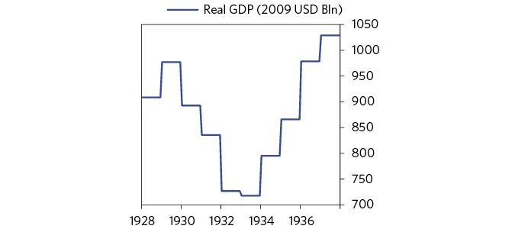

Note how the level of GDP growth was above the level of interest rates.

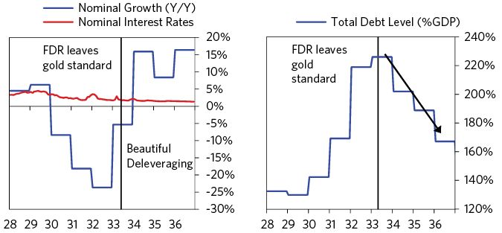

### 1935: The Goldilocks Period

The economy and the markets continued to recover through 1934 and into 1935, when the Federal Reserve began contemplating tightening once again. By 1935 the economy had recovered, deflation had disappeared, and stock prices had soared as a result of the Fed’s earlier policies. At the time, home prices were rising faster than 10 percent per year, and the recovery in equity prices was even faster. The boost to wealth was big, though wealth and economic output remained below pre-depression, bubble levels.

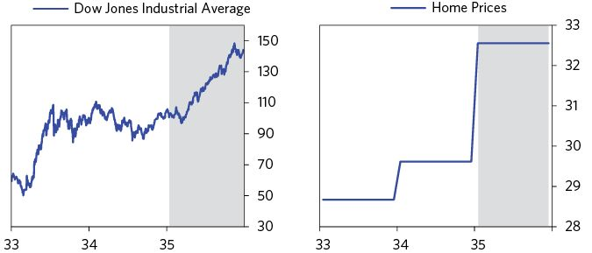

In the spring of 1935, the Fed became increasingly concerned about the rise in excess reserves.187 It feared that the surge in excess reserves could create an expansion in credit and inflation in the future. In March, a background memo was prepared to address the question of what the Fed should do. It recommended no action for the time being. The paper explored the question of whether excess reserves will encourage banks to lend more to the private sector by pushing down the yield on government securities, but it didn’t yet see evidence of that happening, so the Fed held pat. A second issue the paper looked at was how to sell the debt that it accumulated (i.e., how to do a reverse Q.E.).188 The paper rejected doing this for the time being, expressing the view that it would prematurely give too much weight to inflation concerns that hadn’t yet shown signs of materializing, and instead advocated encouraging the expansion.

The cyclical expansion and advances in the stock market and housing price gains continued, which caused the Fed to become more inclined to tighten. In October, another memo expressed heightened concerns over the excess reserves, pondering the appropriate time to reduce them and whether to do that through 1) asset sales or 2) increasing the reserve requirement. In November, the pros and cons of these paths were explored. The argument for reducing excess reserves was to get ahead of the potential for future inflation; the argument against it was that there was no evidence yet for restraint.

In its press release of November 22, the Fed discussed the stock market boom and expressed concerns about inflation. Fears of fueling a bubble were rampant because a number of policy makers, including FDR, remembered that the bubble of the late 1920s caused the stock market bust, which had contributed to the depression. As a result, they were very worried that the steep rise in the stock market in 1935 (nearly a quadrupling!) could fuel a recurrence. The November press release from the Treasury disagreed, noting that inflation was still far off.189

The Fed paid a lot of attention to how the stock purchases were being financed because they had heightened concerns about “speculative credit” after the excess in margin-borrowing during the late 1920s. Raising margin requirements was considered. However, the November Fed memo noted that the purchases were being financed by money, not credit, so no action was taken.190 Still, the stock market advance was considered an emerging bubble, and fears about too easy of a monetary policy remained, so the arguments about whether or not to apply restraints continued. One board member (George Harrison of the New York Fed) suggested raising reserve requirements to curtail the rise in stock prices. Treasury Secretary Henry Morgenthau (still on the Fed Board at the time) rejected this notion. However, he recognized the concern that a rise in reserves could lead to inflation. In December, Emanuel Goldenweiser, the Fed’s head of research, warned of a potential negative psychological reaction to raising reserve requirements. He recommended that the Fed issue a press release saying that any action on reserve requirements would be “precautionary” in nature, and thought that “there is no need to worry about inflation at this time with the very large volume of unused plant capacity and unemployment.” At the end of 1935, following its last meeting, the Fed issued a press release stating that the volume of reserves and gold inflows “continues to be excessive” and warned that “appropriate action may be taken as soon as it appears in the public interest.”191

## 1936–1938: The Tightening Causes Recession

The debate continued at the start of 1936. FDR wanted to signal a concern around inflation ahead of the election, so he urged that reserve requirements be tightened that spring. Fed Chairman Eccles was worried that banks would accumulate a lot of bonds and loans at low rates and then get burned by inflation.192

In May the Fed did not move. While the Banking Act of 1935 meant Treasury Secretary Morgenthau had to resign from the board, he still had influence and was a strong proponent against acting. By that July, Fed Chairman Eccles met alone with FDR, explaining his intention to raise reserves and assuring the president he would not act if he felt interest rates would rise and that the Fed would buy bonds if they sold off. The Fed tightened reserves later that month. Eccles and the Fed moved without informing Morgenthau, who was furious. After a tiny sell off in bonds, Morgenthau ordered Harrison of the New York Fed to purchase bonds using the Treasury’s accounts. The Fed Board in Washington joined in, buying bonds and selling bills as Eccles had promised the president.193 Between August 1936 and May 1937, the Fed doubled reserve requirements from about 8 percent to 16 percent, as shown below. The first tightening, in August 1936, did not hurt stock prices or the economy.  
 It is typically the case that the first tightening does not hurt stocks and the economy.

Because the tightening did not have an effect, reserves were tightened more in two additional phases, the first in March 1937 and the second in May 1937. The largest increase was the first (about half the total), as shown below.

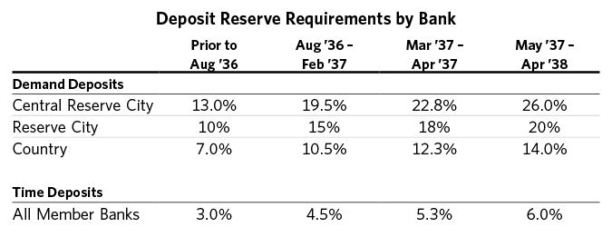

As a result of the reserve tightening, excess reserves fell from $3 billion to less than $1 billion.194

The tightening of monetary policy was intensified by currency devaluations by France and Switzerland, continuing a battle of official devaluations to gain price and trade advantages. In September 1936, the Tripartite Agreement was reached by the United States, Britain, and France, which essentially stated that each nation would refrain from competitive exchange devaluations.195 By then, it had become obvious that all countries could just as easily devalue their currencies in response to other devaluations, creating a huge amount of economic turbulence that left everyone in the same place. At the end of the day, all currencies had devalued a lot against gold, but not so much against each other.

By 1936, war was brewing in Europe, driving capital flight to the US, which continued to fuel advances in stocks and the economy. That year, the president and other policy makers were becoming increasingly concerned by gold inflows (which allowed faster money and credit growth).196 The concerns were threefold:

1. The rapid rise in the stock market. At this time, stocks were up almost four times from their bottom in 1933 and were rising fast: by about 40 percent in 1935 and 25 percent in 1936. Policy makers worried that the gold inflows were coming from foreigners bringing in capital to buy US stocks.
2. The inflationary impact of gold inflows increasing the monetary base. Inflation had risen from roughly 0 percent to around 2 percent in October 1936.
3. The US was becoming vulnerable to an outflow of gold (i.e., capital withdrawal). The specific concern was that the European nations would finance the coming war in part by selling their US assets and pulling gold out, while preventing US holders of their assets from repatriating capital.

To neutralize the effects of these inflows, in December, FDR ordered “sterilization” to begin. Normally, when people sold their gold to the US government in exchange for dollars, the number of dollars increased (i.e., money is printed), which, given the strong economic recovery, wasn’t seen as desirable. Instead, starting December 23, the gold inflows/newly mined gold were sterilized—literally, the Treasury purchased gold inflows by drawing down its cash account at the Federal Reserve instead of printing money. From the end of 1936 to July 1937, the Treasury sterilized about 1.3 billion of gold inflows (approximately 1.5 percent of GDP).197 We can see the increase in sterilization and slowing of gold and other asset purchases in 1936/37 with money growth slowing and dropping below gold reserve growth. The Fed also tightened reserve requirements in order to take money out of circulation, as we have seen.

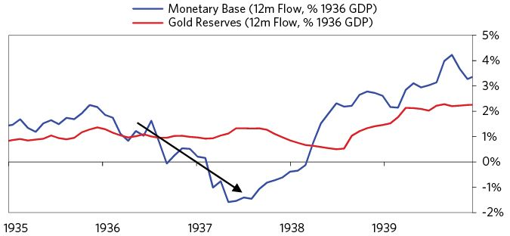

### 1937

The economy remained strong going into early 1937. The stock market was still rising, industrial production remained healthy, and inflation picked up to around 5 percent. The second tightening came in March 1937 and the third in May. While neither the Fed nor the Treasury anticipated that the increase in required reserves combined with the sterilization program would push rates higher, the tighter money and reduced liquidity led to a sell-off in bonds and a rise in the short rate.198 Treasury Secretary Morgenthau was furious and argued that the Fed should offset the “panic” through open market operations to make net purchases of bonds. He ordered the Treasury into the market to purchase bonds itself. Fed Chairman Eccles pushed back on Morgenthau, urging him to balance the budget and raise tax rates to begin to retire debt.199

Additionally there was a fiscal tightening. Federal government outlays fell 10 percent in 1937 and another 10 percent in 1938. The Revenue Act of 1937 was passed to help to close loopholes in the Revenue Act of 1935 (which was sold as the “wealth tax”).200 That act had increased the federal income tax for the highest incomes up to 75 percent.

The federal budget deficit went from around -4 percent of GDP to neutral. The reversal in the budget in 1937 was a consequence of a large increase in taxes, mostly from a rise in the Social Security tax, along with sizable but smaller cuts in spending.201

There was significant pressure on the government to pass redistributive policies, as the recovery thus far was perceived to be uneven (i.e., benefiting the elites over the common man). Workers saw the gains in corporate profits, but didn’t see a subsequent increase in their own compensation. Inequality bred discontent, as evidenced by the sharp increase in the number and intensity of strikes from 1936 to 1937 (the number of strikes rose by 118 percent and the number of workers involved by 136 percent).202

In financial markets, the combination of monetary and fiscal tightening created a significant sell-off in risky assets. Stocks fell the most, but home prices stopped their gains and dipped negative. Credit growth slowed as well, both in aggregate and across all sectors. Nonfinancial business credit creation fell to almost -2 percent, and household credit creation was slightly less negative at about -1 percent. Spending and economic activity fell as a result. With that downturn, unemployment rose to 15 percent, though it was more like a short uptick, especially in comparison to the punishingly high rise at the start of the decade. Stocks bottomed a year later, in April 1938, declining a total of nearly 60 percent!

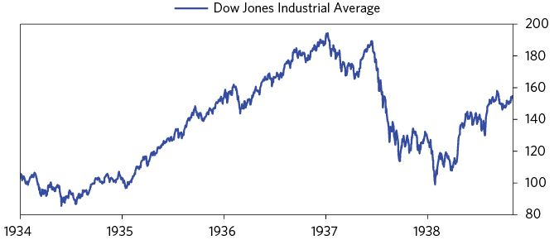

### Late 1937–1938: Policy Makers Reverse Their Course

As markets and the economy turned down in 1937, the Fed accelerated a twist into longer-dated assets and started to do a small amount of net asset purchases. By the end of the year, the Treasury began to reverse its sterilization program in partnership with the Fed.203 Money growth picked up again starting in 1938 and continued to rise with the reverse sterilization and renewed money printing. At the same time, gold inflows slowed and the economy and asset prices deteriorated. Before long, money growth had outpaced growth in gold reserves.

The Fed’s twist is shown below. While the Fed didn’t do much in the way of net asset purchases, it accelerated its buying of long-term bonds in 1937 while selling bills and notes (a process it had actually started in 1936). It also increased net assets by a small amount (slightly above 3 percent by 1938).

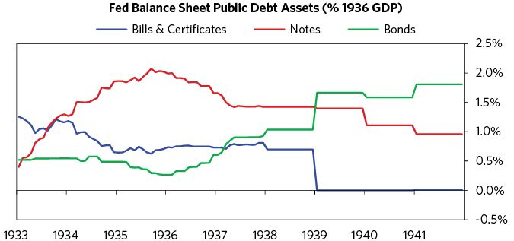

In the spring of 1938, the Fed added to the stimulus by lowering its reserve requirements back to 1936 levels, releasing about $750 million.204 The federal government also increased deficit spending that year and again in 1939 heading into the war. While the government was almost running a balanced budget at the start of 1938, the deficit rose to almost 3 percent of GDP by the start of 1939. Deficit spending above 2 percent of GDP continued throughout the year.

In 1938, the stock market began to recover, though stocks didn’t fully regain their 1937 highs until the end of the war nearly a decade later. Credit flows and the economy also recovered in 1939, following the stimulus and entry into the war.

### The Path to War

While the purpose of this chapter has been to examine the debt and economic circumstances in the United States during the 1930s, the linkages between economic conditions and political conditions, both within the United States and between the United States and other countries—most importantly Germany and Japan—cannot be ignored because economics and geopolitics were very intertwined at the time. Most importantly, Germany and Japan had internal conflicts between the haves (the Right) and the have-nots (the Left), which led to more populist, autocratic, nationalistic, and militaristic leaders who were given special autocratic powers by their democracies to bring order to their badly-managed economies. They also faced external economic and military conflicts arising as these countries became rival economic and military powers to existing world powers.

The case is also a good example of Thucydides’s Trap205—where rivalries between countries lead to wars in order to establish which country is more powerful, which are then followed by periods of peace in which the dominant power/powers get to set the rules because no country can fight them until a rival power emerges, at which time they do it all over again.

To help to convey the picture in the 1930s, I will quickly run though the geopolitical highlights of what happened from 1930 until the official start of the war in Europe in 1939 and the bombing of Pearl Harbor in 1941. While 1939 and 1941 are known as the official start of the wars in Europe and the Pacific, the wars really started about 10 years before that, as economic conflicts that were at first limited progressively grew into World War II. As Germany and Japan became more expansionist economic and military powers, they increasingly competed with the UK, US, and France for both resources and influence over territories. That eventually led to the war, which culminated in it being clear which country (the United States) had the power to dictate the new world order. This has led to a period of peace under that world order and will continue until the same process happens again.

More precisely:

* In 1930, the Smoot-Hawley Tariff began a trade war.
* In 1931, Japan’s resources were inadequate, and its rural poverty became severe, so it invaded Manchuria, China to obtain natural resources. The US wanted to keep China free from Japanese control and was competing for natural resources—especially oil, rubber, and tin—from Southeast Asia, while at the same time Japan and the US had significant trade with each other.
* In 1931, the depression in Japan was so severe that it drove Japan off the gold standard, leading to both the floating of the yen (which depreciated greatly) and big fiscal and monetary expansions that led to Japan being the first country to experience a recovery and strong growth (which lasted until 1937).
* In 1932, there was a lot of internal conflict in Japan, which led to a failed coup and a massive upsurge in right-wing nationalism and militarism. During the period from 1931 to 1937, the military took over control of the government and increased its top-down command of the economy.
* In 1933, Hitler came to power in Germany as a populist promising to exercise control over the bad economy, to bring order to the political chaos of the democracy of the time, and to fight the communists. Within just two months of being named chancellor, he was able to take total authoritarian control; using the excuse of national security, he got the Reichstag to pass the Enabling Act, which gave him virtually unlimited powers (in part by locking up political opponents and also by convincing some moderates that it was necessary). He promptly refused to make reparations payments, stepped out of the League of Nations, and took control of the media. To create a strong economy and attempt to bring prosperity to the people, he created a top-down command economy. For instance, Hitler was involved with setting up Volkswagen to build a more affordable car, and directed the building of the national German Autobahn (highway system). He believed that Germany’s potential was limited by its geographic boundaries, that it didn’t have adequate raw materials to feed the industrial military complex, and that German people should be ethnically united.
* At the same time, Japan became increasingly strong with its top-down command economy, building a military industrial complex, with the military intended to protect its bases in East Asia and Northern China and to expand its controls over other territories.
* Germany also got stronger by building its military industrial complex and looking to expand and claim adjacent lands.
* In 1934, there was severe famine in parts of Japan, causing even more political turbulence and reinforcing the right-wing, militaristic and nationalistic movement. Because the free market wasn’t working for the people, that led to the strengthening of the command economy.
* In 1936, Germany took back the Rhineland militarily, and in 1938, it annexed Austria.
* In 1936, Japan signed a pact with Germany.
* In 1936–7, the Fed tightened, which caused the fragile economy to weaken, and other major economies weakened with it.
* In 1937, Japan’s occupation of China spread, and the second Sino-Japanese War began. The Japanese took over Shanghai and Nanking, killing an estimated 200,000 Chinese civilians and disarmed combatants in the capture of Nanking alone. The United States provided China’s Chiang Kai-shek government with fighter planes and pilots to fight the Japanese, thus putting a toe in the war.
* In 1939, Germany invaded Poland, and World War II in Europe officially began.
* In 1940, Germany captured Denmark, Norway, the Netherlands, Belgium, Luxembourg, and France.
* During this time, most companies in Germany and Japan remained publically owned, but their production was controlled by their respective governments in support of the war.
* In 1940, Henry Stimson became the US Secretary of War. He increasingly used aggressive economic sanctions against Japan, culminating in the Export Control Act of July 2, 1940. In October, he ramped up the embargo, restricting “all iron and steel to destinations other than Britain and nations of the Western Hemisphere.”
* Beginning in September 1940, to obtain more resources and take advantage of the European preoccupation with the war on their continent, Japan invaded several colonies in Southeast Asia, starting with French Indochina. In 1941, Japan extended its reach by seizing oil reserves in the Dutch East Indies to add the “Southern Resource Zone” to its “Greater East Asia Co-Prosperity Sphere.” The “Southern Resource Zone” was a collection of mostly European colonies in Southeast Asia, whose conquest would afford Japan access to key natural resources (most importantly oil, rubber, and rice). The latter, the “Greater East Asia Co-Prosperity Sphere,” was a bloc of Asian countries controlled by Japan, not (as they previously were) the Western powers.
* Japan then occupied a naval base near the Philippine capital, Manila. This threatened an attack on the Philippines, which was, at the time, an American protectorate.
* In 1941, to aid the Allies without fully entering the war, the United States began its Lend-Lease policy. Under this policy, the United States sent oil, food, and weaponry to the Allied Nations for free. This aid totaled over $650 billion in today’s dollars. The Lend-Lease policy, although not an outright declaration of war, ended the United States’ neutrality.
* In the summer of 1941, US President Roosevelt ordered the freezing of all Japanese assets in the United States and embargoed all oil and gas exports to Japan. Japan calculated that it would be out of oil in two years.
* In December 1941, Japan attacked Pearl Harbor, and British and Dutch colonies in Asia. While it didn’t have a plan to win the war, it wanted to destroy the Pacific Fleet that threatened Japan. Japan supposedly also believed that the US was weakened by both fighting a war in two fronts (Europe and the US) and by its political system; Japan thought that totalitarianism and the command military industrial complex approaches of their country and Germany were superior to the individualistic/capitalist approach of the United States.

These events led to the “war economy” conditions explained at the end of Part 1.

News & Federal Reserve Bulletin

January 31, 1925

Radio Corporation Gain is 100 Per Cent

“The Radio Corporation of America’s earnings report for 1924, made public yesterday, shows gross income from operations of $54,848,131. This compares with $26,394,790 in 1923, and $14,830,857 in 1922.”

–New York Times

January 10, 1926

Public Buying Power Took Record Output

“The motor industry again established a new high-water mark for production in turning out about 3,800,000 passenger cars last year, exceeding the previous best record of 1923 by 100,000 cars and of last year by about 500,000 cars.”

–New York Times

July 25, 1926

Our Peak Year In Productivity; Industry and Trade Even Surpassed War Times, Commerce Department Year Book Says

“Industrial and commercial activity of the United States during the calendar year 1925 ‘reached the highest levels ever attained in our history, not even excepting the years of abnormal war activity,’ says the Commerce Department Year Book, made public today.”

–New York Times

August 20, 1926

Business Expansion Expected to Go On

“The last four months of the year should see expansion in the country’s business activity, according to the business review of the National Bank of Commerce and the Irving Bank-Columbia Trust Company. All of the indices of trade, they say, are favorable except in a few industries.”

–New York Times

January 3, 1927

Prosperity in 1927 Forecast By Bank

“The National City Bank, in commenting on the prospects for 1927, declared in a statement yesterday that the new year opens with good prospects for the continuance of prosperity.”

–New York Times

January 14, 1927

Ford in 16 Years Earned $375,927,275

–New York Times

June 17, 1927

$62,233,000 in Gold Now Held Abroad; Federal Reserve Banks Show Gain of $2,685,000 Over Amount of May 13

–New York Times

August 15, 1927

German Bank Warns of Foreign Payments; Thinks Problem of Meeting Foreign Indebtedness Still Far From Solution

–New York Times

August 21, 1927

Durant Predicts Long Bull Market

“William C. Durant, considered one of the most picturesque and spectacular figures identified with the stock market, believes that ‘we are drifting into a so-called bull market unprecedented in magnitude, which will extend over a period of many years to come.’”

–New York Times

September 23, 1927

Brokers’ Loans Reach New Peak

“Federal Reserve Board Report Shows Rise of $34,499,000 for last week. Total at $3,283,750,000.”

–New York Times

September 24, 1927

Over-the-Counter Trading is Slower; Major Activity Continues in Investment Trusts

“With trading at somewhat slower tempo and prices showing traces of easing, the over-the-counter market yesterday continued in much the same position it had maintained throughout the week. Major activity again appeared in the investment trust issues, but in the broader aspects of the market the general complexion was established by the trading in bank and insurance stocks.”

–New York Times

October 11, 1927

Loans To Germany Safe, Says Hahn; Banker Denies There Will Be Difficulties in Repayment—Points to History

–New York Times

November 11, 1927

Bank Deposits Here Biggest in World; Five-Eighths of All Are Held in the United States, Federal Reserve Official Says

–New York Times

December 5, 1927

“Bull Market” Here a Surprise to London

–New York Times

December 12, 1927

Sees United States Wiping Out Poverty

“Secretary Hoover’s report of economic gains since 1921 means not that prosperity has come to the bulk of the American people but that widespread poverty, which has persisted among all peoples through all the ages, may soon be abolished in the United States, according to Professor Irving Fisher, Yale economist, in a copyrighted article made public for tomorrow.”

–New York Times

February 25, 1928

Investment Trusts Cause Albany Clash

“The Republican legislative leadership and the State Banking Department were at odds today over the investment trust bills proposed by Attorney General Albert Ottinger….Senator John Knight, majority leader, made it clear, however, that the passage of the Attorney General’s legislation was on the Republican program...‘The investment trusts are doing an enormous business, which is constantly growing. They need some sort of supervision.’”

–New York Times

February 29, 1928

New Investment Trust Formed

–New York Times

March 13, 1928

Violent Advance in Many Stocks, Day’s Trading Breaks Records

“All doubt as to how last week’s events on the Stock Exchange would affect the speculative mind was removed with yesterday’s market. It reached 3,875,000 yesterday, thereby surpassing all previous achievements.”

–New York Times

March 25, 1928

Speculative Fever Grips The Market: Stories of Large and Quick Profits Whet Public Appetite as Never Before

–New York Times

May 4, 1928

Companies Report an Improved Trend

“Earnings and sales of corporations for the first quarter of the current year, reported yesterday, showed distinct improvement over the same quarter a year ago.”

–New York Times

July 25, 1928

Investment Trust Lists Rising Assets

–New York Times

July 26, 1928

Praises Condition Of Nation’s Banks

“The capital, deposits and total resources of the banks of this country are larger than ever before, according to figures in the annual report of R.N. Sims, Secretary Treasurer of the National Association of Supervisors of State Banks.”

–New York Times

September 2, 1928

Automobile Makers Setting New Records

“New high production records for this season of the year were established during August by several automobile manufacturers, while the industry as a whole continued to reflect the remarkable activity that has characterized it throughout the current year.”

–New York Times

September 14, 1928

New Investment Trust: American Alliance Already Has Funds of $4,750,000 Paid In

–New York Times

January 4, 1929

Moody Forecasts Market: Says 1929 Promises To Be Largely A Duplication of 1928

“The prosperity which has characterized this country with only moderate setbacks since 1923 is likely to continue without great variation well into the future, according to John Moody, president of Moody’s Investors Service.”

–New York Times

January 7, 1929

Chase Bank Assets At A High Record

–New York Times

February 2, 1929

The Reserve Bank’s Admonition

“It was not considered likely yesterday that even the serious remarks of the Federal Reserve Bank regarding the hazards of corporation loans in the call-money market will have any marked effect on the total of money in that market owned by corporations and on the immediate call. Nevertheless, the central banking authority’s observations on this new and unusual practice attracted a great deal of attention yesterday and drew fresh notice to what a year or so ago would have appeared to be an illogical operation.”

–New York Times

February 15, 1929

Reserve Bank Keeps Rate at 5 Per Cent After Long Debate

“In a meeting that lasted for almost five hours and that added a new strain to the already frayed nerves of Wall Street, the directors of the Federal Reserve Bank of New York decided last evening to leave the bank’s rediscount rate unchanged at 5 per cent.”

–New York Times

February 27, 1929

Forms New Trust for Many Accounts: Farmers’ Loan Develops Basic Principle of Revocable Voluntary Investment. Aims at Diversification Operation Consists of Composite Fund, With Company Acting as Trustee and Manager

–New York Times

March 14, 1929

Stocks Rally Moderately on Cheerful Industrial Reports and Easier Call Money

–New York Times

March 15, 1929

Call of Stock Expected

–New York Times

March 1929

Advances in Bill Rates and Discount Rates

“Buying rates on acceptances at the Federal Reserve Bank of New York were advanced on February 15 from 4 3/4 – 4 7/8 to 5 per cent for maturities up to 45 days and from 5 to 5 1/8 to 5 3/4 per cent for longer maturities. An advance in the discount rate from 4 1/2 to 5 percent on all classes of paper of all maturities was made at the Federal Reserve Bank of Dallas, effective March 2, 1929.”

–Federal Reserve Bulletin

March 26, 1929

Stock Prices Break Heavily as Money Soars to 14 percent

“Tightening on the strings of the country’s supply of credit, a development foreshadowed last week, but not considered seriously by speculators in the stock market, brought about yesterday one of the sharpest declines in securities that has ever taken place on the Exchange. Only twice in the history of the Exchange have there been broader breaks.”

–New York Times

March 27, 1929

Stocks Crash Then Rally in 8,246,740 Share Day

“A brisk recovery in the last hour of trading, ranging from 5 to 20 points, brought many stocks to a point where losses on the day were inconsequential, but that rally was too late for thousands of stock holders and speculators who had thrown their holdings overboard earlier in the day.”

–New York Times

March 28, 1929

Stocks Rally Vigorously As Bankers Aid Market

“Calmness after the violent storms of Monday and Tuesday reigned in the markets yesterday. Stockholders regained their courage when it became evident that pivotal issues were being adequately supported and that New York bankers stood ready to supply all the money needed at the going rates.”

–New York Times

April 21, 1929

U.S. Steel to Pay Bonds on Sept. 1; Call of $134,000,000 for Redemption at 115 One of the Largest Recorded

–New York Times

April 22, 1929

Investment Trust Earnings in 1928

“American investment trusts earned an average net income of 11.2 percent on invested capital in 1928, while unrealized profits brought the total to 25 percent.”

–New York Times

April 23, 1929

Draft Plan to List Investment Trusts

“Pressed from many sides by its member firms which have interested themselves in investment trusts to give formal listing privileges to these securities, the New York Stock Exchange authorities are reported to have agreed in principle on the class of such securities which will be admitted to trading. The problem is one of the most important which governors of the Exchange have faced since the war because it involves securities with a market value of upward of $2,000,000,000.”

–New York Times

April 25, 1929

Murphy & Co. Form Investment Trust; Graymur Corporation Will Start Business With Capital of More Than $5,000,000

–New York Times

June 21, 1929

Aldred Gains $1,464,000; Investment Trust’s Stocks in Four Utilities and an Industrial Rise

–New York Times

June 24, 1929

New Investment Trust; Hudson-Harlem Valley Corp. to Acquire Bank and Trust Stocks

–New York Times

July 3, 1929

Bank Borrowings Rose Here in June; Federal Reserve Reports Increase to $425,000,000, Highest in Recent Years

–New York Times

July 13, 1929

Stocks Sweep Up On Wave Of Buying

–New York Times

July 27, 1929

Investment Trust Gains in Earnings

–New York Times

August 10, 1929

Stock Prices Break As Rise In Bank Rate Starts Selling Rush

“The decision to advance the rediscount rate at the New York Federal Reserve Bank to 6 per cent from 5, for the double purpose of easing commercial credit conditions this Autumn and choking off the supply of purely speculative credit for securities stirred in its wake yesterday a storm of apprehensive selling in the country’s stock markets. Foreign markets, too, were weak and unsettled.”

–New York Times

August 17, 1929

Employment Fell a Little in July; But the Increase Over 1928 Was 6% and Earnings 7% Greater

“Employment decreased 0.2 per cent in July, 1929, as compared with June, and payroll totals decreased 3.8 per cent, according to a report issued by the Bureau of Labor Statistics of the United States Department of Labor.”

–New York Times

August 20, 1929

Rapid Advance in Many Stocks, Led by U.S. Steel – Money Unchanged

“With no change in money rates from last week’s final figures, yesterday’s stock market engaged in another advance of the character that has become familiar...the very rapid bidding up of prices for half a dozen industrial stocks of various descriptions, under the lead of United States Steel.”

–New York Times

August 9, 1929

Bank Rate Is Raised To 6% Here As Loans Reach $6,020,000,000

“As brokers’ loans mounted to a high record for the fourth successive week, passing the $6,000,000,000 mark for the first time, directors of the Federal Reserve Bank of New York yesterday advanced the rediscount rate from 5 per cent, the level which has been held since July 13, 1928, to 6 per cent… The financial community was taken completely by surprise by the advance in the rate.”

–New York Times

September 6, 1929

Babson Predicts ‘Crash’ in Stocks; Fisher View Is Opposite

“Wise investors will pay up their loans and avoid margin speculation at this time because a ‘crash’ of the stock market is inevitable, Roger Babson, statistician, said today before the sixteenth National Business Conference at Babson Park, Wellesley…’Stock prices are not too high and Wall Street will not experience anything in the nature of a crash’ in the opinion of Professor Irving Fisher of Yale University, one of the nation’s leading economists and students of the market.”

–New York Times

September 6, 1929

Stock Prices Break on Dark Prophecy

“Out of a clear sky a storm of selling broke on the stock exchange yesterday afternoon and in one hour wiped out millions of dollars in the open market value of securities of all sorts. It was one of the most hectic hours in the history of the Exchange, and wiped out thousands of small speculators who up to noon had been riding along comfortably on their paper profits. In the turbulent last hour of trading, the final quotation of which was not tapped out on Exchange tickers until almost 4 o’clock, about 2,000,000 shares of stock were handled and they hit the exchange in a torrent of liquidation.”

–New York Times

October 4, 1929

Year’s Worst Break Hits Stock Market

“Starting as a mild reaction, that grew in intensity with each succeeding hour, a drastic break in stock prices shook the New York Stock Exchange yesterday afternoon. Liquidation that swept through the market in the final hours cut millions of dollars from the open market value of securities. It was the widest decline of the year, accomplished in little more than two hours time. The break had been foreshadowed by the continued tightening of the financial structure as brokers’ loans increased, week by week, and by the nervousness and apparent hesitation which has characterized market fluctuations during the last fortnight.”

–New York Times

October 8, 1929

Recovery in Stocks Continues

“The recovery on the Stock Exchange which began on Saturday was resumed yesterday, after a brief period of hesitation. Before the day was over, numerous advances running to 10 points had been effected, and the majority of stocks closed around the day’s best prices.“

–New York Times

October 13, 1929

Steady Upward Trend in Earnings by Banks; Deposits also Show Advance in Third Quarter—Stocks Maintain Firm Tone

–New York Times

October 13, 1929

Mortgage Returns Show Good Values; Give Higher Investment Results Than Stocks and Bonds, Reveals Survey. Insurance Reports Used Holdings of 104 Leading Companies Compared in Statistical Study

–New York Times

October 20, 1929

Stocks Sweep Downward Under Heavy Liquidation—Trading Almost at Record Pace

“The sweeping break in prices under which the stock market staggered yesterday was undoubtedly occasioned both by heavy professional sales for the decline and by a recurrent avalanche of forced liquidation.“

–New York Times

October 22, 1929

Stocks Slump Again, but Rally at Close on Strong Support

–New York Times

October 23, 1929

Mitchell Decries Decline in Stocks; On Return from Europe, He Says Many Issues Are Selling Below True Values

–New York Times

October 23, 1929

Stocks Gain Sharply but Slip Near Close

–New York Times

October 24, 1929

Prices of Stocks Crash in Heavy Liquidation, Total Drop in Billions

“Frightened by the decline in stock prices during the last month and a half, thousands of stockholders dumped their shares on the market yesterday afternoon in such an avalanche of selling as to bring about one of the widest declines in history. Even the best of seasoned dividend-paying shares were sold regardless of the prices they would bring and the result was a tremendous smash in which stocks lost from a few points to as much as ninety-six.”

–New York Times

October 24, 1929

Wheat Prices Drop in a Rush to Sell; Tumble in Stocks Is Reflected in Grains and Values Go Swiftly Down

“Reflecting today’s drastic declines in stocks, values in the wheat market toward the close dropped 4 to 4 1/4 cents to a new low for the season.”

–New York Times

October 25, 1929

Financiers Ease Tensions

“Wall Street gave credit yesterday to its banking leaders for arresting the decline on the New York Stock Exchange at a time when the stock market was overwhelmed by selling orders. The conference at which steps were taken that reversed the market’s trend was hurriedly called at the offices of JP Morgan & Co.”

–New York Times

October 25, 1929

Wall Street Optimistic after Stormy Day

“Sentiment as expressed by the heads of some of the largest banking institutions and by industrial executives as well was distinctly cheerful and the feeling was general that the worst had been seen. The opinion of brokers was that selling had got out of hand not because of any inherent weakness in the market but because the public had become alarmed...”

–New York Times

October 25, 1929

Investment Trusts Buy Stocks Heavily, Pour in Their Reserves as Market Drops

–New York Times

October 26, 1929

Stocks Gain as Market Is Steadied; Bankers Pledge Continued Support; Hoover Says Business Basis Is Sound

–New York Times

October 27, 1929

Banking Buoys up Stricken Stocks

“When the financial history of the past exciting week is finally written an unusual chapter will be that devoted to the formation of a coalition of the city’s leading bankers to support the stricken stock market.”

–New York Times

October 27, 1929

Stocks Go Lower in Moderately Active Week-End Trading

–New York Times

October 27, 1929

Bond Dealers Report Investors Returning From Stocks to Securities With Fixed Yield

“In contrast to the depression which struck the stock markets of the country last week, trading in bonds on the New York Stock Exchange and also over the counter reached the highest levels of activity attained so far this year and to the accompaniment of rising prices.”

–New York Times

October 28, 1929

Low Yield on Stocks Drove Prices Down; Berlin Sees Crash Here as Result of Abnormal Valuations for Investment Shares

–New York Times

October 29, 1929

Stocks Drop Sags Hides; Futures Close 15 to 40 Points Off on 1,720,000-Pound Total

–New York Times

October 30, 1929

Reserve Board Finds Action Unnecessary: Six-Hour Session Brings No Change in the New York Rediscount Rate, Officials Are Optimistic

–New York Times

October 1929

Changes in Reserve Bank Portfolio

“The additional demand for reserve bank credit was met through the purchase by the reserve banks of acceptances in the open market. Following upon the reductions in July and August in the buying rates on bills, there was a rapid growth in offerings of acceptances to the reserve banks, and bill holdings of these banks increased by more than $200,000,000 from the first of August to the last of September.”

–Federal Reserve Bulletin

October 30, 1929

Further Fall of Extreme Violence in Stocks, in Largest Recorded Day’s Business

“Until shortly before the end of yesterday’s stock market there was no abatement whatever in the fury of liquidation. The day’s actual transactions of 16,400,000 shares ran far beyond last Thursday’s 12,800,000, and, in a long list of well-known shares, declines ran from 25 to 40 points.”

–New York Times

October 30, 1929

General View Is That It Has Run Its Course and That Basic Condition Is Sound. No ‘Catastrophe’ Is Seen; Transitory Forces Held to Be Behind Decline With Prosperity Not Affected

–New York Times

October 30, 1929

Insurance Heads Urged to Buy Stocks; Conway Suggests Price Level Offers Good Purchases for Investment

–New York Times

October 31, 1929

Sharp Recovery in Stocks, a Few Further Declines—Money 6 Per Cent, Sterling Strong

“The essential fact established by yesterday’s stock market was that panicky liquidation had been checked and that orders which had been placed by bona fide buyers were having their natural effect. All such hysterical declines as those of the present week are certain to end eventually with an upward rebound of prices.”

–New York Times

October 31, 1929

Gains by Bank Stocks Are 5 to 500 Points; Trading Is Heavy

“Bank stocks recovered in price yesterday in a volume of trading said to have surpassed the record of Tuesday. The brisk buying sent prices up from 5 to 500 points. National City Bank led again in volume and at the closing bid was up 85 points on the day... Investment trusts moved irregularly.”

–New York Times

November 1929

National Summary of Business Conditions

“Industrial activity increased less in September than is usual at this season. Production during the month continued above the level of a year ago, and for the third quarter of the year it was at a rate approximately 10 per cent above 1928. There was a further decline in building contracts awarded. Bank loans increased between the middle of September and the middle of October, reflecting chiefly growth in loans on securities.”

–Federal Reserve Bulletin

November 1929

Change in Discount Rate and Bill Rate

“The discount rate on all classes and maturities of paper at the Federal Reserve Bank of New York was reduced from 6 to 5 per cent, effective November 1. Buying rates on bills with maturities under 90 days at the New York bank were reduced from 5 1/8 to 5 effective on October 25, and effective November 1, were further reduced to 4 3/4 per cent. The buying rate on bills of 4 months 7 maturity was reduced from 5 1/8 to 4 3/4 per cent and on bills of 5-6 months’ maturity from 5 1/2 to 5 percent, effective November 1.”

–Federal Reserve Bulletin

November 1, 1929

Bank of England Cuts Rate; Unexpected Reduction to 6 Per Cent Cheered on Exchange—Prices Rise

“The governors of the Bank of England took the bold and unexpected step this morning of lowering the bank rate to 6 per cent after it had stood at 6 1/2 percent through five difficult weeks.”

–New York Times

November 5, 1929

Stocks Sag 2 to 17 Points in Day of Orderly Selling; Sessions Cut to 3 Hours; Prices Decline Steadily

“Deprived of support by last-minute cancellations of buying orders and staggered by an unexpected rush of selling, the stock market pointed sharply downward at the opening yesterday and remained reactionary throughout five hours of orderly trading.”

–New York Times

November 22, 1929

Listed Bonds Gain in Broader Trading; Government Issues in Demand, with 5 at New High Records for Year to Date

“The listed bond market showed further gains yesterday in considerably broader trading, with United States Government bonds again in brisk demand.”

–New York Times

November 29, 1929

Hoover’s Program as Seen by Europe; Feeling General That It Will Allay, but Not Avert, Trade Reaction

–New York Times

December 1, 1929

Hoover Stabilization Plans Require Careful Execution; Basic Principles Sound, but Discrimination Should Be Used in New Construction and Proposed Business Expansion

–New York Times

December 1, 1929

What Mr. Hoover Has Done

“Too much praise cannot be given the President for the prompt and resolute and skillful way in which he set about reassuring the country after the financial collapse. Making a new use of methods which he had frequently employed on a smaller scale when he was Secretary of Commerce, he summoned to Washington leaders in business and banking and industry and agriculture and organized labor, with the aim of inducing them to do everything possible to repair the disaster.”

–New York Times

December 1, 1929

To Aid Hoover Program; Fox Theatres, Inc., to Spend $15,000,000 on Construction Work

–New York Times

December 4, 1929

Wall Street Well Pleased With Hoover Message; Stocks Rise Briskly as It Comes Over the Ticker

“Wall Street appeared well pleased yesterday with President Hoover’s message to Congress. The Street paid particular attention to the sections dealing with revision of the banking laws, the consolidation of railroads and supervision of public utilities...Stocks, which had been moderately firm all morning, started forward briskly during the reading of the message and continued their up-swing until the close.”

–New York Times

December 5, 1929

Says Hoover Move Averted Wage Cuts; Hunt Tells Taylor Society Here President Blocked Reduction in 1921 as Well as Recently

“President Hoover’s attempt to organize the economic forces of the country to check any threatened decline in business at the outset was characterized as a significant experiment toward industrial equilibrium by Dr. Wesley C. Mitchell in an address last night at a meeting of the Taylor Society held at the Hotel Pennsylvania.”

–New York Times

December 10, 1929

Standard Oil Aided 129; Few Employees Buying Company’s Stock Asked Help in Slump

–New York Times

December 13, 1929

Bank of England Cuts Rate to 5%; Reduction From 5, Third Drop in Eleven Weeks, Astonishes London’s Financial District

–New York Times

December 31, 1929

Bonds Irregular on Stock Exchange; Domestic Issues Easier, but Foreign Loans Display Stronger Tone

“Bond prices showed considerable irregularity yesterday on the Stock Exchange, with domestic issues a trifle easier, on the average, and with foreign loans pointed upward. Liberty bonds and treasury issues were a shade lower in dull trading.”

–New York Times

January 1, 1930

General Price Rise Ends 1929 Stock Trading with Wall St. Moderately Bullish for 1930

“In a burst of holiday enthusiasm, which even a tremendous volume of cash sales failed to dampen, the market on the New York Stock Exchange closed the momentous speculative year 1929 with generally higher prices throughout the list. Prices advanced from a point or so to more than 12, with the best of the principal stocks establishing the greatest appreciation.”

–New York Times

January 19, 1930

Building Permits Continue Decline; But Straus Survey Indicates Cheap Money Will Aid Early Recovery

–New York Times

February 5, 1930

A Peak for the Year

“Not only did the volume yesterday establish a new high record on the Stock Exchange for 1930, but the composite averages of the New York Stock Exchange moved into the highest ground they have reached since the break of last autumn. Transactions aggregated 4,362,420 shares. It was the first time this year that business exceeded 4,000,000 shares. The last day to surpass yesterday’s volume was Dec. 20, when the turnover was 5,545,650 shares.”

–New York Times

March 14, 1930

Rediscount Rate Reduced to 3 1/2%; Federal Reserve Bank Here Makes Fourth Cut Since Stock Market Slump

–New York Times

March 17, 1930

Lower Money at Berlin; Day Loans Down to 3 1/2 and 5%, Discounts Cheapest Since 1927

–New York Times

April 1930

National Summary of Business Conditions

“Industrial production increased in February, while the number of workers employed in factories was about the same as in January. Wholesale commodity prices continued to decline. Credit extended by member banks was further reduced in February, but increased in the first two weeks of March. Money rates continued to decline.”

–Federal Reserve Bulletin

April 2, 1930

Big Gain by Stocks Made Last Month; Values of 240 Issues Rose $2,961,240,563 on the Stock Exchange

“With heavier trading than in either January or February, prices of stocks in March showed the greatest appreciation since the market decline last fall.”

–New York Times

April 1930

Changes in Discount Rate and Bill Paper

“The discount rate on all classes and maturities of paper was reduced from 4 to 3 1/2 per cent at the Federal Reserve Bank of New York, effective March 14; and from 4 1/2 to 4 per cent at the Federal Reserve Bank of Cleveland, effective March 15; at the Federal Reserve Bank of Philadelphia, effective March 20; and at the Federal Reserve Bank of San Francisco, effective March 21.”

–Federal Reserve Bulletin

April 11, 1930

Farm Wage April 1 Lowest Since 1923; Situation Reflects Big Supply of Labor Due to Depression in Industrial Employment

“Farm wages on April 1 were the lowest for that date since the Bureau of Agricultural Economics began to collect their figures on a quarterly basis in 1923, the Department of Agriculture announced today.”

–New York Times

April 15, 1930

Pledge Business Aid by Spending Money; Detroit Club Women Resolve on Effort to Dispel Depression Fear and Bring Out Hoarded Cash

–New York Times

April 26, 1930

Elections after Depression

“Between now and next November the uppermost political topic will be the extent to which trade reaction, coming along with a division in the Administration party and with a heavy fall in agricultural prices, will affect the Congressional campaign and the election of Governors.”

–New York Times

May 1930

The Credit Situation

“The credit situation has continued to be relatively easy in recent weeks. Demand for credit from commercial sources has declined further, while demand from the securities markets has increased. During the last two months increased activity in the securities markets, a large volume of bond issues, and—until the middle of April—a rising level of stock prices have been accompanied by an increase of more than $785,000,000 in brokers’ loans at New York City.”

–Federal Reserve Bulletin

May 1, 1930

Studebaker Cuts Dividend Rate to $4; Directors Cite Reduction in Earnings, Due to Decreased Demand for Autos

–New York Times

May 5, 1930

1,028 Economists Ask Hoover to Veto Pending Tariff Bill

“Vigorous opposition to passage of the Hawley-Smoot tariff bill is voiced by 1,028 economists, members of the American Economic Association, in a statement presenting to President Hoover, Senator Smoot, and Representative Hawley by Dr. Claire Wilcox, associate professor of economics at Swarthmore College, and made public here today. They urge the President to veto the measure if Congress passes it.”

–New York Times

June 1930

National Summary of Business Conditions

“The volume of industrial production declined in May by about the same amount as it increased in April. Factory employment decreased more than is usual at this season, and the downward movement of prices continued. Money rates eased further, to the lowest level in more than five years.”

–Federal Reserve Bulletin

June 10, 1930

Urge Tariff Cuts to Aid World Amity

–New York Times

June 14, 1930

Senate Passes Tariff Bill by 44 to 42...Europe Takes First Move in Reprisal

–New York Times

June 15, 1930

Stock Prices Sag on Passage of Tariff

–New York Times

June 16, 1930

Hoover Says He Will Sign Tariff Bill

–New York Times

July 29, 1930

Plan to Avoid Strikes Approved at Meeting; Court to Arbitrate Disputes of Building Trade Unions Tentatively Sanctioned

“A “definite agreement for arbitration for all jurisdictional disputes” was unanimously decided upon at an all day conference between national representatives of employers and unions in the building trades at the Strand Hotel here today, it was announced as the session ended.”

–New York Times

September 10, 1930

Labor Immigration Halted Temporarily At Hoover’s Order

“Acting on the request of President Hoover to restrict immigration as much as possible as a relief measure for unemployment, the State Department has ordered a more strict application of that section of the law withholding visas from immigrants who may become ‘public charges’ after they have entered this country.”

–New York Times

October 1930

Continued Monetary Ease

“Conditions in the money market remained easy through September. Although the usual seasonal trend at this time of the year is upward, there was little change in the demand for reserve-bank credit, and increase in holdings of acceptances by the reserve banks was reflected in a further decline of discounts for member banks.”

–Federal Reserve Bulletin

December 11, 1930

False Rumor Leads to Trouble at Bank

“A small merchant in the Bronx went to the branch of the Bank of United States at Southern Boulevard and Freeman Street yesterday and asked bank officials to dispose of his stock in the institution. He was told that the stock was a good investment and was advised against the sale. He departed and apparently spread a false rumor that the bank had refused to sell his stock.”

–New York Times

December 11, 1930

Stocks Decline, Trading Largest in 4 Weeks—Corn and Cotton Go Lower

–New York Times

December 12, 1930

Bank of U.S. Closes Doors

“While officials of the institution issued a statement expressing hope of an early reopening, leading banks of the city took steps to provide temporary relief for the depositors, offering to loan them 50 per cent of the amount of their deposits. The institution, despite its name, had no connection with the federal government. Deposits at the time of closing were approximately $160,000,000.”

–New York Times

December 17, 1930

Severe Decline on Stock Exchange—Silver Breaks Sharply, Cotton Improves

“Yesterday’s stock market was decidedly weak, under the largest trading since the break in the early days of last month culminated on Nov. 10. In yesterday’s market, declines of 4 to 6 points were numerous, with losses in a few stocks running even larger. The day’s declines affected shares of all descriptions, some of the high-grade stocks being for a time the points of special weakness. There was some irregularly distributed recovery before the closing.”

–New York Times

December 23, 1930

Shut Bankers Trust of Philadelphia

“Directors of the Bankers Trust Company of Philadelphia, after an all-night conference, voluntarily turned over the bank’s affairs to the State Department of Banking and neither the main office nor any of the nineteen branches of the institution opened for business today.”

–New York Times

December 24, 1930

Topics in Wall Street: The Bank Closing

“Wall Street took the news of the suspension of the Chelsea Bank and Trust Company yesterday philosophically. The event, it was felt, while obviously unfortunate for the customers of the closed institution, had little significance for the financial world. The Chelsea Bank operated entirely outside the financial district and its closing has no bearing on the position of other banking institutions. It is, moreover, a small bank as New York banks go, not a member of the Clearing House or the Federal Reserve system.”

–New York Times

December 1930

Recent Banking Developments

“The general level of money rates at the opening of December was as low as at any time since records became available. This ease in the money market has accompanied a further decrease in the demand for credit from the security market, which is shown by a rapid decline in brokers’ loans to the lowest level in five years.”

–Federal Reserve Bulletin

January 1931

A Year of Declining Business Activity

“In November and December there was a further decline in output and in employment in most manufacturing industries. Wholesale prices for many important commodities also continued to decline during the last two months of the year. Business activity, which began to recede in midsummer of 1929 after the rapid expansion of the preceding year and a half, continued to decline at a rapid rate during the last half of 1930, following a brief recovery in the spring. Almost all branches of industry shared in the decline. Employment declined, and total income of both wage earners and farmers decreased. At the same time wholesale prices throughout the world declined considerably, and retail prices also reflected this decline, although in smaller degree.”

–Federal Reserve Bulletin

January 25, 1931

Wall Street Now Flooded with Optimistic Prophecies—Policies of Federal Reserve Bankers Compared

“For the first time in some months Wall Street was treated last week to a shower of optimism. Bankers and industrialists whose opinions weigh heavily with the financial community and who previously had declined to venture into the realm of prophecy struck out openly at the pessimists and with telling effect. Even the taciturn chairman of the First National Bank, George F. Baker, broke his rule of silence to the extent of telling the country that he detected signs of ‘improvement in business conditions along sound lines.’”

–New York Times

February 11, 1931

Stocks Go Higher, Public Buying Again

“Another runaway market developed yesterday on the New York Stock Exchange, with the public and Wall Street professionals joining hands for the first time in a year in an enthusiastic buying demonstration which lifted the main body of stocks 2 to 6 points and sensitive specialties 7 to 14 points.”

–New York Times

February 25, 1931

Stocks Rise Briskly; 330 at New Highs

–New York Times

March 1931

National Summary of Business Conditions

“Industrial activity increased in January by slightly less than the usual seasonal amount, and factory employment and pay rolls declined. Money rates in the open market declined further from the middle of January to the middle of February.”

–Federal Reserve Bulletin

March 1, 1931

Maximum Wage Bill is Passed by House

“The Bacon-Davis maximum wage bill, providing that the highest wage scale prevalent in any community where public works are undertaken under Federal contract, be paid to all laborers and mechanics, was passed in the House this afternoon without a roll-call. The bill goes now to President Hoover, as it already has been passed by the Senate.”

–New York Times

March 2, 1931

Muller Optimistic on Business in 1931; Curb Exchange Head, in Report for 1930, Finds Hope in Theory of Cyclical Changes

–New York Times

March 13, 1931

Special Relief Measures

“To provide direct relief for their unemployed workers and to devise schemes for regularizing unemployment is the double object of several companies working generously and sensibly in the present emergency.”

–New York Times

March 19, 1931

$700,000,000 Deficit in Budget Feared; Experts Admit Indications Are For Unexpected Cut in Income Taxes

–New York Times

March 23, 1931

Germany’s Budget Deficit; Including Deficits Carried Over, Shortage Is 251,000,000 Marks

–New York Times

March 23, 1931

2,000,000,000 Deficit Predicted in France; February Public Revenue Down 104,000,000 Francs; Budget of ‘Supplementary Expenditure’ Up

–New York Times

March 25, 1931

Relief for Jobless Sets City Record; $3,175,000 Spent in February by Eleven Agencies Alone—30,000 Families Aided

–New York Times

March 27, 1931

Borah Urges Rise in Federal Taxes; Says Deficit Makes Increase Necessary and Advocates “Ability-to-Pay” Basis

“A breach in the Republican ranks over the question of Federal tax increases developed today when Senators Borah and Norris advocated action by Congress in December, despite the inclination of the regular party leaders to delay consideration until after the election next year.”

–New York Times

March 29, 1931

Why the Treasury Faces a Large Deficit; Revenues Have Declined and Expenditures Increased Because of the Depression Changes in Estimate

“When the Federal Government closes its accounts on June 30, at the end of the current fiscal year, the treasury’s bookkeeper will write down on the debit side of the ledger a deficit of $700,000,000 or more, if the latest unofficial estimates prove correct.”

–New York Times

March 29, 1931

Red Cross to Hear Hoover on Relief; He Is Expected, at the Annual Meeting, to Amplify Views on Federal Help

“President Hoover will address the Red Cross on the drought-relief situation, and the organization will plan further measures to help the large numbers in the stricken areas who are still in want, at its two-day annual convention which is to begin in Washington on April 13.”

–New York Times

March 31, 1931

Further Irregular Decline in Stocks, Trading Larger—Grain Markets Move Uncertainly

“The course of yesterday’s stock market was plainly enough directed by professional pressure, applied on the theory that the company dividend reductions would have shaken financial confidence and induced actual selling. The extent to which such an influence has operated remains to be seen.”

–New York Times

April 12, 1931

Expansion of Dollar Acceptances Described As Without Parallel in Financial History

“The course of yesterday’s stock market was plainly enough directed by professional pressure, applied on the theory that the company dividend reductions would have shaken financial confidence and induced actual selling. The extent to which such an influence has operated remains to be seen.”

–New York Times

May 1931

Money Market Conditions

“Notwithstanding the low and declining level of money rates in this country, there continued to be a large inflow of gold from abroad. Gold imports, which amounted to $100,000,000 during the first three months of the year, were proceeding at an even more rapid rate after the beginning of April. Particularly noteworthy was the receipt of $19,000,000 of gold from France in the course of one week.”

–Federal Reserve Bulletin

May 1, 1931

Urge Trade Budgets to Avert Depression; National Commerce Chamber Speakers Outline System to Control Expansion

–New York Times

May 3, 1931

March Foreign Trade Grouped by Products; Percentage Decreased From 1929 in Exports Largest in Food and Manufactures

–New York Times

May 4, 1931

Favored-Nation Bid Evaded by Austria; New Trade Pact With Hungary, in Effect June 1, Employs a System of Rebates

“The proposed Austro-Hungarian trade treaty, the negotiations for which have been proceeding for months, now remains only to be paragraphed and will go into force on June 1… The origin of the Austro-Hungarian treaty was a demand by Austrian farmers for greatly increased protection, which could not be refused for political reasons, but which Hungary threatened to counter by raising the duties on Austrian industrial products.”

–New York Times

May 5, 1931

Hoover Urges Arms Cut to Revive Trade in Opening World Chamber of Commerce; Foreign Delegates Attack High Tariffs; 35 Nations Represented; President Asks That Land Forces Be Reduced as Navies Are

–New York Times

May 12, 1931

Austria Acts to Save Biggest Private Bank

“Prompt action by the Austrian Government and banks in advancing $23,000,000 to the Kreditanstalt für Handel und Gewerbe is believed to have saved from failure the country’s largest private bank. Had news of the bank’s condition become known prematurely, according to its directors, a run probably would have resulted which would have forced it to close its doors within twenty-four hours.”

–New York Times

May 22, 1931

Gold Imports $3,604,000; Reserve Bank Here Reported for Week also $10,000 Sent to Germany

–New York Times

May 31, 1931

The Eyes of Europe Are Again on Germany; Looking Forward to a Readjustment of Frontiers and a Revision of Debts, the Reich Is Preparing to Play an Important Role in the Era Now Opening, Wherein She Aims at Industrial Leadership

–New York Times

June 2, 1931

Sharp Fall in Stocks, Railway Shares Especially Weak—Stock Exchange Trading Larger

“The decline on the Stock Exchange continued yesterday; in a good many stocks, at an accelerated pace. While the scope of losses for the day varied widely, some of the individual declines were unusually large.”

–New York Times

June 4, 1931

Stocks Up as Banks Ease Margin Policy

“Shaking off the reactionary influences that depressed prices steadily for several weeks, the stock market pointed sharply upward yesterday in the widest advance since Nov. 15. 1929, the second day of the recovery from the disastrous break of that period. Yesterday’s advance, which extended to every part of the New York Stock Exchange, was accelerated by announcement that banks were adopting a more liberal policy in loans on stock collateral.”

–New York Times

June 4, 1931

$25,000,000 Cut Seen by Canada’s Tariff; Klein Says Increased Rates Imperil Our Export Trade to That Extent

–New York Times

June 5, 1931

Trade Group Asks Ban on Red Goods; State Chamber Also Wants Exports of Machinery to Russia Stopped

–New York Times

June 7, 1931

Drop in Foreign Trade Greater Than in 1921; Lewis Shows Exports 32% and Imports 35% Less Than in Same Period of 1929

–New York Times

June 9, 1931

Sees Politics Waning in Europe’s Situation; J.G. McDonald Finds Ground for Hope Economic Interests Are Gaining Control

–New York Times

June 15, 1931

Paris Is Disturbed over German Crisis; Fears Are Created Less by Economic Difficulties Than by Political Possibilities

–New York Times

June 21, 1931

Paris Is Surprised By Plan of Hoover; Suspension of All War Payments for a Year Is Thought Perhaps Too Generous

“President Hoover’s proposal for a year’s suspension of war-debt and reparations payments has caused very great surprise and interest in Paris. It has proved more far-reaching than was expected even after yesterday’s announcement. Until the exact terms are known and their effect on the existing arrangements are studied the French are reserving comment.”

–New York Times

June 23, 1931

World Prices Soar on Debt Optimism

“Led by New York, tremendous buying enthusiasm swept over the security and commodity markets of the world yesterday in response to week-end developments reflecting the favorable reception of President Hoover’s proposal for a one-year moratorium on war debts and reparations.”

–New York Times

July 14, 1931

Central Banks Agree to Help Reich; Act After All-Day Meeting at Basle; German Bank Runs Bring 2-Day Closing

“Under authority granted by President von Hindenburg, the Bruening Government late tonight decreed that on Tuesday and Wednesday all banks and other credit institutions in Germany shall remain closed and that during this time the ‘execution and acceptance of payments and transfers of any nature whatever at home and abroad are prohibited.’”

–New York Times

July 1931

Loss of Gold by Germany

“In recent weeks additions to this country’s gold stock, which have been continuous since last autumn, greatly increased in volume. In addition to the inflow of gold from Argentina and Canada, a large amount of gold, which had previously been held under earmark for foreign account, was released in the United States. This release of gold was connected with a largescale withdrawal of short-time funds from the German market. During the period from May 31 to June 23 the Reichsbank lost $230,000,000 in gold and $20,000,000 in foreign exchange, with the consequence that its reserves were reduced close to the minimum required by law.”

–Federal Reserve Bulletin

July 14, 1931

German Bonds Fall Sharply Here; Hoover Keeps in Touch with Moves to Aid Reich

“One of the worst breaks in the list of German dollar bonds since war time occurred here yesterday on tie Mock Exchange when the active issues closed the day 2 3/8 to 15 points net lower.”

–New York Times

July 24, 1931

News of Markets in London and Paris; English Prices Depressed on Rise in Bank Rate and Decision on Germany

“The stock markets were depressed today both by the increase in the bank rate to 3 per cent and the decision of the Finance Ministers concerning the German situation, which was not regarded as favorable.”

–New York Times

July 30, 1931

Bankers to Leave Funds in Germany; British and Americans Agree With Reichsbank to Extend Short-Term Loans. Nation is More Confident

“Negotiations at the Reichsbank with British and American bankers for the prevention of further withdrawals of short-term credits from Germany were successfully concluded tonight when the bankers’ representatives agreed they would leave their credits in Germany.”

–New York Times

August 6, 1931

Says An Election Now Would Defeat Hoover; Farley Tells Westchester Democrats President Would Not Win Two Western States

–New York Times

August 7, 1931

Hoover Seeks Means of Averting a ‘Dole’ for the Unemployed; Calls Julius H. Barnes and Silas H. Strawn to White House for Conference

“Realizing that another Winter is approaching with no apparent change for the better in employment conditions, President Hoover and his economic advisers are determined to work out some plan for relief with which to ward off the possible enactment of a “dole” by the next Congress.”

–New York Times

August 24, 1931

Hoover’s Relief Plan Assailed as Callous; Progressive Labor Action Chairman Says President and Advisers Help Fire Revolt Spirit

“President Hoover’s unemployment relief plan is condemned as “inadequate and in many respects vicious,” in a statement issued yesterday by A.J. Muste, chairman of the Conference for Progressive Labor Action, at 104 Fifth Avenue.”

–New York Times

August 26, 1931

Hoover and Mellon Consult on Britain; Treasury Head Said to Have Reported That Confidence Will Restore Situation

“Secretary of the Treasury Mellon, who returned from a European trip last night, today went over the European situation, including the British crisis, with President Hoover.”

–New York Times

August 28, 1931

Hoover Reported to Favor Credits; Subject of Conferences at the White House Undivulged by the Participants

“President Hoover, it was reported late tonight, discussed the proposed bankers’ loan of $400,000,000 to the English Government in his conference with New York bankers and Secretary Mellon at the White House conference last night.”

–New York Times

September 5, 1931

$2,000,000,000 in Gold Finds ‘Refuge’ Here in Flight of Capital; Lack of Confidence Abroad Helps to Build Our Total to Record $5,000,000,000

–New York Times

September 11, 1931

Foreign Fears Bring Gold; “Security” Aims Reflected—Big Circulation Laid to Hoarding

–New York Times

September 11, 1931

French Bank Reduces All Of Its Loans; Home and Foreign Discounts Cut Down—Only Slight Increase of Gold

–New York Times

September 18, 1931

Slight Gain in Gold at Bank of France; Foreign Sight Balances Up 985,000,000 Francs, Foreign Bills Discounted 225,000,000

–New York Times

September 20, 1931

Sterling Exchange Plunges to $4.84 1/2; Cable Transfers Drop 1 5-16c, Sending Pound Lowest Here Since July 22

“Disturbed financial markets in London precipitated a wide-open break in sterling exchange here yesterday, driving the pound down to $4.84 1/2 for cable transfers, well below the gold-shipping point and the lowest price since July 22.”

–New York Times

September 21, 1931

British Recovery Foreseen by Bankers Here; Gold Suspension Move Termed the First Step

“The suspension of the gold standard in England, viewed as a preliminary step to revalorization of the pound at a lower level, may prove the first step in the final solution of Great Britain’s pressing economic problems, according to bankers here.”

–New York Times

September 22, 1931

Would Emulate Britain; League Adviser Holds Germany May Also Drop Gold Standard

–New York Times

September 25, 1931

Sales of Gold Upset Money Market Here; Stock Prices Break; Foreigners Buy $64,000,000, Bringing ‘Loss’ of Metal to $180,600,000; Bankers’ Bills Unloaded; Yield Rate of Acceptances Goes Up but Federal Reserve Clings to 1 Per Cent Discount

–New York Times

September 25, 1931

Sterling at $3.85 on London Market; Prices of Commodities and British Industrials Rise at Rapid Rate

“As a result chiefly of the speculative selling of sterling abroad the pound further declined today, although the prices of commodities and British industrial shares soared upward at great speed.”

–New York Times

September 26, 1931

Pound Still Upsets Markets of World; Stock Exchanges in Number of Cities Remain Closed–Sterling Generally Declines

–New York Times

September 27, 1931

Stocks Move Uncertainly, Most Changes Small–Bonds Are Steadier, Sterling Recovers

–New York Times

September 29, 1931

$51,953,600 in Gold Lost to US in a Day; $31,500,000 Is Earmarked for Foreign Account—Exports of $20,453,500 Top Since 1928

“The action of Sweden and Norway in following Great Britain’s lapse from the gold standard brought further confusion to the foreign exchange market yesterday and provoked foreign central banks to make additional requisitions against the gold stocks of this country for the purpose of strengthening their reserves.“

–New York Times

October 1931

Changes in Discount Rate and Bill Rate

“The discount rate on all classes and maturities of paper was increased from 1 1/2 to 2 1/2 per cent at the Federal Reserve Bank of New York, effective October 9; at the Federal Reserve Bank of Boston from 2 to 2 1/2 per cent, effective October 10; and at the Federal Reserve Bank of Cleveland from 2 1/2 to 3 per cent, effective October 10. At the Federal Reserve Bank of New York buying rates on bills of all maturities were increased.”

–Federal Reserve Bulletin

November 1931

Review of the Month

“During the 6-week period following the suspension of gold payments by Great Britain there was a decrease in the country’s stock of monetary gold amounting to $730,000,000 and an increase in currency outstanding of $390,000,000. Both of these factors increased the demand for reserve bank credit, and the total volume of this credit, notwithstanding a considerable decrease in member bank reserve balances, increased by $930,000,000 during the period, and was at the end of October at the highest level in 10 years. The outflow of gold, which began at the time of the suspension of gold payments by Great Britain on September 21, was the largest movement of the metal during a similar period in any country at any time.”

–Federal Reserve Bulletin

November 1, 1931

Hoover Gives $2,500 to Fund to Assist the Idle of District (NYT)

“President Hoover gave $2,500 today toward District of Columbia unemployment relief. E.C. Graham, chairman of the city’s employment committee, was notified of the donation by a telephone call from Lawrence Richey.”

–New York Times

November 3, 1931

Propose to Hoover Home Credits Plan; Building and Loan League Men Suggest Federal Land Bank Aid to Their Societies

–New York Times

November 4, 1931

Realty Credit Aid Studied by Hoover; President Confers with Glass on Bank System to Rediscount Urban Mortgages

–New York Times

November 5, 1931

Bennett Approves Hoover Credit Plan; Opinion to Broderick Says It Is Legal for State Banks to Participate in Pool

“Banks under the supervision of the State Banking Department may use funds legally to participate in the plan of the National Credit Corporation, which was founded at the suggestion of President Hoover to stabilize the financial situation, according to an opinion rendered yesterday by Attorney General John J. Bennett, Jr.”

–New York Times

November 7, 1931

$350,000,000 Slash in Budget Figures Revealed by Hoover

–New York Times

November 8, 1931

Hoover Plans Aid for Home Builders; Conference of Bankers, Builders and Architects to Be Held in Washington Dec. 2

“The design of the average small home in the United States is defective and construction of better homes for less money is possible, in the opinion of prominent architects who are preparing a report to be submitted to President Hoover’s conference on ‘home building and home ownership,’ which will meet in Washington, D.C., on Dec. 2.”

–New York Times

November 8, 1931

Weekly Business Index Declines to New Low; Comparisons Made with Past Depressions

“The movement of the weekly index of business activity in the final week of October was dominated by the decline in the adjusted index of automobile production from 24.4 to the exceptionally low figure of 15.5.”

–New York Times

November 29, 1931

An Evenly Divided Congress Faces Many Major Problems; Issues Raised by the Depression and by Foreign Events Are Added to the Usual Questions Calling for Solution

–New York Times

December 19, 1931

Ask New Lien Laws to Aid Home Owner; Realty Interests Urge a Cut in Costs of Foreclosure and in Charges of Referees

–New York Times

December 20, 1931

Urges Three Steps to Start Recovery; Col. Thompson Suggests State Spending, Foreclosure Halt and Cut in Prices

–New York Times

December 31, 1931

Credit Pool Set Up to Aid Sound Banks; Plan Suggested by President Hoover Promptly Put into Operation

“An important development of the past year in the field of commercial banking was the organization, at the suggestion of President Hoover, of the National Credit Corporation, designed to provide discounting facilities for sound bank assets not eligible under the present regulations for purchase by the Federal Reserve banks. The plan, which was devised in an effort to halt the wave of bank failures and, by restoring public confidence in the banks, to check hoarding of money, was advanced by Mr. Hoover on Oct. 7.”

–New York Times

December 31, 1931

Say Reserve Banks Can Bring Recovery; Economists Recommend They Halt Liquidation by Ending Credit Contraction. Bill Buying Suggested

–New York Times

December 1931

National Summary of Business Conditions

“Production and employment in manufacturing industries declined further in October, while output of minerals increased more than is usual at this season. There was a considerable decrease in the demand for reserve bank credit after the middle of October, reflecting a reduction in member bank reserve balances and, in November, an inflow of gold, largely from Japan. Conditions in the money market became somewhat easier.”

–Federal Reserve Bulletin

January 3, 1932

Congress Faces Hosts of Problems; Paramount Need Is Action on the Proposed Reconstruction Finance Board

“Foremost among problems facing Congress when it reconvenes is the bill to create a $500,000,000 reconstruction finance corporation, as advocated by President Hoover, which in many functions would duplicate the War Finance Corporation which operated in the days after the World War.”

–New York Times

January 13, 1932

President to Speed $2,000,000,000 Board; He Says Reconstruction Corporation Will Start Work Soon After the Act Passes

“The Reconstruction Finance Corporation, with a contemplated lending capacity of $2,000,000,000, will be in operation a few days after Congress finally passes the bill for its creation, President Hoover told Senate leaders with whom he conferred today.”

–New York Times

January 16, 1932

Reconstruction Bill Passed by the House; $2,000,000,000 Finance Measure Is Adopted

–New York Times

January 17, 1932

Increased Optimism Pervades Business; Passage of Reconstruction Bill and Move Against Deflation Cheer Leaders

“The passage of the Reconstruction Finance Corporation bill by both houses of Congress and the conciliatory attitude with which the delegates to the railroad labor conference in Chicago finally met, together with the fact that the Federal Reserve System appears to have embarked on a policy to halt deflation, all served to create a better feeling in the financial community last week.”

–New York Times

January 17, 1932

Three Banks Are Closed; Two of These Are in Chicago and One Is in Erie, Pa.

–New York Times

January 20, 1932

Joliet (Ill.) Bank Closes; Directors Say, However, That It Is Solvent and Predict Reopening

–New York Times

January 20, 1932

Rensselaer (N.Y.) Bank Closes

–New York Times

January 21, 1932

Two Chicago Banks Close

–New York Times

January 22, 1932

Hoover Asks House to Vote $500,000,000 for Finance Board

–New York Times

February 1932

Reconstruction Finance Corporation

“The principal development affecting the banking situation in January was the enactment of legislation creating the Reconstruction Finance Corporation with a capital of $500,000,000. The Reconstruction Finance Corporation Act, designed principally ‘to provide emergency financing facilities for financial institutions’ and ‘to aid in financing agriculture, industry, and commerce’ was approved by the President on January 22, 1932. In announcing his approval the President said of the new corporation: ‘It brings into being a powerful organization with adequate resources, able to strengthen weaknesses that may develop in our credit, banking, and railway structure in order to permit business and industry to carry on normal activities free from the fear of unexpected shocks and retarding influences.’”

–Federal Reserve Bulletin

February 1932

National Summary of Business Conditions

“Industrial activity declined from November to December by slightly more than the usual seasonal amount, while the volume of factory employment showed about the usual decrease. Wholesale prices declined further.”

–Federal Reserve Bulletin

February 11, 1932

Europe Withdraws $17,045,500 of Gold

“European withdrawals of gold amounting to $17,045,500 were reported yesterday by the Federal Reserve Bank of New York. Imports of $1,070,200 from Canada and $575,000 from India were also announced, and an increase of $100,000 in gold earmarked for foreign accounts was shown.”

–New York Times

February 11, 1932

Changes in Reserve Act

“Development of a powerful financial machine based on revolutionary changes in the Federal Reserve System and designed to stimulate credit through a possible increase of $2,500,000,000 in the currency was decided upon at a non-partisan conference of Democratic and Republican leaders called at the White House today by President Hoover.”

–New York Times

February 11, 1932

Federal Aid Stirs Sharp Senate Clash

“Senators Fess of Ohio and Borah of Idaho, both Republicans, clashed today in a lively debate over the La Follette-Costigan bill for direct Federal aid for the unemployed. Crowded galleries applauded the speakers. Vote on the measure was delayed until tomorrow, when Republican leaders count on Democratic aid for its defeat.”

–New York Times

February 11, 1932

Stocks Fall, Then Recover Most of Their Losses

February 27, 1932

Credit Bill Voted: Hoover Signs Today

“Approved by Congress today without a dissenting vote, the Glass-Steagall credit-expansion bill reached the White House at 6:08 o’clock tonight and will be signed by President Hoover tomorrow.”

–New York Times

February 27, 1932

Bank Conditions Improve in 14 Days

“A noticeable improvement has taken place in the banking situation in two weeks, according to reports received by the Federal Reserve Board and by J.W. Pole, Controller of the Currency. For eight days there have been no national bank failures, a new record for many months, while there has been an appreciable decline in failures of other member and State banks for ten days.”

–New York Times

February 27, 1932

Credit Bill Voted; Hoover Signs Today; Not a Dissenting Voice Is Heard In Congress Against Passage of Bank Aid Measure

–New York Times

March 2, 1932

Senate Body Acts for Broad Inquiry on Short Selling; Banking Committee Will Go Beyond Hoover Idea in Stock Exchange Investigation

“An investigation of the New York Stock Exchange was recommended today by the Senate Banking and Currency Committee. A subcommittee, headed by Senator Walcott, Republican, of Connecticut, immediately began drafting a resolution requesting authority for such an investigation from the Senate.”

–New York Times

March 10, 1932

Hoarding by Banks Put Before Hoover

“A charge that some banks were hoarding money and that their restrictive credit policies crippled industrial activities was laid before President Hoover today by the Institute of Scrap Iron and Steel through its director general, Benjamin Schwartz.”

–New York Times

March 18, 1932

More Gold Taken in by Bank of France

–New York Times

March 20, 1932

Government Economy to Cut Deficit Urged; Expert Says Business Practices Should Be Adopted to Cover Federal Requirements

“Comparing the financial plight of the government at the present time to that of any large industrial organization, W. Clement Moore, economist and tax expert, asserted yesterday that the government should adopt business methods and common sense in attempting to balance the budget.”

–New York Times

April 5, 1932

Gold Holdings Here Down $118,400 in Day

–New York Times

April 8, 1932

President Accepts House Bid for Help in Economy Quest

“President Hoover today accepted the invitation of the House Economy Committee to cooperate with it in reducing Federal expenditures. He requested the entire committee to meet with him at the White House at 11 o’clock Saturday morning.”

–New York Times

April 9, 1932

Stocks Extend Their Decline Again, Breaking Through the Previous Lows—Bonds Also Depressed

“A stock market that has been growing steadily weaker for more than a week was subjected yesterday to further selling pressure in circumstances that served to intensify the mood of discouragement in Wall Street. Measured by points, the decline on the Stock Exchange was of only moderate scope—running from 1 to 3 points among the more prominent issues—but gauged on the basis of percentages the fall was quite sharp.”

–New York Times

June 6, 1932

Congress Prepares for 2-Week Battle

“A week, or possibly a fortnight, of bitter controversy faced Congress tonight with the paramount legislative questions of taxes, economy, relief and possibly the bonus to be settled.”

–New York Times

June 26, 1932

Hoover ‘Wrong,’ Say Relief Bill Backers

“Aroused by the President’s criticism of his unemployment relief bill because of the $500,000,000 appropriated in it for public works, Senator Wagner today delivered a final plea for the measure as it was taken up by a conference of members of the House and Senate.”

–New York Times

July 3, 1932

Convention Throng Hails Roosevelt; Tremendous Ovation for the Nominee Rings Out

–New York Times

July 24, 1932

Roosevelt to Wage Fight in Every State

“Predicting that Governor Franklin D. Roosevelt would be elected by a greater electoral college majority than any Democratic candidate for President except Woodrow Wilson in 1912, James A. Farley, chairman of the Democratic National Committee, declared yesterday that he regarded no State, no matter how strongly Republican in past elections, lost to the Democratic national ticket this year.”

–New York Times

August 1932

Emergency Relief Bill

“New legislation relating to the reserve banks and member banks has been the principal development in the banking situation in recent weeks. On July 21 the President signed the emergency relief and construction act of 1932, the text of which is published elsewhere in this issue. This act authorizes the Reconstruction Finance Corporation, under certain conditions, to make available to States and Territories for the relief of distress a total of not to exceed $300,000,000, the amount advanced by the corporation to bear interest at the rate of 3 per cent. It further provides for loans by the corporation to States and other political bodies or agencies, and to private corporations, for self-liquidating projects of a public or semipublic nature, such as bridges, tunnels, docks, and housing facilities in slum areas.”

–Federal Reserve Bulletin

September 2, 1932

Big Gain by Stocks Recorded in Month; 240 Issues on Exchange Rise $4,041,656,665, Sharpest Advance in Three Years

–New York Times

September 10, 1932

Nation’s Bank Clearings Up 3.6% in a Month Due to Increase of 8.4% in Exchanges Here

–New York Times

September 29, 1932

Stocks of Money Larger in August; Treasury Department Reports Increase of $136,311,347—Gold Up $113,912,811

–New York Times

October 10, 1932

Hoover “Failures” Listed by Ritchie; Farm and Tariff Relief, Prohibition and Balanced Budget Unsolved, Governor Charges

“Declaring that President Hoover had ‘failed to solve the four major problems’ of his administration, Governor Ritchie of Maryland opened tonight with a speech to 2,000 Connecticut Democrats his New England campaign tour for the Roosevelt-Garner ticket.”

–New York Times

October 26, 1932

Copeland Assails Banking “Oligarchy”; Senator Says Hoover Permits Financiers to Impede Our Economic Recovery

“United States Senator Royal S. Copeland of New York, addressing a Democratic rally here tonight, declared it was no credit to big banking interests to boast they were ‘85 per cent liquid—the boast being as cruel as the statement of a hospital showing 85 per cent of its beds empty, when 1,000 patients clamored for admission.’”

–New York Times

November 2, 1932

Nevada Declares a 12-Day Bank Holiday; Low Live-Stock Prices Bring Crisis in State

“A business and bank holiday extending until Nov. 12 was declared throughout the State of Nevada today by Lt. Gov. Morley Griswold, acting in the absence of Governor Fred B. Balzar, who is in Washington.”

–New York Times

November 2, 1932

46,965,230 Voters Register in Nation; Figure Is 10,166,561 Above the Record Poll Cast in the Election of 1928

–New York Times

November 6, 1932

Election of Hoover Sure, Sanders Says; A “Veritable Stampede” to the President Is Reported by Republican Chairman

“Everett Sanders, chairman of the Republican National Committee and director of the Hoover campaign, in a pre-election statement made public yesterday simultaneously in this city and in Chicago, declared that President Hoover would emerge a winner from Tuesday’s election with a “bedrock margin” of 281 electoral votes and at least twenty-one States in his column.”

–New York Times

November 7, 1932

Election Is Key to New Financing; Mills Is Expected to Push Consolidation of Public Debt if Hoover Loses

–New York Times

November 9, 1932

President Is Calm in Admitting Defeat; Stanford Students Serenade Him as He Is Telegraphing to Roosevelt

“President Hoover conceded his defeat in a telegram of congratulations to Governor Roosevelt tonight just as students of Stanford University had gathered before the Hoover home to serenade him and Mrs. Hoover as they did four years ago when the election went Republican.”

–New York Times

November 9, 1932

Roosevelt Pledges Effort to Restore Prosperity; Formal Statement Awaits Final Returns

–New York Times

November 11, 1932

Banker Denies Peril to Gold Standard; B.M. Anderson Jr. Says This Country Never Was Near Discarding It

“At no time in the last thirty-six years has there been justifiable ground for doubt as to the ability of this country to maintain the gold standard, Benjamin M. Anderson Jr., economist of the Chase National Bank, declared yesterday in an address before the forum on investment banking of the Graduate School of Business Administration of New York University.”

–New York Times

November 23, 1932

Three Big Issues Debated at Geneva; Manchuria, Disarmament and Depression Absorb Delegates, with Davis Taking Part

“The Manchurian question, the world economic conference and world disarmament became intermingled in confusing fashion at meetings of statesmen here today, with Norman H. Davis, representative of the Washington State Department, involved in the discussion of all three.”

–New York Times

December 1, 1932

Three Records Set in Nov. 8 Elections; Poll Was Highest for Nation, While Roosevelt Got Most for Winner, Hoover for a Loser

“Nearly complete returns from the Nov. 8 elections show that the American electorate made three new records in casting a total of at least 39,000,000 votes and giving Governor Roosevelt 22,314,023 and President Hoover 15,574,474.”

–New York Times

December 12, 1932

Holds Our Tariffs Key to Depression; German Professor Says Issue Depends on Whether We Lower Barriers

“The world will never get out of the depression unless and until the United States lowers her tariff barriers, according to Professor Felix Bernstein, director of the Institute of Statistics of Goettingen University and an adviser to the German Government on social insurance, taxation and other financial matters.”

–New York Times

December 15, 1932

Nevada Ends Bank Holiday

–New York Times

January 1933

Current Banking Developments

“Demand upon the reserve banks for currency in connection with holiday trade this year was about $120,000,000, compared with $225,000,000 to $275,000,000 in other recent years. This decreased demand for currency reflected both a diminished dollar volume of retail trade, due chiefly to the prevailing lower level of prices, and a continued return of currency from hoarding. The demand for currency did not result this year, as it usually does, in an increase in the outstanding volume of reserve bank credit, since additions of about $150,000,000 of gold to the country’s monetary stock were more than sufficient to provide to member banks the funds necessary for meeting currency withdrawals.”

–Federal Reserve Bulletin

February 1, 1933

Britain Buys Back $13,588,900 Gold; Federal Reserve Sells Final Portion of Sum Earmarked in War Payment

“The Federal Reserve Bank of New York sold yesterday to the Bank of England $13,588,900 of gold, consisting of the remaining portion of the $95,550,000 of bullion earmarked in London for the account of the local Reserve Bank on Dec. 15 in connection with Great Britain’s payment of her war-debt instalment. [sic]”

–New York Times

February 1, 1933

Retail Failures Higher; Other Groups Show Drop in Week, Bradstreet’s Reports

“An increase in retail failures from 404 to 417 featured business defaults for the week ended Jan. 26, according to Bradstreet’s. Each of the other classifications showed a decline. The total number of failures for the week was 605, against 618 in the preceding week.”

–New York Times

February 4, 1933

Gold Supply Declines; $872,600 from Holland Offset by $3,670,000 in Earmarkings

–New York Times

February 8, 1933

Gold Supply Lower by $1,601,500 in Day

–New York Times

February 15, 1933

Retail Failures Up; Other Groups Are Lower for Week, Bradstreet’s Reports

“Despite declines in all other classifications, the number of retail failures showed an increase during the week ended Feb. 9, according to Bradstreet’s. The store defaults totaled 376, against 353 in the preceding week. The total number of failures was 509, which compares with 567 in the previous week.”

–New York Times

February 15, 1933

Cash Rushed to Relieve Michigan

“With the exception of a few banks in the Upper Peninsula, all banks in Michigan were closed today following Governor William A. Comstock’s early morning proclamation declaring an eight-day moratorium for the State’s 550 financial institutions.”

–New York Times

February 24, 1933

Decline Is Resumed on the Stock Exchange, with Acute Unsettlement Taking Place in Bonds

“While the Michigan banking situation showed some signs of improvement yesterday as business was resumed in that State under drastic restrictions, the security markets chose to reflect Wall Street’s somber mood and there was a sharp downward revision of quoted values.”

–New York Times

February 27, 1933

Aspects of an Unsettled Week—The Currency Talk and the New Executive

“The unsettlement of last week’s stock market, the recurrent weakness in the bond market, and the indication that hoarding of currency had increased resulted partly from the not very skillfully handled Michigan episode, but they equally reflected the mental influence of the mischievous talk of experimenting with the currency.”

–New York Times

March 1933

State Bank Holidays

“During the month of February and the first few days of March, banking difficulties in different parts of the country caused the governors and legislatures of many States temporarily to close the banks in those States or to impose or authorize restrictions upon their operations. On the morning of February 14 the Governor of Michigan declared a bank holiday to February 21, “for the preservation of the public peace, health, and safety, and for the equal safeguarding without preference of the rights of all depositors.” This holiday in Michigan was extended, in effect, on February 21, and on February 25 a bank holiday was declared in Maryland, followed within a few days by similar action in a large number of other States. On February 25, a joint resolution was adopted by the Congress of the United States authorizing the Comptroller of the Currency to exercise with respect to national banks such powers as State officials may have with respect to State banks.”

–Federal Reserve Bulletin

March 1933

National Summary of Business Conditions

“Volume of industrial production increased in January by less than the usual seasonal amount, and factory employment and pay rolls continued to decline. Prices of commodities at wholesale, which declined further in January, showed relatively little change in the first three weeks of February.”

–Federal Reserve Bulletin

March 3, 1933

President to Ask Bank Legislation; Will Send Emergency Message Today

“Leaders of the Hoover administration and the new Roosevelt regime conferred last night and into the early morning hours today on the country’s troubled banking situation, but with no tangible result.”

–New York Times

March 5, 1933

“Business as Usual” Pledged in Crisis; Bank Holiday Not to Halt Trade, Wholesalers and Producers Are Agreed

“Faced by a nation-wide shutdown of banking facilities tomorrow and possibly for a good part of this week, manufacturers and wholesalers in the local markets indicated yesterday that they would attempt to continue business as usual, checking credits according to previous performances of customers.”

–New York Times

March 5, 1933

Exchanges Close for Bank Holiday; All Trading Is Suspended for Third Time in History—Entire Nation Affected

“As a result of the declaration of the two-day bank holiday in this State, the New York Stock Exchange and all other security and commodity exchanges in New York City closed yesterday for the duration of the bank holiday. It was the third time in the history of the Stock Exchange that trading was suspended because of widespread unsettlement.”

–New York Times

March 6, 1933

Banks Here Act At Once; City Scrip to Be Ready Today or Tomorrow to Replace Currency

–New York Times

March 7, 1933

Roosevelt Sums Up Task to Governors; Emergency Banking, with Deposits Safeguarded, Must Be Devised, He Says

“President Roosevelt met Governors and their representatives at the White House today and discussed with them measures of relief and ways of meeting the banking situation. The President did not make any definite suggestions on national policies to be carried out in the States, or indicate what his recommendations would be to Congress when it meets on Thursday.”

–New York Times

March 7, 1933

Business Backs Scrip

–New York Times

March 10, 1933

Bank Bill Is Enacted; Emergency Program Put Through in Record Time of 71-2 Hours

“A record for Executive and legislative action was written today in the effort of the nation to end its banking difficulties, but progress was partly checked tonight by the inability of an administrative arm of the government to keep pace.”

–New York Times

March 12, 1933

Exchanges Weigh Plan to Reopen; Brokers, Expecting a Brisk Demand for Stock, Hope for Full Day’s Notice

“The New York Stock Exchange ended yesterday its first week of enforced inactivity since 1914 without any indication as to when trading would be resumed. None of the other security or commodity markets here have yet set a date for reopening, but the New York Cocoa Exchange announced that the board of managers had voted to extend the holiday up to and including next Tuesday.”

–New York Times

March 12, 1933

Hopeful Feeling Marks Business; Industry Ready for Revival of Production When the Banks Reopen

–New York Times

March 15, 1933

Business Will Be Reopened as Usual on the Stock Exchange This Morning—Banks Continue to Resume

“Banks continued yesterday to reopen as financial confidence was restored. The resumption was on such a broad scale that business was almost on a normal basis. The security and commodity markets will start operating this morning, with the exception of the Chicago Board of Trade and the New York Cotton Exchange.”

–New York Times

March 16, 1933

798 Banks in State Reopened in Full; End of National Holiday Finds 80% Licensed, with Most of Others Merely Delayed. All Savings Banks Open

“The banking holiday came to an end in State and nation yesterday, and business once more could be transacted with checking privileges on a nation-wide basis.”

–New York Times

March 16, 1933

Banks Over Nation Approach Normal; Reopenings Continue in All the States as Authorities Speed Restoration

–New York Times

April 1933

National Summary of Business Conditions

“The course of business in the latter part of February and the first half of March was largely influenced by the development of a crisis in banking, culminating in the proclamation on March 6 of a national banking holiday by the President of the United States. Production and distribution of commodities declined by a substantial amount during this period, but showed some increase after banking operations were resumed in the middle of March.”

–Federal Reserve Bulletin

April 22, 1933

House Nearing End of Roosevelt Bills; Leaders Say Action on Administration Measures Will Be Completed This Week

“The Democrats in the House expect to catch up with President Roosevelt’s program before the end of next week. When the House adjourns Friday or Saturday all the Roosevelt measures new before it will have been disposed of, if the plans of the leaders materialize, and all the indications are that they will.”

–New York Times

April 25, 1933

Roosevelt Ends Stalemate Over Bank Bill; Asks $10,000 Limit on Deposit Guarantee

“Banking reform legislation took on new life today when President Roosevelt unexpectedly paused in the midst of his international negotiations to discuss the Glass bill with the Senate Banking subcommittee for an hour.”

–New York Times

April 30, 1933

Roosevelt to Seek Power to Cut Debts; He Will Ask Congress for Such Authority and Explain World’s Economic Needs

“President Roosevelt, in one of the three remaining messages he will send to Congress soon, will ask for specific authority during the recess of Congress to deal individually with debtor nations with the idea of reducing war debts.”

–New York Times

April 30, 1933

Roosevelt Speeds Colossal Program of Public Works; White House Conference Gets Draft of Bill—May Total $2,000,000,000 in Year

“Plans for a public works program, which will be integrated with a plan for national industrial recovery, were ‘speeded up’ at a White House conference today. It is expected that the...program will be completed in about a week.”

–New York Times

May 1, 1933

1 1/4 Billion Sought for Construction; Public and Private Projects Financed by R.F.C. Urged Upon Roosevelt by Council

“A program of public and private construction for estimated outlays of about $1,250,000,000, much of which would be financed by advances from the Reconstruction Finance Corporation, has been placed before President Roosevelt by the American Construction Council, an organization of which Mr. Roosevelt was president from 1922 to 1929.”

–New York Times

May 5, 1933

2-Month Record Set by Roosevelt; He Starts Third with Some of Major Problems Solved and Others Yielding. 14,000 Banks Reopened

“President Roosevelt began the third month of his administration today, celebrating ‘the occasion’ by sending to Congress his plan for an emergency reorganization of the railroads, followed by a conference at the White House with banking and currency experts to perfect his plan for a more permanent solution of the banking problem.”

–New York Times

May 14, 1933

Recovery Measure Before Roosevelt in Night Council; He Will Study Proposal, Including Re-Employment Tax

–New York Times

May 28, 1933

Roosevelt Signs the Securities Bill; President Hails the New Law as Step to “Old-Fashioned Standards”

–New York Times

June 1933

National Summary of Business Conditions

“Industrial activity increased considerably during April and the first 3 weeks of May and wholesale prices of many leading commodities advanced, particularly in the latter part of April and the early part of May. Following the imposition of an embargo on gold on April 20 the exchange value of the dollar declined and on May 20 was 87 percent of its gold parity.”

–Federal Reserve Bulletin

June 5, 1933

Cities Urged to Push Public Works Plans; Head of Recovery Committee Advises Speed in Asking for Federal Aid

-New York Times

June 23, 1933

Public Works Policies Outlined

“In its third long afternoon conference, the Cabinet board, headed by Secretary Ickes, discussed ways of pushing out over the country the $3,000,000 construction fund.”

–New York Times

July 3, 1933

Recovery Program Rounds Into Shape; Swift Accord on First Code Was Reached in Spirit Rate in Trade Annals. Two Policies Emerge: 40-Hour Week, $12 Pay Not Model, and Mass-Hiring of Men Will Not Be Forced

–New York Times

July 9, 1933

Lake States See Signs of Revival; Wisconsin Finds Marked Decline in Unemployment Dependency

“In that region that skirts the western shore of Lake Michigan, and bends around its southern end, there are signs of returning prosperity. That is to say, although the almost forgotten features of the goddess who carries an overflowing cornucopia beneath her arm are not as yet clearly discernible, a form resembling her once familiar figure can be seen approaching.”

–New York Times

July 27, 1933

Stocks Make Partial Recovery in Cautious Dealings—Agricultural Commodities Advance Widely

“Encouraged by the Industrial progress shown in the reports of important companies, the share market moved confidently upward yesterday but in trading that fell far short of the daily average of the last few weeks.”

–New York Times

January 21, 1934

Rise in Production Cheers Steel Men; Rapid Recovery from Year-End Dip Leads Trade to Greater Optimism on Near Future

“Production of steel ingots last week was reported at 34.2 per cent of capacity by the American Iron and Steel Institute, representing a rise of 3.5 points, or 11 per cent, over the previous week. It equaled the rate reported for the week ended on Dec. 23, and there had been no higher rate since late in October.”

–New York Times

April 16, 1934

Price Rise to Spur Steel Operations; Production Rate for This Quarter Forecast as the Largest Since 1930

“While the official forecast of production of steel ingots for last week was 47.4 per cent of capacity, estimates made at the end of the week were that production had been close to 50 per cent. The forecast was the highest since the series was begun last October, except that for the week ended on March 10, which was 47.7 per cent.”

–New York Times

November 27, 1934

Financial Markets; Stocks Reach New High Levels for Present Recovery—Domestic Bonds Also Show Improvement

“Stocks and bonds continued yesterday to reflect returning confidence in the general business position. The share market went into new high ground for the current movement, with well distributed gains of 1 to 2 points or more, while domestic corporation bonds showed further improvement under the leadership of specially favored industrial and railway issues.”

–New York Times

December 24, 1934

Roper Cites Spurt in Business Lines; Commerce Report to Roosevelt Lists Ten Fields in Which Recovery Has Advanced

“The past fiscal year saw definite improvement in the business and financial state of the nation, Secretary Roper informed the President today in his annual report as head of the Department of Commerce.”

–New York Times

January 11, 1935

Banks’ Funds Rise to New High Level

“Under the seasonal influence of a return flow of currency from circulation, coupled with the further disbursement of Treasury funds and a continued rise in monetary gold stocks, excess reserves of member banks of the Federal Reserve System rose to about $1,990,000,000 in the week ended on Wednesday, according to the weekly report of the Federal Reserve System, published yesterday.”

–New York Times

April 7, 1935

Deposits in Banks Now $50,000,000,000

“Based on figures compiled by the Federal Deposit Insurance Corporation today, the deposits of all banks in the United States at the end of December were estimated at close to $50,000,000,000, an approximate gain of over $3,000,000,000 in six months.”

–New York Times

May 23, 1935

Cash Circulation $135,000,000 Higher

“Largely because retail trade and payrolls expanded more than seasonally, currency in circulation from Jan. 23 to April 24 showed a net increase of $110,000,000, or somewhat greater than is usual at this time of year, the Federal Reserve Board reported today in its May bulletin.”

–New York Times

July 2, 1935

Gold Stocks in U.S. Expand $2,000,000,000

“The gold stock of the United States has increased more than $2,000,000,000, or about 30 per cent, since the revaluation of gold in terms of dollars at the end of January, 1934, the Federal Reserve Bank of New York points out in the current issue of its monthly review.”

–New York Times

August 24, 1935

Roosevelt Signs New Banking Law

“The Omnibus Banking Bill, marking a new program of credit control by the government and involving a revision by the Federal Reserve Board, became law today when President Roosevelt signed it in the presence of Congressional leaders and a group representing the Treasury and the Reserve Board.”

–New York Times

October 2, 1935

Increased Deposits Reported by Banks

“Banks here began yesterday to issue reports of their condition at the end of September. These showed gains in deposits and resources, in some cases to the highest marks in the history of the institutions. Generally, there apparently have been only slight changes in the amount of United States Government securities held, according to the reports.”

–New York Times

October 2, 1935

Assets of Trusts Increase Sharply

“Reports issued yesterday by the National Investors group of investment trusts for the nine months ended on Sept. 30 showed a sharp increase in the net assets of each, resulting from the rise in the market value of their portfolios. The statements were issued by the Second National Investors Corporation, the Third National Investors Corporation and the Fourth National Investors Corporation.”

–New York Times

November 1, 1935

Excess Funds Set Record for Banks

“Excess reserves of member banks of the Federal Reserve System surpassed $3,000,000,000 this week for the first time on record. The weekly report of the system as of last Wednesday, issued yesterday, showed member-bank reserve balances at a new high level of $5,653,000,000, up $78,000,000 in the last week, and said that of this amount $3,010,000,000 was in excess of legal requirements. This compared with an excess of $2,930,000,000 the week before.”

–New York Times

November 30, 1935

Reserve-Bank Cut in Holdings Urged

“A recommendation that the Federal Reserve Banks allow some of their holdings of short-term government securities to run off at maturity, thus reducing excess bank reserves and the threat of credit inflation, has been laid before the Open Market Committee of the Reserve System by the Federal Reserve Advisory Council, it was learned here today.”

–New York Times

December 1935

National Summary of Business Conditions

“Volume of industrial production and factory employment, which usually shows little change at this season, increased in October, reflecting chiefly the resumption of activity at textile mills. Wholesale commodity prices, after declining in September and October, advanced in the first half of November.”

–Federal Reserve Bulletin

December 19, 1935

Policy Announced on Bank Reserves

“The Board of Governors of the Federal Reserve System and the Federal Open Market Committee, composed of the governors of the Federal Reserve Banks, in a Joint statement tonight opposed immediate action to reduce excess reserve of member banks, adding, however, that the situation would be watched carefully and appropriate action taken if credit expansion developed which threatened public interest.”

–New York Times

December 22, 1935

Caution Discerned in Reserves Policy

“The joint statement issued in Washington last Wednesday by the Board of Governors of the Federal Reserve and the system’s open-market committee, indicating that no immediate action to reduce excess bank reserves was contemplated, was regarded in Wall Street as the most important pronouncement of Federal Reserve policy in years.”

–New York Times

January 26, 1936

Raising of Margins Viewed as Gesture

“The action of the board of governors of the Federal Reserve System on Friday in raising margin requirements, effective on Feb. 1, was designed primarily to check the spread of inflationary psychology, in the opinion of bankers and brokers as expressed yesterday.”

–New York Times

February 1, 1936

New Reserve Body Takes Reins Today

“Cloaked with the most powerful centralized control over banking in the history of this country, the newly organized Federal Reserve Board will assume office officially tomorrow. The Banking Act of 1935 provided that it take office on Feb. 1.”

–New York Times

February 5, 1936

No Harm Seen by President

“President Roosevelt at his press conference today noted the reversal of the flow of gold to this country. He declined extended comment on this movement, but remarked that the export shipments were doing this country no harm.”

–New York Times

February 15, 1936

Dollar Declines on Inflation Move

“Quotations on the foreign exchange market experienced another abrupt reversal yesterday as a fresh wave of inflation talk cropped out in Washington and Wall Street. Renewing his drive for inflation, Representative Patman of Texas filed a petition to put before the House his plan to pay the veterans’ bonus in currency.”

–New York Times

February 22, 1936

Board Emphasizes Margins as Brake. Reserve Bank Body Intimates It Has No Fear of Speculative Stock Orgy

“The power to raise margin requirements provides an effective instrument for controlling excessive credit demands by stock market speculators, the Federal Reserve Board said today in its monthly bulletin, intimating broadly that there was no need to fear a runaway speculative market so long as this instrument was available.”

–New York Times

May 4, 1936

Flight of Capital Discerned in Paris

“A money market exists only for day-to-day loans, which cost 4 per cent, with the longer-term loans being given only by the Bank of France. The bank’s return for April 24 shows a new increase in bills discounted of almost 400,000,000 francs, while the total of loans on securities and government bonds declined only 100,000,000 francs.”

–New York Times

May 19, 1936

Flight of Capital Depresses the Franc

“Under the pressure of continued flight of capital the franc and other gold-bloc currencies fell further yesterday. The French currency declined to 6.58 7-16 cents, or within 1-16 point of the effective gold-shipping price, and closed at 6.58 1/2 cents, off 11-16 point. Guilders dropped 2 points to 67.59 cents and Swiss francs were off 2 points to 32.35 cents.”

–New York Times

August 9, 1936

Financial Markets; Stocks Close Active and Strong; Railway Average at New High—Bonds Steady—France Loses More Gold

“To the accompaniment of the heaviest Saturday trading since July 11, the stock market extended the strong advance of Friday and closed at the best levels of the week.”

–New York Times

September 27, 1936

Franc Cut to Match Dollar and Sterling

“French Yield at Last to Economic and “Budgetary Pressure and Other Nations Expected to Follow Washington and London to aid.”

–New York Times

September 28, 1936

Swiss to Devalue About 30% Today

“The Swiss Government, it is understood late tonight, plans to ask Parliament tomorrow to make the degree of devaluation of the Swiss franc about 30 per cent.”

–New York Times

November 29, 1936

Volume of “Hot Money” Measured by Treasury; Nervous Capital That Flees from One Country to Another Is the Product of the World’s Disorders

“The magnitude of international movements of capital during the recent period of monetary disorder was revealed for the first time last Friday when the United States Treasury made public a record of the flow of foreign money into this country since the beginning of 1935.”

–New York Times

December 26, 1936

London Unruffled by Our Gold Move; U.S. Treasury’s Sterilizing Action Is Considered a Sound Policy

“The decision of the United States Treasury to sterilize gold imports caused no surprise here in financial circles. It is regarded as merely another step toward giving active expression to the already announced official determination to check unwanted credit inflation or an unrestrained stock market boom.”

–New York Times

January 29, 1937

Gains in Industry Reach New Peaks; Figures for December Highest for the Recovery Period, Conference Board Finds

“On a seasonally adjusted basis, industrial activity in December advanced to a new high level for the recovery period, according to the monthly review issued yesterday by the National Industrial Conference Board.”

–New York Times

February 1937

Increase in Reserve Requirements

“On January 30 the Board announced a further increase in the reserve requirements of member banks. In connection with its action the Board issued the following statement, which was released for publication on January 31: ‘The Board of Governors of the Federal Reserve System today increased reserve requirements for member banks by 33 1/2 percent, as follows: On demand deposits, at banks in central reserve cities, from 19 1/2 to 26 percent; at banks in reserve cities, from 15 to 20 percent; and at ‘country’ banks, from 10 1/2 to 14 percent; on time deposits, at all banks, from 4 1/2 to 6 percent.’”

–Federal Reserve Bulletin

April 1937

National Summary of Business Conditions

“Volume of production, employment, and trade increased more than seasonally in February and wholesale prices of industrial commodities continued to advance.”

–Federal Reserve Bulletin

April 2, 1937

Morgenthau Seeks “Orderly” Market; Federal Reserve and Treasury Have Ample Funds to Aid That Purpose, He Says

“The Federal Reserve Board and the United States Treasury, working together, have ample funds to keep the government bond market orderly, Secretary Morgenthau said today. He added that money flowed in and out of the Treasury all the time and there was sufficient for that purpose.”

–New York Times

May 30, 1937

Roosevelt Hopes to Get $100,000,000 from Tax Evaders; Message to Congress “Probably Tuesday” Will Ask Steps to Plug Law’s Loopholes

–New York Times

June 2, 1937

Roosevelt Asks Congress to Curb Big Tax Evaders; Eight Tricks Cited

“President Roosevelt summoned Congress today to a finish fight on tax avoidances ‘by a minority of very rich individuals,’ not only to save millions in public revenues but to meet a challenge to ‘the decency of American morals.’

–New York Times

November 20, 1937

Leading Stocks Down 1 to 7 Points; Treasury Bonds Strong-Dollar Easier—Wheat Declines

“The stock market experienced yesterday its sharpest decline in exactly one month. Following a fractionally lower opening, stocks moved steadily lower, and the activity increased as prices receded, with the tape sometimes running a few minutes behind the market in reporting transactions.”

–New York Times

December 17, 1937

Federal Deficit Reduced; Now Below $695,245,000 Estimate of President on Oct. 19

–New York Times

June 1937

Recent Banking Developments

“Total deposits at weekly reporting member banks continued to decrease in April and May, reflecting declines in bankers’ balances and in United States Government deposits. Other deposits, which had declined somewhat in March, increased slightly in the following weeks. Sales of securities by banks have been the most important factor in accounting for the decrease in deposits in recent months. Member bank holdings of United States Government obligations continued to decline at New York City banks during April and May, but the decline was less rapid than in earlier months, and holdings of other reporting banks showed little change. Commercial loans by banks increased further, although after the first week of April the rapid growth of previous weeks slackened.”

–Federal Reserve Bulletin

October 1937

System Action to Meet Seasonal Needs

“In the monetary field the principal development of the month was the adoption by the Federal Open Market Committee of a program of supplying member banks with additional reserve funds with which to meet seasonal currency and credit demands. On September 13 the Committee issued the following statement: ‘The Federal Open Market Committee met in Washington on September 11 and 12 and reviewed the business and credit situation. In view of the expected seasonal demands on the banks for currency and credit during the coming weeks the Committee authorized its Executive Committee to purchase in the open market from time to time sufficient amounts of short term U. S. Government obligations to provide funds to meet seasonal withdrawals of currency from the banks and other seasonal requirements. Reduction of the additional holdings in the open market portfolio is contemplated when the seasonal influences are reversed or other circumstances make their retention unnecessary.’”

–Federal Reserve Bulletin

January 5, 1938

Billion Deficit for 1938 Forecast; President’s Resume of Financial Operations and Outlook Goes In Today

“On the eve of the sending of the annual budget to Congress, well-informed officials predicted it would indicate a $1,000,000,000 deficit. The latest official estimate of the prospective deficit for the current year was $895,245,000. Officials indicated, however, the message tomorrow would revise this figure upward.”

–New York Times

April 16, 1938

Requirements Cut for Bank Reserves; Federal Board Puts Into Effect Today Virtually Same Schedule as Before May 1, 1937

“The Federal Reserve Board announced today that ‘as a part of the government’s program for encouragement of business recovery’ it had reduced the reserve requirements on all classes of deposits of all member banks, effective at the opening of business tomorrow.”

–New York Times

October 16, 1938

Stocks Up Irregularly in Increased Trading; Bonds Firm—Dollar Higher—Wheat, Cotton Steady

“The demand for low-priced stocks, especially public utility issues, continued yesterday to feature the stock market. The market as a whole closed irregularly higher. The day’s business on the Stock Exchange reached 1,995,000 shares, the heaviest volume since Oct. 19.”

–New York Times

## Works Cited

Administration of the German Bundestag, “Elections in the Weimar Republic.” Historical Exhibition Presented by the German Bundestag (March 2006). https://www.bundestag.de/ blob/189774/7c6dd629f4afff7bf4f962a45c110b5f/elections_weimar_republic-data.pdf.

Ahamed, Liaquat. Lords of Finance: The Bankers Who Broke the World. New York: Penguin, 2009.

Allison, Graham. Destined for War: Can America and China Escape Thucydides’s Trap? New York: Houghton Mifflin Harcourt, 2017.

Bernanke, Ben S. Essays on the Great Depression. Princeton, NJ: Princeton University Press, 2004.

Blakey, Roy G. and Gladys C. Blakey. “The Revenue Act of 1937.” The American Economic Review Vol. 27, No. 4 (December 1937): 698-704. https://www.jstor.org/stable/1801981?seq=1#page_scan_tab_contents.

Board of Governors of the Federal Reserve System (U.S.). Federal Reserve Bulletin: February 1929. Washington, DC, 1929. https://fraser.stlouisfed.org/files/docs/publications/FRB/1920s/frb_021929.pdf.

Board of Governors of the Federal Reserve System (U.S.). Federal Reserve Bulletin: April 1929. Washington, DC, 1929. https://fraser.stlouisfed.org/files/docs/publications/FRB/1920s/frb_041929.pdf.

Board of Governors of the Federal Reserve System (U.S.). Federal Reserve Bulletin: June 1929. Washington, DC, 1929. https://fraser.stlouisfed.org/files/docs/publications/FRB/1920s/frb_061929.pdf

Board of Governors of the Federal Reserve System (U.S.). Banking and Monetary Statistics: 1914–1941. Washington, DC, 1943. https://fraser.stlouisfed.org/files/docs/publications/bms/1914–1941/BMS14-41_complete.pdf.

Brooks, John. Once in Golconda: A True Drama of Wall Street 1920–1938. New York: Harper & Row, 1969.

Bullock, Hugh. The Story of Investment Companies. New York: Columbia University Press, 1959.

Cannadine, David. Mellon: An American Life. New York: Vintage Books, 2008.

Dell, Fabien. “Top Incomes in Germany and Switzerland Over the Twentieth Century.” Journal of the European Economic Association, Vol. 3, No. 2/3, Papers and Proceedings of the Nineteenth Annual Congress of the European Economic Association (April – May, 2005), 412-421. http://www.jstor.org/stable/40004984.

Eichengreen, Barry. Golden Fetters: The Gold Standard and the Great Depression, 1919–1939. New York: Oxford University Press, 1992.

Eichengreen, Barry. Hall of Mirrors: The Great Depression, the Great Recession, and the Uses—and Misuses—of History. New York: Oxford University Press, 2016.

Eichengreen, Barry. “The Political Economy of the Smoot-Hawley Tariff,” NBER Working Paper Series No. 2001 (August, 1986). http://www.nber.org/papers/w2001.pdf.

Federal Deposit Insurance Corporation. “Historical Timeline: The 1920’s.” Accessed August 21, 2018. https://www.fdic.gov/about/history/timeline/1920s.html.

Federal Deposit Insurance Corporation. “Historical Timeline: The 1930’s.” Accessed August 21, 2018. https://www.fdic.gov/about/history/timeline/1930s.html.

Friedman, Milton and Anna Jacobson Schwartz. A Monetary History of the United States, 1867–1960. Princeton, NJ: Princeton University Press, 1971.

Friedman, Milton and Anna Jacobson Schwartz. The Great Contraction, 1929–1933. Princeton, NJ: Princeton University Press, 2008.

Galbraith, John Kenneth. The Great Crash, 1929. New York: Houghton Mifflin Harcourt, 2009.

Gammack, Thomas H. “Price-Earnings Ratios.” In The Outlook and Independent: An Illustrated Weekly of Current Life. Vol. 152, May 1 – August 28, 1929, edited by Francis Rufus Bellamy, 100. New York: The Outlook Company, 1929.

Gou, Michael, Gary Richardson, Alejandro Komai, and Daniel Park. “Banking Acts of 1932: February 1932.” Federal Reserve History. Accessed August 22, 2018. https://www.federalreservehistory.org/essays/banking_acts_of_1932.

Gray, Christopher. “Streetscapes: The Bank of the United States in the Bronx; The First Domino in the Depression.” New York Times, August 18, 1991. https://nyti.ms/2nOR6rv.

Hendrickson, Jill M. Regulation and Instability in U.S. Commercial Banking: A History of Crises. New York: Palgrave Macmillan, 2011.

Hoover, Herbert. The Memoirs of Herbert Hoover: The Great Depression1929–1941. Eastford, CT: Martino Fine Books, 2016.

Irwin, Douglas A. Clashing over Commerce: A History of US Trade Policy. Chicago: University of Chicago Press, 2017.

Kindleberger, Charles P. The World in Depression, 1929–1939. Berkeley, CA: University of California Press, 2013

Klein, Maury. Rainbow’s End: The Crash of 1929. New York: Oxford University Press, 2001.

Kline, Patrick M. and Enrico Moretti. “Local Economic Development, Agglomeration Economics, and the Big Push: 100 Years of Evidence from the Tennessee Valley Authority,” NBER Working Paper Series No. 19293 (August 2013). http://www.nber.org/papers/w19293.pdf.

McElvaine, Robert S. The Great Depression: America, 1929–1941. New York: Times Books, 1993.

Meltzer, Allan. A History of the Federal Reserve, Volume 1: 1913–1951. Chicago: University of Chicago Press, 2003.

New York Times. “1,028 Economists Ask Hoover To Veto Pending Tariff Bill; Professors in 179 Colleges and Other Leaders Assail Rise in Rates as Harmful to Country and Sure to Bring Reprisals. Economists of All Sections Oppose Tariff Bill.” May 5, 1930. https://nyti.ms/2MLhaBT.

New York Times. “Business Leaders Find Outlook Good; Authorities on All Branches of Finance and Industry Agree Structure Is Sound.” January 1, 1930. https://nyti.ms/2o2rpE8.

New York Times. “Fisher Sees Stocks Permanently High; Yale Economist Tells Purchasing Agent Increased Earnings Justify Rise.” October 16, 1929. https://nyti.ms/2JnPoGO.

New York Times. “Huge Bid for Standard Oil; 1,000,000-Share Order at 50 Is Attributed to J.D. Rockefeller; Exchange to Hunt Bears; Calls on Member Firms for Record of Short Sales at Close on Tuesday; A. T. & T. and 20 Others Up; But Average of Fifty Stocks Declines 9.31 Points–Sales Are 7,761,450 Shares.” November 14, 1929. https://nyti.ms/2N0ZqiT.

New York Times. “Leaders See Fear Waning; Point to ‘Lifting Spells’ [sic] in Trading as Sign of Buying Activity.” October 30, 1929. https://nyti.ms/2OZ0PH5.

New York Times. “Fixed Trust Formed to Gain by Recovery; Stein Brothers & Boyce Project to Run 5 ½ Years —Shares to be Offered at About 10 3/8.” February 25, 1931. https://timesmachine.nytimes.com/timesmachine/1931/02/25/100993342.pdf.

New York Times. “Sterling Falls Here to the Gold Point: Cable Transfers Touch $4.84 ¾ –Federal Reserve Rise Adds to British Difficulties.” August 9, 1929. https://nyti.ms/2MxEwuP.

New York Times, “Stock Prices Will Stay at High Level For Years to Come, Says Ohio Economist.” October 13, 1929. https://nyti.ms/2OUqCAq.

New York Times. “Stocks Driven Down as Wave of Selling Engulfs the Market.” October 20, 1929. https://times machine.nytimes.com/timesmachine/1929/10/20/issue.html

New York Times. “Thirty-Three Banks Vanish in Mergers,” July 21, 1929. https://timesmachine.nytimes.com/ timesmachine/1929/07/21/94168795.pdf.

New York Times. “Topics in Wall Street, January 1, 1930.” January 2, 1930. https://timesmachine.nytimes.com/ timesmachine/1930/01/02/96015717.html?pageNumber=37.

Newton, Walter and Myers, William Starr. The Hoover Administration: A Documented Narrative. New York: C. Scribner’s Sons, 1936.

Oulahan, Richard V. “$423,000,000 Building Plan Pressed by Mellon on Eve of Hoover’s Trade Parleys.” New York Times, November 19, 1929. https://nyti.ms/2OUQVXc.

Oulahan, Richard V. “President Hails Success; He Personally Announces Nations Concerned Are in Accord.” New York Times, July 7, 1931. https://nyti.ms/2OSDjM0.

Piketty, Thomas. “Le capital au 21e siècle.” Editions du Seuil (September 2013), http://piketty.pse.ens.fr/files/ capital21c/en/Piketty2014FiguresTables.pdf.

Roosevelt Sr., Franklin Delano. Fireside Chat 1: On the Banking Crisis (Washington, DC, March 12, 1933),  
 Miller Center, https://millercenter.org/the-presidency/presidential-speeches/march-12-1933-fireside-chat-1-banking-crisis.

Sastry, Parinitha. “The Political Origins of Section 13(3) of the Federal Reserve Act.” FRBNY Economic Policy Review (2018), https://www.newyorkfed.org/medialibrary/media/research/epr/2018/epr_2018_political-origins_sastry.pdf.

Silk, Leonard. “Protectionist Mood: Mounting Pressure Smoot and Hawley.” New York Times, September 17, 1985. https://nyti.ms/2MI3qYE.

Smiley, Gene. Rethinking the Great Depression. Chicago: Ivan R. Dee, 2003.

Thomas, Gordon and Morgan-Witts, Max. The Day the Bubble Burst: A Social History of the Wall Street Crash of 1929. New York: Doubleday & Company, 1979.

U.S. Department of the Interior. Bureau of Reclamation. The Bureau of Reclamation’s Civilian Conservation Corps Legacy: 1933–1942, by Christine E. Pfaff. Denver, Colorado, February 2010. https://www.usbr.gov/cultural/CCC_Book/CCCReport.pdf.

U.S. Department of Labor. Bureau of Labor Statistics. Analysis of Strikes in 1937, by Division of Industrial Relations. Washington, DC, 1938. https://www.bls.gov/wsp/1937_strikes.pdf.

U.S. Department of the Treasury. Report of the Secretary of the Treasury: Revenue Act of 1932. Washington, DC, 1932. https://fraser.stlouisfed.org/files/docs/publications/treasar/pages/59359_1930-1934.pdf.

U.S. Department of Transportation. Federal Highway Administration. State Motor Vehicle Registrations. Washington, DC, 1995. https://www.fhwa.dot.gov/ohim/summary95/mv200.pdf.

Wallis, John J., Fishback, Price V., and Kantor, Shawn E. “Politics, Relief, and Reform: Roosevelt’s Efforts to Control Corruption and Political Manipulation during the New Deal.” Corruption and Reform: Lessons from America’s Economic History, (March 2006): 343-372. http://www.nber.org/chapters/c10006.pdf.

Wigmore, Barrie A. The Crash and Its Aftermath: A History of Securities Markets in the United States, 1929–1933. Westport, CT: Greenwood Press, 1985.

1. Klein, Rainbow’s End, 108.

2. Klein, 29; Federal Highway Administration, “State Motor Vehicle Registrations.”

3. Klein, 27-8.

4. Klein, 143.

5. Brooks, Once in Golcanda, 90.

6. Klein, 172.

7. Gammack, “Price-Earnings Ratios,” 100.

8. “Stock Prices,” New York Times.

9. Klein, 147.

10. Klein, 190.

11. Galbraith, The Great Crash, 20-1, 50.

12. Klein, 160-1.

13. Galbraith, 22.

14. Klein, 146, 227.

15. Bullock, Story of Investment Companies, 8-9.

16. Galbraith, 86.

17. Galbraith, 49-50.

18. Klein, 130.

19. Wigmore, Crash and Its Aftermath, 5.

20. Board of Governors of the Federal Reserve System (U.S.), Banking and Monetary Statistics, 262, 264.

21. “Thirty-Three Banks Vanish,” New York Times.

22. Klein, 175-6.

23. Meltzer, History of the Federal Reserve, 146, 241-2.

24. Klein, 176.

25. Galbraith, 35.

26. Klein, 178-9.

27. Ahamed, Lords of Finance, 323.

28. Board of Governors of the Federal Reserve System (U.S.), “June 1929,” 374-6.

29. “Sterling Falls,” New York Times.

30. Galbraith, 32; FDIC, “Historical Timeline: The 1920’s.”

31. Klein 197-8.

32. Thomas and Morgan-Witts, Day the Bubble Burst, 311.

33. “Fisher Sees Stocks Permanently High,” New York Times.

34. Galbraith, 94-95.

35. “Stocks Driven Down,” New York Times.

36. Ahamed, 354.

37. Cannadine, Mellon, 391.

38. Klein, 204-5.

39. Galbraith, 98.

40. Galbraith, 98.

41. Klein, 209.

42. Ahamed, 354.

43. Klein, 209.

44. Klein, 211.

45. Ahamed, 355.

46. Wigmore, 7.

47. Wigmore, 11.

48. Galbraith, 106.

49. Galbraith, 107.

50. Wigmore, 13.

51. “Premier Issues Hard Hit,” New York Times.

52. Wigmore, 13.

53. Wigmore, 15.

54. Klein, 227.

55. Ahamed, 358.

56. “Leaders See Fear Warning,” New York Times.

57. Galbraith, 116-7.

58. Galbraith, 112-13.

59. Klein, 233.

60. Wigmore, 19.

61. Oulahan, “$423,000,000 Building Plan Pressed.”

62. Klein, 242.

63. Smiley, Rethinking the Great Depression, 11-12..

64. Klein, 244-5.

65. “Huge Bid for Standard Oil,” New York Times.

66. “Topics in Wall Street,” New York Times; “Business Leaders Find Outlook Good,” New York Times.

67. Wigmore, 117.

68. Klein, 263; Ahamed, 362.

69. Klein, 250.

70. Wigmore, 119.

71. Wigmore, 137.

72. Wigmore, 147.

73. Hoover, Memoirs of Herbert Hoover, 47-48.

74. Eichengreen, “Political Economy of Smoot-Hawley,” 5, 23.

75. “1,028 Economists Ask Hoover,” New York Times.

76. Irwin, Clashing over Commerce, 400-1.

77. Gray, “Streetscapes.”

78. It’s worth noting that some of the rise in tariff rates can be attributed to falling import prices. Some tariffs were charged per unit (e.g., 2 cents per bushel of wheat), so the effective tariff rate rose as import prices fell.

79. Irwin, 401-2.

80. Hoover, Memoirs, 47-48.

81. Board of Governors of the Federal Reserve System (U.S.), Banking and Monetary Statistics, 262-3.

82. Wigmore, 160-1.

83. Friedman and Jacobson Schwartz, A Monetary History, 308.

84. Gray.

85. Ahamed, 387.

86. Friedman and Jacobson Schwartz, A Monetary History, 309-10.

87. Smiley, 16.

88. Gray.

89. Board of Governors of the Federal Reserve System (U.S.), Banking and Monetary Statistics, 16.

90. Hoover, Memoirs, 58.

91. Board of Governors of the Federal Reserve System (U.S.), “April 1929,” 257, 299; Board of Governors of the Federal Reserve System (U.S.), “February 1929,” 162.

92. Hoover, Memoirs, 59.

93. “New Fixed Trust Formed,” New York Times.

94. Hoover, Memoirs, 53.

95. Hoover, Memoirs, 42, 53-55.

96. McElvaine, 76.

97. Hoover, Memoirs, 132.

98. Hoover, Memoirs, 53.

99. Ahamed, 324, 402.

100. Administration of the German Bundestag, Research Section, “Elections in the Weimar Republic,” 2.

101. Hoover, Memoirs, 64.

102. Ahamed, 404-6.

103. Ahamed, 406.

104. Hoover, Memoirs, 67.

105. Eichengreen, Golden Fetters, 270.

106. Wigmore, 297.

107. Bernanke, Essays on the Great Depression, 91-2.

108. Wigmore, 297.

109. Hoover, Memoirs, 68-69.

110. Ahamed, 410.

111. Oulahan, “President Hails Success.”

112. Eichengreen, Golden Fetters, 275.

113. Ahamed, 415.

114. Ahamed 415-6.

115. Hoover, Memoirs, 75.

116. Hoover, Memoirs, 77-79.

117. Wigmore, 296.

118. Hoover, Memoirs, 81.

119. Hoover, Memoirs, 81.

120. Ahamed, 428.

121. Hoover, Memoirs, 82.

122. Wigmore, 301.

123. Ahamed, 433.

124. Wigmore, 302.

125. Wigmore, 303.

126. Jones, “Shorting Restrictions,” 2.

127. Wigmore, 289.

128. Ahamed, 435.

129. Friedman and Jacobson Schwartz, The Great Contraction, 39.

130. Friedman and Jacobson Schwartz, A Monetary History, 397.

131. Hoover, Memoirs, 82-3, 87-8.

132. Hoover, Memoirs, 84.

133. Hoover, Memoirs, 88, 93-95, 114.

134. Wigmore, 315.

135. Hoover, Memoirs, 98, 111.

136. Gou, et al., “Banking Acts of 1932.”

137. Wigmore, 318.

138. Eichengreen, Hall of Mirrors, 158.

139. Guo, et al.

140. Eichengreen, Hall of Mirrors, 158.

141. Hoover, “Statement on Signing.”

142. Sastry, “Political Origins of Section 13(3).”

143. Wigmore, 312.

144. Wigmore, 313, 326.

145. Friedman and Jacobson Schwartz, The Great Contraction, 47-8.

146. Eichengreen, Golden Fetters, 315.

147. Wigmore, 331.

148. McElvaine, 91.

149. Smiley, 24.

150. Eichengreen, Hall of Mirrors, 163.

151. Friedman and Jacobson Schwartz, The Great Contraction, 52.

152. Wigmore, 325.

153. Smiley, 68.

154. Wigmore, 308-9.

155. Wigmore 309.

156. United States Department of the Treasury, “Revenue Act of 1932,” 13, 20-21.

157. Wigmore, 313-314.

158. Friedman and Jacobson Schwartz, The Great Contraction, 63.

159. Smiley, 27.

160. Piketty, “Le capital au 21e siècle,” 1, 70.

161. Dell, “Top Incomes in Germany and Switzerland,” 415-6.

162. Smiley, 69-70.

163. Hoover, Memoirs, 203.

164. Hoover, Memoirs, 205-6.

165. Wigmore, 434, 438-9.

166. Wigmore, 444.

167. Ahamed, 443; Wigmore, 444-5.

168. Ahamed, 444.

169. Hoover, Memoirs, 210-2.

170. Wigmore, 428.

171. Smiley, 75.

172. Friedman and Jacobson Schwartz, A Monetary History, 420-2.

173. Ahamed, 454.

174. Roosevelt, Fireside Chat 1.

175. Smiley, 76.

176. Wigmore, 450.

177. Smiley, 76-77.

178. Smiley, 80.

179. Smiley, 77.

180. Smiley, 80.

181. Hendrickson, Regulation and Instability, 143-6.

182. Pfaff, “The Bureau of Reclamation,” 5, 15.

183. Wallis, Fishback, and Kantor, “Politics, Relief, and Reform,” 347; Smiley, 81.

184. Kline and Moretti, “Local Economic Development,” 5-6.

185. McElvaine, 152.

186. Ahamed, 463.

187. Friedman and Jacobson Schwartz, A Monetary History, 518.

188. Meltzer, 492-3.

189. Meltzer, 497-8.

190. Meltzer, 498-9.

191. Meltzer, 498.

192. Meltzer, 502-3.

193. Meltzer, 500-3.

194. Board of Governors of the Federal Reserve System (U.S.), Banking and Monetary Statistics, 395-6, 400.

195. Meltzer, 539-40.

196. Meltzer, 503-5.

197. Meltzer, 506.

198. Meltzer, 509-10.

199. Meltzer, 510.

200. Blakey and Blakey, “Revenue Act of 1937,” 698-9.

201. Meltzer, 521.

202. United States Department of Labor, “Analysis of Strikes,” 3.

203. Meltzer, 523-4.

204. Eggertsson and Pugsley, “Mistake of 1937,” 11; Meltzer, 531.

205. Allison, Destined for War, xvi.

## US Debt Crisis and Adjustment (2007–2011)

This section provides a detailed account of the most recent big US debt crisis, focusing on the period from 2007 to 2011. It was written with reference to the template laid out in the “Archetypal Big Debt Cycle” section but also pays close attention to the enormous number of particulars that occurred during this period. Please note how well the particulars of this case fit with the generalizations described in the template. For example, when you read about the pooling and securitization of mortgages, the levering up of investment banks, and the rapid growth of derivatives that were traded off of regulated exchanges, see these as new ways of providing leverage outside the protection and regulation of authorities. If you don’t make the connection between the particulars of this case and the generalization, then you will miss how classic this debt crisis really was.

In providing you with this narrative, I’m also hoping to convey an up-close feeling of what it was like to go through the experience day-by-day. I encourage you, at each point, to think about what you would do a) as an investor and b) as a policy maker. I will give you that experience by describing the timeline week-by-week (and sometimes day-by-day), while showing a “newsfeed” at the end of the chapter (primarily New York Times articles). I will also include excerpts from Bridgewater Daily Observations, which show what we were thinking at the time. However, I will not describe how we moved our investment positions around because how we do that is proprietary. Because there is so much here, I’ve organized it so that it’s easy to skim by reading just the bold passages.

## The Emerging Bubble: 2004–2006

In the early and healthy part of the typical debt cycle, debt grows appropriately in line with income growth because the debt is being used to finance activities that produce fast income growth to service debts. The debt-to-GDP ratio is a proxy of whether or not this is happening in a balanced way, but a rough one because, at first, the amount of income a debt will produce is a matter of conjecture. During the 1990s, debt-to-GDP ratios increased only a little in the US—and it was a period of relatively strong income growth and low unemployment. The 2001 recession, which was caused by the tightening of monetary policy, the bursting of the dot-com bubble, and the shock of the 9/11 terrorist attacks, prompted the Federal Reserve to lower interest rates all the way from 6.5 percent to 1 percent. Note how close the US rate was to 0 percent at this point. The big rate cuts stimulated borrowing and spending, especially by households. This made the 2001 recession a short-lived and shallow one, but it set the stage for the subsequent bubble period, which was building most rapidly between 2004 and 2006.

During this period, US economic conditions looked excellent by most measures. Growth was relatively steady at 3 to 4 percent, the unemployment rate was below its long term average at between 4 and 5 percent, and inflation was mostly between 2 and 3.5 percent—a bit higher than desirable, but not worrisome by traditional measures. At the same time, the economy was classically entering its “late cycle” phase as capacity constraints began to appear (e.g., the GDP gap was 2 percent and growth in demand was above growth in capacity). Financial and housing markets were very strong, financed by debt. The Federal Reserve, focusing on growth, inflation, and the GDP gap more than debt growth, increased interest rates gradually, from the lows of 1 percent in 2004 to just over 5 percent in 2006.

That was not enough to slow debt-financed asset appreciation. Over those three years, the S&P 500 returned 35 percent, as earnings grew by 32 percent. While these 10 percent per year gains were good, they were not anywhere near the gains seen during the dot-com bubble of the late 1990s. With the economy strong, inflation moderate, and asset prices appreciating well, the economy appeared to most people as though it was in a “Goldilocks” period—not too hot and not too cold. Debt/GDP grew at an average rate of 12.6 percent during the period. Typically that’s when bubbles emerge because central banks focus on inflation and growth (which isn’t a problem) and they don’t adequately worry about debt-financed purchases of investment assets.

Because debt bubbles typically emerge in one or a couple of markets, they are often hidden beneath the averages and can only be seen by doing pro forma financial stress tests of the significant areas to see how they would hold up and what the knock-on effects of them not holding up would be.

### The Housing Market Debt Bubble

In this case, the most important area in which the bubble was emerging was housing. From 2004 to 2006, home prices increased around 30 percent and had increased more than 80 percent since 2000, supported by increasingly liberal lending practices. That was the fastest pace of real housing price increases in a century, except for the immediate post-WWII period. The price rise was classically self-reinforcing in a way that often creates bubbles. Because most houses are bought with borrowed money, home price gains have magnified impacts on equity values. For example, if a household used their savings of $50,000 as a down-payment on a $250,000 house, and that house went up in value to $350,000, then the household’s investment tripled. This allowed for more borrowing and attracted other buyers and other lenders to finance them, as this lending was very profitable.

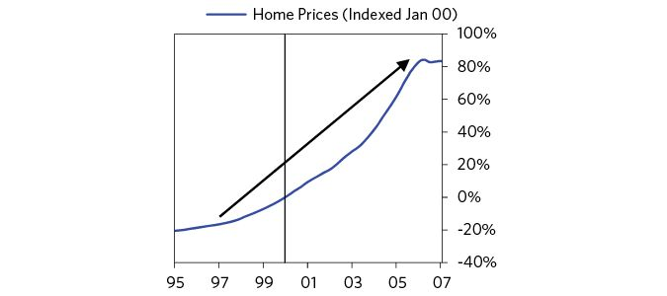

Household debt rose from 85 percent of household disposable income in 2000 to about 120 percent in 2006. Credit standards were lowered, and while all income quintiles increased their debt substantially over the period, the biggest percentage increase in debt between 2001 and 2007 was among borrowers in the bottom quintile of income earners.1 As mortgage lending practices became more liberal, even non-home buyers ran up debts by borrowing against their home equity—home equity loans and cash-out refinancing totaled $500 billion in 2005, up five times compared to 1998.2 That pushed overall US debt to over 300 percent of GDP.

The more prices went up, the more credit standards were lowered (even though it would have been logical for the opposite to happen), but both lenders and borrowers found lending and buying houses on borrowed money to be very profitable. The credit-fueled buying drove up prices even more, creating self-reinforcing expectations and drawing in new borrowers/lenders who did not want to miss out on the action. This is classic in bubble periods.

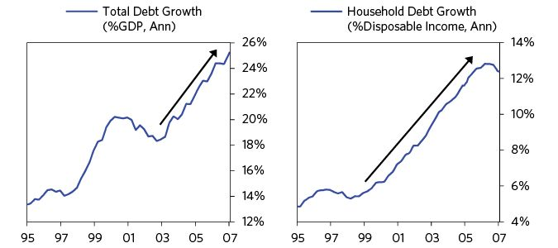

The US housing market was showing every sign of a classic bubble. To repeat my defining characteristics of a bubble:

1. Prices are high relative to traditional measures.
2. Prices are discounting future rapid price appreciation from these high levels.
3. There is broad bullish sentiment.
4. Purchases are being financed by high leverage.
5. Buyers have made exceptionally extended forward purchases (e.g., built inventory, contracted forward purchases, etc.) to speculate or protect themselves against future price gains.
6. New buyers (i.e., those who weren’t previously in the market) have entered the market.
7. Stimulative monetary policy helps inflate the bubble, and tight policy contributes to its popping.

All of these were true for the US housing market. Prices rose quickly and were widely expected to continue doing so (e.g., “home flippers” would buy a home, do some renovations, and aim to take advantage of rising prices to make a short-term profit). Homebuilders were ramping up supply that wouldn’t come on line for months or years, in anticipation of high prices being sustained—new single family home construction doubled between 1995 and 2005.3 As people saw their friends and neighbors becoming richer through homeownership, more people wanted to buy homes. At the peak of the bubble, just shy of 8 percent of households were buying a home each year (around 50 percent more than today). A TIME magazine cover from the summer of 2005 (roughly the peak) conveyed the speculative mania, asking “Will Your House Make You Rich?”

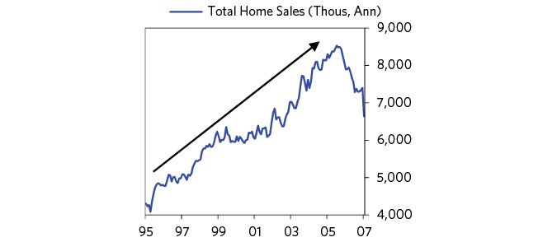

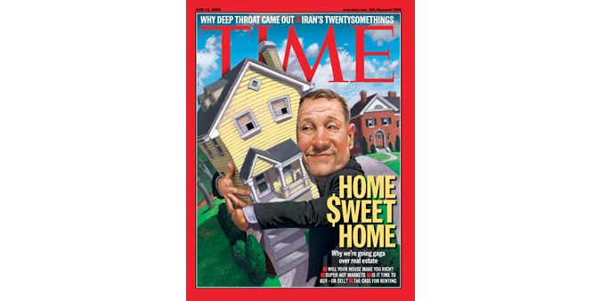

From TIME, 12 June © 2005 Time Inc. All rights reserved. Used by permission and protection by the Copyright Laws of the United States. The printing, copying redistribution, or retransmission of this Content without express written permission is prohibited.

In other words, there was leveraging up to bet more aggressively on prices continuing to increase. At the same time, supplies were increasing as the higher prices encouraged production. Logic should dictate precisely the opposite behavior: those betting on price changes ought to be more inclined to deleverage or sell, and those who lend to them should be more cautious when these things are happening. However, this sort of nonsensical thinking is typical in bubbles.

Just as there was a mania to buy houses, there was a mania to lend to people to buy houses. The chart on the left on the next page shows aggregate mortgage rates. As a result of the Fed’s easy monetary policies, they fell to lows in 2003 not seen since the 1950s, and stayed near those lows well into the housing bubble. Leveraging up took off in 2003-2007, even after rates rose by about 1.5 percent in 2005-2007. The chart on the right shows the loan-to-value ratio of new housing loans—higher numbers mean mortgages had smaller down-payments and larger loans. The fast increase to 80 percent was an indication that banks were more eager to loan and willing to make riskier bets. Other signs of housing loan froth were common. Banks often didn’t require borrowers to show proof of income before receiving a mortgage and they pushed adjustable rate mortgages that enticed borrowers with low “teaser” rates now before rates increased later on. “Subprime” mortgages (e.g., riskier ones) became 20 percent of the market. And as we’ll discuss later in much more detail, banks were able to package this debt in ways that obscured its underlying risks (i.e., “securitization”), helping fuel the easy availability of credit and low interest rates.

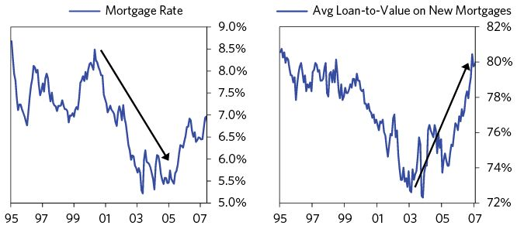

For all of the debt build-up and frenzied housing activity, the economy didn’t overheat and inflation remained moderate, so the Fed, looking at the average numbers, remained unconcerned. It is typically the case that the worst debt bubbles (e.g., the US in 1929, Japan in 1989) are not accompanied by high and rising goods and services inflation, but by asset price inflation financed by debt growth. Typically, central banks make the mistake of accommodating the debt growth because they are focused on goods and services inflation (as measured by the CPI) and/or growth. They are not focused on debt growth, which is what they are creating, and on whether the debts will produce the incomes to service them, which is what they should be thinking about if they want to prevent bad debt crises.

As you can see in the charts below, as inflation was mostly between 2 and 3.5 percent—a bit higher than desirable but not worrisome—the Fed kept interest rates low well into the expansion. In fact, US short-term interest rates were below inflation (i.e., real short-term borrowing costs were negative) from late 2001 until early 2006. Even when the Fed did begin raising short-term rates in mid-2004, long-term nominal interest rates remained roughly flat, and real long-term interest rates declined.

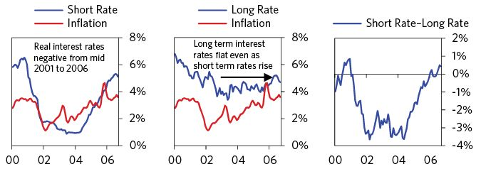

As shown below, the same was broadly true across the developed world.

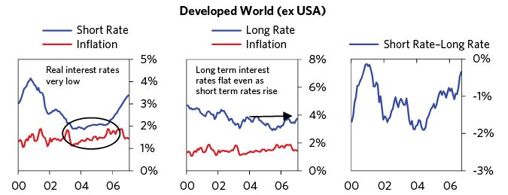

For all these reasons, a global financial bubble was emerging.

In the middle of 2006, Hank Paulson was confirmed as George W. Bush’s Treasury Secretary. He came to that job from the position of chairman and CEO of Goldman Sachs, which gave him an exposure to the markets that made him generally concerned about the excesses in the financial markets, so he convened and held regular meetings with the President’s Working Group on Financial Markets, which was comprised of the top members of the Bush economic team and key regulators.4 The primary benefit of these meetings was that they built close working relationships among the members, most importantly between Paulson, Fed Chairman Ben Bernanke, and New York Fed President Tim Geithner, and their agencies.

In all financial crises, the personalities, capabilities, and ability to work well together play crucial roles in influencing the outcomes. In this case, the most important relationships were between Paulson (an extroverted former CEO who was used to making bold decisions), Bernanke (an introverted economist who was well-schooled in the Great Depression), and Geithner (a practical operator experienced in the workings of government economic policy making). Their complementary qualities, in combination with their often hourly coordination and their shared willingness to be bold and quickly evolve policies based on new learnings, were critical to their navigating through this crisis.

While all three men had concerns about the “dry tinder and gathering storm,” and tried to lean against the excesses that they perceived, the problems weren’t clear enough to them to prompt them to move quickly or forcefully enough to prevent what was to come. They noted the excesses in the subprime market, but none saw these excesses spilling over to the overall housing market, which had not seen a nationwide decline since World War II. Paulson, however, was very concerned about the risks posed by Fannie Mae and Freddie Mac (known as Government Supported Entities, or GSEs), which Larry Summers also highlighted when he was Treasury secretary in the Clinton administration. That prompted Paulson to get President Bush’s support in the fall of 2006 to begin working on legislation with Barney Frank (then the ranking minority member of the House Financial Services Committee) to reform those entities, though that push didn’t lead to progress until the crisis came to a head in the summer of 2008.5

### The Emerging Broader-Based Bubble

The broader economy also showed signs of a bubble. Savings rates declined from low to lower and the US aggressively sucked in capital from abroad. US manufacturing employment fell and the US was rapidly losing global export market share to emerging countries, especially China. However, the increase in housing-related activity camouflaged this; for instance, construction employment in support of building houses increasingly financed by debt rose by around 50 percent compared to 1995.

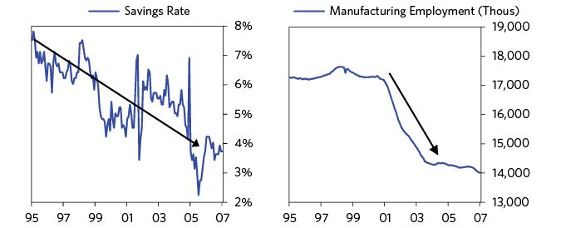

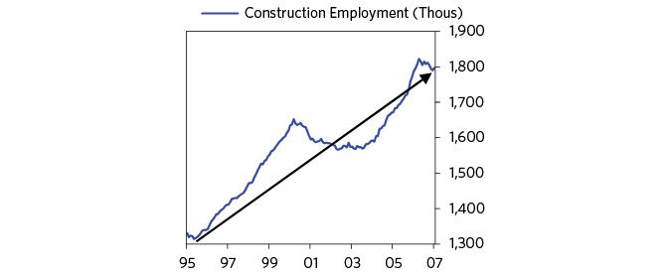

In addition, a lot of money to fund consumption was also borrowed via mortgages and other types of debt instruments. High debt growth to fund consumption rather than investment is a red flag, since consumption doesn’t produce an income, while investment might.

Typical of such periods, a lot of foreign money came pouring in to participate in the bubble, as reflected in both capital inflows and our current account deficit swelling (to 6 percent of GDP). A lot of this money was coming from emerging economies such as China, which were running huge current account surpluses at the time and were choosing to save/invest in US assets. Strong capital inflows allowed US citizens to borrow so they could continue consuming more than they were earning.

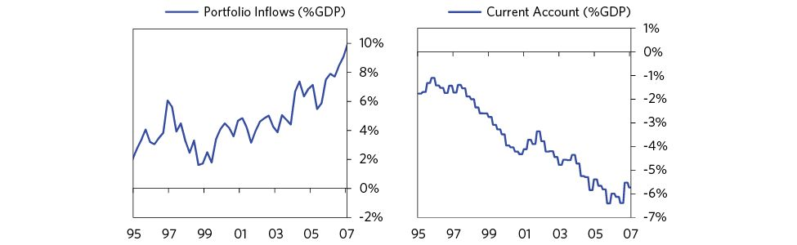

Strong demand for US assets abroad also helped keep long-term borrowing costs low even as the Fed began raising short-term interest rates in late 2004.



Many of these flows went to lending that would not produce the income to service the debts. They supported a dynamic that was unsustainable: The savings rate can’t fall indefinitely, and the wave of lending can’t increase forever. As the debts came due, there would be cash flow problems. When we ran our pro forma financial numbers, we could see that when all these flows tapered off, there would be cash flow problems.

During this period, lending increased and became riskier, and it increasingly occurred outside the regulated and protected banking system. Growth of new ways of lending outside of the normal banking system—often called the “shadow banking” system—is a common feature of bubble periods. Typically, financial institutions build new channels that get around the more established and better-regulated ones because it is initially advantageous to everyone involved. Fewer regulations make it cheaper to lend, borrowers get lower rates and easier terms, and investors get a small boost to returns. Often, shadow banks are able to make these new debt assets seem safe to investors via guarantees or through the way the assets are combined and packaged. Without having been through a crisis to stress-test them, it can be hard to tell if they really are as safe as they’re made out to be. Often, these “innovations” lead to the crisis. That was true in this case.

In the early-to-mid-2000s, a number of new channels for increasing leverage popped up, and a number of existing less-regulated channels became larger. Many of these were short-term in nature and unregulated and thus were particularly vulnerable. During the bubble, there were five key components that helped fuel leveraging outside the traditional banking system:

1. Use of repo agreements and commercial paper. These developed into huge channels through which banks and corporations could borrow over short periods of time. Ben Bernanke notes that “repo liabilities of US broker dealers increased by a factor of 2.5 in the four years before the crisis.”6
2. Large institutional depositors outside the protected banking system. Demand for Treasury securities, especially from foreign investors, outstripped supply, so there was a shortage of safe assets for investors. This led to demand for substitutes like asset-backed commercial paper and repo.
3. Development of money market funds, a short-term savings vehicle which promised higher returns than bank accounts without much additional risk.
4. Globalization of dollar lending, leading to the explosion of dollar borrowing and lending outside of US banks.
5. Securitization of lending, where banks take their traditional loans (auto loans, home loans, etc.) and sell them to other investors. This creates a “moral hazard” problem in which banks have an incentive to make risky loans since they can sell them and not bear the consequences (as long as investors remain willing to buy).

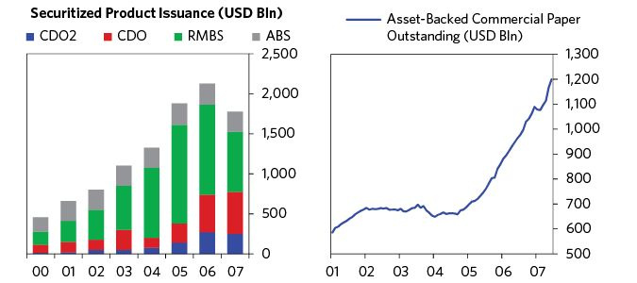

The US financial regulatory system did not keep pace with these developments. It did not provide adequate regulatory visibility into the shadow banks and markets, nor did it provide the authorities with the powers they needed to curb their excesses, though, as is typical, that wasn’t apparent at first. Banks and shadow banks at the time were inadequately capitalized and over-leveraged. This meant they didn’t have much cushion and would be exposed to solvency problems in a downturn. In the 1990s and early 2000s era of financial liberalization and financial engineering, regulators were more concerned about the US financial industry staying competitive with London, which discouraged them from pulling in the reins.

If the debt boom had been financed largely by the banking system, it would have been dramatically easier to manage and the run easier to contain. It still would have been a bad crisis with a bad recession, but not as bad as this crisis turned out to be. There would have been less forced selling and a less dangerous margin spiral, as the FDIC’s systemic risk exemption powers to guarantee liabilities, combined with deposit insurance and the Fed’s discount window, would have had more power and reach.

So it was not just low interest rates that fueled the bubble, but rather a combination of easy money, lax regulation, and risky financial innovations. As the Fed was looking at inflation and not debt growth when setting interest rates, and as policy makers allowed the lax regulation of shadow lending channels to continue, the bubble was allowed to grow.

Borrowers and lenders had severe asset/liability mismatches, which left them especially vulnerable in a downturn. This is a classic ingredient of a severe debt crisis. Most commonly these mismatches come in the following forms:

1. Borrowing short-term and lending long-term, leaving them to be squeezed when those who lent to them short-term don’t want to lend to them anymore or only want to lend to them at interest rates much higher than what they are earning on the loans they have already made.
2. Lending to risky borrowers who will pay higher interest rates than they borrowed at in order to collect the credit spread—until the default rates pick up to a level greater than the credit spread.
3. Borrowing in one currency and lending/investing in another. When the currency they borrowed in rises, it forces borrowers to pay back the loan at a higher exchange rate or a higher interest rate than they can manage.

All these things happened during this bubble, which made these financial intermediaries and those who trusted them with their money very vulnerable to runs and credit problems.

One classic asset/liability mismatch that developed occurred via European banks actively borrowing dollars with short-term debt and then lending them to the world. When dollar credit tightened in the summer of 2007, these banks lost access to funding from the US money markets and became transmitters of contagion around the world.

Still, the economy continued to grow above potential. The GDP gap rose to 3 percent, while inflation rose to 3.7 percent. The Fed continued to tighten to bring the nominal short rate to 5.25 percent and the real short rate to 1.5 percent in 2007.

By 2007, I was sure that we were in a bubble because it had all the classic signs previously described, plus when we did cash flow projections for companies and financial institutions, we suspected that they would not be able to secure the amount of new lending they needed to allow them to roll over their debts that were coming due, while at the same time increasing their borrowing to sustain what they were doing. Without that new lending, there would be a debt crisis. We regularly reported our thinking and estimates to policy makers, giving them the choice of believing our numbers so that they could be better prepared, or correcting our numbers so that we could see where we were wrong. They typically took the research in without comment but with questions.

## The Top: 2007

### The First Half of 2007

Keep in mind that up until this time, hardly anyone was concerned about hardly anything because both the markets and the economy were doing great. Stocks were reaching new highs, the job market remained strong, retail sales were strong, and so was consumer sentiment.

However the housing market and its most aggressive financers began to show some cracks. As the SEC wrote in a memo on January 4, “[t]here is a broad recognition that, with the refinancing and real estate booms over, the business model of many of the smaller subprime originators is no longer viable.”7

Markets were flatter between February and March, and overall market volatility was pretty low and priced to stay that way. Credit spreads, a measure of the perception of the risk of lending to private companies, were relatively low compared to historical norms. In other words, the market was tranquil and priced to stay that way.

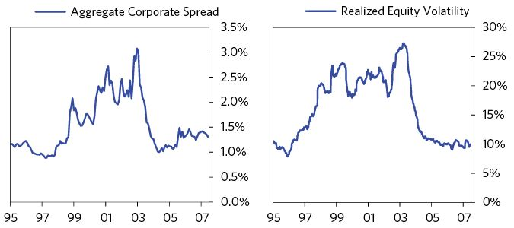

Problems emanating out of subprime mortgage lenders—those that focused on mortgages for less credit-worthy borrowers—continued to grow, with some facing considerable losses, but they did not affect the broader economy and markets. Still, bigger banks were starting to report a rise in bad mortgage debts. We summarized the situation (in our March 13 Daily Observations) as follows:

(BDO) March 13: Subprime Mortgage Fallout  
 Subprime mortgages have been grabbing the headlines, with several of the larger subprime mortgage lenders teetering on the edge of bankruptcy. The story of how the subprime mortgage sector is blowing up even with a relatively strong economy relates closely to the liquidity that is bubbling up in markets around the world. Over the last few years, investment banks have been hard at work creating fancy new products where they can package up a bunch of assets and sell the package for more than the sum of the parts (CDOs, CMOs, synthetic CDOs, etc.). They do this by tranching them up and getting the ratings agencies to rate the best slice AAA, the next slice AA, and so on. This financial “innovation” makes everyone happy: insurance companies get an AAA-rated bond that yields a few basis points more than their other AAA options, and so on down the line. Often hedge funds end up with the bottom piece, and that makes them happy because they get a lot of leverage/volatility. This innovation opens up a source of credit to many risky borrowers (not just households) who previously would have had trouble accessing credit markets. The explosion in subprime mortgages is closely related to this new source of credit. Originators paid less and less attention to underwriting standards because they were just going to hand off the mortgages to the investment banks. The investment banks were eager to package them up and sell them to investors. The investors were getting 5bps more yield for the same credit rating. Lending standards slipped to absurdly low levels, and then a small up-tick in delinquencies caused the banks to refuse to buy the loans and the originators to be stuck with the losses.

…The thing that is really hammering the subprime lenders is “early payment defaults.” The agreements with the investment banks who bought the subprime loans contained provisions that the lender would have to buy back the loans if the borrower missed one of the first few payments. Without fraud, it is very rare for a borrower to miss the first payment on a mortgage. In December, New Century, the second biggest subprime lender in 2006, disclosed that borrowers had failed to make the first payment on fully 2.5% of their loans. When the banks/investors demanded New Century buy back these loans, New Century couldn’t come up with the cash. Several dozen smaller subprime lenders have gone bust this way in the last few months, although New Century is the biggest.

Most people thought that these troubles in one corner of the financial markets would not cause meaningful contagion elsewhere. On March 28, Chairman Bernanke said in Congressional testimony that “the impact on the broader economy and financial markets of the problems in the subprime market seems likely to be contained.”8 I had a similar assessment at the time, though I was more concerned about the extent of leverage and tightening going on in this bubble.

The US stock market continued to rally through April and May, hitting new records. The shaded portion of the chart shows the rally in the first half of the year.

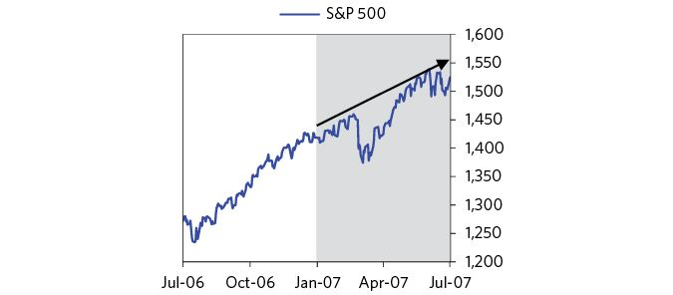

In mid-June, 10-year Treasury yields hit 5.3 percent (the highest point since 2002), and in mid-July, the 90-day T-bill rate hit 5 percent, meaning the yield curve was very flat. That was the cyclical peak because of what came next.

As interest rates rise, so do debt service payments (both on new items bought on credit, as well as on previously acquired credit that was financed with variable rate debt). This discourages additional borrowing (as credit becomes more expensive) and reduces disposable income (as more money is spent on debt service). Because people borrow less and have less money left over to spend, spending slows, and since one person’s spending is another person’s income, incomes drop, and so on and so forth. When people spend less, prices go down, and economic activity decreases.

Simultaneously, as short-term interest rates rise and the yield curve flattens or inverts, liquidity declines, and the return on holding short duration assets (such as cash) increases as their yields rise. As these assets become relatively more attractive to hold in relation to longer duration financial assets (such as bonds, equities, and real estate), as well as those assets with lower grade credit ratings (as the spread to these assets declines), money moves out of financial assets, causing them to fall in value. Declining asset prices in turn create negative wealth effects, which feed back into the economy through declining spending and incomes.

The tightening popped the bubble. As interest rates rose, home prices began to decline, since debt service payments on new homes would be higher, and interest payments on many existing mortgages rose quickly because many subprime borrowers had taken out adjustable rate mortgages (ARMs). As interest rates rose, so did their debt service payments. By June, these tightening pressures flowed through to the first broad sign of financial distress: rising foreclosures and delinquencies started to translate into meaningful losses for bigger banks. In mid-June, two hedge funds run out of the investment bank Bear Stearns that invested in subprime mortgage-backed securities (MBS)—one of them leveraged about 20:19—faced growing losses and a wave of investor redemptions. That required them to do a fire-sale of $3.6 billion of the securities, a large amount for the market.10 The leveraged financial buying shifted into deleveraging selling. As the prices of securities they held fell, the hedge funds faced huge losses and forced liquidations. In the end, Bear Stearns promised a $3.2 billion loan to bail out one of the funds (later reduced to $1.6 billion), and other banks that seized collateral from the hedge funds cooperated to ensure that the market remained stable (e.g., not selling more subprime MBS). The funds would eventually be wiped out. These were relatively small funds, and the initial reverberations were limited.

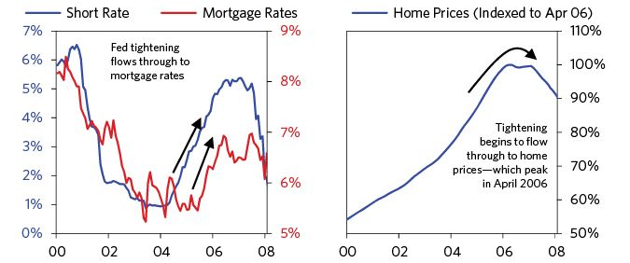

### The Summer of 2007

Economic growth remained healthy and US equity markets hit new highs in mid-July. The most prominent question was whether the Fed’s next move would be to tighten because of inflation concerns, or ease because of housing concerns.

Stress in the housing market was gradually building. The indices of subprime MBS (called the ABX indices) continued to see big price declines (even the AAA bonds, which were likely seen as “riskless” when purchased, fell around 5 percent), and some of the mortgage lenders started reporting increasing numbers of borrowers missing loan payments. One large mortgage lender looked to be closer to bankruptcy, and a small German bank exposed to mortgage loans faced big losses and ended up needing to be acquired by Germany’s state bank. New home sales were falling very quickly. As this news emerged, the markets sold off a bit (ending July down 6 percent from the peak).

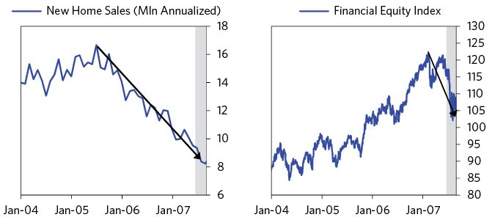

I expected this debt crisis to be self-reinforcing because of the impact that mark-to-market accounting and high leverage would have on lenders. Debt crises and downturns are self-reinforcing behaviors because as losses occur, both lenders and borrowers are less able to lend and borrow, which worsens conditions. For example, when losses occur, one’s capital declines, and because there are limits to how much one can hold in assets relative to one’s capital, that means assets have to be sold, or the buying of assets has to be curtailed. That in turn makes asset prices and lending weaker, producing more losses and reinforcing the cycle further. Because we could get very detailed financial information on banks that allowed us to know their exposures, we could estimate what the values and losses on their positions would be by knowing the pricing of analogous liquid assets. As a result, we constantly did our mark-to-market stress tests, which showed us that the financial sector and those dependent on it were incurring losses before they reported them. We could also get detailed financial information on public companies and our pro forma financial projections showed that many were facing debt squeezes.

Here is what I wrote to our clients and policy makers at the time.

(BDO) July 26: Is This the Big One?  
 You know our view about the crazy lending and leveraging practices going on, creating a pervasive fragility in the financial system, leading us to believe that interest rates will rise until there is a cracking of the financial system, at which time everything will reverse (i.e. there will be a move to focusing on fear from focusing on greed, volatilities will increase, and carry and credit spreads will blow out). We had (and now have) no idea exactly when this will occur and if what’s happening now is the big one. We just know that 1) we want to avoid or fade this lunacy and 2) no one knows how this financial market contagion will play out.

How it will play out is a function of who is carrying what positions and how these positions and players knock up against each other. A few months ago we undertook an extensive study to see which market players held what positions, especially via the derivatives markets. So we read all the studies by government overseers and financial intermediaries, we gathered and examined all the data we could obtain, and we delved into 10-K reports of financial intermediaries. And we concluded that no one has a clue. That is because one can only vaguely examine these exposures one level deep. In other words, while it is easy to see some parties’ exposures (particularly those of regulated financial intermediaries), it is impossible to see who is carrying these and other positions in order to ascertain the net positions of the important parties. For example, the dealers who are at the epicenter of this know who their counterparties are, but they don’t know their counterparties’ total positions. But we do know that these exposures have grown rapidly (about four times as large as five years ago) and are huge (about $400 trillion).

At the time, growth still looked good as the debt and tightening conditions hadn’t yet passed through to the economy. On July 31, we wrote: “Tuesday’s slew of stats continued to convey a picture that the real economy was just fine heading into the recent market action,” but we were extremely concerned that the Fed was too sanguine. In its August 7 monetary policy statement, the Fed said: “Financial markets have been volatile in recent weeks, credit conditions have become tighter for some households and businesses, and the housing correction is ongoing. Nevertheless, the economy seems likely to continue to expand at a moderate pace over coming quarters, supported by solid growth in employment and incomes and a robust global economy.”

In early August 2007, the mortgage market began to seriously unravel. On August 9, BNP Paribas, France’s largest bank and one of the largest in the world by assets, froze $2.2 billion worth of investments in three of its funds because its holdings in US subprime mortgages had exposed it to big losses. Banks in Europe became more nervous about lending to each other, prompting the European Central Bank (ECB) to inject 95 billion euros into the banking system to get rates back to the ECB’s target, and another 61 billion the next day. The US also saw a squeeze in safe Treasury bills and higher yields on riskier commercial paper and interbank lending rates. Money market funds, the main holders of asset-backed commercial paper, saw hits to their asset values and required assistance from their sponsors, banks, and fund families in order to avoid “breaking the buck.” (By “breaking the buck” I mean falling in value below the amount deposited, which is something depositors assumed would never happen but did.)

The unraveling could be seen in interbank markets. The following chart shows a classic measure of interbank stress, the TED spread, in which a higher number means banks are demanding a higher interest rate to compensate for the risks of lending to each other. It was clear that the top in the debt cycle was being made.

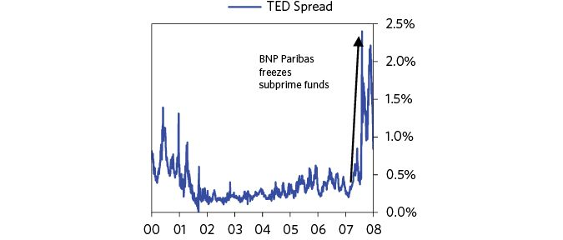

Here is what I wrote to clients and policy makers the next day:

(BDO) August 10: This Is the Big One  
 By that, we mean that this is the financial market unraveling that we’ve been expecting—the one in which there is an unwinding of widely held, irresponsibly created positions that occurred as a result of financial middlemen pressing to invest for high returns the immense amount of liquidity that has been flooding the financial system—i.e., another 1998 or 1994 (which occurred for the same reasons), just bigger. I want to reemphasize that what we know about this is less than what we don’t know because how exactly the cards will fall will depend on who is holding what positions and how they all knock on with each other. Despite us doing an awful lot of work to try to get this all mapped out over the last two years, we couldn’t map this out to an extent that’s worth much because our knowledge of these positions is so imprecise and the array of possible permutations is so wide that forecasting where we will be in a couple of weeks is a bit like predicting how a hurricane will run its course two weeks ahead. We are also highly confident that others, including the key regulators (who have the best windows in), can’t give you a forecast that’s much more reliable, so they are reacting to events. However, having seen this dynamic (i.e., a self-reinforcing panic move away from high risk investments to low risk investments in which badly positioned leveraged players get squeezed) many times before (1998 is the most recent case), we are pretty confident we know some things about how it will play out. This will run through the system with the speed of a hurricane (over the next four to six months), and it will leave weaker financial credits dead or damaged and stronger financial credits in the catbird seat…

…We have a game-plan (developed over many years) that we have confidence in because we planned for times like this, but for safety’s sake, we are checking that all the hatches are battened down and that the expensive radar we’ve developed is working well. That game-plan doesn’t just pertain to our investment strategy; it includes our strategy for handling counterparty risks and transactions costs in an environment of extreme risk-aversion and illiquidity.

What I was referring to as a game plan for this is what we called a “Depression gauge.” Because big debt crises and depressions had happened many times before and we had the template explained in this study, we had created this gauge as a simple algorithm based on the proximity of interest rates to 0 percent, a few measures of debt vulnerability, and indications of the beginning of debt deleveraging that would lead us to change our overall portfolio and risk controls (including our counterparty risks).

Less than a week later, news emerged that Countrywide, the US’s largest mortgage issuer, had exhausted its credit line, and was at risk of declaring bankruptcy. While notable because it was a canary in the coal mine, Countrywide was not a systemically important financial institution.

Over the next several days, stocks fell sharply and yields on commercial paper spiked. The Bank of Japan, the ECB, and the Fed all responded to the market stress by providing liquidity to banks. The worst of the stock sell-off ended when the Fed surprisingly cut interest rates by 0.5 percent—doing so between its regularly scheduled meetings—an unusual move. Chairman Bernanke said he would do more if needed.11 And Bank of America shored up Countrywide by investing $2 billion in exchange for a large stake in the company. These moves alleviated most of the funding strains in the market, and equities recovered a bit. Below is a chart of the stock market up until that time. Note that it was still near its highs.

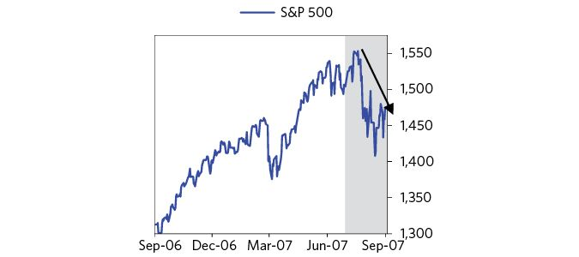

Coming out of this episode, most policy makers and investors thought that the problems in the risky part of the mortgage market would be contained, so the flow-through to the real economy wouldn’t be substantial. Based on our calculations, we saw it differently and wrote: “the day of reckoning will be pushed forward, probably to when there is a big tightening by the Fed or a big turndown in the economy.”

Why Banks and Investors Were So Exposed to Risky Mortgage Securities  
 Why were investors, banks, rating agencies and policy makers misled into thinking mortgage securities were less risky than they actually were? A key reason is the way risk is analyzed. Consider the conventional way investors think about risk. At the time, Value at Risk (VAR), which is a measure of recent volatility in markets and portfolios, was commonly used by investment firms and commercial banks to determine the likely magnitude and occurrence of losses. It typically uses recent volatility as the main input to how much risk (i.e., what size positions) one could comfortably take. As a simplifying illustration, imagine an investor that never wants to lose more than 20 percent. If the most that a subprime mortgage has ever lost in a month is 5 percent, then investors might plug that 5 percent number into a model that then says its “safe” for them to borrow until they own three times leveraged subprime.

This way of thinking about risk caused many investors to increase their exposures beyond what would normally be seen as prudent. They looked at the recent volatility in their VAR calculations, and by and large expected it to continue moving forward. This is human nature and it was dumb because past volatility and past correlations aren’t reliable forecasts of future risks. But it was very profitable. In fact, when we were cutting back on our positions, our clients urged us to increase them because our VAR was low. We explained why we didn’t do that. Extrapolating current conditions forward and imagining that they will be just a slightly different version of today is to us bad relative to considering the true range of possibilities going forward. If anything, I believe that one should bet on the opposite of what happened lately, because boring years tend to sow the seeds of future instability, as well as making the next downturn worse. That’s because low volatility and benign VAR estimates encourage increased leverage. At the time, some leverage ratios were nearing 100:1. To me, leverage is a much better indicator of future volatility than VAR.

In 2007, many banks and investors were heavily exposed to subprime mortgages, since the instruments had not yet had a loss cycle or experienced much volatility. VAR was also self-reinforcing on the down side, because increased market volatility at the peak of the crisis in 2008 made their statistical riskiness look even higher, causing even more selling.

### The Fall of 2007

With stocks on the rebound after the bumpy summer, policy makers started to consider how they should approach the problems emanating from the mortgage market over the longer term.

Beginning in the fall of 2006, Paulson and the Treasury had begun working with Barney Frank and the House Financial Services Committee to reform Fannie and Freddie. They focused on curbing the excesses and increasing the authority of the regulator. A bill passed the House in the spring of 2007 but, stalled in the Senate. Due to significant political opposition, there was no possibility of getting Federal funding to modify mortgages for struggling homeowners. So the Bush Treasury worked with lenders, mortgage servicers, and counselors to motivate these private sector institutions to modify and restructure mortgages with some modest but meaningful success. Also, the Treasury began working with the Fed to jointly develop what they dubbed as the “break the glass” option to go to Congress and get the authority to purchase illiquid mortgage securities if and when this became politically feasible. This was the forerunner of what would become the Troubled Asset Relief Program, or TARP.

The Fed signaled its willingness to ease monetary policy to mitigate any spillover effects the mortgage-related stress might have on the broader economy. Although the data and news showed a steady deterioration in fundamentals, most market participants believed that policy makers would be able to make it through smoothly.

Bernanke began a push within the Fed (in close collaboration with Hank Paulson and the Treasury staff) toward what they dubbed “blue-sky thinking”—unrestricted brainstorming in anticipation of the possibility that conventional policy easing might not be enough.12 As financial contagion spreads beyond the banking sector, increasing numbers of players in the real economy can no longer access credit through the usual channels. In what would become a crucial pillar of the Fed’s response to the crisis, Bernanke considered the possibility of the Fed lending directly to a broader range of counterparties than just depository institutions. This would be a big, bold move, and so unprecedented that Bernanke had to check the rulebook to see if it was allowed. The provision of the Federal Reserve Act that authorized such lending—Section 13(3)—hadn’t been invoked since the Great Depression, but it was still valid. Knowing which needed actions in a crisis are permitted (or not permitted) by law and how to have them approved is a classic challenge in democracies with rigid regulations and robust checks and balances systems.

Worsening circumstances led to expectations for a rate cut from the Fed. Still, there were reasons to ease and reasons not to ease. Two considerations especially weighed against easing. The first concerned inflation: the dollar had been steadily weakening and oil prices steadily rising. Easing would contribute to dollar weakness, higher oil prices, and higher inflation. The other consideration was that the problems all stemmed from wrongheaded speculation, and anything that the Fed did to ameliorate the problems of those speculators would only encourage them to take excessive risks again in the future.

This notion of “moral hazard” was one that the Fed (and Treasury) would have to wrestle with many times throughout the crisis. How the “moral hazard” question is dealt with during big debt crises is one of the biggest determinants of how these crises turn out. Because undisciplined lending and borrowing was the cause of crisis, it is natural to want to let those who were responsible experience the consequences of their actions, and to impose lots of discipline by tightening lending and borrowing. But that’s like putting someone who just suffered a heart attack because they’re too fat straight on a diet and a treadmill. At such times, above all else, the most important thing is to provide life-blood (i.e., stimulants) to keep the systemically important parts of the system alive. It is dangerous to try to be overly precise in getting the right balance between (a) letting those who borrowed and lent badly experience the consequences of their actions and (b) providing judicious amounts of liquidity/lending to help rectify the severity of the contraction. It is far better to err on the side of providing too much than to provide too little. Unlike in the Great Depression, when the Fed allowed banks to fail en masse, the Fed took the view that although it would be good to minimize moral hazard when possible, its top priority had to be saving the economy.

Tim Geithner, who was the president of the New York Fed at the time, shared my thinking. He believed the moral hazard framework was the wrong way to think about policy during a financial crisis because policy needs to be very aggressive in taking out catastrophic risk, and one can’t move slowly or precisely.13 That has proven true time and time again. Providing plenty of liquidity during a liquidity crisis leaves the government open to less risk and leaves the system healthier. In contrast, the moral hazard framework leads people to believe that if you let things burn, the government will assume less risk. In reality, if you let everything burn, the government will end up taking on all of the risk, as it will have to nationalize the system in a much more costly and damaging way.

In the end, policy makers responded to the crisis by guaranteeing almost everything, explicitly or implicitly, and carrying out a dramatic, explicit injection of cash. Geithner told me that the interesting thing about this approach was that instead of losing 5 to 10 percent of GDP on the cost of the financial rescue, we actually earned something like 2 percent of GDP, depending on how you measure it. That’s a dramatic outlier in the history of financial crises, and Geithner credits it to the Fed and Treasury’s very aggressive response and their willingness to put moral hazard concerns aside. I agree.

On September 18, 2007, the Fed cut rates by 0.5 percent, compared to the 0.25 percent expected by the market. As Bernanke put it, “the hawks and doves flocked together.”14 The Fed’s bigger-than-expected move sparked a stock market rally that the New York Times described as “ecstatic,” which brought the S&P 500 back to within 2 percent of its all-time high.

More important than the stimulation that would come from the Fed’s interest rate cuts was the message this sent the markets—that the Fed was willing to take decisive action as needed to help contain the problems that had caused the market turmoil in August. At the same time, it was clear to those who ran the numbers that easing wouldn’t solve the more fundamental problems of financial intermediaries, debtors, and creditors holding more debt assets and liabilities than could be serviced.

The banks’ (and investment banks’) balance sheet and liquidity problems were on both the asset side and the liability side. On the asset side, the problems stemmed from the banks’ ownership of subprime mortgages through securitizations. On the liability side, the banks had become dependent on risky sources of funding. Banks had always relied on short-term funding, but historically this had consisted largely of deposits, which could be controlled with guarantees. Savers can always pull their deposits, and widespread fears about bank solvency had led them to do just that in the Great Depression. This led to the founding of the FDIC in 1933, which dealt with this problem by insuring bank deposits (up to a certain amount). That mostly eliminated the incentives the depositors had to flee, because even if a bank failed, their deposits would be protected.

But by relying on what was known as “short-term wholesale funding,” modern banks had set themselves up for a similar situation to what banks had experienced between 1930 and 1933. Short-term wholesale funding took a variety of forms, but at its core, it was a lot like an uninsured deposit—meaning the depositor had a big incentive to pull it from the bank at the first sign of trouble.

Banks and investment banks had also gotten themselves into trouble by virtue of their central role in what we’ll call the “securitization machine.” At its heart, the securitization machine started with the issuance of risky mortgages and ended with the sale of very safe bonds to institutional investors. Lots of players were involved, but these financial intermediaries played a major role. Basically a mortgage lender would make the loans and sell them to a bank, which would package them up into a bundle of say 1,000 loans. The combined cash flows of these 1,000 loans were thought to be much safer than any individual loan because they benefited from diversification—if one borrower couldn’t repay their mortgage, that might create a loss on one loan, but that wouldn’t affect the ability of the other 999 borrowers to repay their loans. On average, most borrowers had historically been able to repay their mortgage loans, so the result of the packaging was (supposedly) to reduce the overall risk profile of the loans.

The bank would then slice up the total cash flows from the 1,000 loans and distribute them in chunks: 70 to 80 percent would become a super-safe AAA-rated bond, another 10 to 15 percent might become a slightly riskier but still pretty safe AA-rated bond, 5 to 10 percent would become a BBB-rated bond, and some small unrated residual (the “first-loss” piece) would take the losses of the first few borrowers that might default. This was a classic case of data-mining history rather than using sound logic to assess risk. People were leveraging themselves up by betting that they were safe, because the thing they were betting against had never happened before. When the bet went wrong, the self-reinforcing dynamic on the upside shifted to a self-reinforcing dynamic on the downside.

Banks would sell off whatever bonds they could to investors, typically retaining the first-loss piece in order to make the deal work. They carried bonds as inventory (sometimes with the intention of eventually selling them; other times to hold the exposure for return). This worked, which encouraged them to do it more until it didn’t work. To varying degrees, the banks were holding large inventories of these bonds when demand dried up in the third quarter of 2007.

That happened when the write-downs due to mark-to-market accounting began. Bear Stearns saw its 3Q07 earnings drop by 61 percent due to losses related to the hedge funds that had blown up and other exposures it had to subprime mortgages. Morgan Stanley and Lehman Brothers took 7 percent and 3 percent hits to earnings, respectively (relatively small losses). Citigroup, UBS, and Merrill Lynch followed suit, reporting meaningful but manageable losses. Citigroup initially wrote down the largest loss, at $5.9 billion (keep that number in mind in comparison to the numbers later in our story).

Around this time (fall 2007) we started running our own loss estimates and “stress tests” of the financial system—gathering balance sheet data on banks to see their assets and liabilities, and applying liquid market prices as proxies to their illiquid holdings to estimate what they would have to report long before they would have to report it. This was invaluable in anticipating what was going to happen. On October 9, 2007, the S&P 500 closed at its all-time high. That high in stocks wouldn’t be reached again until 2013.

It was clear to most people in the business that banks had a problem with subprime mortgages, though it wasn’t yet clear to them that the whole economy had a major debt problem. To help alleviate the situation and build confidence, a number of major banks proposed joining forces and creating a fund that would aim to raise $75-100 billion for buying distressed subprime mortgage securities. Like other observers, we viewed it as a natural response to the credit crunch that would help to alleviate the risk of contagion. However, by the end of the year, efforts to establish this fund had been abandoned, as the collaborating banks decided that it was “not needed at this time.”15

Meanwhile, despite optimism at home, the credit crunch spread from the US to Europe through two main mechanisms. The first was that some European banks (most notably the British bank Northern Rock) had come to rely on money markets for short-term wholesale funding. When that source of funding began to dry up in the summer of 2007, Northern Rock experienced a classic “run,” with depositors lining up to withdraw funds for three straight days in the middle of September.16 The UK had a similar deposit insurance scheme as the US, but with a lower cap on insured deposits (£35,000). To stem the run, the British government guaranteed all of Northern Rock’s deposits.

The second mechanism resulted from the investments that many European banks had made in subprime securitizations. The largest ones, like UBS and Deutsche Bank, owned stakes in securitizations as a corollary to their role in producing the securitizations themselves. Many smaller banks had simply wanted a piece of the action. After all, many slices of subprime securitizations had been rated AAA, meaning that rating agencies had stamped them as having extremely low risk. During previous periods of stress, such as the savings and loan crisis of the 1980s and the dot-com bubble of the early 2000s, corporate bonds rated AAA had a default rate of 0 percent, according to Standard & Poor’s, one of the big three rating agencies.17 Plus, the subprime securitizations rated AAA offered a premium (though in hindsight, one that was far too small, given the level of risk) relative to corporate bonds of the same rating.

As our risk measures of the banks, investment banks, and broker dealers that we dealt with changed, we shifted our exposures from the riskier ones to safer ones, and also moved into safer assets.

In late October, 2007, sentiment began to turn for the worse as predictions of the overall losses on subprime securitizations started to increase. US stock prices suffered a steep 2.6 percent decline on October 19, after JPMorgan posted a $2 billion write-down and Bank of America announced much weaker-than-expected earnings.

It was becoming clear that losses on subprime mortgages were going to be a bigger problem than previously thought for the banks, but it wasn’t yet clear just how severely the stress in the housing market was going to hit US households, whose consumption represents the bulk of US GDP (around 70 percent). Here’s what we wrote about it at the time:

(BDO) October 30: Falling Home Prices and Wealth  
 The weakening housing market affects the US economy in a number of ways ranging from falling construction, to falling expenditures on housing-related items, to less cash used from mortgage borrowing on non-housing-related consumption, to falling wealth. As we have described previously, the drop in financing alone (money borrowed against houses to spend on other things) made up over 3% at the peak and will likely be negative soon (and will have to be made up some other way if consumption growth is to remain where it is) while the decline in construction at a 20% annual pace is translating to about a 1% drag on real growth...Real estate assets as % GDP peaked at 167%, so the drop in wealth will equal about 50% of GDP.

The impact on households was showing up in a variety of statistics: rising delinquencies on mortgages, slowing purchases of new and existing homes, slowing retail sales growth, etc. Policy makers understood that the situation was about to get worse: the roughly two million of those borrowers with adjustable-rate mortgages we discussed earlier were scheduled to have their teaser rates expire in 2008, and thus were about to see their interest costs jump. Treasury Secretary Paulson announced various measures to help modify mortgages to extend teaser rates for stressed borrowers, but stopped short of putting taxpayer money behind the plan, limiting its potential impact.

Meanwhile, at Bridgewater, we completed our first look loss estimates and stress test by examining the balance sheet data of banks. For us, the exercise was so eye-opening that on November 21 we released what we called a “Special Report,” excerpted here:

Bridgewater Special Report:  
 What We Think Will Be Contained & What We Think Won’t Be Contained

* Some credit problems have surfaced and some haven’t.
* We believe that the credit problems that have surfaced (i.e., the sub-prime/SIV problems) will spread (i.e., there will be a contagion) but they will be contained (i.e., won’t spread beyond being manageable and won’t sink the economy, though they will weaken it). That is because their size is manageable, their ownership is dispersed, and the demand to acquire these positions from buyers of distressed securities is relatively large because of the current environment of plentiful global liquidity. Management of this crisis will of course require wise decision-making and coordination of central banks, finance ministries, legislators and financial institutions in much the same way as management of past financial crises required these. We expect this wise management and coordinated decision-making, especially by central banks and finance ministries, because we have relatively high regard for the people involved and because the actions that are appropriate are relatively clear.
* We also “believe” that the credit problems that lie beneath the surface are much larger and more threatening than the ones that have surfaced. These latent credit problems are the result of a) there being an enormous amount of liquidity that is looking to be invested and b) investors increasingly and imprudently reaching for higher returns via structured, levered, illiquid, risky investments. Like subprime and other credit crunch problems before they surfaced, we and others (including government regulators) do not adequately understand these exposures, so it is difficult to say for sure where the problems lie or to know how they will behave individually and in interaction with each other in a stressful environment. What we do know is that these exposures have grown exponentially, are very large, and are based on many imprudent, sometimes seemingly nonsensical strategies. We also believe that if these problems surface, containing them will be challenging…
* Though we do not believe that the “below the surface problems” will come to the surface any time soon, we also want to make sure that we have no or minimal exposures to, and ample protections against, widening credit and liquidity spreads, declining equities, undoing carry trades, increasing volatility and deteriorating counterparties.
* When we include all of the credit crunch related exposures that exist for all entities, we think that the mark-to-market losses as of today are in the $420 billion range globally, which represents about 1% of global GDP … we estimate their unrealized losses to be much larger than their realized losses so we expect much larger write-downs to come.

So we ran the numbers and were extremely concerned by both what we knew and what we didn’t know. The biggest unknowns, even after we ran the numbers on potential bank losses (which were enormous), were how these losses might ripple through the market, especially via the derivative markets. Derivatives are financial contracts whose value is determined by the value of some underlying asset, rate, index, or even event. Unlike stocks or bonds, they are not used to raise money for spending or investment. Instead, they are primarily instruments for hedging risks and for speculating on changes in prices. They are made through private contracts rather than on exchanges and are unregulated. They were also enormous and opaque to everyone, so no one could get their heads around the exposures that existed—and nobody could really know how the bank and non-bank lender losses would cascade.

More specifically, in the three decades leading up to the crisis, a huge market in over-the-counter derivative contracts (i.e., those not traded on regulated exchanges) developed. In December 2000, Congress clarified that as long as these over the counter contracts (OTC) were between “sophisticated parties,” they did not have to be regulated as futures or securities—effectively shielding OTC derivatives from virtually all oversight.18 Over the next seven years, the OTC market grew quickly. By June 2008, the notional value of these contracts was $672.6 trillion.

A key derivative that would play a major role in the financial crisis was the credit default swap (CDS). A CDS plays a role that is similar to insurance. When an issuer sells a CDS, they promise to insure the buyer against potential defaults from a particular exposure (such as defaults creating losses from mortgage-backed securities) in exchange for a regular stream of payments. CDS’s allow purchasers of mortgage-backed securities (and other assets) to transfer default risk to the party selling the CDS. AIG, for instance, sold lots of this “insurance,” but only kept very small reserves against it—meaning they didn’t have the capacity to pay out if there were large losses.

As noted earlier, I shared my concerns with the Treasury and White House, but they thought that the picture I was painting was implausible because nothing like that had happened in their lifetimes. While I am hesitant to speak about policy makers in general because there are so many differences in what they are like individually and the different seats they sit in (e.g., in the Treasury, White House, Congress, SEC, etc.), I must say that they are much more reactive than proactive, which is understandable because, unlike investors, they are not in the business of having to bet against the consensus and be right, and they operate within political systems that don’t act until there is a broad consensus that there is an intolerable problem. As a result, policy makers generally don’t act decisively until a crisis is on top of them.

As 2007 came to an end, the S&P 500 was down 6 percent from its October peak, but in positive territory for the year as a whole. December’s biggest market sell-off came on a day that the Fed lowered interest rates by 0.25 percent—even though rate cuts ordinarily help stocks—since it was less than the 0.5 percent cut that the markets were expecting. Bond yields had declined more sharply, from yields around 5 percent back in June before the credit crunch began to around 4 percent at the end of the year. The dollar index was down 8.6 percent over the year. Oil, meanwhile, was up a whopping 55 percent to $96, just a hair beneath its all-time high.

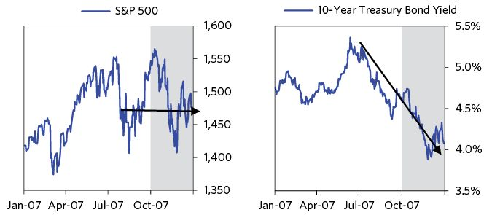

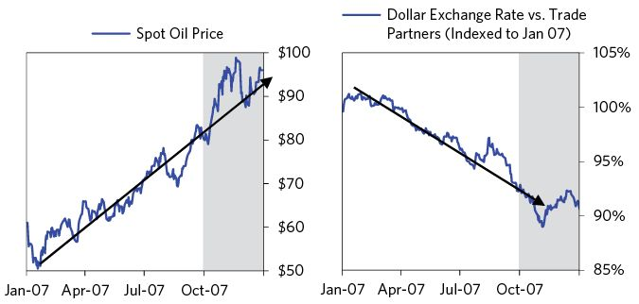

## Depression: 2008

### January–February 2008

At the beginning of the year, cracks began to appear in the economy and the markets. US manufacturing, retail sales, and employment reports were relatively poor. Then came the inevitable announcements of big write downs (i.e., losses) at Citigroup ($22.2 billion) and Merrill Lynch ($14.1 billion), as well as the downgrade of Ambac and MBIA, two bond insurers which had collectively guaranteed about $1 trillion worth of debt and had big exposure to subprime mortgage securities. These repeated losses were due to a combination of previous market declines in their holdings and accounting rules requiring them to be marked to the market and passed through their income statements and balance sheets. By January 20, the S&P 500 was down about 10 percent. Global equity markets were in even worse shape and fell even more, as shown in the chart below, left.

Witnessing all this, the Fed realized that it needed to act. Bernanke told the Federal Open Market Committee that although it wasn’t the Fed’s job to prevent sharp stock market declines, events seemed to “reflect a growing belief that the United States is in for a deep and protracted recession.”19 Emphasizing the need for immediate action, he said “we are facing, potentially, a broad crisis. We can no longer temporize. We have to address this…we have to try to get it under control. If we can’t do that, then we are just going to lose control of the whole situation.”20

Following an emergency meeting on January 22, the Fed cut rates by 75 basis points (i.e., 0.75 percent) to 3.5 percent, citing a “weakening of the economic outlook and increasing downside risks to growth.” A week later, the Fed cut rates again, this time by 50 basis points, citing “considerable stress” in the financial sector, “a deepening of the contraction,” and tight credit for “businesses and households.” The combination of these cuts resulted in the largest calendar month decline in short rates since 1987. The Senate also passed a stimulus package (about $160 billion) to boost demand via tax rebates for low and middle income households.

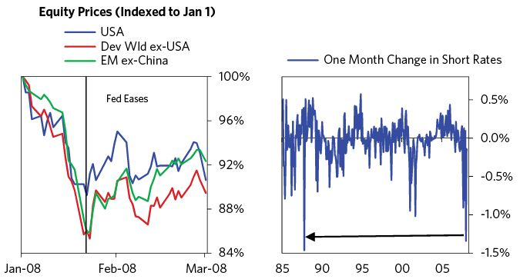

Stocks bounced, but despite the magnitude of the easing, they failed to recoup their losses, and by the end of February, stocks were back to where they had been before the Fed intervened. Credit and economic conditions continued to deteriorate along the way. Massive write-downs were announced at AIG ($11 billion), UBS ($14 billion), and Credit Suisse ($2.8 billion), indicators of service sector growth and consumer confidence hit 7- and 16-year lows, and a much publicized report from UBS estimated that losses from mortgage-backed securities could total $600 billion in the US financial system.

Reflecting on events at the time, we thought it was important to remind our clients that this was not going to be a typical recession but rather a deleveraging/depression-type dynamic, which is quite different in terms of both its potential magnitude and the linkages that drive the contraction. In our Bridgewater Daily Observations on January 31, we wrote:

(BDO) January 31: The Really Big Picture; Not Just a Normal Recession  
 The “R” word has been used a lot to describe the possible contraction in economic activity because all contractions are now called recessions. However, to use that term to describe what’s happening would be misleading in that it connotes an economic contraction like those that occurred in the US many times before, as distinct from those that occurred in Japan in the 1990s and in the US in the 1930s, which are better characterized by the “D” word (e.g., deleveraging).

Contrary to popular belief, a “D” is not simply a more severe version of an “R”—it is an entirely different process…An “R” is a contraction in real GDP, brought on by a tight central bank policy (usually to fight inflation) that ends when the central bank eases. It is relatively well managed via interest rate changes…A “D” is an economic contraction that results from a financial deleveraging that leads assets (e.g., stocks and real estate) to be sold, causing asset prices to decline, causing equity levels to decline, causing more forced selling of assets, causing a contraction in credit and a contraction in economic activity, which worsens cash flows and increases asset sales in a self-reinforcing cycle. In other words, the financial deleveraging causes a financial crisis that causes an economic crisis.

### March 2008–Rescuing Bear Stearns

The first ten days of March saw equities sell off about 4.5 percent (with much larger losses for financials), following high profile defaults at Carlyle Capital ($22 billion in assets under management or AUM), two funds operated by London-based Peloton Partners ($3 billion AUM), and news that Thornburg Mortgage ($36 billion in AUM) was missing margin calls. They were all heavily exposed to mortgage-backed securities and lenders were increasingly hesitant to lend them money.

These concerns quickly spread to major brokerages, especially those known to hold significant exposures to MBS, such as Bear Stearns, Lehman Brothers, and Merrill Lynch, all of which saw their borrowing costs spike. The problems were passing to systemically important financial institutions, threatening the entire system. Even so, the danger was not widely appreciated. Writing on March 10, we noted in our Bridgewater Daily Observations that conditions were quickly “slipping away” and that “Broker/dealers in our experience cannot survive with financing costs close to Bear’s current levels.”

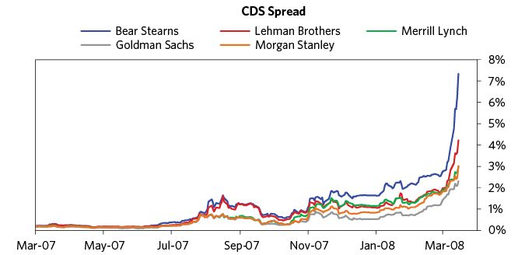

Bear Stearns was the most stressed of the major investment banks. Although Bear was the smallest of them, it still held $400 billion worth of securities that would be dumped onto the market if it failed. Moreover, Bear and its nearly 400 subsidiaries had activities that touched almost every other major financial firm. It had 5,000 trading counterparties and 750,000 open derivatives contracts. As Bernanke put it in his memoirs21 , “size alone wasn’t the problem. Bear was big, but not that big compared to the largest commercial banks.” It was not “too big to fail,” it was “too interconnected to fail.” Bernanke’s greatest fear was that a Bear bankruptcy could trigger a collapse in the $2.8 trillion tri-party repo market (a significant credit pipe for financial institutions), an event that would have “disastrous consequences for financial markets and, as credit froze and asset prices plunged, the entire economy.”

Classically, when a financial institution starts to show early signs of stress, it can experience “runs” that can accelerate into a failure in a matter of days, because runs can lead to losing liquidity. That’s because these institutions rely on short-term borrowing, often overnight borrowing, to hold longer-term, illiquid assets. At the first sight of trouble, it is logical for those who are providing this short-term credit to stop lending in order to avoid losses. We certainly didn’t want to have exposure to a financial institution that was stressed. As more and more market participants change their behaviors in this way, it creates the liquidity crisis that leads to failure. That was what was happening to the financial institutions shown in the chart above to the degrees conveyed by the spreads. The Treasury and the Fed just had a few days to figure out their responses.

Big financial institutions have failed many times in the past. As I described in the prior sections of the book, if the debt is in one’s own currency, and if policy makers have both the knowledge of what it takes to manage it and the authority to do so, then they are capable of handling these situations in a way that minimizes spill-over effects and limits economic pain (though some pain is inevitable). This is a theme we will return to time and time again.

In 2008, the US had a team of policy makers that understood what it would take to manage a debt crisis about as well as one could expect given that debt crises of this magnitude happen about once in a lifetime. I want to reemphasize how significant it was that the economic leadership team had the qualities they had. Treasury Secretary Hank Paulson had more than thirty years of financial market experience at Goldman Sachs, including eight years as CEO, so he brought a good understanding of how financial institutions and markets worked and a forceful leadership style with experience in making tough decisions under pressure. Chairman Bernanke was one of the most prominent economists of the time, and one of the world’s foremost experts on the Great Depression, which obviously provided critical perspective. Tim Geithner, president of the Federal Reserve Bank of New York (which takes a leading role in overseeing the biggest banks and implementing monetary policy), had around two decades of experience in economic policy, including prominent roles at the Treasury and at the IMF, which gave him exposure to the handling of financial crises.

Geithner, Paulson, and Bernanke told me that they were extremely lucky to be on a team that trusted one another and had complementary skill sets, and they all believed that they needed to do whatever they could to prevent the failure of systemically important institutions. In other words, they agreed on the important things that had to be done and they were great at cooperating to do all in their power to get it done. I saw up close how lucky we all were, because without such cooperation and cleverness, we would have had such a terrible disaster that it would have taken decades to recover from it.

The biggest problem Geithner, Paulson, and Bernanke faced is that they didn’t have all the legal authority they needed to make some of the moves that were necessary. For example, by law, the Treasury could only use funds for purposes designated by Congress. While handling a failing traditional bank (e.g., one that took retail deposits) had a clear playbook, primarily administered by the FDIC, there was no authority for the Treasury, the Fed, or any other regulator to provide capital to a failing investment bank. At this point, to save an investment bank, there would have to be a willing private sector buyer to take on the exposure. This limitation proved incredibly consequential.

The urgent need for flexible authority is a classic challenge for policy makers in the midst of crises. The system that is designed to ensure stability during normal times is often poorly suited to crisis scenarios in which immediate, aggressive action is required.

The Treasury and the Fed ran into this challenge with Bear Stearns, so the Fed turned to the plans it sketched out in late 2007, exercising its section 13(3) powers—which hadn’t been used since the Great Depression—to arrest what Bernanke would later call “self-feeding [downward] liquidity dynamics.”22 It announced a $200 billion new program, the Term Securities Lending Facility (TSLF), through which it would allow financial institutions, including major brokerage firms, to borrow cash or treasuries by using risky assets, including nongovernment mortgage-backed securities, as collateral. Markets applauded the injection of liquidity, with stocks posting their largest daily gain (about 4 percent) in over five years.

Despite the announcement of the TSLF, the run on Bear continued. In just four days (March 10-March 14) Bear Stearns saw an $18 billion cash buffer disappear as its customers quickly began withdrawing funds. Treasury Secretary Paulson feared the brokerage could collapse within 24 hours as soon he heard it was facing such a run on liquidity.23 This was because Bear had been making loans of up to 60 days while remaining almost completely reliant on overnight funding. By Thursday, March 14, those fears were confirmed. Lenders in the repo market refused even to accept Treasury securities as collateral when making overnight loans to Bear Stearns.

Bernanke, Geithner, and other Fed officials agreed that another loan from the Fed wasn’t going to help Bear Stearns. It needed more equity—an investor to fill the hole created by all the losses. At this point, the Treasury didn’t have the authority to be that investor. A private sector solution—a healthier institution to acquire Bear—was the best option. To buy time, the Fed, along with JP Morgan, promised on March 13 to extend Bear Stearns “secured funding…as necessary, for an initial period of 28 days.”

JPMorgan, the third largest bank holding company in the country at the time, was the most natural candidate to buy Bear, because it was Bear’s clearing bank, served as an intermediary between Bear and its repo lenders, and was thus considerably more familiar with Bear’s holdings than any other potential suitor. Only JPMorgan could credibly review Bear’s assets and make a bid before Asian markets opened on Sunday, a process which importantly included guaranteeing Bear’s trading book. However, JPMorgan was not willing to proceed if it meant having to take over Bear’s $35 billion mortgage portfolio. To push a deal through, the Fed promised to provide JPM with a $30 billion non-recourse loan to buy out the brokerage (at $2 a share—its peak was $173), secured by Bear’s mortgage pool, meaning that future losses on the mortgage portfolio would be borne by the Fed—and ultimately the taxpayer. They also created a new lending facility where twenty investment banks/brokerages could borrow unlimited sums while posting MBS for collateral.

On Tuesday, the Fed additionally cut rates 75 basis points (bringing the policy rate down to 2.25 percent). The rescue and aggressive injection of liquidity had the desired effect. Stocks rallied and remarkably ended the month flat. Using taxpayer money to save Bear Stearns would prove a controversial decision, but as we noted in our Daily Observations at the time, failure to do so would have resulted in the “financial system…passing the point of no return (i.e., the point at which the blowing out of risk and liquidity premiums would be self-reinforcing).”

Although the markets rebounded, Paulson, Bernanke, and Geithner worried because they saw that, without a buyer, they didn’t have the authority to prevent the bankruptcy of an investment bank in the midst of a panic, and they immediately began to worry about Lehman.24

Paulson and Bernanke met with House Financial Services Committee chairman Barney Frank and told him that they were concerned about Lehman and needed emergency authority to wind down a failing investment bank in the midst of a panic. Frank told them that this would be impossible to get from Congress unless they made a compelling public case that Lehman was about to fail and that its failure would damage the US economy. Paulson and Geithner maintained frequent communication with Lehman’s CEO in an unsuccessful attempt to convince him to sell the bank or raise equity from a strategic, cornerstone investor.25

Later in April, Paulson used the Bear failure to convene a meeting with Senators Chris Dodd and Richard Shelby (the current and former chairmen of the Senate Banking Committee) and Daniel Mudd and Richard Syron (the CEOs of Fannie Mae and Freddie Mac).26 This led to the Senate taking up the GSE reform legislation, which had passed the House in May of 2007 but had stalled in the Senate.

### The Post-Rescue Rally: April–May 2008

In response to the rescue of Bear Stearns and the big easing, stocks rallied and bond yields rose through most of April and May, as markets became increasingly confident that the Fed would do whatever was necessary if things got bad enough. Prominent policy makers struck a tone of cautious optimism, with Treasury Secretary Paulson noting that the economy was beginning to rebound and that he also “expected to see a faster pace of economic growth before the end of the year.”27 The charts below are some of the key markets at the time. You might give some thought to what bets you would’ve made then.

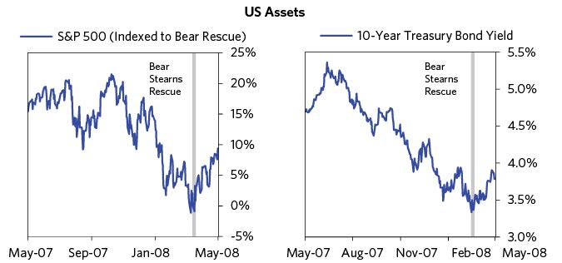

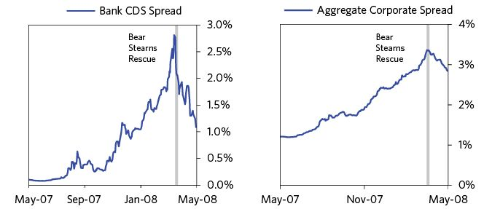

The “expansions of balance sheets” (i.e., the increased lending and buying of assets) through borrowing was beginning to slow, and, as a result, economic conditions continued to weaken as reflected in the economic stats, which came in below expectations. Unemployment continued to climb, consumer confidence and borrowing continued to fall, housing delinquencies and foreclosures continued to rise, and manufacturing and services activity continued to contract. Simultaneously, fresh rounds of write-downs were announced at UBS ($19 billion), Deutsche Bank ($4 billion), MBIA ($2.4 billion), and AIG ($7.8 billion). Reflecting on the market action in the months following the Fed’s rescue, we likened it to a “currency intervention that temporarily reverses the markets but doesn’t change the underlying conditions that necessitated the action.”

Simultaneously oil prices continued to climb (hitting $130 in late May) and the dollar continued to fall. These moves added to the Fed’s dilemma, as it would have to balance keeping its policy accommodative to ward off an economic contraction and a further deterioration in financial conditions with concerns over price stability. The minutes of the Fed’s April meeting reflected this, with the committee acknowledging “the difficulty of gauging the appropriate stance of policy in current circumstances.” Two members even expressed “substantial concerns about the prospects for inflation” and warned that “another reduction in the funds rate…could prove costly over the long run.”

It should be noted that using interest rate and liquidity management policies that affect the whole economy to deal with the debt problems of certain sectors is very inefficient at best. Macroprudential policies are more appropriate (and in fact would’ve been appropriate much earlier, such as in 2007 when they could’ve been used to control the then-emerging bubbles). They were not to be put to use until much later, when pressing circumstances required their use.

Collectively, the combination of new-found optimism in the financial system and growing concerns over price stability meant that when the Fed cut rates in late April, markets priced it as the end of the easing cycle.

### Summer of 2008: Stagflation

In June the S&P fell by 9 percent because surging oil prices led to a spike in inflation at the same time that there were renewed credit problems in the financial sector and poor economic stats.

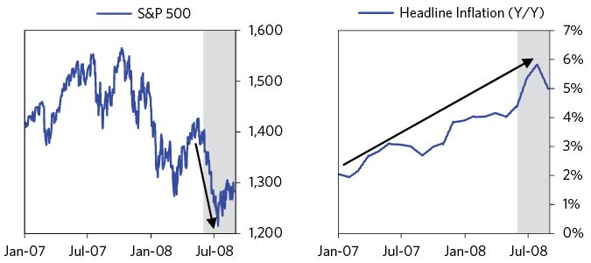

In terms of credit problems, the month began with downgrades of Lehman Brothers, Merrill Lynch, and Morgan Stanley by Standard & Poor’s, with the rating agency noting that it had lost some confidence in these banks’ ability to meet their financial obligations. This was followed by rumors that Lehman had approached the Fed for emergency funding and a release from Moody’s that MBIA and Ambac (two of the country’s largest bond insurers) were likely to lose their AAA ratings (thereby severely impairing their ability to write new insurance). By the end of the month, Moody’s had cut the insurers’ ratings and placed Lehman on credit review, while home foreclosures and mortgage delinquency rates, the underlying drivers of the strains, continued to accelerate.

As we looked at these institutions’ balance sheets, estimated the losses they would have to report, and imagined what the reduced capital from those losses would mean for their lending and sales of assets, it was clear to us that they were headed for serious trouble that would have serious knock-on effects. Basically, they were getting margin calls, which meant that they would have to raise capital or sell assets and contract their lending, which would be bad for the markets and the economy.

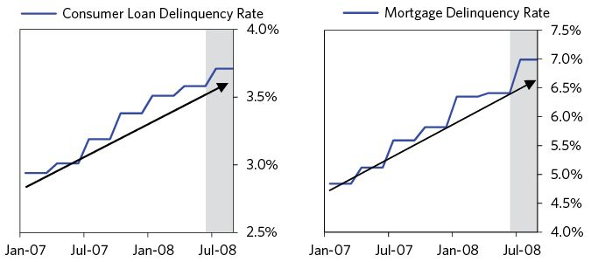

As a result of the contraction in credit, unemployment surged to 5.6 percent (the largest monthly increase in two decades), manufacturing activity declined for the fourth month in a row, and consumer confidence hit a 16-year low. Simultaneously, a CPI print showed that headline inflation rose to 4.4 percent in May, its sharpest increase in six months, and spiked fears of stagflation amidst poor growth and rising inflation expectations.

To ease or not to ease—that was the question. The cross-currents made the answer less than obvious. Throughout the month, policy makers repeatedly alluded to concerns for both economic growth and price stability. Bernanke called rising oil prices unwelcome, and Paulson emphasized that they would be “a real headwind” for the economy. With respect to the exchange rate, Bernanke emphasized that the Fed would “carefully monitor” its implications for inflation and inflation expectations, while Paulson even suggested that he “would never take intervention off the table.”28

The pickup in inflationary pressures prompted a shift of the Fed’s priorities from preventing debt and economic risks to growth and toward assuring price stability. As early as June 4, Bernanke noted that further interest-rate cuts were unlikely due to concerns over inflation, and suggested that the current policy rate was sufficient to promote moderate growth.29 A few days later Bernanke gave a speech noting that the rising commodity prices and the dollar’s depressed value posed a challenge for anchoring long-term inflation. Finally, on June 25, the Fed left rates unchanged, noting that “although downside risks to growth remain, they appear to have diminished somewhat, and the upside risks to inflation and inflation expectations have increased.” Ugh. See the charts below.

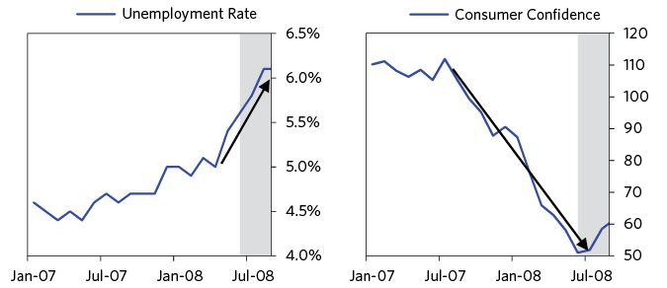

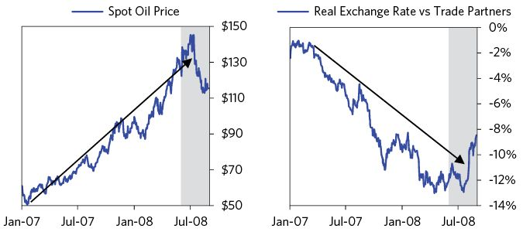

Markets continued to decline, oil prices rose, and a series of ratings downgrades, write-downs, and poor housing stats surfaced during the first two weeks of July. Financial stocks went into a free fall as it became clear that the Fed was behind developments and that the credit problems would not be fixed up via a blanket easy Fed policy even if it aggressively eased. The mortgage crisis and who it would affect next also became clearer. Shares of Freddie Mac and Fannie Mae came under extreme selling pressure, following a report by Lehman Brothers, published on July 7, stating that the two mortgage giants would need a capital infusion of as much as $75 billion to remain solvent. According to Paulson, the report “set off an investor stampede,” with shares of Freddie Mac and Fannie Mae declining by about 45 percent each respectively in the week following the report’s release.30

In mid-July, markets bounced because oil prices declined sharply (leaving more room for the Fed to ease) and policy makers made a series of interventions to shore up confidence in the financial sector—most importantly with respect to Freddie Mac and Fannie Mae. Also, the SEC placed restrictions on shorting 19 financial stocks (including the two mortgage lenders), the Fed extended its emergency lending program for investment banks and brokerages, and the Treasury and the Fed announced a plan under which Freddie Mac and Fannie Mae would be able to tap into public funding (i.e., be bailed out) if on the verge of collapse.

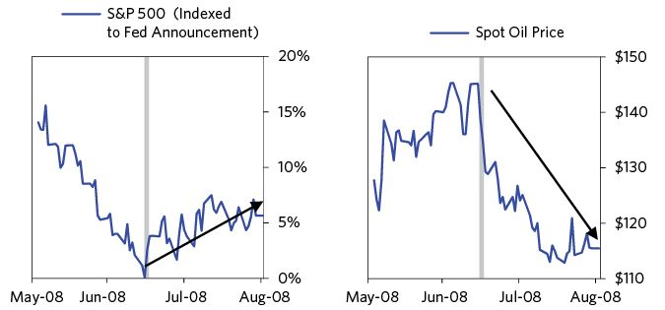

### Taking Control of Fannie and Freddie

Of all the interventions, the guarantee to use public funds to support Fannie Mae and Freddie Mac was the most unprecedented. Fannie Mae and Freddie Mac were two government-sponsored enterprises (GSEs), created by Congress in 1938 and 1970 respectively, with the former being part of Roosevelt’s New Deal following the Great Depression. They were created to stabilize the US mortgage market and promote affordable housing. They did this primarily by buying mortgages from approved private lenders, packaging many together, guaranteeing timely payment on them, and then selling them back to investors.

At first glance, everyone looked to benefit from this arrangement. Private lenders had a ready buyer for about as many mortgages as they could originate. Fannie and Freddie profited greatly from buying riskier mortgages and turning them into a safe asset (i.e., buying something cheap and selling it for more). Banks and other investors were happy to have a greater supply of safe assets to invest in, earning slightly more than they would on equivalent treasury bonds. And households benefited from cheaper borrowing rates.

Of course, all this was based on an implicit guarantee that the government would backstop Fannie and Freddie—it was only that guarantee that allowed the securities issued by GSEs to be seen as about as safe as treasuries, giving them very low borrowing rates. At times, the spread on their debt to treasuries essentially hit 0 percent.

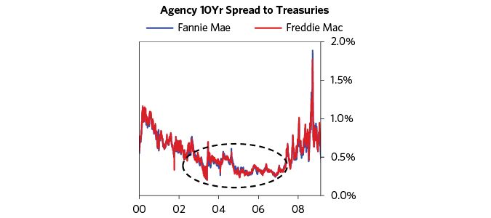

While they weren’t officially guaranteed by law, and government officials had denied for years that there was any guarantee, the private market believed that the government would never let the GSEs fail, as it would hurt too many, including individual homeowners—though they couldn’t be 100 percent sure because the Treasury wouldn’t make that assurance. I remember a dinner meeting I had with the head of a Chinese organization that held a massive amount of bonds issued by the GSEs, in which she expressed her concerns. I especially admired how the Chinese creditors approached this situation analytically and with a high level of consideration. Ironically the larger the GSEs grew, the more “systemically important” they became, which in turn all but guaranteed a government rescue if needed, making them safer and further fueling their growth.

Although Fannie and Freddie were supposed to generate revenue primarily through insuring mortgage debt, by 2007 about two-thirds of their profits came from holding risky mortgage-backed securities. The problems associated with having these exposures were made worse by lax regulation. Congress only required Freddie and Fannie to keep 0.45 percent of their off-balance-sheet obligations and 2.5 percent of their portfolio assets in reserves, meaning that they were significantly undercapitalized, even when compared with commercial banks of equivalent size, which were also severely undercapitalized (meaning that it only took a modest loss to make them go broke). Paulson saw this and openly called them “disasters waiting to happen…extreme examples of a broader problem…too much leverage and lax regulation.”31

By 2007, these two mortgage insurers were twenty times larger than Bear Stearns and either owned, or had guaranteed, $5 trillion dollars in residential mortgages and mortgage-backed securities—about half of what had been issued in the US. Financing such operations also made them one of the largest issuers of debt in the world, with $1.7 trillion outstanding, about 20 percent of which was held by international investors. They were also huge players in the short-term lending market, frequently borrowing up to $20 billion a week. It didn’t take a sharp pencil to see that they were a disaster waiting to happen. The only question was what the government would do.

Doing something to rein them in would be politically challenging. Larry Summers recently described to me the challenges he faced when dealing with them in the 1990s:

“Fannie and Freddie had vast political power. When we said anything raising any concern about them, they had arranged for the Treasury to receive 40,000 pieces of mail saying it is important that Fannie and Freddie be fully enabled to do their vital work. When we testified on Fannie and Freddie, a congressman would pull out an envelope from Fannie with their prepared statements and what their questions were going to be. They would have a set of mayors call if you tried to mess with them. The most disillusioning experience I had with respect to the financial community was at the quarterly dinner for the Treasury Advisory Borrowing Committee. I asked them: ‘What do you guys think about the GSEs?’ They said that the GSEs were like a massively over-leveraged hedge fund—dangerous. They were pretty emphatic. I said, ‘Would you put that in your report?’ and they said they would. The report came back basically saying that Fannie and Freddie are vital contributors to our financial systems. I asked what happened. They said that they checked with their bosses and their bosses said we couldn’t say that because we all had such important client relationships.”

Paulson described this situation as follows:

“We had seen what happened in March when Bear Stearns’s counterparties…abruptly turned away. We had survived that, but the collapse of Fannie and Freddie would be catastrophic. Seemingly everyone in the world—little banks, big banks, foreign central banks, money market funds—[either] owned their paper or were [their] counterparty. Investors would lose tens of billions; foreigners would lose confidence in the US. It might cause a run on the dollar.”32

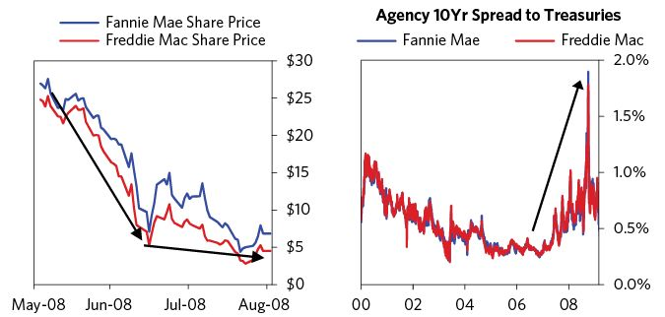

This case exemplifies the very common problem of politics creating government guarantees (implicit or explicit) that make risky assets appear to be safer than they are. This encourages investors to lever up in them, which feeds bad debt growth.

As losses from mortgage-backed securities mounted, shares of Freddie and Fannie plummeted because everyone knew they had a lot of bad debt. Equity holders knew they would get hit even if the creditors were protected. By July 15, Freddie and Fannie’s equity prices had declined by almost 75 percent in less than a year.

Now that the crisis was at hand and undeniably obvious, it had to be dealt with. After frantic behind the scenes negotiations, the Treasury was able to get a bill passed by Congress on July 23 allowing it to use a virtually unlimited (Paulson chose the term “unspecified”) amount of dollars to provide funds to the two GSE’s (limited only by the overall federal debt ceiling), and expanded regulatory oversight of them. The Treasury basically acquired a blank check, backstopped by the taxpayer, to do whatever it took to keep these institutions solvent.

Nationalizing too-big-to-fail financial institutions on the brink of failure is a classic move in a deleveraging that is usually well received, as it signifies that the government is willing to provide a blanket of safety over the system. Remember that when debts are denominated in a country’s own currency, the government has the power to eliminate the risks of default.

Though there are undeniable advantages to a political environment in which there are checks and balances and laws,* during times of crisis there exists the risk that what needs to be done might not be done swiftly enough. That’s because laws are never written so perfectly that they can anticipate and specify how to handle every possible circumstance. Throughout the 2008 financial crisis, there were numerous close calls in which the parties involved did the things that needed to be done, even if that required them to get around the rules to do them.

On July 30, as soon as Congress granted the Treasury the authority to oversee Fannie and Freddie, regulators from the Treasury began working to assess just how dire the situation was. With the help of the Fed and outside accounting specialists, Treasury officials pored over the GSEs’ books. They soon discovered that both Fannie and Freddie had been papering over massive capital losses. Once they had properly accounted for questionably valued intangible assets and improperly valued mortgage guarantees, they saw that both companies were at least tens of billions of dollars underwater. As Paulson later put it, “We’d been prepared for bad news, but the extent of the problems was startling.”33

From mid-August until the bailout, the situation was analyzed; terms were finalized on September 7. The Treasury then raced to build a plan that would serve its economic goals without bumping up against legal constraints. In the end, it decided to put the GSEs into conservatorship while injecting capital through guaranteed purchases of preferred stock. Conservatorship would allow both Fannie and Freddie to keep running relatively normally following the takeover, while the guaranteed stock purchases would allow the Treasury to effectively backstop their debt, even after the 18-month limit on its authority expired. And, importantly, Paulson wouldn’t have to give Fannie and Freddie any heads up—all it would take was a go-ahead from their direct regulator, the Federal Housing Finance Agency (FHFA).

Bailing out the GSEs was more of a political challenge than an economic one. The executives of both companies still believed they were on sound footing. After all, just a couple of weeks before the FHFA had sent the GSEs drafts of reports concluding they were sufficiently capitalized. If news of the planned takeover leaked, the executives of Fannie and Freddie would have time to mobilize their lobbyists and congressional allies in Washington to fight it. And if there were a fight, there was no guarantee that the Treasury would win—in Paulson’s words, the GSEs were famously the “toughest streetfighters in town.”34

Convincing the FHFA examiners required the coordination and combined influence of the Treasury, the Fed, the OCC, and the FDIC. The FHFA, which had repeatedly blessed Fannie and Freddie’s books on the basis of loose statutory accounting rules, was embarrassed at the thought of reversing itself so suddenly. But after weeks of pressure from the Treasury and its allies, the FHFA examiners gave in on September 4. The next day, the news was given to the boards of the two companies. Fearing that any friction or delay in the takeover might send markets plunging, Paulson set out, in his own words, “to ambush Freddie and Fannie” with no advance warning.35

Paulson described the Fannie-Freddie situation to me as follows. In July 2008, when Fannie and Freddie were beginning to fail, the Treasury asked for very expansive emergency powers. As Freddie and Fannie combined were nine times larger than Lehman Brothers and the dominant sources of mortgage financing during the crisis, they could not be allowed to fail. However, Paulson’s political people had told him that if they put a big dollar number in front of Congress for approval, Congress would likely get spooked. As Paulson couldn’t ask for unlimited authority to inject capital into the two GSEs, he decided to ask for “unspecified” authority.

However, when the Treasury finally got the “unspecified” authority, it was temporary, i.e., it expired in October 2009. This presented a challenge, because Fannie and Freddie had long-term debt and insured long term mortgages. So it took some creative financial engineering to turn this expansive authority, which Congress had intended to be only temporary, into what was for all intents and purposes a long-term guarantee. To do this, policy makers used their ability to immediately issue long-term preferred stock. Then they used these preferred shares to backstop Fannie and Freddie and absorb any potential losses.

This particular move—with its legal finagling—and the need to convince numerous lawmakers to set aside their ideological opposition to bailouts for financial institutions, while at the same time getting Congress to raise the debt ceiling sufficiently to allow for a potentially meaningful capital injection, were unprecedented and remarkable. But as Paulson described it later, “if Congress failed to come through, markets would implode. The stakes were enormous.”36

In early August, falling oil prices and the Treasury’s unprecedented intervention helped usher in an interval of relief, with equities rallying modestly through August (about 2 percent), financials down only 1 percent, and the free fall of Freddie and Fannie stock halted. However, despite the growing perception that financial markets were stabilizing, the underlying drivers of credit problems, and their feedback mechanisms into the real economy, had not changed.

On August 18, I reminded the readers of our Daily Observations that the worst was yet to come.

(BDO) August 18: Entering the Second Stage of the Deleveraging  
 It seems to me that we have been through much of the first stage and are now entering the second stage (i.e., the avalanche stage) of the deleveraging. While the Fed did a great job of providing liquidity where it reasonably could, the accounting adjustments (e.g., allowing losses to be written down over several years) weren’t made, so we are approaching a solvency crisis that we think is about to result in an avalanche of asset sales. So now the question is whether they will create a safety net in time to catch these assets so that they don’t crash and bring down the financial system and the economy with it. Frankly, we think that this will be a race to the wire.

## The Crash: September 2008

In September the crisis entered a new stage in which there was a genuine risk that the world economy would plunge into a depression. Since so much happened, I will transition into a nearly day-by-day account of events.

Over the first week of September, there was a mix of good and bad news in the form of oil prices falling precipitously (which reduced concern over inflation and provided a tailwind to US consumer spending.) Airlines and retailers, hopeful of a pickup in consumer spending, were particular beneficiaries. At the same time, falling oil prices reflected weakening global growth.

While financial players like Lehman Brothers, Freddie, Fannie, and Ambac were struggling, it also seemed as though solutions to their problems were in the works. For example, Lehman’s stock rose on news that it had made progress in negotiations to sell part of itself to the Korea Development Bank, while good news from Freddie (a successful sale of $4 billion in debt) and Ambac (the announced launch of a new insurance subsidiary) partially softened investor concerns surrounding these companies.

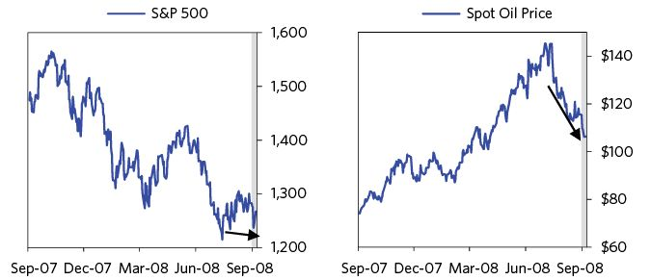

These positive developments were set against a continuous trickle of negative stat releases—in particular, an unanticipated spike in jobless claims and a notable uptick in the unemployment rate (from 5.7 percent to 6.1 percent). Stocks declined by 2.5 percent. Weak economic reports also filtered in from outside the US. From Canada to Australia, the story was the same—slowing demand, slowing output, and no end in sight. All in all, stocks ended the first week of September just slightly down.

The big news came after markets closed at the end of the week, when reports broke that the federal government would take over Fannie Mae and Freddie Mac.

### Lehman Goes Bankrupt: September 8-15

Stocks rose about two percent on Monday, September 8, as the market responded positively to news of the nationalization of Fannie and Freddie, a bold move that would have been unthinkable months before. The New York Times wrote that “financial stocks led the surge, propelled by hope that the government’s decision had averted a calamity and marked a possible turning point in the credit crisis that has troubled banks for nearly a year” (my emphasis). Boy, was that wrong.

Writers of accounts such as this one, who have the benefit of hindsight, typically paint pictures of what happened in ways that make what happened seem obvious. However, as that rally and comment reflect, it is an entirely different matter when one is in the moment. Just days before the crisis would become much worse, the New York Times wrote on three separate occasions (September 3, 5, and 10) about “bargain hunters” coming in with the stock market down around 20 percent from peak and many individual stocks down much more. Lehman Brothers, for instance, was trading down some 80 percent, but it was a company with a good reputation, a nearly 160-year history, and it looked to be on the verge of finding a buyer or strategic investor. Below is its share price through early September. While the picture is clearly within the downtrend, there were rallies, and in just about all of them, one could make the argument that the bottom was being made. In investing, it’s at least as important to know when not to be confident and when not to make a bet as it is to have an opinion and make one.

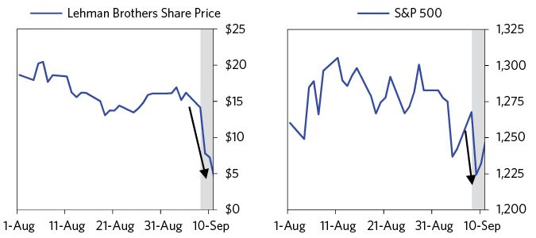

The strategic investor who would come in and save Lehman never materialized and Lehman’s stock fell by almost 50 percent on Tuesday. Other major bank stocks, including Citigroup, Morgan Stanley, and Merrill, sold off 5–10 percent, while the overall market was down about 3 percent, and credit spreads widened substantially. Both investors and regulators began to wonder whether Lehman could survive until the weekend.

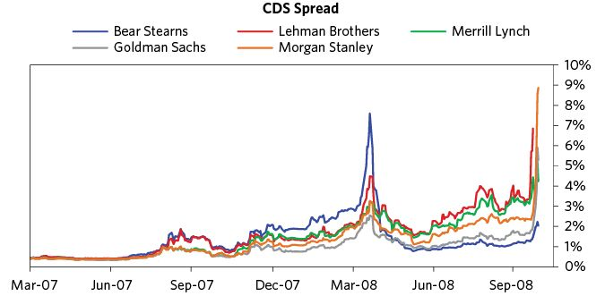

There were no clear, legally acceptable paths for saving failing investment banks, yet these investment banks were “systemically important” (i.e., they could easily take the whole system down with them). While the Fed was able to lend to Lehman to alleviate its liquidity problem, there were limitations on how much they should under these conditions. And since Lehman faced a solvency problem in addition to a liquidity problem, it wasn’t even clear that more liquidity could save it.

As we described earlier, a solvency problem can only be dealt with by providing more equity capital (or changing the accounting/regulatory rules). This meant that some entity needed to invest in it or acquire it. Neither the Fed nor the Treasury had the authority to provide that. Hence, there was a need to find a private sector investor/buyer, like Bear Stearns had with JPMorgan. But finding an investor for Lehman was harder than it was for Bear. Lehman was bigger, with a bigger, more complicated, and murkier mess of losing positions.

Finding a buyer was made even harder by the fact that Lehman wasn’t the only investment bank needing a buyer to survive. Merrill Lynch, another iconic Wall Street investment bank, was in a similarly dire situation. As with Lehman, many believed that without an investor Merrill was no more than a week away from bankruptcy.37

On Thursday Lehman’s shares continued their free fall, declining another 42 percent as rumors swirled that Barclays and Bank of America, though interested, were unwilling to buy without government assistance. At this point, Lehman was continually rolling $200 billion in overnight loans just to stay running, putting it at huge risk of a pullback in credit.38

On Friday Lehman’s shares dropped 17 percent on news that neither the Fed nor the Treasury would backstop any deal. Lehman’s failure would pass through the system quickly, causing a domino effect that took a toll on AIG (its stock fell 31 percent). But, remarkably, most of the market still believed that the financial sector’s problems would be contained. The overall market closed on Friday up 0.4 percent, aided by falling oil prices.

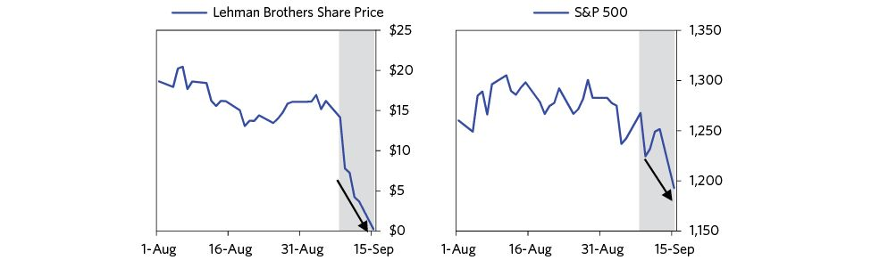

On Friday evening, reports surfaced that Fed officials had gathered the heads of Wall Street’s major banks—from Goldman Sachs to the Bank of New York Mellon—to urge them to bail out Lehman. Whether there would be any takers remained to be seen. Bank of America, Barclays, and HSBC had reportedly expressed interest, but none wanted to do the deal without government support. And Treasury officials publicly insisted no support would come.

Paulson had hoped that by motivating a consortium of financial institutions to take on Lehman’s bad loans, a potential acquisition of Lehman could be facilitated (as a potential buyer could leave a substantial portion of Lehman’s bad assets behind when they acquired the firm). But while some progress was made with the consortium, no potential buyer emerged. Without a potential buyer, the Fed did not have any authorities which would have been effective in preventing the failure of a nonbank in the midst of a panic-driven run, according to Paulson, Bernanke, and Geithner.39

Bernanke and Geithner had many conversations together and with Paulson about what they could do to help prevent Lehman’s failure, but, as in the case of Bear Stearns, they did not believe that a Fed loan would be effective. They believed that the legal requirement that a loan had to be “secured to their satisfaction” limited the amount they could lend, and that meant they could not lend Lehman enough to save it or guarantee its trading book. The weeks before that fateful weekend were consumed by the effort to figure out a way to prevent Lehman’s failure despite those constraints. They were willing to be very creative with their authority and to take a lot of risk, but only within the bounds of what the law allowed. They erred on the side of doing more, not less, but Section 13(3) (the section of the Federal Reserve Act that allowed for emergency lending to a wider set of borrowers) did not make them alchemists. Loans were not equity, and they had to be guided by what would work in practice.

Most everyone agrees that it would have been a lot better if these policy makers had the authority to liquidate Lehman in an orderly way; this was another classic example of how political constraints together with imperfectly thought-out legal constraints can get in the way of actions that are widely agreed to be beneficial.

On Sunday afternoon the news broke that Lehman was headed for bankruptcy, and all hell broke loose. The shock was way bigger than any before because of Lehman’s size and interconnectedness to other vulnerable institutions, which made it clear that the contagion would spread. Even worse, the government’s failure to save it raised doubts about whether it could save the system. Lehman’s failure was particularly scary because of its large and poorly understood interconnectedness with the rest of the financial system.

There were a couple of major channels of potential contagion. The most important (and least clear) was Lehman’s substantial presence in derivatives markets. At the time of its bankruptcy, Lehman was a party to between $4 and $6 trillion worth of exposure in CDS, accounting for about 8 percent of the total market. Though many of these exposures were offsetting—Lehman did not actually owe huge sums on net—its failure sent clients scrambling to find new counterparties. At the time, no one knew how large Lehman’s net exposure was, or who was on the other side of it; we were crossing the line into a big, disastrous unknown. On September 11, we wrote in the Daily Observations:

The uncertainty of this situation is tremendous. What happens when you go to settle a currency forward transaction with a counterparty that suddenly doesn’t exist? Maybe everything goes fine, but maybe some unexpected condition bites you in the ass. What if you haven’t been collecting mark-to-market gains from one of your dealers (we collect constantly from everyone), they go down, and now you are a general creditor? Who do you transfer the risk to? Maybe Merrill is right behind Lehman. What do you about that? And who might be behind it? If everyone is asking these questions the natural path is to cut back on trading and concentrate positions with a few firms. But these few firms have the incentive to ration their capacity to the highest quality financial institutions and managers. The inevitable result is substantially lower liquidity, higher transactions cost, and higher volatility. Higher volatility then feeds back into the real economy because people and businesses transact at these prices. And capital constraints in the financial sector mean that credit growth remains low, which undermines economic growth. We are getting very close to crossing this line.

While Lehman’s bankruptcy was the largest in US history (and still is), with some $600 billion in reported assets, it was only about two-thirds the size of Goldman Sachs, and a quarter as large as JPMorgan. They were all connected and the losses and liquidity problems were spreading fast.

We called this stage of the crisis the “avalanche”—the point at which a smaller problem in one corner of the financial system (subprime mortgages) was building in self-reinforcing ways into much bigger problems, and fast.

### Aftermath of the Lehman Collapse: September 15–18

On Monday morning, September 15, Lehman Brothers filed for bankruptcy, and the stock market fell by nearly 5 percent. No industry was spared, though the financial sector took the brunt of the pain, with shares of banks and insurers falling by about 10 percent. Credit spreads blew out and credit flow ground to a halt. Over the course of the following week, markets, policy makers, and we at Bridgewater struggled to figure out the ripple effects from Lehman, which of course we couldn’t because the interrelationships and exposures were too complex and too opaque. It was clear to us that blanket protections would have to be put into place, because the consequences of the uncertainties themselves would be devastating as everyone ran from any entity that could go under. But if policy makers couldn’t or wouldn’t save Lehman Brothers, how could they save the system?

One of the Fed’s immediate responses, announced the night before, was an unprecedented expansion in the “Primary Dealer Credit Facility”: They were willing to lend to investment banks against almost any collateral, including extremely risky instruments—e.g., equities, subprime mortgages, and junk bonds. It should have been seen as an enormous step for a central bank to take, and in a more normal environment, it would have been. But the Lehman collapse overshadowed it.

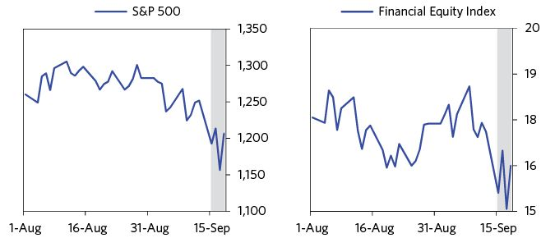

Paulson would later write in his book that he felt constrained from even being able to explain in a forthright way why Lehman had failed without creating more problems—a common issue policy makers face when communicating during a crisis. As he put it:

“I was in a painful bind that I all too frequently found myself in as a public official. Although it’s my nature to be forthright, it was important to convey a sense of resolution and confidence to calm the markets and to help Americans make sense of things…I did not want to suggest that we were powerless. I could not say, for example, that we did not have the statutory authority to save Lehman—even though it was true. Say that and it would be the end of Morgan Stanley, which was in far superior financial shape to Lehman but was already under an assault that would dramatically intensify in the coming days. Lose Morgan Stanley, and Goldman Sachs would be next in line—if they fell, the financial system might vaporize and with it, the economy.”40

With big questions on the direction policy was heading, I wrote the following note to our clients on September 15:

(BDO) September 15: Where We Are Now  
 We have known about the losses that had to be taken by financial institutions for some time. They were discussed and conveyed to you in the tables that we sent to you repeatedly, over the last year. So, these problems were known. We described them as ‘known and manageable’ because, besides being known, we felt that they were manageable via sensible government policies—of providing liquidity (by the Fed), changing accounting rules and/or creating a safety net (by the Treasury, in cooperation with Congress)—and then clearly articulating these policies to provide the necessary confidence that would allow the debt restructuring process to progress in an orderly manner…

While we are still trying to figure out what the Treasury and Fed’s approaches are, over the last few days they made some more things clear by innuendo. They made clear that they’re willing to take the chance of diving into the depths of the scary unknown without a clear safety net in place. So, now we sit and wait to see if they have some hidden trick up their sleeves or if they really are as reckless as they seem. With interest rates heading toward 0 percent, financial intermediaries broken and the deleveraging well under way, it appears that we are headed into a new domain in which the classic monetary tools won’t work and the Japan in the 1990s and US in the 1930’s dynamic will drive things

Meanwhile, reports came in showing how the financial meltdown was passing to the economy, leading it to plummet. A Fed report showed industrial output down sharply in August; AIG saw its credit ratings downgraded, potentially triggering additional collateral requirements; and Hewlett Packard announced it was cutting 25,000 jobs. With America’s financial system obviously in crisis, the problems quickly spread globally, prompting European and Asian central banks to announce new liquidity provision measures to shore up their own markets.

Credit markets were in turmoil. As financial players sorted through the tangle of counterparty risks and obligations created by Lehman’s failure, interbank lending seized up and Libor (the rate at which banks lend to each other) settled at almost twice the prior week’s levels. The contagion was spreading to everyone, even the strongest. Privately, executives from blue-chip firms like GE admitted to regulators that even they were having trouble borrowing in the commercial paper market, which could put them in a cash-flow bind and force them to default. Prime money market funds started to register increasing stress, high redemptions, and losses (we’ll discuss this in more detail a little later). By the end of the day, credit spreads on Morgan Stanley widened to levels greater than those for Lehman on Friday.

Throughout the day, regulators scrambled to keep up with AIG’s rapid decline. AIG was one of the largest insurers, with around $1 trillion in assets at peak. Its problems centered around it having issued hundreds of billions of dollars of insurance contracts on bonds (called CDS and CDOs), which required it to pay out if a bond faced losses. Many of these insured bonds were repackaged subprime mortgages, so AIG was exposed to a staggering amount of losses. Since many other financial institutions were counting on these insurance contracts, AIG was systemically important. And it looked to be heading toward failure fast. On Sunday, it had said it would need $40 billion in funding. Now, just a day later, it was suggesting it would need $85 billion.41



On Tuesday, the Fed made two surprising policy moves—one far bolder than expected, the other more timid. On the one hand, the Fed, in a regularly scheduled meeting to set interest rates, decided not to change them, when the market expected them to be lowered—a significant disappointment that hurt the markets. Remarkably, even as the market looked to be on the verge of a depression, the Fed remained concerned about inflation, putting in their statement, “The downside risks to growth and the upside risks to inflation are both of significant concern to the Committee.” In his memoir, Bernanke would later write that “in retrospect, that decision was certainly a mistake,” caused in part by “substantial sentiment at the meeting in favor of holding our fire until we had a better sense of how the Lehman situation would play out.”42

However, more importantly, the Fed also made an announcement that redefined the limits of US central banking. It courageously announced that it would provide $85 billion in emergency funding to AIG. The deal, drafted in a rush on the afternoon of Tuesday, September 16, came with tough terms attached. AIG would pay a floating interest rate starting at 11.5 percent, while giving the government an 80 percent ownership stake in the company. Because AIG did not have enough safe financial assets to secure the loan, it pledged nearly everything else it owned as collateral—including its insurance subsidiaries, financial services companies, and various real estate holdings (including a ski resort!). The Fed loan worked because the market believed AIG was solvent (because of the value of its insurance subsidiaries, which had investment-grade credit ratings). The fact that these served as collateral for the Fed’s loan was also critical to the Fed’s decision.43

But even under these terms, the loan was an unusually risky one for the Fed—after all, the companies AIG put up as collateral were not nearly as easy to value or to sell as the AAA securities the Fed accepted in normal times. And there was still a risk that AIG would go under, despite the Fed’s help. Geithner would later say, “Deciding to support AIG was one of the most difficult choices I have ever been involved in in over 20 years of public service.”44

News of AIG’s bailout did not lift markets on Wednesday. Instead, stocks slid by about 4.7 percent, with shares of major financial institutions down by double digits. Rates on commercial paper continued to rise, while yields on three-month treasury bills fell to just above 0 percent (down from around 1.6 percent a week before) as investors fled to safety. Through this chaos, regulators announced a series of stabilizing measures. The SEC moved to tighten controls over short sellers (a common crisis response), and bank regulators proposed revisions to accounting rules to help dress up bank balance sheets.

Let’s spend a minute on the importance of accounting, especially mark-to-market accounting. For banks, some assets are “marked-to-market,” which means that every day banks take a look at what they could sell those assets for, and value them at those prices. Other assets are allowed to be valued in different ways, often by an in-house methodology that depends on the asset. When an asset that banks are required to mark-to-market is selling at fire-sale prices, any bank holding it looks like they are taking significant losses, which reduces their capital and thus requires them to raise money or sell assets, which further strains liquidity and puts further downward pressure on assets. It also scares the hell out of people dealing with them. Accounting changes that allow banks to realize losses over a longer time period (i.e., not marking assets to market) prevents some of these problems. Of course, changing accounting rules to hide losses during a financial crisis doesn’t engender confidence either, so regulators have to be careful.

But accounting changes wouldn’t change the more fundamental issue—that overindebted US households and financial institutions were defaulting on their debts because they were overlevered. It was clear that financial institutions needed to be recapitalized (e.g., via an equity investment), and they needed to find buyers for their more troubled assets. So Paulson turned to Congress for funding and authorization for the Treasury department to play that role.

### The Government Comes Up with a Bailout Fund: September 18–31

Paulson, Bernanke, and congressional leaders (most importantly, Barney Frank) thought the best way to restore confidence was to buy troubled assets through what would become the Troubled Asset Relief Program. They could have pursued nationalizing the banks, but there was no precedent for it in the US, and when banks were nationalized in other countries, they were penalized with harsh terms. For that reason, banks were reluctant to accept capital and nationalization until just before or immediately after they failed. Paulson did not believe this was the way to go, because it would be more damaging than helpful to the task of reviving capital flows.

Buying assets seemed sensible because a big source of the banks’ problems were the large amounts of complex, highly illiquid mortgage securities on their balance sheets. The theory was that if the government provided some market for them, prices would rise, capital would be freed up, and confidence would be restored, allowing the banking system to begin to recapitalize.

When Wall Street learned about the possible TARP plan on Thursday, the market rose. The rally continued on Friday, with stocks up 4 percent, as more of the details emerged. President Bush and Secretary Paulson announced that the federal government was prepared to spend $500 billion to buy up troubled mortgages, while congressional leaders promised to act quickly to pass any proposal. Then the Fed unveiled $180 billion in new swap lines for global central banks, somewhat easing fears of a dollar liquidity crunch in foreign markets. The SEC instituted a ban on the short-selling of nearly 800 financial stocks. And Goldman Sachs and Morgan Stanley came under the government’s legal authority to provide a blanket of protection by voluntarily becoming bank holding companies, giving them greater access to the Fed’s lending channels.

The Treasury also unveiled a creative new move to shore up troubled money market funds, which held $3.5 trillion. Money market funds had become very popular as an alternative to bank deposits for both retail and institutional investors. Most investors were attracted by their high interest rates and undeterred by their lack of FDIC protection; they didn’t appreciate that they were delivering those higher interest rates by investing in higher-yielding and higher-risk loans. They also believed that they would not lose money in them as their principal was protected.

Prime money-market funds had been a crucial source of liquidity for all kinds of businesses, since they buy commercial paper, a type of short-term debt that businesses use to fund their operations. Because the commercial paper they hold is generally diversified and highly rated, these funds are usually considered almost riskless—like CDs or bank deposits. But a few prime funds took losses when Lehman failed, specifically the Reserve Primary Fund, which “broke the buck” on September 16. Fears that others might take losses caused many investors to pull their money. As the dollars flowed out of these funds, they had to liquidate their holdings of commercial paper. The result was that hundreds of billions of dollars that had been funding the day-to-day operations of businesses dried up in a matter of days.



After the Reserve Fund broke the buck, Ken Wilson, who was at Treasury at the time, had gotten a call at 7 a.m. from Northern Trust, followed by others from Black Rock, State Street, and Bank of New York Mellon. All of them reported runs on their money-market funds. Meanwhile, GE had been in the news, explaining that they couldn’t sell their paper. Then Coca-Cola CFO Muhtar Kent called and said they were going to be unable to make their $800 million quarterly dividend payment at the end of the week because they couldn’t roll their paper. Even AAA-rated industrial- and consumer-products companies couldn’t roll their paper! The situation was very quickly metastasizing from Wall Street to Main Street.

To stop the run on money-market funds, Paulson decided to guarantee them outright. The only problem was that the funds would need a substantial backstop and the Treasury couldn’t immediately find the cash. To get around the problem, Treasury officials turned to a creative source—tapping the $50 billion Exchange Stabilization Fund (ESF) to back up its guarantee. This plan was announced Friday, September 19, four days after the Lehman collapse. Treasury Secretaries can get into big trouble if they spend money that hasn’t been appropriated. So Paulson got his general counsel to give him an opinion that he could use that $45 billion, since if the whole economy went down it wouldn’t be good for the dollar.45 Some of Paulson’s colleagues questioned whether $45 billion would be enough, given that there were $3.5 trillion worth of money-market funds. Paulson didn’t know if it would be, but he didn’t have a better idea.

The Treasury team was moving so fast that Sheila Bair (the head of the FDIC) called and complained that not only was she not consulted, but because of the guarantee all of the money would now go from bank deposits to Money-Market Funds. That was a good point. So the Treasury clarified that the guarantee was only applicable to money-market funds that were in trouble as of September 19. The guarantee worked incredibly well and markets immediately turned. According to Paulson, this was because when you say something is a guarantee and not just a backstop, it is much more reassuring to investors.

The ESF was meant to be used to defend the dollar against runs, but its mandate was flexible enough that the fund could be diverted to more pressing uses. And it could be done quickly, with only presidential approval. This was exactly the kind of quick thinking and creativity that was required to navigate the regulatory and political minefield and get what was needed done.

The coordinated and comprehensive policy shifts were a relief to investors. Our Daily Observations from the day speaks for itself:

(BDO) September 18: Great Moves!  
 The Treasury, Fed, and Congress finally agreed to agree to build the safety net!!!!

Overnight central banks added $180 billion in liquidity!

Regulators moved against short sellers.

Morgan Stanley was frozen and is about to be dealt with, and Goldman isn’t far behind, but moves are in the works to deal with them.

The week’s optimism faded, however, as further details of TARP emerged (or, rather, failed to emerge) over the weekend. The formal proposal put forward by the Bush administration on Saturday, September 20, was three pages long, and was intended to be an outline rather than a fait accompli to Congress. The proposal, to be called TARP (Troubled Asset Relief Program), called for $700 billion in purchases of mortgage-related assets, but offered few details on how these purchases would be administered or what other actions might be taken—and that amount of money was a pittance in comparison to the need. As we explained to our clients when the bill was first unveiled, troubled asset purchases couldn’t have much impact on their own:

(BDO) September 25: The Proposed Plan Disappoints:  
 Buying up $700 billion in mortgages (along with some other assets) will hardly help us at all. If these mortgages are bought at market prices it won’t change the financial conditions of nearly anyone materially, the mortgages will be a small percentage of the amount that needs to be bought, and the action won’t deal with most of the problems that exist. If they are bought at a premium, this will be both an unethical direct subsidy that is on the wrong side of the line, and it will mean that the amount of money spent will buy less and it still won’t contain the problems.

To make matters worse, legislators were put off by the unchecked authority the bill would give the Treasury, so getting it through Congress wasn’t assured. When markets opened on Monday, stocks sold off, closing down 3.8 percent and the dollar fell against most major currencies.

The evolving story of the TARP bill’s difficult journey through Washington DC—set against a backdrop of poor economic releases and icy credit markets—drove the ups and downs throughout the week of September 22. Most importantly, political struggles between those who wanted to provide the support and those who didn’t drove the markets Monday through Wednesday. As Bernanke and Paulson urged immediate action in testimony before Congress on Tuesday, President Bush addressed the nation in support of TARP on Wednesday. Yet little apparent progress came out of Congress. Legislative momentum was interrupted by debates over the need for a more comprehensive bill with more significant aid for homeowners and better-defined limits on the authority of the Treasury. Compensation for executives at banks became a hot-button issue. Many other issues that had some politicians anti- and others pro-led to lots of arguing and little progress.

As is classic in deleveraging scenarios, this political debate took on populist overtones. Though congressional leaders mostly supported the bill, rank-and-file members argued that it would be like a handout to the banks that caused so much trouble in the first place. Arguing over who ought to bear the costs is typical during deleveragings and highly counterproductive; it can be like doctors in the emergency ward arguing over who will pay the bill. All attention needs to be directed to saving the patient—how the costs should be handled can be decided later.

Even proposing the TARP bill was risky. If it didn’t pass, there was likely to be an extremely negative market reaction. And they needed it passed in very difficult circumstances: as soon as possible, weeks before a presidential election and amid a populist uproar from both the left and the right over its unprecedented size and scope. Given the vote counts in Congress, the bill would need to pass on a bipartisan basis, which by this point was extremely rare on any new important law (and has become even rarer since). If either of the presidential candidates opposed the bill, it would have been nearly impossible to get passed—McCain and Palin initially taking an anti-bailout position put the bill at risk, though they eventually supported it. (Paulson was on the phone almost daily with both presidential candidates.) The only factor working in the bill’s favor was that it usually takes a crisis to get Congress to act, and the financial crisis was in its most acute stage. The difficulties in getting TARP passed are a good illustration of why regulators need broad emergency authorities versus needing to rely on Congress to act.

Financial markets pulsated in response to each undulation between “they will” and “they won’t” do what was necessary in time. Credit spreads on CDS for Goldman Sachs and Morgan Stanley, which had narrowed following their transformations into bank holding companies over the weekend, widened through the week, and huge outflows from prime money-market funds and into government funds continued to put pressure on commercial paper. On Thursday night, the FDIC seized control of Washington Mutual, marking the largest bank failure in American history, before shifting its assets to JPMorgan in a $1.9 billion deal (they would seize Wachovia a few days later). As we wrote on Friday, September 26, “There is so much jam packed into each day that it is hard to pick what to comment on. The big picture through which we see all the daily news is that we are in the avalanche phase of the deleveraging.”

The political stalemate in Congress seemed to break early Sunday morning, as Secretary Paulson, flanked by House Speaker Nancy Pelosi and Senate Majority Leader Harry Reid, announced that an agreement had been reached on a $700 billion bailout bill.

But when the bill came up for a vote on Monday afternoon, it failed. Stocks fell 8.8 percent in the largest single-day drop since 1987. Around the world, reverberations sent markets spiraling downward; oil prices fell by $10 because in a depression the demand for it would be much less. Central banks, meanwhile, scrambled to offer emergency loans to shell-shocked institutions. Interbank lending markets froze, while rates on short-term treasuries fell to just above zero.

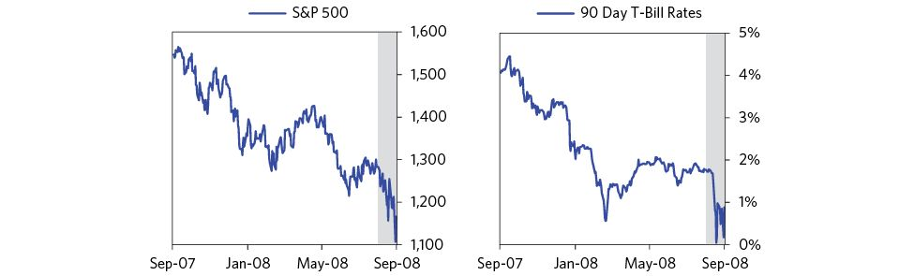

Again, among the most important aspects of successfully managing a crisis is having wise and knowledgeable decision-makers who have the authority to do whatever it takes. The Congressional vote was a sign that the Treasury would have to struggle to get the authority it needed. At the time, we wrote:

(BDO) September 29: A Credibility Test  
 The financing of US consumption and the global financial system operates on faith. Recent developments have obviously strained the faith in the financial system. Today’s failure in the House of the bill, whose passage was assured by those supposedly in control, has shined the global spotlight on US decision makers. The question of whether the US can do what needs to get done has been further complicated. In the end, the world’s financiers (China, OPEC) will decide whether US policy makers have passed the test.

Even had the bailout passed, maintaining the necessary global faith in the system would have been difficult. Today the degree of difficulty has risen and the risk of a loss of faith has increased given the chaotic process and lack of leadership illustrated in Washington. There is still a lot to lose.

Officials at the Treasury and Congressional leaders were working around the clock to get the bailout bill passed. The process was painful: Convincing Republicans and Democrats to work together is hard enough during a normal year, but TARP was being considered only a month before a hotly contested presidential election. Republicans hated to look as though they were abandoning their free-market principles and their commitment to fiscal responsibility just to support a bank bailout. Democrats worried about giving a major legislative win to an outgoing Republican administration just before an election. And both Obama and McCain worried that the other would try to bolster his populist credentials by taking a stand against a so-called “Wall Street bailout.” If that happened, Paulson worried, the bill would have little chance of passing.46

But politics wasn’t the only headache associated with TARP. While the Treasury had been working with Congress to get TARP passed, two of the biggest bank failures in US history occurred (WaMu and Wachovia), and several European countries had to step up and bail out their own banks. Treasury officials could see that $700 billion in purchases of toxic assets wouldn’t be enough to rescue markets. But if the money was put directly into the banks as capital, they could buy many times the $700 billion because they could lever up.

Even though they said they weren’t going to put capital in the banks through TARP, they pushed to get authority to do it if necessary. The question would be how to do it fast and well. Rather than try to distinguish between healthy and unhealthy banks, an analytical nightmare, which would have prompted a lot of arguing and would have taken more time than they had while stigmatizing the banks they supported (which could have worsened the runs), the Treasury instead offered to buy preferred stocks on very attractive terms. This allowed it to put capital into 700 banks very quickly.

What Paulson did was enormously unpopular because, understandably, the public wanted to punish the banks. In my opinion, the move was necessary and appropriate. It also worked out very well for the taxpayer, because the money that went into TARP’s capital programs prevented a catastrophic collapse, which would have been as bad or worse than the Great Depression—not to mention that it all came back plus an almost $50 billion profit for the taxpayers. This willingness to do the unpopular but right things to benefit people is both heroic and underappreciated. Too many people who have never actually been on the field throw beer cans from the stands. This can lead to disastrous results, unless the players are smart enough and courageous enough to do what is right despite the unpopularity of doing it.

With a lot of negotiating, TARP eventually got through, which was an extraordinary accomplishment because it was a very rare, consequential bipartisan action from Congress. As you can imagine, everyone was on pins and needles because of the enormity of the uncertainties. As with most such cases, it took being at the edge of the precipice to bring about the coordinated action to do the right thing. While it would be great if policy makers could take the right steps early on to prevent such crises, that’s unfortunately not consistent with how political systems work. From having been through a bunch of these sorts of dramas in many countries over many years, I can attest that political systems typically make the right decisions only after heated fighting and literally just hours before disaster is about to strike.

But by the time the bill passed on October 3, there was broad agreement among investors that the bill wouldn’t be enough. Stocks sold off 1.4 percent.

### October 2008

For policy makers, the first days of October were a scramble to get as much done in as short a time as possible. With the economy deteriorating daily, nearly every regulatory department had a major policy change in the works, each with its own roadblocks, tradeoffs, and benefits.

At the FDIC, regulators worked on raising the ceiling on deposit coverage. The FDIC’s analysts knew they needed to provide more coverage—Depression-style bank runs on Wachovia had made that clear—but they also worried that raising the limit too high would draw depositors from foreign banks with lower limits, choking off liquidity in Europe and Asia. So they settled on a compromise measure—raising the limit from $100,000 to $250,000 on October 3 as part of the same bill that authorized TARP—hoping it would be enough to ease pressure on struggling banks but not so much that it would start a deposit-insurance war with foreign regulators. The FDIC later followed up with the Transaction Account Guarantee Program that fully guaranteed non-interest bearing transaction accounts at participating banks.

Every day, a new wave of bad news hammered stocks. The economy was sinking fast. In the first week of October alone, PMI (a survey of purchasing managers) came in well below expectations, data on factory orders showed a 4 percent decline in August, and a payroll report showed a loss of 159,000 jobs in September—marking the worst month in five years. The following week, similarly grim economic stats came out in retail sales (down 7.7 percent year over year).

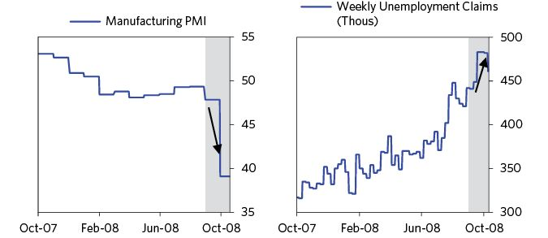

During this period of constant bad news, stocks sold off literally every day. Between October 1 and October 10, investors in the S&P 500 took total losses of 22 percent, without a single day of gains. Crude oil continued to fall rapidly as well, ending the first half of the month at $75 per barrel. Some days saw huge routs even when there wasn’t much news. On October 9, for instance, stocks sold off 7.6 percent on record volume, with virtually nothing important enough to warrant it.

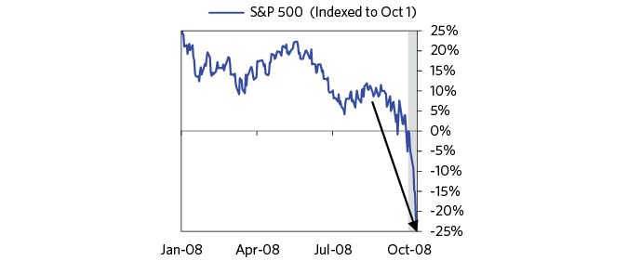

This acute pain wasn’t concentrated only in the financial sector. Reports surfaced that major nonfinancial corporations were relying on credit lines to finance continuing operations as they found themselves all but shut out of corporate paper markets. Some companies announced that they were slashing dividends to keep up cash reserves, and outflows from prime money-market funds continued. In the household sector, a report showed that consumer credit had fallen in August for the first time since 1998. Similar stories were unfolding globally, as liquidity dried up in every major market, even as central banks announced unprecedented interventions.

In the face of so much pain, policy makers rolled out ever-larger initiatives to thaw frozen credit markets and ease concerns throughout the financial system. On October 7, for instance, the Fed announced an extraordinary new plan to purchase unsecured commercial paper. Since bank lending had been almost completely choked off and money-market funds had pulled hundreds of billions of dollars out of commercial paper markets, major nonfinancial companies were struggling just to continue funding normal operations. Fearing major layoffs and disruptions across the economy if these companies couldn’t access funding, the Fed felt compelled to step in. To do so, it created what it called the Commercial Paper Funding Facility—technically an independent entity that would buy up commercial paper using loans provided by the Fed under its Section 13(3) powers. In practice, the Fed was agreeing to finance commercial paper purchases directly, with no backstop against losses by the Treasury. The move took the Fed to the edge of its statutory authority or perhaps a bit beyond (depending on who you ask), as the central bank is generally not permitted to take on much exposure with such risky credit. The Fed bravely did what it needed to do and hoped that the fees the CPFF charged borrowers could be used to cover any losses, though covering losses was appropriately not the primary objective.

Just days after the passage of TARP, Paulson began hinting that the funds might be used to capitalize the banks instead of just purchasing troubled assets, as he said he had been anticipating for weeks.47 On October 9, at Paulson’s urging, White House officials started to signal that TARP money might go to capital injections into banks.

There was so much to do, and policy-making needed to proceed at a furious pace. It was an utterly insane week.

The single largest push on the part of policy makers came over Columbus Day Weekend: October 11–13. On Saturday, October 11, President Bush met with members of the G7 in Washington to publicly commit himself to a coordinated international effort to contain what had become a global financial crisis. It was agreed that the members of the G7 would move together to inject capital into their banking institutions and increase deposit insurance guarantees. Over the next two days, officials from the Treasury raced to finalize America’s part of the international commitment. The centerpieces of the new program were two bold new policy changes—a huge expansion of FDIC insurance coverage, and a massive injection of capital into the banking system.

Typically, the FDIC is only responsible for insuring the deposits of commercial banks. Under the new Temporary Liquidity Guarantee Program, however, the FDIC’s authority had been stretched to guarantee the debt of any single systemically important bank and to backstop losses on all newly issued unsecured debt by banks and bank-holding companies as well as all noninterest-bearing transaction accounts. This amounted to a guarantee of nearly all bank debt. It was an extraordinary measure that many feared might have serious unintended consequences, but, as Paulson would later write, “To be frank, I hated these options, but I didn’t want to preside over a meltdown.”48

Under the new Capital Purchase Program, the Treasury planned to use its TARP money to take equity stakes in as many banking institutions as possible, up to a limit of 3 percent of risk-weighted assets or $250 billion. As explained earlier, the investments would come in the form of preferred stock with a 5 percent dividend.

Paulson needed even the healthiest banks to participate, because if only the weak ones did, participation would create a stigma that could encourage runs. And so, though the Treasury had no power to force banks to take capital, it did what it could. On Monday, October 13, Paulson invited the CEOs of nine major banks to his private conference room, and explained that he expected everyone in attendance to participate, and even prescribed the amount of capital he expected each bank to take. None left without taking government money. By the end of the meeting, Paulson had pledged $125 billion of the $700 billion Congress had given him.

But even with the cash injection, markets in the US, Europe, and Japan continued to worsen. So it became clear to Paulson, Bernanke, and Geithner that they had to act with even greater force. Bernanke and Paulson had very consequential meetings with central bankers and the finance ministers in the G7 to coordinate an international response. Paulson and President Bush also met with G20 finance ministers. Meanwhile, there were teams moving very fast at the Treasury working to develop the US response. Several people took Paulson aside and warned him that they were perhaps moving too fast, and that doing so could be dangerous. However, Paulson believed that if policy makers did not move quickly, they would have nothing that would work when all the markets opened on Tuesday after the three-day Columbus Day weekend.49

Paulson says that the most powerful step they took was the Temporary Liquidity Guarantee Program, in which the FDIC used its funds, which were established to protect savers, to guarantee the liabilities of financial institutions, including the unsecured liabilities of bank holding companies.50 At one point, the FDIC’s general counsel said this was illegal. However, Paulson and others spent a lot of time convincing its head, Sheila Bair, that this was the right thing to do, and she ultimately made the very courageous decision to back it—which made a huge difference.51

As news of the programs leaked on Monday, October 13 (and policy makers around the world announced similar projects), the markets that were open surged. Stocks rallied by 11.6 percent, the largest single-day increase in the S&P 500 since 1939.

It’s worth pausing for a moment to consider how significant these announcements were in the larger story of the crisis. Up to this point, most of the government responses had come in the form of ad hoc reactions to individual disasters. The Fed had borne a disproportionately large share of the burden, and it was not at all clear that other agencies would adequately support it. But now it seemed increasingly clear that policy makers in the US and around the world were committed to taking extraordinary, coordinated action. Still, huge uncertainties lay ahead, as the underlying economy continued to deteriorate. Here’s how we described this moment to our clients at the time:

(BDO) October 13: The Governments Are Doing Everything Possible; Now We Will Have to See If It’s In Time  
 These are great moves. They are doing everything that we had hoped that they would do. While these would have worked in stage one of the crisis—e.g., if they did them instead of allowing Lehman to go bankrupt—the crisis has spread to a stage 3 condition, so we just have to wait and see. The big question is whether the massive liquidity injections and bank recapitalizations will get to those who are at the periphery of the system.

Many dominos are now falling that are beyond the reach of government. We know of lots of them that are big and scary and we are sure that we don’t know of many others. So, it is hard to know for sure how these big problems will be affected by these policy changes and what the effects of these big credit/liquidity problems will be…

We are in very uncertain times. But, for the first time we can now say with confidence that the major developed countries’ governments are doing all in their power to deal with this crisis.

Fears and uncertainties surrounding the economy kept volatility extremely high over the next week. On Wednesday, for instance, stocks fell 9 percent following grim retail sales numbers for September and a warning from Bernanke that any “broader economic recovery” would be slow to arrive.52 The following day, the market rebounded by 4.3 percent, even in the face of a number of disappointing stat releases, and rates on commercial paper fell slightly.

But by Monday, October 20, markets had registered a meaningful easing of conditions in interbank lending and commercial paper. Rates on commercial paper touched four-week lows, while short-term treasury yields crept up. This thawing of credit conditions helped lift stocks, and represented a significant easing of the pressure on banks.

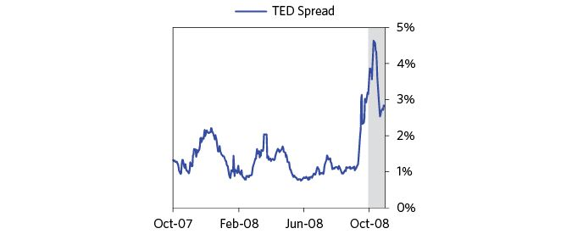

Still, most of the financial mismatches that were squeezing financial institutions and companies (i.e., borrowing short term and lending longer term, borrowing in one currency and lending in another) had yet to be resolved. There was a squeeze for dollars because foreign financial institutions that had borrowed dollars and lent them out now had to pay them back, and/or had to deal with their debtors, who had to pay them back in dollars when dollars, money, and credit were hard to come by. Though the Fed continually expanded its dollar swap lines (i.e., liquidity lending) with developed-world central banks throughout October, it was not able to provide enough dollar liquidity to alleviate this global dollar squeeze. Part of the problem lay in central banks’ reluctance to lend Fed-provided dollars against locally denominated collateral because of their fears of default and logistical issues. The largest squeeze occurred in emerging markets, where major dollar debts had built up and debtors were scrambling for dollars. All in all, the dollar rallied 8 percent in October.

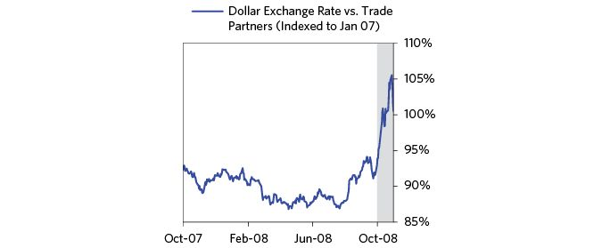

Here’s how we explained the situation to our clients at the time:

(BDO) October 22: The Dollar Squeeze  
 A debt is a short cash position—i.e., a commitment to deliver cash that one doesn’t have. Because the dollar is the world’s reserve currency, and because of the dollar surplus recycling that has taken place over the past few years…lots of dollar denominated debt has been built up around the world. So, as dollar liquidity has become tight, there has been a dollar squeeze. This squeeze…is hitting dollar-indebted emerging markets (particularly those of commodity exporters) and is supporting the dollar. When this short squeeze ends, which will happen when either the debtors default or get the liquidity to prevent their default, the US dollar will decline. Until then, we expect to remain long the USD against the euro and emerging market currencies.

The actual price of anything is always equal to the amount of spending on the item being exchanged divided by the quantity of the item being sold (i.e., P = $/Q), so a) knowing who is spending and who is selling what quantity (and ideally why) is the ideal way to get at the price at any time, and b) prices don’t always react to changes in fundamentals as they happen in the ways characterized by those who seek to explain price movements in connection with unfolding news. During this period, volatility remained extremely high for reasons that had nothing to do with fundamentals and everything to do with who was getting in and out of positions for various reasons—like being squeezed, no longer being squeezed, rebalancing portfolios, etc. For example, on Tuesday, October 28, the S&P gained more than 10 percent and the next day it fell by 1.1 percent when the Fed cut interest rates by another 50 basis points. Closing the month, the S&P was down 17 percent—the largest single-month drop since October 1987.

### November–December 2008

In the midst of this chaos, on November 4, Barack Obama was elected President amid record turnout, and would come into office with big majorities in both houses of Congress. Heading into the election, Obama had promised billions in government spending on infrastructure, unemployment insurance, and Medicaid, and was supportive of TARP—and control of Congress would allow him to move quickly.

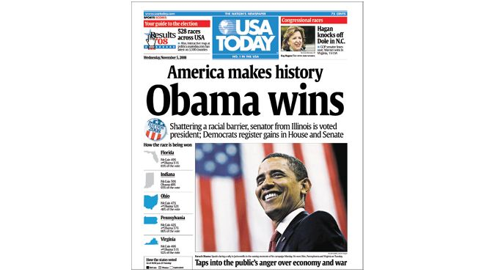

From USA Today, 5 November © 2008 Gannett-USA Today. All rights reserved. Used by permission and protection by the Copyright Laws of the United States. The printing, copying redistribution, or retransmission of this Content without express written permission is prohibited.

While the financial contagion may have been slowed by the Treasury and the Fed’s actions so far, it became clearer in the last couple months of 2008 that the economy was falling at a far faster pace than even the most pessimistic observers feared, and that we were heading for the worst downturn since the Great Depression and into the great unknown.

To us the economy was now in the classic early days of a deleveraging/depression, when monetary policy could not work normally. Interest rates could no longer be lowered and innumerable avenues of credit had dried up.

Most of the important economic stats released in November were worse than the already very poor expectations. Consumer spending fell at an extraordinary rate; retail sales fell by over 8 percent and auto sales were down 30 percent year over year. Businesses across industries reacted to poor results with historic layoffs. The unemployment rate moved up past 6.8 percent, the highest level since 1994, and projections for layoffs and unemployment increased dramatically. December saw the worst manufacturing reading since 1982. The economy was imploding.

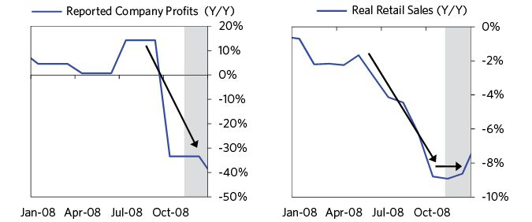

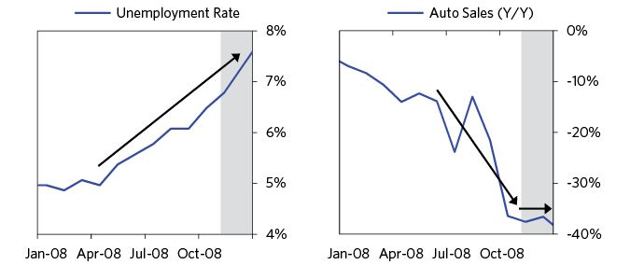

Businesses across industries looked to the federal government for aid to shore up their finances. The auto industry in particular remained in dire straits and actively sought backstops from the federal government. However, the Treasury department was reluctant to broaden the $700 billion TARP package to include industrial companies and was thus unwilling to assist major automakers. In early November, the Treasury turned down a request by General Motors for $10 billion to help finance a possible merger with Chrysler. Without funding from the federal government and with credit markets remaining nonfunctional, automakers turned to selling assets to raise cash. Both Ford and General Motors sold their stakes in other automakers during the month.

On November 10, AIG reported a $25 billion quarterly loss (while securing an additional $150 billion from the government to curtail financial contagion). Fannie Mae posted a $29 billion loss and said it might need more than the $100 billion the Treasury had already pledged to keep it afloat.

Paulson hadn’t said anything publicly about how his thinking was changing, as he hadn’t wanted to influence the election.53 The market was expecting a significant asset repurchase program. However, in a mid-November postelection speech, Paulson announced his plans for modifying Treasury’s use of TARP. He disclosed that Treasury no longer planned to buy illiquid assets because the market for these securities was frozen. Funds would instead be channeled to banks and nonbank financial companies (though not auto companies) as equity-like capital to better free them up to resume normal lending. Additionally, a new lending program was announced that was targeted at consumer lending markets. This new program allowed the Treasury to put up part of the funding for auto loans, credit cards, and student loans. The markets, however, reacted negatively to the adjustment. Paulson noted after the fact: “As I feared, the markets focused on the fact that there wouldn’t be a program to purchase mortgage-related assets.”54 This rattled the markets and the S&P dropped 5.2 percent.

Stocks reached a new low on November 20, down over 20 percent for the month (and 52 percent from their highs). Oil collapsed (now below $50 a barrel), and home prices continued to fall. However, this new low was met with a relatively quick reversal on news that Obama would nominate Timothy Geithner to be Treasury secretary and Larry Summers (former Treasury secretary) to be director of the National Economic Council, as both were justifiably considered highly capable. Summers came into this job having been concerned about the possibility of a major debt crisis for a while (in a speech in early March before Bear’s collapse, he had said, “I believe that we are facing the most serious combination of macroeconomic and financial stresses that the United States has faced in a generation—and possibly much longer than that,”55 and he was an advocate of big policy moves in response to the crisis. He would end up as a key decision-maker in the administration’s policy toward auto companies. Bernanke would of course stay at the Fed, so there was good continuity among the leaders of the economic team. These moves helped assure policy continuity between administrations.

On November 25, the Federal Reserve and the Treasury announced $800 billion in lending and asset purchases aimed at pushing down mortgage rates (to help the housing market). The central bank committed to purchases of $600 billion in debt tied to home loans. This was their first Quantitative Easing (QE) program. This was a classic and critical step in managing a deleveraging. Central bankers in the midst of crises are forced to choose between 1) “printing” more money (beyond what’s needed for bank liquidity) to replace the decline in private credit, and 2) allowing a big tightening as credit collapses. They inevitably choose to print, as they did in this case, which is when things changed dramatically.

I hope you will read the prior section, about the US debt crisis in the 1928–38 period (as well as look at the other cases) to see how true this is. What was different in 2008 was the speed with which the policy makers made this crucial step. The 1930–33 depression went on so long because policy makers were so slow to react—not because their problems were worse, because they weren’t. Still, the 2008 crisis would have been a lot less painful if the policy makers had acted even earlier.

See the chart below to get a sense of what happened in response to the news of “quantitative easing.” 30-year fixed mortgage rates fell nearly 1 percent on the news (and 10-year Treasury yields declined 22 basis points).

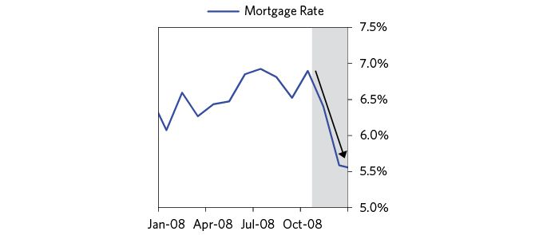

Still, the stock market ended the month down 7.5 percent, as it wasn’t clear if these moves were too little too late.

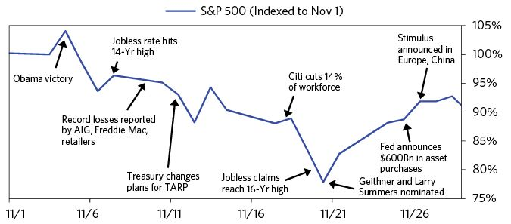

We wrote to clients on this announcement:

(BDO) November 25: Why We Expect More Shock & Awe And What It Will Mean  
 Though we can’t speak for them, we believe that the Fed and the new Treasury folks understand the deleveraging/depression dynamic and the seriousness of the one that we’re in. In fact, we believe that their understanding is now quite similar ours, so they are doing what we would do, and that they will probably do about what we would do. Along these lines, we expect shock and awe type moves from both the Fed and the Administration (i.e., the Treasury and other departments).

Today’s Fed’s announced moves are just the latest steps down the path of continuing to broaden the securities bought and increase the amounts spent to bring down credit spreads and add liquidity to the system. We expect more because we expect that they will do “whatever it takes” that they can get away with.

Big policy announcements were also coming from other major countries as they saw their own economies slide. For instance, the UK government announced a $30 billion stimulus package (via a reduction in sales tax and measures to help homeowners, pensioners, and small businesses); China cut interest rates; and the EU outlined a $258 billion fiscal plan. Other central banks also increased emergency lending measures (e.g., the Bank of Japan implemented a new provision allowing commercial banks to borrow unlimited funds from the central bank, collateralized). And in December, interest rates were lowered across the developed world as the global economy slowed.

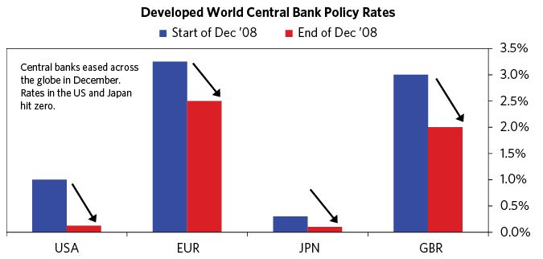

As for the US Federal Reserve, it cut its overnight rate to its lowest level ever (between 0 percent and 0.25 percent), hitting the zero bound. Chairman Bernanke noted: “the decision was historic.”56 Stocks rallied and the dollar fell following the announcement, largely because it was clear that “printing money,” buying debt, and providing big guarantees to do whatever was needed to reverse this debt/liquidity crisis would occur.

The increased likelihood of a deal with the auto companies funded from TARP also helped markets, not just because it helped those companies but because it was emblematic of a more forceful approach to saving the system. TARP was enacted to deal with financial institutions. Paulson repeatedly said that they didn’t intend to use TARP funds for the autos, while the Bush Administration made it clear that it didn’t want an auto bankruptcy and worked diligently with Congress to prevent one by trying to get the legislative authority to use a portion of the $25 billion that Congress had already appropriated to help the autos meet fuel efficiency standards for emergency loans for restructuring. There was real progress in this regard, with a bill passing in the House, but the legislation stalled in the Senate in mid-December. On December 19, just before leaving office, President Bush officially announced plans to extend $13.4 billion in emergency loans to Chrysler and General Motors. By the end of the month, the government expanded this bailout package unexpectedly, delivering additional support to the auto industry (which buoyed stocks). Because TARP money could only be given to financial institutions, the funds had to be directed through the auto companies’ financing arm. Additionally, the financing affiliate of General Motors (GMAC) was approved to reorganize as a bank (to receive federal aid), which allowed GMAC to start making new loans to less credit-worthy borrowers. After that, they then helped the auto companies by recapitalizing and rescuing their finance companies just before leaving office. The market was also optimistic about the fiscal stimulus being pledged by president-elect Obama. The transition exemplified the very best of political behavior on the part of both transitioning presidents. Also, the continuity of Bernanke and Geithner on the economic leadership team helped.

While all these moves were big, there was of course good reason to question whether the damage already done was too great for a full recovery to occur. While stocks rallied on the hope of stimulus and progress with the automakers, December ended with volatility (uncertainty) priced to remain high.

Bridgewater closed out 2008 with significant gains for our investors, when most other investors had significant losses. What a year! What a relief!

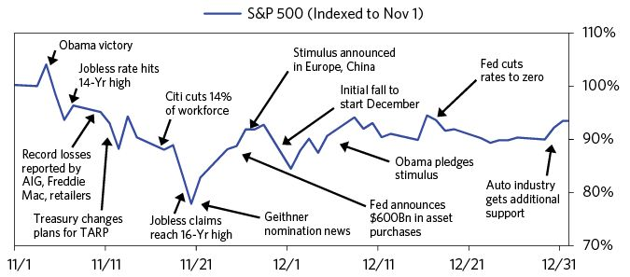

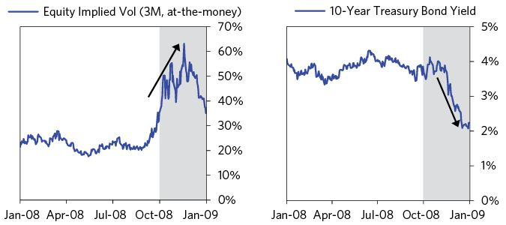

Having the template explained in Part 1 and understanding the dynamics of the Great Depression in the 1930s as well as we did (and so many other deleveragings) helped us a lot. The chart below shows interest rates and money supply (M0) since 1925 to encompass both periods. In both cases they hit virtually 0 percent and in both cases “money printing” followed. Note that these were the only times since 1900 that these things happened, and that, in both cases, immediately following this “money printing”/QE the markets and the economy bottomed.

Quantitative easing is like a giant shot of adrenalin to save a patient that is having a massive heart attack. The only question I had in late 2008 was if this overdue and great move would work or if it had come too late.

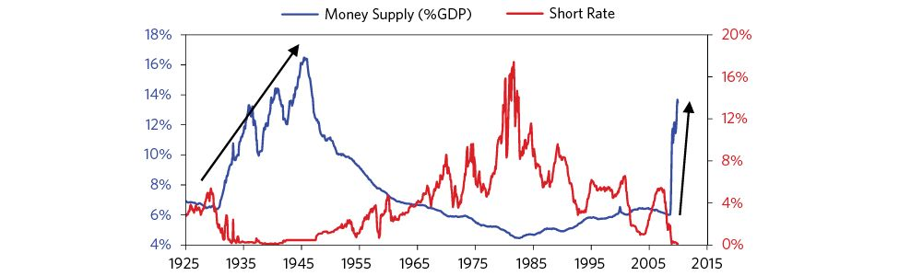

## Transition from an “Ugly” to a “Beautiful” Deleveraging: 2009

It’s worth briefly recapping where the US economy was at this point. Virtually every economic indicator looked to be falling extremely quickly. As an illustration, in a single day in January, reports of employment cuts across companies totaled 62,000. In addition to weak economic growth, there were still at least five major financial institutions at risk of failure: Fannie Mae, Freddie Mac, AIG, Citigroup, and Bank of America; each of these was bigger than Lehman. And a new, untested administration was about to be handed the reins. This note conveys our picture of the economy at the time:

(BDO) January 9: The US Economy Remains in Freefall…  
 The US economy remains in free-fall with the impact of the credit contraction now hitting where it hurts most, employment. Initially the financial sector suffered, then demand and now employment. The transition from demand to employment was sealed when business revenues fell faster than costs in the fourth quarter, compressing margins and driving earnings down (not yet reported, but almost certainly occurred). Businesses were then motivated to cut their biggest expense item, labor. The extreme pace of payroll reductions, over 500 thousand per month in November and December, reflects business’s attempt to sustain their operating earnings.

This is even more important than in most economic contractions given the lack of credit. The lack of credit means that businesses must generate cash flow internally; they cannot rely on a loan to get them through a cash bind. This magnifies the pressure to lay off workers.

When President Obama took office on January 20, the markets began to focus on the administration’s economic policies. Secretary Geithner’s announcement of his financial stability plan on February 10 was seen as a major bellwether for administration financial policies. He outlined57 broadly how he was going to “clean up and strengthen the nation’s banks.” He explained that the approach would stress test the nation’s major banks to determine which institutions needed additional capital and that the administration would shore up their capital with a combination of public and private funds. Investors were uncertain about the details of Geithner’s plan: Would there be nationalizations; would losses be imposed on shareholders or taxpayers? Investors were provided only with the broad strokes, leaving them to expect the worst. The S&P fell 3 percent as Geithner spoke and ended the day down 4.9 percent.

Rumors that the Obama administration was considering nationalization continued to circulate, so the Treasury, FDIC, OCC, OTS, and the Federal Reserve released a joint statement to assure58 the public that nationalization was a last resort outcome, stating: “Because our economy functions better when financial institutions are well managed in the private sector, the strong presumption of the Capital Assistance Program is that banks should remain in private hands.” The “strong presumption” wasn’t enough—the S&P fell 3.5 percent on the day.

Later in the month, Geithner released further details about the plan that the Treasury and Fed had collectively worked out for the “stress test:” the Federal Reserve would assess how well the country’s big banks would withstand a major contraction in the economy, defined as a 3.3 percent contraction in GDP, 8.9 percent unemployment, and a 22 percent fall in housing prices. If they lacked the capital to withstand the stress test, banks would turn to private markets first and then public funds to fill the gap. Of course Geithner couldn’t yet provide the funds until the Fed finished their assessment on how exactly the shortfall would be filled. For about 18 months, we had regularly run our own estimates of bank losses by analyzing their holdings, marking them to market, and then doing scenario analysis. We were pretty confident that our estimates were good. So we were eager to see what the Fed’s stress tests would look like, mostly to see if they would forthrightly show the numbers and then deal with them.

In addition to Geithner’s Financial Stability Plan, the Obama administration announced a series of other fiscal policies aimed at jumpstarting the economy and getting credit flowing again. We won’t go into depth on all of them here, but will give some details about the two most meaningful announcements:

* On February 17, President Obama signed into law the American Recovery and Reinvestment Act. The stimulus totaled $787 billion, with $288 billion specifically set aside for tax reductions, $144 billion for state and local governments, $105 billion for infrastructure, and the rest for federal spending programs. Notably, the tax reduction was funneled to taxpayers within days—a virtually instantaneous stimulus. The infrastructure spending, on the other hand, would take years to ramp up as projects needed to be scoped and planned for, so it mattered less in the short term.
* On February 18, the administration announced a plan worth up to $275 billion to address the housing crisis. With the goal of helping “as many as nine million American homeowners refinance their mortgages or avert foreclosure,” the Homeowner Affordability and Stability Plan offered $75 billion in direct spending to keep at-risk homeowners in their homes. It also provided incentives to lenders to alter the terms of their loans to troubled borrowers to make them more affordable. And it gave Fannie Mae and Freddie Mac an additional $200 billion in financing.

Over the course of February, US policy makers also announced or expanded other policies—including the Term Asset-Backed Securities Loan Facility (TALF). TALF was a Fed policy which helped stimulate various types of consumer loans by lending up to $1 trillion on a non-recourse basis to holders of AAA asset-backed securities. It was set to begin on March 5 as an extension of a number of liquidity programs set to expire at the end of April. Despite all this stimulation, markets continued to fall, as shown in the chart below.

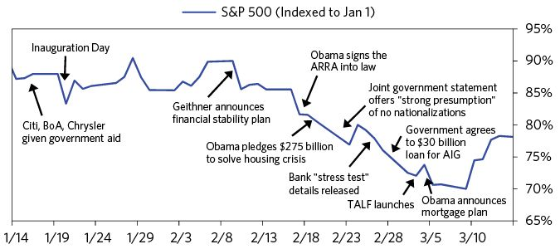

Reports of ongoing weakness in the financial sector and economy continued to pile up. On Sunday March 1, news broke that AIG planned to report a $62 billion 4th quarter loss (the largest quarterly loss in US corporate history), and that the Treasury and Fed had agreed to provide AIG with an additional $30 billion in capital and loosen the terms of its earlier loan to the insurer. Markets plunged on Monday as fear of knock-on effects were triggered and the first economic stat releases from February showed the economy contracting at an accelerating rate. Monthly auto sales fell 5.8 percent to the weakest level since the early 1980s and the economy shed 651,000 jobs.

The next week opened with more of the same. On Monday, March 9, the World Bank came out with a very pessimistic report and Warren Buffett said that the economy had “fallen off a cliff.” The stock market fell by 1 percent. Investor sentiment was extremely bearish and selling was exhausted. That was the day the bottom in the US stock market and the top in the dollar were made, though it was impossible to know that at the time.

Stocks surged 6.4 percent on Tuesday, led by a 38 percent jump in Citigroup shares, following a memo to employees from Citigroup’s CEO stating that the bank was once again profitable, a well-received speech by Chairman Bernanke on reforms to financial regulation, and reports that lawmakers were close to re-instituting the uptick rule to slow short-selling of stocks.

### Policy Makers Launch Coordinated Counterattack: March–April 2009

Behind the scenes, policy makers at the Fed and the Treasury department were planning a coordinated set of “shock and awe” policies designed to shore up the financial system and provide the money needed to make up for contracting credit. These policies were much more aggressive than earlier easings, and were released in a sequence of mega-announcements. How they were announced magnified the impact on markets.

The first of these announcements came on March 18 when, in a move that surprised markets, the Fed announced that it was expanding its QE purchases of Agency MBS by $750 billion and agency debt by $100 billion, and that it would expand its purchases to US government bonds, making up to $300 billion in purchases over the next six months. In addition to increased QE, the Fed expanded the collateral that was eligible for TALF to a wider set of financial assets and stated its continuing expectations of “keeping rates exceptionally low for an extended period.”

The market action around the $1 trillion plus announcement was huge. There was an enormous Treasury rally (the 48 basis point fall in yields was the biggest change in a couple of decades), stocks rallied, the dollar sold off, and gold rallied. The intraday charts below show how big the moves following the announcement were.

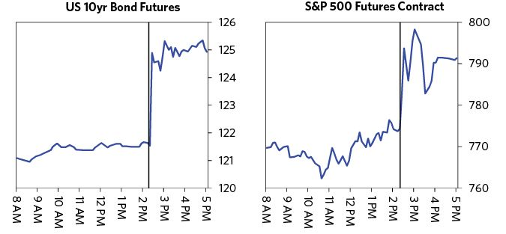

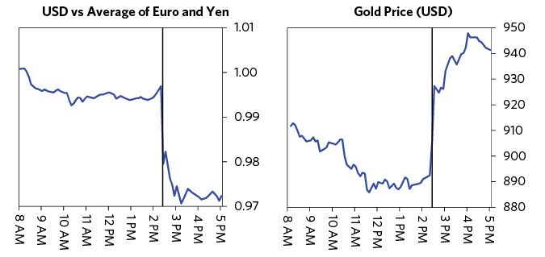

Then, on March 23, Secretary Geithner announced an expanded set of policies that aimed to buy $500 billion to $1 trillion worth of troubled assets from banks. At the heart of the program was the three-part Public-Private Investment Partnership (PPIP), which incentivized private investment firms to buy banks’ bad assets using their own capital. In effect, it allowed firms to leverage their investments in troubled assets using money borrowed from the Fed, with a guarantee that they would not lose more than their initial investment if the assets fell below their initial value. In another move coordinated with the Fed, Geithner also announced a possible expansion of TALF, to finance residential and commercial MBS, and said the agencies were considering making legacy securities eligible for the program.

On the day of the announcement, the S&P rose 7.1 percent led by an 18 percent rally in financial shares.

On March 24, The Fed and the Treasury each announced plans to overhaul financial regulations and expand government power in seizing “too big to fail” banks, as well as insurers, investment banks, and other investment funds. Two days later, Secretary Geithner outlined a wider overhaul of financial regulations, which greatly increased federal regulatory oversight of insurance companies, hedge funds, and private equity funds, with expanded regulatory powers over any company deemed “too big to fail.” While not a key part of the stimulative counter-attack, the move was well-received by markets.

At the end of March, Summers and Geithner oversaw a team led by Steven Rattner, a smart financier, to create the plan that would push GM and Chrysler into what Larry Summers described as a “cushioned bankruptcy.” Bankruptcy would force the trade unions and creditors to negotiate ways to reduce debts, and ample US government support (including a large guarantee of GM’s car warrantees) would ensure that GM could remain functioning while the company was restructured. While the automobile companies felt they couldn’t function in bankruptcy, Summers thought that, with sufficient support, a bankrupt automobile company could function, and that there was no reason that the debt needed to be paid in full.

And then on April 2 came two major announcements. In the first, the G20 reported that it had reached an agreement on a greater than what we expected increase to IMF funding. Specifically, G20 countries agreed to immediately provide $250 billion in additional IMF financing, with the aim of eventually adding up to $500 billion in new lending capacity to the IMF’s roughly $250 billion of existing liquid resources. The combination of dramatically expanded IMF lending capacity and more flexible lending terms was expected to dramatically reduce the immediate liquidity needs of a number of emerging-market countries. Emerging currencies soared following the announcement.

The second announcement came from the Financial Accounting Standards Board (FASB), which had passed two proposals to ease mark-to-market accounting rules. The changes, which had been expected to pass for a couple of weeks, gave banks more discretion in reporting the value of mortgage securities. While markets embraced the move, at the time we thought that these changes would have relatively little impact on banks’ abilities to write off losses over time, while relieving some (but not all) of the accounting pressures on insurance companies.

The size of the coordinated government response to the credit crisis was unprecedented. At the time, we characterized the moves as “an enormous wave.” The first table below, which we shared with our clients at the time, adds up all of the US government purchases and guarantees that had been announced by April 2009. Remarkably, the US government was backstopping two-thirds of all debt, about $29 trillion dollars.

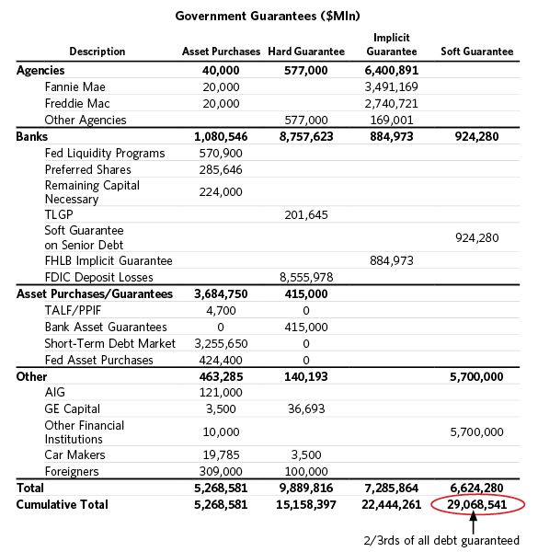

While President Bush took a more hands off approach, believing his team knew best what to do and supporting them to do it, President Obama took a hands on approach, digging into the facts and numbers and being actively engaged in discussions about issues. He instituted a presidential daily economic briefing, analogous to the daily national security briefing. Every morning, the president met with his economic team, and for the first months, every one of those meetings was about the ongoing crisis. According to Larry Summers, the president read every word they sent him, and he was very much into understanding what the approach was, why they recommended it, and what alternatives were being turned down. It was a time when market and economic developments were more important than anything else.

How investors fared in the bear market varied a lot. They generally fell into three broad categories: 1) those who were clobbered and let their fears prompt them to reduce their risks (sell “risky” assets) the more they got clobbered, 2) those who were clobbered and had blind faith that in the end things would work out, so they held on or even bought more risky assets, and 3) those who had a pretty good understanding of what was happening and did a good job of selling high and buying low. There were very few in the third group.

As for us, while we had done a good job up until that point, we didn’t want to take on hardly any bets at this stage. Back in the 2007 bubble, the gap between what was discounted in market pricing and what was likely appeared very large to us. Now market pricing was discounting a terrible set of conditions and the range of potential outcomes was enormous. While policy makers were making the right moves, whether they would work and what else lay beneath the surface in exposures remained unknown.

A little later in April, we wrote in reference to the degree of money printing and stimulus spending: “Like pandemics, D-processes come along very infrequently, so we don’t have many to look back on and, in those that we have, this antidote was never administered in this dosage.”

In these crises there is no such thing as getting everything exactly right, especially in the eyes of everyone. There was a public uproar over the Treasury’s actions, especially about how “generous” its deal was for banks that were recapitalized, and how bankers weren’t being punished. Reports that AIG had paid large, previously-committed bonuses after it received a bailout from the Treasury focused on how Secretary Geithner knew about the bonuses and allowed them to be paid out. The reports infuriated a public already upset with government bailouts of financial institutions and put the Treasury’s plans for further action at risk.

Such reactions are classic. As economic pain increases, populist calls to “punish the bankers that caused this mess” are the norm and they make it difficult for policy makers to take the actions that are necessary to save the financial system and the economy. At such times bankers can want to stop “being bankers” by stopping investing or lending. Their doing so in the midst of the crisis would make the crisis much worse.

While the financial crisis and how it was handled contributed somewhat to the rise of populism in subsequent years, in the end saving the system is much more important than striving for precision. Larry Summers makes the comparison to battlefield medicine—it’s never perfect, you’re going to realize you made mistakes, and you’re going to look bad, even if you do the best possible job. I can’t say this enough: in my opinion, judging the policy makers in this way is unfair. The fact that they do their job anyway, and that they help as many people as they do, is what makes them heroes in my eyes.

In mid-March, at the peak of the controversy, members of Congress and the media were publicly calling for Secretary Geithner’s resignation, even though he had executed his job with great skill, wisdom, and care. Had they succeeded in forcing a resignation or otherwise derailed the Treasury’s bold and necessary plans to recapitalize the banking system, the bad economic consequences would have been large.

Geithner wrote the following in his book, conveying the challenge of handling public outrage:

“The public outrage was appropriate, and I understood why the President wanted to embrace it, but I didn’t see how we could ever satisfy it. We had no legal authority to confiscate the bonuses that had been paid during the boom. We had no power to set compensation for most private firms. We had more authority over firms receiving TARP funds, but we couldn’t reduce bonuses to levels that the public might find acceptable without unleashing an exodus of talent from those banks, reducing their prospects of navigating their way to safety. In any case, I thought the public’s rage on these issues was insatiable. I feared the tougher we talked about the bonuses, the more we would own them, fueling unrealistic expectations about our ability to eradicate extravagance in the financial industry.”59

The uproar ultimately faded after President Obama strongly stood behind Tim. But after what was seen as Geithner’s lack of action, the House of Representatives passed a bill on March 19 that put a 90 percent tax on bonuses paid out by companies that received government bailouts worth $5 billion or more. While the scope of the tax was limited mostly to the AIG bonuses, the sense of distrust for government support among many executives in the financial sector (who saw the tax as the government changing the rules after the fact) would be a continuing source of tension.

Fortunately, the bottoms in the markets and the economy were being made, because had things gotten any worse or gone on any longer our capitalist and democratic system would’ve been at risk of breaking. All else being equal, prices for goods, services, and investment assets go down when a rate of buying lessens and go up when the rate of selling lessens. For that reason, tops are typically made when the rate of buying is unsustainable (which is also when people think prices will rise) and bottoms are made when the rate of selling is at a pace that’s unsustainable (typically when most people are bearish). In the weeks before and after the big announcements, pressures eased, signs of an economic rebound emerged, and markets rallied. A series of economic releases during the first week of April showed that while the economy continued to contract during March, the pace of contraction was slower than expected. And as the charts below show, while the major economic stats continued contracting through March at the fastest pace in decades, the contractions looked to be leveling off and maybe reversing.

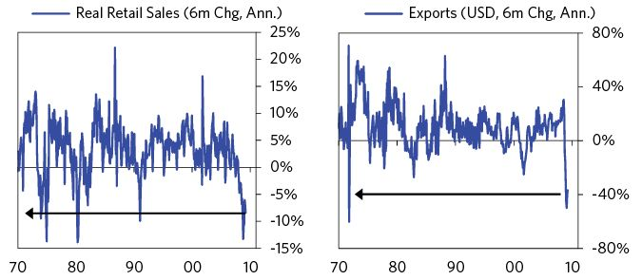

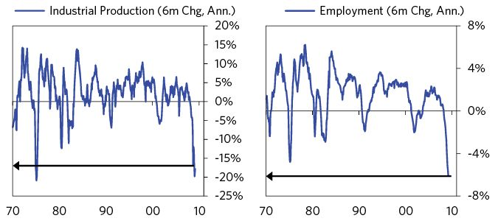

By mid-April, stock and commodity markets around the world had rebounded sharply from their March lows. The S&P was up 25 percent, oil was up over 20 percent, and bank CDS spreads fell almost 30 percent, but in level terms they remained near their extremes. This appeared to be due more to a slower rate of selling than a pickup in buying.

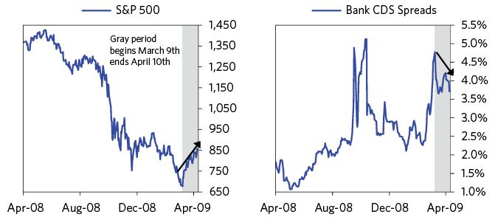

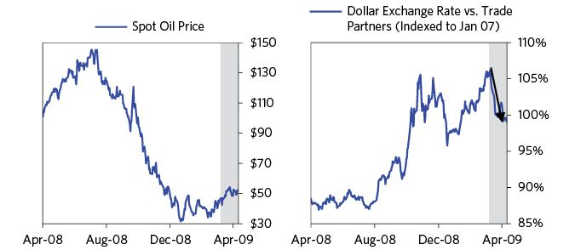

The obvious question at the time was whether a bottom was being made or if we were just seeing another bear market rally. After all, there had been a number of classic bear market rallies along the way—e.g., the S&P had staged a 19 percent rally over a week at the end of October and a 24 percent rally over the last six weeks of 2008 before giving up the gains of each and hitting new lows.

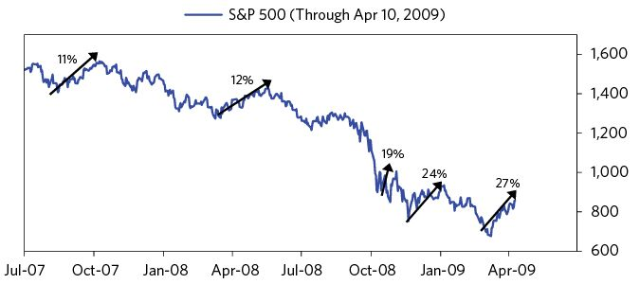

### The Bank Stress Test

One of the key questions for determining whether the US was headed for a sustained recovery was the health of the banks. Despite recent drips of good news, there wasn’t broad transparency on whether the banks were still encumbered by toxic assets or a big need for capital. We had been running our numbers for months and saw huge numbers that weren’t being brought to light or being dealt with. But in February Tim Geithner said the Fed was going to do those stress tests. I didn’t know if they would fudge the numbers to make them look better than they were or if they’d tell it like it was so they could deal with the problems appropriately.

On May 7 the Fed released its results. In response I wrote:

(BDO) May 7: We Agree!  
 The Stress Test numbers and ours are nearly the same!!! The regulators did an excellent job of explaining exactly what they did for this stress test and showing the numbers that produced the results. They did virtually exactly what we did since we started putting out our loss estimates nearly two years ago, and their numbers are essentially the same as ours. The differences between our numbers and theirs are more a matter of terminology than of substance. For example, the biggest difference between their estimates and ours is due to the number of years they and we are counting—i.e., their loss estimate is for the losses that will occur over the next two years and ours is for the total amount of losses that will be taken on these assets over the lives of these assets. As there will be losses in years 3, 4, etc., in addition to those in the first two years, naturally the total losses (i.e., ours) will be greater than the losses incurred over the next two years (i.e., theirs). We won’t conjecture why they did it that way, though we do know from our projections that the maximum capital needs (i.e., when earnings fall short relative to losses) is probably at the end of two years. Anyway, that accounts for most of the difference in our total loss estimates, and in addition we may also have a slightly worse economic scenario than they do. Once these adjustments are made, we see essentially the same picture. What a relief!!! For the first time in the last two years we are confident that the regulators really do understand the scale of the banking problem!

Tim Geithner, who read Bridgewater Daily Observations daily throughout the crisis, took this one to President Obama. In his memoir, he described the moment as follows:

“The next morning, I walked into the Oval Office for the President’s daily economics briefing with a report from Bridgewater Associates, the world’s largest hedge fund firm. Many experts, including Larry, regarded Bridgewater’s Daily Observations as among the smartest and most credible sources of private-sector economic analysis—and among the darkest about the banks. In front of the economic team and the President’s political advisers, I handed that day’s Observations to the President...

I wasn’t dancing in the end zone, but that was a good day for the home team.”60

We were in sync about what was and what needed to be done about it. What a relief!

## The Beginning of the Beautiful Deleveraging: June–December 2009:

In the second half of 2009, the policies (i.e., providing liquidity via QE, capital via fiscal policies, and other supports via macro-prudential policies) reduced risks and increased the buying and prices of “riskier” assets, and the economy began to recover. This shift was analogous to others that produced “beautiful deleveragings” for reasons explained earlier.

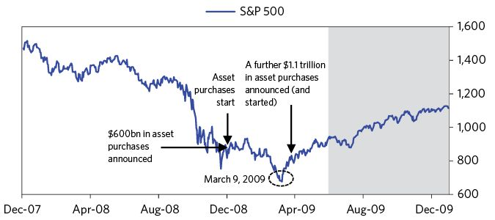

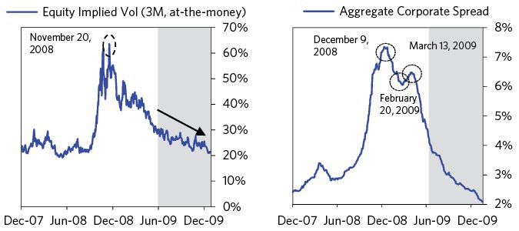

While we won’t discuss all the improving news of this period in depth, we will highlight two points. First, frequent concerns over inflation stemming from the fast pace of central bank printing didn’t materialize, which fortunately laid to rest the incorrect belief that printing a lot of money would cause inflation to accelerate. The Fed’s “printing money” would not cause an acceleration of inflation if it was replacing contracting credit.

As we explained to our clients that summer:

* Reflations don’t necessarily cause inflation because they can simply negate deflations, depending on how far they are taken and what the money goes to.
* It is overly simplistic to talk about “inflation” because “inflation” is an average of many things that behave differently from one another. For example, when an economy is depressed, during reflations (which is normally the case, because otherwise there’s no need for reflations), there is little or no inflation in labor costs and assets that are used for production (e.g., real estate, equipment, etc.), while there is inflation in assets that benefit from decreases in the value of money/currency (e.g., internationally traded commodities, gold, etc.).

Second, Congress and the Obama administration shifted their attentions to significantly increasing financial industry regulation and oversight. The following timeline gives a sense of how quickly these new laws and regulations were being written:

June 17: Obama delivers a speech outlining a legislative proposal for comprehensive financial services reform, which eventually led to the passing of Dodd-Frank. The proposal included heightened regulation, consolidation of existing regulatory bodies (with greater regulatory authority given to the Fed), more consumer protections, more regulation of credit rating agencies, and updated rules around winding down banks, among many other components. The bill itself wouldn’t be passed until 2010.

June 24: The SEC suggested regulations for money market funds that would require them to hold some portion of their portfolios in highly liquid investments. Additionally, the proposed regulations would restrict money market funds’ holdings to high-quality securities.

June 30: The Treasury Department released a bill to Congress to create a Consumer Financial Protection Agency. The agency would take control of all consumer protection programs currently run by the Fed, the Comptroller of the Currency, the Office of Thrift Supervision, FDIC, FTC, and the National Credit Union Administration.

July 23: The Federal Reserve proposed changes to Regulation Z (Truth in Lending). The changes aimed to improve the consumer disclosure laws for closed-end mortgages and home-equity credit. It would require APR and monthly payments (on adjustable-rate loans) to be communicated to the buyer.

October 22: The Fed proposed a review of 28 banking organizations’ incentive compensation policies, to see whether or not they are “risk-appropriate,” and to go through a similar process at smaller banks. This proposal came on the same day that the Special Master for TARP Executive Compensation released61 the determinations for executive compensation for the “top 25 most highly paid at the seven firms receiving exceptional assistance.”

December 11: The House passed the creation of the Financial Stability Council and Consumer Financial Protection Agency

Changing laws in ways that would have made the crisis less bad are typical at the end of big debt crises. Then, over long time frames (e.g., 25 years), as the hangover wears off and a new euphoria sets in, these laws are increasingly flouted and new forms of leverage are produced by new forms of entities, leading to a new debt crisis that evolves similarly.

## 2010 through Mid-2011

As 2010 began, the financial markets were strong (up nearly 65 percent from their March 2009 lows) because they were flush with liquidity thanks to the Fed’s QE, and they were safer due to fiscal and regulatory changes. But the economy labored because many borrowers were weaker and more cautious, and lending standards had tightened.

Now, the markets started to discount a move to normalcy. The credit markets priced in that the Fed would tighten two or three times within the year—roughly the amount of tightening you’d expect in a standard business-cycle recovery from a recession. That was odd given conditions. Unemployment rates were still a hair away from postwar highs, wage growth was stuck, homes prices were flat at well-below the prior peak (meaning many middle-class mortgage borrowers remained underwater), credit standards were tightened, and borrowers who were still okay financially remained disinclined to lever up, while those who were inclined to lever up were financially dead. It was hard to imagine there would be a normal pickup.

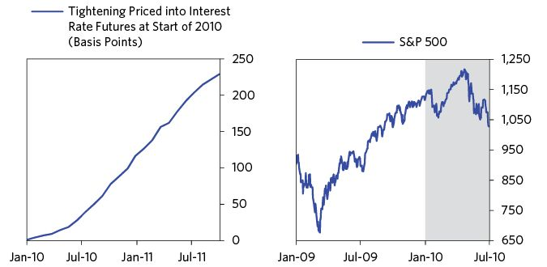

Around this time, most of the world’s central banks and governments were slowing their aggressive rates of stimulus. The Fed ended the first round of quantitative easing in March after purchasing $1.25 trillion in mortgage-backed securities. The pace of fiscal stimulus from programs like the America Recovery and Reinvestment Act were set to peak later in the year. Abroad, there were pockets of tightening as countries like China increased interest rates.

Importantly, at this point it wasn’t clear to investors that merely slowing or ending quantitative easing was equivalent to tightening—and not that different from raising interest rates. Some thought it was enough to simply pump a lot of money into the economy to stimulate it—and the Fed had certainly done that, printing over $2 trillion. But the flow of money was more important than the amount of money, as it was this flow of asset purchases that helped sustain their increases in value and the growth of lending to buyers in the economy, because credit growth remained slow. Yet the Fed’s amount of stimulation was then popularly believed to be too much and irresponsible. We had a different view, doubting that developed economies would tighten as fast as what others thought and had priced in. We laid it out in the Daily Observations of February 17:

(BDO) February 17: The Coming Tightening  
 It is now the established view among the electorate, central bankers, and elected officials that central banks printing and buying of financial assets and central governments budget deficits must be reined in because these actions are financially irresponsible. We think that this universally accepted view is at best premature and at worst dangerous….When we take a sharp pencil to these plans and their implications, we conclude that it is too much restraint—unless there is either major pickup in private debt growth or a major realignment of developed and emerging country currencies, both of which appear unlikely to happen in the amounts required.

At the same time, we did our pro forma financial projections in Europe and saw a debt crisis brewing there due to a mismatch between: a) the amount of borrowing debtors needed to rollover maturing debt and sustain what they were doing, and b) the amount of lending that would be required to come from banks that had already stretched their balance sheets. In February, several of Europe’s more indebted countries—Portugal, Ireland, Italy, Spain, and especially Greece—struggled to meet their debt obligations and were facing deteriorating economic conditions. While the news flow associated with this led to some day-to-day volatility in global markets, most assessed the issue to be contained to Greece (and potentially Portugal) and that it would not pose larger problems for the European monetary system or the global economy. In a note to clients in early February, we calculated that the problem would probably be much worse:

(BDO) February 4: Tightening + Over-indebtedness = High Risk  
 “We judge the over-indebtedness problems of the European debtor countries (PIGS) to be comparable in magnitude to some of the worst emerging-market debt problems of the past.

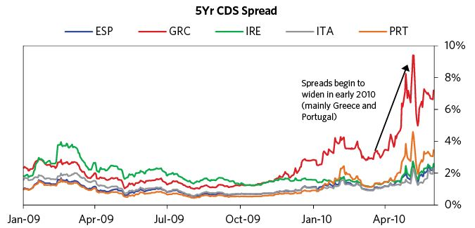

But the European debt crisis is a different story. While I won’t go into it now, it is noteworthy that the same sequence of events followed, in that policy makers didn’t believe they would face a debt crisis until they had it. When it came, they made the same rookie mistakes of leaning too heavily on deflationary levers like austerity and of not printing money and of not providing protections against defaults for systemically important entities until the pain became intolerable.

From May until July, the US equity market, which had rallied nearly 10 percent from the start of the year through late April, fell over 15 percent, largely on contagion worries about Europe and softness in the US economic numbers. That weakness led to the realization that the Fed was likely to maintain its course on its 0-percent-interest-rate policy. US bond yields fell over 100 basis points over the next four months. The pace of improvement in the economy slowed in the summer of 2010. Timely reads on labor market health showed only modest improvement in unemployment claims, while the unemployment rate was still near highs. There was still a lot of slack in the economy. Weakness at this level of economic activity would have been terrible.

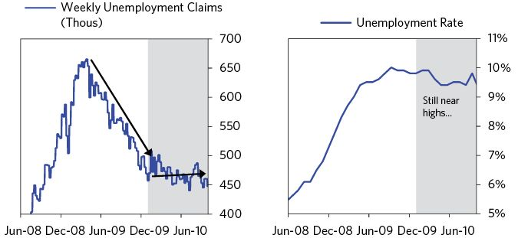

Bernanke addressed further QE in a speech in Jackson Hole, making it clear that it was a key policy option if needed, saying, “a first option for providing additional monetary accommodation, if necessary, is to expand the Federal Reserve’s holdings of longer-term securities.”62 He also emphasized his belief that QE had been effective and had “made an important contribution to the economic stabilization and recovery.” As the chart below shows, the 10-year break-even inflation rate had fallen by 50 basis points in the several months leading up to Bernanke’s August speech, reflecting concerns of sustained very low inflation or deflation. However, after he signaled that further QE was a strong possibility, the markets rebounded strongly. The real economy response naturally lagged the essentially instantaneous market response, but it wasn’t long before growth picked up as well.

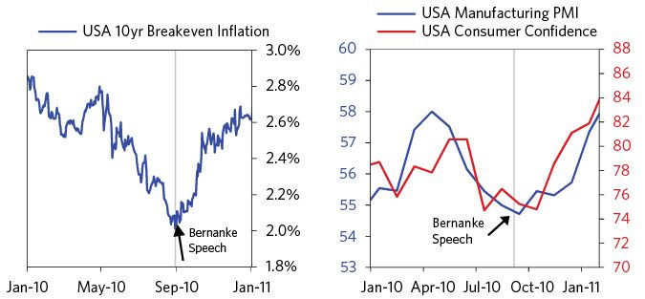

In early October 2010, New York Fed President Bill Dudley described economic conditions as “wholly unsatisfactory” and argued that “further action is likely to be warranted.”63 Dudley went on to give an assessment of the underlying drivers of US growth that was broadly similar to our own view at the time, based largely on this observation (from our October 1 BDO): “Consumers are facing slow income growth, lower asset prices relative to prior to the crisis, and a much lower ability to borrow as a result of lower wealth, higher debt levels, and lower incomes. As a result, households have not responded to lower rates by saving less or borrowing.” On October 6, I wrote the following:

(BDO) October 6: The Next Shoe to Drop: More QE and Devaluations  
 What is happening is all very classic. Though they’re all different, in most ways deleveragings are basically the same and transpire via a similar sequence of events. As we have described them in the Daily Observations and in our “Template for Understanding What’s Going On,” we won’t dwell on this sequence, but will remind you of a few things that we think are especially relevant now.

All deleveragings are due to declines in private sector credit growth that require increases in both central bank money creation and central government deficits in order to offset the effects of the decline in private sector credit. Though many of us are financially conservative and feel that there is something unethical about printing money to bail out debtors and creditors, it is important to recognize that austerity to deal with debt-deleveraging problems has never worked when these problems were big. When austerity has been tried, even in persistent attempts to get out of debt, it has eventually been abandoned by all governments because it didn’t work, and it was too painful. That is because the decreased borrowing and spending (and consequences of these on employment and many other pain points) make this type of deleveraging as self-reinforcing on the downside as the increased debts and spending that cause bubbles is on the upside. As a result, all of the deleveragings that we have studied (which is most of those that occurred over the last couple of hundred years) eventually led to big waves of money creation, fiscal deficits and currency devaluations (against gold, commodities, and stocks).

The QE broadly worked in providing additional needed stimulus. Despite continued debt problems in Europe, the US economy and markets finished 2010 on a high note. Growth picked up after a brief lull between QE1 and QE2, the S&P 500 had 13 percent total returns for 2010, and inflation expectations had been re-anchored by the Fed’s proven determination to continue stimulating as long as necessary. On March 15 of 2011, this is how we saw domestic conditions as they developed:

(BDO) March 15: Transitioning Beyond the “Sweet Spot”  
 As previously mentioned, it is pretty clear that the US economy is going through a post-contraction growth spurt that is being supported by monetary policy, fiscal policy and an improvement in credit growth. As this recovery is occurring with both a) considerable slack domestically (and in Europe and Japan) and b) overheating demand in emerging countries, we see limited inflation pressures, with those pressures that exist largely coming via the prices of items that are being demanded by emerging countries. Said differently, 2010/2011 in a cyclical context appears quite like the “sweet spot” part of the cycle that typically occurs during the first two years of a recovery, when there remains adequate slack and low inflation pressures. However, this recovery from a contraction is taking place during a deleveraging and therefore has been more dependent on the Fed’s printing of money and the central government’s fiscal stimulus.

By this point, it was clear that the governments different programs to support the financial system broadly worked. Compared to other countries, the US financial system experienced:

* A relatively fast speed at which the financial system was recapitalized (and that TARP capital was repaid)
* A relatively fast speed at which they unwound emergency credit programs
* Good overall financial returns on the rescue across the various programs.

We will end this case study here, because in the second quarter of 2011 real GDP returned to its pre-crisis levels. This wasn’t the end of the recovery by any means. There was still plenty of slack in the economy and a self-reinforcing upward cycle. The charts below show the unemployment rate, GDP growth, the GDP gap (showing the estimated amount of slack in the economy’s capacity to produce), and the S&P 500 stock market index from 2006 until the writing of this on the tenth anniversary of the 2008 Lehman debt crisis. The shaded bars show where they were in 2Q 2011. The second set of charts show existing and projected debt-to-GDP ratios from 1920 until 10 years from now. These numbers do not include non-debt obligations such as those for pensions and health care, which are considerably larger than debts. But that’s another issue to be explained at another time.

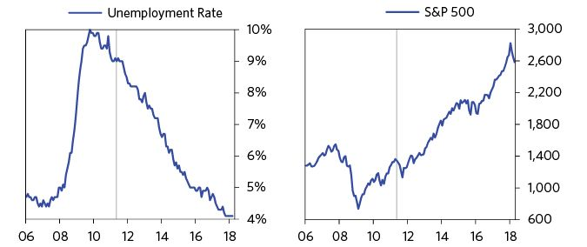

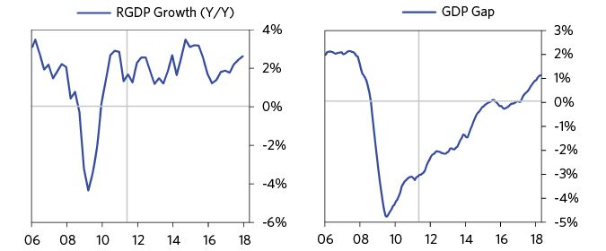

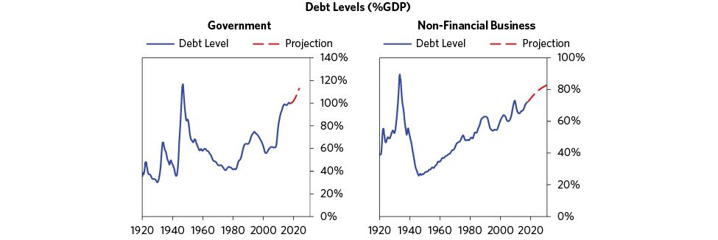

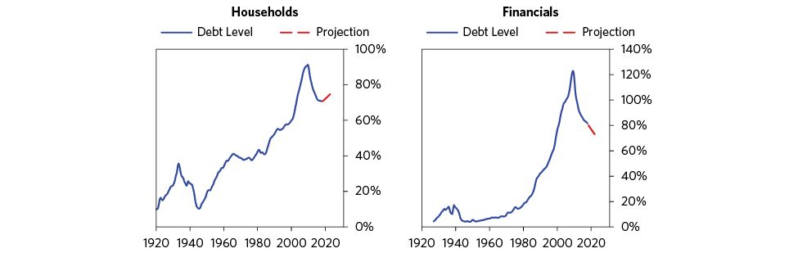

News & Bridgewater Daily Observations (BDO)

January 22, 2004

Home Building Keeps Driving the Economy

“The Commerce Department said yesterday that construction began on a larger-than-expected number of homes in December, capping the best year for new housing in a quarter of a century and leading some industry analysts to raise their housing forecasts for 2004.”

–New York Times

April 22, 2004

Greenspan Calms Investors On Growth

“One day after Mr. Greenspan rocked financial markets by declaring that the threat of deflation had disappeared, investors in stocks and Treasury securities seemed calmed by the Fed chairman’s strong hint that rising productivity and low inflation would allow the central bank to keep interest rates at rock-bottom levels a bit longer….Mr. Greenspan said that the economy had ‘entered a period of more vigorous expansion.’”

–New York Times

September 26, 2004

Next Up on Reality TV: Flipping Real Estate, for Fun and Profit

“It was only a matter of time before the Southern California real estate market turned from a hair-raising reality into a hair-raising reality television show...In most parts of the country, people buy places because they want to live in them. But in markets where prices rise every month, flipping looks like an easy way to get rich.”

–New York Times

October 20, 2004

Mortgage Debt Not Big Burden, Greenspan Says

“Alan Greenspan on Tuesday defended one of the most tangible results of his tenure as chairman of the Federal Reserve Board: the big increase in homeowner debt.

In his most detailed discussion yet on the subject, Mr. Greenspan disputed analysts who worry that home buyers have become swept up in a speculative housing bubble that the Fed is partly responsible for creating.’”

–New York Times

November 6, 2004

When Good Debt Turns Bad

“No one knows if or when accumulated debt could become unsustainable. But after years of encouraging borrowing with rock-bottom interest rates, policy makers should at least admit the possibility of a debilitating crunch—and act accordingly.”

–New York Times

April 28, 2005

Mortgage Applications Up

“Mortgage applications increased last week as people took advantage of a decline in borrowing costs to buy homes and refinance existing loans, a private survey showed yesterday.”

–New York Times

May 10, 2005

The U.S. Housing Bubble

“The US housing market started to look frothy a few years back and now looks to us to be in a full-blown bubble. The housing market has been a major source of strength to the US economy, and the popping of this bubble would have more dire consequences than an equity market fall. Selling one’s house at a loss can be very traumatic—it is the largest and most leveraged asset of the household sector. Losing equity in one’s house can devastate the household sector’s net worth, and losing more than one’s equity can paralyze the economy (e.g., most people couldn’t sell their homes, which means that they couldn’t move).”

–BDO

May 25, 2005

Steep Rise in Prices for Homes Adds to Worry About a Bubble

“Home prices rose more quickly over the last year than at any point since 1980, a national group of Realtors reported yesterday, raising new questions about whether some local housing markets may be turning into bubbles destined to burst...Over all, home prices have never fallen by a significant amount, and Alan Greenspan, the chairman of the Federal Reserve, said on Friday that a national drop in price remained unlikely.”

–New York Times

May 31, 2005

Fed Debates Pricking the U.S. Housing ‘Bubble’

“Mr. Greenspan and other officials have long argued that it is not their job to influence the price of assets whether stock prices or real estate. Rather, they contend, the central bank’s job is to keep inflation low and to promote the maximum sustainable growth without fueling inflation.”

–New York Times

July 9, 2005

Boom in Jobs, Not Just Houses, as Real Estate Drives Economy

“The real estate industrial complex, the economic engine that has become one of the few reliable sources of growth in recent years. Encompassing everything from land surveyors to general contractors to loan officers, the sprawling sector has added 700,000 jobs to the nation’s payrolls over the last four years, according to an analysis by Economy.com, a research firm.”

–New York Times

August 17, 2005

Healthy Housing Market Lifted the Economy in July -New York Times

August 28, 2005

Greenspan Says Housing Boom Is Nearly Over

“Looking forward to the time after he steps down as chairman of the Federal Reserve, Alan Greenspan predicted here on Saturday that the nation’s frenzied housing boom—and the consumer spending that it has spurred—is near an end.”

–New York Times

October 4, 2005

Slowing Is Seen in Housing Prices in Hot Markets

“A real estate slowdown that began in a handful of cities this summer has spread to almost every hot housing market in the country, including New York.”

–New York Times

December 17, 2005

New Strategy for Growth at Citigroup

“For the first time in at least five years, Citigroup is focusing on expanding existing businesses. It will broaden its retail presence in the United States by adding about 300 branches and banking centers, largely in areas like Philadelphia and New Jersey, where it already has customers.”

–New York Times

January 8, 2006

Warning: Beware of Warnings About Real Estate

“Fund investors who amassed colossal gains in real estate over the previous few years were warned not to expect a repeat in 2005. The long-running rally could lose steam, some analysts predicted, which meant that it was time to consider selling. But those naysayers turned out to be wrong. Many investors who stayed the course and ignored the warnings about real estate bubbles continued to profit: the sector ended yet another year among the top fund categories.”

–New York Times

February 1, 2006

Exit Greenspan, Amid Questions on Economy

“Stepping down on Tuesday after 18 years as steward of the nation’s economy, Alan Greenspan left his successor a wide berth to set his own policy but some major uncertainties about the future.

But the handoff also meant that Mr. Bernanke would face murkier choices at a time of substantial risks that increase the chances for serious missteps.”

–New York Times

February 10, 2006

US Trade Deficit Hit Record High In 2005

“The U.S. trade deficit jumped nearly 18 percent in 2005, the government reported Friday, hitting its fourth consecutive record as consumer demand for imports increased, energy prices soared and the dollar strengthened against other currencies...

The $725.8 billion gap, which is almost exactly twice the deficit in 2001, was driven by a 12 percent jump in imports and a more muted 10 percent increase in exports, the Commerce Department reported in Washington. The nation last had a trade surplus, of $12.4 billion, in 1975.”

–New York Times

April 19, 2006

Fed Signals Policy Shift on Rates

“The Federal Reserve hinted Tuesday that it might stop its campaign to raise interest rates as early as next month, a possibility that set off a surge in stocks even as crude oil prices rose above $71 a barrel...Officials suggested that, after nudging up short-term interest rates 15 times in nearly two years, the increase in May might be the last one for some time.”

–New York Times

July 10, 2006

Paulson Sworn In As Treasury Secretary

“Former Goldman Sachs chief executive Henry M. Paulson was sworn in as the nation’s 74th Treasury secretary on Monday, and he pledged to make sure the United States does not retreat from the world economy.

‘We must always remember that the strength of the U.S. economy is linked to the strength of the global economy,’ Paulson said in remarks during a brief ceremony.”

–Associated Press

Aug 23, 2006

How Big A Problem Will the Housing Slowdown Be?

“The economy in aggregate is continuing to hum along with the exception of housing. Is housing the dead canary in the coal mine, or will the economy churn along despite the housing slowdown? We’re wrestling with this…”

–BDO

August 24, 2006

New Signs of Cooling in Housing

“The housing market is deteriorating by the month. In the latest and strongest indication that the home buying and selling frenzy is over, the National Association of Realtors reported yesterday that sales of previously owned homes fell to the lowest level in July in more than two years, prices flattened and sellers waited longer and longer to find buyers for their homes.”

–New York Times

September 14, 2006

Foreclosures Are Up on Some Mortgages

“Foreclosures on prime adjustable-rate mortgages rose to a four-year high in the second quarter, a sign that more homeowners with good credit ratings are having trouble paying their bills...The rate of subprime ARM’s — representing lending to people with poor credit histories — that were entering foreclosure rose to 2.01 percent, the highest since the fourth quarter of 2003, the report showed.”

–Bloomberg

October 24, 2006

This Time, It’s Not the Economy

“President Bush, in hopes of winning credit for his party’s stewardship of the economy, is spending two days this week campaigning on the theme that the economy is purring. ‘No question that a strong economy is going to help our candidates,’ Mr. Bush said in a CNBC interview yesterday, ‘primarily because they have got something to run on, they can say our economy’s good because I voted for tax relief.’”

–New York Times

October 27, 2006

New-Home Prices Fall Sharply

“Home builders, struggling to keep ahead in a weakening market, cut prices and offered a variety of other discounts in September to help sell their newly constructed houses, the latest government and industry statistics show. The Commerce Department reported yesterday that the median price of a new home plunged 9.7 percent last month, compared with September 2005, falling to $217,100, the biggest such drop since December 1970.”

–New York Times

November 7, 2006

In Arizona, ‘For Sale’ Is a Sign of the Times

“Until recently, this fast-growing area was a paradise on earth for home builders. Fulton Homes’ developments, for example, were so popular last year that it was able to raise prices on its new homes by $1,000 to $10,000 almost every week...Today, the number of unsold homes in the area has soared to almost 46,000 from just a few thousand in early 2005. And builders are pulling back as fast as they can.”

–New York Times

December 6, 2006

What Statistics on Home Sales Aren’t Saying

“The truth is that the official numbers on house prices—the last refuge of soothing information about the real estate market on the coasts—are deeply misleading. Depending on which set you look at, you’ll see that prices have either continued to rise, albeit modestly, or have fallen slightly over the last year. But the statistics have a number of flaws, perhaps the biggest being that they are based only on homes that have actually sold.”

–New York Times

January 5, 2007

Job Market Ends 2006 on Strong Note

-New York Times

January 13. 2007

Retail Sales Last Month Surprised With Big Rise

-Reuters

January 20, 2007

Consumer Sentiment Reaches 3-Year High

-Reuters

January 26, 2007

Sales of Existing Homes in ’06 Had Biggest Drop in 17 Years

-Associated Press

February 2, 2007

Jobs Growth Slows but Remains Strong

-New York Times

February 5, 2007

Growing Financial Risks

“Market returns are driven by how events transpire relative to what is discounted. At this time the markets are discounting the lowest risks in decades, yet we believe that the imbedded risks in the system are quite large. We’ll explain.

Right now the financial markets are awash with liquidity...It seems to us that money is now being thrown at financial instruments like it is being thrown at the art, jewelry and high-priced real-estate markets. Prices of risky assets, particularly those with positive carry, are being driven up, and yields/carries are being driven down, making expected future returns low. Simultaneously volatility has shrunk; as a result, low volatility is being assumed to continue and reaching for yields has caused increased leverage to be employed in order to try to squeeze more return out of the puny spreads/carry trades.”

–BDO

February 8, 2007

HSBC Reports Rise in Troubled Loans

“HSBC Holdings, a bank based in Britain, said on Wednesday that its charge for bad debts would be more than $10.5 billion for 2006, some 20 percent above analysts’ average forecasts, because of problems in its mortgage portfolio.”

–Reuters

February 27, 2007

Black Tuesday in China

“They’re calling it Black Tuesday in China: local stock markets unexpectedly sold off, losing nearly 9% of their value, and putting pressure on equity prices around the world.

Analysts said the Shanghai and Shenzhen markets were reacting to widespread rumors of plans by the Chinese government to raise interest rates or institute a capital gains tax, measures that would serve to temper local stock markets that were up about 10% for the year before Tuesday’s decline.”

–Forbes

March 6, 2007

Stocks Rise in Asia, Europe and U.S.

“The five-day slide in Asian stock markets halted today, as investors took advantage of low prices and started buying again, sparking relief in the region.”

–New York Times

March 10, 2007

Investors Get a Break, but Some Lenders Absorb Blows

“The crisis in mortgage loans to people with weak, or subprime, credit intensified as a large lender, New Century Financial, stopped accepting loan applications because several of its financial backers cut off access to credit lines...Several dozen mortgage companies have gone out of business because of high default rates on mortgages written last year when lending standards were significantly more relaxed.”

–New York Times

March 22, 2007

Markets Soar After Remarks From Fed

“Wall Street rallied sharply yesterday after the Federal Reserve raised investors’ hopes that it had warmed to the idea of lowering short-term interest rates.

After triple-digit gains yesterday, the Dow Jones industrial average has surged 337 points this week, its best three-day performance since November 2004.

The Fed, as expected, left short-term interest rates unchanged at 5.25 percent at the conclusion of its two-day meeting. But investors, who nervously awaited the economic statement that accompanies the Fed’s decision, were encouraged that the central bank had not referred to the possibility of ‘additional firming’ of rates as it did in January.”

–Associated Press

March 22, 2007

After Sell-Off, Chinese Stocks Back at a Record

-New York Times

March 23, 2007

Existing-Home Sales Rise Most in 3 Years

-Associated Press

April 2, 2007

New Century Files for Bankruptcy

-New York Times

April 17, 2007

Shares Rally on Strong Earnings Reports

“Stocks rose yesterday as better-than-expected profits at Citigroup and a healthy increase in consumer spending renewed the optimism of investors about the economy.”

–Associated Press

April 22, 2007

For the Dow, Three Record Highs in Five Days

-New York Times

April 26, 2007

Durable-Goods Picture Shows Surprising Strength

-New York Times

May 17, 2007

Mixed News About Housing Only Briefly Slows the Rally

“Wall Street shot higher yesterday after investors shrugged off a mixed reading on the housing sector and focused on a jump in industrial output, a retreat in crude oil prices and new cash pouring into the stock market.”

–Associated Press

May 25, 2007

Shares Fall After a Surge in Home Sales

“Wall Street retreated yesterday after housing data showed that sales surged in April by the largest jump in 14 years, dampening hopes of an interest rate cut to stimulate the economy.”

– Associated Press

June 2, 2007

Wall St. Buoyed by Economic Data

“Wall Street carved out a solid advance yesterday after data on job creation, manufacturing and inflation injected the market with renewed confidence about the economy and sent major indexes to record closes.”

–Associated Press

June 5, 2007

Shares Post Slight Gains as Slide in China Is Shrugged Off

-Associated Press

June 8, 2007

Yields on Treasuries Climb; Shares Tumble Again

“Not long ago, Wall Street trembled when it looked as if the slowing American economy might be getting worse. But now, anxiety over the potential for higher inflation, driven by a strong global economy, is preoccupying investors.

Yesterday, that fear again took its toll on stocks and bonds, giving share prices their steepest three-day decline since markets dropped around the world in February, and the interest rate on the benchmark 10-year Treasury note rose above 5 percent for the first time since last summer.”

–New York Times

June 13, 2007

Bond Yields Soar, Driving Shares Down

-New York Times

June 15, 2007

Wall Street Rises on Tame Inflation Data

-Associated Press

June 15, 2007

More Trouble in Subprime Mortgages

“Delinquencies and foreclosures among homeowners with weak credit moved higher in the first quarter, particularly in California, Florida and other formerly hot real estate markets, according to an industry report released on Thursday. The report, published by the Mortgage Bankers Association, came as the Federal Reserve held a hearing on what regulators could do to address aggressive abusive lending practices.”

–New York Times

June 21, 2007

Bear Stearns Staves Off Collapse of 2 Hedge Funds

-New York Times

June 23, 2007

Bear Stearns to Bail Out Troubled Fund

-New York Times

July 3, 2007

Glancing at Implied Vols

“Recent market action has begun to show a slight pickup in implied volatility across all markets, but these increases have come from levels that were as low as they have been in more than 10 years. Looking broadly across markets, we continue to see very low expected future currency, bond, and commodity volatility, while future expected volatility in the equities is low but closer to normal relative to history.”

–BDO

July 13, 2007

Fitch May Downgrade Bonds Tied to Subprime Mortgages

-Bloomberg

July 14, 2007

Dow and S.&P. 500 Set Record Highs

“In a week in which the Dow swung more than 450 points and rose 283 points in Thursday’s session alone, investors grappled with unease over soured subprime loans and the broader economy before casting off such concerns and bidding stocks higher amid signs the consumer might yet again pull through and give Wall Street reason to climb.”

–Associated Press

July 16, 2007

ABX Crash

“The market for subprime mortgage debt got significantly worse Monday helping to pace treasuries, and the price action suggests a player, larger than the Bear Stearns funds that blew up in June, is going bust. The Bear Stearns collapse in June hit the low rated tranches; last Friday and Monday the rout began in the higher rated tranches. The triple A rated tranches of subprime mortgage pools were in free-fall on Monday. For instance, the triple A tranches on 2007 mortgages covered by the ABX originally slated to pay a meager 9bps of spread are now trading at 440bps of spread.”

–BDO

July 26, 2007

Market Falls Sharply on Housing and Oil Worries

“Wall Street hit a sharp skid today as more worrisome signs about the health of the housing market emerged and oil prices remained near record levels.”

–New York Times

August 1, 2007

A Rise in Confidence Amid Mild Inflation

“Personal spending rose at its slowest rate in nine months in June while inflation moderated, but consumers’ moods brightened considerably in early July, data showed yesterday.”

–Reuters

August 3, 2007

Stocks Fall Sharply Amid Credit Fears

-New York Times

August 7, 2007

American Home Mortgage Seeks Chapter 11 Bankruptcy Protection

-Associated Press

August 7, 2007

Fed Leaves Rate Steady; No Sign of Future Cut

“The Federal Reserve today largely sidestepped the growing anxiety over how tightening credit standards will affect the economy, deciding to leave its benchmark interest rate unchanged at 5.25 percent. More important than the decision to hold rates steady—which was widely expected—the Fed did not significantly adjust the language in its statement explaining the decision.”

–New York Times

August 9, 2007

Government May Raise Limits on Home-Loan Purchases

“Alphonso R. Jackson, the secretary of housing and urban development, said yesterday that the government might raise the limit on purchases of home loans by Fannie Mae and Freddie Mac to increase liquidity in the mortgage market. Mr. Jackson said that he and Fannie Mae’s chief executive, Daniel H. Mudd, talked about Fannie Mae’s request to be allowed to buy mortgages beyond a current $722.5 billion federal limit.”

–Bloomberg

August 9, 2007

Paribas Freezes Funds as Subprime Woes Keep Spreading

“France’s biggest listed bank, BNP Paribas, froze 1.6 billion euros ($2.2 billion) worth of funds on Thursday, citing problems in the United States subprime mortgage market. The warning, which came a week after subprime-related losses drove two Bear Stearns funds into bankruptcy protection, sent shivers through nervous financial markets. ‘The complete evaporation of liquidity in certain market segments of the U.S. securitization market has made it impossible to value certain assets fairly regardless of their quality or credit rating,’ BNP said. Its shares fell more than 3 percent, and stock futures in the United States moved sharply lower.”

–New York Times

August 10, 2007

Stocks Tumble as French Bank Reacts to Home Loan Worries

-New York Times

August 10, 2007

Fed Injects Reserves Into System

“The Federal Reserve, trying to calm turmoil on Wall Street, announced today that it will pump as much money as needed into the financial system to help overcome the ill effects of a spreading credit crunch. The Fed, in a short statement, said it will provide ‘reserves as necessary’ to help the markets safely make their way. The central bank did not provide details but said it would do all it can to ‘facilitate the orderly functioning of financial markets.’”

–Associated Press

August 11, 2007

Central Banks Intervene to Calm Volatile Markets

“Central banks around the world stepped up efforts to slow the losses. The Bank of Japan added liquidity for the first time since the market problems began. The European Central Bank injected money into the system for a second day, adding another 61 billion euros ($84 billion), after providing 95 billion euros the day before. The Federal Reserve yesterday added money by lending $19 billion against mortgage-backed securities, then another $19 billion in reverse repurchase agreements.”

–New York Times

August 11, 2007

Europeans Are Wondering About Subprime Exposure

-New York Times

August 16, 2007

Countrywide’s Big Credit Draw Fuels Market Fears

“Stocks fell sharply Wednesday in the United States, set off by worries that Countrywide Financial, the largest mortgage lender in the nation, could face bankruptcy if liquidity worsens after a Merrill Lynch analyst flagged that possibility. The mood grew even more grim Thursday morning, when the lender said it tapped its entire $11.5 billion credit line to boost cash on hand.”

–New York Times

August 18, 2007

Fed Cuts Lending Rate in Surprise Move

“The Federal Reserve today approved a half-percentage point cut in its discount rate on loans to banks, saying that it now feels that ‘tighter credit and increased uncertainty have the potential to restrain economic growth going forward.’ Stocks immediately surged when markets opened on Wall Street, but shed much of the gains in morning trading.”

–New York Times

August 22, 2007

Bank of America Takes Countrywide Stake

-Associated Press

August 22, 2007

Top U.S. Banks Draw Upon Fed Discount Window

“More banks have stepped forward and said they have availed themselves of the Federal Reserve’s discount-lending rate cut amid the credit market’s turmoil last week. The four biggest banks in the United States — Citigroup, J.P. Morgan Chase, Bank of America and Wachovia — said that they each borrowed $500 million through the so-called discount window by taking out loans directly from the Fed.”

–New York Times

August 31, 2007

Bush Offers Relief for Some on Home Loans

“President Bush, in his first response to families hit by the subprime mortgage crisis, announced several steps today to help Americans who have credit problems meet the rising cost of their housing loans.

In remarks this morning at the White House, Mr. Bush said he would work to ‘modernize and improve’ the Federal Housing Administration ‘by lowering down payment requirements, by increasing loan limits, and providing more flexibility in pricing.’

Administration officials said...that the goal would be to change its federal mortgage insurance program in a way that would let an additional 80,000 homeowners with spotty credit records sign up, beyond the 160,000 likely to use it this year and next.”

–New York Times

September 1, 2007

Soothing Words and a Big Gain

“Wall Street closed out another erratic week with a big gain yesterday after investors took comments from President Bush and the Federal Reserve chairman, Ben S. Bernanke, as reassuring signs that Wall Street would not be left to deal with problems in the mortgage and credit markets on its own.”

–Associated Press

September 6, 2007

Stocks Slip as Fed Says Credit Crisis Is Contained

-New York Times

September 7, 2007

Rate of Home Foreclosures Hits Record

-New York Times

September 7, 2007

The Bigger Problem

“In our opinion, what is happening here is bigger than what the world now commonly refers to as the ‘credit crisis.’ Normally, credit problems occur when borrowers get into a lot of debt and cash flows suffer, either because interest rates rise or the economy falls. But imagine a dynamic in which the credit keeps flowing and debts keep increasing. That is the dynamic that’s happening. It is an extension of having too much credit/liquidity, not too little.

...The American household sector as a whole is now in pretty bad shape (i.e., has a bad balance sheet and poor cash flow outlook), so that pushing more money into its hands will lead to worse and worse financial problems pretty quickly, so we expect that there will be spreading of credit problems even though interest rates will decline and credit will be readily available. And we believe that this will continue until foreign investors increasingly realize that the US is not a good place to invest.”

–BDO

September 8, 2007

Stocks Tumble as Job Report Leads Investors to Shift to Bonds

”Shares fell sharply yesterday and investors sought safety in government debt after a Labor Department report showed an abrupt drop in employment in August and raised fears of a recession.

The Standard & Poor’s 500-stock index closed down 1.7 percent…The yield on the 10-year Treasury note, which moves in the opposite direction from the note’s price, fell to its lowest level, at 4.37 percent, in more than a year and a half. On Thursday evening, the yield was 4.51 percent.”

–New York Times

September 14, 2007

Credit Fears Ease, and Markets Climb

-New York Times

September 14, 2007

British Lender Offered Emergency Loan

“The British government said it had authorized the Bank of England to provide a ‘liquidity support facility’ of unspecified size to Northern Rock, a mortgage lender based in Newcastle, England, that has expanded aggressively in recent years...Northern Rock’s need for emergency financing represents a significant broadening of the effects of the crisis in global financial markets, analysts said, because until now problems at European banks have stemmed mostly from their direct exposure to United States subprime loans.”

–New York Times

September 19, 2007

Global Markets Rise Sharply After Rate Cut

-New York Times

September 20, 2007

Fed Chief Calls for New Mortgage Rules

“Ben S. Bernanke, the chairman of the Federal Reserve, said today that the growing turmoil from increasingly permissive subprime lending had demonstrated a need for tougher restrictions on what borrowers and lenders can do.”

–New York Times

September 21, 2007

Credit Turmoil Bruised Most on Wall Street, but Pain Was Not Shared Equally

“Wall Street’s first reports since this summer’s credit storm revealed extensive damage, but better-than-expected earnings this week from four brokerage firms offered some comfort. There was clear separation among the investment banks, as Goldman Sachs powered through the turmoil in the credit markets to post a 79 percent increase in profit yesterday, its third-best quarter ever. At Bear Stearns, earnings fell 61 percent on sharp losses related to its hedge funds and exposure to subprime investments.”

–New York Times

September 21, 2007

Economic Indicators Drop the Most in 6 Months as Confidence Ebbs

–Bloomberg

September 22, 2007

Fed Governor Warns Against Shielding Investors From Their Losses

–Bloomberg

September 24, 2007

Beware Moral Hazard Fundamentalists

“The term ‘moral hazard’ originally comes from the area of insurance. It refers to the prospect that insurance will distort behaviour, for example when holders of fire insurance take less precautions with respect to avoiding fire or when holders of health insurance use more healthcare than they would if they were not insured. In the financial arena the spectre of moral hazard is invoked to oppose policies that reduce the losses of financial institutions that have made bad decisions. In particular, it is used to caution against creating an expectation that there will be future ‘bail-outs.’”

–Financial Times

September 27, 2007

S.E.C. Inquiry Looks for Conflicts in Credit Rating

“The Securities and Exchange Commission has opened an investigation into whether the credit-rating agencies improperly inflated their ratings of mortgage-backed securities because of possible conflicts of interest, the head of the commission told Congress on Wednesday.”

–New York Times

September 28, 2007

Home Sales and Prices Fall Sharply

-New York Times

October 2, 2007

Stocks Soar on Hopes Credit Crisis Is Over

“Blue-chip stocks pushed into record territory yesterday as investors seemed to shrug off this summer’s problems with subprime mortgage lending...The advances came as two banks, Citigroup and UBS, predicted declines in third-quarter earnings or losses related to problems with mortgage-backed securities and loans...But the profit warnings eased anxiety about the long-term effects of problems that began in mortgage lending, analysts said, leaving Wall Street with a sense that the worst of the fallout from this summer’s credit crisis had passed.”

–New York Times

October 6, 2007

A Big Loss at Merrill Stirs Unease

-New York Times

October 9, 2007

Tranquil Session Before Earnings Data

“Wall Street finished a quiet session mostly lower yesterday as investors cashed in some gains from last week’s rally and awaited quarterly corporate earnings reports...Earnings are expected to reflect the difficulty some companies, particularly in the financial and housing sectors, have faced because of upheaval in the credit markets amid overly leveraged debt and defaults in subprime mortgages.”

–New York Times

October 10, 2007

New Moves in Washington to Ease Mortgage Crisis

“House Democrats squared off against the Bush administration today over measures to help homeowners trapped in a vise of unaffordable subprime mortgages and falling home prices.

The Democratic-controlled House passed a bill that would require the nation’s two government-sponsored mortgage finance companies and the Federal Housing Administration’s insurance program to channel up to $900 million a year into a new fund for affordable rental housing.”

–New York Times

October 11, 2007

Democrats and White House Split Over Mortgage Relief Plans

“The Democratic-controlled House passed a bill that would require the nation’s two government-sponsored mortgage finance companies and the Federal Housing Administration’s insurance program to channel up to $900 million a year into a new fund for affordable housing.”

–New York Times

October 15, 2007

Banks Create a Fund to Protect Credit Market

“Citigroup, Bank of America and JPMorgan Chase will create a fund, called a conduit, that will be able to buy around $75 billion to $100 billion in highly rated bonds and other debt from structured investment vehicles, or SIVs. Those vehicles own mortgage-backed bonds and other securities and have had trouble obtaining financing since early August, when the credit markets froze up.’”

–New York Times

October 17, 2007

Paulson Says Housing Woes to Worsen

-New York Times

October 17, 2007

Foreigners Shedding U.S. Securities

–Bloomberg

October 18, 2007

Core Inflation Remains Steady, Presenting a Puzzle to the Fed

-New York Times

October 19, 2007

Earnings Reports Trigger Steep Stock Sell-Off

-New York Times

October 22, 2007

China Bank to Buy $1 Billion Stake in Bear Stearns

-New York Times

October 24, 2007

Loss and Larger Write-Down at Merrill

“Merrill Lynch, the brokerage firm, reported its first quarterly loss in nearly six years today, after it increased the amount of its write-down by $2.9 billion for a total of $7.9 billion...Much of the loss and write-down was tied to problems in the subprime mortgage market and writing down the value of collateralized debt obligations.”

–New York Times

October 25, 2007

Home Sales Slump at 8-Year Low

-New York Times

October 25, 2007

New Signs in Europe of U.S. Mortgage Fallout

“The ill tidings came in several European capitals on Thursday: from a reduced growth forecast in Germany to a report by the Bank of England, which said financial markets were still vulnerable to shocks from the crisis that originated in the American home-mortgage market.”

–New York Times

October 27, 2007

Homeownership Declines for Fourth Consecutive Quarter

(Bloomberg)

October 30, 2007

UBS Reports a Larger-than-Expected Loss

-New York Times

November 2, 2007

New York Says Appraiser Inflated Value of Homes

-New York Times

November 3, 2007

Citigroup Chief Is Set to Exit Amid Losses

-New York Times

November 3, 2007

Auto Sector’s Role Dwindles, and Spending Suffers

-New York Times

November 3, 2007

Big Drop in Merrill Stock on Hint of New Troubles

“Merrill Lynch, still operating without a permanent chief executive, saw its shares fall sharply yesterday on the possibility that it might have to write down more of its high-risk credit exposure.”

–New York Times

November 6, 2007

Bond Buyers Are Losing Confidence

“Investors say they are most troubled by the accelerating pace of write-downs and credit downgrades in the residential mortgage area, but they are also starting to question the value of bonds in related areas like commercial mortgages and consumer debt.”

–New York Times

November 7, 2007

G.M. Posts Its Biggest Quarterly Loss

-New York Times

November 8, 2007

Morgan Stanley Takes a Hit on Mortgages

-New York Times

November 10, 2007

Another Steep Plunge Ends Harsh Week for Stocks

-New York Times

November 10, 2007

3 Big Banks See Troubles; Barclays Falls on Rumors

Three big banks [Wachovia, Bank of America, and JPMorgan Chase] warned yesterday about continuing losses in the credit markets, while Barclays of London denied speculation that it was facing a huge write-down of assets.”

–New York Times

November 20, 2007

New Worries About Credit Drive Down Stock Markets

-New York Times

November 24, 2007

Housing History Sends Recession Warning

“The Federal Reserve Board forecast this week that there will be no recession in the United States in the foreseeable future...If the Fed is right, and the economy does stay out of recession, with the unemployment rate barely rising at all, then it will be the first time ever that a housing slowdown this severe has not coincided with a recession.”

–New York Times

December 3, 2007

Mortgage Relief Impact May Be Limited

“The Bush administration’s effort to help at least some people in danger of defaulting on their subprime mortgages could affect only a small share of those who took out such loans during the final two years of the housing bubble, industry analysts said today.”

–New York Times

December 5, 2007

Wall Street Firms Subpoenaed in Subprime Inquiry

-New York Times

December 11, 2007

Mortgage Crisis Forces the Closing of a Fund

“Losses on investments weakened by the deepening housing crisis have forced Bank of America to close a multibillion-dollar high-yield fund, the largest of its kind, after wealthy investors withdrew billions of dollars in assets.”

–New York Times

December 11, 2007

Fed Cuts Rate a Quarter Point; Stocks Dive

-New York Times

December 12, 2007

Fed Leads Drive to Strengthen Bank System

“A day after the Federal Reserve disappointed investors with a modest cut in interest rates, central banks in North America and Europe announced on Wednesday the most aggressive infusion of capital into the banking system since the terrorist attacks of September 2001.“

–New York Times

December 13, 2007

3 Big Banks See No Relief as Write-Offs Mount Up

–Bloomberg

December 14, 2007

Investors Shrug Off Global Cash Injection

-New York Times

December 19, 2007

E.C.B. Makes $500 Billion Infusion

-New York Times

December 19, 2007

In Reversal, Fed Approves Plan to Curb Risky Lending

“The Federal Reserve, acknowledging that home mortgage lenders aggressively sold deceptive loans to borrowers who had little chance of repaying them, proposed a broad set of restrictions Tuesday on exotic mortgages and high-cost loans for people with weak credit.”

–New York Times

December 21, 2007

Big Bond Insurer Discovers That Layers of Risk Do Not Create a Cushion

“On Thursday, shares of the nation’s biggest insurer of financial risk, MBIA, fell 26 percent after it disclosed that it was guaranteeing billions of dollars of the kind of complex debt that unnerved the credit market this summer. The move came a day after Standard & Poor’s downgraded another bond insurer and assigned a negative outlook to four companies, including MBIA.”

–New York Times

December 22, 2007

Big Fund to Prop Up Securities Is Scrapped

-New York Times

December 24, 2007

Merrill to Get $6.2 Billion Cash Injection

-Reuters

December 28, 2007

Weak Data Puts Shares in a Tailspin

-New York Times

December 31, 2007

Markets End Lower to End the Year

“For the first time since 2002, when the last bear market ended, Treasuries outperformed the S&P 500. Including dividends and interest payments, the S&P returned 5.5 percent while a Merrill Lynch index that tracks government-backed debt returned 8.5 percent.”

–New York Times

January 2, 2008

Stocks Drop on Manufacturing Report

“Manufacturing activity unexpectedly shrank in December, reviving fears of an impending recession.”

–New York Times

January 4, 2008

Weak Job Growth Numbers Prompt Stock Selloff

“The unemployment rate surged to 5 percent in December as the nation added only 18,000 jobs, the smallest monthly increase in four years.”

–New York Times

January 15, 2008

Stocks Plunge on Economic News and Bank Woes

“Stocks fell sharply on Tuesday after Citigroup announced a $9.8 billion quarterly loss and.…retail sales fell in December.”

–New York Times

January 17, 2008

Dow Plunges More Than 300 Points on Grim Outlook

“Shares of MBIA and Ambac….tumbled Thursday after credit ratings firms said they would re-examine the company’s financial health.”

–New York Times

January 18, 2008

Bush Calls for $145 Billion Economic Aid Package

“To provide ‘a shot in the arm to keep a fundamentally strong economy healthy’ and avert a slide into recession.”

–New York Times

January 21, 2008

Stocks Plunge Worldwide on Fears of a U.S. Recession

-New York Times

January 22, 2008

Fed Cuts Rate 0.75% and Stocks Swing

“It was the biggest short-term cut since October 1984.”

–New York Times

January 23, 2008

Fed’s Action Stems Sell-Off in World Markets

“The Federal Reserve confronted by deepening panic in global financial markets about a possible recession in the United States...stopped a vertigo-inducing plunge in stock prices.”

–New York Times

January 31, 2008

Fed Cuts Key Rate as Stimulus Plan Advances

“The Federal Reserve cut short-term interest rates on Wednesday for the second time in eight days...the Senate pushed ahead on a $161 billion plan to prop up Main Street with tax rebates.”

–New York Times

February 5, 2008

Dow Off 370 Points on Weak Business Survey

“Stocks plummeted on Wall Street on Tuesday after a business survey provided another strong signal that the United States may be in the early stages of a recession. The Dow Jones industrial average closed down 370 points...The Institute for Supply Management reported that activity in the non-manufacturing sector contracted in January for the first time since March 2003.”

–New York Times

February 11, 2008

White House Remains Optimistic on Economy

“The White House predicted on Monday that the economy would escape a recession and that unemployment would remain low this year, though it acknowledged that growth had already slowed sharply.…The administration’s official forecast calls for the economy to expand 2.7 percent this year and for unemployment to remain low at 4.9 percent. That is much more optimistic than those of many analysts on Wall Street.”

–New York Times

February 16, 2008

Signs of Consumer Pullback Weigh on Shares

“The Dow industrials and the Nasdaq slipped Friday on concerns about retail spending after an index of consumer sentiment fell to a 16-year low and...A Reuters/University of Michigan index of consumer sentiment sent a shiver through the market as it dropped in February to a level associated with past recessions.”

–Reuters

February 28, 2008

Write-Down Sends A.I.G. to $5 Billion Loss

-New York Times

February 29, 2008

Economic Fears Put End to 4-Day Winning Streak

“Stocks sank Thursday as investors fretted over a rise in unemployment claims and the prospect of more bank failures.…In testimony to Congress, the Federal Reserve chairman, Ben S. Bernanke, said Thursday that large American banks would probably recover from the recent credit crisis, but other banks were at risk of failing. Three small banks have failed since the summer.”

-Associated Press

March 6, 2008

Credit and Mortgage Woes Sink Stocks

“Renewed anxiety about the availability of bank loans — and fears that the Federal Reserve may be unable to curb the credit slump — sent stock markets down sharply on Wall Street on Thursday...The credit market troubles arrived on the day of a report that home foreclosures reached an all-time high in 2007.”

–New York Times

March 6, 2008

Mortgage Defaults Reach a New High

“The number of loans past due or in foreclosure jumped to 7.9 percent, from 7.3 percent at the end of September and 6.1 percent in December 2006. Before the third quarter, the rate had never risen past 7 percent since the survey began in 1979.”

–New York Times

March 7, 2008

Stocks Slide on Renewed Fears of Recession

“Stocks slid on Wall Street on Friday as investors digested a discouraging employment report that revived fears the nation may already be in a recession.

The Dow Jones industrials dropped at the opening bell after the Labor Department reported that the economy lost 63,000 jobs in February, an unexpected and ominous decline.”

–New York Times

March 10, 2008

Slipping Away

“As you know we have a vague fear that the degree of levered counterparty positions that have built up over the years creates a kind of house of financial cards. With financial markets making new lows, new problems are popping up.

More and more entities are failing on margin calls, and this is flowing through to the dealers who have the exposures when entities fail on margin. Financials were crushed Monday as rumors of liquidity trouble at Bear Stearns flew. While we don’t have any view on rumors, the quantity of major entities failing on margin calls (TMA, Carlyle Financial) is likely creating trouble at many dealers. The counterparty exposures across dealers have grown so exponentially that it is difficult to imagine any one of them failing in isolation.

Bear Stearns has entered a non-equilibrium situation, as its business, in all likelihood, cannot be sustained at current market prices. Either things are going to get a lot better, or a lot worse for Bear. Broker/dealers in our experience cannot survive with financing costs close to Bear’s current levels.”

–BDO

March 11, 2008

Fed Plans to Lend $200 Billion to Banks

“Scrambling to ease the strain on the credit market, the Federal Reserve announced a $200 billion program on Tuesday that would allow financial institutions, including the nation’s major investment banks, to borrow ultra-safe Treasury money by using some of their riskiest investments as collateral.”

–New York Times

March 11, 2008

Dow Climbs 416.66 for its Biggest Gain in Over 5 Years

“Wall Street enjoyed its best trading day in more than five years on Tuesday — complete with a 400-point gain in the Dow Jones industrial average — after the Federal Reserve injected a burst of financial adrenaline into the ailing banking system.”

–New York Times

March 11, 2008

More Liquidity (Good), But No Accounting Change (Bad)

“We think that three things are required to prevent the avalanche/deleveraging from getting unmanageable—1) providing liquidity to financially strained financial intermediaries, 2) changing accounting rules so that the losses can be written off over adequate time to prevent their ruin and/or material contractions in their balance sheets, and c) improving confidence by making it clear that these actions will keep the financial system operating effectively. The Fed is doing its part. The Treasury, Congress and accounting regulators aren’t doing their parts yet.”

–BDO

March 14, 2008

JPM and Fed Move to Bail Out Bear Stearns

“With the support of the Federal Reserve Bank of New York, JPMorgan said.…it had ‘agreed to provide secured funding to Bear Stearns, as necessary, for an initial period of up to 28 days.’”

–New York Times

March 14, 2008

Stocks Tumble on Bank’s Troubles

“Stocks took a sharp dive on Friday after an emergency bailout for Bear Stearns, the troubled investment bank, rocked Wall Street’s confidence in the fragile credit market.

…Early in the day, the Fed issued a statement that it would ‘continue to provide liquidity as necessary’ to keep the wheels of the financial system turning. But investors seemed to take little solace in the pledge.

…The news from Bear Stearns came after the bank had insisted for days that its finances were in adequate shape. But its chief executive said the bank’s liquidity had ‘significantly deteriorated’ since Thursday.”

–New York Times

March 14, 2008

One can look at today’s developments for Bear Stearns...

“One can look at today’s developments for Bear Stearns and other US investment companies as either today’s events or the latest manifestation of the deleveraging process. If you look at these developments as just today’s news, it won’t do you much good in preparing you for what might come next. So, before discussing today’s developments for Bear Stearns and other investment companies, we will remind you of the situation that investment companies are in.”

–BDO

March 17, 2008

Fed Acts to Rescue Financial Markets

“The Federal Reserve on Sunday approved a $30 billion credit line to engineer the takeover of Bear Stearns and announced an open-ended lending program for the biggest investment firms on Wall Street.”

–New York Times

March 18, 2008

Dow Surges 420 Points on Fed Rate Cut and Earnings

“Investors sent stocks soaring to their highest gains in five years on Tuesday as shares of financial firms surged in the hopes that the Federal Reserve has finally taken hold of the credit crisis. The Dow Jones industrial average gained 420 points.”

–New York Times

March 17, 2008

We think that the Fed has done a fabulous job.…

“We think the Fed is doing a great job. We wouldn’t do anything different because doing anything different would produce intolerable results. Of course we have moral hazard concerns; we believe the Fed does too. But the line has to be drawn somewhere and we think that it is at that point that the equity of the financial intermediary is essentially gone and before the point that the credit problems pass to others -- and that is taking it right to the edge (perhaps a bit too far).

While we believe the Fed is acting appropriately, that does not mean that we are confident that things will be all right. That’s because the Fed can’t do it alone (i.e., as you know, we think we need the accounting changes and they are for others to provide). Also, what probably will be required of the Fed boggles the mind.

The good thing is that the regulators now realize how serious the problems are. The question is whether they can move fast enough. As mentioned, an avalanche can be prevented, but it can’t be reversed.”

–BDO

March 23, 2008

With the Fed to the Rescue, Stocks Surge

“It was a week of extraordinary intervention in the financial markets by the Federal Reserve, and of wild swings in prices.”

–New York Times

March 27, 2008

A Downturn as Data Revives Pessimism

“Wall Street pulled back on Wednesday after a drop in durable goods orders for February injected more pessimism about the economy into the stock market. The Dow Jones industrial average fell nearly 110 points...Investors were disappointed to see a 1.7 percent dip last month in orders for durable goods, which are costly items like refrigerators, cars and computers. The drop followed a decline of 5.3 percent in January.”

–Associated Press

April 1, 2008

Stocks Surge on Hopes Financial Woes Are Easing

“Despite the discouraging numbers—$19 billion in write-downs at UBS and nearly $4 billion at Deutsche in the first quarter alone—investors appeared hopeful that the bad news could signal the last of Wall Street’s subprime woes.”

–New York Times

April 2, 2008

The Loan Losses Are Still to Come

“Financial institutions lost money in many instruments that did not even exist in past financial crises...While the new ways for banks to lose money have gathered the markets’ focus and a lot of them are now priced in, the losses from the old way (bad loans) are just about to come to a head.”

–BDO

April 3, 2008

The Real Economy Is Still Weak

“While financial markets have bounced off lows in recent weeks, the real economy is still weak (close to zero growth) and still gaining momentum on the downside. Employment, production, demand, and investment are all weak and weakening.”

–BDO

April 4, 2008

Unemployment Rate Rises After 80,000 Jobs Cut

“Sharp downturns in manufacturing and construction sectors led the decline, the biggest in five years.”

–New York Times

April 15, 2008

Rising Oil and Food Prices Stoke Inflation Fears

“A gauge of prices paid by American producers jumped 1.1 percent in March, the Labor Department said on Tuesday, sharply accelerating from a 0.3 percent increase in February.”

–New York Times

April 17, 2008

Tracking the Economy’s Response to Stimulation

“The Fed’s efforts to stimulate the economy...have so far prevented a total collapse of the financial system but have not improved conditions in the real economy.”

–BDO

April 25, 2008

Stocks Mostly Up as Investors Overcome Economic Worries

“Wall Street ended its second consecutive winning week with a moderate advance Friday, overcoming concerns about consumer confidence and inflation.”

–Associated Press

April 30, 2008

Fed Cuts Rates by a Quarter Point, and It Signals a Pause

“The Federal Reserve...reduced short-term interest rates Wednesday for the seventh time in seven months, and signaled a likely pause from any additional cuts for now.”

–New York Times

April 30, 2008

On Wednesday the Fed eased for what is priced in to be the last time in this easing cycle

–BDO

May 1, 2008

Market Bounces on Bear Rescue

“The Bear rescue was the equivalent of a currency intervention that temporarily reverses the markets but doesn’t change the underlying conditions that necessitated the action.”

–BDO

May 2, 2008

Fed Moves to Ease Strains in Credit Markets

“The Fed said it was stepping up the amounts offered in its Term Auction Facility auctions...to $75 billion from $50 billion.”

–Reuters

May 9

Bad Investments and a $7.8 Billion Loss at A.I.G

“The company’s chief executive, Martin J. Sullivan, conceded….that A.I.G. had badly underestimated the extent of the problems.”

–New York Times

May 21, 2008

Tough Choices for the Fed lie ahead

“…The headaches for central bankers, and most investors for that matter, come when the growth and inflation aspects of the central banks’ mandates give diverging signals...The recent market action and Fed rhetoric suggests there is growing concern about the divergence of growth and inflation.”

–BDO

June 2, 2008

Real events are starting to feed back onto financial events

“Markets in recent weeks have been trading off of a favorable shift in perceptions that is not well-grounded in reality. Monday’s announcement by S&P to cut the long-term debt ratings of Morgan Stanley, Merrill Lynch and Lehman was a renewed dose of reality.”

–BDO

June 3, 2008

Downgrade of 3 Banks Revives Credit Fears

“Shares of Lehman Brothers, Merrill Lynch and Morgan Stanley...sank after a major rating agency, Standard & Poor’s, said it had lost some confidence in the banks’ ability to meet financial obligations.”

–New York Times

June 4, 2008

Dow Plunges 100 Points on Credit Strife

“The market….tumbled in early afternoon after reports that Lehman Brothers planned to raise $4 billion in capital became a rumor that the investment bank had approached the Federal Reserve to borrow money.”

–Associated Press

June 3, 2008

U.S. Manufacturing Slips as Inflation Gauge Surges

“United States manufacturing declined in May for the fourth consecutive month while inflation surged to the highest in four years, heightening fears of stagflation.”

–Reuters

June 4, 2008

Fed Chairman Signals an End to Interest Rate Cuts Amid Concerns About Inflation

“The Federal Reserve chairman, Ben S. Bernanke, signaled on Tuesday that further interest rate cuts were unlikely because of concerns about inflation.”

–Associated Press

June 5, 2008

Moody’s May Downgrade Ratings of MBIA and Ambac Units

“Moody’s Investors Services said on Wednesday that it was likely to cut the top ratings of the bond insurance arms of MBIA and Ambac Financial, in a move that may cripple their ability to write new insurance.”

–Reuters

June 7, 2008

Oil Prices and Joblessness Punish Shares

“Wall Street suffered its worst losses in more than two months on Friday after crude oil prices spiked over $138, an increase of nearly $11, and the unemployment rate rose more than expected.”

–New York Times

June 9, 2008

Global Shift in Inflation Expectations

“Short rates have been getting hammered in recent weeks as the markets are awakening to the shift in emphasis that central bankers are putting on inflation in relation to economic growth.”

–BDO

June 10, 2008

Paulson Won’t Rule Out Dollar Intervention

“Mr. Paulson...said record oil prices were ‘a problem’ for the American economy. ‘There’s nothing welcome about it and it’s a real headwind,’ he added.”

–Reuters

June 11, 2008

Concerns on Economy Are Shifting to Inflation

“There is a growing sense among investors that the Fed has shifted its focus to the fight against inflation, leaving behind—for now—concerns about the outlook for economic growth.”

–New York Times

June 14, 2008

Moody’s Is Reviewing Lehman’s Credit

“Moody’s Investors Service said on Friday that it had placed Lehman Brothers Holdings on review for a possible downgrade, citing the investment bank’s demotion of both its president and chief financial officer.”

–Reuters

June 15, 2008

A Mixed Bag, with Inflation a Top Worry

“On Friday, the Labor Department reported that the Consumer Price Index in May rose at a 4.2 percent annual rate, its fastest pace in six months.”

–New York Times

June 20, 2008

Moody’s Cuts Insurer Ratings

“Moody’s Investors Service stripped the insurance arms of Ambac Financial Group and MBIA of their AAA ratings, citing their impaired ability to raise capital and write new business.”

–Reuters

June 25, 2008

Consumer Confidence Declines to a 16-Year Low

“Consumer confidence dropped to its lowest point in 16 years in June while home values fell in 20 metropolitan areas across the country, according to two economic reports released Tuesday.”

–New York Times

June 26, 2008

Shares Advance Modestly as Fed Leaves Rates Alone

“Wall Street ended an erratic day with a modest gain after the Federal Reserve left interest rates unchanged and issued a mixed assessment of the economy.”

–Associated Press

June 28, 2008

Oil Hits New High as Dow Flirts with Bear Territory

“With a 145-point slide on Friday, the Dow Jones industrial average flirted with bear market territory, meaning that it is down 20 percent from its high on October 9, 2007...Another surge in the price of oil, which traded above $142 on Friday afternoon after gaining $5 a day earlier, discouraged investors and had helped nudge the Dow down 1.1 percent to 11,327 at 2 p.m.”

–New York Times

June 30, 2008

Markets are tightening while the economy is deteriorating and financials are in free-fall

“In the past three months since the Bear Stearns rescue a set of economic and market conditions have transpired that are inherently unsustainable and self-defeating. While the tax refunds and a few other unsustainable sources of money have stabilized spending and the economy, market prices that directly impact the economy have responded in a way that is uniformly restrictive. At the same time, the bounce in financial stocks that originally conveyed a more positive tone to the financial landscape has largely disappeared. Instead, deteriorating credit conditions in the real economy are feeding back onto the financial system, leaving behind a very big pile of financial institutions whose stock prices are in free-fall and whose market value of leverage is exploding. This high market value of leverage (assets divided by market cap) implies that on the margin, ever smaller declines in the value of their assets will wipe out ever larger chunks of equity value, the classic over-leveraged death spiral. Bigger losses lie ahead and the banking industry does not have enough healthy entities to absorb the dying ones. And, the sovereign wealth funds have lost their appetite for large doses of bank equity. The inadequacy of bank capital combined with the coming need to liquidate ever-larger portfolios of bank assets will further constrain credit growth in the economy. In the meantime, market prices are acting as a restrictive force against growth at the same time that the financial sector is collapsing.”

–BDO

July 6, 2008

Oil Climbs as Stocks Fall. Sound Familiar?

“In a pattern that has been repeated for weeks, oil prices rose and the stock market fell.”

–New York Times

July 10, 2008

Sharp Fall for Stocks Amid Angst in Lending

“Freddie Mac...was the worst performing stock in the S.& P. 500. Its shares dropped 23.8 percent.”

–New York Times

July 15, 2008

Stocks Fall Back After Early Gains on Rescue Plan

“The United States treasury secretary, Henry Paulson Jr., and the Federal Reserve chairman, Ben Bernanke, acted after the shares of Freddie Mac and Fannie Mae came under enormous selling pressure last week.”

–New York Times

July 16, 2008

S.E.C. Unveils Measures to Limit Short-Selling

“The Securities and Exchange Commission, under pressure to respond to the tumult in the financial industry, announced emergency measures on Tuesday to curb certain kinds of short-selling that aims at Fannie Mae and Freddie Mac, as well as Wall Street banks.”

–New York Times

July 19, 2008

Freddie Mac Takes Step Toward Raising Capital

“The nation’s two beleaguered mortgage finance giants continued to win back investors on Friday, as Freddie Mac, the smaller of the two companies, took a crucial step toward raising capital.

After more than a week of sharp swings, the price of Freddie Mac’s shares jumped once again, this time after the company registered with the Securities and Exchange Commission and reiterated its commitment to raise more capital.”

–New York Times

July 20, 2008

As Oil Slides, Rallies for Dow and S.& P.

“On Sunday, the Treasury secretary, Henry M. Paulson Jr., proposed a broad rescue plan for Fannie Mae and Freddie Mac, the mortgage finance giants. The Federal Reserve also announced that Freddie and Fannie would have access to cheap loans from the Fed’s discount window.”

–New York Times

July 21, 2008

Trouble at Fannie Mae and Freddie Mac Stirs Concern Abroad

“For more than a decade, Fannie Mae and Freddie Mac, the housing giants that make the American mortgage market run, have attracted overseas investors with a simple pitch: the securities they issue are just as good as the United States government’s, and they usually pay better...Now that the two companies are at risk, how their rescue is handled will ultimately test the world’s faith in American markets.”

–New York Times

July 22, 2008

All Markets are Trading as One...

“All markets are trading as one, with a recent turning point of July 15. The turning point was marked by a $17 drop in oil prices, limits on shorting financials when short interest was at a record, and a few positive earnings surprises from the banks. Of course this action can’t last because the forces that drive these markets are widely varied and often conflicting, but such action is common when sentiment gets to extremes….Meanwhile, there has been no reversal in the underlying economic conditions as reflected in the economic stats through July. They have continued to weaken.”

–BDO

July 23, 2008

Paulson Urges Americans to Be Patient on Economy

“‘Our markets won’t make progress in a straight line, and we should expect additional bumps in the road,’ Mr. Paulson said in remarks at the New York Public Library in Midtown Manhattan. ‘We have been experiencing more bumps recently, and until the housing market stabilizes further we should expect some continued stresses in our financial markets.’”

–New York Times

July 25, 2008

Bank Failure Expectations

“The disorderly collapse of a large financial institution has yet to happen—in part because the Fed provision of liquidity has helped avoid a run (with the exception of IndyMac), and so far each time an entity has come close either a bailout or a buyout has come in order to ensure that an institution isn’t forced to liquidate. Given the continued strains on financial entities, new financial institution failures are likely. Market expectations are currently pricing roughly 4% of financial institutions going bankrupt in the next 6 months, implying an asset liquidation of $600 bln...The banking sector as a whole has only about half of that amount of free equity capital available today, much of which will need to be available to absorb credit losses on old loans.”

–BDO

July 29, 2008

Bank Shares Retreat, Giving Up Gains

“A sell-off of stocks accelerated in late trading Monday as investors moved out of shares of investment and commercial banks, many of which have given back all of their gains from last week...A late-afternoon announcement by Treasury Secretary Henry M. Paulson Jr. that four major banks were planning to issue a new type of bond to aid the mortgage market did not stem the bank stocks’ slide. The sell-off only intensified in all three major indexes just after Mr. Paulson spoke.”

–New York Times

July 29, 2008

A New Tool Announced to Support Home Loans

“The Treasury Department and the nation’s four biggest banks on Monday said they were ready to kick-start a market for a new tool to support home financing in the latest effort to spur a moribund housing market...The Treasury released a set of ‘best practices’ for institutions that issue so-called covered bonds, and Bank of America, Citigroup, JPMorgan Chase and Wells Fargo said they planned to begin issuing them.’

–Reuters

July 31, 2008

Fed Extends Emergency Borrowing Program

“The Fed said the program, in which investment houses can tap the central bank for a quick source of cash, will be available through January 30. Originally the program, started on March 17, was supposed to last until mid-September.”

–Associated Press

August 4, 2008

Developed World Entering Recession

“…Across most of the developed world growth rates are collapsing at accelerating rates….we expect developed central banks will be heading toward easing while the markets are still pricing in tightening.”

–BDO

August 5, 2008

Fed Holds Key Rate Steady Amid Growth Concerns

-New York Times

August 7, 2008

In Retail Sales, More Signs of a Slowdown

“Stocks fell sharply as sales reports revealed a country that is ratcheting back its spending habits and abandoning mid-tier and discount shopping mall mainstays.”

–New York Times

August 7, 2008

A.I.G. Posts a Large Loss as Housing Troubles Persist

“American International Group lost more than $5 billion in the second quarter as housing values slid and disruptions continued in the credit markets.”

–New York Times

August 12, 2008

After $43 Billion in Write-Downs, UBS to Split Main Businesses

-New York Times

September 2, 2008

Oil Prices Plunge to Five-Month Low

“The drop in oil prices dragged down the entire commodities sector, and initially lifted the stock markets as investors hoped that cheaper energy could nudge up consumer spending.”

–New York Times

September 3, 2008

Investor Jitters Produce Mixed Markets

“One bright spot in the market Wednesday was the troubled financial sector, which drew some bargain hunters because of positive news on a few big names: the Ambac Financial Group, Freddie Mac and Lehman Brothers Holdings.”

–Associated Press

September 3, 2008

Investments Are Faltering in Chrysler and GMAC

-New York Times

September 4, 2008

Bear Returns to Wall St. as Major Indexes Plunge

“The Dow Jones industrial average plummeted 344.65 points on Thursday on a confluence of poor news about the economy, although investors could not pin the drop on any overriding reason.”

–New York Times

September 4, 2008

Lehman Weighs Split to Shed Troubling Loans

-New York Times

September 5, 2008

U.S. Rescue Seen at Hand for 2 Mortgage Giants

“Senior officials from the Bush administration and the Federal Reserve on Friday called in top executives of Fannie Mae and Freddie Mac, the mortgage finance giants, and told them that the government was preparing to place the two companies under federal control, officials and company executives briefed on the discussions said.”

–New York Times

September 5, 2008

U.S. Jobless Rate Rises Past 6%, Highest Since ’03

-New York Times

September 6, 2008

Mortgage Giant Overstated the Size of Its Capital Base

“The government’s planned takeover of Fannie Mae and Freddie Mac, expected to be announced as early as this weekend, came together hurriedly after advisers poring over the companies’ books for the Treasury Department concluded that Freddie’s accounting methods had overstated its capital cushion, according to regulatory officials briefed on the matter.”

–New York Times

September 6, 2008

Stocks Rebound After Early Losses

-Associated Press

September 7, 2008

A Sigh of Relief, but Hard Questions Remain on U.S. Economy

“Investors around the world breathed a sigh of relief on Sunday after the federal government took over and backed Fannie Mae and Freddie Mac, assuring a continued flow of credit through America’s wounded mortgage system.

But the takeover of the companies reinforced concerns about troubles of the American economy and highlighted its significant reliance on foreign investors, particularly in Asia.”

–New York Times

September 8, 2008

Stocks Soar on Takeover Plan

“Stock markets around the world rallied Monday after the federal takeover of Fannie Mae and Freddie Mac, but even the most optimistic investors worried that other problems in the economy remain unaddressed.”

–New York Times

September 8, 2008

The Latest Step Down the Inevitable Path of Dealing With Fannie and Freddie

“At a big picture level, this is playing out in all the obvious ways… It was long ago inevitable that these GSEs were going to fail… And, it was inevitable that, when faced with this choice, the US government would stand behind its implied guarantee and defacto nationalize the GSE… Given that the big picture was so obvious, what isn’t obvious to us is why the Treasury waited so long before acting.”

–BDO

September 9, 2008

Shares Fall on Worries About Lehman

“Stocks tumbled Tuesday after fresh concerns about the stability of Lehman Brothers Holdings touched off renewed jitters about the overall financial sector.”

–New York Times

September 10, 2008

After a Sell-Off, Bargain Hunters Step In

“The markets ended moderately higher on Wednesday as investors bought the stocks of energy, materials and consumer-staple companies, but remained cautious about the financial sector.”

–New York Times

September 10, 2008

Washington Mutual Stock Falls on Investor Fears

“As Wall Street scoured the financial industry Wednesday for the next weakest link after Lehman Brothers, it set its sights on a familiar target: Washington Mutual, the nation’s largest savings and loan.”

–New York Times

September 11, 2008

Market Climbs After a Bleak Beginning

“Stocks staged a strong comeback Thursday afternoon after an initial plunge at the opening bell, as a drop in oil prices helped placate fears about problems at some of the nation’s biggest banks.”

–New York Times

September 11, 2008

Investors Turn Gaze to A.I.G.

“Investors skittish about further losses in the financial industry have pounced on the American International Group, the beleaguered insurance company that has reported some of the biggest losses in the spreading credit crisis.”

–New York Times

September 12, 2008

Markets, Distracted by Lehman’s Woes, Close Mixed

-Associated Press

September 12, 2008

U.S. Gives Banks Urgent Warning to Solve Crisis

“As Lehman Brothers teetered Friday evening, Federal Reserve officials summoned the heads of major Wall Street firms to a meeting in Lower Manhattan and insisted they rescue the stricken investment bank and develop plans to stabilize the financial markets.”

–New York Times

September 13, 2008

Lehman’s Fate Is in Doubt as Barclays Pulls Out of Talks

“Unable to find a savior, the troubled investment bank Lehman Brothers appeared headed toward bankruptcy on Sunday, in what would be one of the biggest failures in Wall Street history.”

–New York Times

September 14, 2008

Stunning Fall for Main Street’s Brokerage Firm

“Merrill, which has lost more than $45 billion on its mortgage investments, agreed to sell itself on Sunday to Bank of America for $50.3 billion in stock, according to people briefed on the negotiations.”

–New York Times

September 15, 2008

Wall St.’s Turmoil Sends Stocks Reeling

“Fearing that the crisis in the financial industry could stun the broader economy, investors drove stocks down almost 5 percent Monday...With Lehman filing for bankruptcy and A.I.G. in distress, investors were worried that consumers and companies would have difficulty getting loans.”

–New York Times

September 16, 2008

Fed’s $85 Billion Loan Rescues Insurer

“Fearing a financial crisis worldwide, the Federal Reserve reversed course on Tuesday and agreed to an $84 billion bailout that would give the government control of the troubled insurance giant American International Group.

The decision, only two weeks after the Treasury took over the federally chartered mortgage finance companies Fannie Mae and Freddie Mac, is the most radical intervention in private business in the central bank’s history.”

–New York Times

September 16, 2008

The Fed’s Balance Sheet Is the New Safety Net

“After allowing the system to go over the edge and seeing the avalanche begin, the safety net is now being quickly stitched together via the Fed having to use its balance sheet because there is nothing else in its place. While this is exactly what we would have done if you put us in their position today, it’s tragic that this is the position they are in both because the Fed should not be in this position and because it is not clear that taking these actions now will save the day at this late stage.”

–BDO

September 17, 2008

Financial Crisis Enters New Phase

“The financial crisis entered a potentially dangerous new phase on Wednesday when many credit markets stopped working normally as investors around the world frantically moved their money into the safest investments, like Treasury bills.”

–New York Times

September 18, 2008

Vast Bailout by U.S. Proposed in Bid to Stem Financial Crisis

“The head of the Treasury and the Federal Reserve began discussions on Thursday with Congressional leaders on what could become the biggest bailout in United States history.

While details remain to be worked out, the plan is likely to authorize the government to buy distressed mortgages at deep discounts from banks and other institutions.”

–New York Times

September 18, 2008

Great Moves!

“The Treasury, Fed, and Congress finally agreed to agree to build the safety net!!!! Overnight central banks added $180 billion in liquidity! Regulators moved against short sellers. Morgan Stanley was frozen and is about to be dealt with, and Goldman isn’t far behind, but moves are in the works to deal with them.”

–BDO

September 21, 2008

This Newest Move by the Treasury Is Shockingly Disappointing

“The newest move to contain the credit crisis (The “Temporary Asset Relief Plan”) is extraordinary in: 1) The breadth of the authority it gives the Treasury, and 2) The lack of specifics it provides. So, it doesn’t engender confidence. In fact, on the heels of moves that both happened and didn’t happen, it undermines our confidence.”

–BDO

September 22, 2008

With Bailout Picture Unclear, Markets Tumble

“Fresh concerns about the biggest government bailout in history sent stock markets down sharply on Monday, while a weakening dollar sparked a frantic rush into commodities as investors remained nervous about the health of Wall Street.”

–New York Times

September 22, 2008

What Markets Are Saying

“The market action Monday for the most part was a disaster for US policy makers. US assets were abandoned, as stocks and treasury bonds declined while the dollar collapsed and commodities surged. This action is consistent with a loss of faith in the US as a reserve currency, and, if it continues, puts the US economy and financial system even more at risk.”

–BDO

September 24, 2008

Economic Activity Is Slowing across Many Areas, Fed Chairman Says

“The chairman of the Federal Reserve, Ben S. Bernanke, described the nation’s economy on Wednesday as one that was barely limping along and could buckle if financial institutions did not get a $700 billion crutch from the government.”

–New York Times

September 25, 2008

As Stocks Rally, Credit Markets Appear Frozen

-New York Times

September 25, 2008

Government Seizes WaMu and Sells Some Assets

-New York Times

September 26, 2008

The Fed Continues the Fight on the Liquidity Front, But it is Not Enough

“The big picture through which we see all the daily news is that we are in the avalanche phase of the deleveraging, and we suspect the steps being considered in Washington now are not nearly adequate to reverse the situation.”

–BDO

September 28, 2008

The Plan Is Pretty Good; Now We Have To See How it Is Employed and Whether It’s Too Late

“The plan allows the government all that we had hoped for in order to restore liquidity, solvency, and confidence, but it is not as forceful or as timely as we had hoped.”

–BDO

September 29, 2008

Defiant House Rejects Huge Bailout; Next Step Is Uncertain

“Defying President Bush and the leaders of both parties, rank-and-file lawmakers in the House on Monday rejected a $700 billion economic rescue plan in a revolt that rocked the Capitol, sent markets plunging and left top lawmakers groping for a resolution.”

–New York Times

September 29, 2008

A Credibility Test

“Today’s failure in the House of the bill, whose passage was assured by those supposedly in control, has shined the global spotlight on US decision makers. The question of whether the US can do what needs to get done has been further complicated. In the end, the world’s financiers (China, OPEC) will decide whether US policy makers have passed the test.”

–BDO

September 30, 2008

A Recovery in Shares on Hopes of a Bailout

-New York Times

October 1, 2008

After Two Days of Whiplash, a Small Decline for Stocks

“Tension mounted in the money markets on Wednesday as the Senate prepared to vote on the government’s bailout plan. Many companies and banks had trouble borrowing money. Where credit was available, it was typically only on an overnight basis, rather than for weeks or months.”

–New York Times

October 1, 2008

Manufacturing Index Shows Sharp Decline

-New York Times

October 2, 2008

Persistent Anxiety over Tight Credit Sends Stocks Plunging

“Stocks dropped sharply on Thursday as signs of the economy’s worsening health and a continued choking of credit unnerved investors ahead of a crucial vote in Washington on a financial rescue plan.”

–New York Times

October 3, 2008

Bailout Bill Fails to Reassure Investors

-New York Times

October 3, 2008

Horrible Market Action

“Price action around the TARP has been very bad, consistent with our view that the TARP won’t be a game changer. Friday’s price action in stocks held to the classic buy-the-rumor, sell-the-fact pattern. Except that normally you get a big rally into good news and a selloff after the news is fact, culminating in a net gain...this time...the stock market traded to new lows after the vote became fact.”

–BDO

October 3, 2008

159,000 Jobs Lost in September, the Worst Month in Five Years

-New York Times

October 5, 2008

Financial Crises Spread in Europe

-New York Times

October 6, 2008

Fed Considers Plan to Buy Companies’ Unsecured Debt

“Under the program, the Fed said that it would buy the unsecured short-term debt that companies rely on to finance their day-to-day activities. ‘This facility should encourage investors to once again engage in term lending in the commercial paper market,’ the Fed said Tuesday in a statement.”

–New York Times

October 7, 2008

U.S. Markets Plunge Despite Hint of Rate Cut

-New York Times

October 8, 2008

Supply and Illiquidity

“You’ve got increasing government supply with tight liquidity; dealers can’t finance inventory, hedge funds can’t borrow, foreigners are losing confidence in the dollar as a reserve currency, and the desire for cash is trumping all forms of risk, even the yield curve risk of a treasury bond.”

–BDO

October 8, 2008

A.I.G. to Get Additional $37.8 Billion

-New York Times

October 9, 2008

U.S. Considers Cash Injections into Banks

“Having tried without success to unlock frozen credit markets, the Treasury Department is considering taking ownership stakes in many United States banks to try to restore confidence in the financial system, the White House said on Thursday.”

–New York Times

October 9, 2008

U.S. Auto Shares Plunge on a Grim Sales Forecast

-New York Times

October 10, 2008

Whiplash Ends a Roller Coaster Week

“For three straight days, the stock market collapsed in the last hour of trading. On Friday, it merely swooned...It was one of the wildest moves in stock market history, and perhaps a fitting conclusion to the worst week in at least 75 years. The Dow and the broader Standard & Poor’s 500-stock index both closed down 18 percent for the week.”

–New York Times

October 10, 2008

Battered Money Funds Find Relief

“Investor confidence in money funds, long considered as safe as bank deposits, was shaken on September 16 when losses at a multibillion-dollar money fund set off weeks of withdrawals...Hardest hit were the so-called prime money funds, which have the most latitude in buying commercial paper and other short-term assets that help finance business operations. But on Thursday, both institutional and retail prime funds collected fresh assets.”

–New York Times

October 11, 2008

White House Overhauling Rescue Plan

“As international leaders gathered here on Saturday to grapple with the global financial crisis, the Bush administration embarked on an overhaul of its own strategy for rescuing the foundering financial system. Two weeks after persuading Congress to let it spend $700 billion to buy distressed securities tied to mortgages, the Bush administration has put that idea aside in favor of a new approach that would have the government inject capital directly into the nation’s banks—in effect, partially nationalizing the industry.”

–New York Times

October 11, 2008

Bush Vows to Resolve Crisis

“President Bush sought to present a united global front in responding to the financial crisis on Saturday, saying the world’s leading industrialized countries had agreed on common steps to stabilize the markets and shore up the banking system….Mr. Bush said the countries had agreed to general principles in responding to the crisis, including working to prevent the collapse of important financial institutions, and protecting the deposits of savers.”

–New York Times

October 12, 2008

Margin Calls Prompt Sales, and Drive Shares Even Lower

-New York Times

October 13, 2008

Stocks Soar 11 Percent on Aid to Banks

“On Monday, for the first time this October, the Dow Jones industrial average ended the day higher than it began. Nine hundred and thirty-six points higher, to be exact, making for the biggest single-day percentage gain in 75 years. The surge came as governments and central banks around the world mounted an aggressive, coordinated campaign to unlock the global flow of credit, an effort that investors said they had been waiting for.”

–New York Times

October 15, 2008

GMAC Struggles with Financing

-New York Times

October 18, 2008

Home Building at Slowest Pace since 1991

-New York Times

October 19, 2008

Regions in Recession, Bush Aide Says

“President Bush’s top economic adviser said Sunday that some regions of the United States were struggling with high jobless rates and seemed to be in recession.”

–New York Times

October 20, 2008

Signs of Easing Credit and Stimulus Talk Lift Wall Street

“The tentative re-emergence of trust among lenders—a rare commodity of late—raised hopes that the immediate financial pressures on banks, businesses and municipalities could ease somewhat, cushioning the blow of a likely recession. That encouraging signs appeared at all was enough to bring a wave of relief to Wall Street, where the Dow Jones industrial average rose 413 points, or 4.7 percent.”

–New York Times

October 20, 2008

Fed Chairman Endorses New Round of Stimulus

“The chairman of the Federal Reserve, Ben S. Bernanke, said on Monday that he supported a second round of additional spending measures to help stimulate the economy.“

–New York Times

October 20, 2008

U.S. Is Said to Be Urging New Mergers in Banking

“In a step that could accelerate a shakeout of the nation’s banks, the Treasury Department hopes to spur a new round of mergers by steering some of the money in its $250 billion rescue package to banks that are willing to buy weaker rivals, according to government officials.“

–New York Times

October 21, 2008

Fed Adds to Its Efforts to Aid Credit Markets

“In another bold gambit to restore confidence in the financial system, the Fed announced that it would provide a backstop for the short-term debt that many money-market funds hold. The central bank will buy certificates of deposit and certain types of commercial paper from the funds, in hopes of restoring the free flow of credit and easing worries about the investments. It is the third program of its kind that the Fed has announced this month. “

–New York Times

October 23, 2008

Rise in Jobless Claims Exceeds Forecast

-New York Times

October 23, 2008

Greenspan Concedes Error on Regulation

“For years, a Congressional hearing with Alan Greenspan was a marquee event. Lawmakers doted on him as an economic sage. Markets jumped up or down depending on what he said. Politicians in both parties wanted the maestro on their side. But on Thursday, almost three years after stepping down as chairman of the Federal Reserve, a humbled Mr. Greenspan admitted that he had put too much faith in the self-correcting power of free markets and had failed to anticipate the self-destructive power of wanton mortgage lending. “

–New York Times

October 27, 2008

White House Explores Aid for Auto Deal

“The Bush administration is examining a range of options for providing emergency financial help to spur a merger between General Motors and Chrysler, according to government officials...People familiar with the discussions said the administration wanted to provide financial assistance to the deeply troubled Big Three Detroit automakers, possibly by using the Treasury Department’s wide-ranging authority under the $700 billion bailout program that Congress approved this month.”

–New York Times

October 27, 2008

The Fed Continues to Try to Get the Dollars Where They Are Needed

“The Fed continues to push unprecedented liquidity into the system across a variety of channels. The unprecedented push of liquidity has more than doubled the Fed’s balance sheet by increasing their assets and liabilities by nearly a trillion dollars, but it has still not offset the private sector need. The world has accumulated so many dollar debts, and the ability to roll and grow these debts was so ingrained in the financial system’s architecture, that the breakdown requires the unprecedented push from the Fed. Nonetheless, the risks the Fed faces in embarking on this course are numerous, and so much of the global financial system lays out of the Fed’s reach.”

–BDO

October 29, 2008

Concerned Fed Trims Key Rate by a Half Point

-New York Times

October 29, 2008

A Rate of Zero Percent from the Fed? Some Analysts Say It Could Be Coming

-New York Times

October 30, 2008

Fed Adds $21 Billion to Loans for A.I.G.

-New York Times

November 1, 2008

A Template for Understanding What’s Going On

“We believe that the world economy is going through a deleveraging/depression process that will be quite painful for many people…. Contrary to popular thinking, a deleveraging/depression is not simply a severe version of a recession – it is an entirely different process.”

–BDO

November 2, 2008

U.S. Rejects G.M.’s Call for Help in a Merger

-New York Times

November 3, 2008

Automakers Report Grim October Sales

-New York Times

November 4, 2008

Obama Sweeps to Historic Victory

“According to early exit poll data, 62% of voters said the economy was their top concern. All other issues, including terrorism and the war in Iraq, were far behind...With strong majorities in Congress, President-elect Obama is likely to start fast, with a large economic-stimulus package.”

–Wall Street Journal

November 7, 2008

Jobless Rate at 14-Year High after October Losses

-New York Times

November 7, 2008

Creating Liquidity but Failing to Create Credit

“Essentially, through some asset purchases and a series of swaps, the Fed has exchanged T-bills for other more illiquid, lower grade and longer duration credits, and through the process has provided many key entities with short term liquidity. But it hasn’t been able to get a privately-funded credit expansion going because it is uneconomic for creditors to lend, especially when they are squeezed. Without a credit expansion, the deleveraging/depression will continue until ultimately there will be a global debt restructuring (i.e., diminishing the size of creditors’ claims on debtors).”

–BDO

November 10, 2008

A.I.G. Secures $150 Billion Assistance Package

-New York Times

November 10, 2008

Fannie Mae Loses $29 Billion on Write-Downs

-New York Times

November 11, 2008

Retail Worries Help Push Markets Lower

-New York Times

November 11, 2008

Oil Prices Drop to 20-Month Low

-New York Times

November 11, 2008

We Are Thrilled with the Fed’s Management and Are Hopeful That There Will Be Excellent Management at the Treasury

“While the Fed sowed the seeds of this crisis by allowing credit growth to be fast enough to cause rapid deteriorations in Americans’ balance sheets (at first under Greenspan and then under Bernanke), and the Treasury allowed the deleveraging crisis to move beyond that which was manageable, the Fed behaved superbly once the deleveraging crisis became apparent to it, thereby mitigating the implosion in credit. It has quietly, imaginatively and aggressively redefined the optimal way that central banks should behave in depressions by essentially replacing, rather than relying on, impaired financial institutions to provide credit to key entities.”

–BDO

November 12, 2008

Major Indexes Fall Sharply as Economic Uncertainty Spurs Fear

“The financial markets had been trading down all morning but began a sharp slide just before Treasury Secretary Henry M. Paulson Jr. appeared at a news conference to discuss the $700 billion financial bailout package. Mr. Paulson said those government assets would not be used to buy troubled securities, as originally planned, but would instead go to buying stock in banks and infusing money into other financial institutions.”

–New York Times

November 13, 2008

U.S. Shifts Focus in Credit Bailout

-New York Times

November 13, 2008

Understanding the Changing Plans for the TARP

“Paulson’s statements Wednesday and Thursday show another shift in the plans for the use of the TARP. The shift away from directly buying mortgage assets (unlevered) to injecting more capital into banks and now working on other mechanisms that further lever the funds outside the banking system via potentially guaranteeing new securitization vehicles make sense to us.”

–BDO

November 14, 2008

After Loss, Freddie Mac Seeks Aid

-Associated Press

November 14, 2008

A Record Decline in October’s Retail Sales

-New York Times

November 17, 2008

Citigroup Plans to Sell Assets and Cut More Jobs

“In one the largest single rounds of layoffs on record, not just for the financial industry but for any industry, Citigroup said on Monday that it planned to eliminate a staggering 52,000 jobs, or 14 percent of its global work force.”

-New York Times

November 17, 2008

G.M. Sells Suzuki Stake in Its Effort to Raise Cash

-Associated Press

November 17, 2008

Markets Move Lower in Late Trading

-New York Times

November 17, 2008

The Need for Bankruptcies and the Risks of Preventing Them

“Our economy’s most basic problem is that many individuals’ and companies’ debt service payments are too large relative to the cash flows they produce to service them. As a result, they will have to go through debt restructurings that will write-down debts to levels that reduce required debt service payments to levels that are consistent with debtors’ abilities to pay. Bankruptcy is the most common way of bringing about these restructurings. The more bankruptcies we have, and the sooner we have them, the quicker we can get this economic crisis behind us.”

–BDO

November 18, 2008

Ford, Trying to Raise Cash, Sells Stake in Mazda

-New York Times

November 18, 2008

Home Prices Decline by 9%

-New York Times

November 19, 2008

Stocks Drop Sharply and Credit Markets Seize Up

“The Standard & Poor’s 500-stock index fell 6.7 percent, leaving that benchmark down about 52 percent from its peak in October 2007.”

–New York Times

November 20, 2008

New Jobless Claims Reach a 16-Year High, U.S. Says

-New York Times

November 20, 2008

Oil Closes Below $50, Lowest Price since May 2005

-New York Times

November 20, 2008

Stocks Soar on News of Choice for Treasury

-New York Times

November 21, 2008

The Balance Sheet Problem

“The thaw in credit markets since the Fed decided to inject equity into banks has been insufficient in preventing the avalanche of credit market selling. The freeze that continues in credit markets is evidenced by the breakdown of basic financing relationships in markets that were taken for granted as arbitrages when financing was available. The economy will be in free fall until new credit is available at rates that make sense given economic conditions, and new credit is unlikely to be made available at such rates while there are so many dislocations to take advantage of first. Today, there is just no willingness to use up balance sheet (create credit) for even arbitrages, much less the financing of new economic activity.”

–BDO

November 23, 2008

Britain Poised to Announce Stimulus

-New York Times

November 25, 2008

U.S. Details $800 Billion Loan Plans

“The mortgage markets were electrified by the Fed’s announcement that it would swoop in and buy up to $600 billion in debt tied to mortgages guaranteed by Fannie Mae and Freddie Mac. Interest rates on 30-year fixed-rate mortgages fell almost a full percentage point, to 5.5 percent, from 6.3 percent.”

–New York Times

November 26, 2008

New Efforts for Stimulus in Europe and China

-New York Times

November 28, 2008

In Short Session, Stocks Cap 5-Session Rally

“Wall Street finished higher Friday, wrapping up its biggest five-day rally in more than 75 years, even as investors digested signs of a bleak holiday season for retailers...The stock market closed three hours early the day after Thanksgiving and locked in gains of 16.9 percent for the Dow since the rally began November 21, while the S.& P. 500 is up 19.1 percent.”

–New York Times

December 17, 2008

OPEC Agrees to Another Cut in Production

-New York Times

December 17, 2008

As the Fed Flattens Rates, the Dollar Gets Bruised

-New York Times

December 18, 2008

How So Many Investors Lost Money in 2008 & Lessons for the Future

“From our perspective, most investors lost money because:

1. They had a lot more exposure to beta than alpha.

2. The beta exposure was much more heavily in assets that do badly during economic bad times (e.g., stocks, private equity, real estate, bonds with credit risk, etc.) than in assets that do well in bad times (e.g. Treasury bonds).

3. The risk and liquidity premiums rose a lot (which happens in bad times).

4. The alphas typically had lots of systematic biases in them to do well in good times and to do badly in bad times—e.g., the average “hedge” fund has been about 70% correlated with stocks, so it’s not surprising that hedge funds are down a lot when stocks are down a lot.”

–BDO

December 18, 2008

Rules Aim to Protect Credit Card Users

-Associated Press

December 19, 2008

Stocks Jump, Then Slide Back, After Auto Bailout

-New York Times

December 22, 2008

Irregularity Uncovered at IndyMac

-New York Times

December 23, 2008

November Home Sales Fell Faster Than Expected

-New York Times

December 24, 2008

Fed Approves GMAC Request to Become a Bank

-New York Times

December 24, 2008

New Jobless Claims Hit 26-Year High

-Reuters

December 29, 2008

U.S. Agrees to a Stake in GMAC

-New York Times

December 30, 2008

Shares Climb as G.M. Gets More Money

-Reuters

December 30, 2008

GMAC Makes It Easier to Get a Car Loan

“GMAC said it would begin making loans immediately to borrowers with credit scores of 621 or higher, a significant easing from the 700 minimum score the company started requiring two months ago as it struggled to stay afloat. And G.M. said it would offer a new round of low-rate financing, including zero percent interest on some models.”

–New York Times

January 2, 2009

Manufacturing Reports Show Depth of Global Downturn

“In the United States on Friday, a crucial measure of manufacturing activity fell to the lowest level in 28 years in December. The Institute for Supply Management, a trade group of purchasing executives, said its manufacturing index was 32.4 in December, down from 36.2 in November.”

–New York Times

January 4, 2009

Auto Industry Still Coming to Grips With the Damage of 2008

“Each of the six largest automakers, including foreign and domestic brands, is expected to say that its sales in the United States fell at least 30 percent in December.”

–New York Times

January 5, 2009

Fed to Begin Buying Mortgage-Backed Securities

-Associated Press

January 5, 2009

Putting the Stimulus Plan In Perspective:

“Our estimates suggest the lack of both supply and demand for credit will create a hole in the economy that is around $1.2 trillion, and that at least based on what we know now, the government stimulus in 2009 will offset only about 1/3 of that.”

–BDO

January 6, 2009

In Fed Rate Cut, Fears of Long Recession

-New York Times

January 9, 2009

Jobless Report Sends Shares Tumbling

“Stocks slid on news that unemployment rates had hit their highest levels in 16 years as the economy slipped further into recession.”

–New York Times

January 12, 2009

Bush Agrees to Obama Bailout Request

–CBS

January 15, 2009

Weak Economy and Retail Sales Hurt Shares

“Barraged by more signs of economic distress from retailers and the Federal Reserve, stocks plunged the most in weeks on Wednesday.”

–New York Times

January 16, 2009

Wall Street Ends Higher After New Bank Bailout

“Some investors cheered news on Friday that the federal government had agreed to inject an additional $20 billion into Bank of America and absorb as much as $98.2 billion in losses, but for others, more financial bailouts and huge losses at Bank of America and Citigroup were dark omens of the direction of the financial markets and the broader economy.”

–New York Times

January 20, 2009

Obama is Sworn In as the 44th President

–New York Times

January 26, 2009

Senate Confirms Geithner for Treasury

–New York Times

January 28, 2009

Bank Stocks Lead Wall Street Rally

“Reports that the government was considering a deal to set up a ‘bad bank’ to absorb toxic assets ignited a broad rally on Wednesday, with financial companies leading the way.”

–New York Times

January 30, 2009

Board Announces Policy to Help Avoid Preventable Foreclosures on Certain Residential Mortgage Assets

–Federal Reserve Press Release

February 6, 2009

Markets Rise Despite Report

“Not even the loss of 598,000 jobs could dampen Wall Street’s soaring mood.”

–New York Times

February 10, 2009

Secretary Geithner Introduces Financial Stability Plan

–Treasury Press Release

February 10, 2009

Stocks Slide as New Bailout Disappoints

-New York Times

February 10, 2009

There wasn’t much of a surprise…

“The key takeaway for the members and staff present at the briefing seems to have been that the Treasury’s plan was at its infancy and far from where members of Congress expected it to be.”

–BDO

February 13, 2009

Stimulus Plan Approved by Congress

-New York Times

February 17, 2009

Signing Stimulus, Obama Doesn’t Rule Out More

-New York Times

February 18, 2009

$275 Billion Plan Seeks to Address Housing Crisis

“President Obama announced a plan on Wednesday to help as many as nine million American homeowners refinance their mortgages or avert foreclosure.”

–New York Times

February 20, 2009

Markets Close Lower as Fears Over Banks Persist

-New York Times

February 20, 2009

The Eve of Nationalization?

“While nationalization seems to us the best option it is still extremely dangerous. The goal of nationalization is to re-capitalize these institutions in an acceptable way, while sustaining the basic underlying infrastructure of the financial system.”

–BDO

February 23, 2009

3rd Rescue Would Give U.S. 40% of Citigroup

-New York Times

February 25, 2009

Markets Lose Gains After Bank Test Details Are Disclosed

“In a reflection of the market’s recent volatility, stocks fell in early trading Wednesday, giving back most of the gains from a 236-point rally in the Dow Tuesday...They rebounded in the afternoon as federal regulators announced details on the stress tests for banks worth more than $100 billion. But in the last minutes of trading, the major indexes dipped back into the red.”

–New York Times

February 27, 2009

G.D.P. Revision Suggests a Long, Steep Downfall

“In the fourth quarter, the gross domestic product fell at an annualized rate of 6.2 percent, the steepest decline since the 1982 recession and sharper than the 3.8 percent reported earlier.”

–New York Times

February 27, 2009

U.S. Agrees to Raise Its Stake in Citigroup

-New York Times

March 1, 2009

U.S. Is Said to Offer Another $30 Billion in Funds to A.I.G.

-New York Times

March 1, 2009

In Letter, Warren Buffett Concedes a Tough Year

-New York Times

March 2, 2009

U.S. Treasury and Federal Reserve Board Announce Participation in AIG Restructuring Plan

“The U.S. Treasury Department and the Federal Reserve Board today announced a restructuring of the government’s assistance to AIG in order to stabilize this systemically important company in a manner that best protects the U.S. taxpayer. Specifically, the government’s restructuring is designed to enhance the company’s capital and liquidity in order to facilitate the orderly completion of the company’s global divestiture program.”

-Federal Reserve Press Release

March 18, 2009

Fed Plans to Inject Another $1 Trillion to Aid the Economy

“The Federal Reserve sharply stepped up its efforts to bolster the economy on Wednesday, announcing that it would pump an extra $1 trillion into the financial system by purchasing Treasury bonds and mortgage securities. Having already reduced the key interest rate it controls nearly to zero, the central bank has increasingly turned to alternatives like buying securities as a way of getting more dollars into the economy, a tactic that amounts to creating vast new sums of money out of thin air.”

-New York Times

March 18, 2009

The Inevitable and Classic Central Bank Purchases

“Rather than being a surprise, today’s Fed moves were an inevitable, necessary and very classic step in the D-process. In fact, the way we run our calculations, the Fed’s purchases of Treasury securities will end up being in the vicinity of $1.5-$2.0 trillion.

At the big picture level, events are transpiring in the very classic way that happens in depressions and that is outlined in our “Template for Understanding What’s Going On,” except the Fed is understandably doing these things earlier in the process than is typical. Those who run the Fed are clearly trying to prevent the debt restructuring phase and go directly to the credit creation phase by doing all the classic debt relief things now. So are the folks in the administration. In addition to printing money, these will include initiatives to encourage credit creation (e.g. TALF, PPIF, etc.), and accounting and regulatory forbearance.”

–BDO

March 20, 2009

Financial Shares Lead the Market Down

“Stocks dropped on Friday as investors worried about the consequences of efforts on Capitol Hill to claw back bonuses from firms that received government bailouts...On Thursday, the House of Representatives responded to growing furor over bonuses at the American International Group by passing a bill that would impose a 90 percent tax on bonuses awarded this year by companies that received $5 billion or more in bailout money. The Senate is expected to take up its version of the bill next week.”

-New York Times

March 22, 2009

U.S. Rounding Up Investors to Buy Bad Assets

“Obama administration officials worked Sunday to persuade reluctant private investors to buy as much as $1 trillion in troubled mortgages and related assets from banks, with government help.”

-New York Times

March 23, 2009

U.S. Expands Plan to Buy Banks’ Troubled Assets

“The Obama administration’s new plan to liberate the nation’s banks from a toxic stew of bad home loans and mortgage-related securities is bigger and more generous to private investors than expected, but it also puts taxpayers at great risk...Taken together, the three programs unveiled on Monday by the Treasury secretary, Timothy F. Geithner, could buy up to $2 trillion in real estate assets that have been weighing down banks, paralyzing credit markets and delaying the economic recovery.”

-New York Times

March 23, 2009

Banking Plan Propels Wall St. to Best Day in Months

-New York Times

March 26, 2009

Geithner to Outline Major Overhaul of Finance Rules

“The Obama administration will detail on Thursday a wide-ranging plan to overhaul financial regulation by subjecting hedge funds and traders of exotic financial instruments, now among the biggest and most freewheeling players on Wall Street, to potentially strict new government supervision, officials said.”

-New York Times

March 27, 2009

Bankers Pledge Cooperation With Obama

“The 13 chief executives emerged from the 90-minute meeting pledging to cooperate with the administration’s efforts to shore up the banking industry and the broader economy. On a bright day with the cherry blossoms in bloom, administration officials and the bankers presented a unified message to the nation: We’re all in this together.”

-New York Times

March 27, 2009

Auto Sales for March Offer Hope

-New York Times

April 2, 2009

Change in Bank Rules Lifts Stocks

“Hopes that the worst days of the financial crisis are retreating lifted stock markets on Thursday after government leaders pledged huge new financial rescues and a regulatory group moved to rewrite financial regulations and accounting rules...The Financial Accounting Standards Board voted to ease mark-to-market standards, giving companies more leeway in valuing mortgage-backed securities.”

–New York Times

April 2, 2009

Banks Get New Leeway in Valuing Their Assets

“A once-obscure accounting rule that infuriated banks, who blamed it for worsening the financial crisis, was changed Thursday to give banks more discretion in reporting the value of mortgage securities...During the financial crisis, the market prices of many securities, particularly those backed by subprime home mortgages, have plunged to fractions of their original prices. That has forced banks to report hundreds of billions of dollars in losses over the last year...”

–New York Times

April 2, 2009

The G20 Agreement on IMF Funding and Accounting Changes

“Thursday’s reported developments in the form of the G20 announcement regarding IMF support and mark-to-market accounting rule changes are steps in this general direction to relieve the squeeze. The IMF announcement is a big step, while the FASB proposal will have a more limited effect on the accounting front...In our view, the most important part of the announcement relates to the commitments to immediate IMF financing already made, and to similar such commitments which are likely to be forthcoming from the US in the near future. We would expect a US commitment in the region of $100bn, which would bring the total increase in IMF resources to $350bn...we are in the process of reviewing the proposals that FASB passed yesterday. Our preliminary thoughts are that these changes will have relatively little impact on banks’ abilities to write-off losses over time, while relieving some (but not all) of the accounting pressures on insurance companies.”

–BDO

April 3, 2009

Big Bonuses at Fannie and Freddie Draw Fire

-New York Times

April 5, 2009

Treasury Chief Says He’s Open to Ousting Heads of Frail Banks

-New York Times

April 6, 2009

Central Banks Expand Currency Swaps

“Central banks in the United States, Europe, Britain and Japan announced an agreement on Monday that could provide some $287 billion in liquidity to the Federal Reserve, in the form of currency swaps...Under the arrangement, the Fed could draw on these lines to provide more liquidity to financial institutions, this time in the form of foreign currency.”

–New York Times

April 6, 2009

Muted Signs of Life in the Credit Markets

-New York Times

April 7, 2009

Fed Minutes Show Worry as Credit Seized Up

“A major economic weakening in the United States and across the world helped prod the Federal Reserve to pump more than $1 trillion into the economy last month, according to minutes of a recent Fed meeting released on Wednesday...At their latest meeting, members of the central bank’s Open Market Committee worried about persistent declines in the economy and talked about the best way to loosen credit markets.”

–New York Times

April 21, 2009

Markets Rally on Geithner’s Reassurances on Banks

“Stock markets closed solidly higher on Tuesday, a day after Wall Street posted its biggest losses since early March and financial stocks plunged more than 10 percent. Bank stocks rebounded, bolstered by reassurances from the Treasury secretary, Timothy F. Geithner, that most banks were well capitalized...In written testimony to a Congressional oversight panel, Mr. Geithner said a ‘vast majority’ of banks had more capital than they needed right now.”

–New York Times

April 22, 2009

Regulators to Meet With Banks on Friday on ‘Stress’ Tests

“Federal Regulators have quietly scheduled face-to-face meetings on Friday with leaders of the nation’s biggest banks to reveal the preliminary results of the stress tests.”

–New York Times

April 24, 2009

Wall St. Unfazed by Stress Test Details

“Investors are unlikely to know the results of the government’s stress tests of major banks until May 4, but Wall Street cleared one hurdle on Friday: stocks did not lose their footing after regulators laid out how they were conducting the assessments.

Shares pushed higher even though few details were forthcoming on the ratios and metrics being used to determine whether banks need to raise more capital. Still, investors speculated that most of the 19 financial institutions were well capitalized and would not need huge new infusions of capital from private investors or the government.”

–New York Times

April 24, 2009

World Finance Leaders Meet, and Cautiously Glimpse “Green Shoots” of Recovery

“Sounding slightly less terrified than they have at any time in the last six months, finance ministers from the United States and other wealthy nations said Friday that they saw ‘signs of stabilization’ in the global economic crisis...In a joint statement, the group went further and predicted that economic activity should begin to edge up later this year, though they cautioned that growth would be ‘weak’ and that the outlook could darken again.”

–New York Times

April 28, 2009

A New Plan to Help Modify Second Mortgages

“The Obama administration sought to expand its $50 billion plan to reduce home foreclosures, announcing a new program on Tuesday to help troubled homeowners modify second mortgages or piggyback loans...Under the new plan, the Treasury Department will offer cash incentives and subsidies to lenders who agree to substantially reduce the monthly payments on second mortgages or forgive those loans entirely.”

–New York Times

May 1, 2009

Citi Is Said to Require New Capital

-New York Times

May 1, 2009

Fed to Begin Lending Program in June

“The Federal Reserve announced Friday that it would start a much-awaited program in June to encourage commercial real estate lending...The goal is to expand the availability of these loans, help prevent defaults on commercial properties like office parks and malls and make the sale of distressed properties easier, the Fed said...The new commercial real estate component is part of a broader program introduced in March, called the Term Asset-Backed Securities Loan Facility, or TALF, that aims to jump-start lending to consumers and small businesses.”

–New York Times

May 4, 2009

Existing-Home Sales Rise for a Second Month

-New York Times

May 6, 2009

Banks Gain Ahead of Stress-Test Results

“Some of the big banks may need billions of dollars in additional capital, but Wall Street decided Wednesday to view the glass of the financial system as half full...Investors bought shares of major banks and regional banks as the government prepared to release the results of its stress tests of 19 major financial companies. Investors were speculating that the banks were in decent shape, even if they are required by the government to raise more capital to withstand deeper economic declines.”

–New York Times

May 7, 2009

Stress Test Results Split Financial Landscape

“The stress tests released by the Obama administration Thursday painted a broad montage of the troubles in the nation’s banking industry and, for the first time, drew a stark dividing line through the new landscape of American finance...Broadly speaking, the test results suggested that the banking industry was in better shape than many had feared. Of the nation’s 19 largest banks, which sit atop two-thirds of all deposits, regulators gave nine a clean bill of health.”

–New York Times

May 7, 2009

Central Banks in Europe Ease Credit Policies Again

-New York Times

May 8, 2009

Bank Exams Over, Wall Street Celebrates

“Stock prices climbed Friday as investors seemed to endorse the results of the government’s stress tests of 19 major banks and to new figures showing that the pace of job losses was beginning to moderate.”

–New York Times

May 8, 2009

U.S. Jobless Rate Hits 8.9%, but Pace Eases

-New York Times

May 8, 2009

2 Banks Cited in Stress Tests Find Ready Investors

“A day after the bank stress tests were released, two major institutions, Wells Fargo and Morgan Stanley, handily raised billions of dollars in the capital markets on Friday to satisfy new federal demands for more capital. A third, Bank of America, hastily laid out plans to sell billions of dollars in new stock.”

–New York Times

May 18, 2009

Geithner Says He Favors New Policies, Not Pay Caps

“Treasury Secretary Timothy F. Geithner said on Monday that the government should not impose caps on executive pay at institutions that receive federal bailouts, but instead should set policies that discourage all financial companies from rewarding excessive risk-taking.”

–New York Times

May 20, 2009

Fed Considered Increasing Its Purchase of Debt

“Seeking to keep interest rates in check and heal the credit markets, the Federal Reserve last month debated whether it should expand a program to buy mortgage and Treasury securities, according to minutes of the meeting released Wednesday.”

–New York Times

May 20, 2009

Bank Raised Billions, Geithner Says

“The country’s biggest banks have made moves to bolster their balance sheets by about $56 billion since the government disclosed the results of its financial ‘stress tests’ two weeks ago, Treasury Secretary Timothy F. Geithner said Wednesday.”

–New York Times

May 21, 2009

Long-Term Job Claims Rise, but Layoff Rate Edges Down

-New York Times

May 21, 2009

Treasury Is Said to Plan Second Bailout for GMAC

-New York Times

May 21, 2009

U.S. Is Said to Be Weighing Financial Consumer Agency

-New York Times

May 26, 2009

Consumer Confidence Rose Sharply in May

-New York Times

June 1, 2009

Obama Is Upbeat for G.M.’s Future

“President Obama marked the lowest point in General Motors’ 100-year history—its bankruptcy filing on Monday—by barely mentioning it, instead focusing his remarks on the second chance G.M. will have to become a viable company with more government aid.”

–New York Times

June 4, 2009

Stocks Advance on Hopes for Economic Rebound

“Even though the economy remains weak, investors on Thursday were already looking ahead to a recovery and setting their sights on inflation….Investors seeking signs of economic stability were also encouraged by reports on Thursday showing reductions in first-time unemployment claims and continuing jobless claims for last week.”

–New York Times

June 4, 2009

Jobless Claims Decline Slightly, the First Time in 20 Weeks

“The number of people on the unemployment insurance rolls fell slightly last week for the first time in 20 weeks, and the tally of new jobless claims also dipped, the government said Thursday...The report provides a glimmer of good news for job seekers, though both declines were small and the figures remain significantly above the levels associated with a healthy economy.”

–New York Times

June 5, 2009

Hints of Hope Even as Jobless Rate Jumps to 9.4%

“The American economy shed 345,000 jobs in May, and the unemployment rate spiked to 9.4 percent, but the losses were far smaller than anticipated, amplifying hopes of recovery... Economists described the Labor Department’s monthly jobs report, released Friday, as an unambiguous sign of improvement, yet also clear evidence of broadening national distress, as millions of households grapple with joblessness and lost working hours.”

–New York Times

June 9, 2009

10 Large Banks Allowed to Exit U.S. Aid Program

“The Obama administration marked with little fanfare a major milestone in its bank rescue effort—its decision on Tuesday to let 10 big banks repay federal aid that had sustained them through the worst of the crisis—as policy makers and industry executives focused on the challenges still before them...The bank holding companies, among them American Express, Goldman Sachs, JPMorgan Chase and Morgan Stanley, plan to return a combined $68.3 billion.”

–New York Times

June 10, 2009

Fed Sees Bright Spots in Weak Economy

-New York Times

June 12, 2009

U.S. Consumer Confidence Hits a 9-Month High

-New York Times

June 15, 2009

Shares in Retreat on Fear of Slow, Late Recovery

“Hopes for an economic rebound lifted Wall Street off the mat this spring. But on Monday, investors took cover in a broad sell-off as they faced the prospect that any recovery could be slow and a long way off...Two new reports helped to underscore the difficult times ahead for the American economy.”

–New York Times

June 17, 2009

Financial Regulatory Reform

“While this crisis had many causes, it is clear now that the government could have done more to prevent many of these problems from growing out of control and threatening the stability of our financial system. Gaps and weaknesses in the supervision and regulation of financial firms presented challenges to our government’s ability to monitor, prevent, or address risks as they built up in the system. No regulator saw its job as protecting the economy and financial system as a whole...We must act now to restore confidence in the integrity of our financial system. The lasting economic damage to ordinary families and businesses is a constant reminder of the urgent need to act to reform our financial regulatory system and put our economy on track to a sustainable recovery.”

-US Treasury Press Release

June 24, 2009

SEC Proposes Rule Amendments to Strengthen Regulatory Framework for Money Market Funds

-SEC Press Release

July 2, 2009

Joblessness Hits 9.5%, Deflating Recovery Hopes

“The American economy lost 467,000 more jobs in June, and the unemployment rate edged up to 9.5 percent in a sobering indication that the longest recession since the 1930s had yet to release its hold.”

–New York Times

July 8, 2009

I.M.F. Upgrades Outlook for Economy

-New York Times

July 16, 2009

New Jobless Claims Are Lowest Since January

-New York Times

July 16, 2009

Geithner Sees Evidence of a Financial Recovery

-New York Times

July 23, 2009

Dow Closes Over 9,000; First Time Since January

-New York Times

August 6, 2009

New Jobless Claims Fall, Beating Estimates

“The government said Thursday that the number of newly laid-off workers seeking unemployment insurance fell last week...The Labor Department said that initial claims for jobless benefits dropped to a seasonally adjusted 550,000 for the week ending August 1, down from an upwardly revised figure of 588,000...That was much lower than analysts’ estimates of 580,000, according to a survey by Thomson Reuters.”

–New York Times

August 7, 2009

Bulls Send Markets to Heights Last Seen in 2008

-New York Times

August 12, 2009

Fed Views Recession as Near an End

“Almost exactly two years after it embarked on what was the biggest financial rescue in American history, the Federal Reserve said on Wednesday that the recession is ending and that it would take a step back toward normal policy.”

–New York Times

September 19, 2009

Leading Senator Pushes New Plan to Oversee Banks

-New York Times

November 16, 2009

Continuing Unemployment Is Predicted by Fed Chief

-New York Times

January 4, 2010

Manufacturing Data Helps Invigorate Wall Street

-New York Times

January 6, 2010

U.S. Service Sector Shows Modest Growth

-Associated Press

January 8, 2010

Consumer Borrowing Fell Once Again in November

-Associated Press

January 13, 2010

U.S. Regions Show Gains and Softness, Fed Reports

-New York Times

January 22, 2010

3-Day Slide Sends Markets Down About 5 Percent

“A new worry seemed to crop up daily. On Wednesday traders fretted about earnings, particularly for banks. On Thursday, President Obama’s plans to restrict big banks seemed to send the market lower.”

–New York Times

January 27, 2010

A Day Before Vote on Bernanke, Fed Leaves Rates Alone

-New York Times

January 27, 2010

The Fed’s Withdrawal from Quantitative Easing

“Given still weak underlying economic conditions, we expect that the Fed will keep interest rates near 0% longer than currently discounted and continue to expect rolling down the yield curve to be attractive for some time.”

–BDO

February 1, 2010

Shares Gain on Earnings Reports and Signs of Stability in Housing

-New York Times

February 4, 2010

Investors Fear Europe’s Woes May Extend Global Slump

-New York Times

February 4, 2010

Tightening + Over-indebtedness = High Risk

“As you know, we believe that monetary and fiscal policies are beginning to tighten globally and the mature industrialized countries are over-indebted, so we believe that we are about to enter a period of testing whether central banks and central governments can really ‘pull back’ as planned. Based on our calculations, we doubt that they can stick to the plan as outlined without causing unacceptable consequences.”

–BDO

February 11, 2010

Prospect of Aid for Greece Gives Wall Street a Boost

-New York Times

February 24, 2010

Bernanke Expects Extended Low Rates

-New York Times

March 3, 2010

Changes and Levels in Economic Activity and in Financial Asset Prices

“It seems that there is a great deal of confusion regarding ‘how things are going’ in developed countries that has arisen from observers sometimes looking at changes, sometimes looking at levels, sometimes looking at economic activity, sometimes looking at the drivers of economic activity and sometimes looking at markets. Specifically, a) those who are looking at changes in financial markets’ prices are most optimistic, b) those who are looking at changes in economic activity and levels of market values are less optimistic, c) and those who are looking at the levels of economic activity and the drivers of economic activity are least optimistic.”

–BDO

March 5, 2010

Markets Find the Upside of the Jobs Report

-New York Times

March 31, 2010

Fed Ends Its Purchasing of Mortgage Securities

-New York Times

July 13, 2010

6-Day Winning Streak for U.S. Indexes

“Stock indexes in the United States rose for a sixth consecutive session on Tuesday, propelled by a strong start to the corporate earnings season.”

–New York Times

July 14, 2010

The Template and the Slowdown

“We suspect that the most important difference between our views and others concerns the long-term debt cycle. As long-term debt cycles transpire slowly—essentially over a lifetime—most people haven’t experienced many of them, unlike the business cycle which most of us have seen many of. So, while recessions are well understood, deleveragings are not well understood.”

–BDO

July 21, 2010

Bernanke Comment on Uncertainty Unsettles Market

-New York Times

July 21, 2010

Obama Signs Bill Overhauling Financial Rules

-New York Times

July 29, 2010

More Will Likely Be Necessary From the Fed

“While monetization policies are currently viewed as risky, we think the implications of monetary inaction during a deleveraging and deflation are riskier. Monetization should not be viewed like a light switch that works in an all-or-none sort of way; it should be viewed like a spigot that regulates the flow in degrees. It works similar to interest rate cuts or putting your foot on the accelerator of a car. When doing either, you judge the right amount primarily by watching the reactions. When things start to pick up, you start to let off. When things start to slow down, you start to press the pedal harder. The same is true for monetizations. In our view, it is time for the Fed to put its foot back down on the monetization accelerator.”

–BDO

August 10, 2010

Fed Move on Debt Signals Concern About Economy

“Federal Reserve officials, acknowledging that their confidence in the recovery had dimmed, moved again on Tuesday to keep interest rates low and encourage economic growth. They also signaled that more aggressive measures could follow if the job market and other indicators continued to weaken.”

–New York Times

August 24, 2010

Wall Street Hit Again, This Time by Housing Data

-New York Times

September 1, 2010

Wall Street Surges After Good Reports

-New York Times

September 7, 2010

Renewed European Worry Hurts Shares

-New York Times

September 21, 2010

Fed Stands Pat and Says It Is Still Ready to Buy Debt

-New York Times

September 21, 2010

Another Step Toward More Quantitative Easing

“We suspect the Fed will end up having to push much harder than anyone currently expects, as it is likely that the currently planned quantitative easing will not be nearly as effective per dollar as the last stage of QE was. This is because the economic impact of the Fed printing and spending money (QE) depends on who gets the money and what they do with it.”

–BDO

September 24, 2010

Signs of Stability Help Extend September’s Rally

-New York Times

October 1, 2010

In Comments, Fed Officials Signal New Economic Push

-New York Times

October 14, 2010

ECB Policy

“We see overall growth rates decelerating, debt problems on the periphery that at a minimum remain an intense weight on growth and a fiscal policy of austerity that is clearly a drag. It is against that backdrop that the ECB is ‘normalizing’ its balance sheet (both by letting its longer-term lending facilities roll off and by decreasing the pace of its asset purchases), and as a result pushing up both short-term interest rates and the euro. This de facto tightening of monetary policy seems like a mistake to us, and we suspect will cause conditions to deteriorate (likely further pressuring peripheral credits) and eventually cause the ECB to reverse course (pushing down rates and probably the euro).”

–BDO

October 15, 2010

Bernanke Weighs Risks of New Action

-New York Times

October 25, 2010

Fed Reviewing Foreclosure Procedures

-Associated Press

November 3, 2010

Fed to Spend $600 Billion to Speed Up Recovery

“The Federal Reserve, getting ahead of the battles that will dominate national politics over the next two years, moved Wednesday to jolt the economy into recovery with a bold but risky plan to pump $600 billion into the banking system.”

–New York Times

November 12, 2010

Shares and Commodities Fall on Currency Concerns

“Stocks fell Friday and commodity prices declined, reflecting concerns about global issues and the possibility of a slower economy in China...Investors were also apparently reacting to signs of financial pressures in Europe and to the possibility that China’s higher-than-forecast inflation rate of 4.4 percent in October could lead to measures to slow its economy.”

–New York Times

November 18, 2010

Stocks Surge Worldwide on the Prospect of a Rescue for Ireland

“Stocks in the United States rose Thursday after Ireland indicated that it would seek billions in aid from international lenders to rescue its banks. That eased concerns about the health of Europe’s financial system and helped buoy investor sentiment globally.”

–New York Times

November 23, 2010

Wall Street Falls, Unsettled by Debt Crisis and Korea

-New York Times

December 1, 2010

Portugal Bond Sale Highlights Stress in Euro Zone

-New York Times

December 14, 2010

Fed Goes Ahead With Bond Plan

-New York Times

December 21, 2010

Fed Extends Currency Swaps With Europe

-Associated Press

January 3, 2011

Wall Street Starts Year With a Surge

“On the first day of trading of the year, the broader market reached its highest level since 2008, led by a gain of more than 2 percent in financial shares.

Bank of America was up more than 6 percent after it announced that it made a $1.34 billion net cash payment to Fannie Mae and one to Freddie Mac of $1.28 billion to buy back troubled mortgages on December 31. In doing so, it tackled an issue overshadowing the markets.”

–New York Times

February 1, 2011

Dow and S.& P. Close at Highest Levels Since 2008

–Reuters

February 8, 2011

Fed Casts A Wide Net In Defining Systemic Risk

“Federal regulators on Tuesday took an expansive view of the types of companies that could be deemed essential enough to the financial system that they should be subjected to greater oversight.

The Federal Reserve, in a 22-page proposal required by the Dodd-Frank financial legislation, outlined initial criteria for identifying ‘systemically important financial institutions,’ whose collapse would pose a serious threat to the economy.”

–New York Times

February 16, 2011

Fed Forecasts Faster Growth as Economy Improves

-New York Times

February 25, 2011

Shares Climb as Oil Prices and Supply Concerns Ease

-Associated Press

March 3, 2011

Wall Street Gains On Upbeat Jobs Data

-New York Times

March 10, 2011

Increasing Global Divergences

“As you know, we divide the world into debtors and creditors, and we divide each of these groups into those with independent monetary policies and those with linked monetary policies. We believe that debtors with linked monetary policies (i.e., who can’t print money) will experience many years of hardship and economic weakness, and that creditors who can’t stop printing money because they have linked exchange rates will go through an extended period of overheating. We also believe that these pressures will intensify over the next 18 months, leading to cracks and seismic shifts in these linkages. These views influence our market positioning in credit spreads, yield curves, currencies, commodities and equities.”

–BDO

March 15, 2011

Stocks End Lower as Traders Focus on Japan Crisis

-New York Times

March 20, 2011

Dow Soars Above 12,000 on AT&T Deal for T-Mobile

-New York Times

## Works Cited

Associated Press, “Fed Chairman Signals an End to Interest Rate Cuts Amid Concerns About Inflation,” New York Times, June 4, 2008, https://nyti.ms/2BC431y.

Bernanke, Ben S. “Causes of the Recent Financial and Economic Crisis,” Testimony Before the Financial Crisis Inquiry Commission (Washington D.C., September 2, 2010). https://www.federalreserve.gov/newsevents/testimony/bernanke20100902a.htm

Bernanke, Ben S. The Courage to Act: A Memoir of a Crisis and Its Aftermath. New York: W.W. Norton & Company, 2017.

Bernanke, Ben S. “The Economic Outlook and Monetary Policy.” Speech, Federal Reserve Bank of Kansas City Economic Symposium, August 27, 2010. The Federal Reserve. https://www.federalreserve.gov/newsevents/speech/bernanke20100827a.htm

Board of Governors of the Federal Reserve System (U.S.). Joint Statement by the Treasury, FDIC, OCC, OTS, and the Federal Reserve. Washington, DC, 2009. https://www.federalreserve.gov/newsevents/pressreleases/bcreg20090223a.htm.

Creswell, Julie and Vikas Bajaj. “$3.2 Billion Move by Bear Stearns to Rescue Fund,” New York Times, June 23, 2007. https://nyti.ms/2hanv9c.

da Costa, Pedro Nicolaci. “Bernanke says U.S. economy faces big threat,” Reuters, October 15, 2008. https://www. reuters.com/article/us-financial-fed-bernanke/bernanke-says-u-s-economy-faces-big-threat-  
 idUSTRE49E6Y820081015.

Dudley, William C. “The Outlook, Policy Choices and Our Mandate” Remarks at the Society of American Business Editors and Writers Fall Conference, City University of New York, Graduate School of Journalism. New York City, October 1, 2010. https://www.newyorkfed.org/newsevents/speeches/2010/dud101001.

Elliott, Larry and Jill Treanor. “The Day the Credit Crunch Began, Ten Years On: ‘The World Changed,’” The Guardian, August 3, 2017. https://www.theguardian.com/business/2017/aug/02/day-credit-crunch-began-  
 10-years-on-world-changed.

Ellis, David and Ben Rooney. “Banks to Abandon ‘Super-SIV’ Fund,” CNNMoney.com, December 21, 2007. https://money.cnn.com/2007/12/21/news/companies/super_siv/index.htm?postversion=2007122116.

Federal Reserve Bank, “2016 Survey of Consumer Finances Chartbook,” (October 16, 2017), 835. https://www. federalreserve.gov/econres/files/BulletinCharts.pdf.

Geithner, Timothy F. “Introducing the Financial Stability Plan.” (Speech, Washington, D.C., February 10, 2009) https://www.treasury.gov/press-center/press-releases/Pages/tg18.aspx

Geithner, Timothy F. Stress Test: Reflections on the Financial Crisis. New York: Broadway Books, 2015.

Greenspan, Alan and James Kennedy. “Sources and Uses of Equity Extracted from Homes,” Finance and Economics Discussion Series, Division of Research and Statistics and Monetary Affairs (Washington, D.C.: Federal Reserve Board, 2007–20), 16–72. https://www.federalreserve.gov/pubs/feds/2007/200720/200720pap.pdf.

Lukken, Walt. “Reauthorization: Let the Debate Begin.” Futures & Derivatives Law Report 24, no. 6 (2004): 1-9. https://www.cftc.gov/sites/default/files/idc/groups/public/@newsroom/documents/speechandtestimony/opafdlrlukkenarticle.pdf

Memorandum from Financial Economist to Erik R. Sirri, Robert L.D. Colby, Herbert F. Brooks, Michael A Macchiaroli, Thomas K. McGowan, “Re: Risk Management Reviews of Consolidated Supervised Entities,” January 4, 2007. https://fcic-static.law.stanford.edu/cdn_media/fcic-docs/2007-01- 04%20SEC%20Risk%20Management%20Review%20of%20Consolidated%20Supervised%20Entities.pdf

Nizza, Mike. “Paulson Says Economy Is Starting to Rebound,” New York Times, May 17, 2008. https://nyti. ms/2BBJJgD.

Paulson Jr., Henry M. On the Brink: Inside the Race to Stop the Collapse of the Global Financial System. New York: Business Plus, 2010.

Raum, Tom and Daniel Wagner. “Geithner grilled on AIG bailout,” The Post and Courier, January 27, 2010. https://www.postandcourier.com/business/geithner-grilled-on-aig-bailout/article_e0713d80-bbf1-5e81-ba9d-377b93532f34.html.

Reuters, “2 Bear Stearns Funds Are Almost Worthless,” New York Times, July 17, 2007. https://nyti.ms/2fHPu2b.

Reuters, “Paulson Won’t Rule Out Dollar Intervention,” New York Times, June 10, 2008. https://nyti.ms/2BAWQid.

Stolberg, Sheryl Gay and Steven R. Weisman. “Bush Talks Up Dollar as He Heads to Europe,” New York Times, June 10, 2008. https://nyti.ms/2o1glHj.

Summers, Larry. “Opening Remarks at the SIEPR Economic Summit.” (Speech, Stanford University, March 7, 2008). Accessed at: http://delong.typepad.com/larry-summers-stanford-march-7-2008.pdf

U.S. Census Bureau. “Number of Stories in New Single-Family Houses Sold.” https://www.census.gov/const/ C25Ann/soldstories.pdf.

U.S. Department of the Treasury. The Special Master for TARP Executive Compensation Issues First Rulings. Washington, DC, 2009. https://www.treasury.gov/press-center/press-releases/Pages/tg329.aspx.

Vazza, Diane, Nick W. Kraemer, Nivritti Mishra Richhariya, Mallika Jain, Abhik Debnath, and Aliasger Dohadwala. “Default, Transition, and Recovery: 2017 Annual Global Corporate Default Study and Rating Transitions,” S&P Global Ratings, April 5, 2018. http://media.spglobal.com/documents/RatingsDirect_DefaultTransitionandRecovery2017 AnnualGlobalCorporateDefaultStudyAndRatingTransitions_38612717_Apr-17-2018.PDF.

* Rules create a clarity of expectations that facilitates decision making that is more structured and less arbitrary and politicized.

1. Federal Reserve Bank, “2016 Survey of Consumer Finances Chartbook,” 835.

2. Greenspan and Kennedy, “Sources and Uses of Equity,” 16-17.

3. US Census Bureau, “Number of Stories.”

4. Paulson, On the Brink, 45, 50-52.

5. Paulson, 57-58.

6. Bernanke, “Causes of the Recent Financial and Economic Crisis.”

7. Memorandum, “Re: Risk Management Reviews.”

8. Bernanke, “Causes of the Recent Financial and Economic Crisis.”

9. Reuters, “2 Bear Stearns Funds.”

10. Creswell and Bajaj, “$3.2. Billion Move to Rescue Fund.”

11. Bernanke, The Courage to Act, 156.

12. Bernanke, The Courage to Act, 156.

13. Geithner, Stress Test, 9.

14. Bernanke, The Courage to Act, 160.

15. Ellis and Rooney, “Banks to Abandon ‘Super-SIV’ Fund.”

16. Elliott and Treanor, “The Day the Credit Crunch Began.”

17. Vazza, et al. “Default, Transition, Recovery”; Andrews, “Mortgage Relief Impact.”

18. Lukken, “Reauthorization,” 3.

19. Bernanke, The Courage to Act, 194.

20. Bernanke, The Courage to Act, 194.

21. Bernanke, The Courage to Act, 208, 215-6.

22. Bernanke, The Courage to Act, 208.

23. Paulson, On the Brink, 93.

24. Bernanke, The Courage to Act, 218.

25. Geithner, Stress Test, 166-7.

26. Paulson, 132-5.

27. Nizza, “Economy Is Starting to Rebound.”

28. Stolberg and Weisman, “Bush Talks Up Dollar”; Reuters, “Paulson Won’t Rule Out.”

29. Associated Press, “Fed Chairman Signals an End.”

30. Paulson, 142.

31. Paulson, 57.

32. Paulson, 4.

33. Paulson, 162.

34. Paulson, 167.

35. Paulson, 1.

36. Paulson, 147.

37. Paulson, 219.

38. Ibid, 185.

39. Paulson, 209, Geithner, Stress Test, 96.

40. Paulson, 225.

41. Paulson, 229.

42. Bernanke, The Courage to Act, 280.

43. Bernanke, The Courage to Act, 281.

44. Raum and Wagner, “Geithner Grilled on AIG.”

45. Paulson, 252-3.

46. Paulson, 233.

47. Paulson, 342.

48. Paulson, 353.

49. Paulson, 353.

50. Paulson, 369.

51. Paulson, 357-8.

52. Da Costa, “Bernanke Says U.S. Economy.”

53. Paulson, 396.

54. Paulson, 399-400.

55. Summers, “SIEPR Economic Summit,” 1.

56. Bernanke, The Courage to Act, 378.

57. Geithner, “Introducing the Financial Stability Plan.”

58. Board of Governors of the Federal Reserve, “Joint Statement.”

59. Geithner, Stress Test, 291.

60. Geithner, Stress Test, 349-50.

61. US Treasury, “The Special Master for TARP.”

62. Bernanke, “Economic Outlook.”

63. Dudley, “The Outlook.”

# PART 3: Compendium of 48 Case Studies

Glossary of Key Economic Terms

Primarily Domestic Currency Debt Crises (Typically Deflationary Deleveragings)

United States 1929 • UK 1929 • Japan 1929 • France 1929 • UK 1943 • United States 1945 • Norway 1990 • Finland 1991 • Sweden 1991 • Japan 1991 • United States 2007 • Austria 2008 • Germany 2008 • Greece 2008 • Hungary 2008 • Ireland 2008 • Italy 2008 • Netherlands 2008 • Portugal 2008 • Spain 2008 • UK 2008

Non-Domestic Currency Debt Crises (Typically Inflationary Deleveragings)

Germany 1918 • Argentina 1980 • Brazil 1980 • Chile 1981 • Mexico 1981 • Peru 1982 • Philippines 1983 • Malaysia 1984 • Peru 1987 • Argentina 1989 • Brazil 1990 • Turkey 1993 • Mexico 1994 • Bulgaria 1995 • Thailand 1996 • Indonesia 1997 • Korea 1997 • Malaysia 1997 • Philippines 1997 • Russia 1997 • Colombia 1998 • Ecuador 1998 • Turkey 2000 • Argentina 2001 • Iceland 2008 • Russia 2008 • Russia 2014

Appendix: Macroprudential Policies

Note that blank charts indicated data that we could not readily find; the cases of post-WWII Germany, Italy, and Japan were excluded because of data inadequacies.

## Glossary of Key Economic Terms

Below we explain some of the economic concepts used in Part 3 (and other parts of the books as well). These explanations are simplified for brevity.

balance of payments: The balance of all of the transactions (i.e., purchases of goods, services, financial assets, and other payments) between people/organizations in a particular country/currency and the rest of the world. Think of the transaction balance for a particular type of good—e.g., when someone in a country buys oil, they give up some form of capital to get the oil. When the balance of payments worsens, it’s like when a family’s financial condition worsens because inflows (the revenue and lending it gets) goes down relative to its expenditures, and when the balance of payments improves, the reverse is true.

balance-of-payments crisis: A type of economic crisis in which there is a worsening of the balance of payments so that a country’s entities lack adequate buying power in world markets to meet its needs. The country has essentially run out of cash and credit.

bubble: A stage of the debt cycle that typically sees self-reinforcing and unsustainable rises in debt, asset prices, and growth. The key word here is “unsustainable,” so that the temporary boom conditions will be followed by a bust. Imagine borrowing a lot of money to live an expensive life style; it can continue for the near term but is unsustainable and will result in bad times when the adjustment happens.

capital inflows/outflows: The movement of money and credit across borders to buy capital/investment assets (like bonds, currency, equities, a factory, etc.). Foreigners buying/selling a country’s assets are ‘inflows’ and domestic players buying/selling foreign assets are ‘outflows.’

core inflation: Inflation that excludes the prices of especially volatile goods, such as commodities.

currency peg: An exchange rate policy in which a country tries to keep its currency at a fixed value to another currency, a mix of currencies, or an asset such as gold.

current account balance: Exports minus imports plus net income receipts. Think of it as essentially being net income (income minus expenses). If a country has a current account deficit, its expenses are more than its income, so it has to make up the difference with capital transactions (like borrowing or selling equity) that are accounted for in the capital account balance.

debt service: The cost of maintaining debts over a given period, including interest and principal payments.

deleveraging: The process of reducing debt burdens.

deleveraging attribution: Bridgewater analysis of what led to increases or decreases in debt burdens. The black dot represents the annualized change in debt as a percentage of GDP over the period. (A positive percentage means a country’s debt levels have increased, and vice versa.) We then show what caused this change: above 0 represents something that increased debt burdens, and below 0 represents something that decreased debt burdens. We show factors that increase or decrease GDP (e.g., inflation and real growth), and factors that increase or decrease debt (e.g., a country borrowing to cover interest payments or other new borrowing). Note that the attribution methodology differs between countries, mostly depending on data availability.

depression: A severe economic downturn at the stage of a debt crisis that typically involves self-reinforcing declines in asset prices and growth. This most classically occurs when central banks are limited in their abilities to ease monetary policy to relieve the economic downturn.

easing: Central bank monetary policy moves that have the effect of making money and credit more available, usually either by lowering interest rates, printing money, changing regulations, or central government fiscal policy moves of changing spending, taxation, or regulations.

fiscal balance: Whether a government is spending more than it earns in tax revenue. A government running a deficit is spending more than it earns (and must either be borrowing or spending down savings), while a government running a surplus is earning more than it spends.

foreign FX returns: The returns an investor experiences by investing in a foreign currency. Incorporates both the change in the exchange rate and the interest that the investor earns above or below what he or she would earn at home.

FX: Foreign exchange rate.

FX debt: Debt denominated in a currency other than that of an investor’s home country.

GDP: Gross domestic product; this represents the total value (i.e., price times quantity) of all final goods and services produced in a country. GDP is the most commonly used means of representing the size of an economy. Often, we’ll express other economic concepts as a percentage of GDP (e.g., debt), to give a sense of whether those are large or small in the context of a particular economy.

GDP gap: An imprecise measure of whether an economy is operating at a high rate of capacity or a low rate of capacity. It is based on the difference between what an economy is producing today versus the level of production it is estimated to be able to sustain over a longer period of time without negative consequences (known as an economy’s “potential”). If an economy has a negative GDP gap, it is producing at a level that has slack (e.g., factories aren’t running at full capacity). If an economy has a positive GDP gap, it is producing at a level in which there is very little slack. This is often referred to as an “output gap” or “slack.”

liquidity: A measure of whether money and credit are relatively scarce or readily available. When liquidity is low, money and credit are scarce and, in order to borrow, even very creditworthy borrowers have to pay a higher interest rate. When liquidity is high, creditworthy borrowers have no trouble borrowing and pay lower interest rates.

long rate: Interest rates on longer term debt. The nominal long rate we show for this is typically the 10-year government bond yield.

money 0: A measure of the total amount of money that has been printed in a certain currency, usually based on the amount of physical currency in circulation plus reserves held at a central bank. Also referred to as M0.

nominal growth: The change in the value (i.e., price times quantity) of what a country produces (e.g., its GDP). “Nominal” refers to the fact that this includes cases where prices rise from inflation, as opposed to real growth (see below).

potential: An imprecise measure of the level of production an economy is estimated to be able to sustain when operating near capacity. GDP gap represents whether an economy’s current level of production is higher or lower than potential.

real: Economic terms that include the word “real” are adjusted to remove the impact of inflation. See the next few items in the glossary for some examples. Importantly, there is often no precision to these measures (e.g., a country’s precise real FX is unknowable).

real FX: An imprecise measure of whether the currency is cheap or expensive based on looking at the relative currency levels and relative price levels of countries today relative to what they were in the past. A positive real FX represents a currency that is more expensive and a negative one means it’s cheaper using this measure. Usually measured versus a country’s trade partners (i.e. a trade-weighted index or TWI).

real GDP: An imprecise measure of the quantity of goods and services produced in a country (as opposed to the total value of goods and services produced, which is influenced by inflation).

real growth: An imprecise measure of the change in the quantity of goods and services produced in a country (as opposed to nominal growth, which is influenced by inflation).

real interest rates: Interest rates that have been adjusted to take out the effects of inflation. If the real interest rate is negative, inflation is running higher than the amount of interest being earned, meaning that lenders are losing buying power over time.

reflation: Instances when monetary policy is easy/stimulative and helps produce an economic recovery.

reserves: A country’s holding of foreign currency and/or gold savings—essentially the government’s savings in foreign currency that can be drawn upon to make purchases and used to affect the supply, demand, and price of its own currency.

short rate: Interest rates on lending for very short periods of time, usually 3 months or less.

stimulation: See “easing.”

tightening: Policy moves that reduce the availability of money and credit, which has the effect of slowing economic growth, usually by increasing interest rates, allowing money supplies to shrink, cutting government spending, or changing rules to restrict bank lending.

yield curve: The difference between shorter-term interest rates and longer-term interest rates. If short rates are above longer-term rates, the yield curve is said to be inverted, meaning short-term interest rates are priced to fall. If short rates are below longer-term rates, short-term interest rates are priced to rise.

## 48 Debt Crises

This section goes through each of the 48 debt crises we examined, so that you can live through them on your own. This case list was generated by us systematically screening for periods of deleveraging across major countries over the last century—focusing on those cases with a real GDP decline of more than 3%—as well as triangulating that list against the work of others like the IMF and prominent academics. This by no means encapsulates all the debt crises that have occurred over the past century, but it provides a good sample of debt crises and deleveragings that highlight the key similarities (as discussed in Part 1) as well as the differences.

Each case includes a simple computer-generated text analysis of what happened along with a bunch of charts showing the basic stats. These “auto-text” comments are observations of the basic stats and they present a very simplified version of our algorithmic analysis. I am providing you with these to show you how, by viewing cases through a simplified lens (based on the even more simplified template explained in Part 1), the important things pop. Note how the perspective you gain by seeing these situations in a simple way contrasts with the perspective you get when viewing the more complete blizzard of details described in Part 2. I hope seeing the cases at this level helps you more easily see the principle-level commonalities and differences explained in the “Archetypal Big Debt Crisis” template.

### United States 1926–1936 Case Auto-Summary

As show in the charts below, the United States experienced a classic deflationary deleveraging cycle between 1926 and 1936.

#### The Bubble Phase

Between 1926 and 1929, the United States experienced a bubble that was driven by a self-reinforcing cycle of rising debt, strong equity returns, and strong growth. By the bubble’s end, debts had reached a pre-crisis peak of 125% of GDP. In this case, the debt was in the United States’s domestic currency, and the majority was owned domestically, too. Aided by that rising debt, growth was strong (at 3%), while levels of economic activity were high (the GDP gap peaked at 13%). Furthermore, strong asset returns (equities averaged 31% annualized returns over the bubble period) encouraged more borrowing and helped to stimulate growth. During this bubble period, policy makers initiated a moderate tightening (with short rates rising around 250 bps). Taken together, these bubble pressures, combined with tightening money and credit, created an unsustainable situation.

#### The Depression Phase

Eventually the dynamic turned, producing a self-reinforcing bust and an “ugly deleveraging,” which ran from 1929 to 1933. High debt levels left the United States vulnerable to a shock—which came in the form of the 1929 stock market crash. The United States suffered from self-reinforcing declines in GDP (falling by 26%), in stock prices (falling by 84%) and in home prices (falling by 24%). Unemployment rates increased by 23%. The United States’s financial institutions also came under considerable pressure. As shown in the attribution chart to the right, even though the United States needed a deleveraging, its debt as a % GDP went up by 98% (26% annualized), driven by a mix of falling real incomes, deflation, and interest payments financed with new debt.

The gauges below are composed from a compendium of stats shown in the chart deck that follows. Note these are meant to be rough measures.

*The first two charts show gauges which measure bubble/depression conditions and tightness/easiness of money and credit. For each gauge, the difference from zero conveys the extent of the bubble while the crossing above/below zero represents the shifting into or out of the bubble.

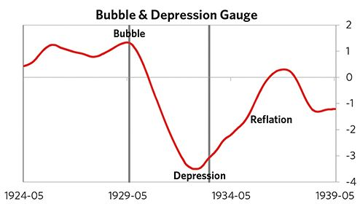

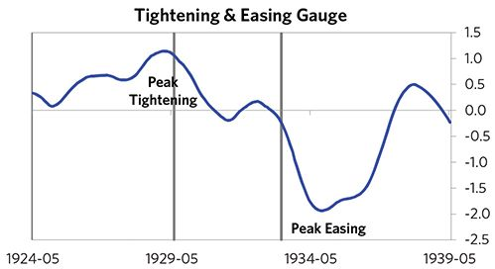

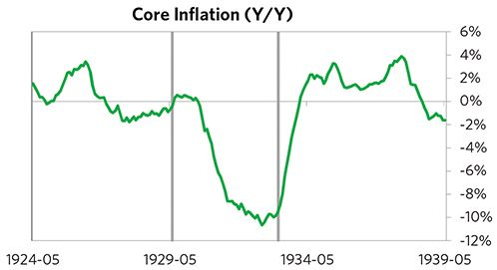

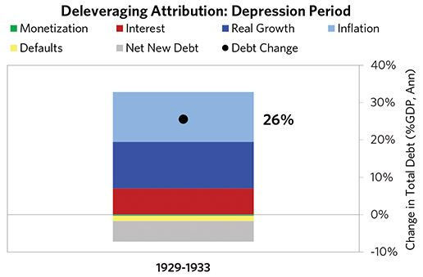

#### The Reflation Phase

After a slightly longer than average bust phase, policy makers were able to provide enough stimulation to turn the deleveraging into a beautiful one and create a period of reflation, which began in 1933. In terms of monetary policy, the government broke the peg to gold, M0 increased by 6% of GDP, interest rates were ultimately pushed down to 0%, and real FX averaged -5% during the stimulative phase. Over the cycle, the United States was very aggressive in managing its financial institutions and bad debts, pulling 8 out of 9 classic policy levers. In particular, it provided liquidity and directly purchased troubled assets. This stimulation helped bring nominal growth well above nominal interest rates (with growth averaging 8% during this period and sovereign long rates falling to 3%). During this phase, unemployment rates declined by 14% and debt as a % of GDP fell by 70% (21% annualized), as shown in the attribution chart to the right. Throughout this “beautiful” period, the reduction in debt-to-income ratios was driven primarily by rising real incomes and to a lesser extent by inflation. It took 7 years before real GDP reached its prior peak and equity prices in USD terms recovered within 25 years.

The crisis had a notable impact on the politics of the United States, as it helped set the stage for FDR, whom many people consider a populist leader, to take power.

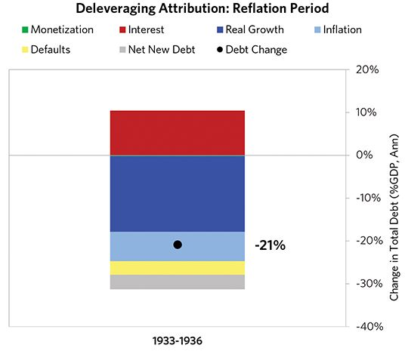

### United States 1926–1936 Chart Deck Appendix

#### Indebtedness

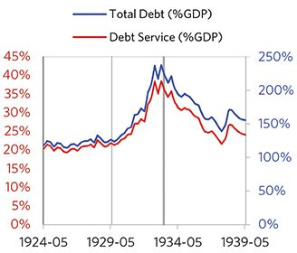

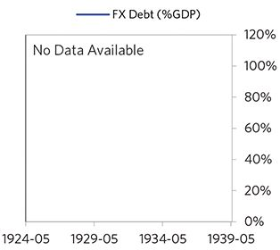

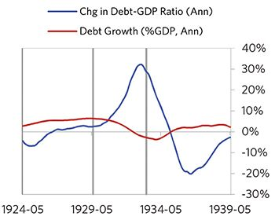

#### Monetary and Fiscal Policy

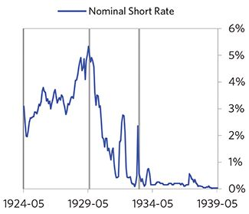

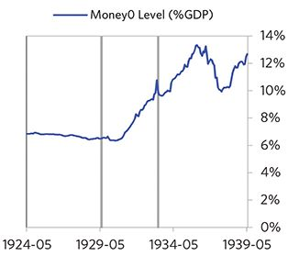

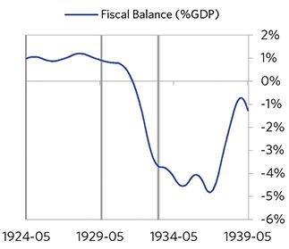

#### Economic Conditions

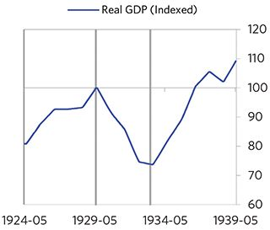

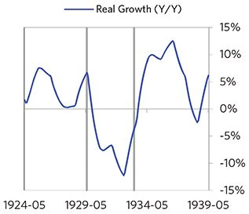

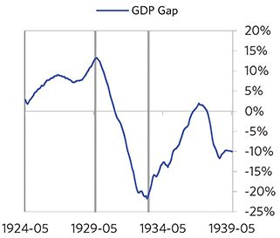

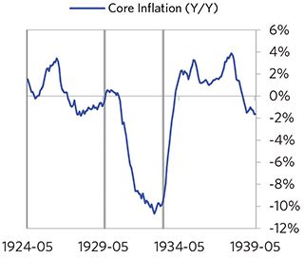

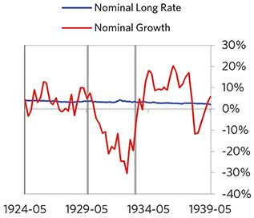

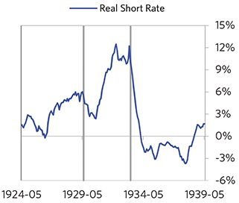

#### Markets

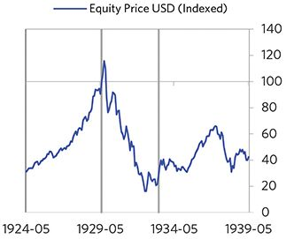

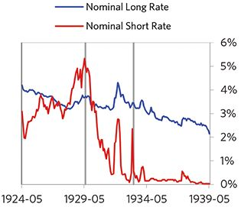

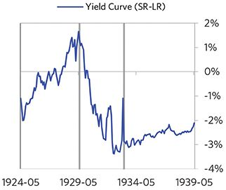

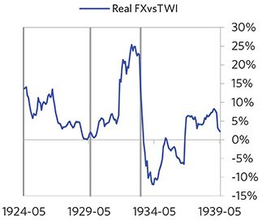

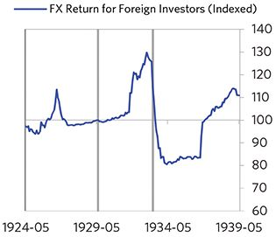

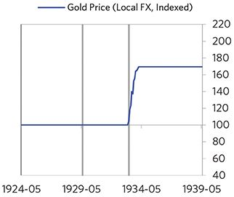

#### External Position

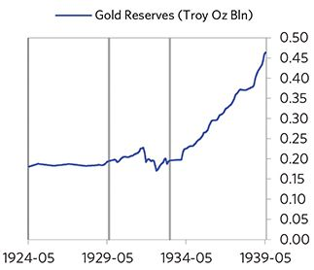

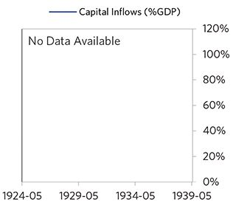

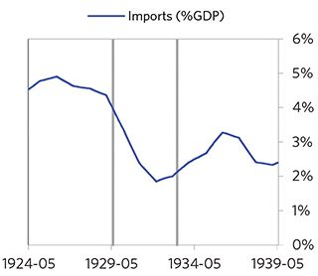

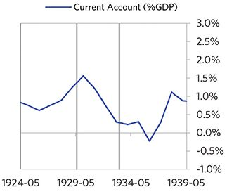

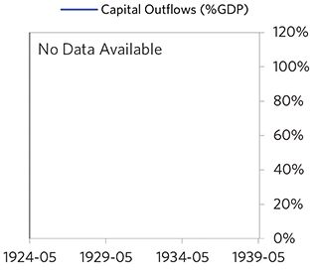

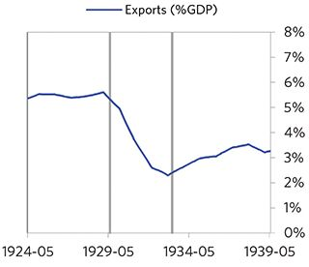

### United Kingdom 1927–1936 Case Auto-Summary

As show in the charts below, the United Kingdom experienced a classic deflationary deleveraging cycle between 1927 and 1936.

#### The Bubble Phase

Unlike many other cases, the United Kingdom didn’t experience a broad-based bubble in the years before the crisis, but it was tied to other countries, economies, and financial markets that were experiencing bubble-like conditions. And it did build up a substantial debt stock, with debts reaching 210% of GDP prior to the crisis. In this case, the debt was in the United Kingdom’s domestic currency, and the majority was owned domestically, too.

#### The Depression Phase

Eventually the cycle turned, producing a self-reinforcing bust and an “ugly deleveraging,” which ran from 1929 to 1931. High debt levels left the United Kingdom vulnerable to a shock—which came in the form of ripples from a stock crash in the US and the early Great Depression. The United Kingdom suffered from self-reinforcing declines in GDP (falling by 10%), and in stock prices (falling by 61%). Unemployment rates increased by 7%. As shown in the attribution chart to the right, even though the United Kingdom needed a deleveraging, its debt as a % GDP went up by 13% (6% annualized), driven primarily by interest payments financed with new debt and to a lesser extent by falling real incomes. This was partially offset by paying down existing debt.

The gauges below are composed from a compendium of stats shown in the chart deck that follows. Note these are meant to be rough measures.

*The first two charts show gauges which measure bubble/depression conditions and tightness/easiness of money and credit. For each gauge, the difference from zero conveys the extent of the bubble while the crossing above/below zero represents the shifting into or out of the bubble.

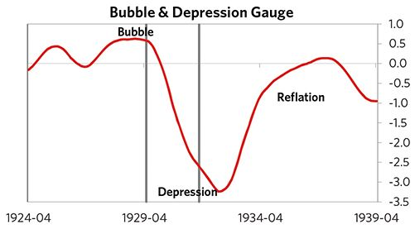

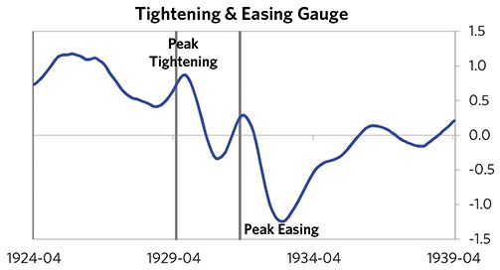

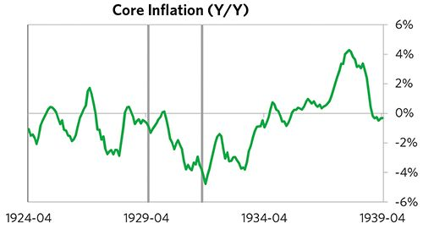

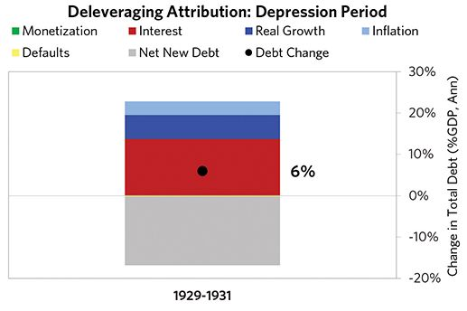

#### The Reflation Phase

After a slightly shorter than average bust phase, policy makers were able to provide enough stimulation to turn the deleveraging into a beautiful one and create a period of reflation, which began in 1931. In terms of monetary policy, the government broke the peg to gold, M0 increased by 2% of GDP, interest rates were ultimately pushed down to 0%, and real FX averaged -8% during the stimulative phase. Over the cycle, the United Kingdom was not aggressive in managing its financial institutions and bad debts, pulling 1 out of 9 classic policy levers. This and other stimulative measures helped bring nominal growth well above nominal interest rates (with growth averaging 4% during this period and sovereign long rates falling to 3%). During this phase, unemployment rates declined by 8% and debt as a % of GDP fell by 29% (5% annualized), as shown in the attribution chart to the right. Throughout this “beautiful” period, the reduction in debt-to-income ratios was driven primarily by paying down existing debt and to a lesser extent by rising real incomes. This was partially offset by interest payments financed with new debt. It took 5 years before real GDP reached its prior peak and equity prices in USD terms recovered within 8 years.

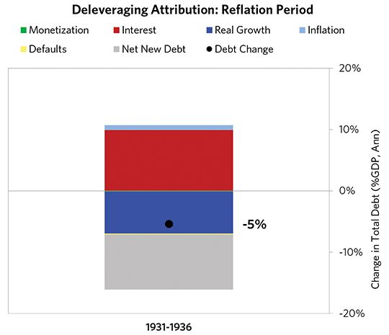

### United Kingdom 1927–1936 Chart Deck Appendix

#### Indebtedness

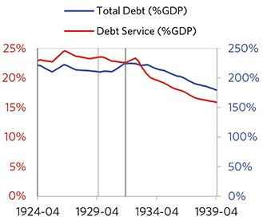

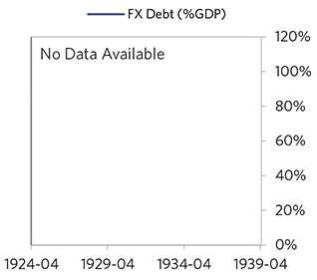

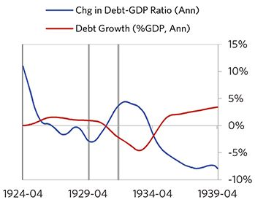

#### Monetary and Fiscal Policy

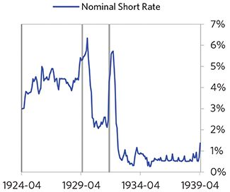

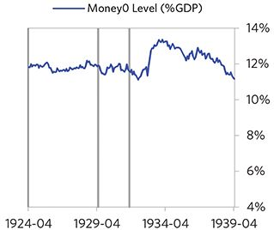

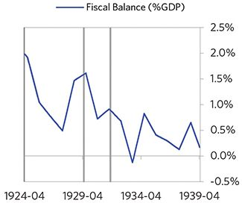

#### Economic Conditions

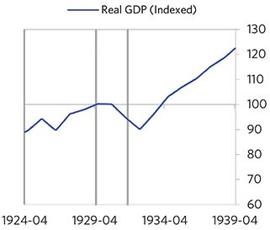

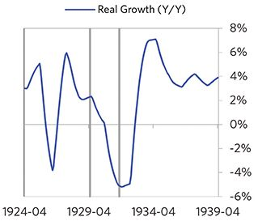

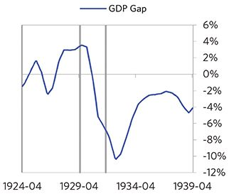

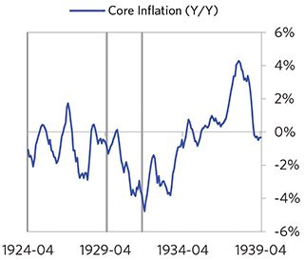

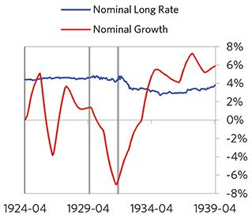

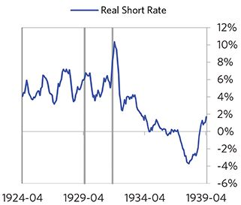

#### Markets

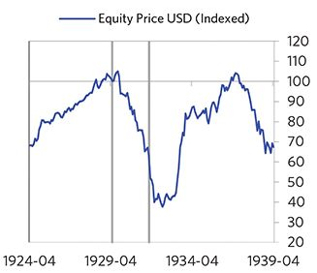

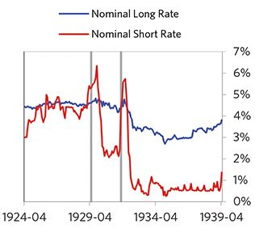

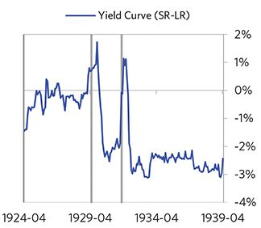

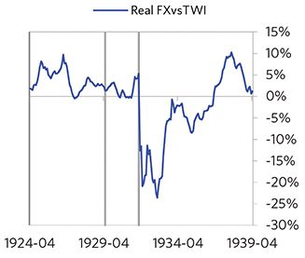

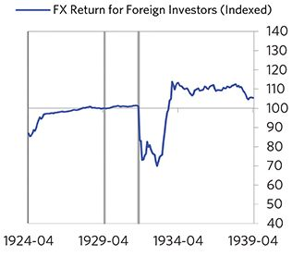

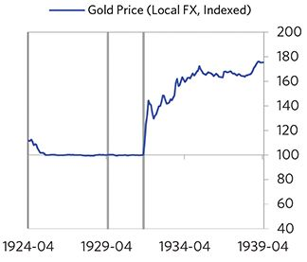

#### External Position

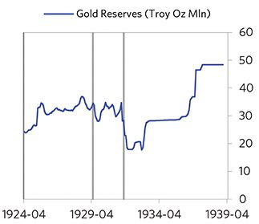

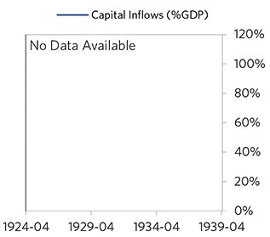

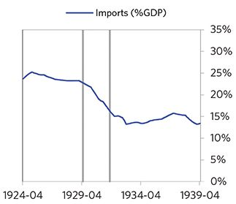

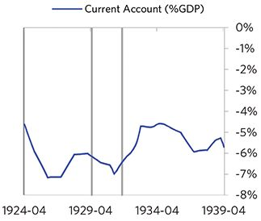

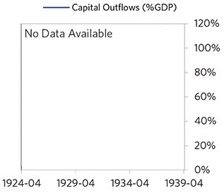

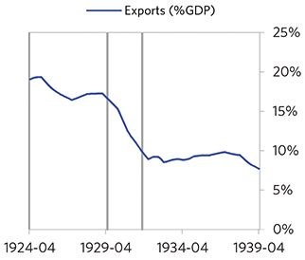

### Japan 1925–1936 Case Auto-Summary

As show in the charts below, Japan experienced a classic deflationary deleveraging cycle between 1925 and 1936.

#### The Bubble Phase

Unlike many other cases, Japan didn’t experience a broad- based bubble in the years before the crisis, but it was tied to other countries, economies, and financial markets that were experiencing bubble-like conditions. And it did build up a substantial debt stock, with debts reaching 65% of GDP prior to the crisis. In this case, the debt was in Japan’s domestic currency, and the majority was owned domestically, too.

#### The Depression Phase

Eventually the cycle turned, producing a self-reinforcing bust and an “ugly deleveraging,” which ran from 1927 to 1931. High debt levels left Japan vulnerable to a shock— which came in the form of the 1929 global stock market crash. Japan suffered from self-reinforcing declines in GDP (falling by 4%), and in stock prices (falling by 47%). Japan’s financial institutions also came under considerable pressure. As shown in the attribution chart to the right, even though Japan needed a deleveraging, its debt as a % GDP went up by 36% (8% annualized).

The gauges below are composed from a compendium of stats shown in the chart deck that follows. Note these are meant to be rough measures.

*The first two charts show gauges which measure bubble/depression conditions and tightness/easiness of money and credit. For each gauge, the difference from zero conveys the extent of the bubble while the crossing above/below zero represents the shifting into or out of the bubble.

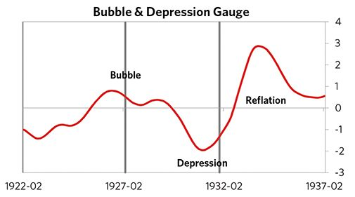

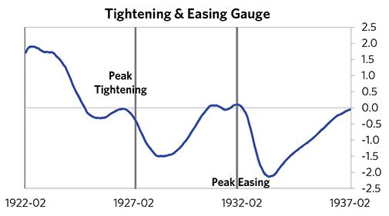

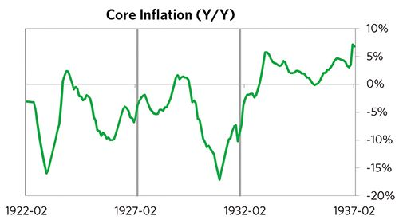

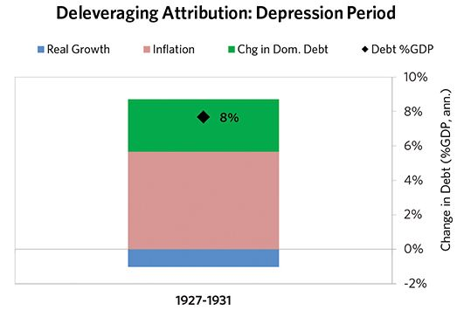

#### The Reflation Phase

After a slightly longer than average bust phase, policy makers were able to provide enough stimulation to turn the deleveraging into a beautiful one and create a period of reflation, which began in 1931. In terms of monetary policy, the government broke the peg to gold, interest rates were ultimately pushed down to 2%, and real FX averaged -26% during the stimulative phase. Over the cycle, Japan was somewhat aggressive in managing its financial institutions and bad debts, pulling 3 out of 9 classic policy levers. This stimulation helped bring nominal growth above nominal interest rates (with growth averaging 4.7% during this period and sovereign long rates falling to 3.9%). During this phase, debt as a % of GDP fell by 18% (4% annualized), as shown in the attribution chart to the right. Throughout this “beautiful” period, the reduction in debt-to-income ratios came mostly from income rising, driven primarily by higher real growth.

The crisis had a notable impact on the politics of Japan, as it helped set the stage for Hideki Tojo, whom many people consider a populist leader, to take power.

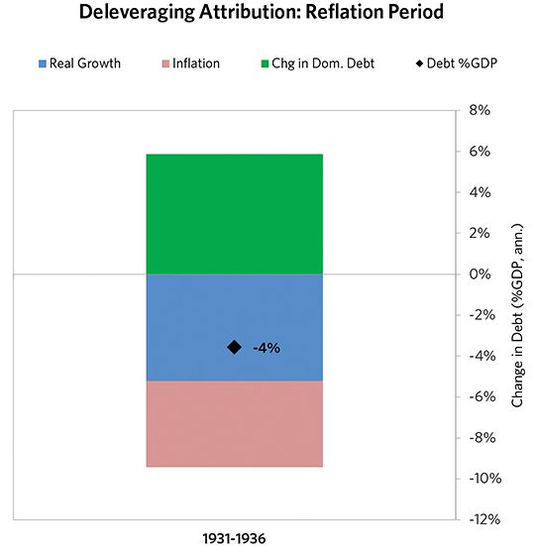

### Japan 1925–1936 Chart Deck Appendix

#### Indebtedness

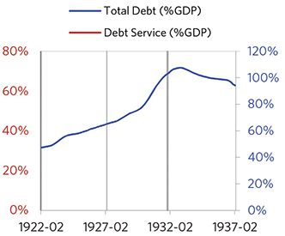

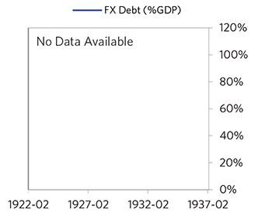

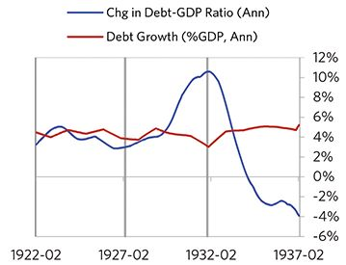

#### Monetary and Fiscal Policy

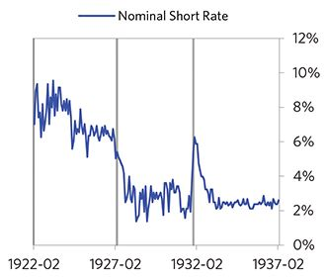

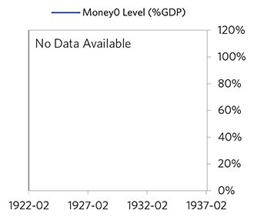

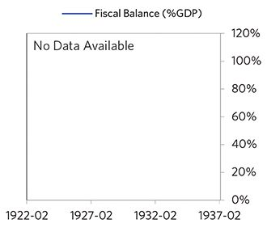

#### Economic Conditions

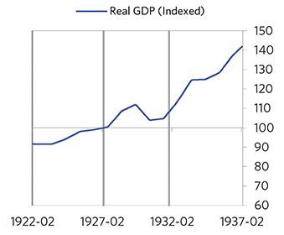

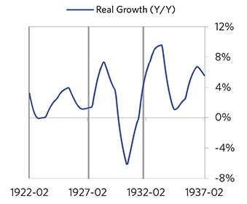

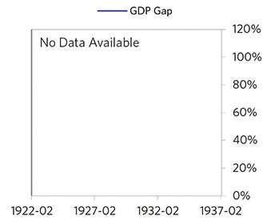

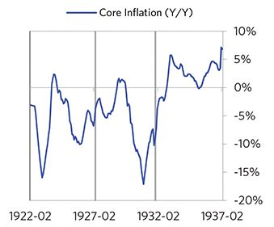

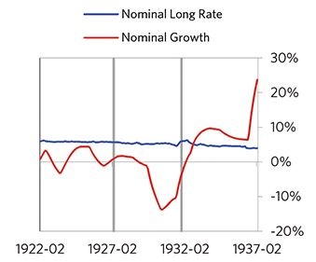

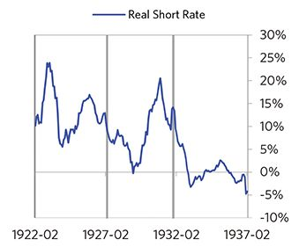

#### Markets

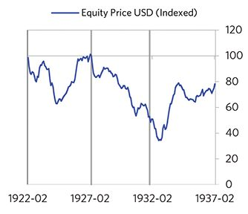

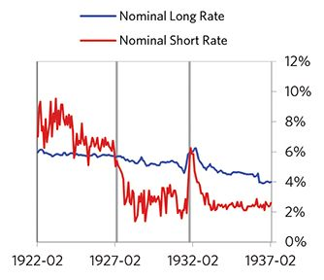

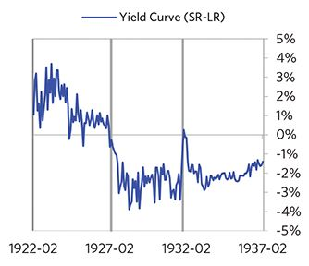

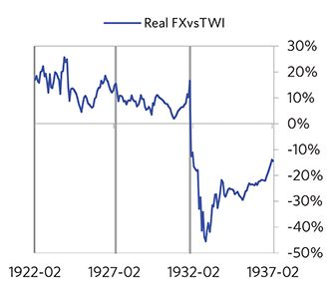

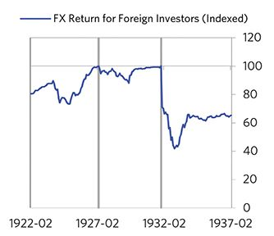

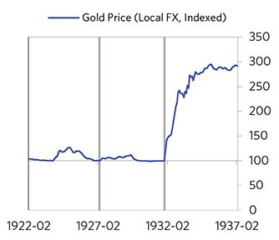

#### External Position

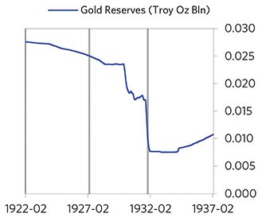

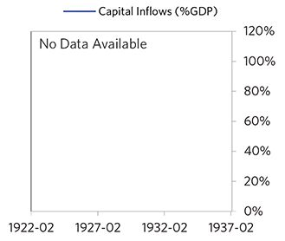

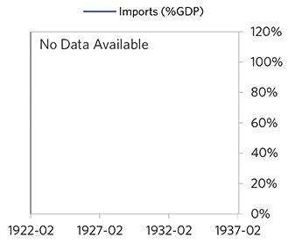

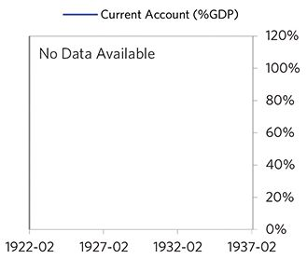

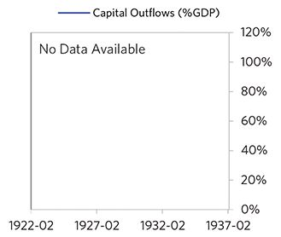

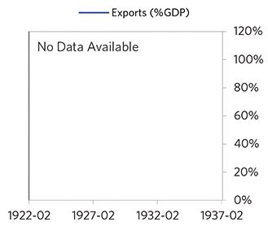

### France 1926–1938 Case Auto-Summary

As show in the charts below, France experienced a classic deflationary deleveraging cycle between 1926 and 1938.

#### The Bubble Phase

Between 1926 and 1929, France experienced a bubble that was driven by a self-reinforcing cycle of strong growth and strong equity returns. Debts actually declined by 13% of GDP during the bubble to a pre-crisis level of 205% of GDP. In this case, the debt was in France’s domestic currency, and the majority was owned domestically, too. Growth was strong (at 3%), while levels of economic activity were high (the GDP gap peaked at 9%). Furthermore, strong asset returns (equities averaged 45% annualized returns over the bubble period) encouraged more borrowing and helped to stimulate growth. Taken together, these bubble pressures, combined with tightening money and credit and the weakened conditions of related countries, created an unsustainable situation.

#### The Depression Phase

Eventually the dynamic turned, producing a self-reinforcing bust and an “ugly deleveraging,” which ran from 1929 to 1936. High debt levels left France vulnerable to a shock—which came in the form of ripples from a stock crash in the US and the early Great Depression. France suffered from self-reinforcing declines in GDP (falling by 17%), and in stock prices (falling by 57%). France’s financial institutions also came under considerable pressure. As shown in the attribution chart to the right, even though France needed a deleveraging, its debt as a % GDP was roughly flat through this period.

The gauges below are composed from a compendium of stats shown in the chart deck that follows. Note these are meant to be rough measures.

*The first two charts show gauges which measure bubble/depression conditions and tightness/easiness of money and credit. For each gauge, the difference from zero conveys the extent of the bubble while the crossing above/below zero represents the shifting into or out of the bubble.

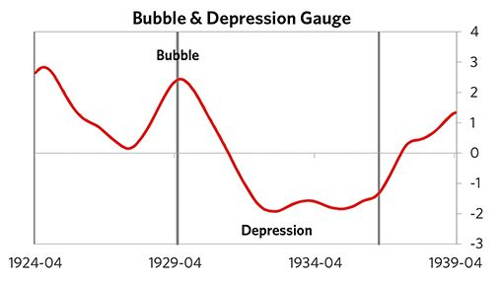

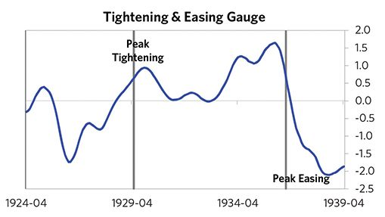

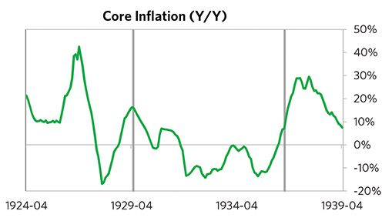

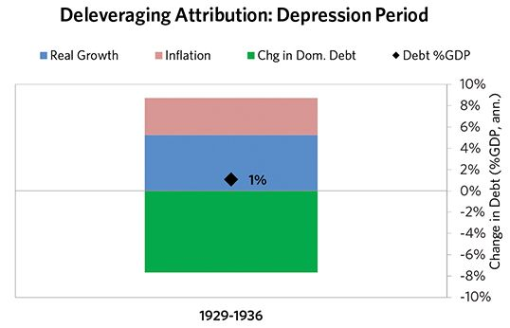

#### The Reflation Phase

After a relatively long bust phase, policy makers were able to provide enough stimulation to turn the deleveraging into a beautiful one and create a period of reflation, which began in 1936. In terms of monetary policy, the government broke the peg to gold, interest rates were ultimately pushed down to 2%, and real FX averaged -4% during the stimulative phase. Importantly, policy makers allowed inflation to run high (averaging 10% during this period), which boosted nominal growth and helped reduce the domestic debt burden. Over the cycle, France was somewhat aggressive in managing its financial institutions and bad debts, pulling 3 out of 9 classic policy levers. This stimulation helped bring nominal growth well above nominal interest rates (with growth averaging 15% during this period and sovereign long rates falling to 4%). During this phase, debt as a % of GDP fell by 37% (15% annualized), as shown in the attribution chart to the right. Throughout this “beautiful” period, the reduction in debt-to-income ratios came mostly from income rising, driven primarily by higher inflation. It took 21 years before real GDP reached its prior peak.

The crisis had a notable impact on the politics of France, as it helped set the stage for Leon Blum, whom many people consider a populist leader, to take power in 1936.

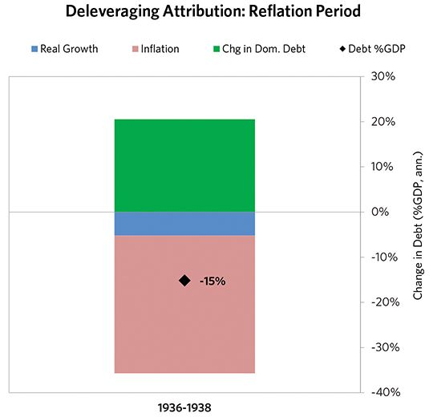

### France 1926–1938 Chart Deck Appendix

#### Indebtedness

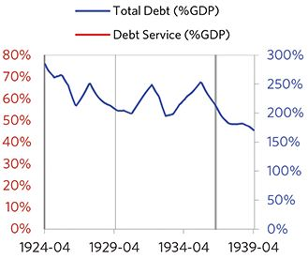

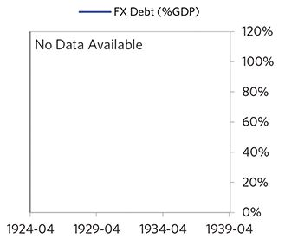

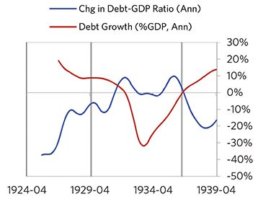

#### Monetary and Fiscal Policy

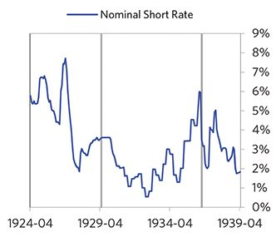

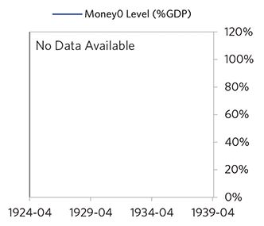

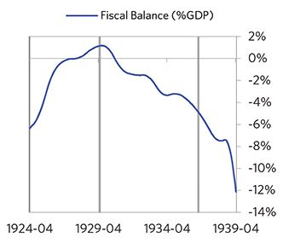

#### Economic Conditions

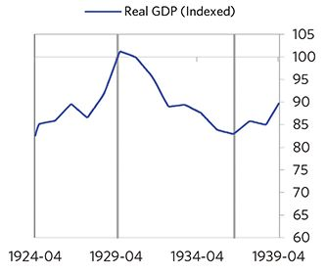

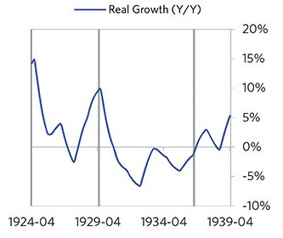

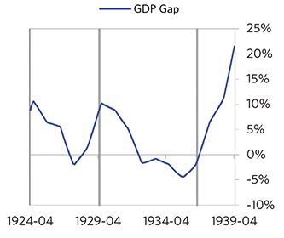

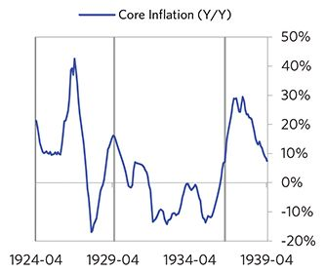

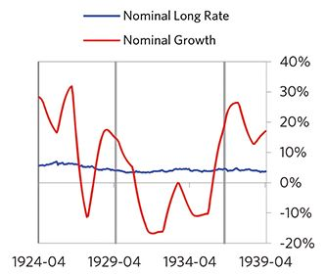

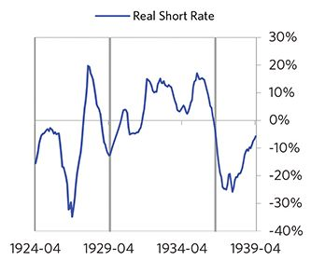

#### Markets

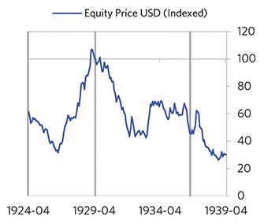

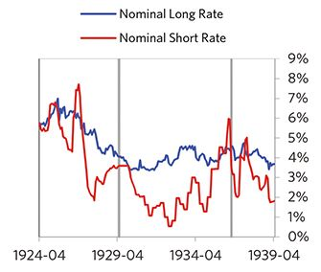

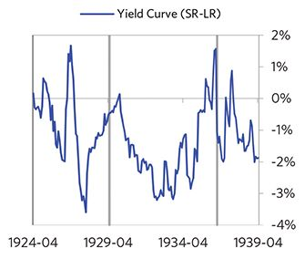

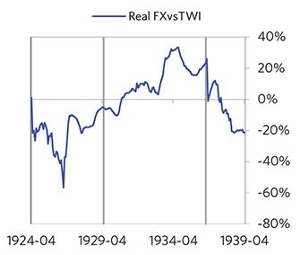

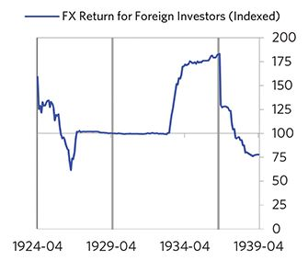

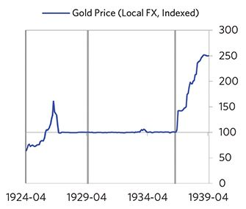

#### External Position

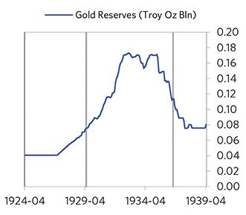

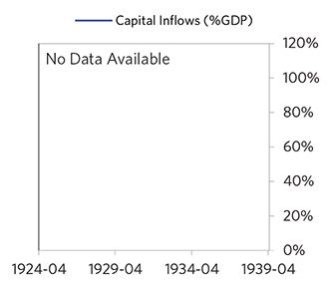

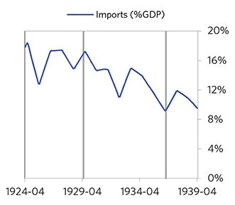

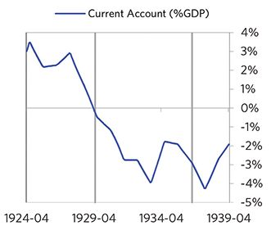

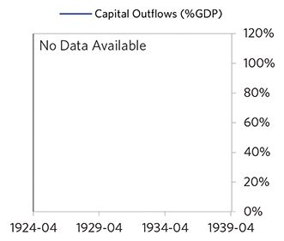

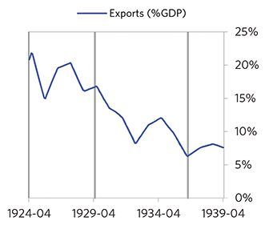

### United Kingdom 1941–1967 Case Auto-Summary

As show in the charts below, the United Kingdom experienced a classic wartime deflationary deleveraging cycle between 1941 and 1967. As is typical for winners of big wars, the United Kingdom experienced a brief postwar recession as the economy transitioned away from war production, and a more orderly deleveraging.

#### The War Phase

Unlike the typical case that entails a bubble, this debt crisis had its roots in WW2. During the war, the United Kingdom borrowed a lot of money to finance its big fiscal deficit, shifted much of its economy to war production, and shifted much of its workforce to the armed services and war production. For these reasons, the economic stats are not reflective of typical economic linkages. Through the war, debts rose sharply. In this case, the debt was in the United Kingdom’s domestic currency, and the majority was owned domestically, too. Aided by wartime spending, growth was strong through this period (at 6%), while levels of economic activity were high (the GDP gap peaked at 10%). Meanwhile, strong asset returns (equities averaged 16% annualized returns over the war period) helped to stimulate growth.

#### The Postwar Phase

As the war neared an end, the United Kingdom entered a postwar recession, which ran from 1943 to 1947. Since the United Kingdom won the war, its postwar slump was less bad than it was for the losers. Nevertheless, the United Kingdom suffered from self-reinforcing declines in GDP (falling by 15%). As shown in the attribution chart to the right, even though the United Kingdom needed a deleverag- ing, its debt as a % GDP went up by 102% (25% annualized) as incomes declined and as the government continued to shoulder war-related costs (with a peak fiscal deficit of 31% of GDP during the ugly period).

The gauges below are composed from a compendium of stats shown in the chart deck that follows. Note these are meant to be rough measures.

*The first two charts show gauges which measure bubble/depression conditions and tightness/easiness of money and credit. For each gauge, the difference from zero conveys the extent of the bubble while the crossing above/below zero represents the shifting into or out of the bubble.

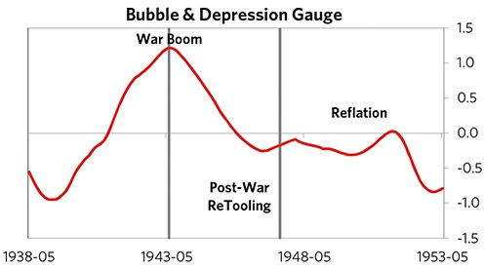

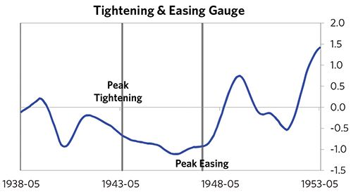

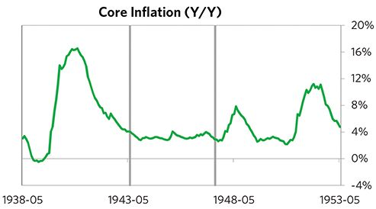

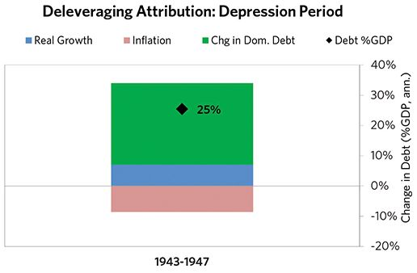

#### The Reflation Phase

After a slightly longer than average bust phase, policy makers were able to provide enough stimulation to turn the deleveraging into a beautiful one and create a period of reflation, which began in 1947. In terms of monetary policy, the government devalued the currency versus gold by 30%, M0 actually decreased by 8% of GDP, interest rates were ultimately pushed down to 1%, and real FX averaged -10% during the stimulative phase. Importantly, policy makers allowed inflation to run high (averaging 4% during this period), which boosted nominal growth and helped reduce the domestic debt burden. This and other stimulative measures helped bring nominal growth well above nominal interest rates (with growth averaging 7% during this period and sovereign long rates falling to 2%). During this phase, unemployment rates were flat and debt as a % of GDP fell by 139% (7% annualized), as shown in the attribution chart to the right. Throughout this “beautiful” period, the reduction in debt-to-income ratios came mostly from income rising, driven primarily by higher inflation. It took 10 years before real GDP reached its prior peak.

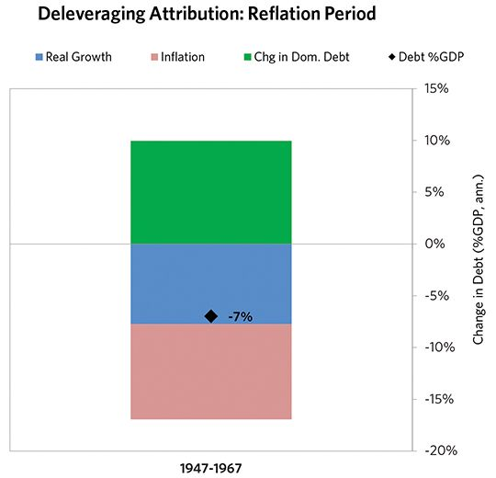

### United Kingdom 1941–1967 Chart Deck Appendix

#### Indebtedness

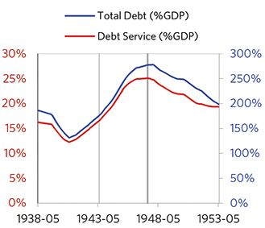

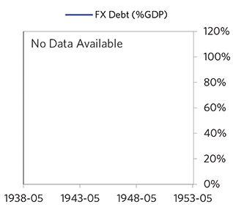

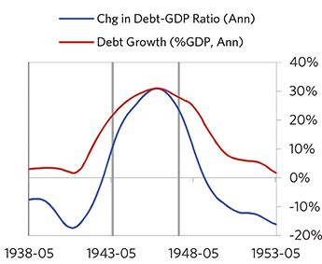

#### Monetary and Fiscal Policy

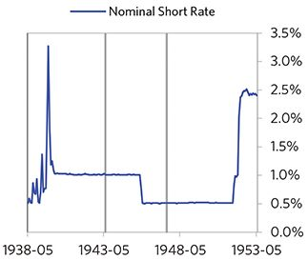

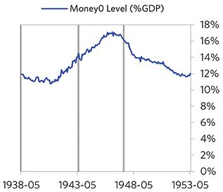

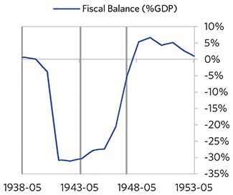

#### Economic Conditions

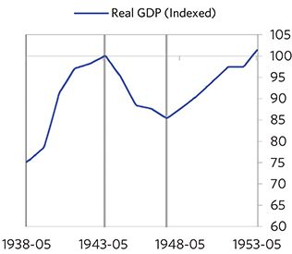

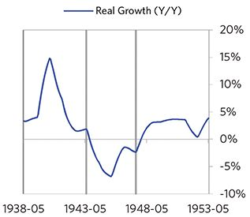

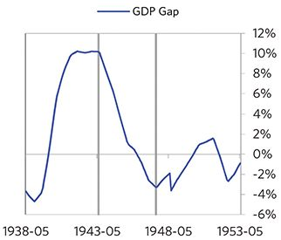

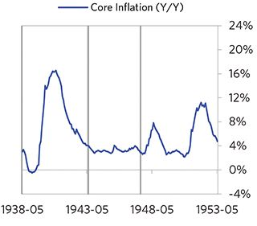

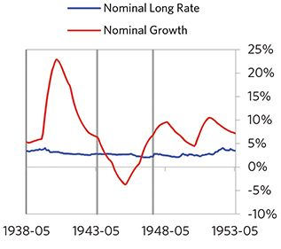

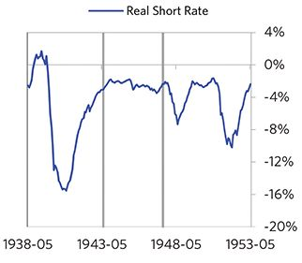

#### Markets

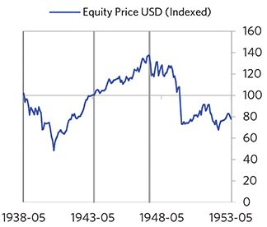

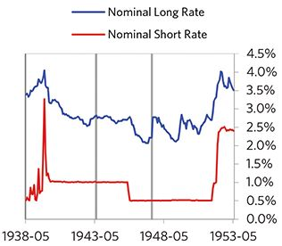

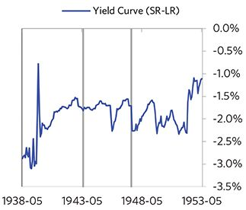

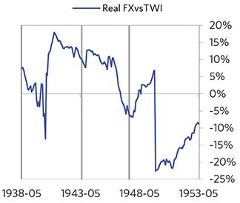

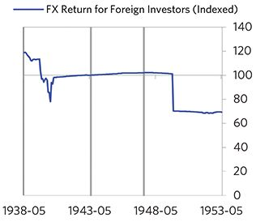

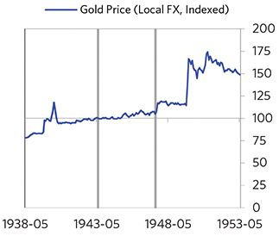

#### External Position

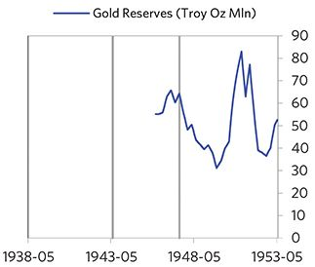

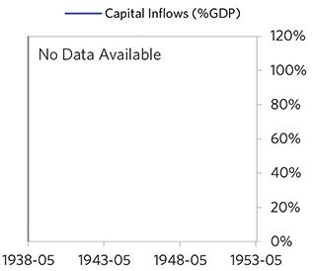

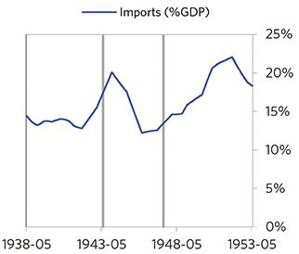

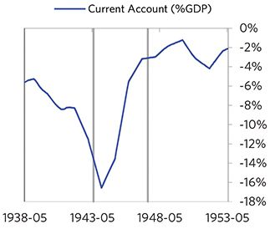

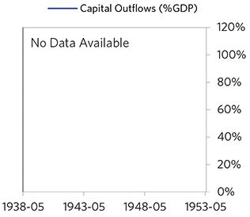

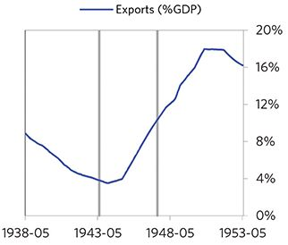

#### Government and Military

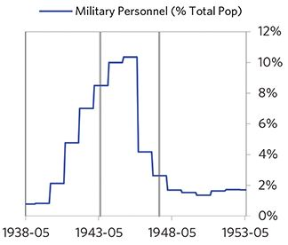

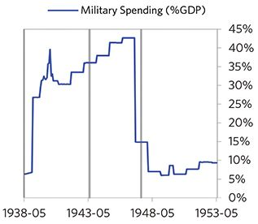

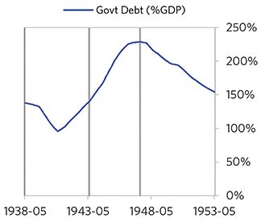

### United States 1943–1951 Case Auto-Summary

As show in the charts below, the United States experienced a classic wartime deflationary deleveraging cycle between 1943 and 1951. As is typical for winners of big wars, the United States experienced a brief postwar recession as the economy transitioned away from war production, and a more orderly deleveraging.

#### The War Phase

Unlike the typical case that entails a bubble, this debt crisis had its roots in WW2. During the war, the United States borrowed a lot of money to finance its big fiscal deficit, shifted much of its economy to war production, and shifted much of its workforce to the armed services and war production. For these reasons, the economic stats are not reflective of typical economic linkages. Through the war, debts rose to 150% of GDP. In this case, the debt was in the United States’s domestic currency, and the majority was owned domestically, too. Aided by wartime spending, growth was strong through this period (at 13%), while levels of economic activity were high (the GDP gap peaked at 19%). Meanwhile, strong asset returns (equities averaged 15% annualized returns over the war period) helped to stimulate growth.

#### The Postwar Phase

When the fighting ended, the United States entered a postwar recession, which ran from 1945 to 1950. Since the United States won the war, its postwar slump was less bad than it was for the losers. Nevertheless, the United States suffered from self-reinforcing declines in GDP (falling by 13%). Unemployment rates increased by 5%. As shown in the attribution chart to the right, even though the United States needed a deleveraging, its debt as a % GDP was roughly flat through this period.

The gauges below are composed from a compendium of stats shown in the chart deck that follows. Note these are meant to be rough measures.

*The first two charts show gauges which measure bubble/depression conditions and tightness/easiness of money and credit. For each gauge, the difference from zero conveys the extent of the bubble while the crossing above/below zero represents the shifting into or out of the bubble.

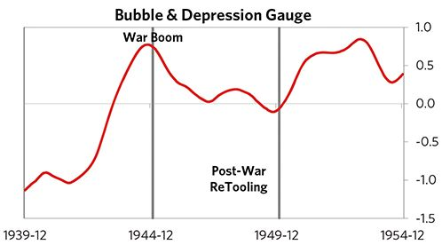

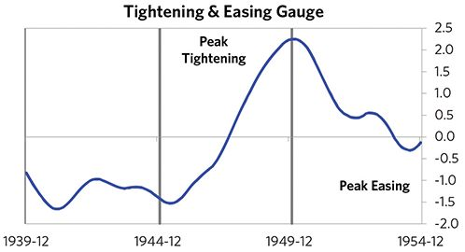

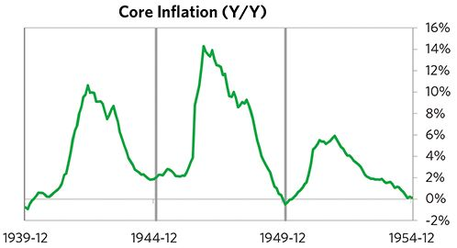

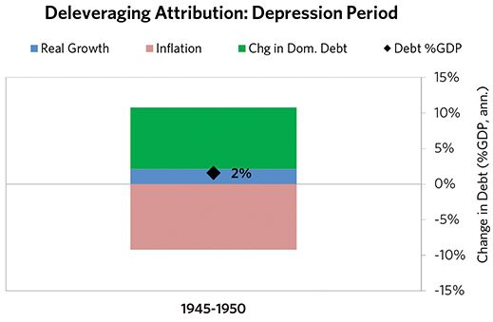

#### The Reflation Phase

After a relatively long bust phase, policy makers were able to provide enough stimulation to turn the deleveraging into a beautiful one and create a period of reflation, which began in 1950. In terms of monetary policy, M0 actually decreased by 0.9% of GDP and interest rates were ultimately pushed down to 1% during the stimulative phase. The central bank’s choice to stay easy even as activity picked up sharply helped bring nominal growth well above nominal interest rates (with growth averaging 11% during this period and sovereign long rates averaging 2%). During this phase, unemployment rates declined by 2% and debt as a % of GDP fell by 22% (14% annualized), as shown in the attribution chart to the right. Throughout this “beautiful” period, the reduction in debt-to-income ratios came mostly from income rising, driven primarily by higher real growth. It took 6 years before real GDP reached its prior peak.

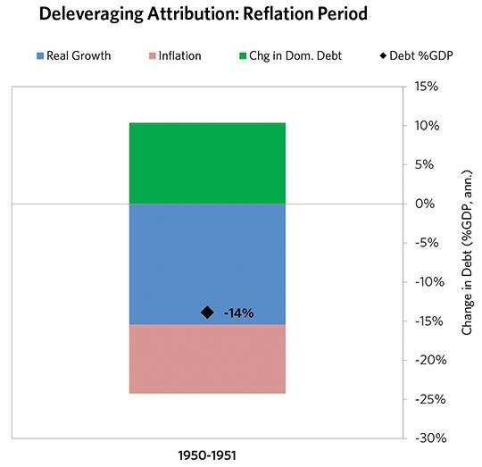

### United States 1943–1951 Chart Deck Appendix

#### Indebtedness

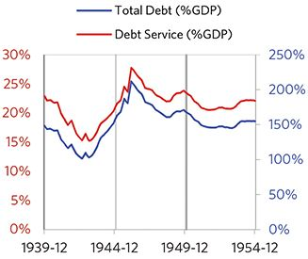

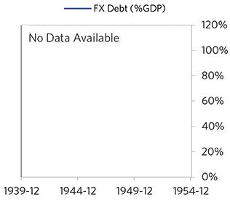

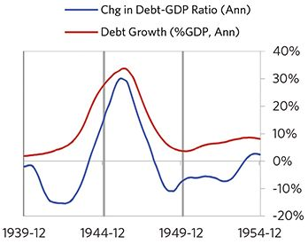

#### Monetary and Fiscal Policy

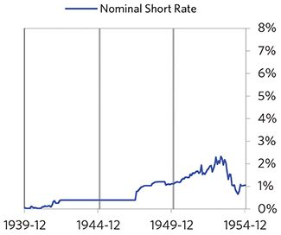

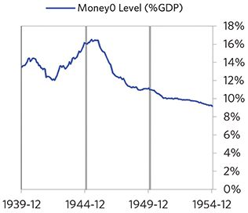

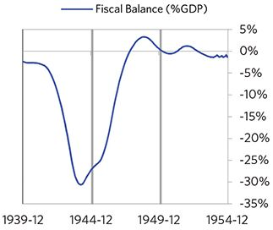

#### Economic Conditions

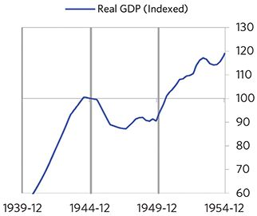

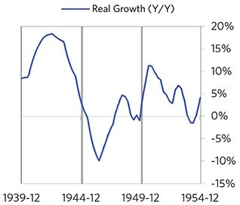

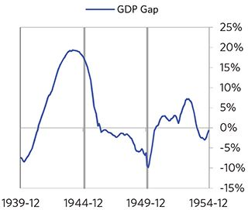

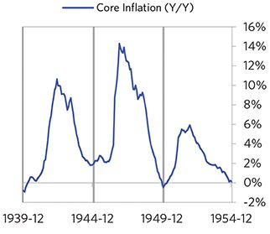

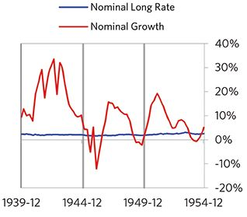

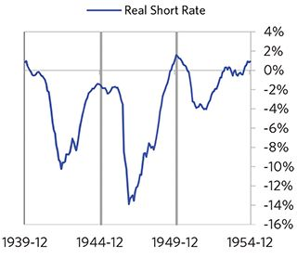

#### Markets

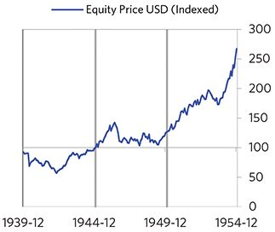

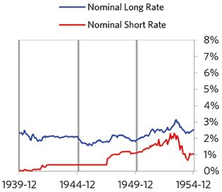

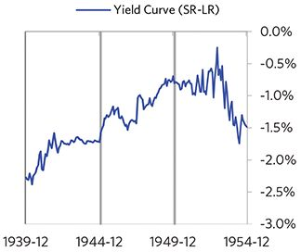

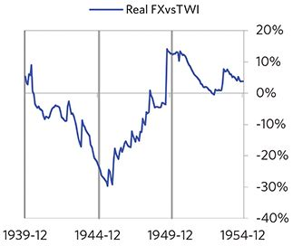

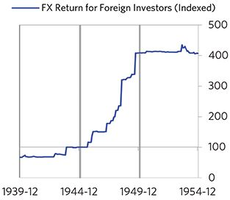

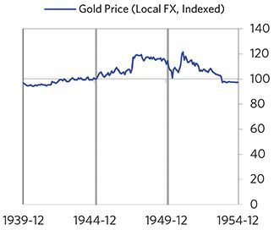

#### External Position

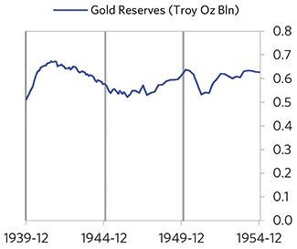

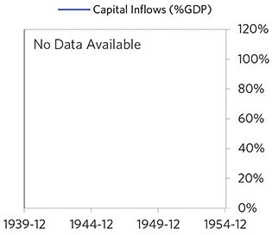

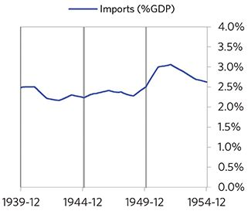

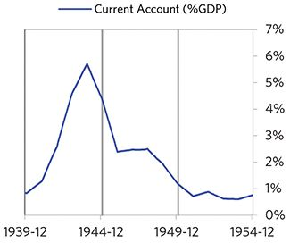

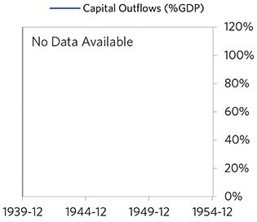

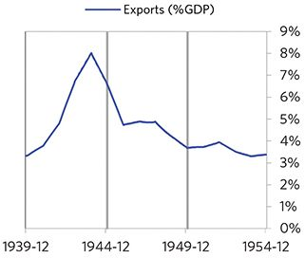

#### Government and Military

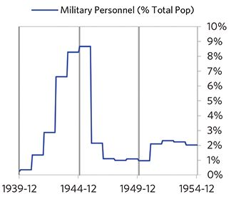

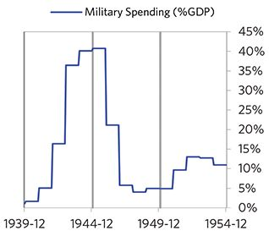

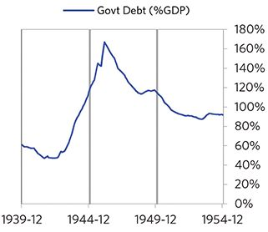

### Norway 1984–1996 Case Auto-Summary

As show in the charts below, Norway experienced a classic deflationary deleveraging cycle between 1984 and 1996.

#### The Bubble Phase

Between 1984 and 1987, Norway experienced a bubble that was driven by a self-reinforcing cycle of strong growth, strong equity returns, and strong housing returns. By the bubble’s end, debts had reached a pre-crisis peak of 211% of GDP. In this case, the debt was in Norway’s domestic currency, and the majority was owned domestically, too. During the bubble phase, investment inflows were moder- ately strong, averaging around 4% of GDP, which helped to finance a current account deficit of 2% of GDP. Aided by that capital, growth was strong (at 3%), while levels of economic activity were high (the GDP gap peaked at 5%). Furthermore, strong asset returns (housing prices averaged 19% annualized returns over the bubble period) encouraged more borrowing and helped to stimulate growth. During this bubble period, policy makers initiated a large tightening (with short rates rising around 700 bps). Taken together, these bubble pressures, combined with tightening money and credit, created an unsustainable situation.

#### The Depression Phase

Eventually the dynamic turned, producing a self-reinforcing bust and an “ugly deleveraging,” which ran from 1987 to 1992. At its pre-crisis peak, debt service reached 58% of GDP, making Norway vulnerable to a shock—which came in the form of ripples from commodity price declines. Norway suffered from self-reinforcing declines in GDP (falling by 4%) and in home prices (falling by 38%). Norway’s financial institutions also came under considerable pressure. As shown in the attribution chart to the right, even though Norway needed a deleveraging, its debt as a % GDP was roughly flat through this period.

The gauges below are composed from a compendium of stats shown in the chart deck that follows. Note these are meant to be rough measures.

*The first two charts show gauges which measure bubble/depression conditions and tightness/easiness of money and credit. For each gauge, the difference from zero conveys the extent of the bubble while the crossing above/below zero represents the shifting into or out of the bubble.

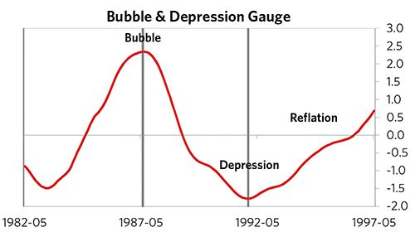

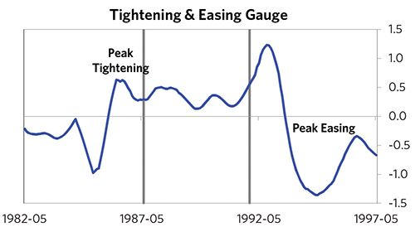

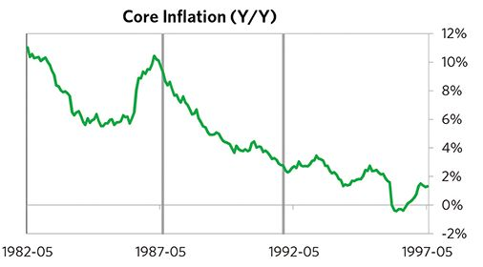

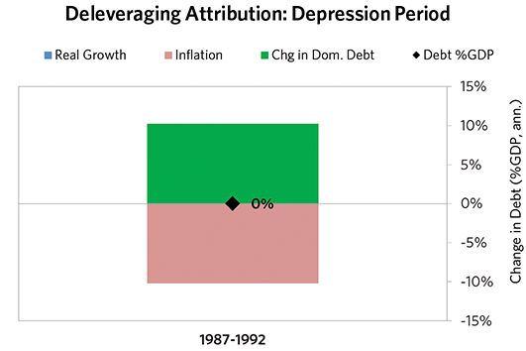

#### The Reflation Phase

After a relatively long bust phase, policy makers were able to provide enough stimulation to turn the deleveraging into a beautiful one and create a period of reflation, which began in 1992. In terms of monetary policy, M0 increased by 2% of GDP, interest rates were ultimately pushed down to 4%, and real FX averaged 3% during the stimulative phase. Over the cycle, Norway was aggressive in managing its financial institutions and bad debts, pulling 4 out of 9 classic policy levers. In particular, it nationalized banks and provided liquidity. It also enacted structural reforms designed to increase labor market flexibility. This stimulation helped bring nominal growth close to nominal interest rates (with growth averaging 6.1% during this period and sovereign long rates falling to 5.5%). During this phase, unemployment rates declined by 4% and debt as a % of GDP fell by 35% (7% annualized), as shown in the attribution chart to the right. Throughout this “beautiful” period, the reduction in debt-to-income ratios came mostly from income rising, driven primarily by higher real growth. It took 5 years before real GDP reached its prior peak.

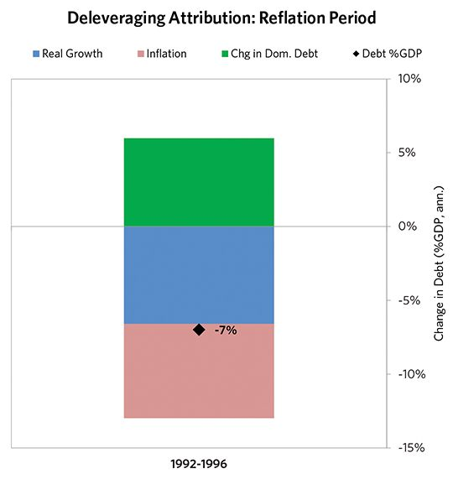

### Norway 1984–1996 Chart Deck Appendix

#### Indebtedness

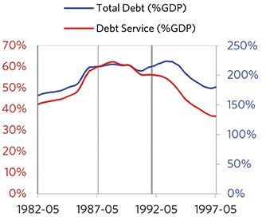

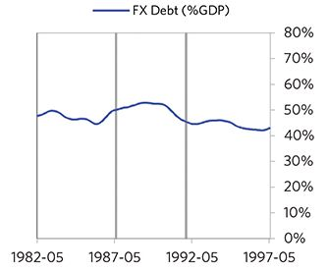

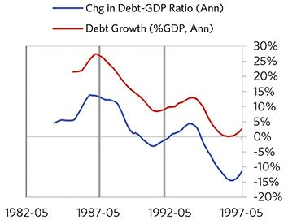

#### Monetary and Fiscal Policy

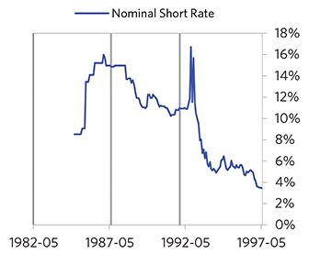

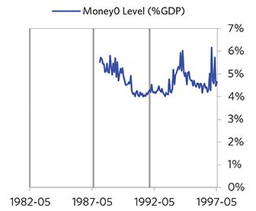

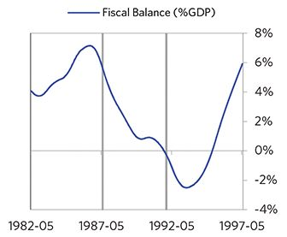

#### Economic Conditions

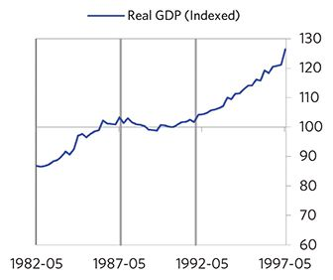

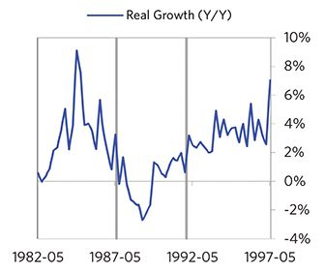

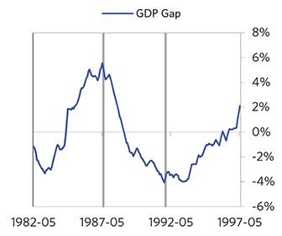

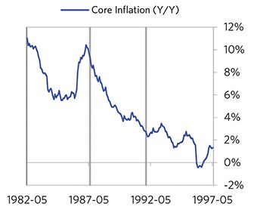

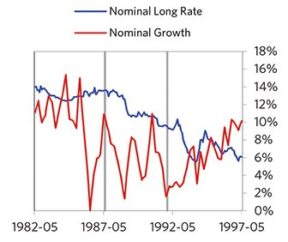

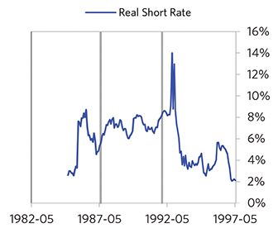

#### Markets

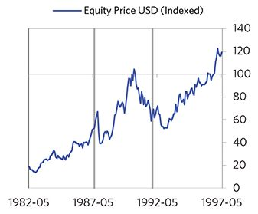

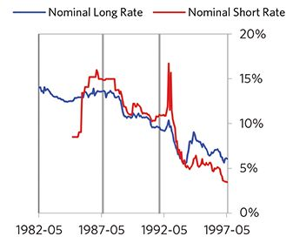

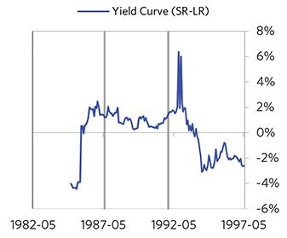

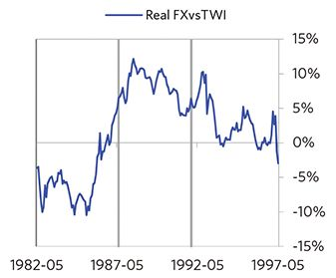

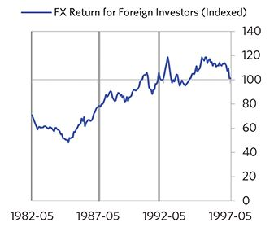

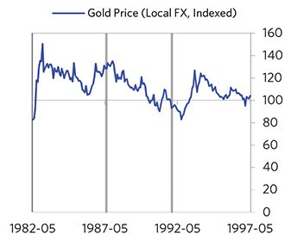

#### External Position

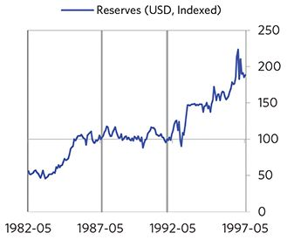

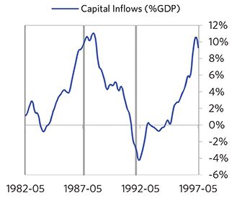

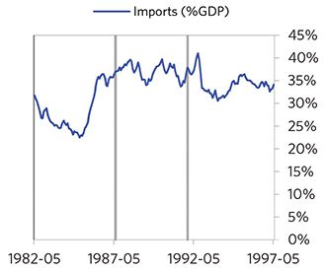

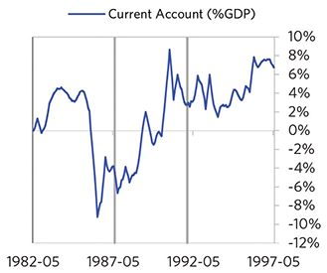

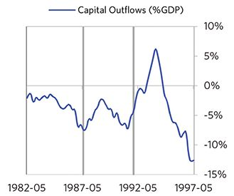

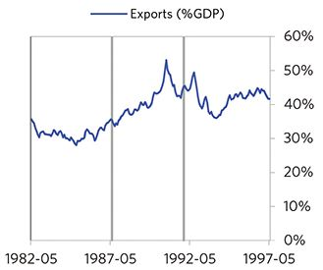

### Finland 1987–2001 Case Auto-Summary

As show in the charts below, Finland experienced a classic deflationary deleveraging cycle between 1987 and 2001.

#### The Bubble Phase

Between 1987 and 1989, Finland experienced a bubble that was driven by a self-reinforcing cycle of strong growth and strong equity returns. By the bubble’s end, debts had reached a pre-crisis peak of 272% of GDP. In this case, the debt was in Finland’s domestic currency, though a high share was owned by foreigners, which left Finland with some exposure to a pullback in foreign capital. During the bubble phase, investment inflows were low but positive, averaging around 3% of GDP, while Finland maintained a current account deficit of 3% of GDP. Aided by that capital, growth was strong (at 5%). Furthermore, strong asset returns (equities averaged 18% annualized returns over the bubble period) encouraged more borrowing and helped to stimulate growth. During this bubble period, policy makers initiated a large tightening (with short rates rising around 700 bps). Competitiveness became an issue, as Finland’s real FX peaked at +24%. Taken together, these bubble pressures and Finland’s dependence on foreign financing, combined with tightening money and credit, created an unsustainable situation.

#### The Depression Phase

Eventually the dynamic turned, producing a self-reinforcing bust and an “ugly deleveraging,” which ran from 1989 to 1993. High debt levels left Finland vulnerable to a shock— which came in the form of asset price declines hitting bank solvency. Finland suffered from self-reinforcing declines in GDP (falling by 12%), in stock prices (falling by 36%) and in home prices (falling by 32%). Unemployment rates increased by 13%. Finland’s financial institutions also came under considerable pressure. As shown in the attribution chart to the right, even though Finland needed a deleveraging, its debt as a % GDP went up by 32% (9% annualized) as incomes declined.

The gauges below are composed from a compendium of stats shown in the chart deck that follows. Note these are meant to be rough measures.

*The first two charts show gauges which measure bubble/depression conditions and tightness/easiness of money and credit. For each gauge, the difference from zero conveys the extent of the bubble while the crossing above/below zero represents the shifting into or out of the bubble.

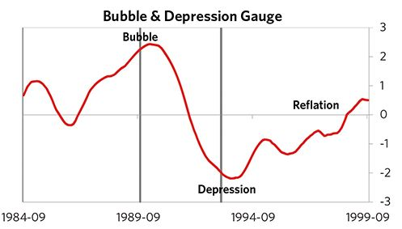

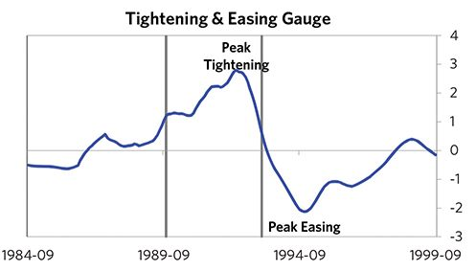

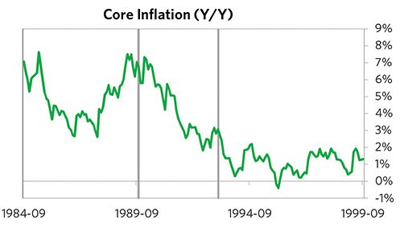

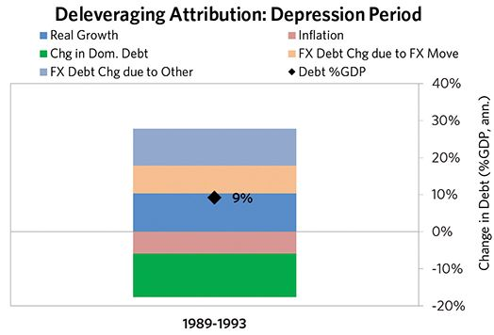

#### The Reflation Phase

After a slightly longer than average bust phase, policy makers were able to provide enough stimulation to turn the deleveraging into a beautiful one and create a period of reflation, which began in 1993. In terms of monetary policy, M0 increased by 7% of GDP, interest rates were ultimately pushed down to 3%, and real FX averaged -10% during the stimulative phase. Over the cycle, Finland was very aggressive in managing its financial institutions and bad debts, pulling 7 out of 9 classic policy levers. In particular, it nationalized banks, provided liquidity, and directly purchased troubled assets. This stimulation helped bring nominal growth well above nominal interest rates (with growth averaging 6% during this period and sovereign long rates falling to 4%). During this phase, unemployment rates declined by 6% and debt as a % of GDP fell by 72% (8% annualized), as shown in the attribution chart to the right. Throughout this “beautiful” period, the reduction in debt-to-income ratios came mostly from income rising, driven primarily by higher real growth. It took 7 years before real GDP reached its prior peak and equity prices in USD terms recovered within 5 years.

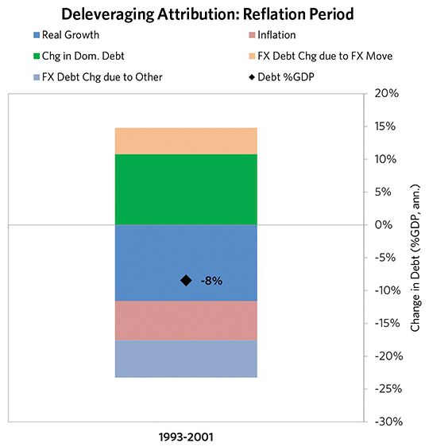

### Finland 1987–2001 Chart Deck Appendix

#### Indebtedness

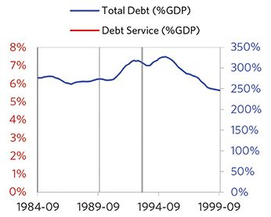

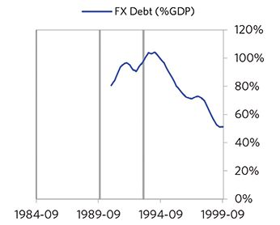

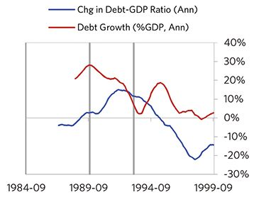

#### Monetary and Fiscal Policy

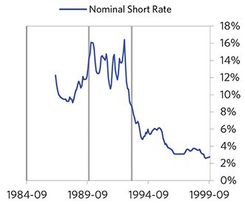

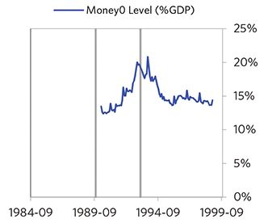

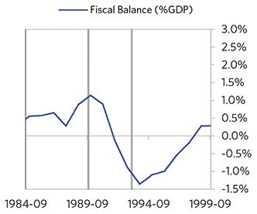

#### Economic Conditions

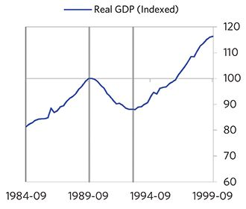

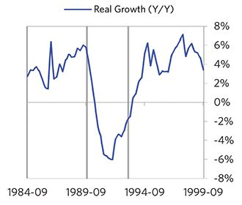

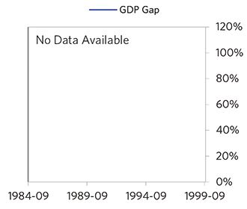

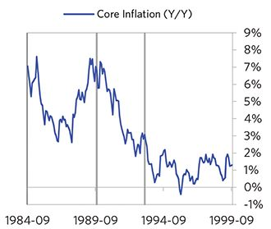

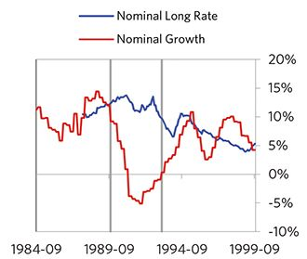

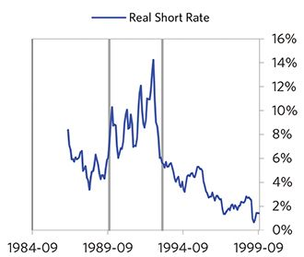

#### Markets

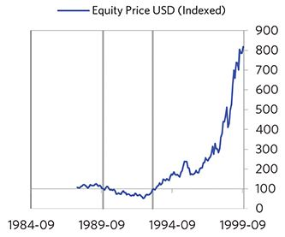

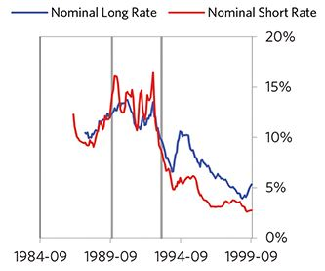

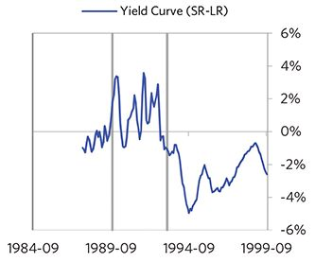

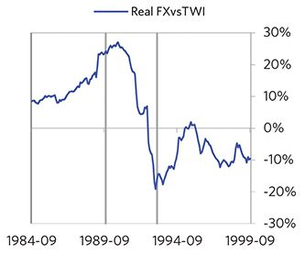

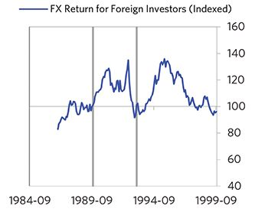

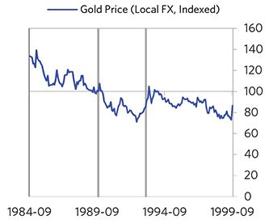

#### External Position

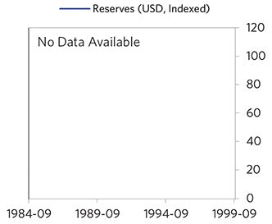

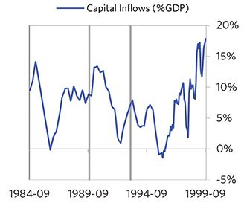

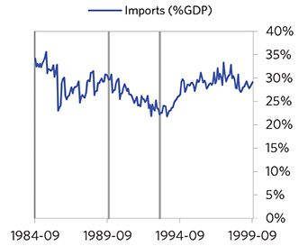

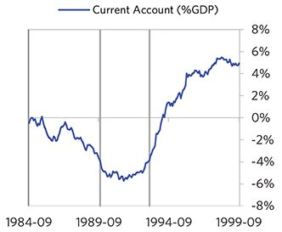

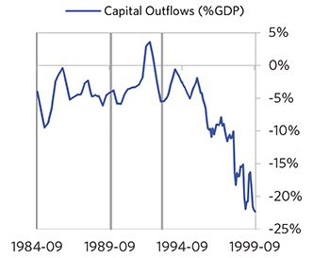

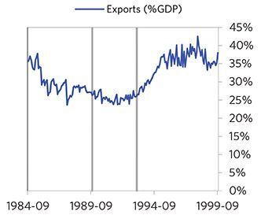

### Sweden 1987–2000 Case Auto-Summary

As show in the charts below, Sweden experienced a classic deflationary deleveraging cycle between 1987 and 2000.

#### The Bubble Phase

Between 1987 and 1990, Sweden experienced a bubble that was driven by a self-reinforcing cycle of rising debt, strong growth, and strong housing returns. Debts rose by 15% of GDP during the bubble to a pre-crisis peak of 239% of GDP. In this case, the debt was in Sweden’s domestic currency, and the majority was owned domestically, too. During the bubble phase, investment inflows were low but positive, averaging around 2% of GDP, while Sweden maintained a current account deficit of 3% of GDP. Aided by that rising debt and capital, growth was moderate (at 2%), while levels of economic activity were high (the GDP gap peaked at 4%). During this bubble period, policy makers initiated a large tightening (with short rates rising around 500 bps). Competitiveness became an issue, as Sweden’s real FX peaked at +15%. Taken together, these bubble pressures, combined with tightening money and credit, created an unsustainable situation.

#### The Depression Phase

Eventually the dynamic turned, producing a self-reinforcing bust and an “ugly deleveraging,” which ran from 1990 to 1993. At its pre-crisis peak, debt service reached 65% of GDP, making Sweden vulnerable to a shock—which came in the form of housing price declines hitting bank solvency. Sweden suffered from self-reinforcing declines in GDP (falling by 6%), in stock prices (falling by 34%) and in home prices (falling by 7%). Unemployment rates increased by 9%. Sweden’s financial institutions also came under consider- able pressure. As shown in the attribution chart to the right, even though Sweden needed a deleveraging, its debt as a % GDP went up by 40% (12% annualized) as incomes declined and as the government had to borrow more in response to the crisis (with a peak fiscal deficit of 10% of GDP during the ugly period).

The gauges below are composed from a compendium of stats shown in the chart deck that follows. Note these are meant to be rough measures.

*The first two charts show gauges which measure bubble/depression conditions and tightness/easiness of money and credit. For each gauge, the difference from zero conveys the extent of the bubble while the crossing above/below zero represents the shifting into or out of the bubble.

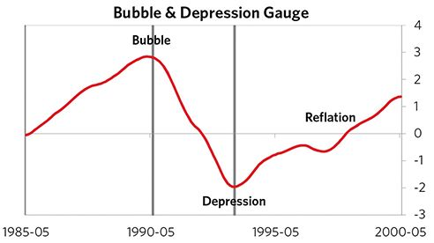

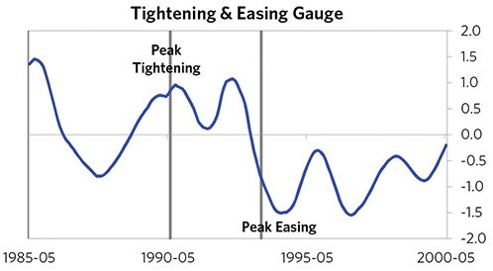

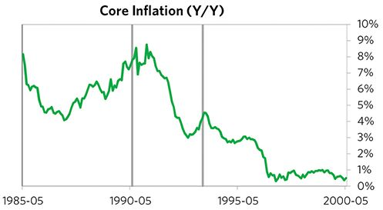

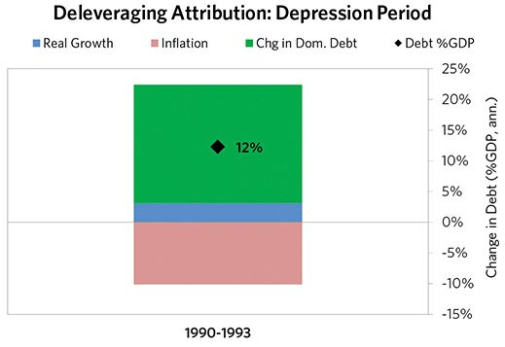

#### The Reflation Phase

After a relatively short bust phase, policy makers were able to provide enough stimulation to turn the deleveraging into a beautiful one and create a period of reflation, which began in 1993. In terms of monetary policy, M0 increased by 5% of GDP, interest rates were ultimately pushed down to 3%, and real FX averaged -5% during the stimulative phase. Over the cycle, Sweden was very aggressive in managing its financial institutions and bad debts, pulling 7 out of 9 classic policy levers. In particular, it nationalized banks, provided liquidity, and directly purchased troubled assets. It also enacted structural reforms designed to increase labor market flexibility. This stimulation helped bring nominal growth above nominal interest rates (with growth averaging 5% during this period and sovereign long rates falling to 4%). During this phase, unemployment rates declined by 1% and debt as a % of GDP fell by 28% (4% annualized), as shown in the attribution chart to the right. Throughout this “beautiful” period, the reduction in debt-to-income ratios came mostly from income rising, driven primarily by higher real growth. It took 3 years before real GDP reached its prior peak and equity prices in USD terms recovered within 4 years.

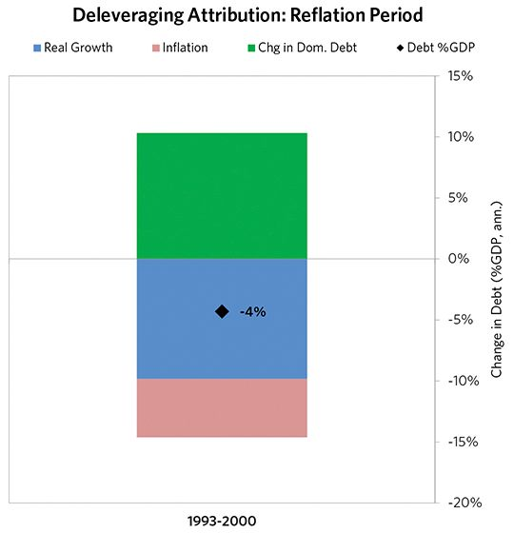

### Sweden 1987–2000 Chart Deck Appendix

#### Indebtedness

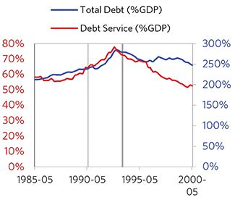

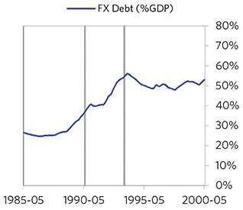

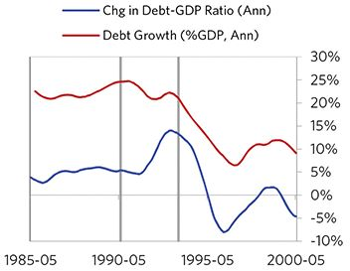

#### Monetary and Fiscal Policy

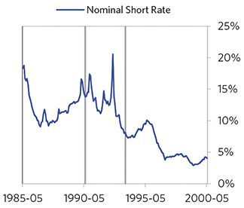

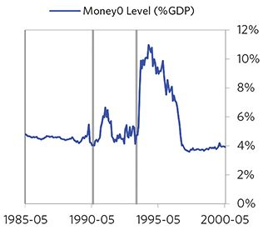

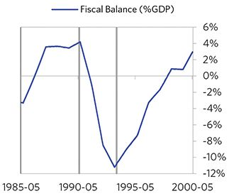

#### Economic Conditions

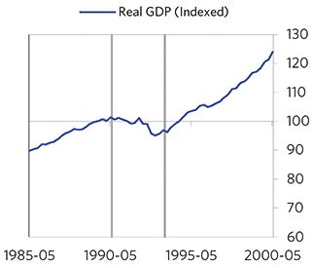

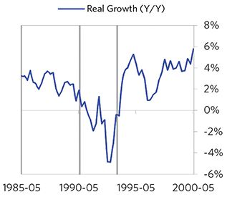

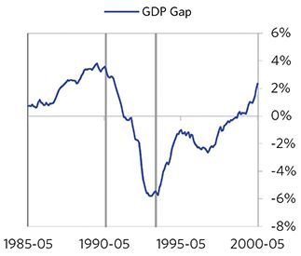

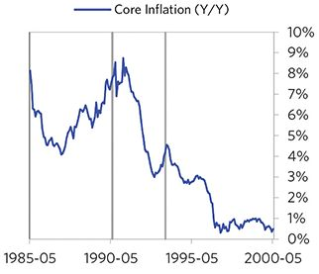

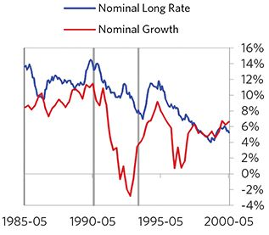

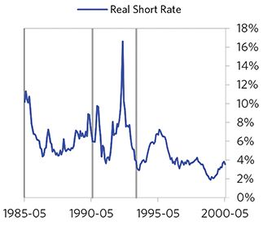

#### Markets

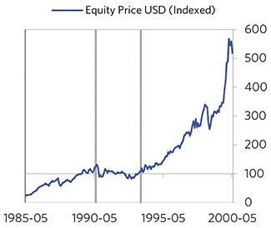

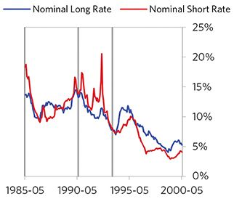

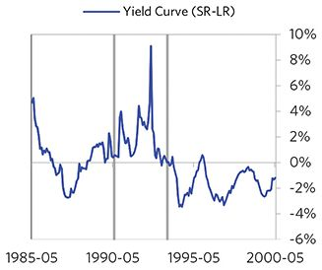

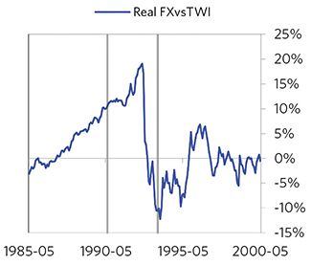

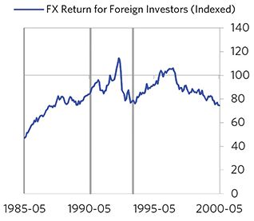

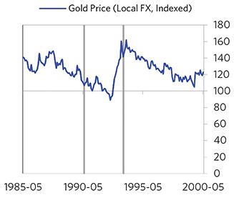

#### External Position

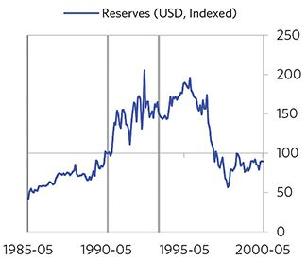

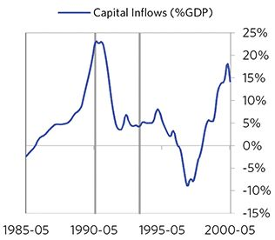

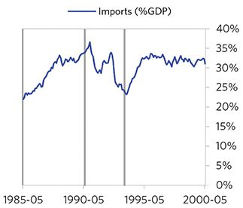

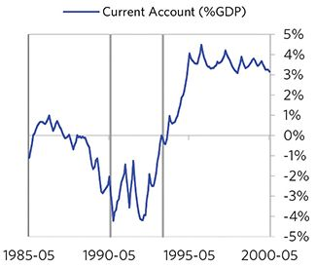

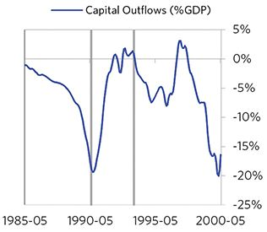

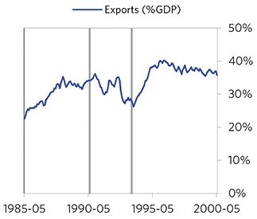

### Japan 1987–2017 Case Auto-Summary

As show in the charts below, Japan experienced a classic deflationary deleveraging cycle between 1987 and 2017.

#### The Bubble Phase

Between 1987 and 1989, Japan experienced a bubble that was driven by a self-reinforcing cycle of rising debt, strong growth and strong asset returns. Debts rose by 24% of GDP during the bubble to a pre-crisis peak of 307% of GDP. In this case, the debt was in Japan’s domestic currency, the majority was owned domestically, and Japan was a net creditor (which helped keep the exchange rate strong even through shocks, due to capital repatriations). During the bubble phase, investment inflows were low, averaging around 1% of GDP. Aided by that rising debt, growth was strong (at 5%), while levels of economic activity were high (the GDP gap peaked at 4%). Furthermore, strong asset returns (equities averaged 28% annualized returns over the bubble period) encouraged more borrowing and helped to stimulate growth. During this bubble period, policy makers initiated a large tightening (with short rates rising around 450 bps). Taken together, these bubble pressures, combined with tightening money and credit, created an unsustainable situation.

#### The Depression Phase

Eventually the dynamic turned, producing a self-reinforcing bust and an “ugly deleveraging,” which ran from 1989 to 2013. At its pre-crisis peak, debt service reached 78% of GDP, making Japan vulnerable to a shock—which came in the form of real estate and stock market busts. Japan suffered from self-reinforcing declines in stock prices (falling by 67%) and in home prices (falling by 43%). Unemployment rates increased by 3%. Japan’s financial institutions also came under considerable pressure. As shown in the attribution chart to the right, even though Japan needed a deleveraging, its debt as a % GDP went up by 59% (3% annualized), driven primarily by interest payments financed with new debt.

The gauges below are composed from a compendium of stats shown in the chart deck that follows. Note these are meant to be rough measures.

*The first two charts show gauges which measure bubble/depression conditions and tightness/easiness of money and credit. For each gauge, the difference from zero conveys the extent of the bubble while the crossing above/below zero represents the shifting into or out of the bubble.

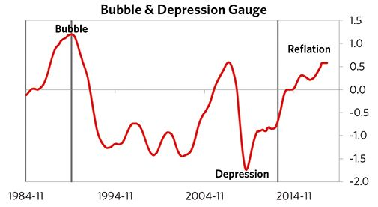

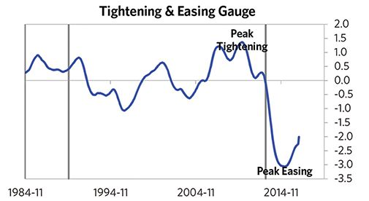

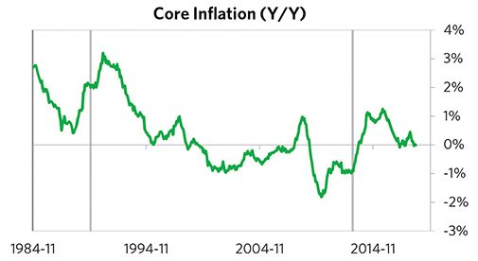

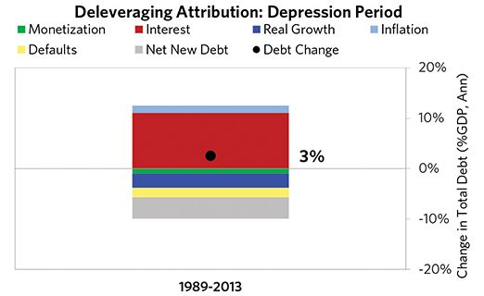

#### The Reflation Phase

In this case, the resolution of the debt problems was very slow, as monetary policy was not sufficiently easy to push nominal GDP growth above nominal interest rates for quite some time. Eventually, however, policy makers were able to provide enough stimulation to turn the deleveraging into a beautiful one and create a period of reflation, which began in 2013. In terms of monetary policy, M0 increased by 58% of GDP, interest rates were ultimately pushed down to 0%, and real FX averaged -10% during the stimulative phase. Over the cycle, Japan was very aggressive in managing its financial institutions and bad debts, pulling 7 out of 9 classic policy levers. In particular, it nationalized banks, provided liquidity, and directly purchased troubled assets. It also enacted structural reforms designed to increase labor market flexibility. This stimulation helped bring nominal growth well above nominal interest rates (with growth averaging 2% during this period and sovereign long rates falling to 0%). During this phase, unemployment rates were flat and debt as a % of GDP fell by 43% (9% annualized), as shown in the attribution chart to the right. Throughout this “beautiful” period, the reduction in debt-to-income ratios was driven primarily by monetization and to a lesser extent by rising real incomes.

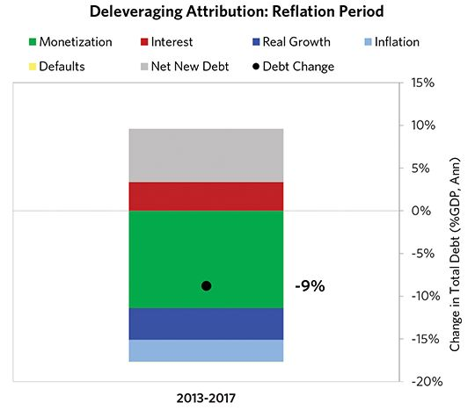

### Japan 1987–2017 Chart Deck Appendix

#### Indebtedness

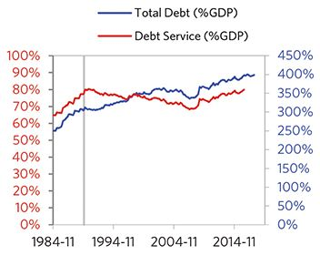

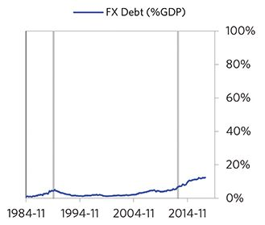

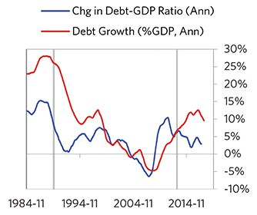

#### Monetary and Fiscal Policy

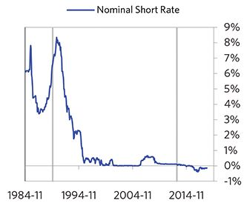

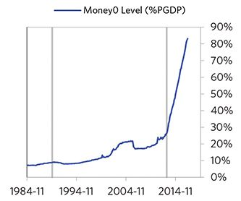

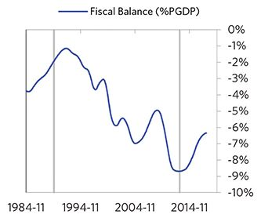

#### Economic Conditions

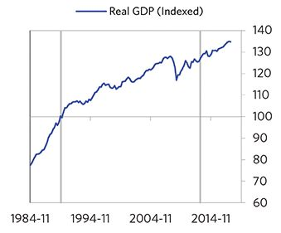

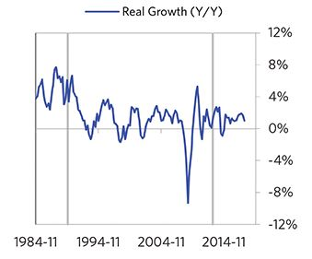

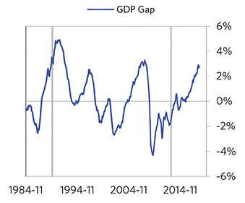

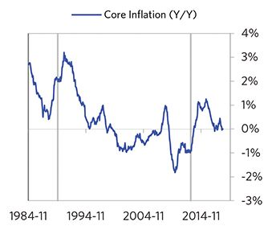

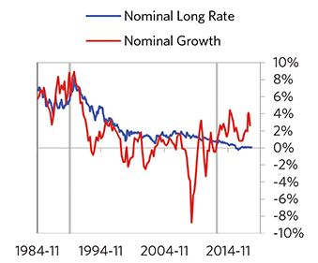

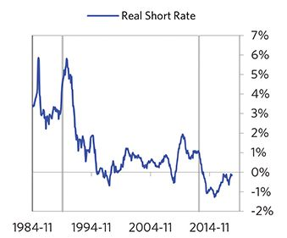

#### Markets

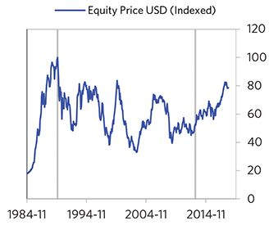

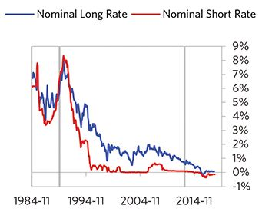

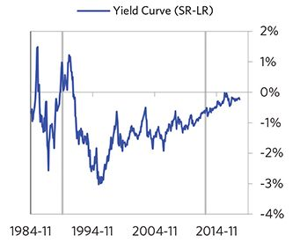

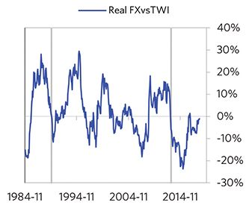

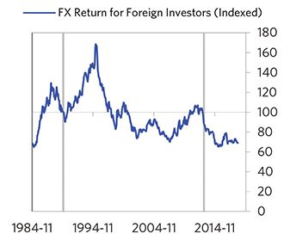

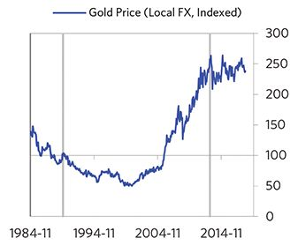

#### External Position

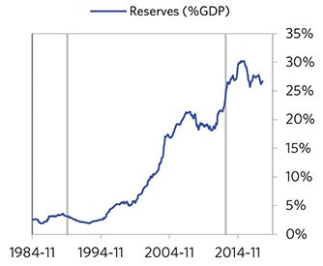

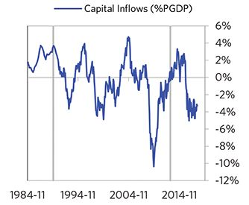

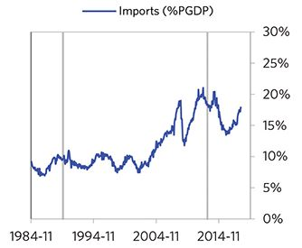

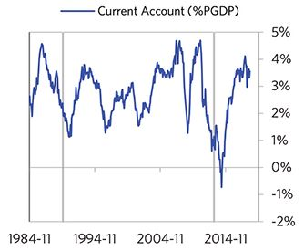

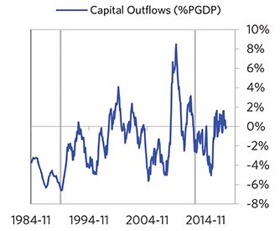

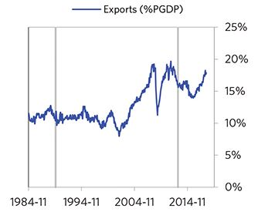

### United States 2004–2014 Case Auto-Summary

As show in the charts below, the United States experienced a classic deflationary deleveraging cycle between 2004 and 2014.

#### The Bubble Phase

Between 2004 and 2007, the United States experienced a bubble that was driven by a self-reinforcing cycle of rising debt, strong growth and strong asset returns. Debts rose by 38% of GDP during the bubble to a pre-crisis peak of 349% of GDP. In this case, the debt was in the United States’s domestic currency, and the majority was owned domestically, too. During the bubble phase, investment inflows were moderately strong, averaging around 8% of GDP, which helped to finance a current account deficit of 6% of GDP. Aided by that rising debt and capital, growth was strong (at 3%), while levels of economic activity were high (the GDP gap peaked at 3%). Furthermore, strong asset returns (equities averaged 14% annualized returns over the bubble period) encouraged more borrowing and helped to stimulate growth. During this bubble period, policy makers initiated a large tightening (with short rates rising around 400 bps). Taken together, these bubble pressures, combined with tightening money and credit, created an unsustainable situation.

#### The Depression Phase

Eventually the dynamic turned, producing a self-reinforcing bust and an “ugly deleveraging,” which ran from 2007 to 2009. At its pre-crisis peak, debt service reached 68% of GDP, making the United States vulnerable to a shock—which came in the form of a housing bust. The United States suffered from self-reinforcing declines in GDP (falling by 4%), in stock prices (falling by 50%) and in home prices (falling by 28%). Unemployment rates increased by 5%. The United States’s financial institutions also came under considerable pressure. As shown in the attribution chart to the right, even though the United States needed a deleverag- ing, its debt as a % GDP went up by 23% (15% annualized), driven primarily by interest payments financed with new debt and to a lesser extent by falling real incomes.

The gauges below are composed from a compendium of stats shown in the chart deck that follows. Note these are meant to be rough measures.

*The first two charts show gauges which measure bubble/depression conditions and tightness/easiness of money and credit. For each gauge, the difference from zero conveys the extent of the bubble while the crossing above/below zero represents the shifting into or out of the bubble.

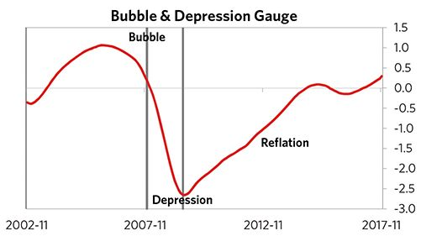

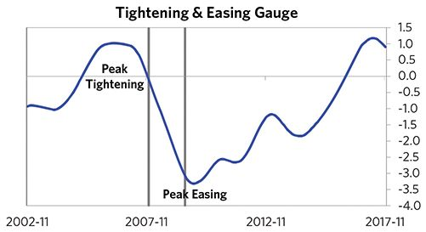

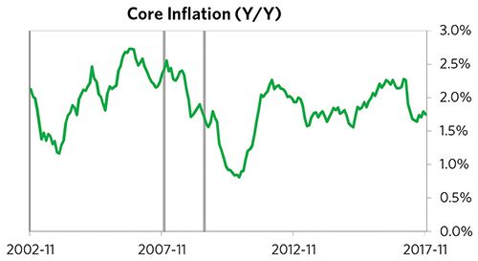

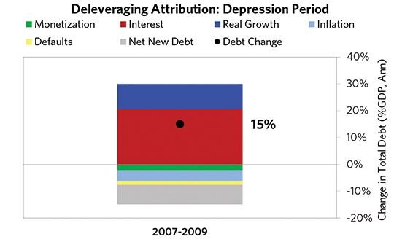

#### The Reflation Phase

After a slightly shorter than average bust phase, policy makers were able to provide enough stimulation to turn the deleveraging into a beautiful one and create a period of reflation, which began in 2009. In terms of monetary policy, M0 increased by 16% of GDP, interest rates were ultimately pushed down to 0%, and real FX averaged -10% during the stimulative phase. Over the cycle, the United States was very aggressive in managing its financial institutions and bad debts, pulling 6 out of 9 classic policy levers. In particular, it recapitalized banks, provided liquidity, and directly purchased troubled assets. This stimulation helped bring nominal growth well above nominal interest rates (with growth averaging 3% during this period and sovereign long rates falling to 2%). During this phase, unemployment rates declined by 3% and debt as a % of GDP fell by 59% (11% annualized), as shown in the attribution chart to the right. Throughout this “beautiful” period, the reduction in debt-to-income ratios was driven by a mix of rising real incomes, inflation, and paying down existing debt. This was partially offset by interest payments financed with new debt. It took 4 years before real GDP reached its prior peak and equity prices in USD terms recovered within 5 years.

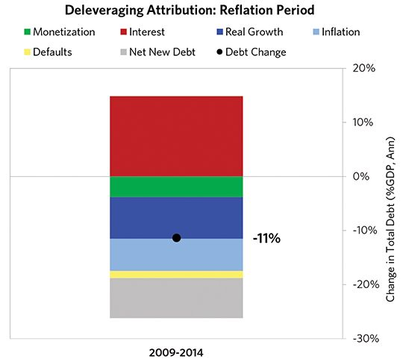

### United States 2004–2014 Chart Deck Appendix

#### Indebtedness

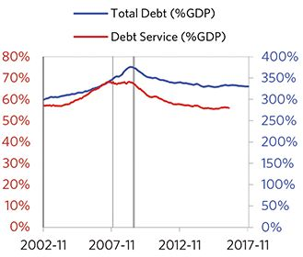

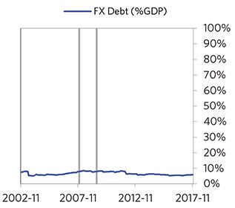

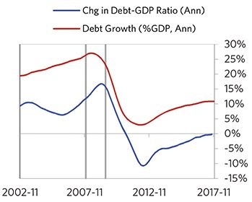

#### Monetary and Fiscal Policy

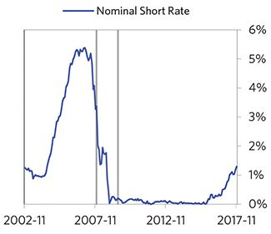

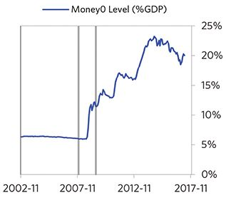

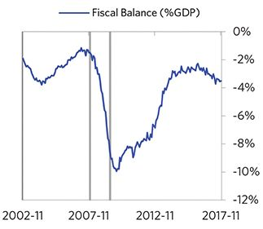

#### Economic Conditions

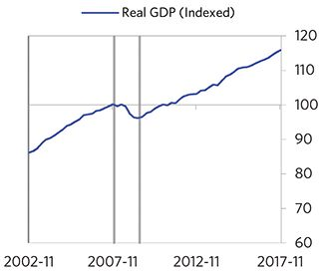

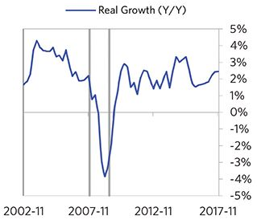

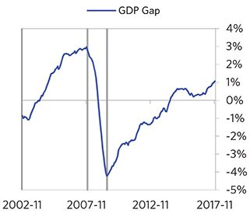

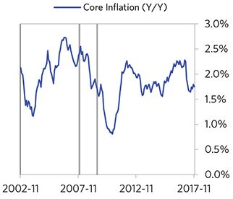

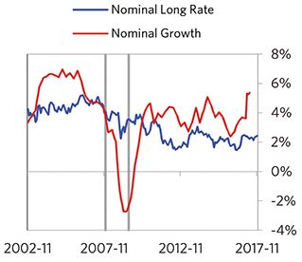

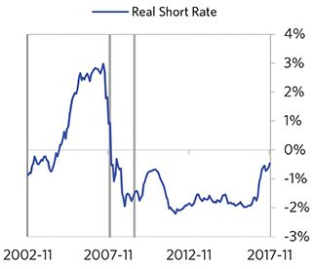

#### Markets

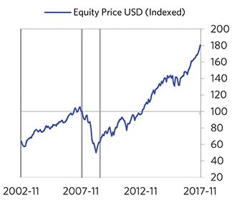

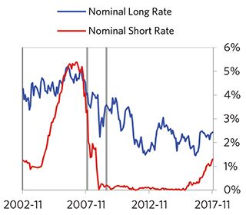

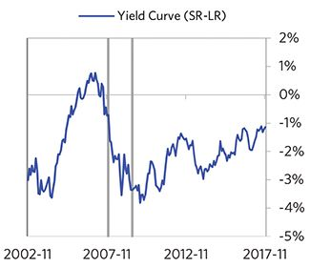

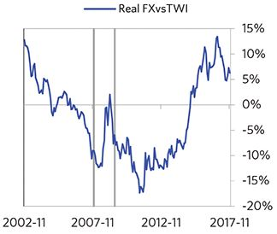

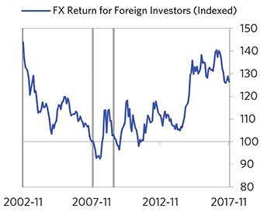

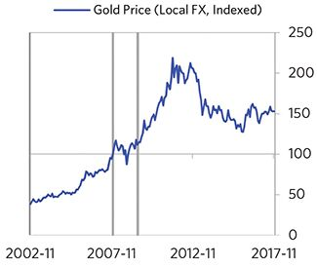

#### External Position

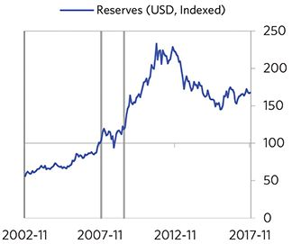

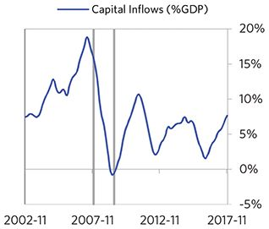

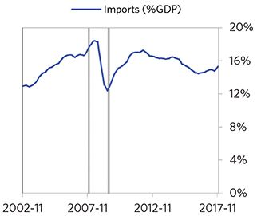

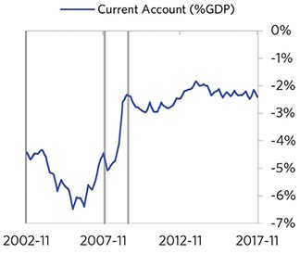

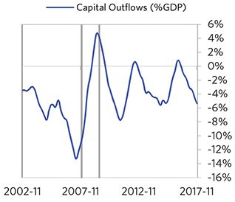

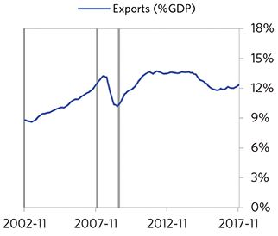

### Austria 2005–2017 Case Auto-Summary

As show in the charts below, Austria experienced a classic deflationary deleveraging cycle between 2005 and 2017.

#### The Bubble Phase

Between 2005 and 2008, Austria experienced a bubble that was most characterized by strong equity returns. Debts rose by 19% of GDP during the bubble to a pre-crisis peak of 279% of GDP. In this case, the debt was in Euros, which, while technically Austria’s domestic currency, is not a currency that Austria had control over. In addition, a high share of debt was owned by foreigners, which left Austria with some exposure to a pullback in foreign capital. Aided by that capital, growth was strong (at 3%). Furthermore, strong asset returns (equities averaged 20% annualized returns over the bubble period) encouraged more borrowing and helped to stimulate growth. During this bubble period, policy makers initiated a moderate tightening (with short rates rising around 200 bps). Taken together, these bubble pressures and Austria’s dependence on foreign financing, combined with tightening money and credit and the weakened conditions of related countries, created an unsustainable situation.

#### The Depression Phase

Eventually the dynamic turned, producing a self-reinforcing bust and an “ugly deleveraging,” which ran from 2008 to 2009. At its pre-crisis peak, debt service reached 69% of GDP, making Austria vulnerable to a shock—which came in the form of the 2008 global financial crisis. Austria suffered from self-reinforcing declines in GDP (falling by 4%), and in stock prices (falling by 66%). Austria’s financial institutions also came under considerable pressure. As shown in the attribution chart to the right, even though Austria needed a deleveraging, its debt as a % GDP went up by 39% (32% annualized) as incomes declined.

The gauges below are composed from a compendium of stats shown in the chart deck that follows. Note these are meant to be rough measures.

*The first two charts show gauges which measure bubble/depression conditions and tightness/easiness of money and credit. For each gauge, the difference from zero conveys the extent of the bubble while the crossing above/below zero represents the shifting into or out of the bubble.

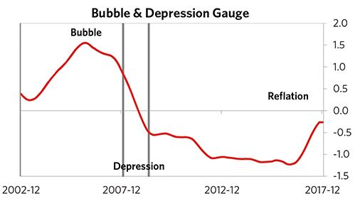

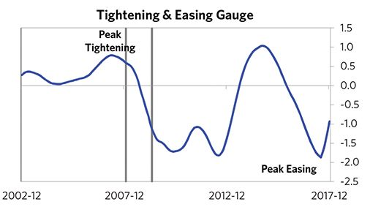

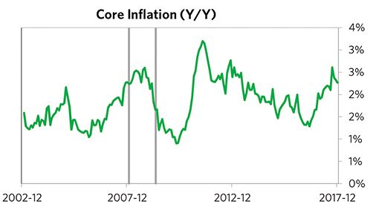

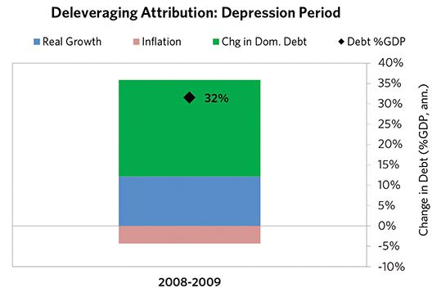

#### The Reflation Phase

After a relatively short bust phase, ECB policy makers were able to provide enough stimulation to turn the deleveraging into a beautiful one and create a period of reflation, which began in 2009. In terms of monetary policy, M0 increased by 19% of GDP, interest rates were ultimately pushed down to 0%, and real FX averaged -2% during the stimulative phase. Over the cycle, Austria was aggressive in managing its financial institutions and bad debts, pulling 5 out of 9 classic policy levers. In particular, it recapitalized banks and provided liquidity. This stimulation helped bring nominal growth well above nominal interest rates (with growth averaging 3% during this period and sovereign long rates falling to 0%). During this phase, unemployment rates were flat and debt as a % of GDP fell by 74% (9% annual- ized), as shown in the attribution chart to the right. Throughout this “beautiful” period, the reduction in debt-to-income ratios came mostly from income rising, driven primarily by higher inflation. It took 3 years before real GDP reached its prior peak, but equity prices in USD terms haven’t yet fully recovered.

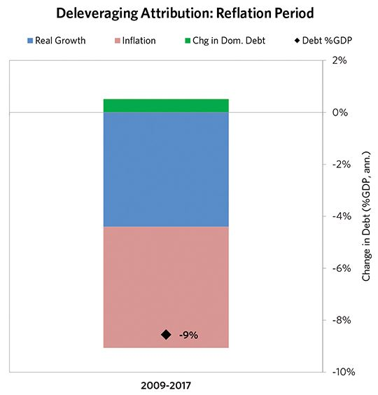

### Austria 2005–2017 Chart Deck Appendix

#### Indebtedness

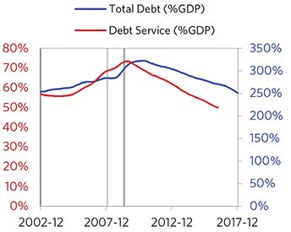

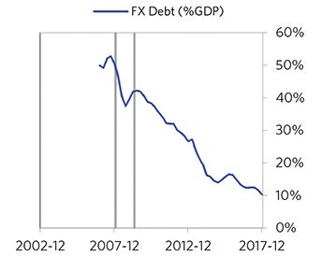

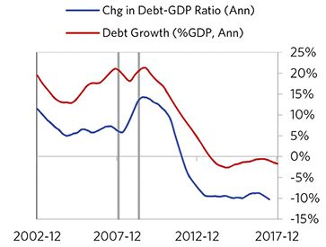

#### Monetary and Fiscal Policy

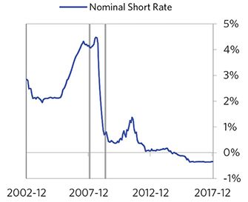

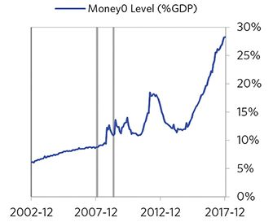

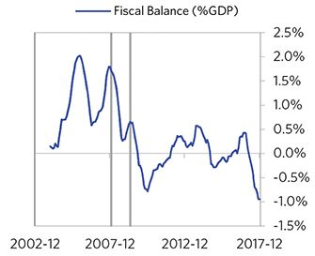

#### Economic Conditions

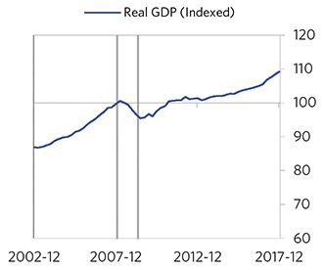

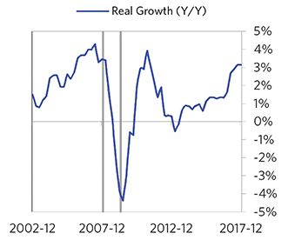

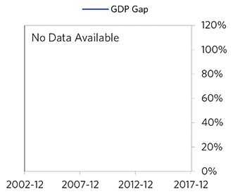

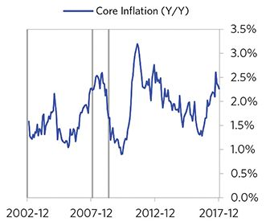

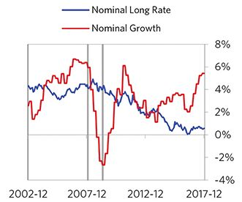

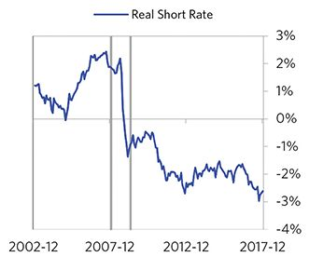

#### Markets

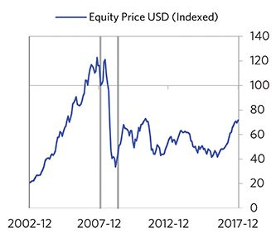

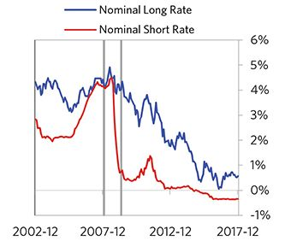

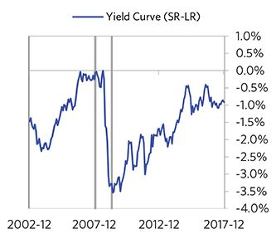

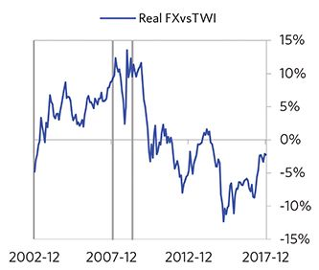

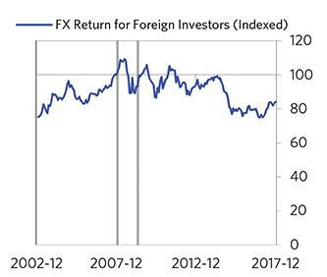

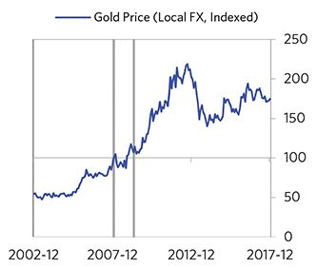

#### External Position

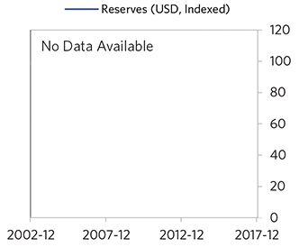

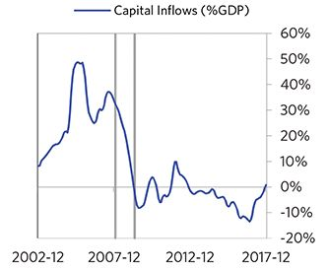

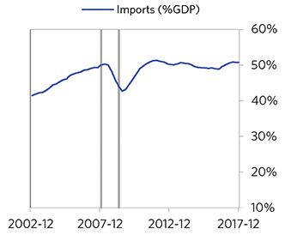

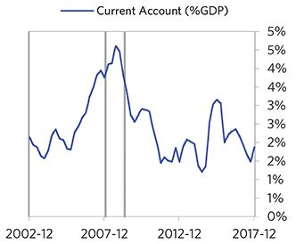

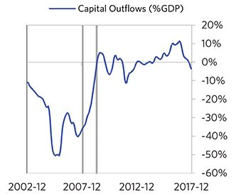

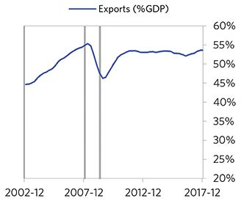

### Germany 2006–2017 Case Auto-Summary

As show in the charts below, Germany experienced a classic deflationary deleveraging cycle between 2006 and 2017.

#### The Bubble Phase

Unlike many other cases, Germany didn’t experience a broad-based bubble in the years before the crisis, but it was tied to other countries, economies, and financial markets that were experiencing bubble-like conditions. And it did build up a substantial debt stock, with debts reaching 261% of GDP prior to the crisis. In this case, the debt was in Euros, which, while technically Germany’s domestic currency, is not a currency that Germany had control over. Most of the debt was owned domestically.

#### The Depression Phase

Eventually the cycle turned, producing a self-reinforcing bust and an “ugly deleveraging,” which ran from 2008 to 2009. At its pre-crisis peak, debt service reached 51% of GDP, making Germany vulnerable to a shock—which came in the form of the 2008 global financial crisis. Germany suffered from self-reinforcing declines in GDP (falling by 7%), and in stock prices (falling by 53%). Germany’s financial institutions also came under considerable pressure. As shown in the attribution chart to the right, even though Germany needed a deleveraging, its debt as a % GDP went up by 26% (18% annualized) as incomes declined.

The gauges below are composed from a compendium of stats shown in the chart deck that follows. Note these are meant to be rough measures.

*The first two charts show gauges which measure bubble/depression conditions and tightness/easiness of money and credit. For each gauge, the difference from zero conveys the extent of the bubble while the crossing above/below zero represents the shifting into or out of the bubble.

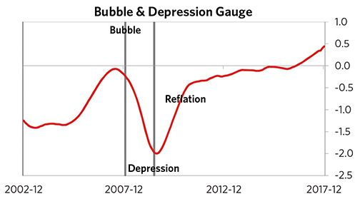

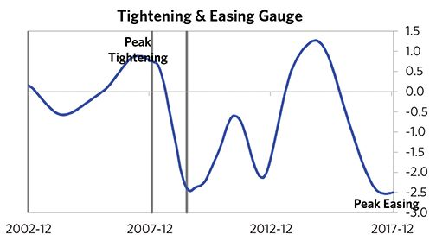

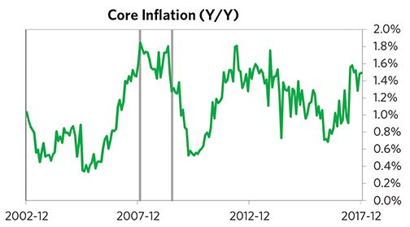

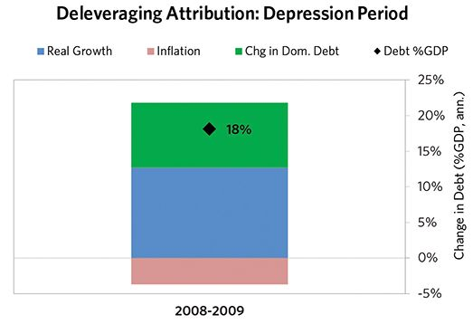

#### The Reflation Phase

After a slightly shorter than average bust phase, ECB policy makers were able to provide enough stimulation to turn the deleveraging into a beautiful one and create a period of reflation, which began in 2009. In terms of monetary policy, M0 increased by 14% of GDP, interest rates were ultimately pushed down to -1%, and real FX averaged -4% during the stimulative phase. Over the cycle, Germany was very aggressive in managing its financial institutions and bad debts, pulling 6 out of 9 classic policy levers. In particular, it nationalized banks, provided liquidity, and directly purchased troubled assets. This stimulation helped bring nominal growth well above nominal interest rates (with growth averaging 3% during this period and sovereign long rates falling to 0%). During this phase, unemployment rates declined by 4% and debt as a % of GDP fell by 56% (7% annualized), as shown in the attribution chart to the right. Throughout this “beautiful” period, the reduction in debt-to-income ratios came mostly from income rising, driven primarily by higher real growth. It took 3 years before real GDP reached its prior peak, but equity prices in USD terms haven’t yet fully recovered.

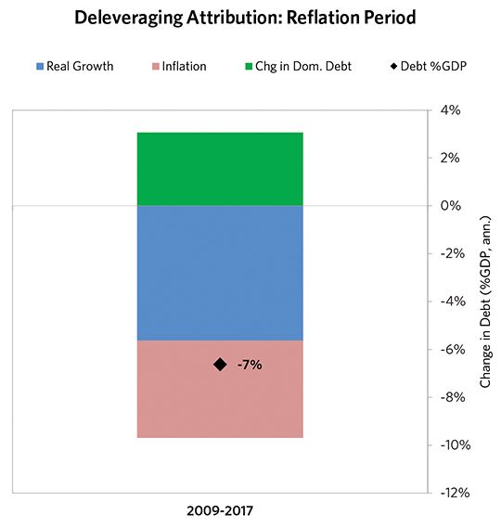

### Germany 2006–2017 Chart Deck Appendix

#### Indebtedness

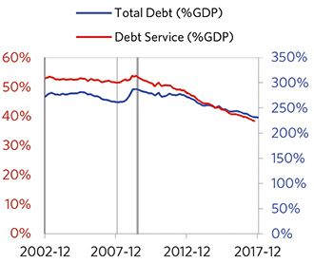

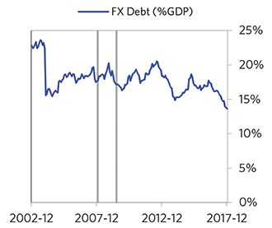

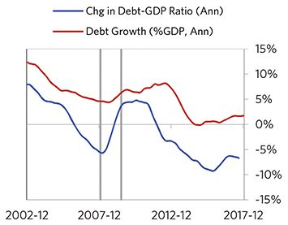

#### Monetary and Fiscal Policy

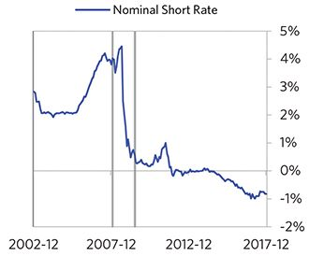

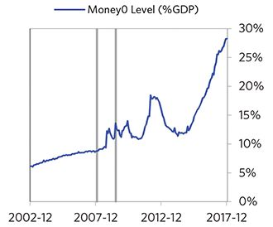

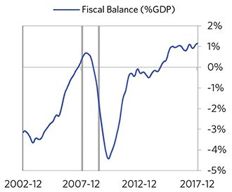

#### Economic Conditions

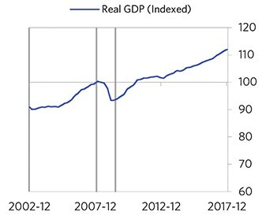

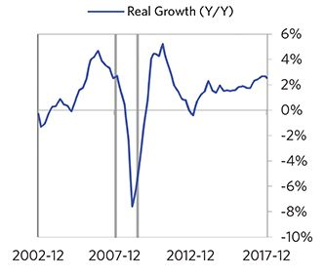

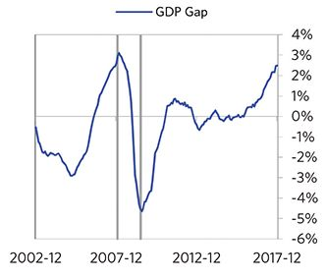

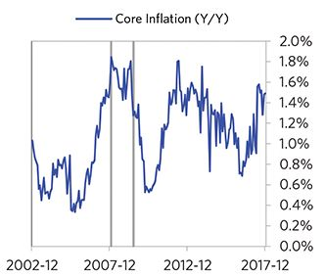

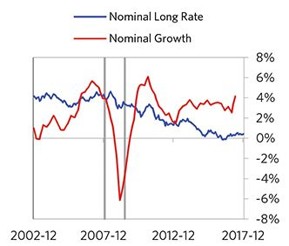

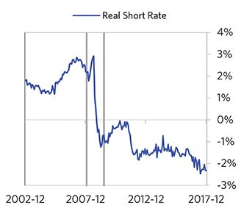

#### Markets

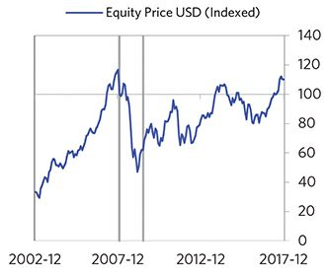

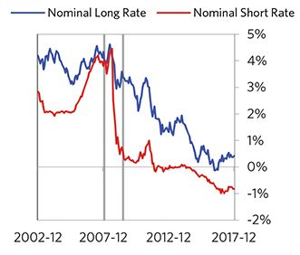

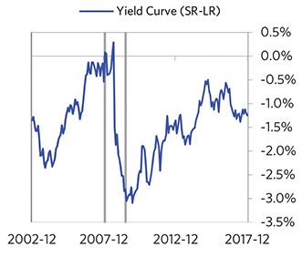

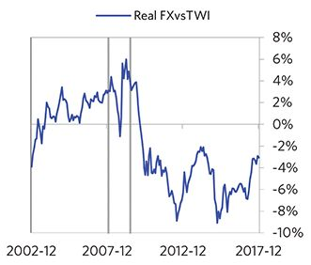

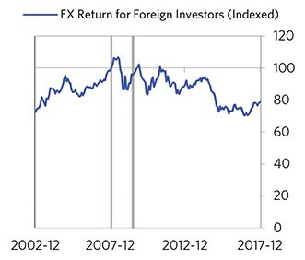

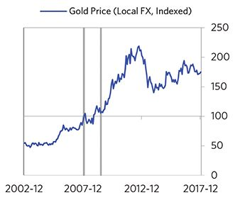

#### External Position

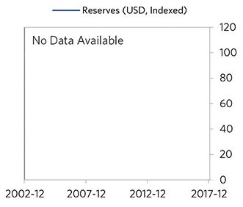

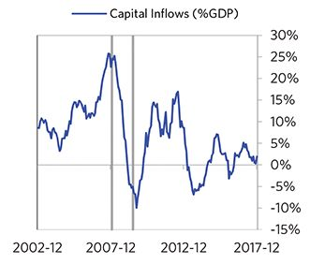

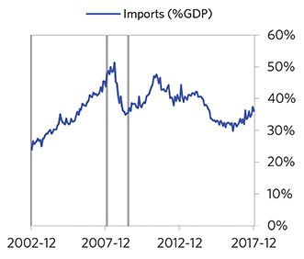

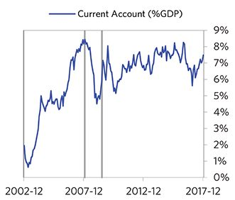

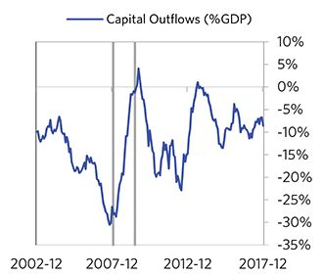

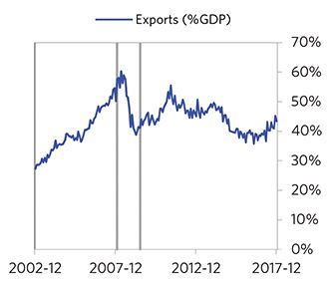

### Greece 2005–2018 Case Auto-Summary

As show in the charts below, Greece experienced a classic deflationary deleveraging cycle starting in 2005.

#### The Bubble Phase

Between 2005 and 2008, Greece experienced a bubble that was driven by a self-reinforcing cycle of rising debt, strong growth and strong asset returns. Debts rose by 40% of GDP during the bubble to a pre-crisis peak of 206% of GDP. In this case, the debt was in Euros, which, while technically Greece’s domestic currency, is not a currency that Greece had control over. In addition, a high share of debt was owned by foreigners, which left Greece with some exposure to a pullback in foreign capital. During the bubble phase, investment inflows were strong, averaging around 22% of GDP, which helped to finance a current account deficit of 13% of GDP. Aided by that rising debt and capital, growth was strong (at 3%), while levels of economic activity were high (the GDP gap peaked at 10%). Furthermore, strong asset returns (equities averaged 19% annualized returns over the bubble period) encouraged more borrowing and helped to stimulate growth. During this bubble period, policy makers initiated a moderate tightening (with short rates rising around 200 bps). Taken together, these bubble pressures and Greece’s dependence on foreign financing, combined with tightening money and credit and the weakened conditions of related countries, created an unsustainable situation.

#### The Depression Phase

Eventually the dynamic turned, producing a self-reinforcing bust and an “ugly deleveraging,” which ran from 2008 to 2017. At its pre-crisis peak, debt service reached 42% of GDP, making Greece vulnerable to a shock—which came in the form of the 2008 global financial crisis. Greece suffered a fall in foreign funding (with capital inflows falling by 34% of GDP), leading to a tightening (short rates increased by 86%) - which in turn led to self-reinforcing declines in GDP (falling by 27%), in stock prices (falling by 91%) and in home prices (falling by 42%). Unemployment rates increased by 15%. Greece’s financial institutions also came under considerable pressure. As shown in the attribution chart to the right, even though Greece needed a deleveraging, its debt as a % GDP went up by 101% (11% annualized), driven primarily by falling real incomes and to a lesser extent by interest payments financed with new debt.

The gauges below are composed from a compendium of stats shown in the chart deck that follows. Note these are meant to be rough measures.

*The first two charts show gauges which measure bubble/depression conditions and tightness/easiness of money and credit. For each gauge, the difference from zero conveys the extent of the bubble while the crossing above/below zero represents the shifting into or out of the bubble.

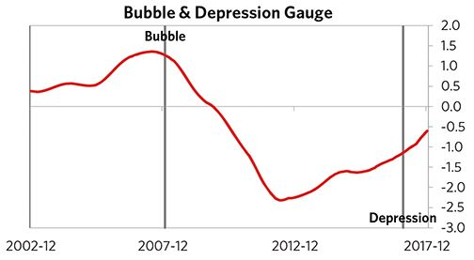

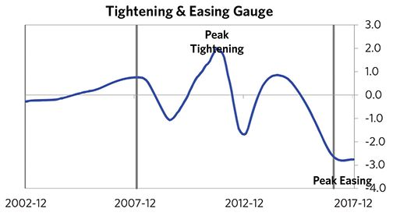

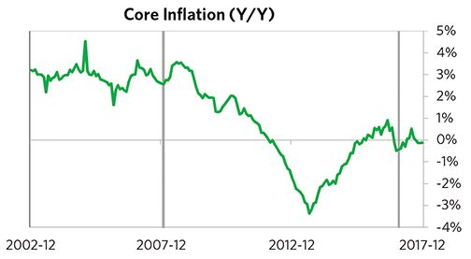

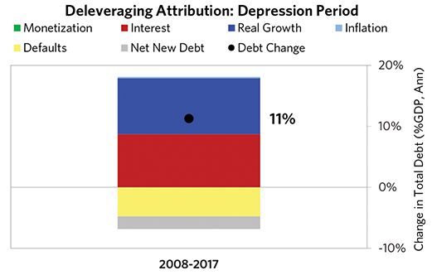

#### The Reflation Phase

So far, Greece hasn’t transitioned into much of a “beautiful” phase, as the nominal growth rate was never pushed above nominal interest rates by adequate monetary easing.

The crisis had a notable impact on the politics of Greece, as it helped set the stage for Alexis Tsipras, whom many people consider a populist leader, to take power.

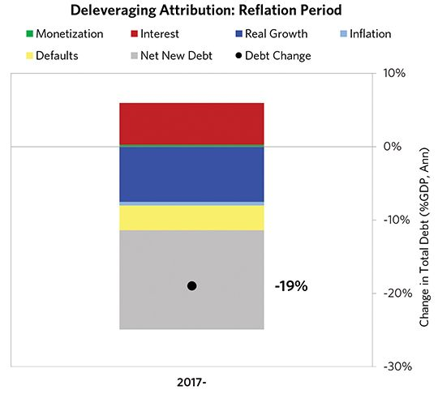

### Greece 2005–2018 Chart Deck Appendix

#### Indebtedness

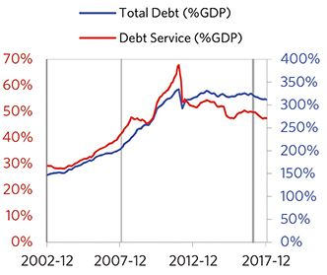

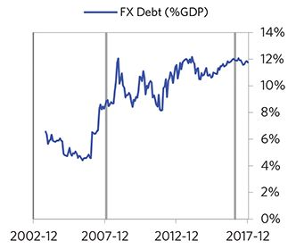

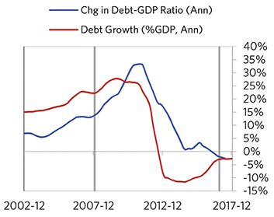

#### Monetary and Fiscal Policy

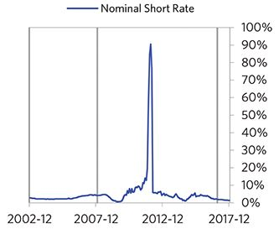

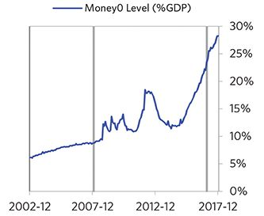

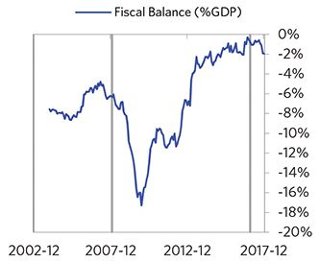

#### Economic Conditions

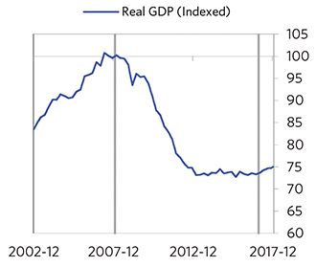

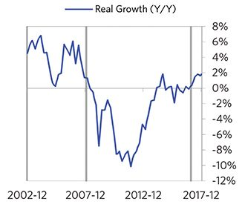

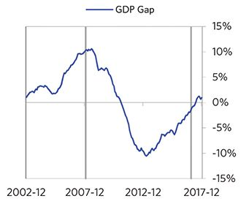

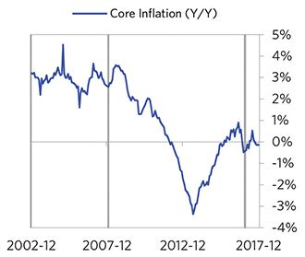

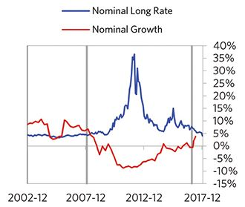

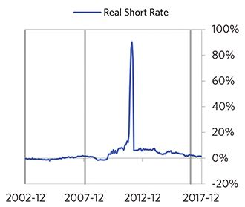

#### Markets

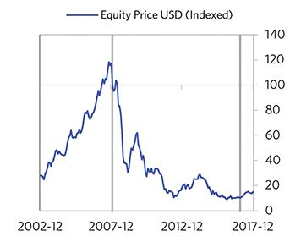

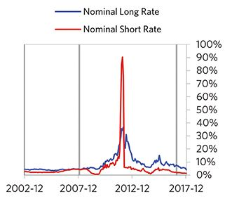

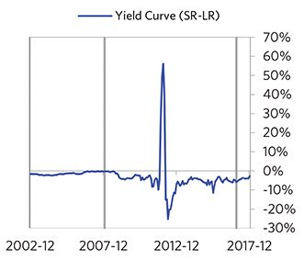

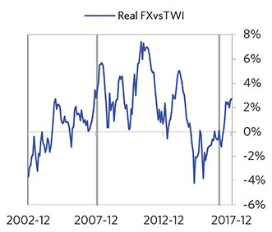

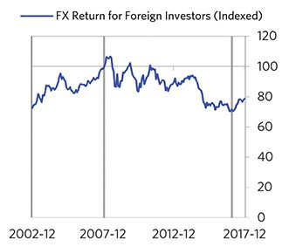

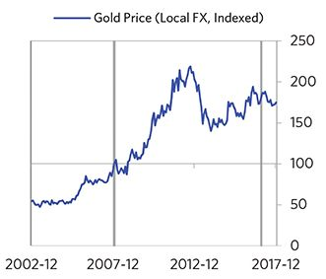

#### External Position

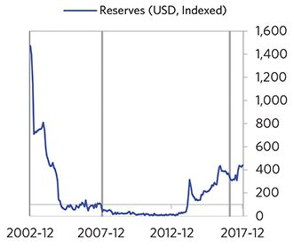

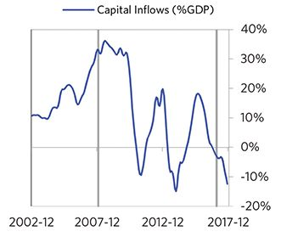

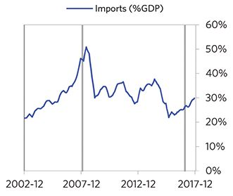

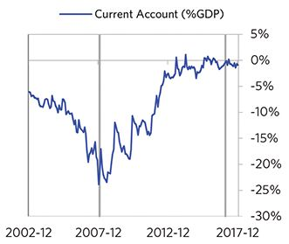

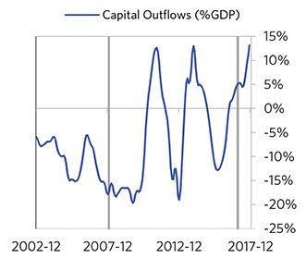

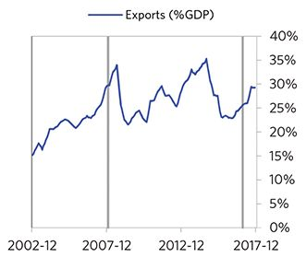

### Hungary 2005–2017 Case Auto-Summary

As show in the charts below, Hungary experienced a classic deflationary deleveraging cycle between 2005 and 2017.

#### The Bubble Phase

Between 2005 and 2008, Hungary experienced a bubble that was driven by a self-reinforcing cycle of rising debt, strong equity returns, and strong growth. Debts rose by 45% of GDP during the bubble to a pre-crisis peak of 214% of GDP. In this case, the debt was in Hungary’s domestic currency, though a high share was owned by foreigners, which left Hungary with some exposure to a pullback in foreign capital. During the bubble phase, investment inflows were moderately strong, averaging around 6% of GDP, which helped to finance a current account deficit of 8% of GDP. Aided by that rising debt and capital, growth was strong (at 3%), while levels of economic activity were high (the GDP gap peaked at 5%). Furthermore, strong asset returns (equities averaged 14% annualized returns over the bubble period) encouraged more borrowing and helped to stimulate growth. Taken together, these bubble pressures and Hungary’s dependence on foreign financing, combined with the weakened conditions of related countries, created an unsustainable situation.

#### The Depression Phase

Eventually the dynamic turned, producing a self-reinforcing bust and an “ugly deleveraging,” which ran from 2008 to 2013. At its pre-crisis peak, debt service reached 31% of GDP, making Hungary vulnerable to a shock—which came in the form of the 2008 global financial crisis. Hungary suffered a fall in foreign funding (with portfolio inflows falling by 12% of GDP), leading to a tightening (policy makers hiked short rates by 5%)—which in turn led to self-reinforcing declines in GDP (falling by 7%), in stock prices (falling by 73%) and in home prices (falling by 16%). Unemployment rates increased by 3%. Hungary’s financial institutions also came under considerable pressure. As shown in the attribution chart to the right, even though Hungary needed a deleveraging, its debt as a % GDP went up by 37% (7% annualized) as incomes declined and as the government had to borrow more in response to the crisis (with a peak fiscal deficit of 5% of GDP during the ugly period).

The gauges below are composed from a compendium of stats shown in the chart deck that follows. Note these are meant to be rough measures.

*The first two charts show gauges which measure bubble/depression conditions and tightness/easiness of money and credit. For each gauge, the difference from zero conveys the extent of the bubble while the crossing above/below zero represents the shifting into or out of the bubble.

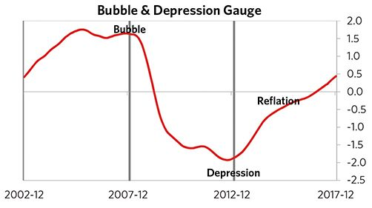

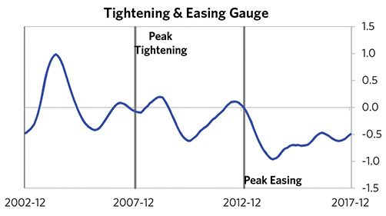

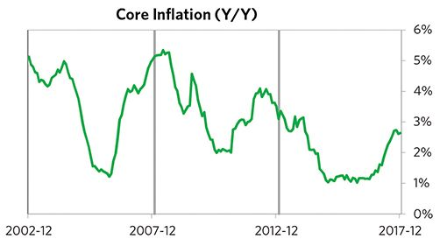

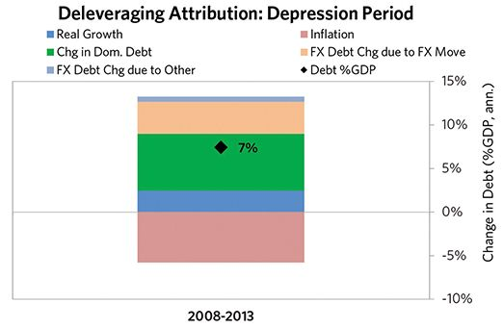

#### The Reflation Phase

After a relatively long bust phase, policy makers were able to provide enough stimulation to turn the deleveraging into a beautiful one and create a period of reflation, which began in 2013. In terms of monetary policy, M0 increased by 4% of GDP, interest rates were ultimately pushed down to 0%, and real FX averaged -6% during the stimulative phase. Over the cycle, Hungary was aggressive in managing its financial institutions and bad debts, pulling 4 out of 9 classic policy levers. It also benefited from an IMF assistance program. This stimulation helped bring nominal growth well above nominal interest rates (with growth averaging 5% during this period and sovereign long rates falling to 2%). During this phase, unemployment rates declined by 7% and debt as a % of GDP fell by 51% (12% annualized), as shown in the attribution chart to the right. Throughout this “beautiful” period, the reduction in debt-to-income ratios came mostly from income rising, driven primarily by higher real growth. It took 6 years before real GDP reached its prior peak, but equity prices in USD terms haven’t yet fully recovered.

The crisis had a notable impact on the politics of Hungary, as it helped set the stage for Viktor Orban, whom many people consider a populist leader, to take power.

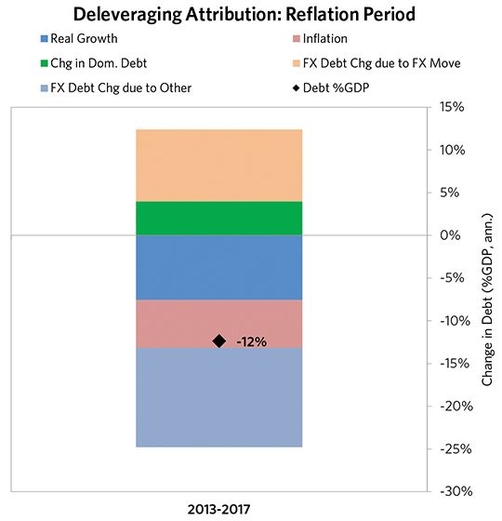

### Hungary 2005–2017 Chart Deck Appendix

#### Indebtedness

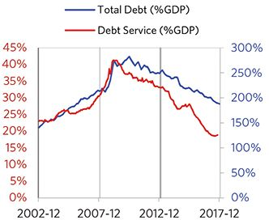

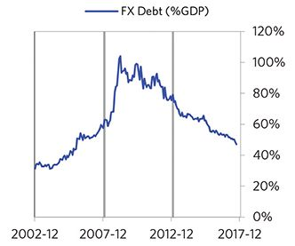

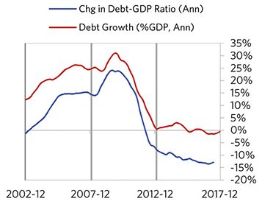

#### Monetary and Fiscal Policy

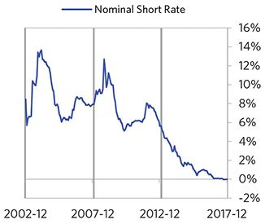

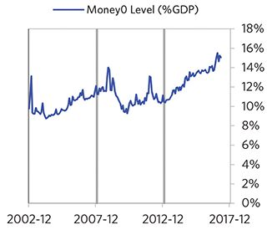

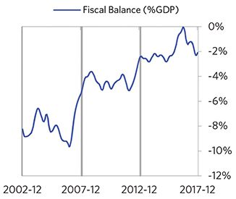

#### Economic Conditions

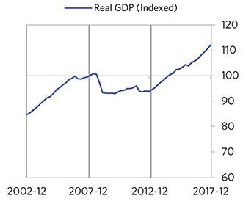

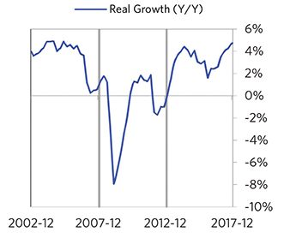

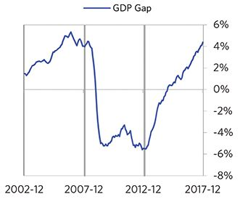

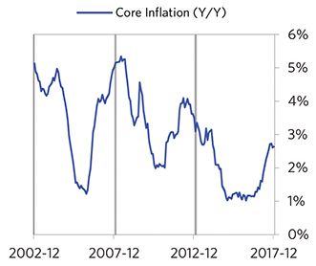

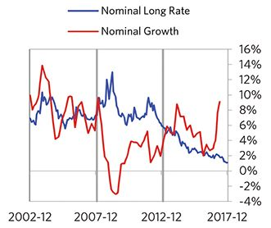

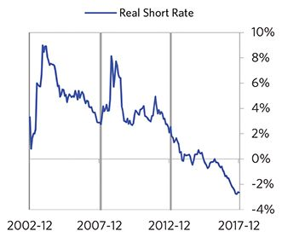

#### Markets

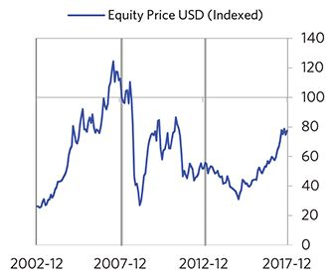

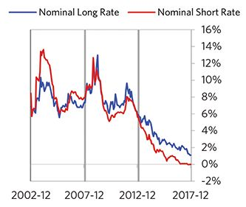

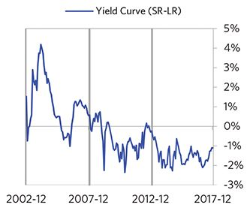

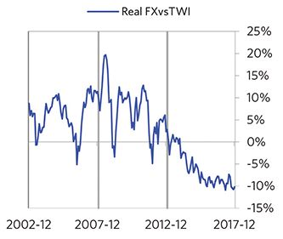

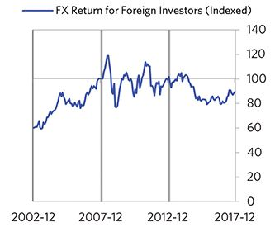

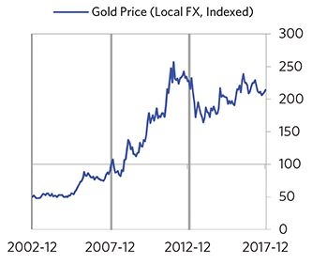

#### External Position

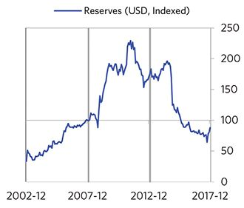

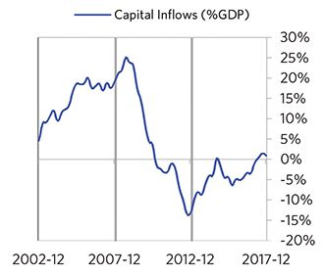

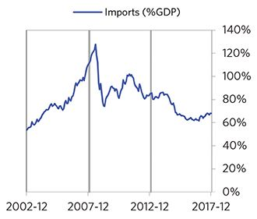

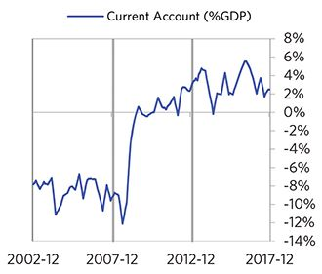

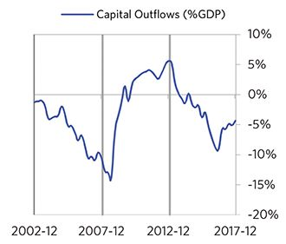

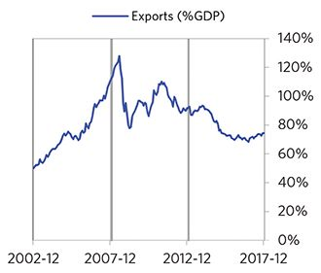

### Ireland 2005–2017 Case Auto-Summary

As show in the charts below, Ireland experienced a classic deflationary deleveraging cycle between 2005 and 2017.

#### The Bubble Phase

Between 2005 and 2008, Ireland experienced a bubble that was driven by a self-reinforcing cycle of rising debt, strong growth, and strong housing returns. Debts rose by 94% of GDP during the bubble to a pre-crisis peak of 271% of GDP. In this case, the debt was in Euros, which, while technically Ireland’s domestic currency, is not a currency that Ireland had control over. In addition, a high share of debt was owned by foreigners, which left Ireland with some exposure to a pullback in foreign capital. During the bubble phase, investment inflows were strong, averaging around 95% of GDP, which helped to finance a current account deficit of 5% of GDP. Aided by that rising debt and capital, growth was strong (at 5%), while levels of economic activity were high (the GDP gap peaked at 8%). Furthermore, moderate asset returns (equities averaged 5% annualized returns over the bubble period) encouraged more borrowing and helped to stimulate growth. During this bubble period, policy makers initiated a moderate tightening (with short rates rising around 220 bps). Competitiveness became an issue, as Ireland’s real FX peaked at +17%. Taken together, these bubble pressures and Ireland’s dependence on foreign financing, combined with tightening money and credit and the weakened conditions of related countries, created an unsustainable situation.

#### The Depression Phase

Eventually the dynamic turned, producing a self-reinforcing bust and an “ugly deleveraging,” which ran from 2008 to 2013. At its pre-crisis peak, debt service reached 77% of GDP, making Ireland vulnerable to a shock—which came in the form of the European debt crisis. Ireland suffered from self-reinforcing declines in GDP (falling by 9%), in stock prices (falling by 73%) and in home prices (falling by 53%). Unemployment rates increased by 9%. Ireland’s financial institutions also came under considerable pressure. As shown in the attribution chart to the right, even though Ireland needed a deleveraging, its debt as a % GDP went up by 35% (7% annualized), driven primarily by interest payments financed with new debt and to a lesser extent by deflation. This was partially offset by defaults.

The gauges below are composed from a compendium of stats shown in the chart deck that follows. Note these are meant to be rough measures.

*The first two charts show gauges which measure bubble/depression conditions and tightness/easiness of money and credit. For each gauge, the difference from zero conveys the extent of the bubble while the crossing above/below zero represents the shifting into or out of the bubble.

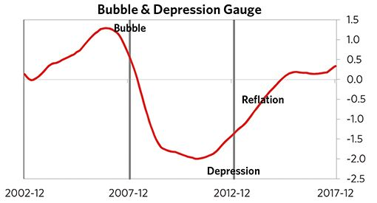

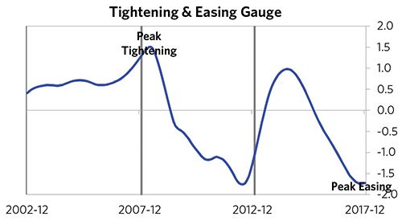

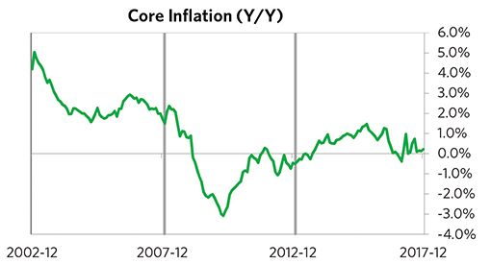

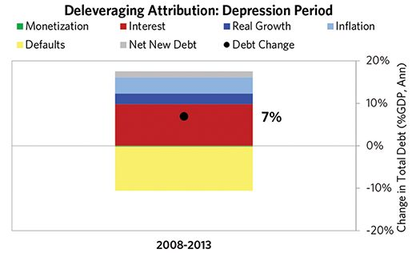

#### The Reflation Phase

After a relatively long bust phase, ECB policy makers were able to provide enough stimulation to turn the deleveraging into a beautiful one and create a period of reflation, which began in 2013. In terms of monetary policy, M0 increased by 14% of GDP, interest rates were ultimately pushed down to 0%, and real FX averaged -19% during the stimulative phase. Over the cycle, Ireland was very aggressive in managing its financial institutions and bad debts, pulling 7 out of 9 classic policy levers. In particular, it nationalized banks, provided liquidity, and directly purchased troubled assets. It also benefited from an IMF assistance program and enacted structural reforms designed to increase labor market flexibility. This stimulation helped bring nominal growth well above nominal interest rates (with growth averaging 6% during this period and sovereign long rates falling to 0%). During this phase, unemployment rates declined by 8% and debt as a % of GDP fell by 116% (25% annualized), as shown in the attribution chart to the right. Throughout this “beautiful” period, the reduction in debt-to-income ratios was driven by a mix of rising real incomes and paying down existing debt. It took 6 years before real GDP reached its prior peak, but equity prices in USD terms haven’t yet fully recovered.

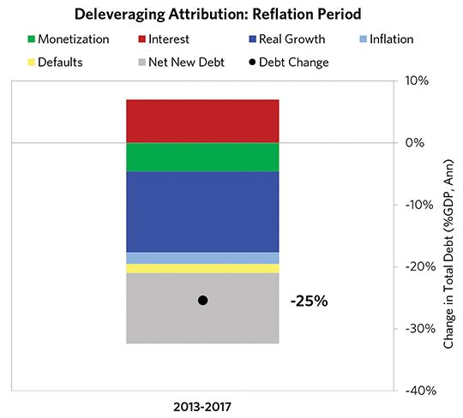

### Ireland 2005–2017 Chart Deck Appendix

#### Indebtedness

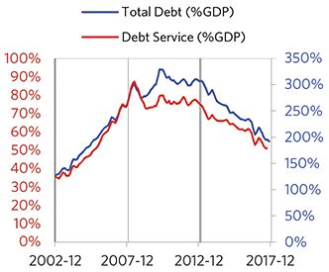

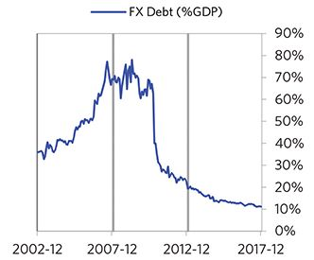

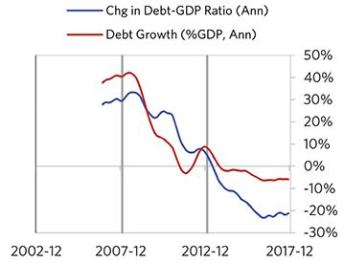

#### Monetary and Fiscal Policy

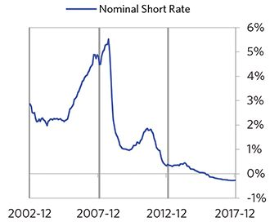

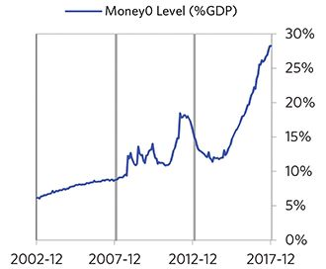

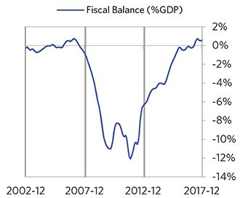

#### Economic Conditions

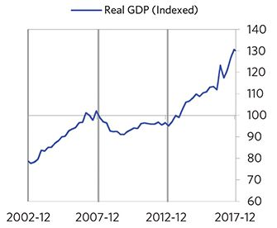

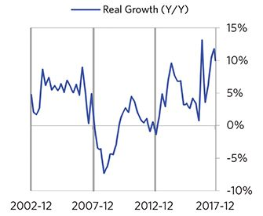

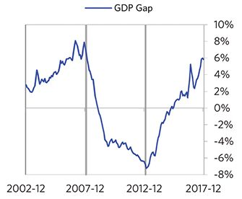

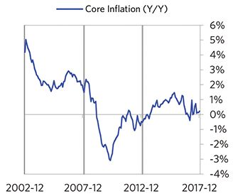

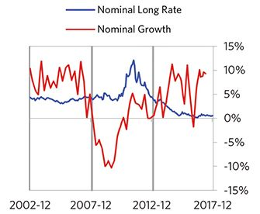

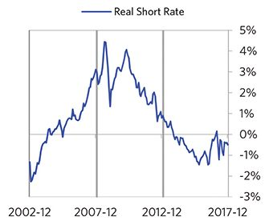

#### Markets

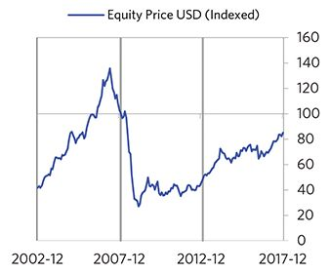

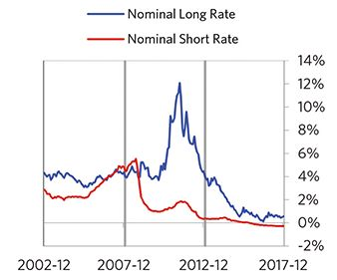

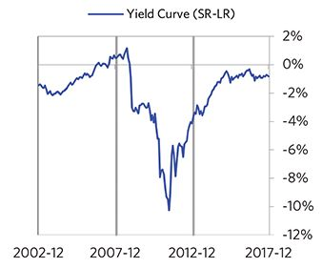

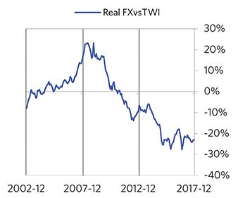

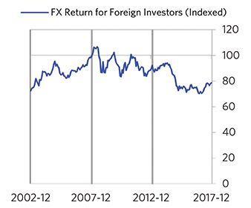

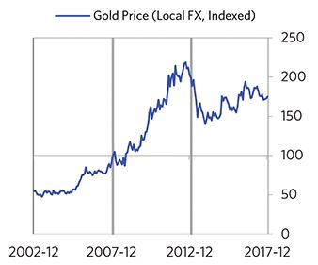

#### External Position

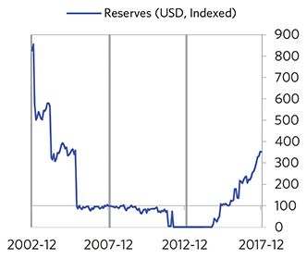

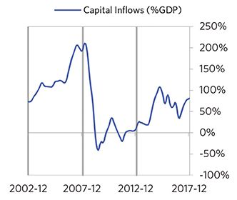

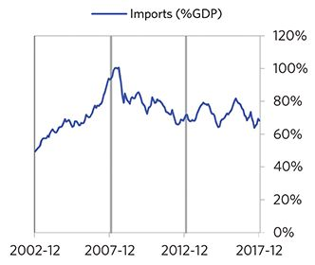

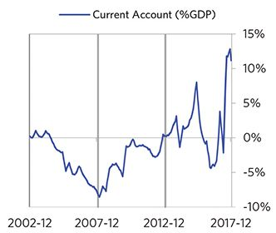

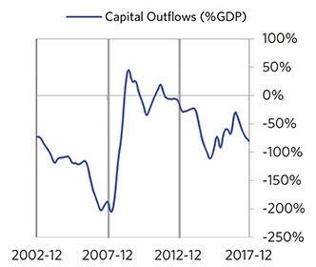

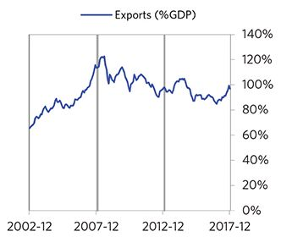

### Italy 2005–2017 Case Auto-Summary

As show in the charts below, Italy experienced a classic deflationary deleveraging cycle between 2005 and 2017.

#### The Bubble Phase

Between 2005 and 2008, Italy experienced a bubble that was driven by a self-reinforcing cycle of rising debt and strong growth. Debts rose by 29% of GDP during the bubble to a pre-crisis peak of 270% of GDP. In this case, the debt was in Euros, which, while technically Italy’s domestic currency, is not a currency that Italy had control over. In addition, a high share of debt was owned by foreigners, which left Italy with some exposure to a pullback in foreign capital. During the bubble phase, investment inflows were moderately strong, averaging around 7% of GDP, which helped to finance a current account deficit of 1% of GDP. Aided by that rising debt and capital, growth was moderate (at 2%), while levels of economic activity were high (the GDP gap peaked at 4%). Furthermore, strong asset returns (equities averaged 7% annualized returns over the bubble period) encouraged more borrowing and helped to stimulate growth. During this bubble period, policy makers initiated a moderate tightening (with short rates rising around 200 bps). Taken together, these bubble pressures and Italy’s dependence on foreign financing, combined with tightening money and credit and the weakened conditions of related countries, created an unsustainable situation.

#### The Depression Phase

Eventually the dynamic turned, producing a self-reinforcing bust and an “ugly deleveraging,” which ran from 2008 to 2015. At its pre-crisis peak, debt service reached 58% of GDP, making Italy vulnerable to a shock—which came in the form of the European debt crisis. Italy suffered a fall in foreign funding (with portfolio inflows falling by 14% of GDP)—which in turn led to self-reinforcing declines in GDP (falling by 9%), in stock prices (falling by 67%) and in home prices (falling by 15%). Unemployment rates increased by 6%. Italy’s financial institutions also came under consider- able pressure. As shown in the attribution chart to the right, even though Italy needed a deleveraging, its debt as a % GDP went up by 48% (7% annualized), driven primarily by interest payments financed with new debt and to a lesser extent by falling real incomes.

The gauges below are composed from a compendium of stats shown in the chart deck that follows. Note these are meant to be rough measures.

*The first two charts show gauges which measure bubble/depression conditions and tightness/easiness of money and credit. For each gauge, the difference from zero conveys the extent of the bubble while the crossing above/below zero represents the shifting into or out of the bubble.

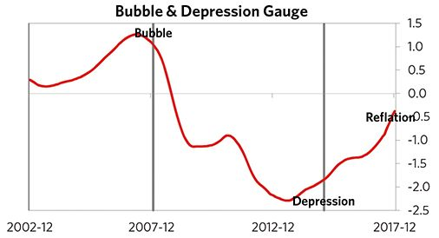

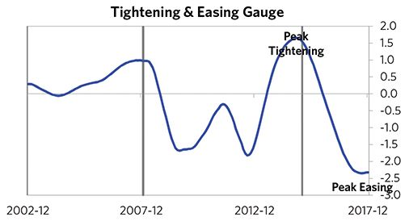

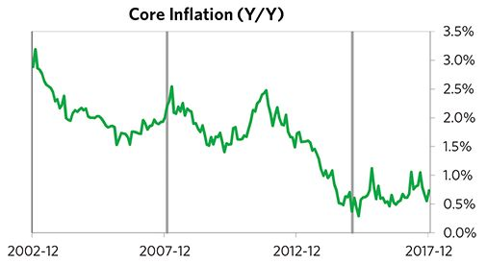

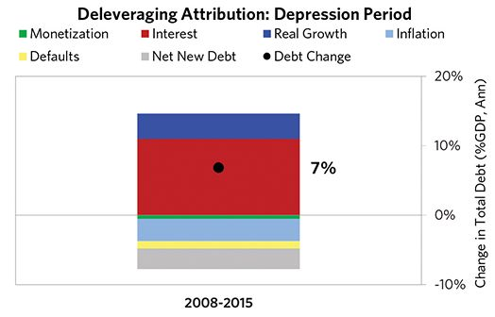

#### The Reflation Phase

After a relatively long bust phase, ECB policy makers were able to provide enough stimulation to turn the deleveraging into a beautiful one and create a period of reflation, which began in 2015. In terms of monetary policy, M0 increased by 16% of GDP, interest rates were ultimately pushed down to 0%, and real FX averaged -1% during the stimulative phase. Over the cycle, Italy was aggressive in managing its financial institutions and bad debts, pulling 4 out of 9 classic policy levers. It also enacted structural reforms designed to increase labor market flexibility. This stimulation helped bring nominal growth above nominal interest rates (with growth averaging 1.8% during this period and sovereign long rates falling to 1.2%). During this phase, unemployment rates declined by 1% and debt as a % of GDP fell by 36% (14% annualized), as shown in the attribution chart to the right. Throughout this “beautiful” period, the reduction in debt-to-income ratios was driven by a mix of monetization and paying down existing debt. Real GDP has not yet reached its prior peak and equity prices in USD terms haven’t yet fully recovered.

The crisis had a notable impact on the politics of Italy, as it helped set the stage for Giuseppe Conte, whom many people consider a populist leader, to take power in 2018.

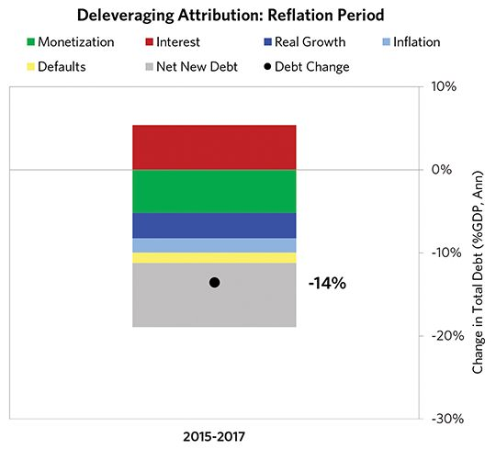

### Italy 2005–2017 Chart Deck Appendix

#### Indebtedness

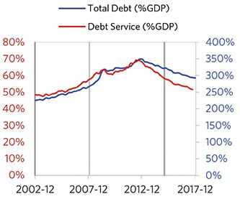

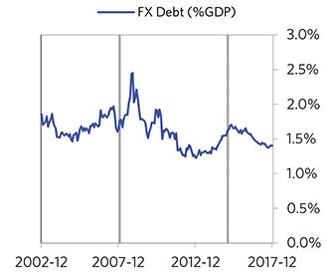

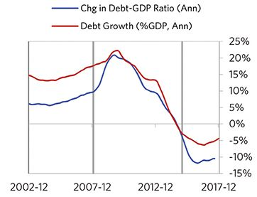

#### Monetary and Fiscal Policy

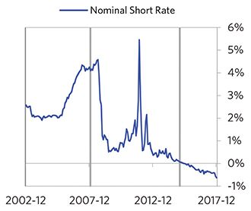

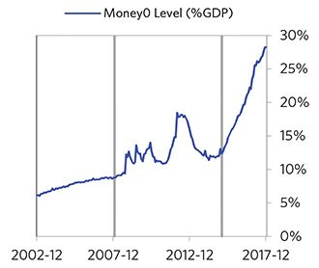

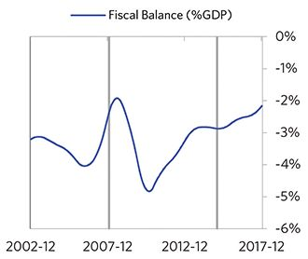

#### Economic Conditions

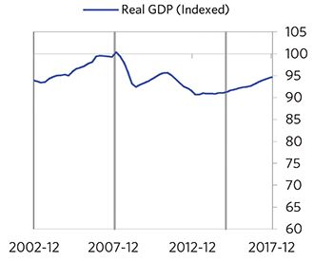

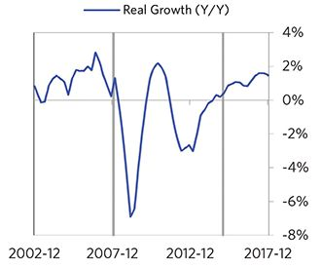

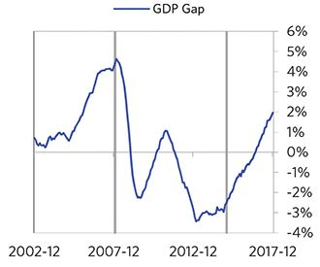

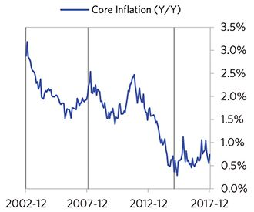

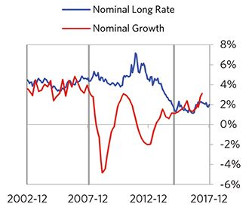

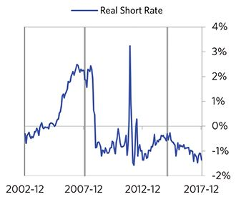

#### Markets

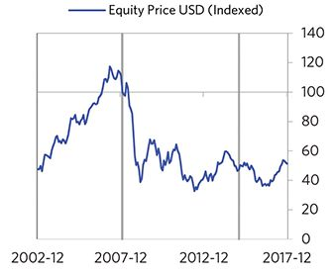

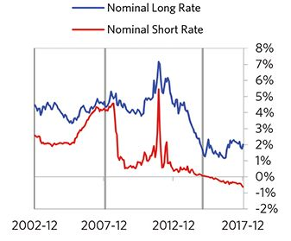

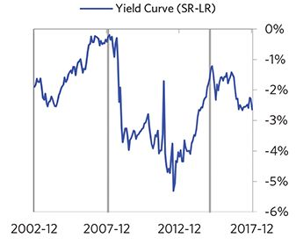

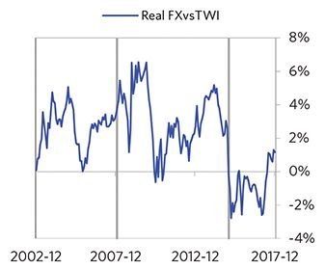

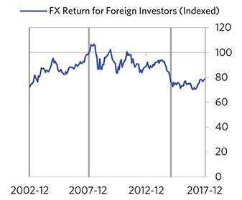

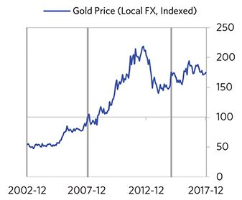

#### External Position

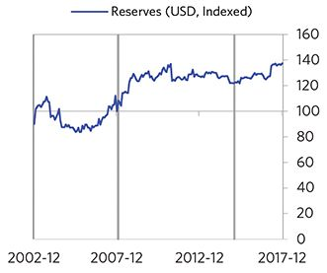

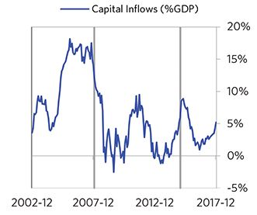

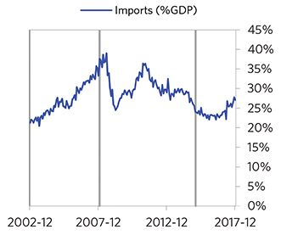

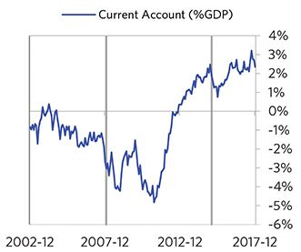

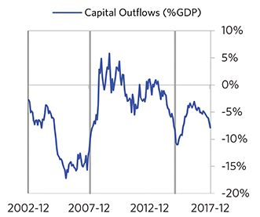

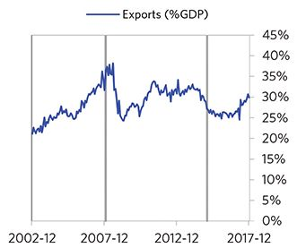

### Netherlands 2006–2017 Case Auto-Summary

As show in the charts below, the Netherlands experienced a classic deflationary deleveraging cycle between 2006 and 2017.

#### The Bubble Phase

Between 2006 and 2008, the Netherlands experienced a bubble that was driven by a self-reinforcing cycle of rising debt, strong equity returns, and strong growth. Debts rose by 10% of GDP during the bubble to a pre-crisis peak of 355% of GDP. In this case, the debt was in Euros, which, while technically the Netherlands’s domestic currency, is not a currency that the Netherlands had control over. In addition, a high share of debt was owned by foreigners, which left the Netherlands with some exposure to a pullback in foreign capital. During the bubble phase, investment inflows were strong, averaging around 14% of GDP. Aided by that rising debt and capital, growth was strong (at 3%), while levels of economic activity were high (the GDP gap peaked at 5%). Furthermore, strong asset returns (equities averaged 11% annualized returns over the bubble period) encouraged more borrowing and helped to stimulate growth. During this bubble period, policy makers initiated a moderate tightening (with short rates rising around 200 bps). Taken together, these bubble pressures and the Netherlands’s dependence on foreign financing, combined with tightening money and credit and the weakened conditions of related countries, created an unsustainable situation.

#### The Depression Phase

Eventually the dynamic turned, producing a self-reinforcing bust and an “ugly deleveraging,” which ran from 2008 to 2014. At its pre-crisis peak, debt service reached 68% of GDP, making the Netherlands vulnerable to a shock—which came in the form of the 2008 global financial crisis. The Netherlands suffered from self-reinforcing declines in GDP (falling by 4%), in stock prices (falling by 57%) and in home prices (falling by 20%). Unemployment rates increased by 4%. The Netherlands’s financial institutions also came under considerable pressure. As shown in the attribution chart to the right, even though the Netherlands needed a deleveraging, its debt as a % GDP went up by 74% (12% annualized) as incomes declined.

The gauges below are composed from a compendium of stats shown in the chart deck that follows. Note these are meant to be rough measures.

*The first two charts show gauges which measure bubble/depression conditions and tightness/easiness of money and credit. For each gauge, the difference from zero conveys the extent of the bubble while the crossing above/below zero represents the shifting into or out of the bubble.

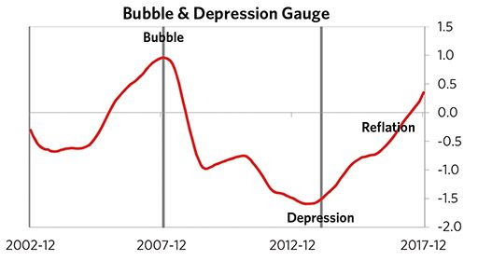

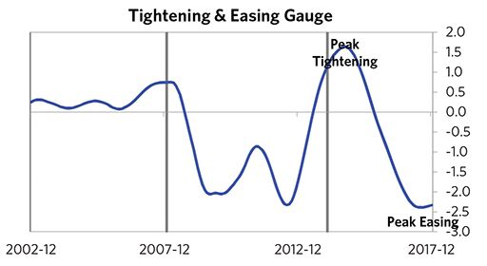

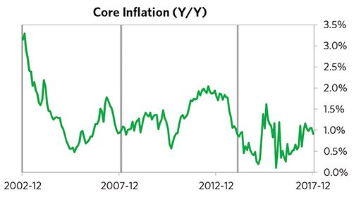

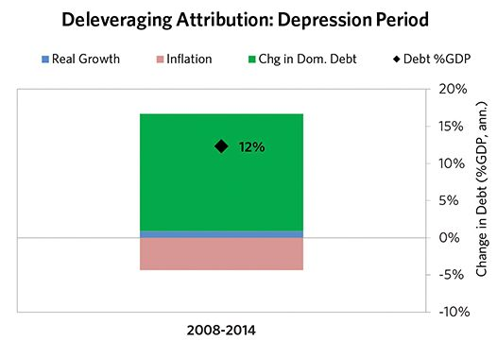

#### The Reflation Phase

After a relatively long bust phase, ECB policy makers were able to provide enough stimulation to turn the deleveraging into a beautiful one and create a period of reflation, which began in 2014. In terms of monetary policy, M0 increased by 16% of GDP, interest rates were ultimately pushed down to -1%, and real FX averaged -2% during the stimulative phase. Over the cycle, the Netherlands was aggressive in managing its financial institutions and bad debts, pulling 5 out of 9 classic policy levers. In particular, it nationalized banks and provided liquidity. This stimulation helped bring nominal growth well above nominal interest rates (with growth averaging 3% during this period and sovereign long rates falling to 0%). During this phase, unemployment rates declined by 3% and debt as a % of GDP fell by 46% (12% annualized), as shown in the attribution chart to the right. Throughout this “beautiful” period, the reduction in debt-to-income ratios came mostly from income rising, driven primarily by higher real growth. It took 7 years before real GDP reached its prior peak, but equity prices in USD terms haven’t yet fully recovered.

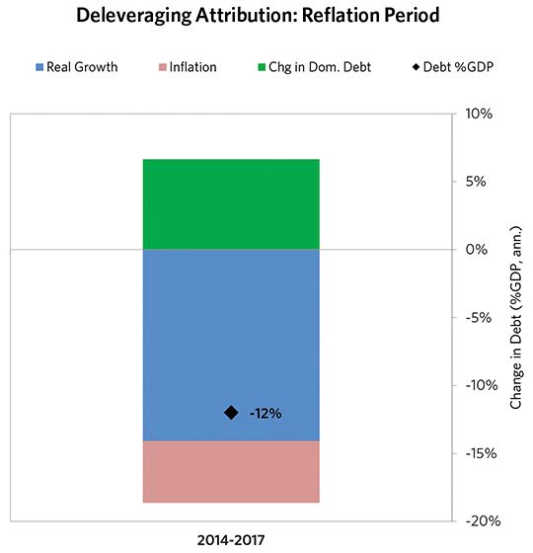

### Netherlands 2006–2017 Chart Deck Appendix

#### Indebtedness

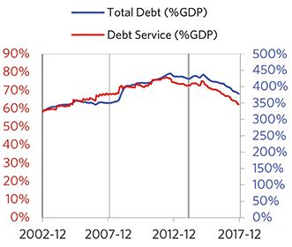

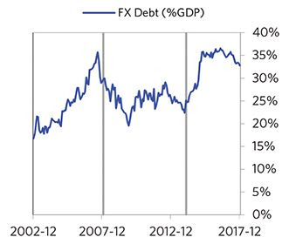

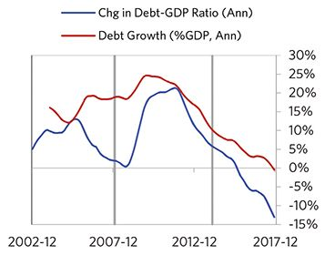

#### Monetary and Fiscal Policy

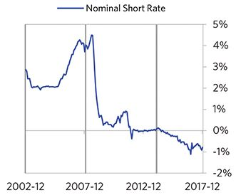

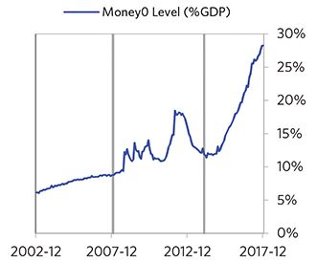

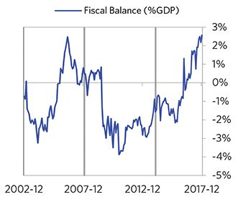

#### Economic Conditions

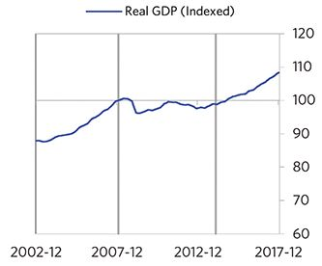

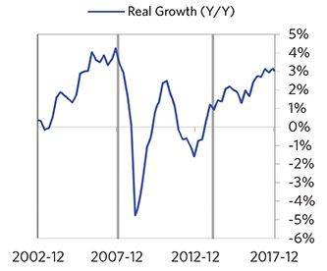

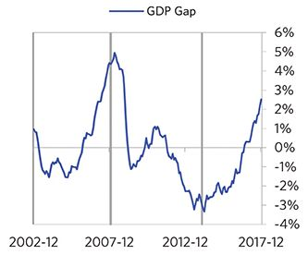

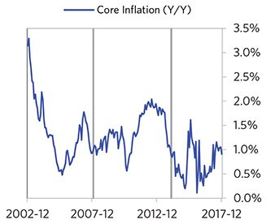

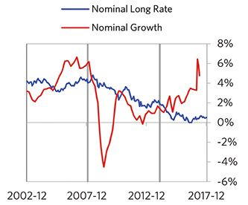

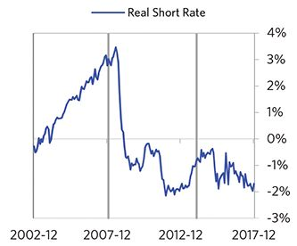

#### Markets

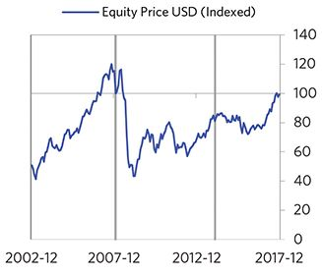

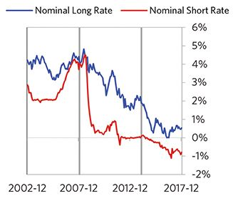

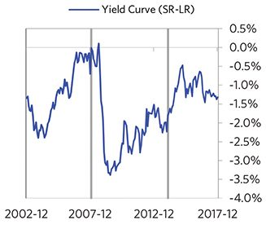

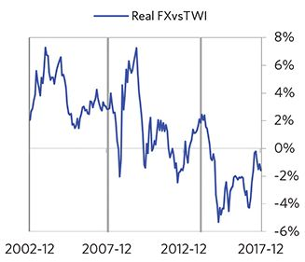

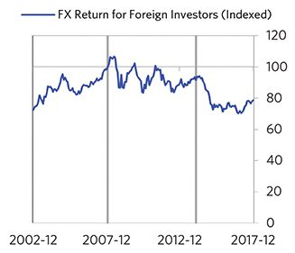

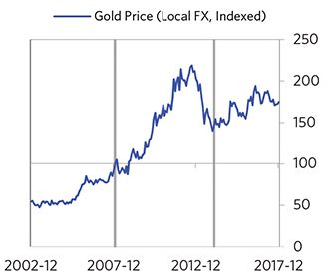

#### External Position

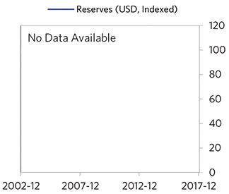

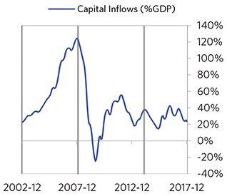

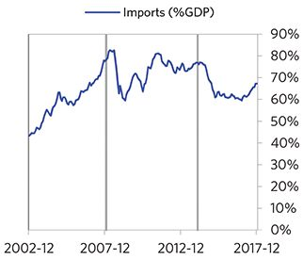

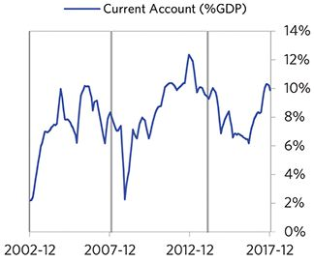

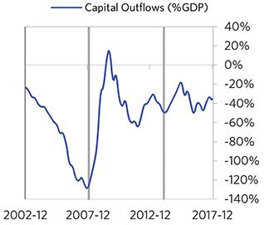

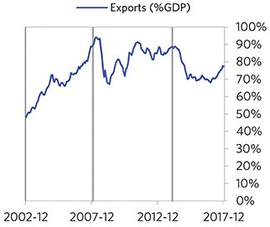

### Portugal 2007–2017 Case Auto-Summary

As show in the charts below, Portugal experienced a classic deflationary deleveraging cycle between 2007 and 2017.

#### The Bubble Phase

Between 2007 and 2008, Portugal experienced a bubble that was driven by a self-reinforcing cycle of rising debt, strong equity returns, and strong growth. Debts rose by 36% of GDP during the bubble to a pre-crisis peak of 273% of GDP. In this case, the debt was in Euros, which, while technically Portugal’s domestic currency, is not a currency that Portugal had control over. In addition, a high share of debt was owned by foreigners, which left Portugal with some exposure to a pullback in foreign capital. During the bubble phase, investment inflows were strong, averaging around 10% of GDP, which helped to finance a current account deficit of 11% of GDP. Aided by that rising debt and capital, growth was moderate (at 2%), while levels of economic activity were high (the GDP gap peaked at 3%). Furthermore, strong asset returns (equities averaged 16% annualized returns over the bubble period) encouraged more borrowing and helped to stimulate growth. During this bubble period, policy makers initiated a moderate tightening (with short rates rising around 220 bps). Taken together, these bubble pressures and Portugal’s dependence on foreign financing, combined with tightening money and credit and the weakened conditions of related countries, created an unsustainable situation.

#### The Depression Phase

Eventually the dynamic turned, producing a self-reinforcing bust and an “ugly deleveraging,” which ran from 2008 to 2013. At its pre-crisis peak, debt service reached 48% of GDP, making Portugal vulnerable to a shock—which came in the form of the European debt crisis. Portugal suffered a fall in foreign funding (with portfolio inflows falling by 40% of GDP)—which in turn led to self-reinforcing declines in GDP (falling by 10%), in stock prices (falling by 65%) and in home prices (falling by 18%). Unemployment rates increased by 9%. Portugal’s financial institutions also came under considerable pressure. As shown in the attribution chart to the right, even though Portugal needed a deleveraging, its debt as a % GDP went up by 105% (21% annualized), driven by a mix of falling real incomes, interest payments financed with new debt, and net new borrowing. Those new debts came in part because the government had to borrow more in response to the crisis (with a peak fiscal deficit of 8% of GDP during the ugly period).

The gauges below are composed from a compendium of stats shown in the chart deck that follows. Note these are meant to be rough measures.

*The first two charts show gauges which measure bubble/depression conditions and tightness/easiness of money and credit. For each gauge, the difference from zero conveys the extent of the bubble while the crossing above/below zero represents the shifting into or out of the bubble.

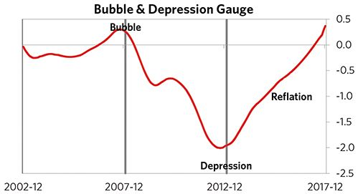

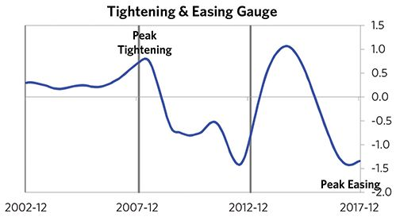

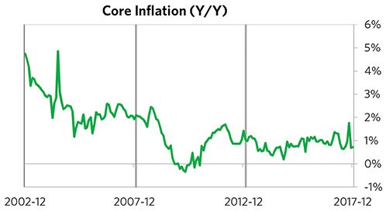

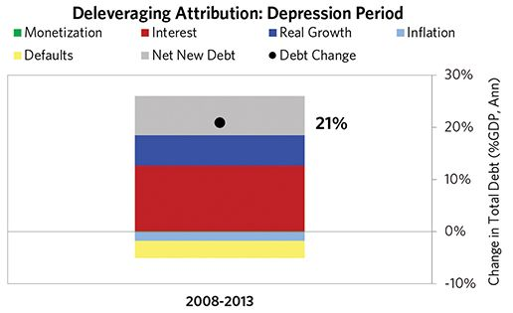

#### The Reflation Phase

After a relatively long bust phase, ECB policy makers were able to provide enough stimulation to turn the deleveraging into a beautiful one and create a period of reflation, which began in 2013. In terms of monetary policy, M0 increased by 15% of GDP, interest rates were ultimately pushed down to 0%, and real FX averaged -1% during the stimulative phase. Over the cycle, Portugal was aggressive in managing its financial institutions and bad debts, pulling 4 out of 9 classic policy levers. It also benefited from an IMF assistance program and enacted structural reforms designed to increase labor market flexibility. This stimulation helped bring nominal growth above nominal interest rates (with growth averaging 2.0% during this period and sovereign long rates falling to 1.7%). During this phase, unemployment rates declined by 9% and debt as a % of GDP fell by 77% (16% annualized), as shown in the attribution chart to the right. Throughout this “beautiful” period, the reduction in debt-to-income ratios was driven by a mix of defaults and paying down existing debt. It took 9 years before real GDP reached its prior peak, but equity prices in USD terms haven’t yet fully recovered.

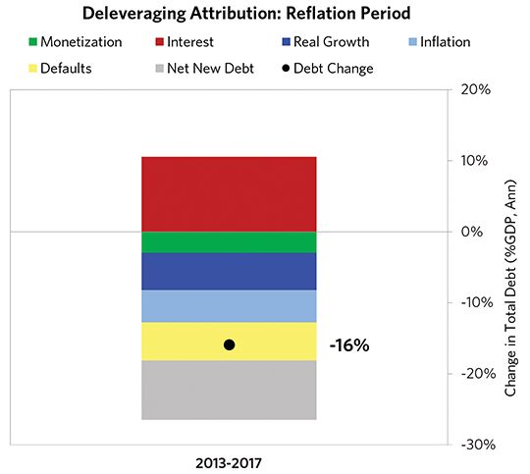

### Portugal 2007–2017 Chart Deck Appendix

#### Indebtedness

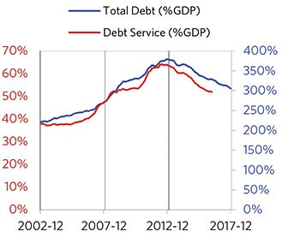

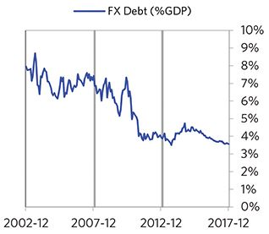

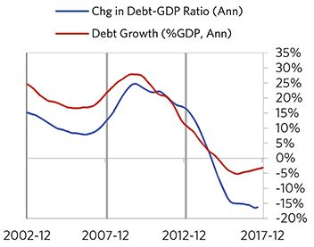

#### Monetary and Fiscal Policy

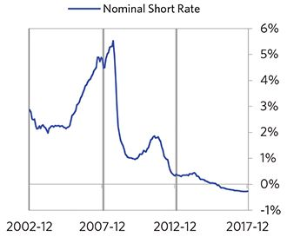

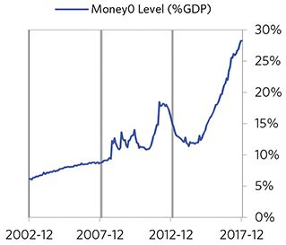

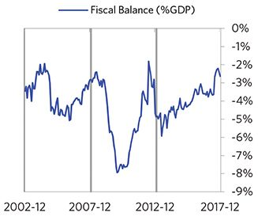

#### Economic Conditions

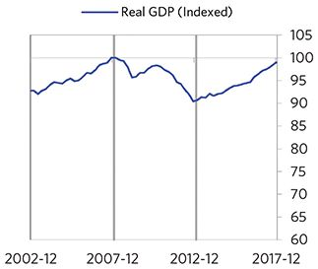

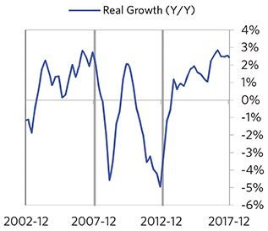

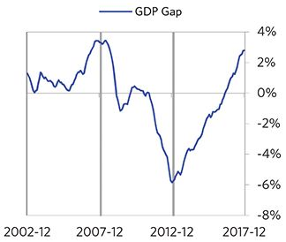

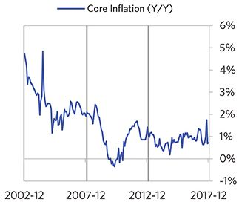

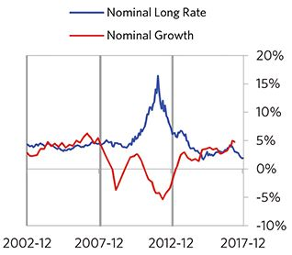

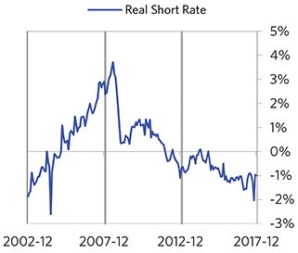

#### Markets

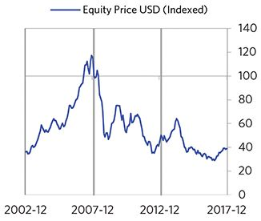

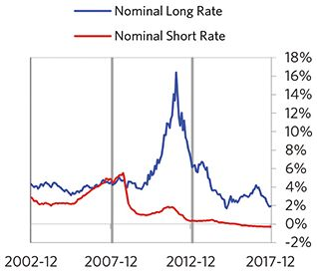

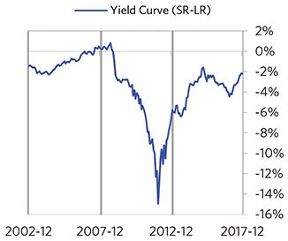

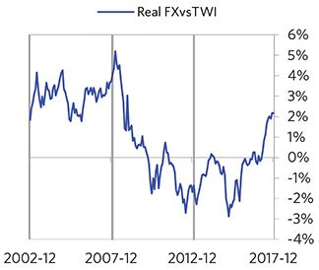

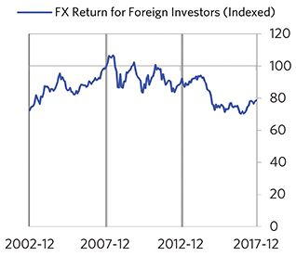

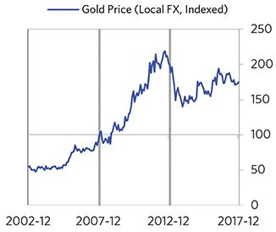

#### External Position

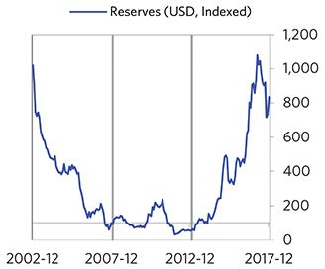

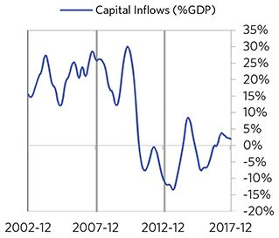

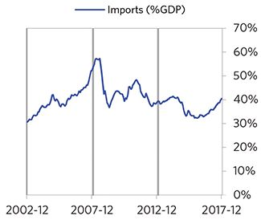

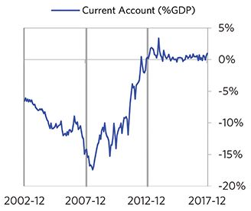

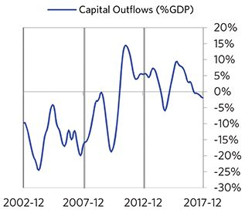

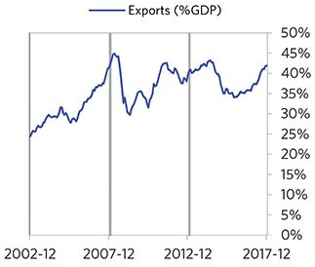

### Spain 2005–2017 Case Auto-Summary

As show in the charts below, Spain experienced a classic deflationary deleveraging cycle between 2005 and 2017.

#### The Bubble Phase

Between 2005 and 2008, Spain experienced a bubble that was driven by a self-reinforcing cycle of rising debt, strong growth and strong asset returns. Debts rose by 93% of GDP during the bubble to a pre-crisis peak of 313% of GDP. In this case, the debt was in Euros, which, while technically Spain’s domestic currency, is not a currency that Spain had control over. In addition, a high share of debt was owned by foreigners, which left Spain with some exposure to a pullback in foreign capital. During the bubble phase, investment inflows were strong, averaging around 27% of GDP, which helped to finance a current account deficit of 10% of GDP. Aided by that rising debt and capital, growth was strong (at 4%), while levels of economic activity were high (the GDP gap peaked at 6%). Furthermore, strong asset returns (equities averaged 17% annualized returns over the bubble period) encouraged more borrowing and helped to stimulate growth. During this bubble period, policy makers initiated a moderate tightening (with short rates rising around 200 bps). Taken together, these bubble pressures and Spain’s dependence on foreign financing, combined with tightening money and credit and the weakened conditions of related countries, created an unsustainable situation.

#### The Depression Phase

Eventually the dynamic turned, producing a self-reinforcing bust and an “ugly deleveraging,” which ran from 2008 to 2013. At its pre-crisis peak, debt service reached 64% of GDP, making Spain vulnerable to a shock—which came in the form of the European debt crisis. Spain suffered a fall in foreign funding (with capital inflows falling by 16% of GDP)—which in turn led to self-reinforcing declines in GDP (falling by 9%), in stock prices (falling by 60%) and in home prices (falling by 31%). Unemployment rates increased by 17%. Spain’s financial institutions also came under consider- able pressure. As shown in the attribution chart to the right, even though Spain needed a deleveraging, its debt as a % GDP went up by 86% (17% annualized), driven primarily by interest payments financed with new debt and to a lesser extent by falling real incomes.

The gauges below are composed from a compendium of stats shown in the chart deck that follows. Note these are meant to be rough measures.

*The first two charts show gauges which measure bubble/depression conditions and tightness/easiness of money and credit. For each gauge, the difference from zero conveys the extent of the bubble while the crossing above/below zero represents the shifting into or out of the bubble.

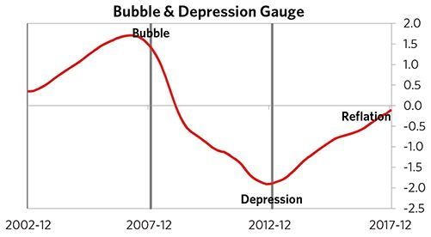

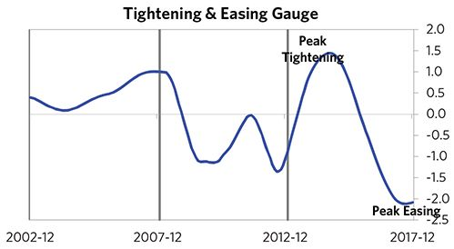

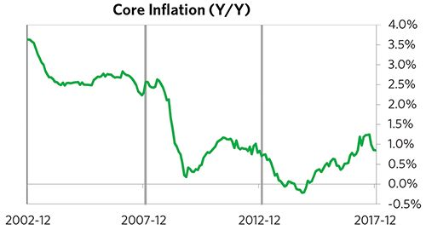

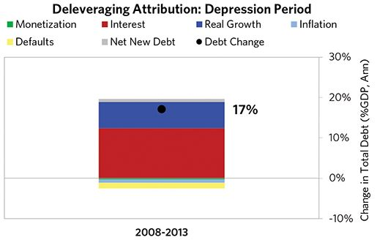

#### The Reflation Phase

After a relatively long bust phase, ECB policy makers were able to provide enough stimulation to turn the deleveraging into a beautiful one and create a period of reflation, which began in 2013. In terms of monetary policy, M0 increased by 15% of GDP, interest rates were ultimately pushed down to -1%, and real FX averaged 0% during the stimulative phase. Over the cycle, Spain was aggressive in managing its financial institutions and bad debts, pulling 5 out of 9 classic policy levers. In particular, it provided liquidity and directly purchased troubled assets. It also enacted structural reforms designed to increase labor market flexibility. This stimulation helped bring nominal growth well above nominal interest rates (with growth averaging 2% during this period and sovereign long rates falling to 1%). During this phase, unemployment rates declined by 10% and debt as a % of GDP fell by 112% (23% annualized), as shown in the attribution chart to the right. Throughout this “beautiful” period, the reduction in debt-to-income ratios was driven primarily by paying down existing debt and to a lesser extent by rising real incomes. It took 9 years before real GDP reached its prior peak, but equity prices in USD terms haven’t yet fully recovered.

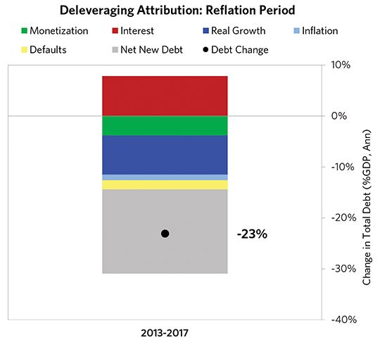

### Spain 2005–2017 Chart Deck Appendix

#### Indebtedness

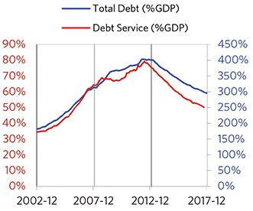

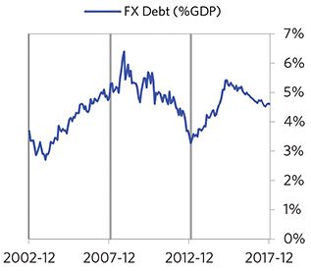

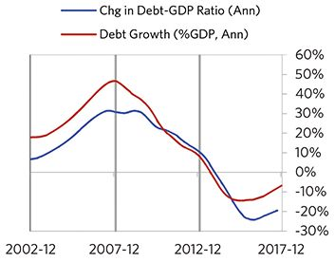

#### Monetary and Fiscal Policy

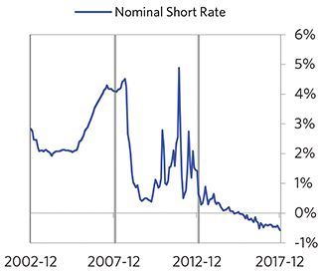

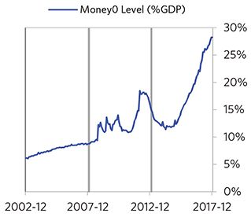

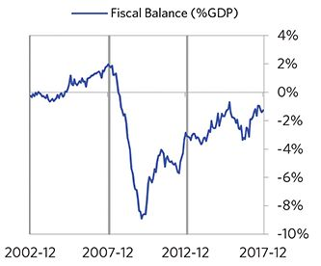

#### Economic Conditions

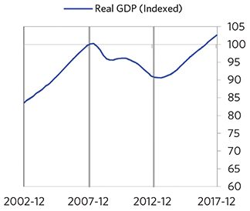

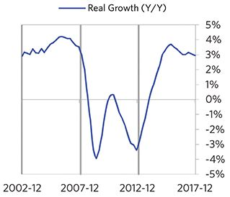

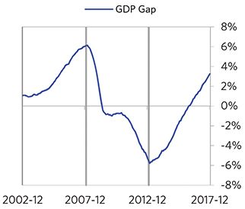

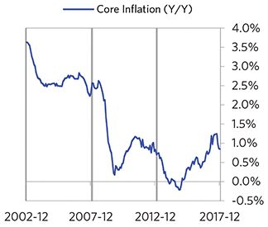

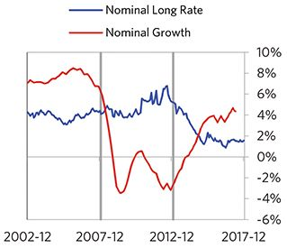

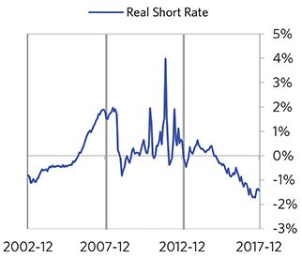

#### Markets

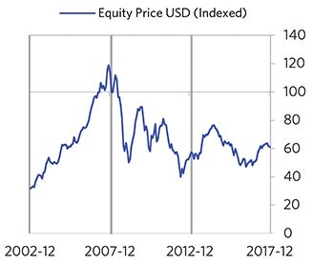

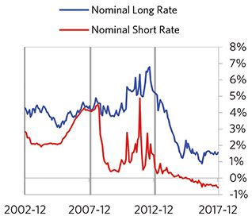

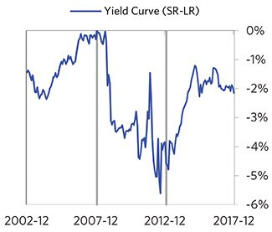

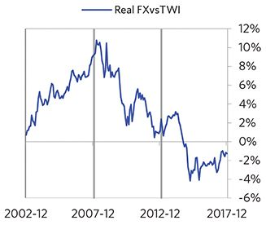

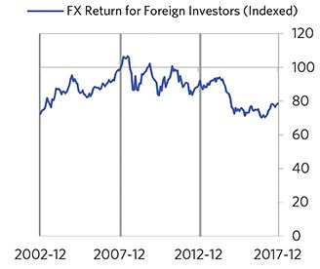

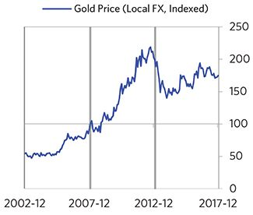

#### External Position

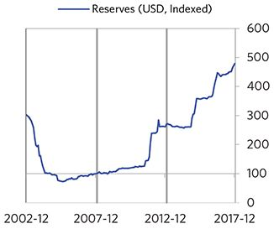

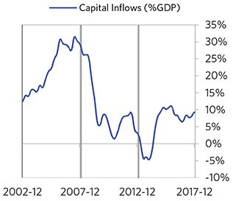

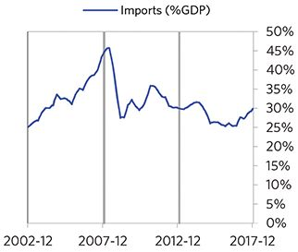

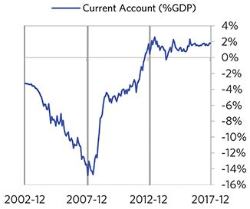

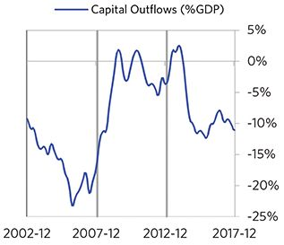

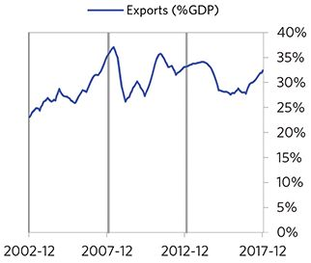

### United Kingdom 2005–2015 Case Auto-Summary

As show in the charts below, the United Kingdom experienced a classic deflationary deleveraging cycle between 2005 and 2015.

#### The Bubble Phase

Between 2005 and 2008, the United Kingdom experienced a bubble that was driven by a self-reinforcing cycle of rising debt and strong growth. Debts rose by 89% of GDP during the bubble to a pre-crisis peak of 437% of GDP. In this case, the debt was in the United Kingdom’s domestic currency, and the majority was owned domestically, too. During the bubble phase, investment inflows were strong, averaging around 14% of GDP, which helped to finance a current account deficit of 3% of GDP. Aided by that rising debt and capital, growth was strong (at 3%), while levels of economic activity were high (the GDP gap peaked at 4%). Furthermore, strong asset returns (equities averaged 8% annualized returns over the bubble period) encouraged more borrowing and helped to stimulate growth. Taken together, these bubble pressures, combined with tightening money and credit and the weakened conditions of related countries, created an unsustainable situation.

#### The Depression Phase

Eventually the dynamic turned, producing a self-reinforcing bust and an “ugly deleveraging,” which ran from 2008 to 2009. At its pre-crisis peak, debt service reached 82% of GDP, making the United Kingdom vulnerable to a shock— which came in the form of the 2008 global financial crisis. The United Kingdom suffered from self-reinforcing declines in GDP (falling by 6%), in stock prices (falling by 52%) and in home prices (falling by 19%). Unemployment rates increased by 3%. The United Kingdom’s financial institu- tions also came under considerable pressure. As shown in the attribution chart to the right, even though the United Kingdom needed a deleveraging, its debt as a % GDP went up by 34% (24% annualized), driven primarily by interest payments financed with new debt and to a lesser extent by falling real incomes.

The gauges below are composed from a compendium of stats shown in the chart deck that follows. Note these are meant to be rough measures.

*The first two charts show gauges which measure bubble/depression conditions and tightness/easiness of money and credit. For each gauge, the difference from zero conveys the extent of the bubble while the crossing above/below zero represents the shifting into or out of the bubble.

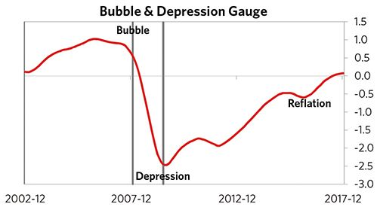

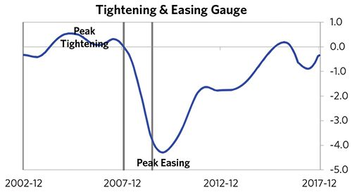

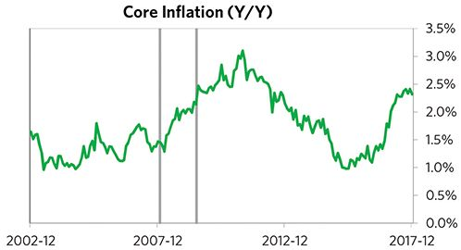

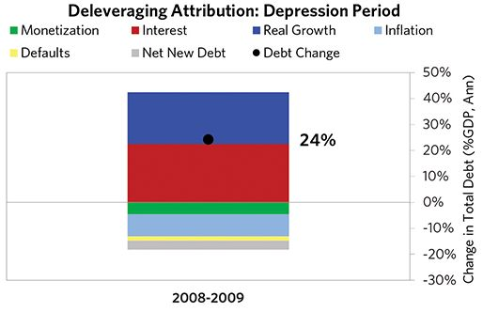

#### The Reflation Phase

After a slightly shorter than average bust phase, policy makers were able to provide enough stimulation to turn the deleveraging into a beautiful one and create a period of reflation, which began in 2009. In terms of monetary policy, M0 increased by 10% of GDP, interest rates were ultimately pushed down to 0%, and real FX averaged -5% during the stimulative phase. Over the cycle, the United Kingdom was very aggressive in managing its financial institutions and bad debts, pulling 6 out of 9 classic policy levers. In particular, it nationalized banks, provided liquidity, and directly purchased troubled assets. This stimulation helped bring nominal growth well above nominal interest rates (with growth averaging 4% during this period and sovereign long rates falling to 1%). During this phase, unemployment rates declined by 2% and debt as a % of GDP fell by 73% (12% annualized), as shown in the attribution chart to the right. Throughout this “beautiful” period, the reduction in debt-to-income ratios was driven by a mix of rising real incomes and inflation. This was partially offset by interest payments financed with new debt. It took 5 years before real GDP reached its prior peak, but equity prices in USD terms haven’t yet fully recovered.

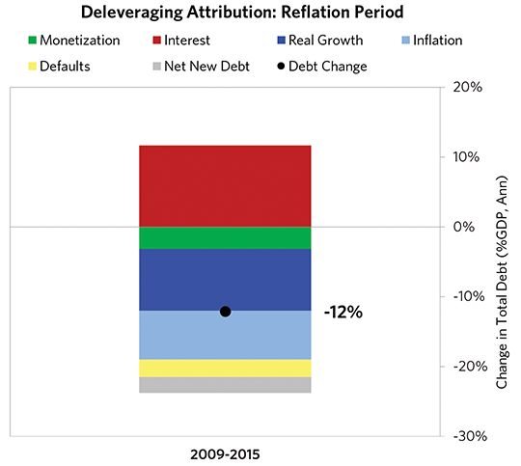

### United Kingdom 2005–2015 Chart Deck Appendix

#### Indebtedness

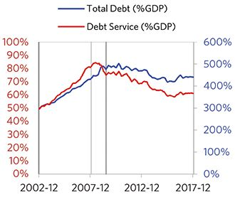

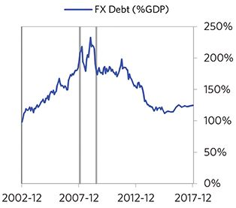

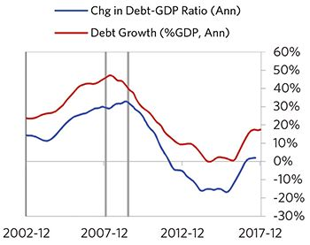

#### Monetary and Fiscal Policy

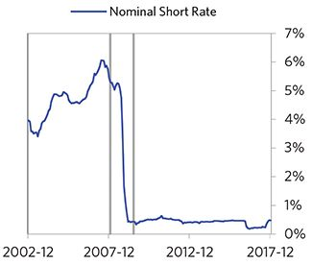

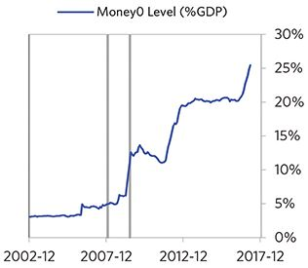

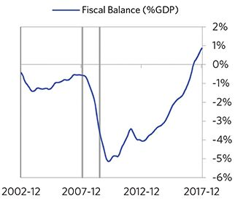

#### Economic Conditions

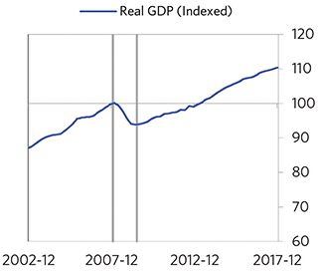

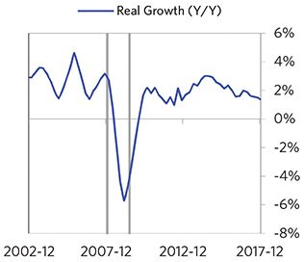

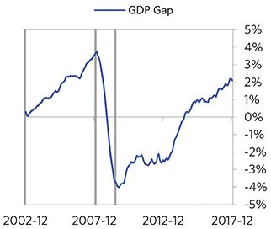

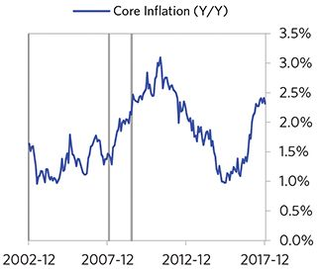

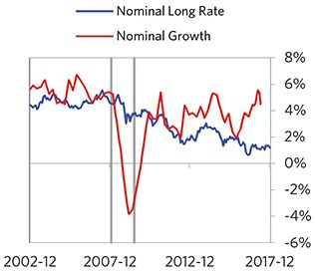

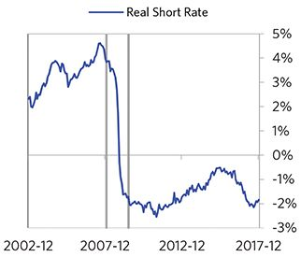

#### Markets

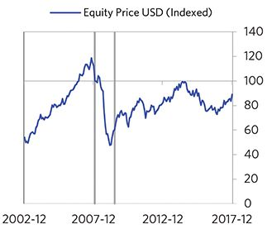

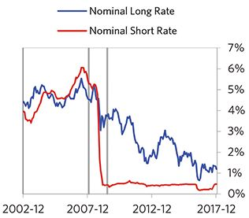

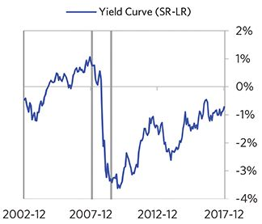

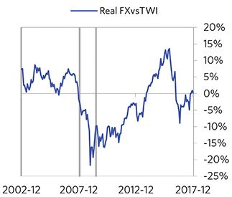

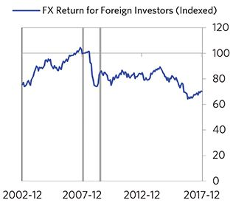

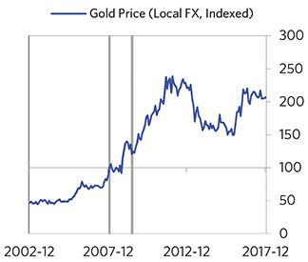

#### External Position

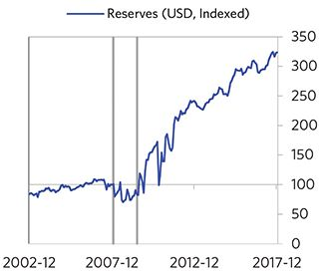

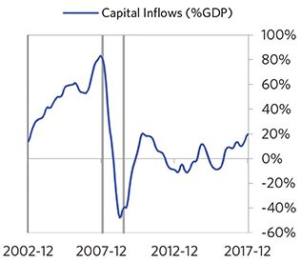

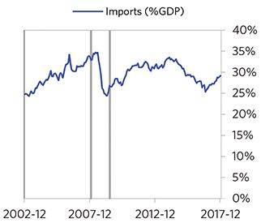

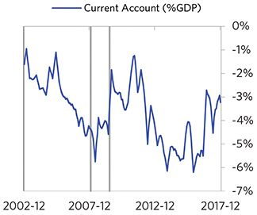

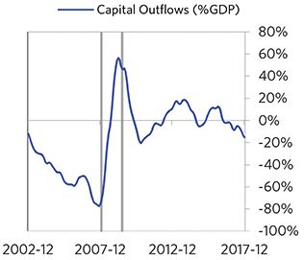

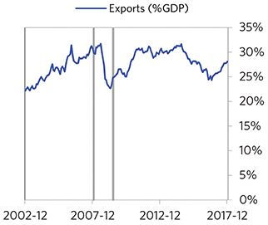

### Germany 1918–1925 Case Auto-Summary

As show in the charts below, Germany experienced a classic wartime hyperinflationary deleveraging cycle between 1918 and 1925. As is typical for losers of big wars, Germany experienced a prolonged postwar depression (given widespread damage to its industrial base), and a more painful deleveraging.

#### The War Phase

Unlike the typical case that entails a bubble, this debt crisis had its roots in WW1. During the war, Germany borrowed a lot of money to finance its big fiscal deficit, shifted much of its economy to war production, and shifted much of its workforce to the armed services and war production. For these reasons, the economic stats are not reflective of typical economic linkages. Through the war, debts rose to 158% of GDP. In this case, a high share of the debt was in foreign currencies (64% of GDP). Hampered by wartime losses, growth was weak through this period (at -6%).

#### The Postwar Phase

When the fighting ended, Germany entered a postwar depression and balance of payments crisis, which ran from 1918 to 1923. Since Germany lost the war and was saddled with very large foreign currency debts, its postwar depression was far worse than it was for the winners. Germany suffered from self-reinforcing declines in GDP (falling by 5%), and in stock prices (falling by 97%). Unemployment rates increased by 16%. Germany’s financial institutions also came under considerable pressure. As shown in the attribu- tion chart to the right, even though Germany needed a deleveraging, its debt as a % GDP went up by 165% (31% annualized) as incomes declined and as the government continued to shoulder war-related costs (with a peak fiscal deficit of 11% of GDP during the ugly period).

The gauges below are composed from a compendium of stats shown in the chart deck that follows. Note these are meant to be rough measures.

*The first two charts show gauges which measure bubble/depression conditions and tightness/easiness of money and credit. For each gauge, the difference from zero conveys the extent of the bubble while the crossing above/below zero represents the shifting into or out of the bubble.

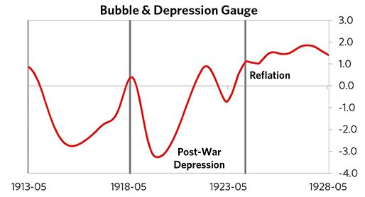

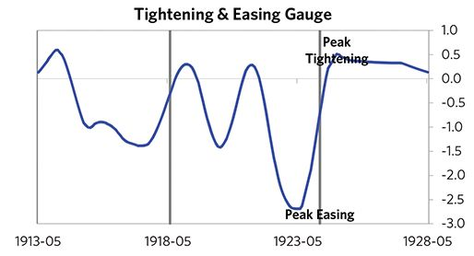

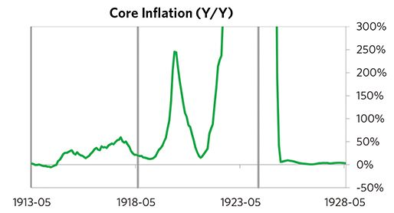

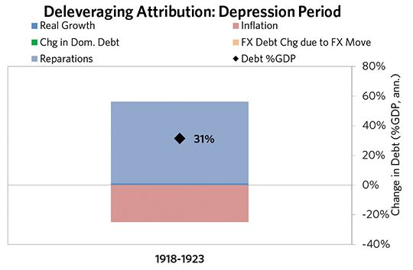

#### The Reflation Phase

A key determinant of how balance of payments/currency crises play out is how policy makers respond to adverse capital flows: whether they allow a tightening of financial conditions to flow through (painful but typically necessary to resolve the crisis), or print money to make up for money leaving (which can be inflationary). In this case, the tightening wasn’t enough to produce the needed adjust- ments before the country fell into a spiral of declining exchange rates and hyperinflation. Inflation peaked at over 10,000%. That makes sense given that Germany had most of the classic “risk factors” for bigger inflation spirals (with the biggest risk factor being their fiscal deficit). Germany was aggressive in managing its financial institutions and bad debts, pulling 5 out of 9 typical policy levers. But, as is classic, stopping the inflationary spiral ultimately required Germany to make more significant structural changes, including abandoning the hyperinflated papiermark and adopting the reichsmark in 1924. It took 15 years before real GDP reached its prior peak.

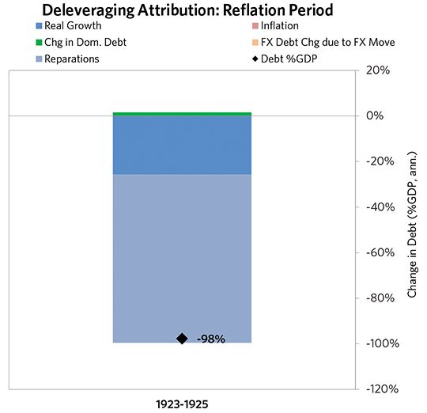

### Germany 1918–1925 Chart Deck Appendix

#### Indebtedness

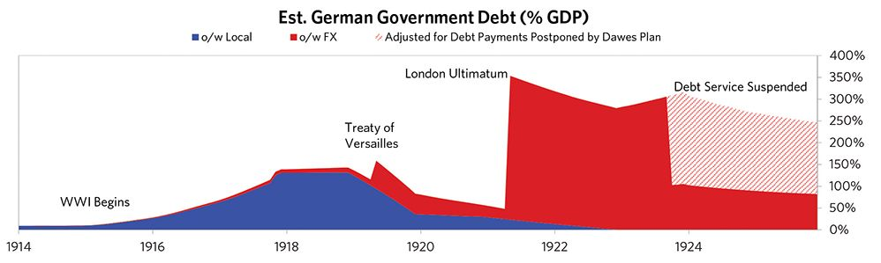

#### Monetary and Fiscal Policy

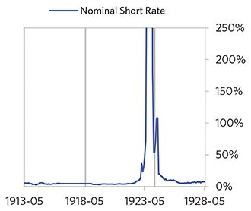

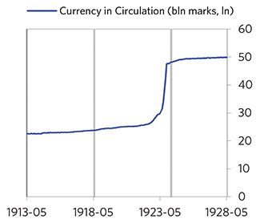

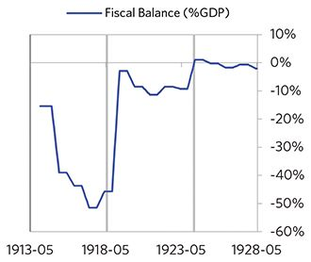

#### Economic Conditions

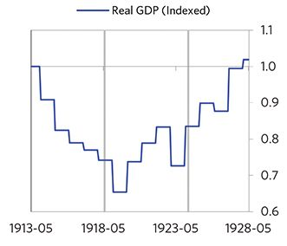

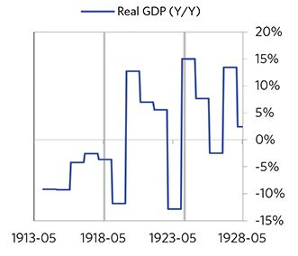

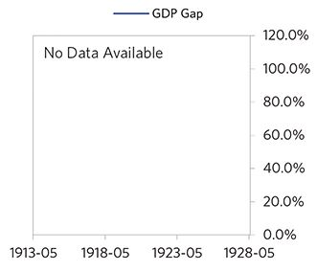

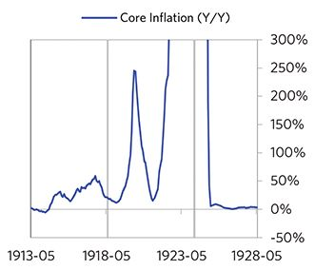

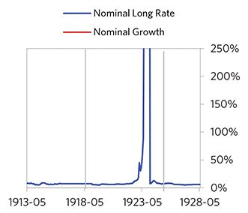

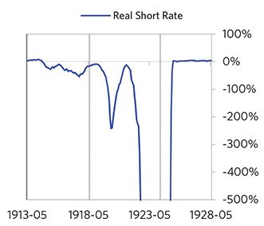

#### Markets

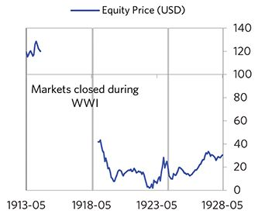

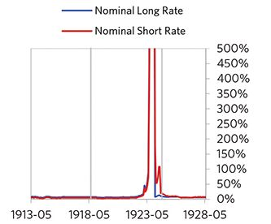

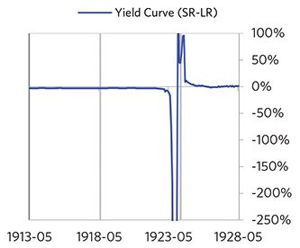

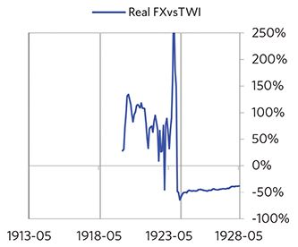

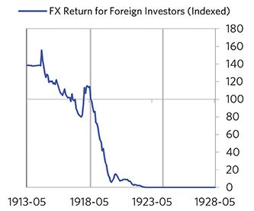

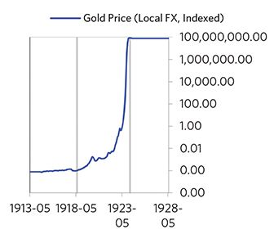

#### External Position

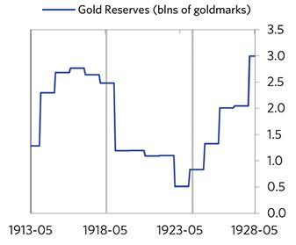

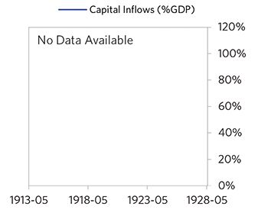

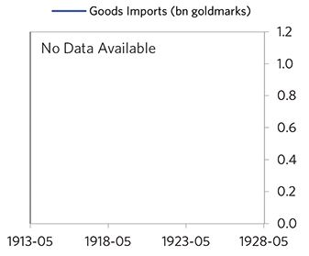

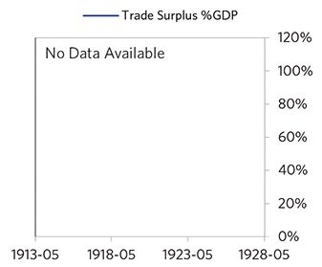

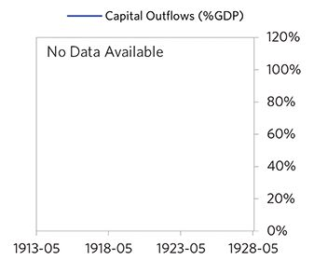

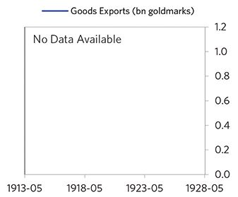

#### Government and Military

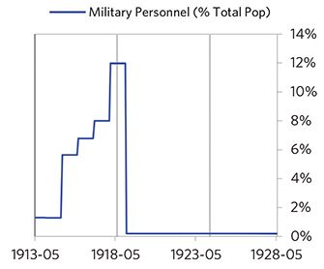

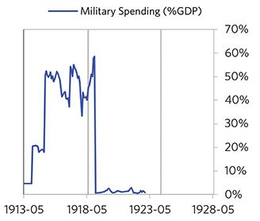

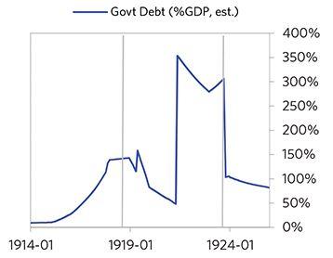

### Argentina 1977–1988 Case Auto-Summary

As show in the charts below, Argentina experienced a classic hyperinflationary deleveraging cycle between 1977 and 1988.

#### The Bubble Phase

Between 1977 and 1980, Argentina experienced a bubble that was driven by a self-reinforcing cycle of rising debt, strong equity returns, and strong growth. By the bubble’s end, debts had reached a pre-crisis peak of 39% of GDP. In this case, a high share of the debt was in foreign currencies (15% of GDP)—leaving Argentina with a large exposure to a pullback in foreign capital. During the bubble phase, investment inflows were low but positive, averaging around 2% of GDP. Aided by that rising debt and capital, growth was moderate (at 2%), while levels of economic activity were high (the GDP gap peaked at 8%). Furthermore, strong asset returns (equities averaged 52% annualized returns over the bubble period) encouraged more borrowing and helped to stimulate growth. Competitiveness became an issue, as Argentina’s real FX peaked at +70%. Taken together, these bubble pressures and Argentina’s dependence on foreign financing, combined with the weakened conditions of related countries, created an unsustainable situation.

#### The Depression Phase

Eventually the dynamic turned, producing a self-reinforcing bust and a balance of payments/currency crisis, which ran from 1980 to 1985. High debt levels left Argentina vulnera- ble to a shock—which came in the form of the 1980s Latin American Debt Crisis. Argentina suffered a fall in foreign funding (with capital inflows falling by 9% of GDP), leading to a tightening (policy makers hiked short rates by more than 250%) and a meaningful decline in the currency (real FX fell by 93%)—which coincided with self-reinforcing declines in GDP (falling by 14%), and in stock prices (falling by 91%). Unemployment rates increased by 3%, while currency weakness contributed to very high and rising inflation. Argentina’s financial institutions also came under considerable pressure. Meanwhile, the central bank spent down its reserves to defend the currency (drawing down reserves by 83%), though it eventually abandoned its currency defense. As shown in the attribution chart to the right, even though Argentina needed a deleveraging, its debt as a % GDP went up by 33% (7% annualized), in part because the currency fell (which increased the burden of foreign-denominated debts) and in part because the government had to borrow more in response to the crisis (with a peak fiscal deficit of 5% of GDP).

The gauges below are composed from a compendium of stats shown in the chart deck that follows. Note these are meant to be rough measures.

*The first two charts show gauges which measure bubble/depression conditions and tightness/easiness of money and credit. For each gauge, the difference from zero conveys the extent of the bubble while the crossing above/below zero represents the shifting into or out of the bubble.

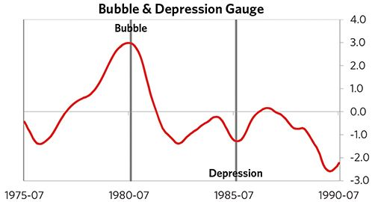

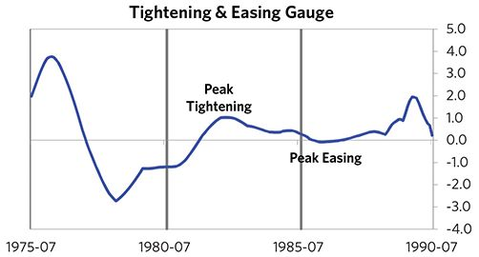

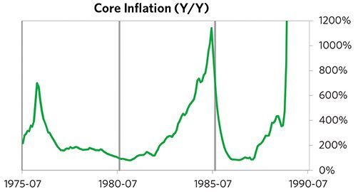

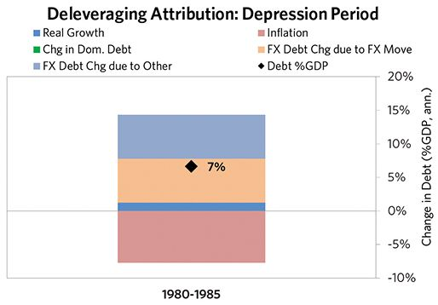

#### The Reflation Phase

A key determinant of how balance of payments/currency crises play out is how policy makers respond to adverse capital flows: whether they allow a tightening of financial conditions to flow through (painful but typically necessary to resolve the crisis), or print money to make up for money leaving (which can be inflationary). In this case, the tightening wasn’t enough to produce the needed adjust- ments before the country fell into a spiral of declining exchange rates and hyperinflation. Real FX bottomed at -138% and inflation peaked at over 1,000%. That makes sense given that Argentina had around half of the classic “risk factors” for bigger inflation spirals (with the biggest risk factor being low real short rates). Argentina was somewhat aggressive in managing its financial institutions and bad debts, pulling 3 out of 9 typical policy levers. In particular, it nationalized banks and provided liquidity. It also benefited from an IMF assistance program. But, as is classic, stopping the inflationary spiral ultimately required Argentina to make more significant structural changes, including abandoning the hyperinflated peso ley and adopting the peso argentino in 1983. It took 7 years before real GDP reached its prior peak.

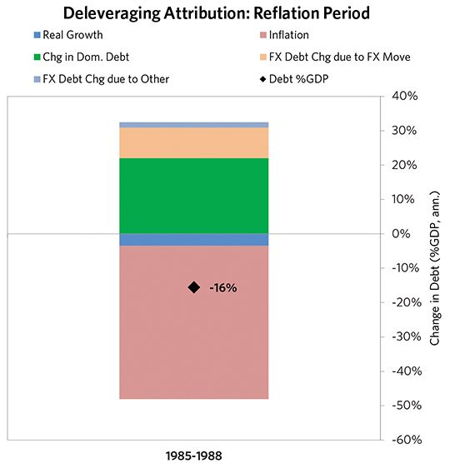

### Argentina 1977–1988 Chart Deck Appendix

#### Indebtedness

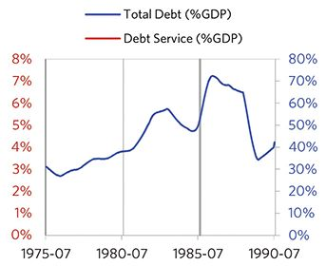

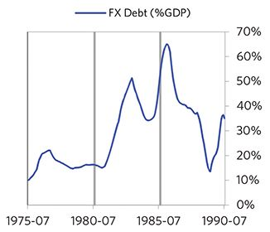

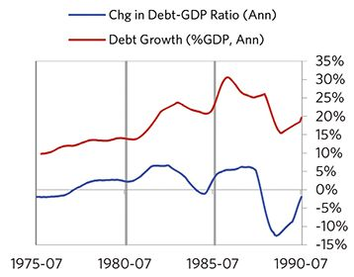

#### Monetary and Fiscal Policy

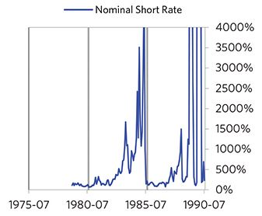

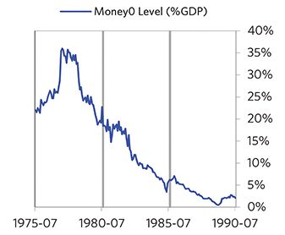

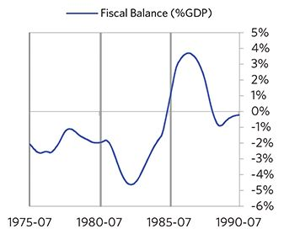

#### Economic Conditions

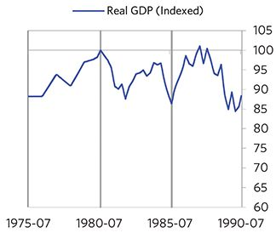

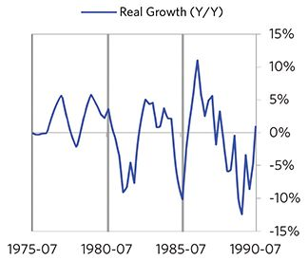

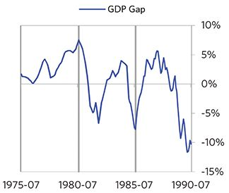

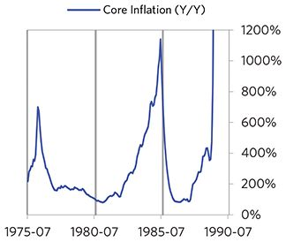

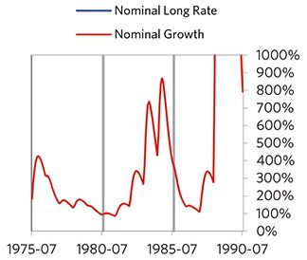

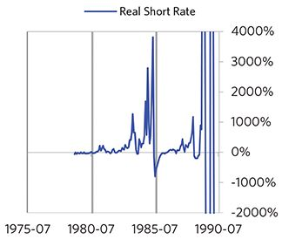

#### Markets

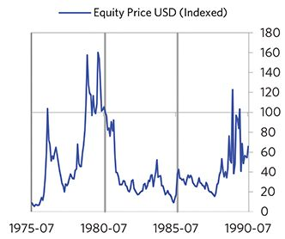

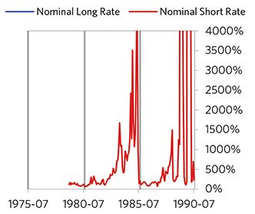

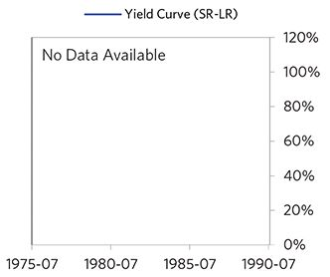

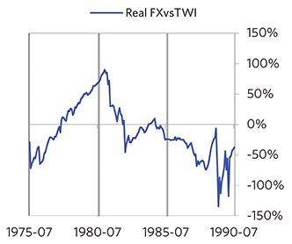

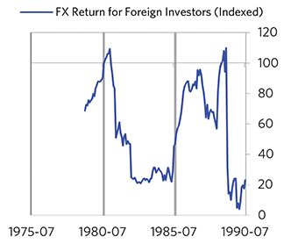

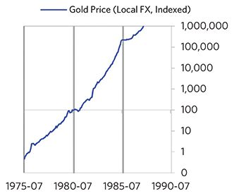

#### External Position

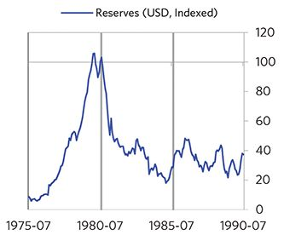

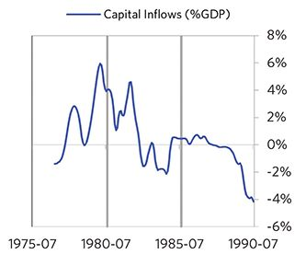

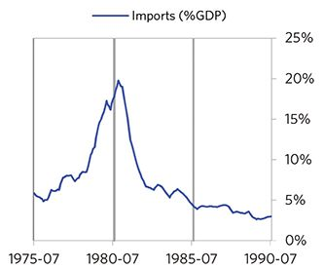

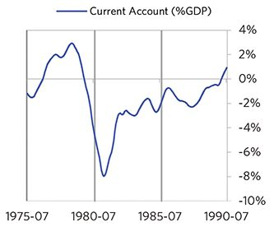

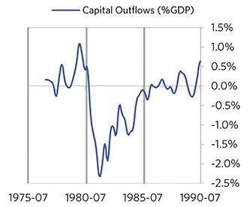

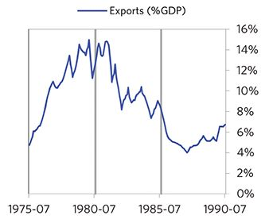

### Brazil 1977–1987 Case Auto-Summary

As show in the charts below, Brazil experienced a classic inflationary deleveraging cycle between 1977 and 1987.

#### The Bubble Phase

Unlike many other cases, Brazil didn’t experience a broad-based bubble in the years before the crisis, but it was tied to other countries, economies, and financial markets that were experiencing bubble-like conditions. And it did build up a substantial debt stock driven by unsustainably strong capital inflows, with debts reaching 158% of GDP prior to the crisis. In this case, a high share of the debt was in foreign currencies (70% of GDP)—leaving Brazil with a large exposure to a pullback in foreign capital. Brazil also became somewhat dependent on continuous foreign financing, running a current account deficit of 5% of GDP (with investment inflows averaging 6% of GDP in the years before the crisis). Ultimately, these high debts and Brazil’s dependence on foreign financing, combined with the weakened conditions of related countries, created an unsustainable situation.

#### The Depression Phase

Eventually the cycle turned, producing a self-reinforcing bust and a balance of payments/currency crisis, which ran from 1980 to 1983. High debt levels left Brazil vulnerable to a shock—which came in the form of the 1980s Latin American Debt Crisis. Brazil suffered a fall in foreign funding (with capital inflows falling by 5% of GDP), leading to a tightening (policy makers hiked short rates by 234%) and a meaningful decline in the currency (real FX fell by 20%)—which coincided with self-reinforcing declines in GDP (falling by 6%), and in stock prices (falling by 51%). In addition, currency weakness contributed to very high and rising inflation, peaking at 124% during the depression phase, which is high compared to other similar cases. That makes sense given that Brazil had most of the classic “risk factors” for bigger inflation spirals (with the biggest risk factor being low real short rates). Brazil’s financial institutions also came under considerable pressure. Meanwhile, the central bank spent down its reserves to defend the currency (drawing down reserves by 70%), though it eventually abandoned its currency defense. As shown in the attribution chart to the right, even though Brazil needed a deleveraging, its debt as a % GDP went up by 54% (18% annualized), in part because the currency fell (which increased the burden of foreign-de- nominated debts) and in part because the government had to borrow more in response to the crisis (with a peak fiscal deficit of 11% of GDP).

The gauges below are composed from a compendium of stats shown in the chart deck that follows. Note these are meant to be rough measures.

*The first two charts show gauges which measure bubble/depression conditions and tightness/easiness of money and credit. For each gauge, the difference from zero conveys the extent of the bubble while the crossing above/below zero represents the shifting into or out of the bubble.

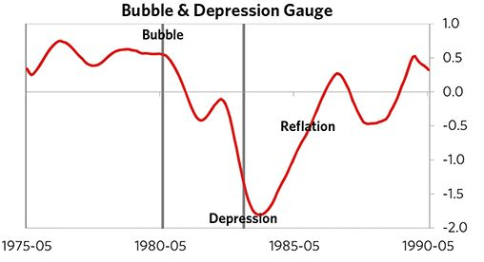

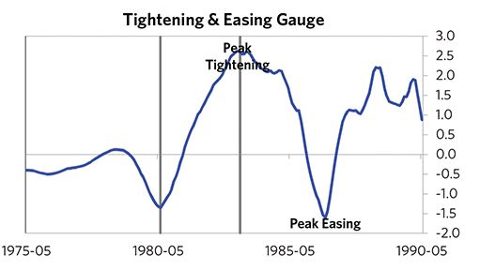

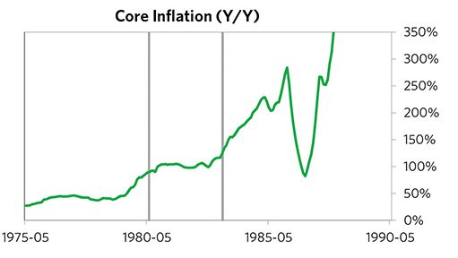

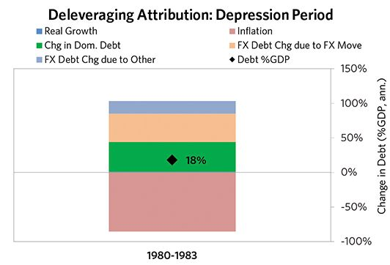

#### The Reflation Phase

A key determinant of how balance of payments/currency crises play out is how policy makers respond to adverse capital flows: whether they let their currency go and allow a tightening of financial conditions to flow through (painful but typically necessary to resolve the crisis), or print money to make up for money leaving (which can be inflationary). In this case, they abandoned the currency peg and, after a slightly longer than average “ugly” phase, policy makers allowed enough tightening to flow through to reduce spending on imports (the current account balance improved by 3% of GDP), and make the currency more attractive to hold. Brazil was aggressive in managing its financial institutions and bad debts, pulling 4 out of 9 classic policy levers. In particular, it nationalized banks and provided liquidity. It also benefited from an IMF assistance program. As shown in the attribution chart to the right, debt as a % of GDP fell by 121% (27% annualized) over the course of this adjustment period. The reduction in debt-to-income ratios came mostly from nominal income rising. Meanwhile, Brazil’s now lower currency (with real FX bottoming at -33% during the beautiful period) set up the country for renewed competitiveness. It took 4 years before real GDP reached its prior peak and equity prices in USD terms recovered within 1.9 years.

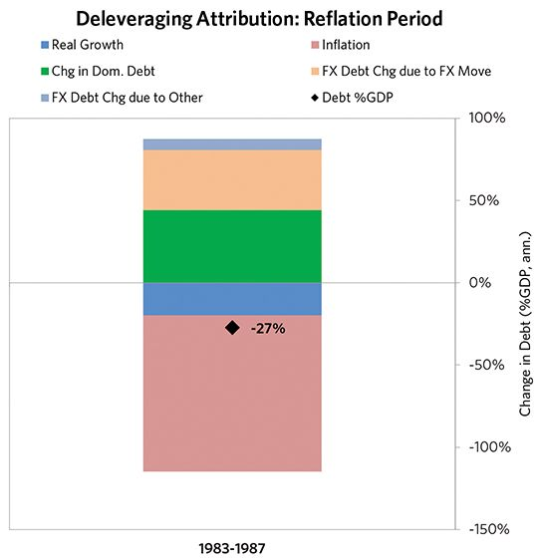

### Brazil 1977–1987 Chart Deck Appendix

#### Indebtedness

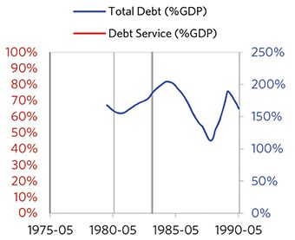

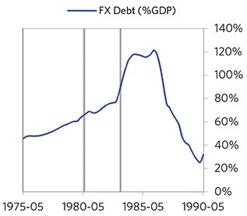

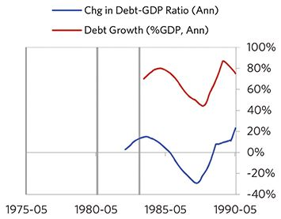

#### Monetary and Fiscal Policy

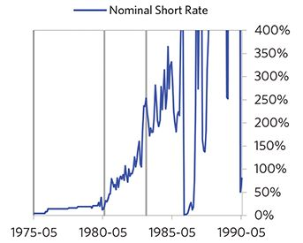

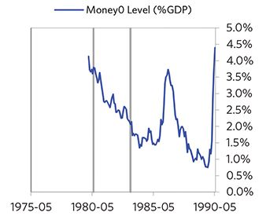

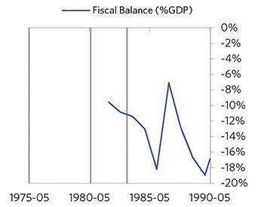

#### Economic Conditions

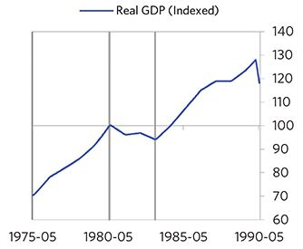

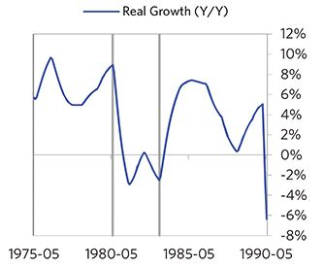

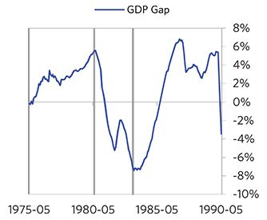

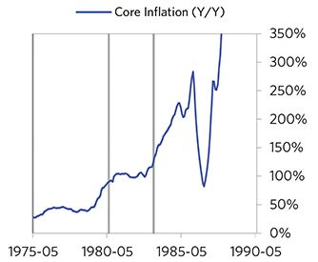

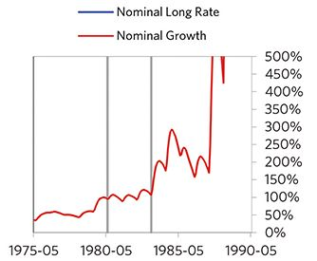

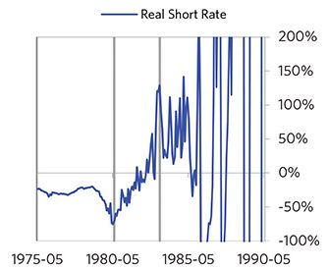

#### Markets

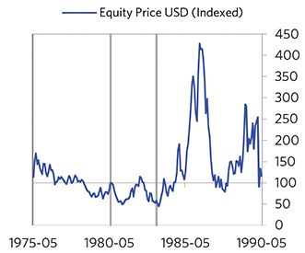

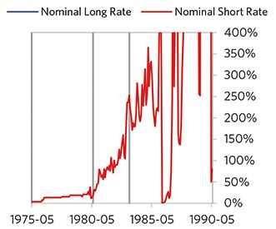

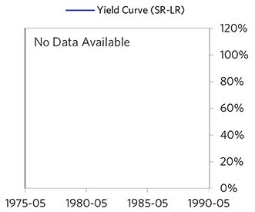

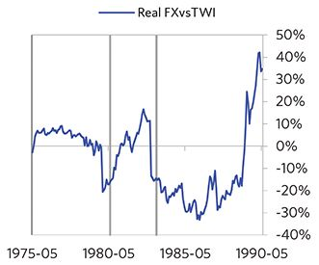

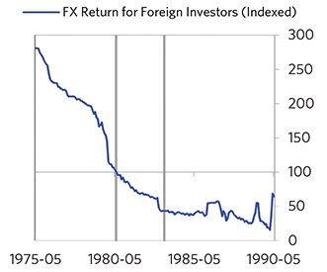

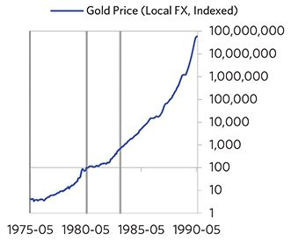

#### External Position

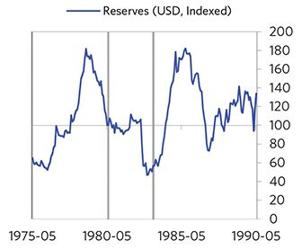

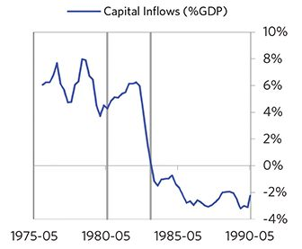

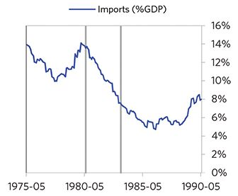

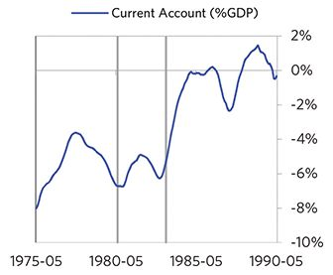

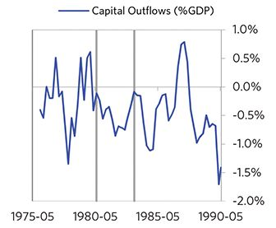

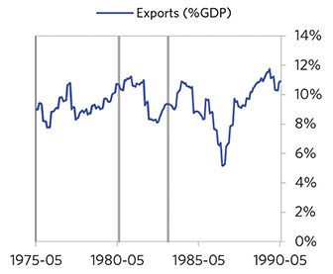

### Chile 1978–1995 Case Auto-Summary

As show in the charts below, Chile experienced a classic inflationary deleveraging cycle between 1978 and 1995.

#### The Bubble Phase

Between 1978 and 1981, Chile experienced a bubble that was driven by a self-reinforcing cycle of unsustainably strong capital inflows, rising debt, strong equity returns, and strong growth. Debts rose by 86% of GDP during the bubble to a pre-crisis peak of 145% of GDP. In this case, a high share of the debt was in foreign currencies (32% of GDP)—leaving Chile with a large exposure to a pullback in foreign capital. During the bubble phase, investment inflows were strong, averaging around 14% of GDP, which helped to finance a current account deficit of 11% of GDP. Aided by that rising debt and capital, growth was strong (at 7%), while levels of economic activity were high (the GDP gap peaked at 11%). Furthermore, strong asset returns (equities averaged 36% annualized returns over the bubble period) encouraged more borrowing and helped to stimulate growth. Competitiveness became an issue, as Chile’s real FX peaked at +36%. Taken together, these bubble pressures and Chile’s dependence on foreign financing, combined with the weakened conditions of related countries, created an unsustainable situation.

#### The Depression Phase

Eventually the dynamic turned, producing a self-reinforcing bust and a balance of payments/currency crisis, which ran from 1981 to 1985. At its pre-crisis peak, debt service reached 45% of GDP, making Chile vulnerable to a shock—which came in the form of the 1980s Latin American Debt Crisis. Chile suffered a fall in foreign funding (with capital inflows falling by 40% of GDP), leading to a tightening (policy makers hiked short rates by 31%) and a meaningful decline in the currency (real FX fell by 50%)—which coincided with self-reinforcing declines in GDP (falling by 14%), and in stock prices (falling by 74%). In addition, currency weakness contributed to high and rising inflation, peaking at 33% during the depression phase, which is normal compared to other similar cases. That’s true despite the fact that Chile had most of the classic “risk factors” for bigger inflation spirals (with the biggest risk factor being a long history of poorly-controlled inflation). Chile’s financial institutions also came under considerable pressure. Meanwhile, the central bank spent down its reserves to defend the currency (drawing down reserves by 53%), though it eventually abandoned its currency defense. As shown in the attribution chart to the right, even though Chile needed a deleveraging, its debt as a % GDP went up by 73% (19% annualized), in part because the currency fell (which increased the burden of foreign-denominated debts) and in part because the government had to borrow more in response to the crisis (with a peak fiscal deficit of 4% of GDP).

The gauges below are composed from a compendium of stats shown in the chart deck that follows. Note these are meant to be rough measures.

*The first two charts show gauges which measure bubble/depression conditions and tightness/easiness of money and credit. For each gauge, the difference from zero conveys the extent of the bubble while the crossing above/below zero represents the shifting into or out of the bubble.

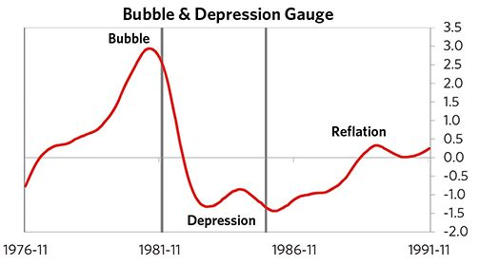

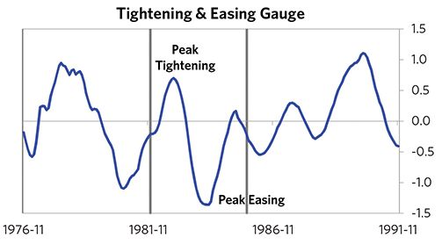

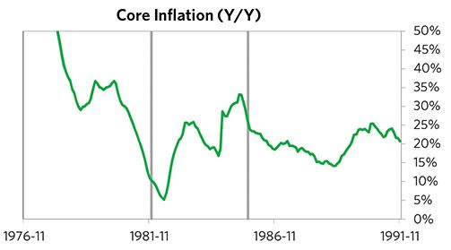

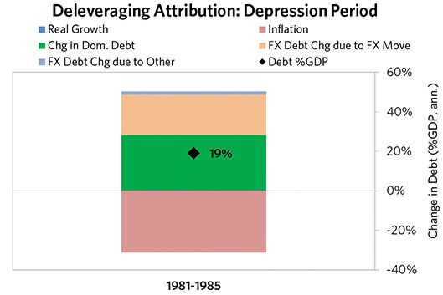

#### The Reflation Phase

A key determinant of how balance of payments/currency crises play out is how policy makers respond to adverse capital flows: whether they let their currency go and allow a tightening of financial conditions to flow through (painful but typically necessary to resolve the crisis), or print money to make up for money leaving (which can be inflationary). In this case, they abandoned the currency peg and, after a slightly longer than average “ugly” phase, policy makers allowed enough tightening to flow through to reduce spending on imports (the current account balance improved by 11% of GDP), and make the currency more attractive to hold. Chile was aggressive in managing its financial institu- tions and bad debts, pulling 5 out of 9 classic policy levers. In particular, it provided liquidity and directly purchased troubled assets. It also benefited from an IMF assistance program and enacted structural reforms designed to increase labor market flexibility. As shown in the attribution chart to the right, debt as a % of GDP fell by 129% (13% annualized) over the course of this adjustment period. The reduction in debt-to-income ratios came mostly from nominal income rising. Meanwhile, Chile’s now much lower currency (with real FX bottoming at -32% during the beautiful period) set up the country for renewed competitiveness. It took 5 years before real GDP reached its prior peak and equity prices in USD terms recovered within 9 years.

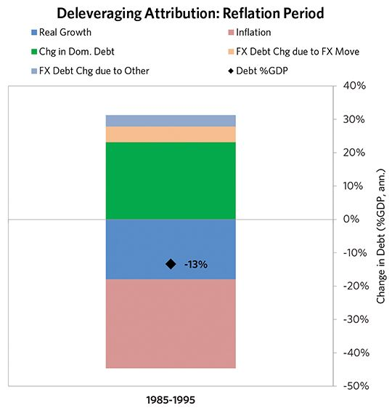

### Chile 1978–1995 Chart Deck Appendix

#### Indebtedness

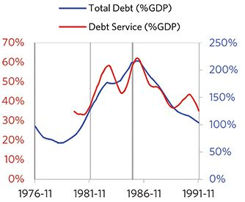

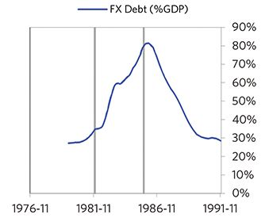

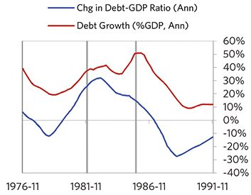

#### Monetary and Fiscal Policy

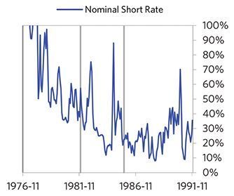

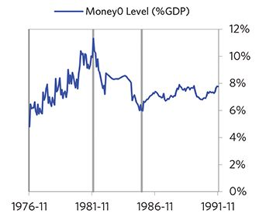

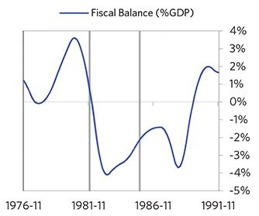

#### Economic Conditions

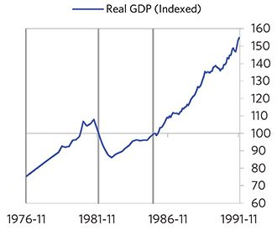

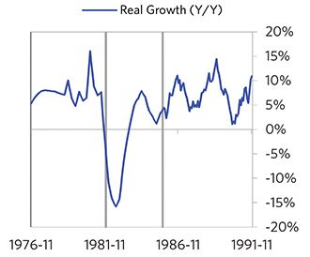

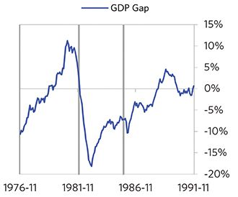

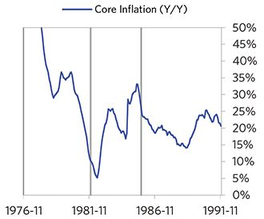

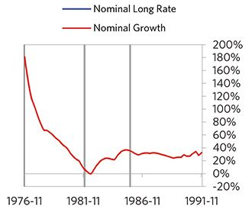

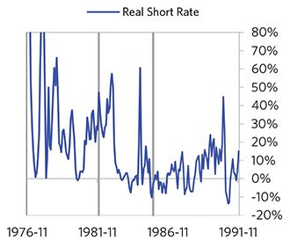

#### Markets

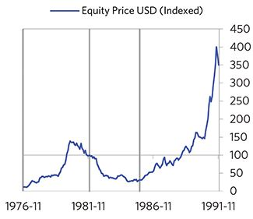

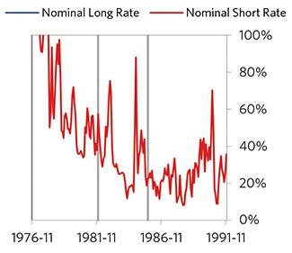

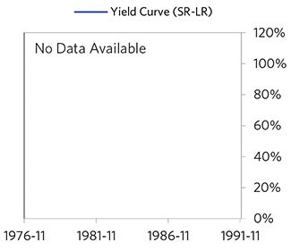

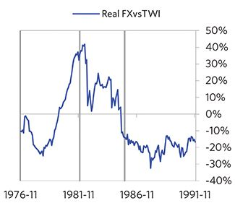

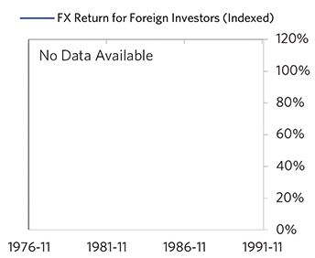

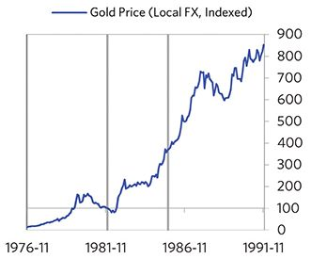

#### External Position

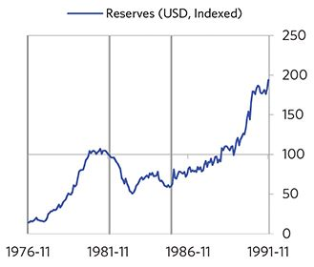

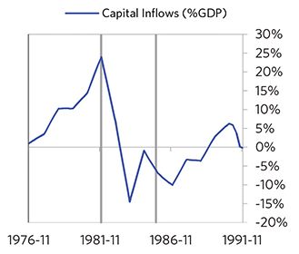

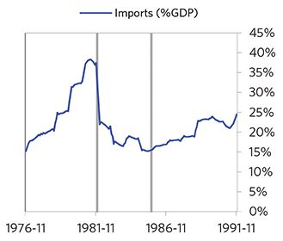

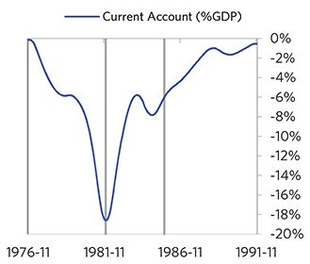

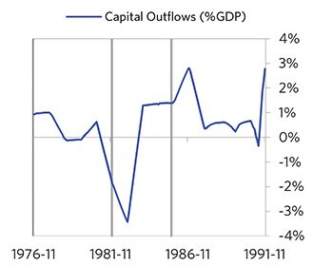

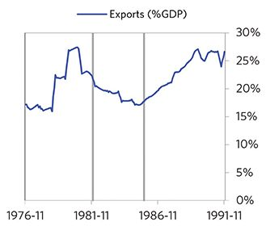

### Mexico 1979–1991 Case Auto-Summary

As show in the charts below, Mexico experienced a classic inflationary deleveraging cycle between 1979 and 1991.

#### The Bubble Phase

Between 1979 and 1981, Mexico experienced a bubble that was driven by a self-reinforcing cycle of unsustainably strong capital inflows, rising debt and strong growth. By the bubble’s end, debts had reached a pre-crisis peak of 65% of GDP. In this case, a high share of the debt was in foreign currencies (26% of GDP)—leaving Mexico with a large exposure to a pullback in foreign capital. During the bubble phase, investment inflows were strong, averaging around 8% of GDP, which helped to finance a current account deficit of 6% of GDP. Aided by that rising debt and capital, growth was strong (at 9%), while levels of economic activity were high (the GDP gap peaked at 9%). Competitiveness became an issue, as Mexico’s real FX peaked at +30%. Taken together, these bubble pressures and Mexico’s dependence on foreign financing, combined with the weakened conditions of related countries, created an unsustainable situation.

#### The Depression Phase

Eventually the dynamic turned, producing a self-reinforcing bust and a balance of payments/currency crisis, which ran from 1981 to 1987. At its pre-crisis peak, debt service reached 31% of GDP, making Mexico vulnerable to a shock—which came in the form of the 1980s Latin American Debt Crisis and falling oil prices. Mexico suffered a fall in foreign funding (with capital inflows falling by 17% of GDP), leading to a tightening (policy makers hiked short rates by 128%) and a meaningful decline in the currency (real FX fell by 74%)—which coincided with self-reinforcing declines in GDP (falling by 7%), and in stock prices (falling by 86%). In addition, currency weakness contributed to very high and rising inflation, peaking at 151% during the depression phase, which is high compared to other similar cases. That makes sense given that Mexico had most of the classic “risk factors” for bigger inflation spirals (with the biggest risk factor being their fiscal deficit). Mexico’s financial institutions also came under considerable pressure. Meanwhile, the central bank spent down its reserves to defend the currency (drawing down reserves by 66%), though it eventually abandoned its currency defense. As shown in the attribution chart to the right, even though Mexico needed a deleveraging, its debt as a % GDP went up by 41% (7% annualized), in part because the currency fell (which increased the burden of foreign-de- nominated debts) and in part because the government had to borrow more in response to the crisis (with a peak fiscal deficit of 13% of GDP).

The gauges below are composed from a compendium of stats shown in the chart deck that follows. Note these are meant to be rough measures.

*The first two charts show gauges which measure bubble/depression conditions and tightness/easiness of money and credit. For each gauge, the difference from zero conveys the extent of the bubble while the crossing above/below zero represents the shifting into or out of the bubble.

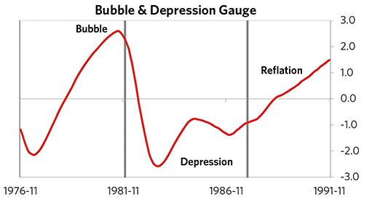

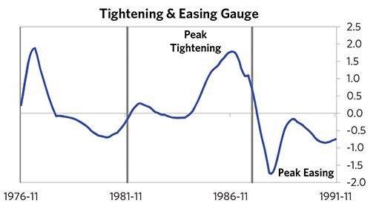

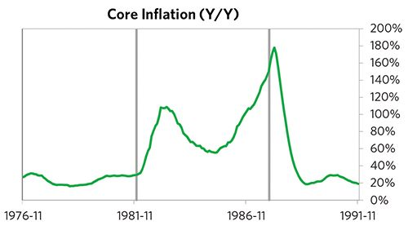

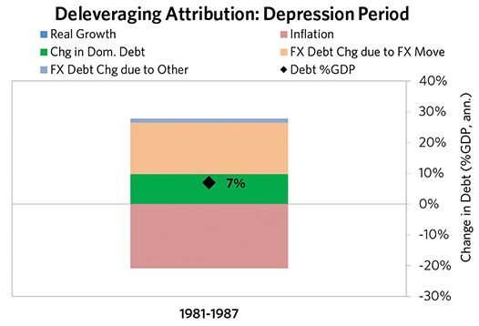

#### The Reflation Phase

A key determinant of how balance of payments/currency crises play out is how policy makers respond to adverse capital flows: whether they let their currency go and allow a tightening of financial conditions to flow through (painful but typically necessary to resolve the crisis), or print money to make up for money leaving (which can be inflationary). In this case, they abandoned the currency peg and, after a relatively long “ugly” phase, policy makers allowed enough tightening to flow through to reduce spending on imports (the current account balance improved by 10% of GDP), and make the currency more attractive to hold. Mexico was not aggressive in managing its financial institutions and bad debts, pulling 2 out of 9 classic policy levers. It also benefited from an IMF assistance program and enacted structural reforms designed to increase labor market flexibility. As shown in the attribution chart to the right, debt as a % of GDP fell by 31% (8% annualized) over the course of this adjustment period. The reduction in debt-to-income ratios came mostly from nominal income rising. Meanwhile, Mexico’s now much lower currency (with real FX bottoming at -44% during the beautiful period) set up the country for renewed competitiveness. It took 7 years before real GDP reached its prior peak and equity prices in USD terms recovered within 6 years.

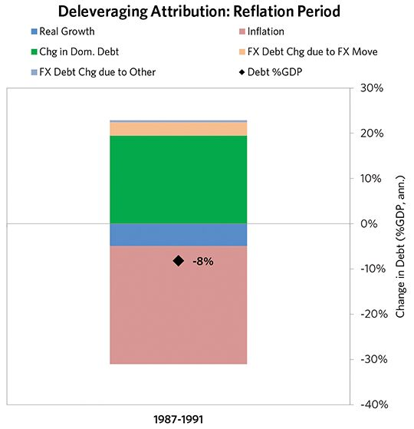

### Mexico 1979–1991 Chart Deck Appendix

#### Indebtedness

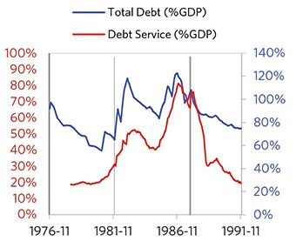

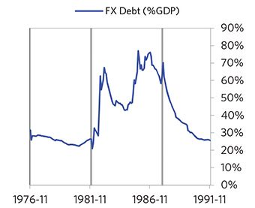

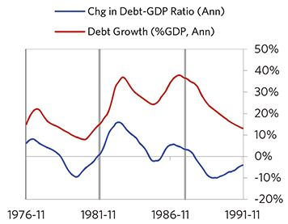

#### Monetary and Fiscal Policy

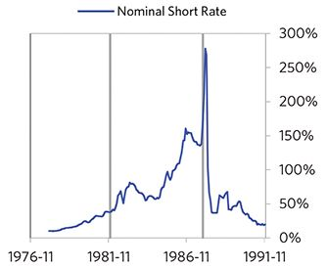

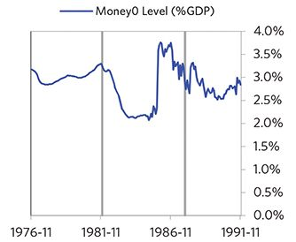

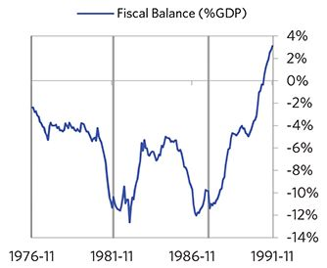

#### Economic Conditions

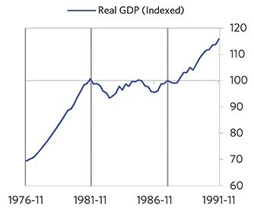

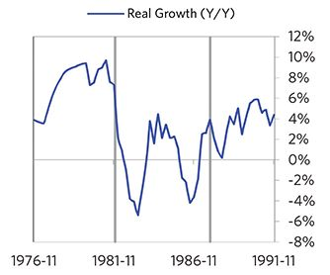

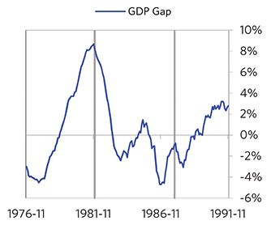

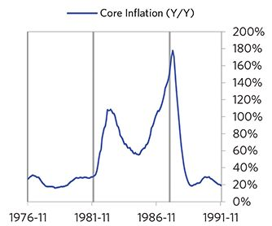

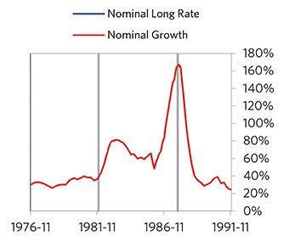

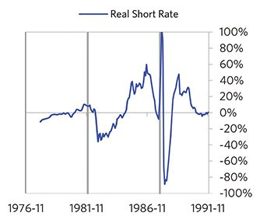

#### Markets

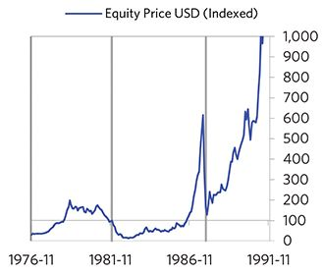

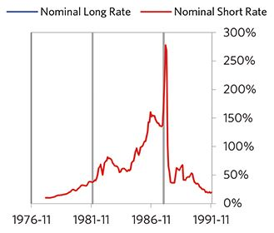

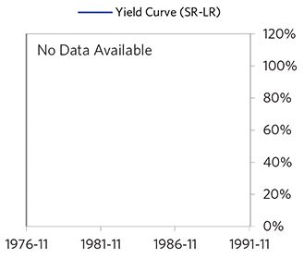

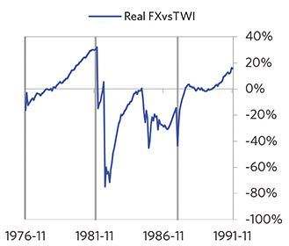

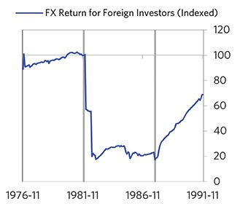

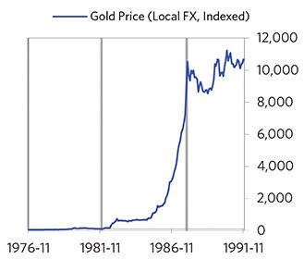

#### External Position

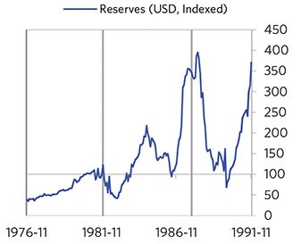

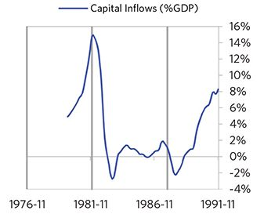

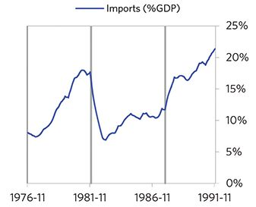

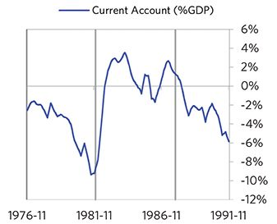

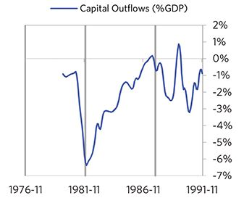

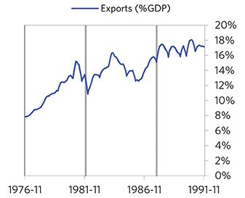

### Peru 1980–1986 Case Auto-Summary

As show in the charts below, Peru experienced a classic inflationary deleveraging cycle between 1980 and 1986.

#### The Bubble Phase

Unlike many other cases, Peru didn’t experience a broad- based bubble in the years before the crisis, but it was tied to other countries, economies, and financial markets that were experiencing bubble-like conditions. And it did build up a substantial debt stock, with debts reaching 107% of GDP prior to the crisis. In this case, a high share of the debt was in foreign currencies (106% of GDP)—leaving Peru with a large exposure to a pullback in foreign capital. Peru also became somewhat dependent on continuous foreign financing, running a current account deficit of 4%. Ultimately, these high debts and Peru’s dependence on foreign financing, combined with the weakened conditions of related countries, created an unsustainable situation.

#### The Depression Phase

Eventually the cycle turned, producing a self-reinforcing bust and a balance of payments/currency crisis, which ran from 1982 to 1985. High debt levels left Peru vulnerable to a shock—which came in the form of the 1980s Latin American Debt Crisis. Peru suffered from self-reinforcing declines in GDP (falling by 13%), and in stock prices (falling by 56%). Unemployment rates increased by 5%, while currency weakness contributed to very high and rising inflation, peaking at 190% during the depression phase, which is high compared to other similar cases. That makes sense given that Peru had most of the classic “risk factors” for bigger inflation spirals (with the biggest risk factor being low real short rates). Peru’s financial institutions also came under considerable pressure. Meanwhile, the central bank spent down its reserves to defend the currency (drawing down reserves by 44%), though by the end policy makers had abandoned their currency defense and the currency had fallen by 53%. As shown in the attribution chart to the right, even though Peru needed a deleveraging, its debt as a % GDP went up by 163% (42% annualized), in part because the currency fell (which increased the burden of foreign-de- nominated debts) and in part because the government had to borrow more in response to the crisis (with a peak fiscal deficit of 5% of GDP).

The gauges below are composed from a compendium of stats shown in the chart deck that follows. Note these are meant to be rough measures.

*The first two charts show gauges which measure bubble/depression conditions and tightness/easiness of money and credit. For each gauge, the difference from zero conveys the extent of the bubble while the crossing above/below zero represents the shifting into or out of the bubble.

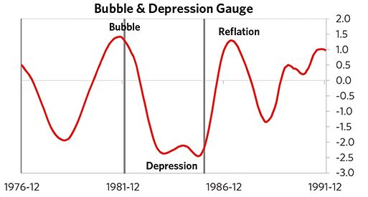

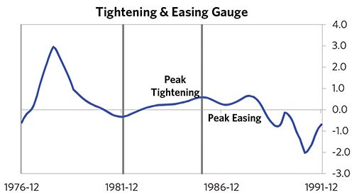

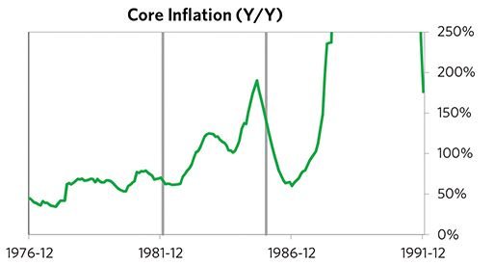

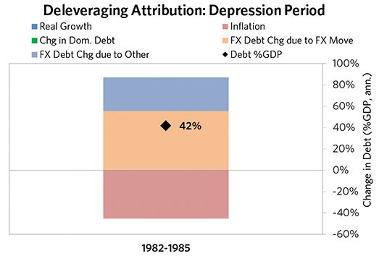

#### The Reflation Phase

A key determinant of how balance of payments/currency crises play out is how policy makers respond to adverse capital flows: whether they let their currency go and allow a tightening of financial conditions to flow through (painful but typically necessary to resolve the crisis), or print money to make up for money leaving (which can be inflationary). In this case, they abandoned the currency peg and, after a slightly longer than average “ugly” phase, policy makers allowed enough tightening to flow through to reduce spending on imports (the current account balance improved by 13% of GDP), and make the currency more attractive to hold. Peru was somewhat aggressive in managing its financial institutions and bad debts, pulling 3 out of 9 classic policy levers. In particular, it nationalized banks and provided liquidity. It also benefited from an IMF assistance program and enacted structural reforms designed to increase labor market flexibility. As shown in the attribution chart to the right, debt as a % of GDP fell by 88% (88% annualized) over the course of this adjustment period. The reduction in debt-to-income ratios came mostly from nominal income rising. Meanwhile, Peru’s now much lower currency (with real FX bottoming at -46% during the beautiful period) set up the country for renewed competitiveness. It took 4 years before real GDP reached its prior peak and equity prices in USD terms recovered within 6 years.

The crisis had a notable impact on the politics of Peru, as it helped set the stage for Alan Garcia Perez, whom many people consider a populist leader, to take power.

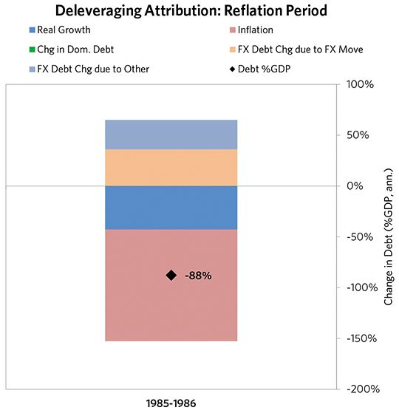

### Peru 1980–1986 Chart Deck Appendix

#### Indebtedness

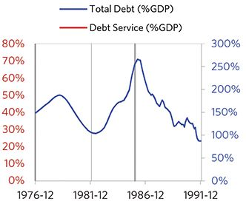

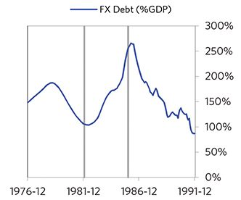

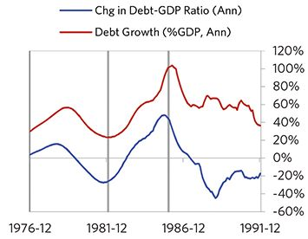

#### Monetary and Fiscal Policy

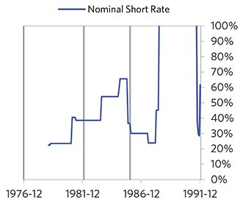

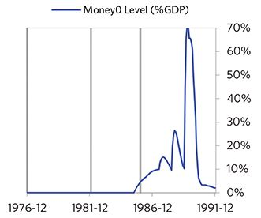

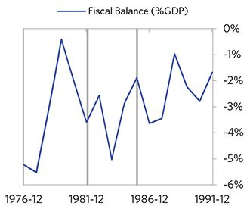

#### Economic Conditions

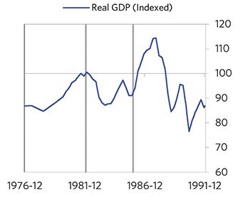

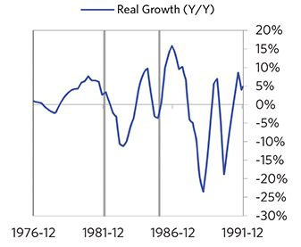

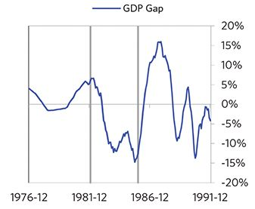

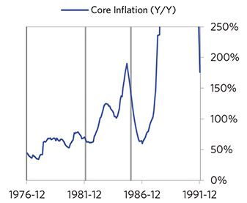

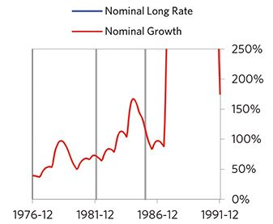

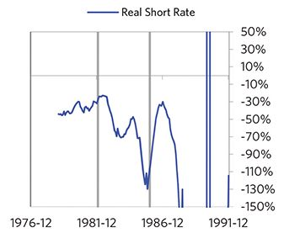

#### Markets

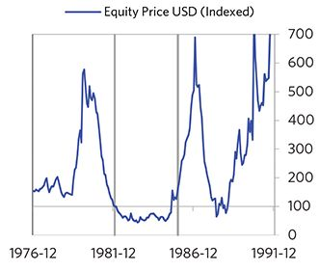

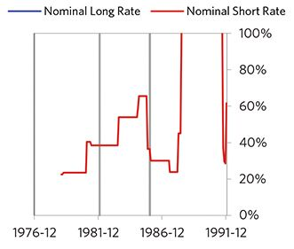

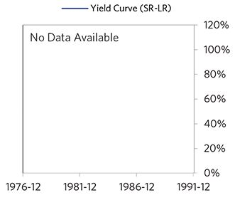

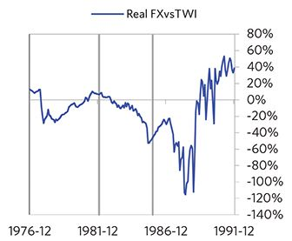

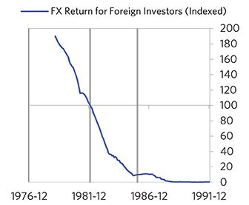

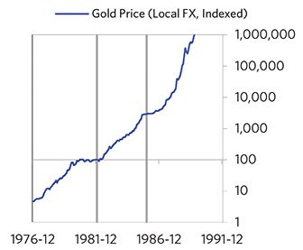

#### External Position

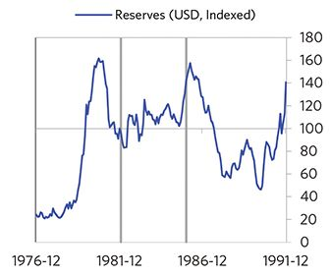

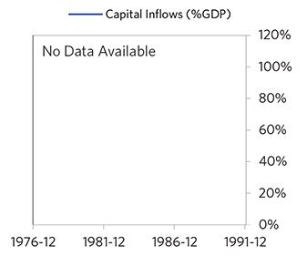

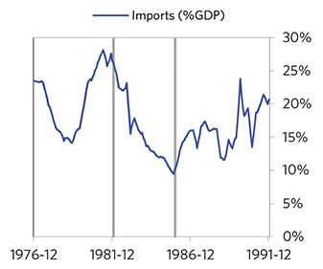

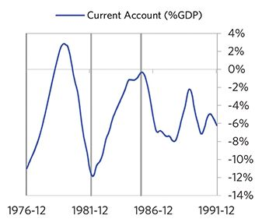

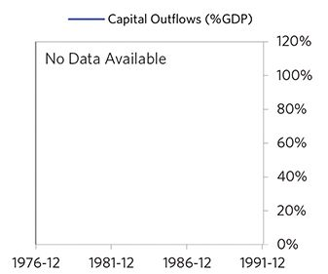

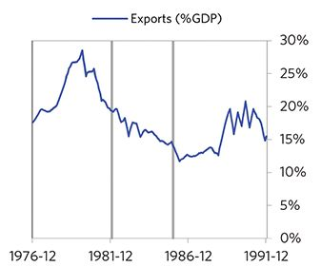

### Philippines 1979–1992 Case Auto-Summary

As show in the charts below, the Philippines experienced a transitory inflationary deleveraging cycle between 1979 and 1992. This is also a classic example of a country “letting its currency go” in the face of external pressures, which produces some temporary inflation but ultimately gives policy makers more flexibility to set interest rates.

#### The Bubble Phase

Between 1979 and 1982, the Philippines experienced a bubble that was most characterized by unsustainably strong capital inflows and strong currency returns. Debts rose by 16% of GDP during the bubble to a pre-crisis peak of 77% of GDP. In this case, a high share of the debt was in foreign currencies (56% of GDP)—leaving the Philippines with a large exposure to a pullback in foreign capital. During the bubble phase, investment inflows were strong, averaging around 9% of GDP, which helped to finance a current account deficit of 7% of GDP. Aided by that rising debt and capital, growth was strong (at 4%), while levels of economic activity were high (the GDP gap peaked at 9%). Competitiveness became an issue, as the Philippines’s real FX peaked at +18%. Taken together, these bubble pressures and the Philippines’s dependence on foreign financing created an unsustainable situation.

#### The Depression Phase

Eventually the dynamic turned, producing a self-reinforcing bust and a balance of payments/currency crisis, which ran from 1982 to 1984. High debt levels left the Philippines vulnerable to a shock—which came in the form of rapidly declining commodity prices and political violence. The Philippines suffered a fall in foreign funding (with capital inflows falling by 9% of GDP), leading to a tightening (policy makers hiked short rates by 34%) and a meaningful decline in the currency (real FX fell by 16%)—which coincided with self-reinforcing declines in GDP (falling by 11%), and in stock prices (falling by 71%). In addition, currency weakness contributed to high and rising inflation, peaking at 58% during the depression phase, which is normal compared to other similar cases. That makes sense given that the Philippines had around half of the classic “risk factors” for bigger inflation spirals (with the biggest risk factor being high foreign-denominated debts). The Philippines’s financial institutions also came under considerable pressure. Meanwhile, the central bank spent down its reserves to defend the currency (drawing down reserves by 100%), though it eventually abandoned its currency defense. As shown in the attribution chart to the right, even though the Philippines needed a deleveraging, its debt as a % GDP was roughly flat through this period.

The gauges below are composed from a compendium of stats shown in the chart deck that follows. Note these are meant to be rough measures.

*The first two charts show gauges which measure bubble/depression conditions and tightness/easiness of money and credit. For each gauge, the difference from zero conveys the extent of the bubble while the crossing above/below zero represents the shifting into or out of the bubble.

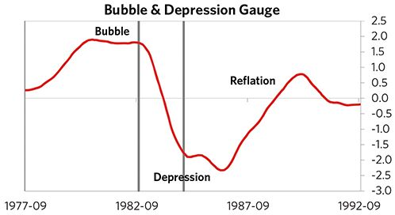

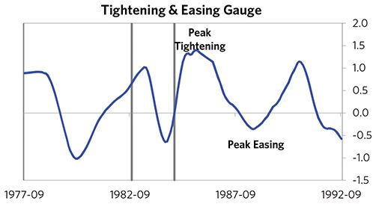

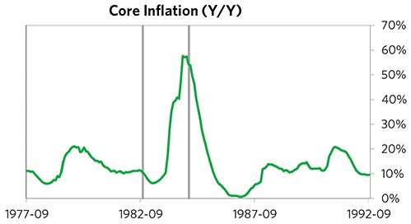

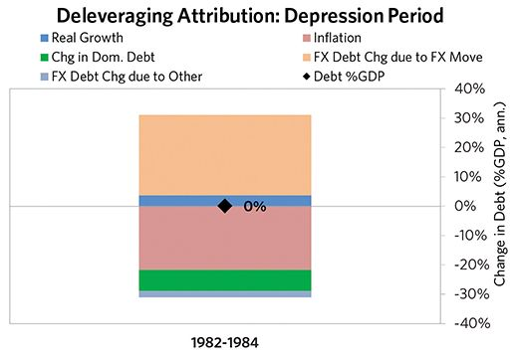

#### The Reflation Phase

A key determinant of how balance of payments/currency crises play out is how policy makers respond to adverse capital flows: whether they let their currency go and allow a tightening of financial conditions to flow through (painful but typically necessary to resolve the crisis), or print money to make up for money leaving (which can be inflationary). In this case, they abandoned the currency peg and, after a slightly shorter than average “ugly” phase, policy makers allowed enough tightening to flow through to reduce spending on imports (the current account balance improved by 7% of GDP), and make the currency more attractive to hold. The Philippines was very aggressive in managing its financial institutions and bad debts, pulling 7 out of 9 classic policy levers. In particular, it nationalized banks, provided liquidity, and directly purchased troubled assets. It also benefited from an IMF assistance program and enacted structural reforms designed to increase labor market flexibility. As shown in the attribution chart to the right, debt as a % of GDP fell by 9% (1% annualized) over the course of this adjustment period. The reduction in debt-to-income ratios came mostly from nominal income rising. Meanwhile, the Philippines’s now lower currency (with real FX bottoming at -19% during the beautiful period) set up the country for renewed competitiveness. It took 6 years before real GDP reached its prior peak and equity prices in USD terms recovered within 5 years.

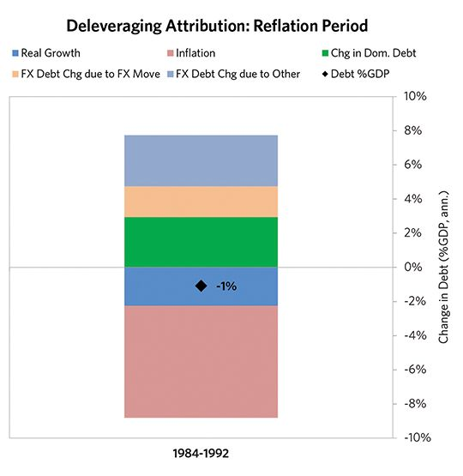

### Philippines 1979–1992 Chart Deck Appendix

#### Indebtedness

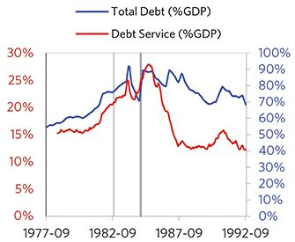

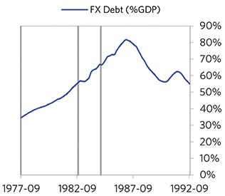

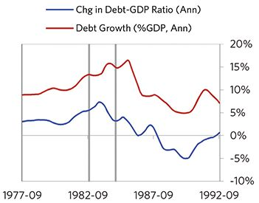

#### Monetary and Fiscal Policy

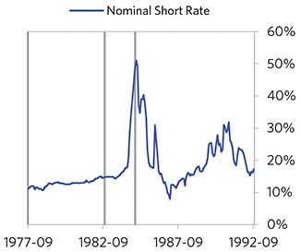

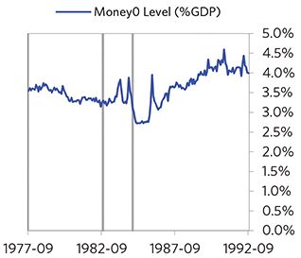

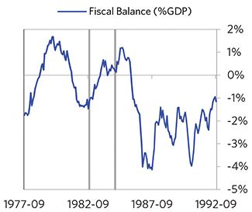

#### Economic Conditions

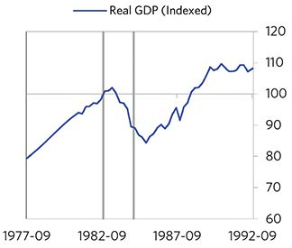

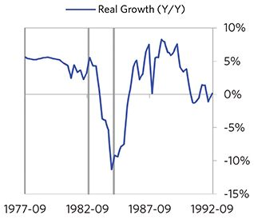

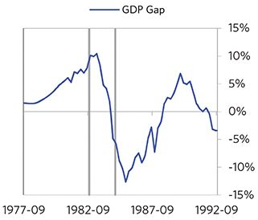

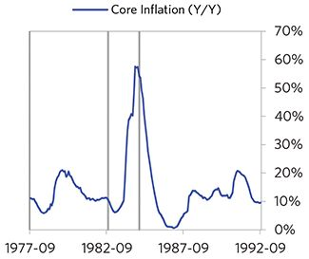

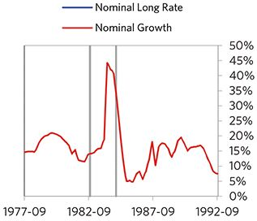

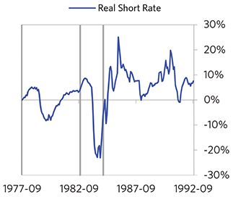

#### Markets

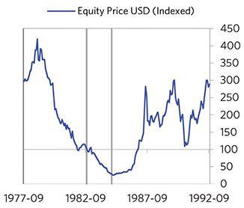

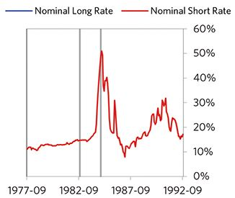

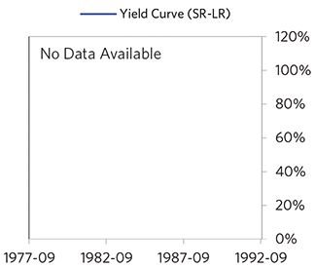

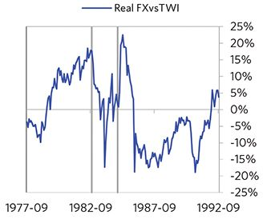

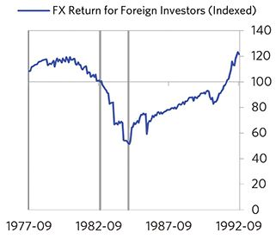

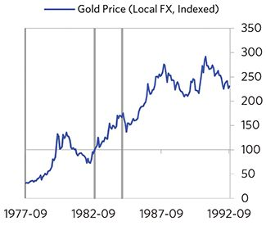

#### External Position

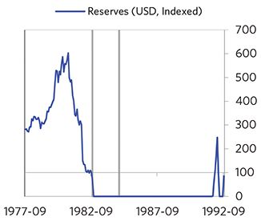

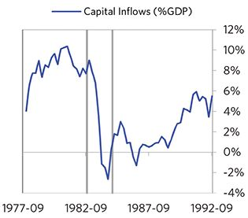

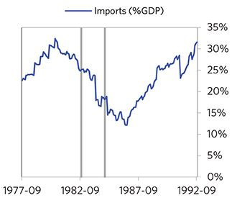

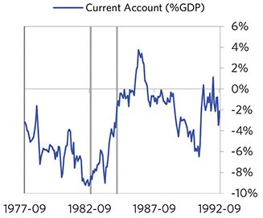

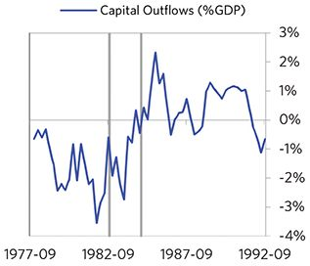

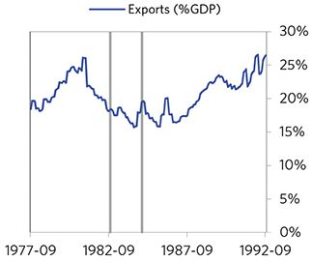

### Malaysia 1981–1990 Case Auto-Summary

As show in the charts below, Malaysia experienced a transitory inflationary deleveraging cycle between 1981 and 1990. This is also a classic example of a country “letting its currency go” in the face of external pressures, which produces some temporary inflation but ultimately gives policy makers more flexibility to set interest rates.

#### The Bubble Phase

Between 1981 and 1984, Malaysia experienced a bubble that was driven by a self-reinforcing cycle of unsustainably strong capital inflows, rising debt and strong growth. Debts rose by 40% of GDP during the bubble to a pre-crisis peak of 153% of GDP. In this case, a high share of the debt was in foreign currencies (42% of GDP)—leaving Malaysia with a large exposure to a pullback in foreign capital. During the bubble phase, investment inflows were strong, averaging around 14% of GDP, which helped to finance a current account deficit of 10% of GDP. Aided by that rising debt and capital, growth was strong (at 7%), while levels of economic activity were high (the GDP gap peaked at 3%). Competitiveness became an issue, as Malaysia’s real FX peaked at +20%. Taken together, these bubble pressures and Malaysia’s dependence on foreign financing, combined with the weakened conditions of related countries, created an unsustainable situation.

#### The Depression Phase

Eventually the dynamic turned, producing a self-reinforcing bust and a balance of payments/currency crisis, which ran from 1984 to 1987. High debt levels left Malaysia vulnerable to a shock—which came in the form of commodity price declines hitting exports. Malaysia suffered a fall in foreign funding (with capital inflows falling by 11% of GDP), leading to a meaningful decline in the currency (real FX fell by 19%)—which coincided with self-reinforcing declines in stock prices (falling by 56%). Unemployment rates increased by 2%. Malaysia’s financial institutions also came under considerable pressure. Meanwhile, the central bank spent down its reserves to defend the currency (drawing down reserves by 26%), though it eventually abandoned its currency defense. As shown in the attribution chart to the right, even though Malaysia needed a deleveraging, its debt as a % GDP went up by 43% (17% annualized), in part because the currency fell (which increased the burden of foreign-denominated debts) and in part because the government had to borrow more in response to the crisis (with a peak fiscal deficit of 10% of GDP).

The gauges below are composed from a compendium of stats shown in the chart deck that follows. Note these are meant to be rough measures.

*The first two charts show gauges which measure bubble/depression conditions and tightness/easiness of money and credit. For each gauge, the difference from zero conveys the extent of the bubble while the crossing above/below zero represents the shifting into or out of the bubble.

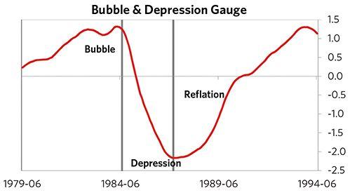

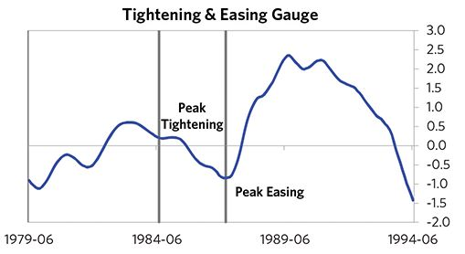

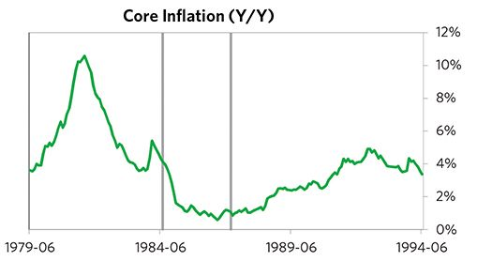

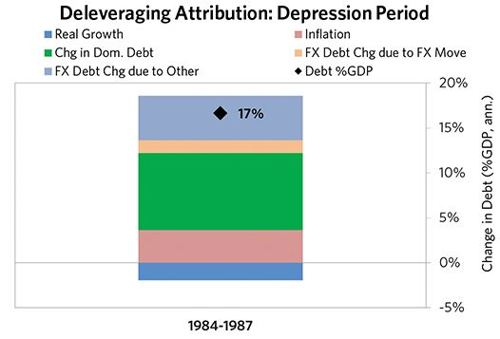

#### The Reflation Phase

A key determinant of how balance of payments/currency crises play out is how policy makers respond to adverse capital flows: whether they let their currency go and allow a tightening of financial conditions to flow through (painful but typically necessary to resolve the crisis), or print money to make up for money leaving (which can be inflationary). In this case, they abandoned the currency peg and, after a slightly shorter than average “ugly” phase, policy makers allowed enough tightening to flow through to reduce spending on imports (the current account balance improved by 9% of GDP), and make the currency more attractive to hold. Malaysia was aggressive in managing its financial institutions and bad debts, pulling 5 out of 9 classic policy levers. In particular, it nationalized banks and provided liquidity. As shown in the attribution chart to the right, debt as a % of GDP fell by 74% (21% annualized) over the course of this adjustment period. The reduction in debt-to-income ratios came mostly from nominal income rising, driven primarily by higher real growth. Meanwhile, Malaysia’s now lower currency (with real FX bottoming at -12% during the beautiful period) set up the country for renewed competitive- ness. It took 1.8 years before real GDP reached its prior peak and equity prices in USD terms recovered within 6 years.

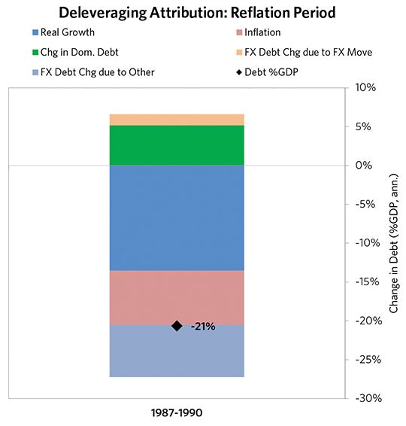

### Malaysia 1981–1990 Chart Deck Appendix

#### Indebtedness

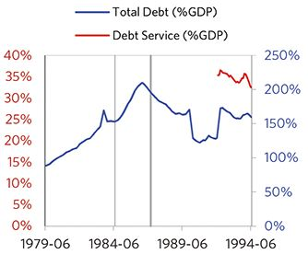

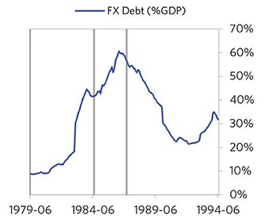

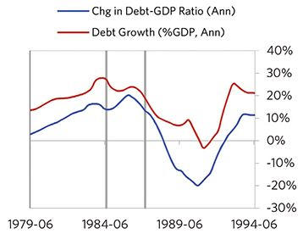

#### Monetary and Fiscal Policy

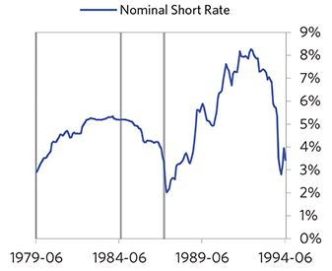

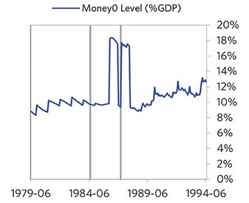

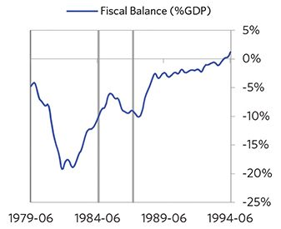

#### Economic Conditions

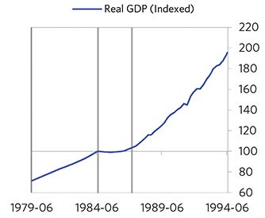

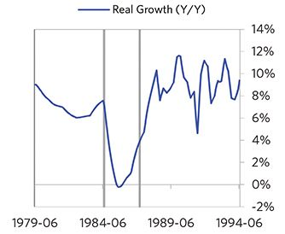

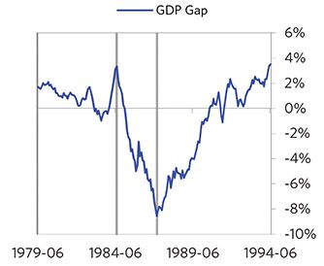

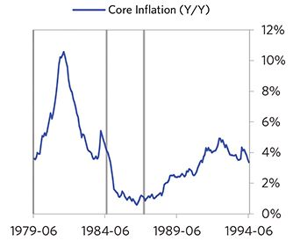

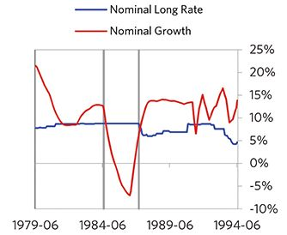

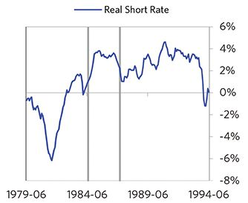

#### Markets

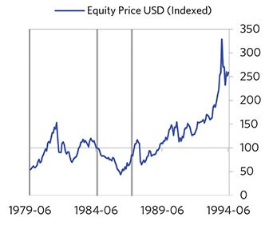

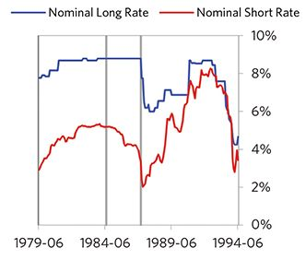

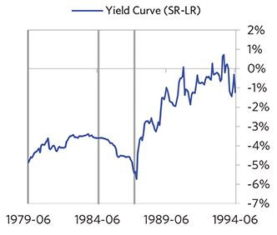

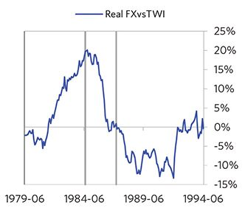

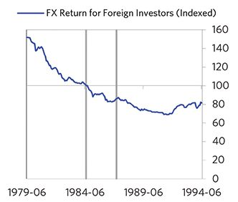

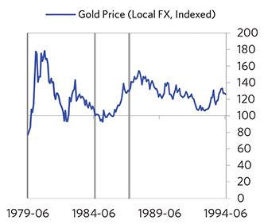

#### External Position

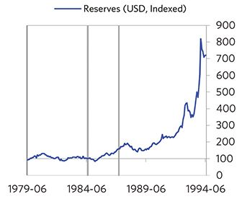

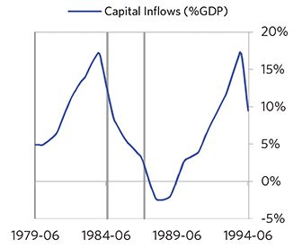

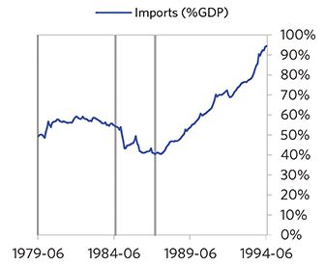

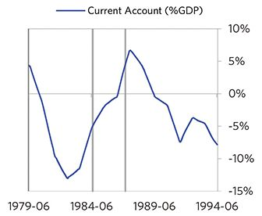

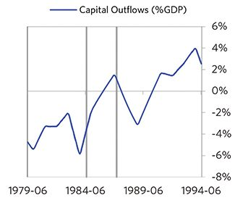

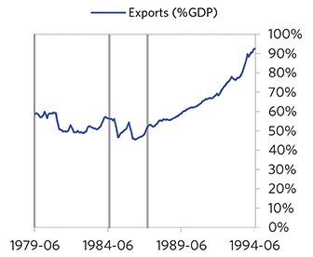

### Peru 1986–1995 Case Auto-Summary

As show in the charts below, Peru experienced a classic hyperinflationary deleveraging cycle between 1986 and 1995.

#### The Bubble Phase

Between 1986 and 1987, Peru experienced a bubble that was driven by a self-reinforcing cycle of rising debt, strong equity returns, and strong growth. Debts rose by 55% of GDP during the bubble to a pre-crisis peak of 184% of GDP. In this case, a high share of the debt was in foreign currencies (182% of GDP)—leaving Peru with a large exposure to a pullback in foreign capital. Peru maintained a current account deficit of 3% of GDP. Aided by that rising debt, growth was strong (at 5%), while levels of economic activity were high (the GDP gap peaked at 11%). Furthermore, strong asset returns (equities averaged 124% annualized returns over the bubble period) encouraged more borrowing and helped to stimulate growth. Taken together, these bubble pressures and Peru’s dependence on foreign financing created an unsustainable situation.

#### The Depression Phase

Eventually the dynamic turned, producing a self-reinforc- ing bust and a balance of payments/currency crisis, which ran from 1987 to 1990. High debt levels left Peru vulnerable to a shock—which came in the form of Peru’s leadership not being willing to cooperate with international creditors. Peru suffered from self-reinforcing declines in GDP (falling by 30%), and in stock prices (falling by 91%). Peru’s financial institutions also came under considerable pressure. Though it was caught in an ugly deleveraging, Peru nevertheless managed to reduce its debt as a %GDP by 106% (30% annualized) through this period (as shown in the attribution chart to the right). The reduction in debt-to-income ratios came mostly from income rising, driven primarily by higher inflation.

The gauges below are composed from a compendium of stats shown in the chart deck that follows. Note these are meant to be rough measures.

*The first two charts show gauges which measure bubble/depression conditions and tightness/easiness of money and credit. For each gauge, the difference from zero conveys the extent of the bubble while the crossing above/below zero represents the shifting into or out of the bubble.

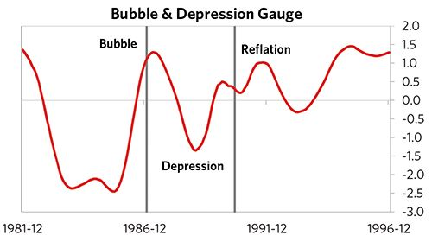

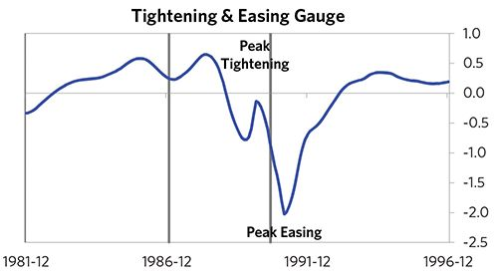

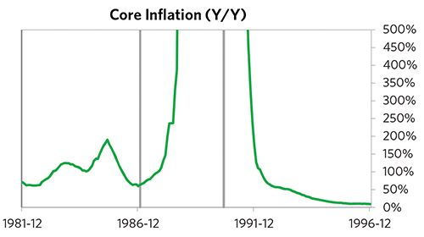

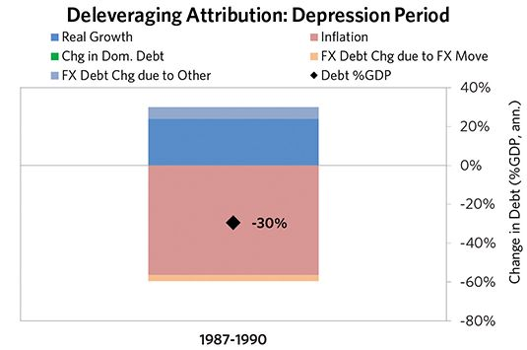

#### The Reflation Phase

A key determinant of how balance of payments/currency crises play out is how policy makers respond to adverse capital flows: whether they allow a tightening of financial conditions to flow through (painful but typically necessary to resolve the crisis), or print money to make up for money leaving (which can be inflationary). In this case, the tightening wasn’t enough to produce the needed adjust- ments before the country fell into a spiral of declining exchange rates and hyperinflation. Real FX bottomed at -115% and inflation peaked at over 10,000%. That makes sense given that Peru had most of the classic “risk factors” for bigger inflation spirals (with the biggest risk factor being low real short rates). Peru was somewhat aggressive in managing its financial institutions and bad debts, pulling 3 out of 9 typical policy levers. In particular, it nationalized banks and provided liquidity. It also enacted structural reforms designed to increase labor market flexibility. But, as is classic, stopping the inflationary spiral ultimately required Peru to make more significant structural changes, including abandoning the hyperinflated inti and adopting the sol in 1991. It took 9 years before real GDP reached its prior peak.

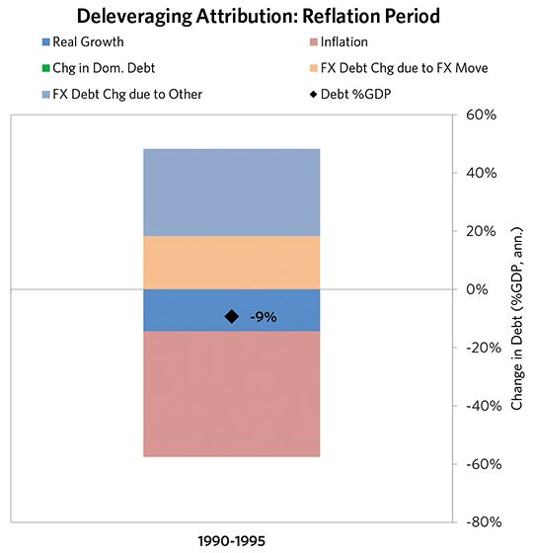

### Peru 1986–1995 Chart Deck Appendix

#### Indebtedness

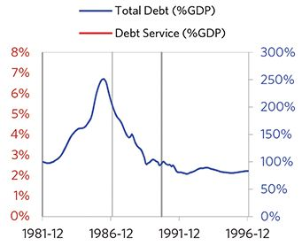

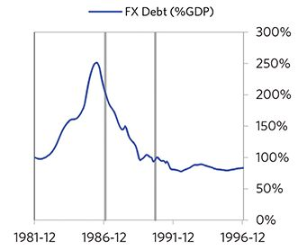

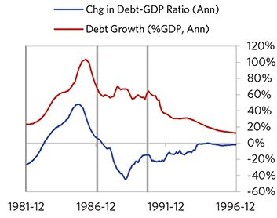

#### Monetary and Fiscal Policy

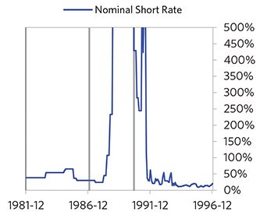

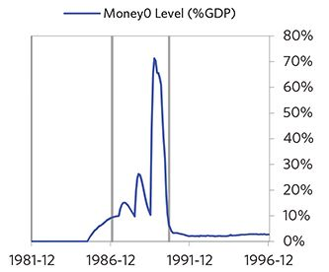

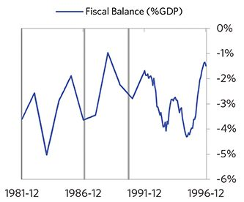

#### Economic Conditions

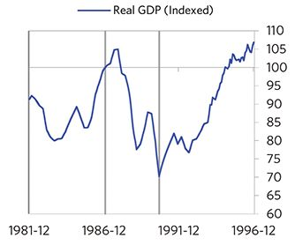

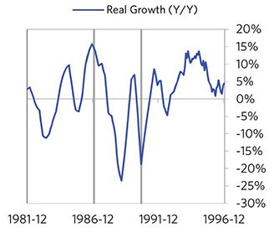

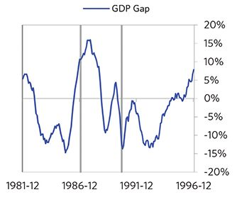

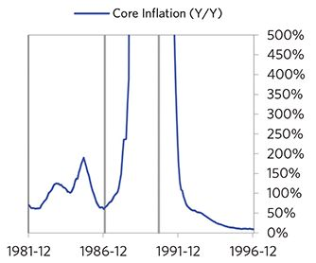

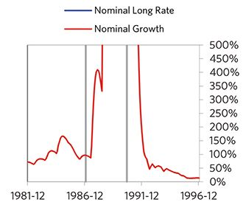

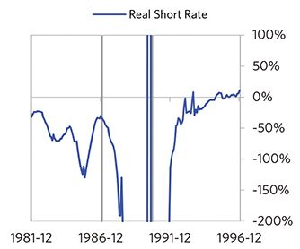

#### Markets

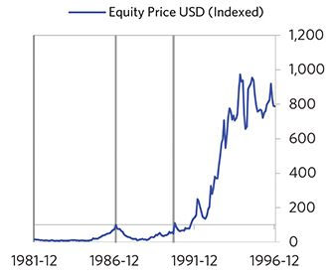

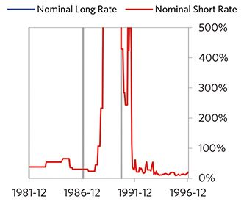

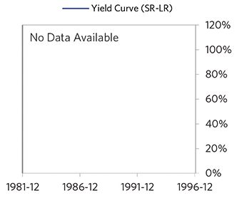

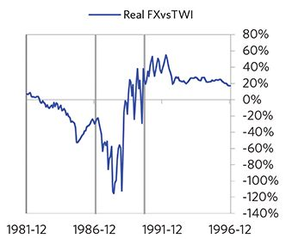

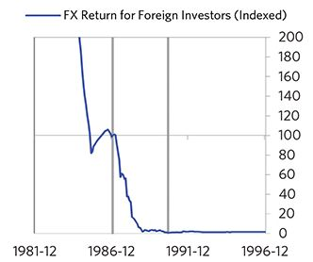

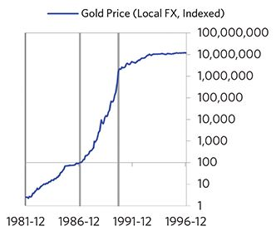

#### External Position

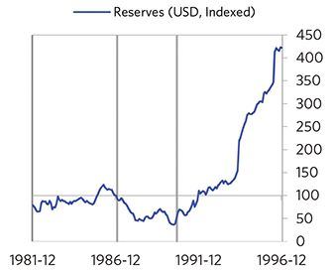

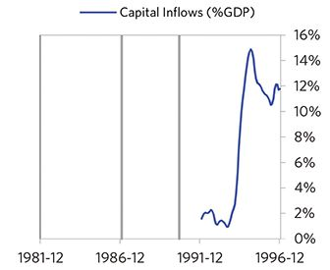

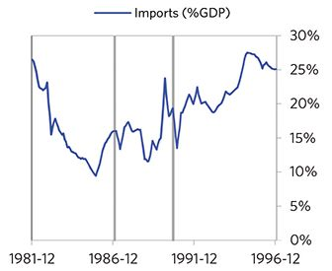

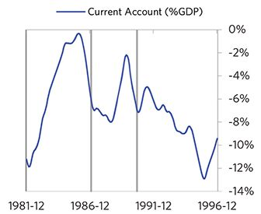

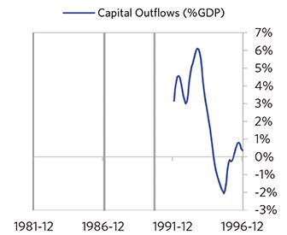

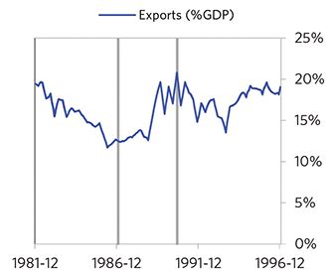

### Argentina 1987–1993 Case Auto-Summary

As show in the charts below, Argentina experienced a classic hyperinflationary deleveraging cycle between 1987 and 1993.

#### The Bubble Phase

Unlike many other cases, Argentina didn’t experience a broad-based bubble in the years before the crisis, but it was tied to other countries, economies, and financial markets that were experiencing bubble-like conditions. And it did build up a substantial debt stock, with debts rising by 15% of GDP to a pre-crisis peak of 70% of GDP during a period of leveraging up. In this case, a high share of the debt was in foreign currencies (39% of GDP)—leaving Argentina with a large exposure to a pullback in foreign capital. Ultimately, these high debts, combined with structural weaknesses in the economy, created an unsustainable situation.

#### The Depression Phase

Eventually the cycle turned, producing a self-reinforcing bust and a balance of payments/currency crisis, which ran from 1987 to 1990. High debt levels left Argentina vulnera- ble to a shock—which came in the form of commodity price declines hitting exports. Argentina suffered a fall in foreign funding (with capital inflows falling by 4% of GDP), leading to a tightening (policy makers hiked short rates by more than 250%) and a meaningful decline in the currency (real FX fell by 60%)—which coincided with self-reinforcing declines in GDP (falling by 16%), and in stock prices (falling by 33%). Unemployment rates increased by 3%, while currency weakness contributed to very high and rising inflation. Argentina’s financial institutions also came under considerable pressure. Meanwhile, the central bank spent down its reserves to defend the currency (drawing down reserves by 26%), though it eventually abandoned its currency defense. Though it was caught in an ugly delever- aging, Argentina nevertheless managed to reduce its debt as a %GDP by 30% (11% annualized) through this period (as shown in the attribution chart to the right). The reduction in debt-to-income ratios came mostly from income rising, driven primarily by higher inflation.

The gauges below are composed from a compendium of stats shown in the chart deck that follows. Note these are meant to be rough measures.

*The first two charts show gauges which measure bubble/depression conditions and tightness/easiness of money and credit. For each gauge, the difference from zero conveys the extent of the bubble while the crossing above/below zero represents the shifting into or out of the bubble.

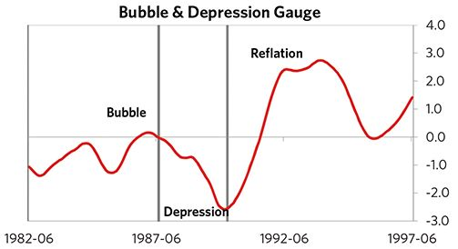

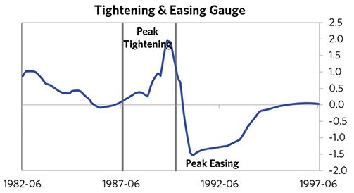

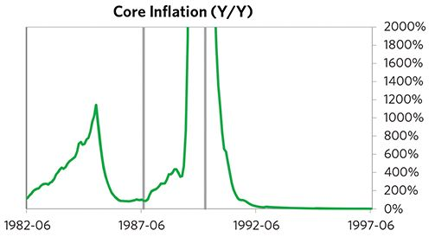

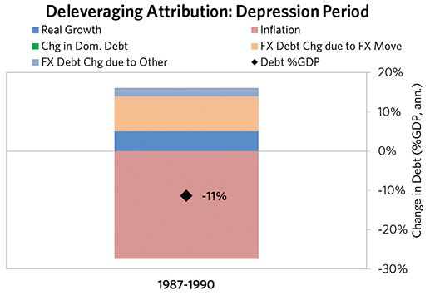

#### The Reflation Phase

A key determinant of how balance of payments/currency crises play out is how policy makers respond to adverse capital flows: whether they allow a tightening of financial conditions to flow through (painful but typically necessary to resolve the crisis), or print money to make up for money leaving (which can be inflationary). In this case, the tightening wasn’t enough to produce the needed adjust- ments before the country fell into a spiral of declining exchange rates and hyperinflation. Real FX bottomed at -135% and inflation peaked at over 10,000%. That makes sense given that Argentina had around half of the classic “risk factors” for bigger inflation spirals (with the biggest risk factor being a long history of poorly-controlled inflation). Argentina was somewhat aggressive in managing its financial institutions and bad debts, pulling 3 out of 9 typical policy levers. It also benefited from an IMF assistance program and enacted structural reforms designed to increase labor market flexibility. But, as is classic, stopping the inflationary spiral ultimately required Argentina to make more significant structural changes, including abandoning the hyperinflated austral and adopting the current Argentine peso, which was initially pegged to the US dollar. It took 4 years before real GDP reached its prior peak and equity prices in USD terms recovered within 2 years.

The crisis had a notable impact on the politics of Argentina, as it helped set the stage for Carlos Menem, whom many people consider a populist leader, to take power.

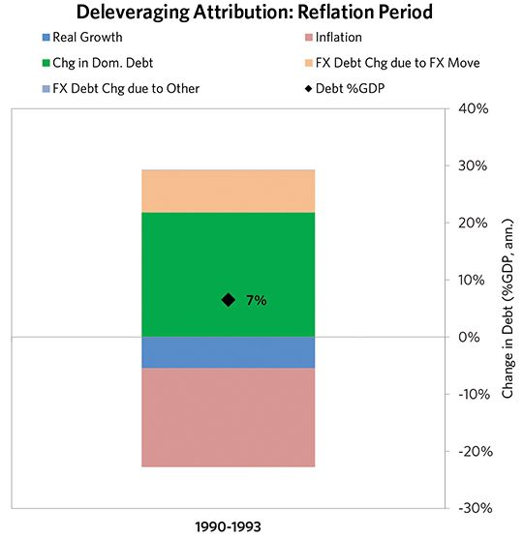

### Argentina 1987–1993 Chart Deck Appendix

#### Indebtedness

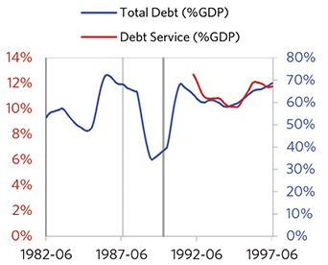

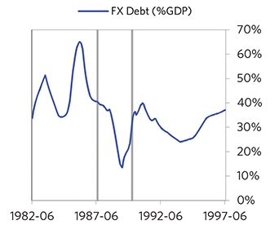

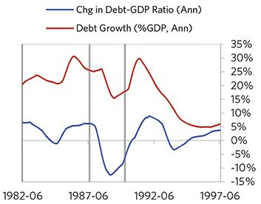

#### Monetary and Fiscal Policy

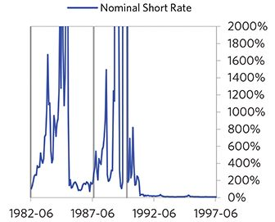

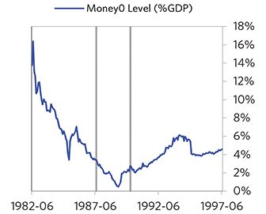

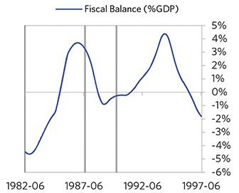

#### Economic Conditions

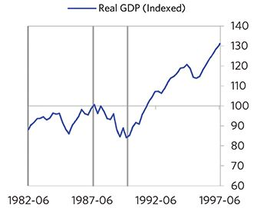

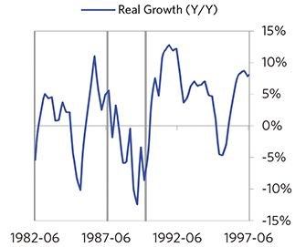

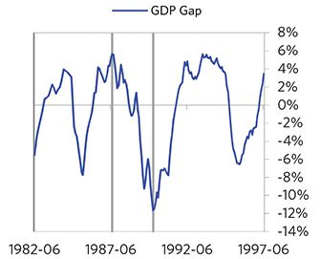

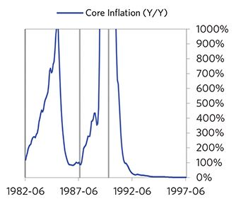

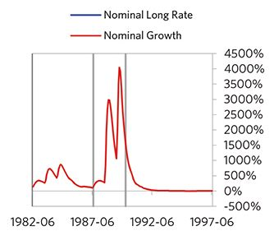

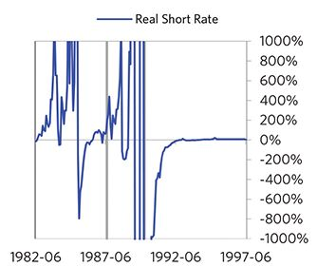

#### Markets

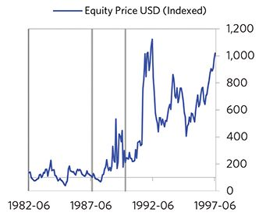

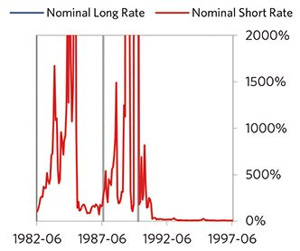

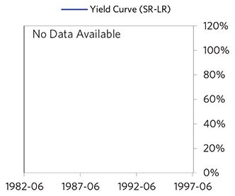

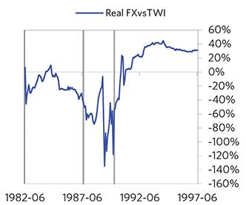

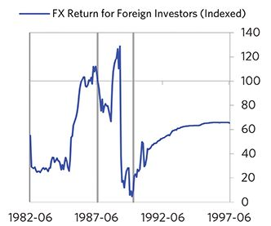

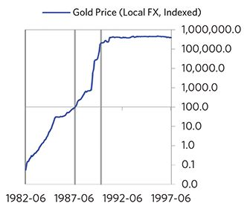

#### External Position

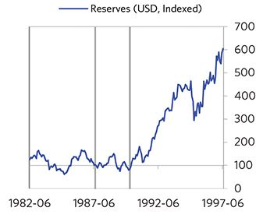

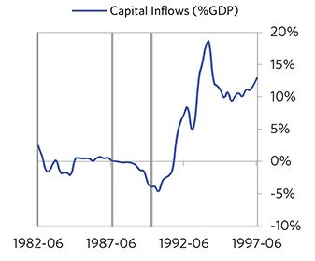

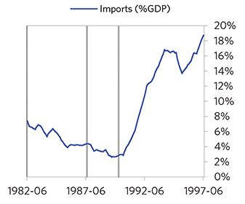

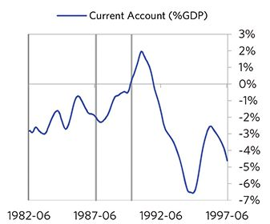

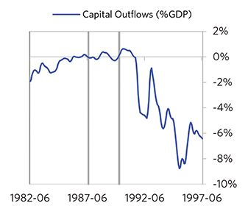

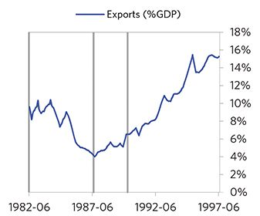

### Brazil 1987–1995 Case Auto-Summary

As show in the charts below, Brazil experienced a classic hyperinflationary deleveraging cycle between 1987 and 1995.

#### The Bubble Phase

Between 1987 and 1990, Brazil experienced a bubble that was driven by a self-reinforcing cycle of rising debt, strong equity returns, and strong growth. Debts rose by 69% of GDP during the bubble to a pre-crisis peak of 177% of GDP. In this case, a high share of the debt was in foreign currencies (26% of GDP)—leaving Brazil with a large exposure to a pullback in foreign capital. During the bubble phase, investment inflows were low, averaging around -3% of GDP. Aided by that rising debt, growth was strong (at 3%), while levels of economic activity were high (the GDP gap peaked at 7%). Furthermore, strong asset returns (equities averaged 16% annualized returns over the bubble period) encouraged more borrowing and helped to stimulate growth. Competitiveness became an issue, as Brazil’s real FX peaked at +35%. Taken together, these bubble pressures, combined with the weakened conditions of related countries, created an unsustainable situation.

#### The Depression Phase

Eventually the dynamic turned, producing a self-reinforcing bust and a balance of payments/currency crisis, which ran from 1990 to 1991. High debt levels left Brazil vulnerable to a shock—which came in the form of a collapse of price control regulations and an inflation shock. Brazil suffered from self-reinforcing declines in GDP (falling by 7%), and in stock prices (falling by 70%). Unemployment rates increased by 4%, while currency weakness contributed to very high inflation. Brazil’s financial institutions also came under considerable pressure. Meanwhile, the central bank spent down its reserves to defend the currency (drawing down reserves by 28%), though by the end policy makers had abandoned their currency defense and the currency had fallen by 19%. As shown in the attribution chart to the right, even though Brazil needed a deleveraging, its debt as a % GDP went up by 40% (37% annualized), in part because the currency fell (which increased the burden of foreign-de- nominated debts) and in part because the government had to borrow more in response to the crisis (with a peak fiscal deficit of 19% of GDP).

The gauges below are composed from a compendium of stats shown in the chart deck that follows. Note these are meant to be rough measures.

*The first two charts show gauges which measure bubble/depression conditions and tightness/easiness of money and credit. For each gauge, the difference from zero conveys the extent of the bubble while the crossing above/below zero represents the shifting into or out of the bubble.

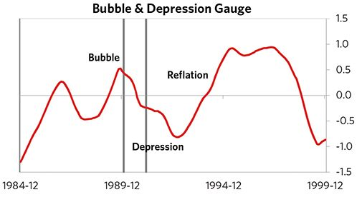

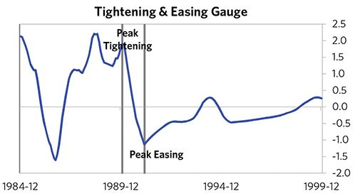

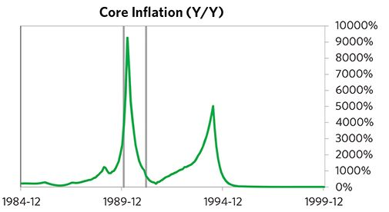

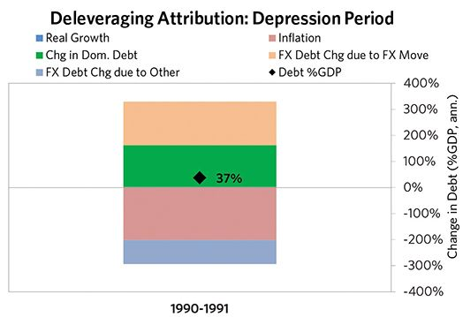

#### The Reflation Phase

A key determinant of how balance of payments/currency crises play out is how policy makers respond to adverse capital flows: whether they allow a tightening of financial conditions to flow through (painful but typically necessary to resolve the crisis), or print money to make up for money leaving (which can be inflationary). In this case, the tightening wasn’t enough to produce the needed adjust- ments before the country fell into a spiral of declining exchange rates and hyperinflation. Real FX bottomed at -16% and inflation peaked at over 5,000%. That makes sense given that Brazil had most of the classic “risk factors” for bigger inflation spirals (with the biggest risk factor being a long history of poorly-controlled inflation). Brazil was not aggressive in managing its financial institutions and bad debts, pulling 2 out of 9 typical policy levers. It also benefited from an IMF assistance program and enacted structural reforms designed to increase labor market flexibility. But, as is classic, stopping the inflationary spiral ultimately required Brazil to make more significant structural changes, including abandoning the hyperinflated cruzado and adopting first the cruzeiro and then the modern real in 1994. It took 1.4 years before real GDP reached its prior peak and equity prices in USD terms recovered within 3 years.

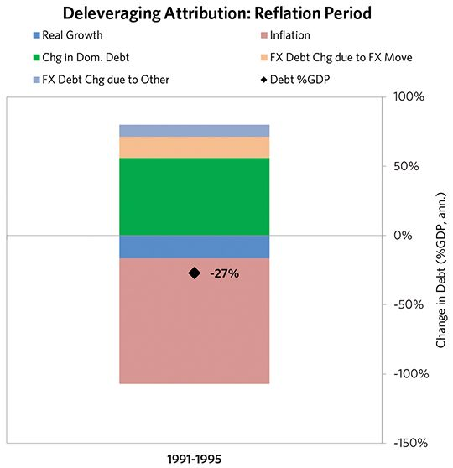

### Brazil 1987–1995 Chart Deck Appendix

#### Indebtedness

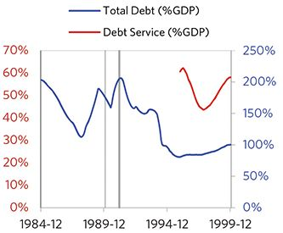

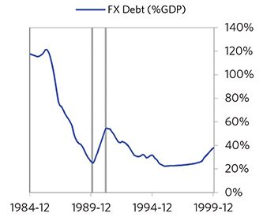

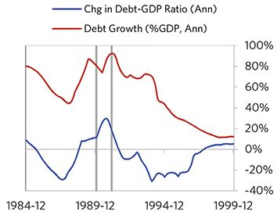

#### Monetary and Fiscal Policy

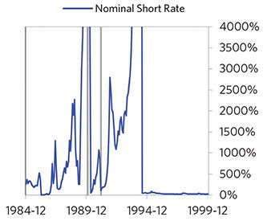

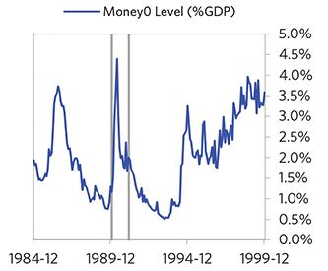

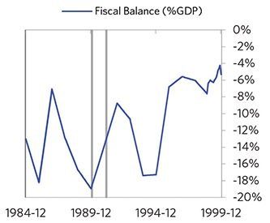

#### Economic Conditions

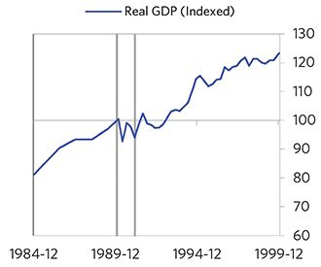

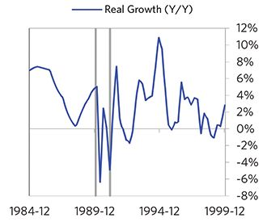

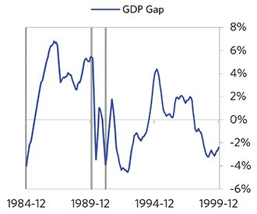

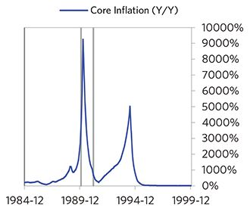

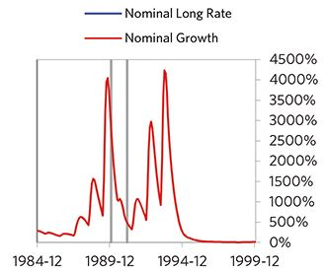

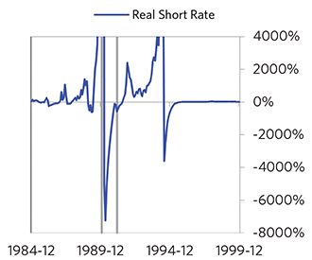

#### Markets

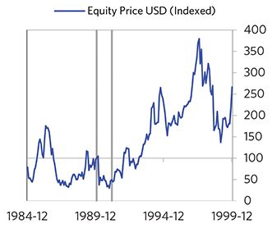

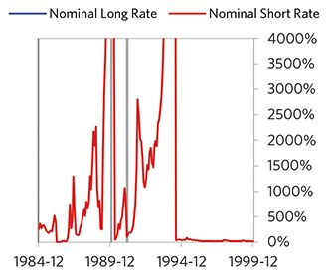

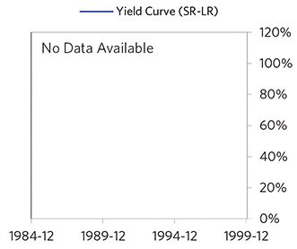

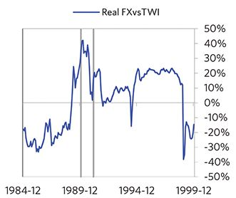

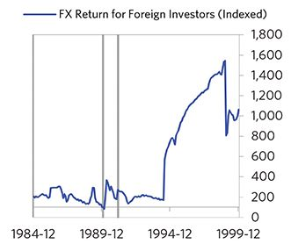

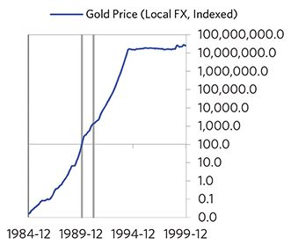

#### External Position

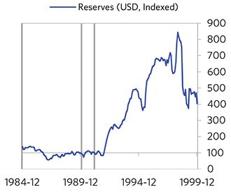

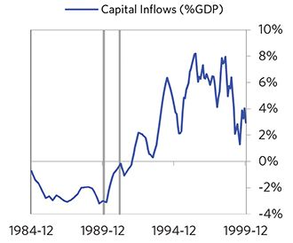

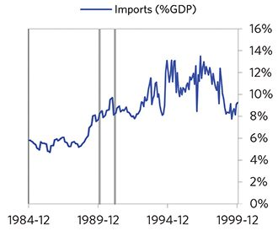

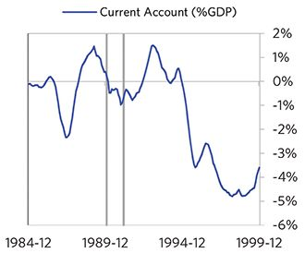

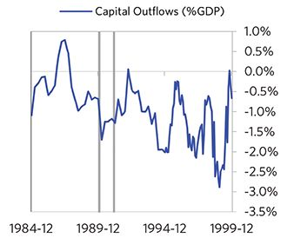

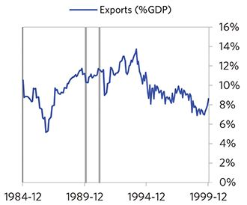

### Turkey 1990–1995 Case Auto-Summary

As show in the charts below, Turkey experienced a classic inflationary deleveraging cycle between 1990 and 1995.

#### The Bubble Phase

Unlike many other cases, Turkey didn’t experience a broad-based bubble in the years before the crisis, but it did build up a substantial debt stock, with debts reaching 41% of GDP prior to the crisis. In this case, a high share of the debt was in foreign currencies (26% of GDP)—leaving Turkey with a large exposure to a pullback in foreign capital. Turkey also became somewhat dependent on continuous foreign financing, with investment inflows averaging 2% in the years before the crisis. Ultimately, these high debts and Turkey’s dependence on foreign financing created an unsustainable situation.

#### The Depression Phase

Eventually the cycle turned, producing a self-reinforcing bust and a balance of payments/currency crisis, which ran from 1993 to 1994. High debt levels left Turkey vulnerable to a shock—which came in the form of moves by the govern- ment to undermine central bank independence. Turkey suffered a fall in foreign funding (with capital inflows falling by 8% of GDP), leading to a tightening (policy makers hiked short rates by 203%) and a meaningful decline in the currency (real FX fell by 26%)—which coincided with self-reinforcing declines in GDP (falling by 12%), and in stock prices (falling by 70%). In addition, currency weakness contributed to very high and rising inflation, peaking at 117% during the depression phase, which is high compared to other similar cases. That’s true despite the fact that Turkey had only about a quarter of the classic “risk factors” for bigger inflation spirals (with the biggest risk factor being a long history of poorly-controlled inflation). Turkey’s financial institutions also came under considerable pressure. Meanwhile, the central bank spent down its reserves to defend the currency (drawing down reserves by 99%), though it eventually abandoned its currency defense. As shown in the attribution chart to the right, even though Turkey needed a deleveraging, its debt as a % GDP went up by 9% (17% annualized), in part because the currency fell (which increased the burden of foreign-denominated debt).

The gauges below are composed from a compendium of stats shown in the chart deck that follows. Note these are meant to be rough measures.

*The first two charts show gauges which measure bubble/depression conditions and tightness/easiness of money and credit. For each gauge, the difference from zero conveys the extent of the bubble while the crossing above/below zero represents the shifting into or out of the bubble.

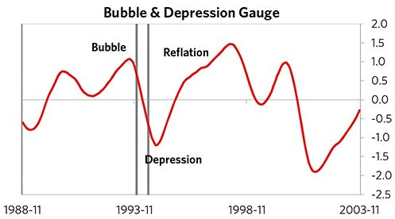

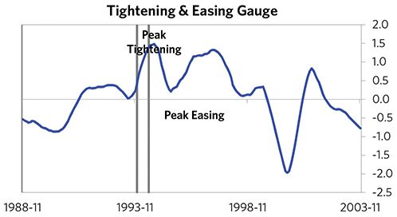

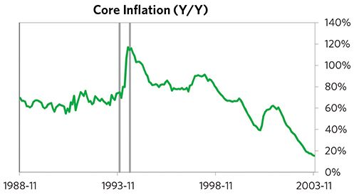

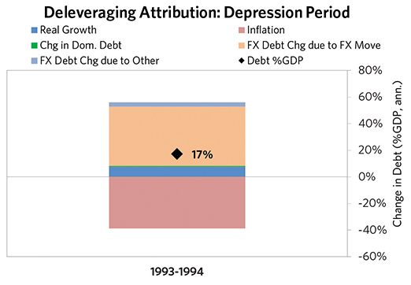

#### The Reflation Phase

A key determinant of how balance of payments/currency crises play out is how policy makers respond to adverse capital flows: whether they allow a tightening of financial conditions to flow through (painful but typically necessary to resolve the crisis), or print money to make up for money leaving (which can be inflationary). In this case, after a relatively short “ugly” phase, policy makers allowed enough tightening to flow through to reduce spending on imports (the current account balance improved by 5% of GDP), and make the currency more attractive to hold. Turkey was somewhat aggressive in managing its financial institutions and bad debts, pulling 3 out of 9 classic policy levers. It also benefited from an IMF assistance program. As shown in the attribution chart to the right, debt as a % of GDP fell by 11% (7% annualized) over the course of this adjustment period. The reduction in debt-to-income ratios came mostly from nominal income rising. Meanwhile, Turkey’s now much lower currency (with real FX bottoming at -21% during the beautiful period) set up the country for renewed competitive- ness. It took 1.6 years before real GDP reached its prior peak and equity prices in USD terms recovered within 4 years.

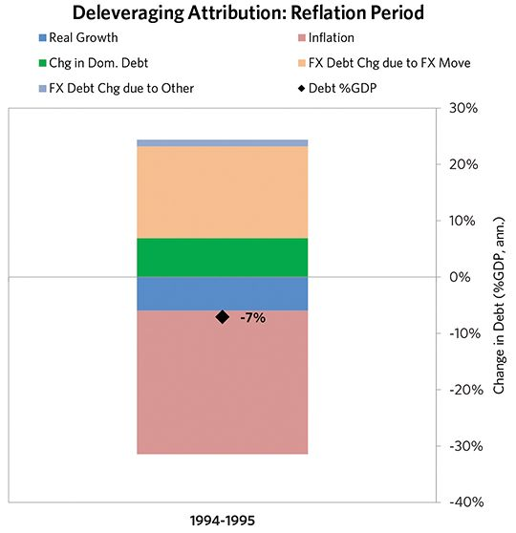

### Turkey 1990–1995 Chart Deck Appendix

#### Indebtedness

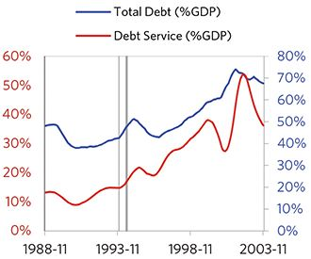

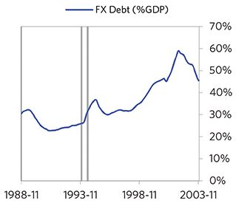

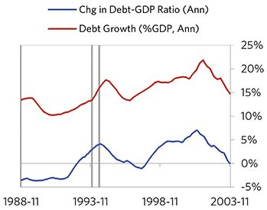

#### Monetary and Fiscal Policy

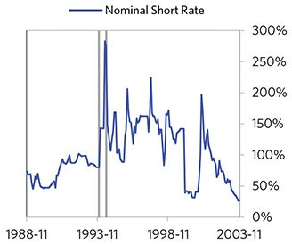

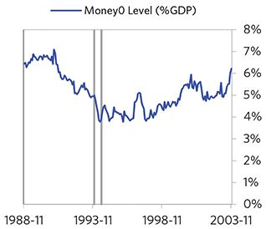

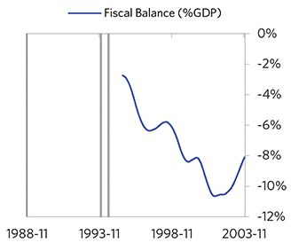

#### Economic Conditions

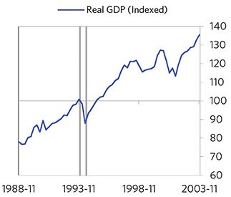

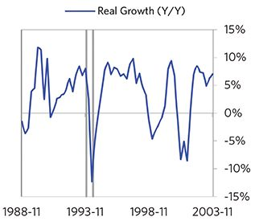

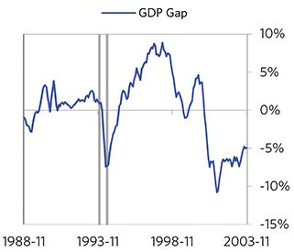

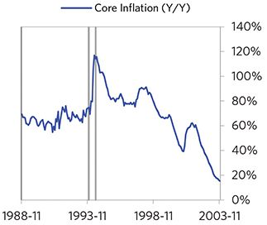

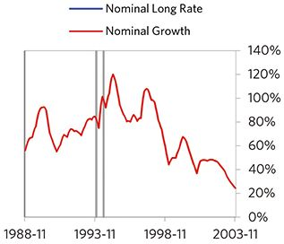

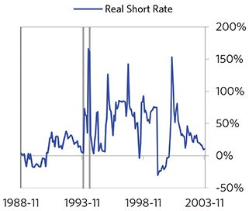

#### Markets

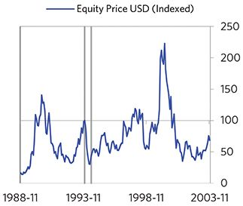

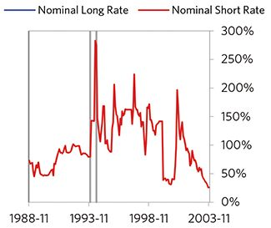

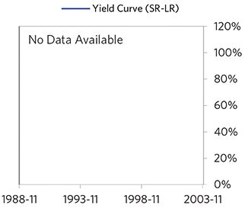

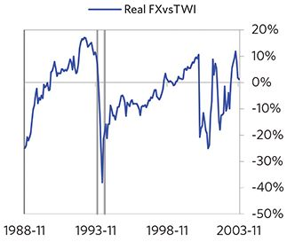

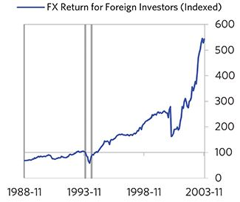

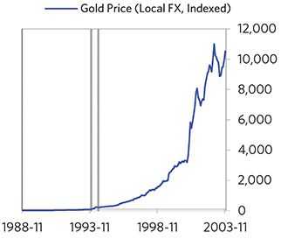

#### External Position

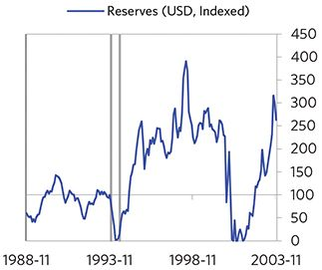

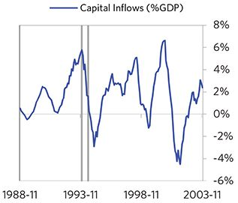

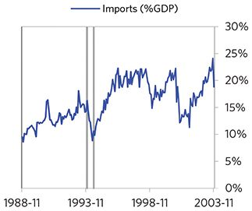

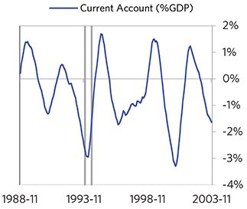

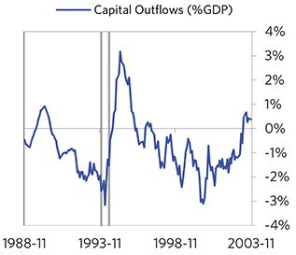

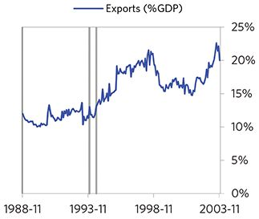

### Mexico 1991–2005 Case Auto-Summary

As show in the charts below, Mexico experienced a classic inflationary deleveraging cycle between 1991 and 2005.

#### The Bubble Phase

Between 1991 and 1994, Mexico experienced a bubble that was driven by a self-reinforcing cycle of unsustainably strong capital inflows, rising debt, strong equity returns, and strong growth. Debts rose by 10% of GDP during the bubble to a pre-crisis peak of 85% of GDP. In this case, a high share of the debt was in foreign currencies (25% of GDP)—leaving Mexico with a large exposure to a pullback in foreign capital. During the bubble phase, investment inflows were strong, averaging around 8% of GDP, which helped to finance a current account deficit of 7% of GDP. Aided by that rising debt and capital, growth was strong (at 4%), while levels of economic activity were high (the GDP gap peaked at 3%). Furthermore, strong asset returns (equities averaged 25% annualized returns over the bubble period) encouraged more borrowing and helped to stimulate growth. Taken together, these bubble pressures and Mexico’s dependence on foreign financing created an unsustainable situation.

#### The Depression Phase

Eventually the dynamic turned, producing a self-reinforcing bust and a balance of payments/currency crisis, which ran from 1994 to 1995. High debt levels left Mexico vulnerable to a shock—which came in the form of an outbreak of political violence. Mexico suffered from self-reinforcing declines in GDP (falling by 10%), and in stock prices (falling by 66%). Unemployment rates increased by 3%, while currency weakness contributed to high and rising inflation, peaking at 43% during the depression phase, which is normal compared to other similar cases. That makes sense given that Mexico had around half of the classic “risk factors” for bigger inflation spirals (with the biggest risk factor being a long history of poorly-controlled inflation). Mexico’s financial institutions also came under considerable pressure. Meanwhile, the central bank spent down its reserves to defend the currency (drawing down reserves by 100%), though by the end policy makers had abandoned their currency defense and the currency had fallen by 37%. As shown in the attribution chart to the right, even though Mexico needed a deleveraging, its debt as a % GDP was roughly flat through this period.

The gauges below are composed from a compendium of stats shown in the chart deck that follows. Note these are meant to be rough measures.

*The first two charts show gauges which measure bubble/depression conditions and tightness/easiness of money and credit. For each gauge, the difference from zero conveys the extent of the bubble while the crossing above/below zero represents the shifting into or out of the bubble.

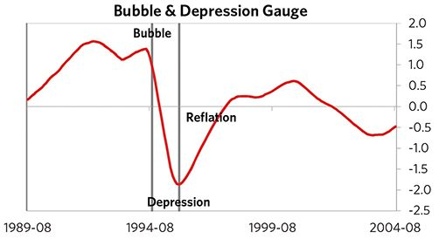

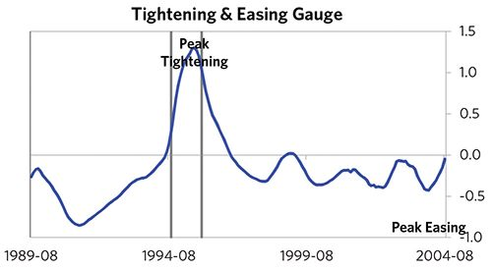

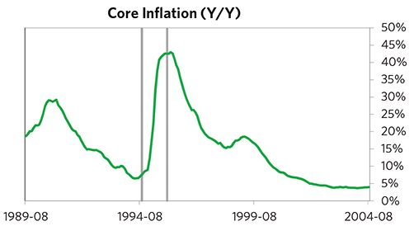

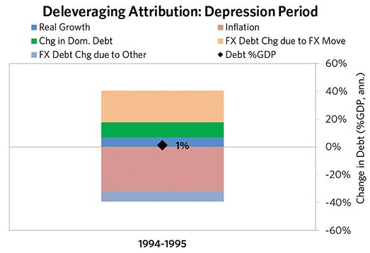

#### The Reflation Phase

A key determinant of how balance of payments/currency crises play out is how policy makers respond to adverse capital flows: whether they let their currency go and allow a tightening of financial conditions to flow through (painful but typically necessary to resolve the crisis), or print money to make up for money leaving (which can be inflationary). In this case, they abandoned the currency peg and, after a relatively short “ugly” phase, policy makers allowed enough tightening to flow through to reduce spending on imports (the current account balance improved by 7% of GDP), and make the currency more attractive to hold. Mexico was very aggressive in managing its financial institutions and bad debts, pulling 6 out of 9 classic policy levers. In particular, it nationalized banks, provided liquidity, and directly purchased troubled assets. It also benefited from an IMF assistance program and enacted structural reforms designed to increase labor market flexibility. As shown in the attribution chart to the right, debt as a % of GDP fell by 41% (4% annualized) over the course of this adjustment period. The reduction in debt-to-income ratios came mostly from nominal income rising. Meanwhile, Mexico’s now much lower currency (with real FX bottoming at -26% during the beautiful period) set up the country for renewed competitiveness. It took 2 years before real GDP reached its prior peak and equity prices in USD terms recovered within 10 years.

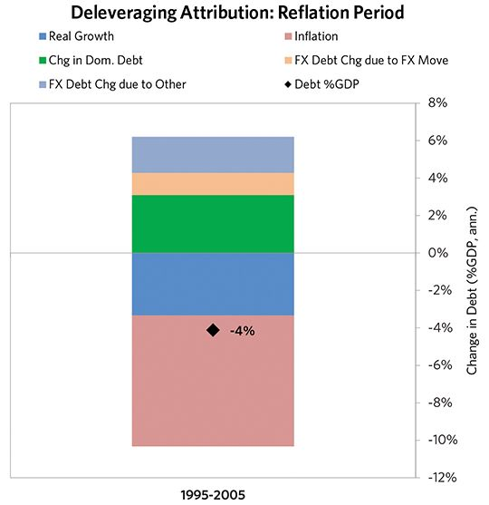

### Mexico 1991–2005 Chart Deck Appendix

#### Indebtedness

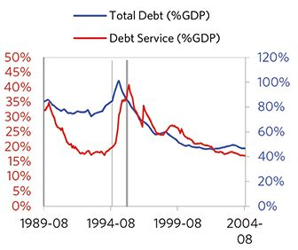

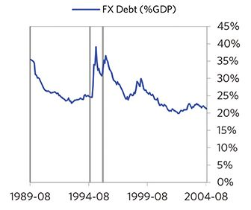

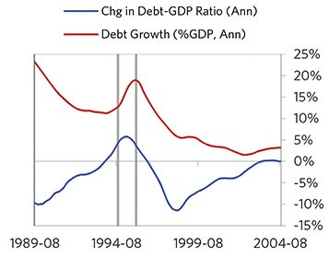

#### Monetary and Fiscal Policy

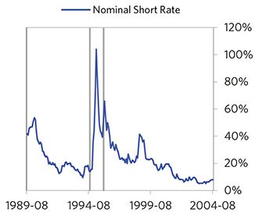

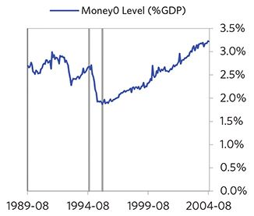

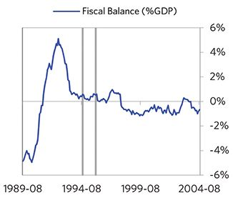

#### Economic Conditions

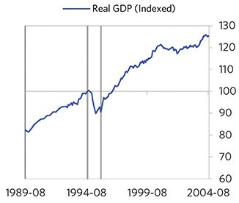

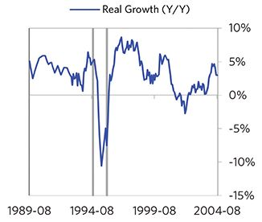

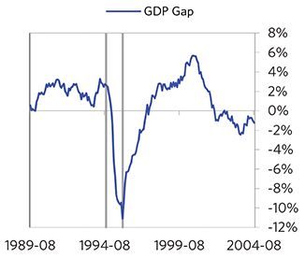

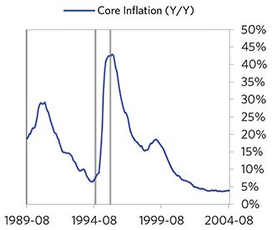

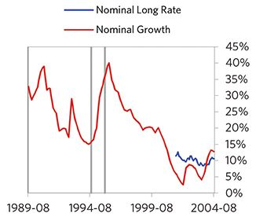

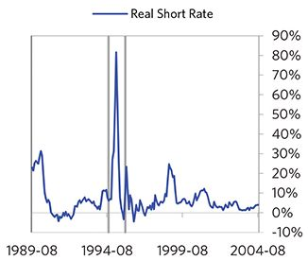

#### Markets

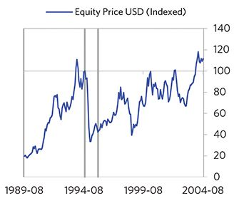

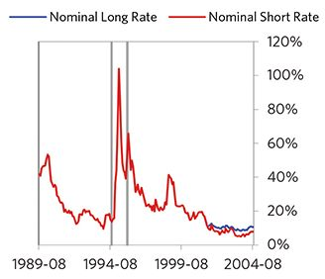

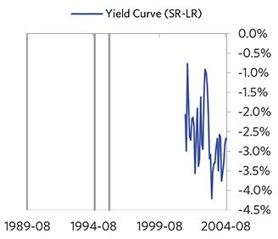

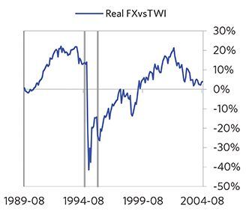

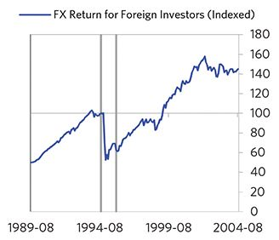

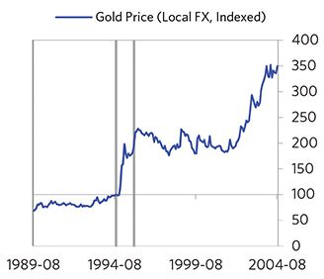

#### External Position

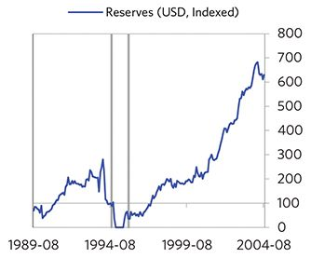

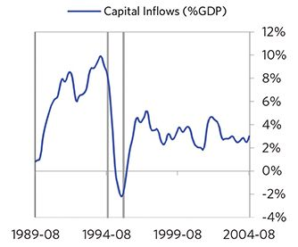

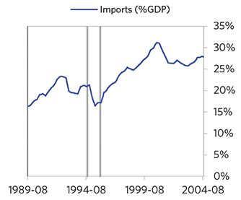

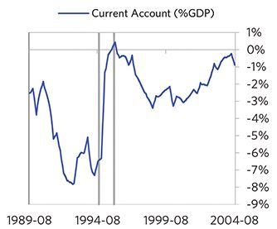

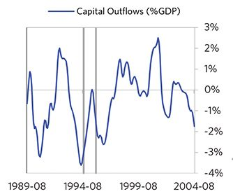

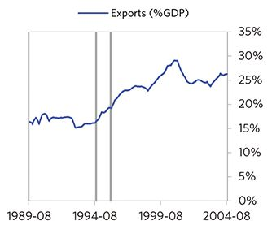

### Bulgaria 1995–2003 Case Auto-Summary

As show in the charts below, Bulgaria experienced a classic hyperinflationary deleveraging cycle between 1995 and 2003.

#### The Bubble Phase

Unlike many other cases, Bulgaria didn’t experience a broad-based bubble in the years before the crisis, but it did build up a substantial debt stock. In this case, a high share of the debt was in foreign currencies (82% of GDP)—leaving Bulgaria with a large exposure to a pullback in foreign capital. Bulgaria also became somewhat dependent on continuous foreign financing, running a current account deficit of 4%. Ultimately, these high debts and Bulgaria’s dependence on foreign financing created an unsustainable situation.

#### The Depression Phase

Eventually the cycle turned, producing a self-reinforcing bust and a balance of payments/currency crisis, which ran from 1995 to 1997. High debt levels left Bulgaria vulnerable to a shock—which came in the form of a wave of losses from over-indebted companies/banks. Bulgaria suffered a fall in foreign funding (with capital inflows falling by 6% of GDP), leading to a tightening (policy makers hiked short rates by 228%) and a meaningful decline in the currency (real FX fell by 96%)—which coincided with self-reinforcing declines in GDP (falling by 13%). In addition, currency weakness contributed to very high and rising inflation. Bulgaria’s financial institutions also came under considerable pressure. Meanwhile, the central bank spent down its reserves to defend the currency (drawing down reserves by 75%), though it eventually abandoned its currency defense.

The gauges below are composed from a compendium of stats shown in the chart deck that follows. Note these are meant to be rough measures.

*The first two charts show gauges which measure bubble/depression conditions and tightness/easiness of money and credit. For each gauge, the difference from zero conveys the extent of the bubble while the crossing above/below zero represents the shifting into or out of the bubble.

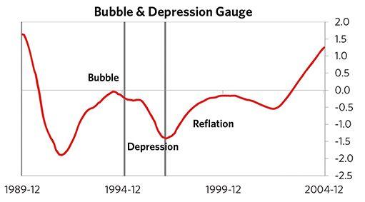

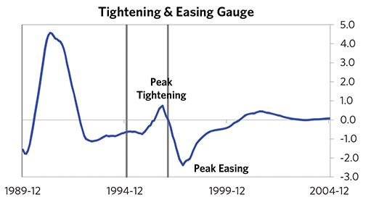

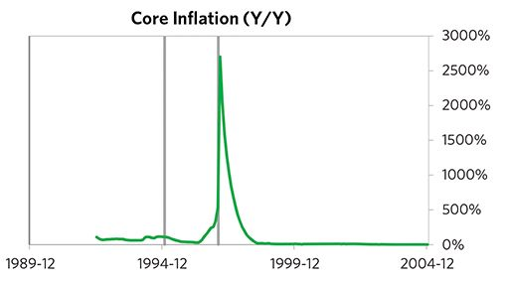

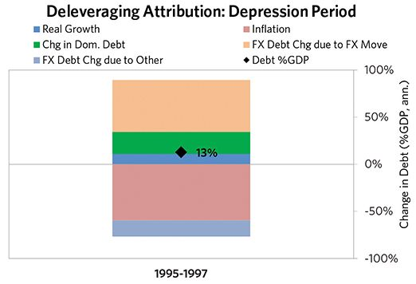

#### The Reflation Phase

A key determinant of how balance of payments/currency crises play out is how policy makers respond to adverse capital flows: whether they allow a tightening of financial conditions to flow through (painful but typically necessary to resolve the crisis), or print money to make up for money leaving (which can be inflationary). In this case, the tightening wasn’t enough to produce the needed adjust- ments before the country fell into a spiral of declining exchange rates and hyperinflation. Real FX bottomed at -63% and inflation peaked at over 500%. That makes sense given that Bulgaria had most of the classic “risk factors” for bigger inflation spirals (with the biggest risk factor being a long history of poorly-controlled inflation). Bulgaria was aggressive in managing its financial institutions and bad debts, pulling 5 out of 9 typical policy levers. In particular, it nationalized banks, provided liquidity, and directly purchased troubled assets. It also benefited from an IMF assistance program. But, as is classic, stopping the inflation- ary spiral ultimately required Bulgaria to make more significant structural changes, including redenominating the lev, pegging it to the Deutsche Mark and backing it by foreign exchange reserves. It took 8 years before real GDP reached its prior peak.

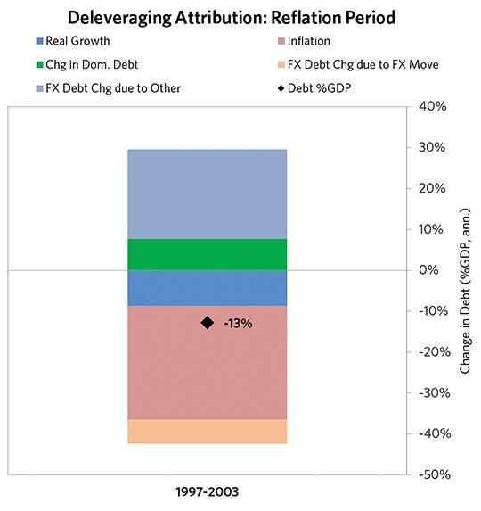

### Bulgaria 1995–2003 Chart Deck Appendix

#### Indebtedness

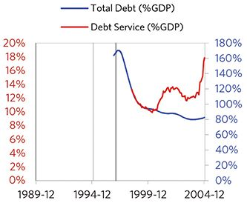

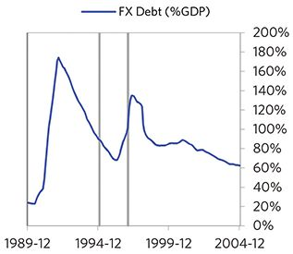

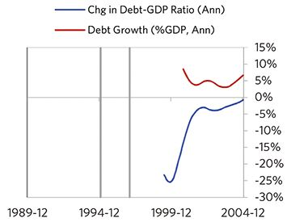

#### Monetary and Fiscal Policy

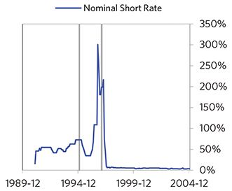

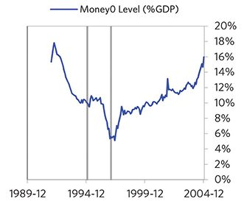

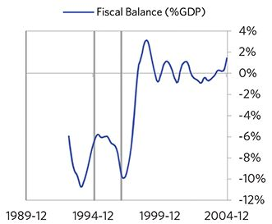

#### Economic Conditions

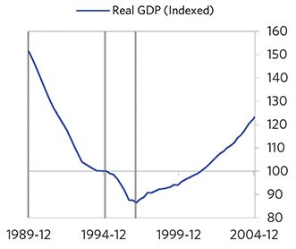

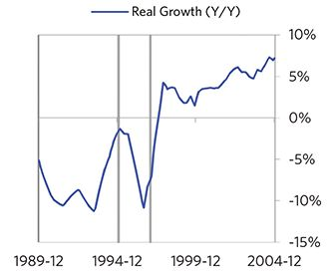

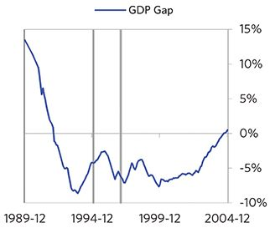

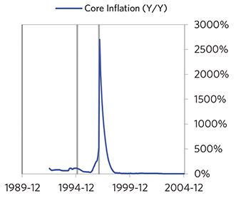

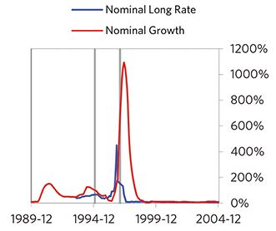

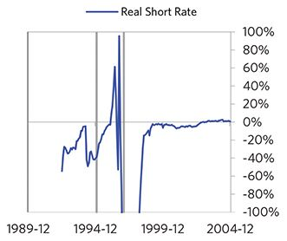

#### Markets

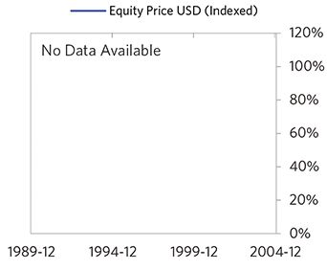

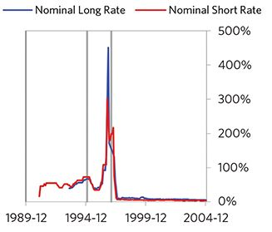

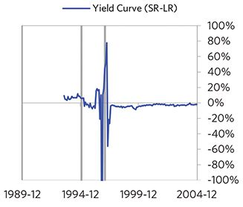

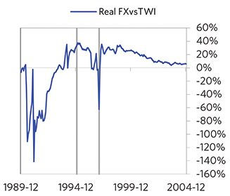

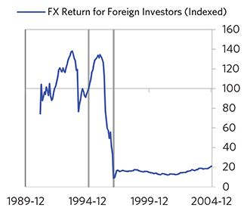

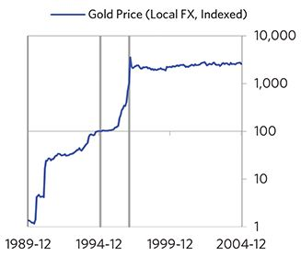

#### External Position

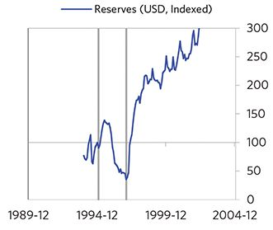

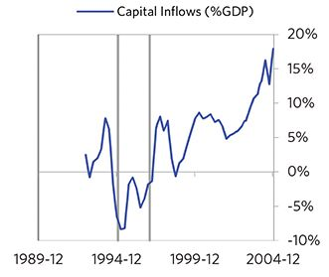

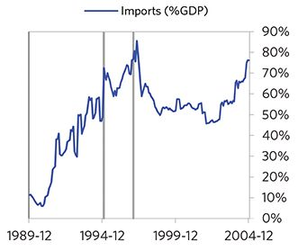

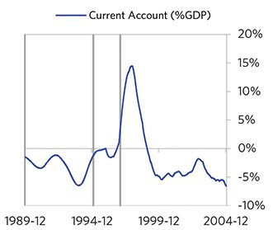

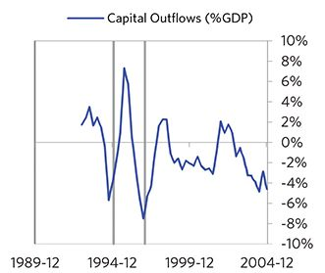

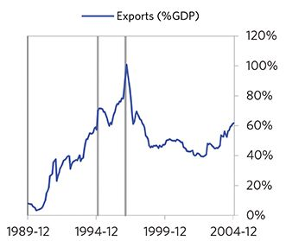

### Thailand 1993–2004 Case Auto-Summary

As show in the charts below, Thailand experienced a transitory inflationary deleveraging cycle between 1993 and 2004. This is also a classic example of a country “letting its currency go” in the face of external pressures, which produces some temporary inflation but ultimately gives policy makers more flexibility to set interest rates.

#### The Bubble Phase

Between 1993 and 1996, Thailand experienced a bubble that was driven by a self-reinforcing cycle of unsustainably strong capital inflows, rising debt, strong equity returns, and strong growth. Debts rose by 44% of GDP during the bubble to a pre-crisis peak of 183% of GDP. In this case, a high share of the debt was in foreign currencies (51% of GDP)—leaving Thailand with a large exposure to a pullback in foreign capital. During the bubble phase, investment inflows were strong, averaging around 15% of GDP, which helped to finance a current account deficit of 9% of GDP. Aided by that rising debt and capital, growth was strong (at 8%), while levels of economic activity were high (the GDP gap peaked at 8%). Furthermore, strong asset returns (equities averaged 12% annualized returns over the bubble period) encouraged more borrowing and helped to stimulate growth. Taken together, these bubble pressures and Thailand’s dependence on foreign financing created an unsustainable situation.

#### The Depression Phase

Eventually the dynamic turned, producing a self-reinforc- ing bust and a balance of payments/currency crisis, which ran from 1996 to 1998. At its pre-crisis peak, debt service reached 49% of GDP, making Thailand vulnerable to a shock—which came in the form of a wave of losses from over-indebted companies/banks. Thailand suffered a fall in foreign funding (with capital inflows falling by 34% of GDP), leading to a tightening (policy makers hiked short rates by 11%) and a meaningful decline in the currency (real FX fell by 19%)—which coincided with self-reinforcing declines in GDP (falling by 14%), and in stock prices (falling by 87%). In addition, currency weakness contributed to moderate and rising inflation, peaking at 8% during the depression phase, which is low compared to other similar cases. That makes sense given that Thailand had only about a quarter of the classic “risk factors” for bigger inflation spirals (with the biggest risk factor being their current account deficit). Thailand’s financial institutions also came under considerable pressure. Meanwhile, the central bank spent down its reserves to defend the currency (drawing down reserves by 100%), though it eventually abandoned its currency defense. As shown in the attribution chart to the right, even though Thailand needed a deleveraging, its debt as a % GDP went up by 36% (18% annualized), in part because the currency fell (which increased the burden of foreign-denominated debt).

The gauges below are composed from a compendium of stats shown in the chart deck that follows. Note these are meant to be rough measures.

*The first two charts show gauges which measure bubble/depression conditions and tightness/easiness of money and credit. For each gauge, the difference from zero conveys the extent of the bubble while the crossing above/below zero represents the shifting into or out of the bubble.

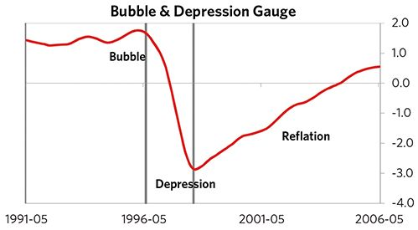

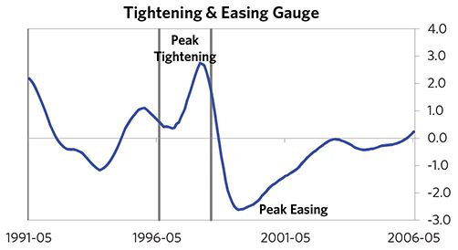

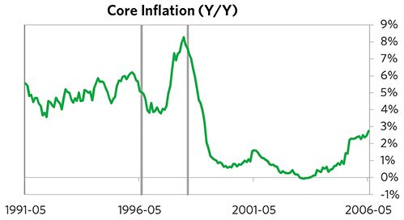

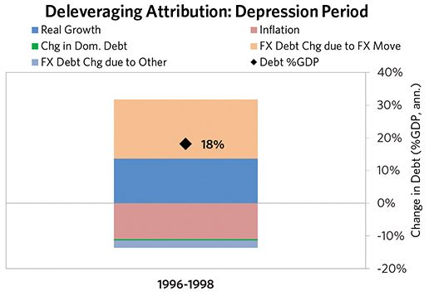

#### The Reflation Phase

A key determinant of how balance of payments/currency crises play out is how policy makers respond to adverse capital flows: whether they let their currency go and allow a tightening of financial conditions to flow through (painful but typically necessary to resolve the crisis), or print money to make up for money leaving (which can be inflationary). In this case, they abandoned the currency peg and, after a slightly shorter than average “ugly” phase, policy makers allowed enough tightening to flow through to reduce spending on imports (the current account balance improved by 21% of GDP), and make the currency more attractive to hold. Thailand was very aggressive in managing its financial institutions and bad debts, pulling 8 out of 9 classic policy levers. In particular, it nationalized banks, provided liquidity, and directly purchased troubled assets. It also benefited from an IMF assistance program. As shown in the attribution chart to the right, debt as a % of GDP fell by 88% (15% annualized) over the course of this adjustment period. The reduction in debt-to-income ratios came mostly from nominal income rising, driven primarily by higher real growth. Meanwhile, Thailand’s now lower currency (with real FX bottoming at -16% during the beautiful period) set up the country for renewed competitiveness. It took 5 years before real GDP reached its prior peak and equity prices in USD terms recovered within 23 years.

The crisis had a notable impact on the politics of Thailand, as it helped set the stage for Thaksin Shinawatra, whom many people consider a populist leader, to take power in 2001.

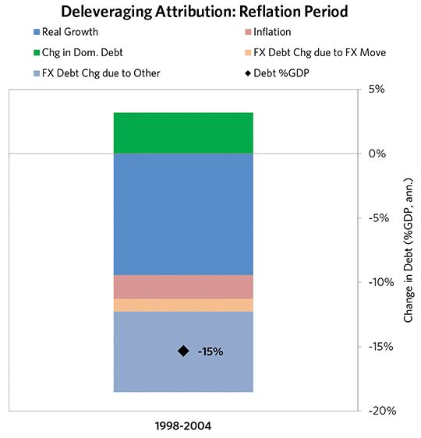

### Thailand 1993–2004 Chart Deck Appendix

#### Indebtedness

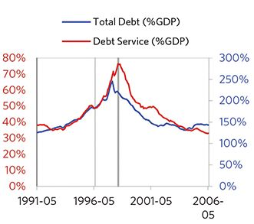

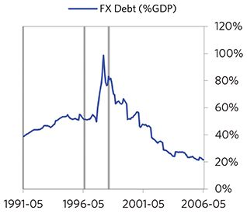

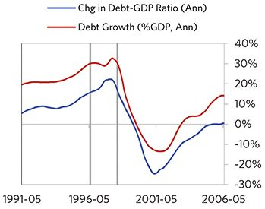

#### Monetary and Fiscal Policy

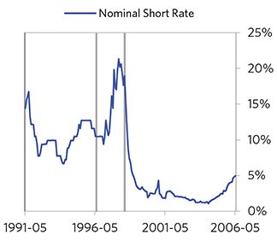

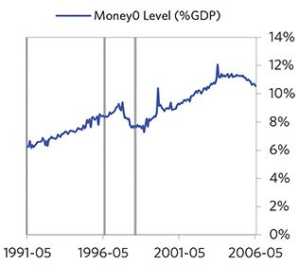

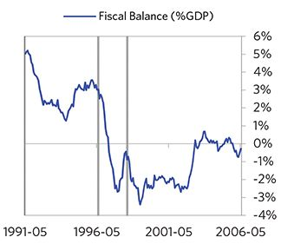

#### Economic Conditions

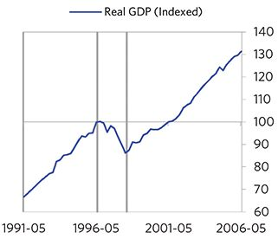

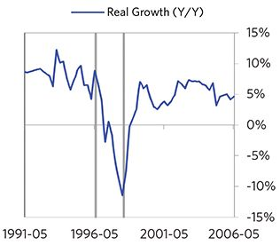

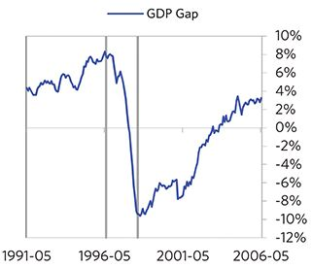

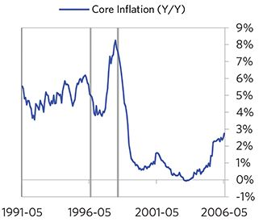

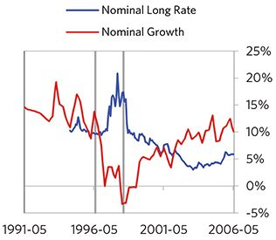

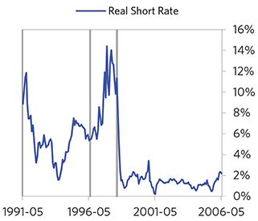

#### Markets

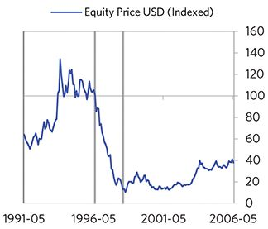

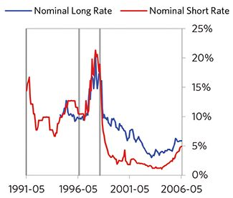

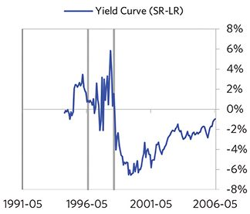

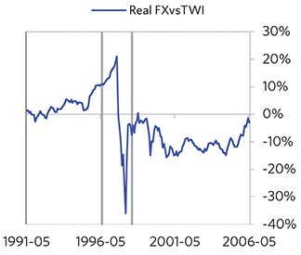

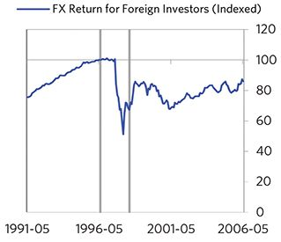

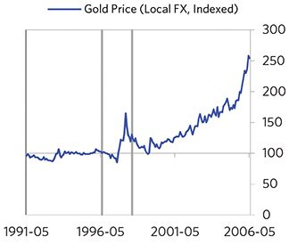

#### External Position

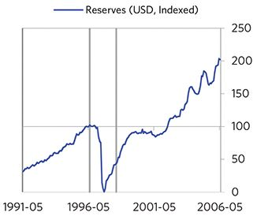

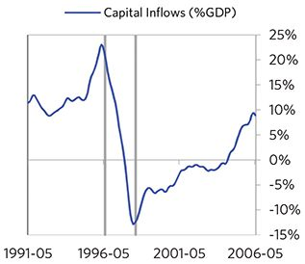

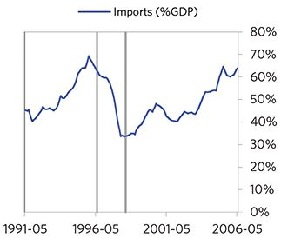

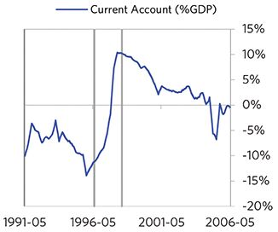

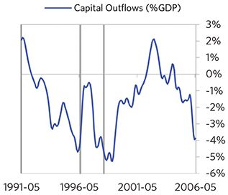

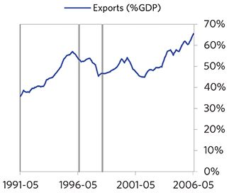

### Indonesia 1994–2012 Case Auto-Summary

As show in the charts below, Indonesia experienced a transitory inflationary deleveraging cycle between 1994 and 2012. This is also a classic example of a country “letting its currency go” in the face of external pressures, which produces some temporary inflation but ultimately gives policy makers more flexibility to set interest rates.

#### The Bubble Phase

Between 1994 and 1997, Indonesia experienced a bubble that was driven by a self-reinforcing cycle of unsustainably strong capital inflows, rising debt, strong equity returns, and strong growth. By the bubble’s end, debts had reached a pre-crisis peak of 104% of GDP. In this case, a high share of the debt was in foreign currencies (51% of GDP)—leaving Indonesia with a large exposure to a pullback in foreign capital. During the bubble phase, investment inflows were low but positive, averaging around 5% of GDP, while Indonesia maintained a current account deficit of 3% of GDP. Aided by that rising debt and capital, growth was strong (at 7%), while levels of economic activity were high (the GDP gap peaked at 13%). Furthermore, strong asset returns (equities averaged 12% annualized returns over the bubble period) encouraged more borrowing and helped to stimulate growth. Competitiveness became an issue, as Indonesia’s real FX peaked at +19%. Taken together, these bubble pressures and Indonesia’s dependence on foreign financing, combined with the weakened conditions of related countries, created an unsustainable situation.

#### The Depression Phase

Eventually the dynamic turned, producing a self-reinforcing bust and a balance of payments/currency crisis, which ran from 1997 to 1998. High debt levels left Indonesia vulnerable to a shock—which came in the form of the 1997 Asian financial crisis. Indonesia suffered a fall in foreign funding (with capital inflows falling by 13% of GDP), leading to a tightening (policy makers hiked short rates by 43%) and a meaningful decline in the currency (real FX fell by 110%)—which coincided with self-reinforcing declines in GDP (falling by 14%), and in stock prices (falling by 89%). In addition, currency weakness contributed to high and rising inflation, peaking at 59% during the depression phase, which is normal compared to other similar cases. That’s true despite the fact that Indonesia had only about a quarter of the classic “risk factors” for bigger inflation spirals (with the biggest risk factor being high foreign-denominated debts). Indonesia’s financial institutions also came under considerable pressure. Meanwhile, the central bank spent down its reserves to defend the currency (drawing down reserves by 23%), though it eventually abandoned its currency defense. As shown in the attribution chart to the right, even though Indonesia needed a deleverag- ing, its debt as a % GDP went up by 132% (132% annualized), in part because the currency fell (which increased the burden of foreign-denominated debt).

The gauges below are composed from a compendium of stats shown in the chart deck that follows. Note these are meant to be rough measures.

*The first two charts show gauges which measure bubble/depression conditions and tightness/easiness of money and credit. For each gauge, the difference from zero conveys the extent of the bubble while the crossing above/below zero represents the shifting into or out of the bubble.

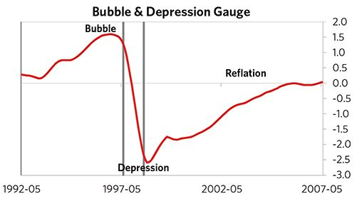

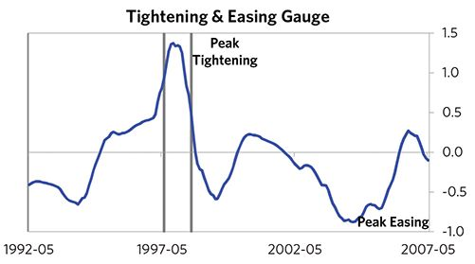

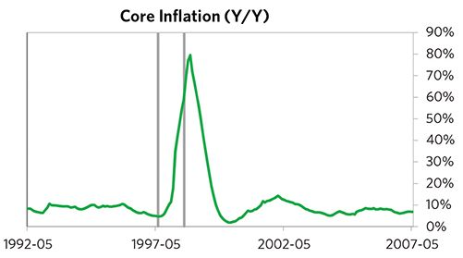

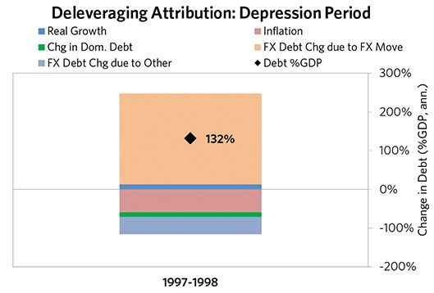

#### The Reflation Phase

A key determinant of how balance of payments/currency crises play out is how policy makers respond to adverse capital flows: whether they let their currency go and allow a tightening of financial conditions to flow through (painful but typically necessary to resolve the crisis), or print money to make up for money leaving (which can be inflationary). In this case, they abandoned the currency peg and, after a relatively short “ugly” phase, policy makers allowed enough tightening to flow through to reduce spending on imports (the current account balance improved by 4% of GDP), and make the currency more attractive to hold. Indonesia was very aggressive in managing its financial institutions and bad debts, pulling 7 out of 9 classic policy levers. In particu- lar, it nationalized banks, provided liquidity, and directly purchased troubled assets. It also benefited from an IMF assistance program. As shown in the attribution chart to the right, debt as a % of GDP fell by 178% (13% annualized) over the course of this adjustment period. The reduction in debt-to-income ratios came mostly from nominal income rising. Meanwhile, Indonesia’s now much lower currency (with real FX bottoming at -90% during the beautiful period) set up the country for renewed competitiveness. It took 5 years before real GDP reached its prior peak and equity prices in USD terms recovered within 13 years.

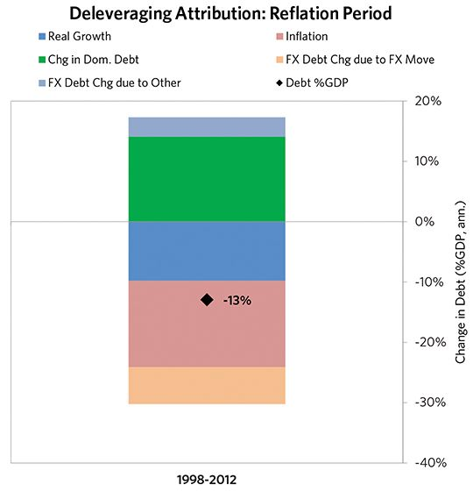

### Indonesia 1994–2012 Chart Deck Appendix

#### Indebtedness

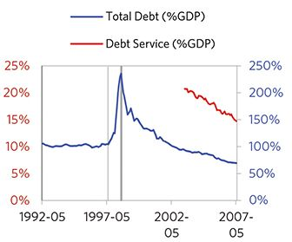

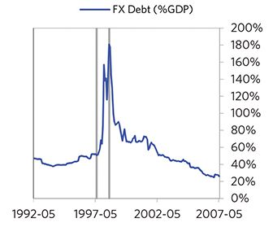

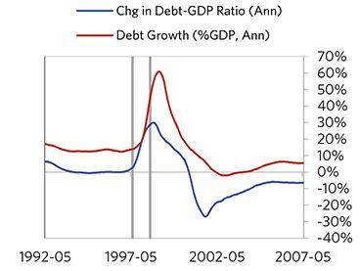

#### Monetary and Fiscal Policy

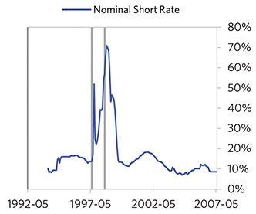

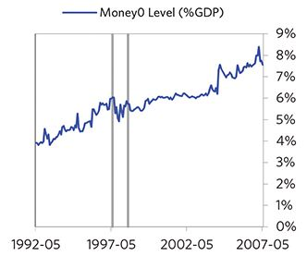

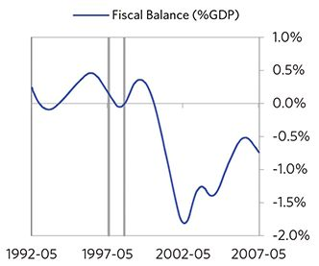

#### Economic Conditions

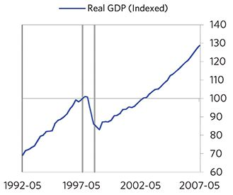

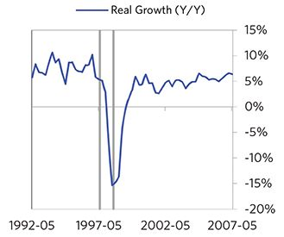

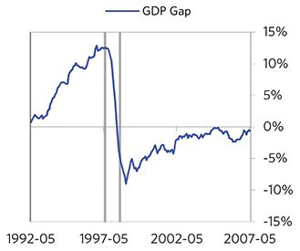

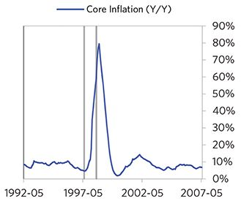

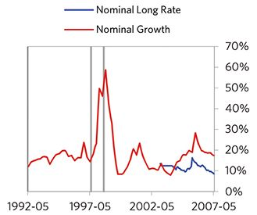

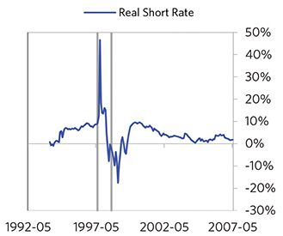

#### Markets

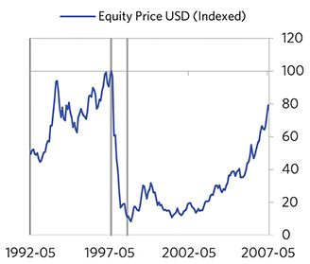

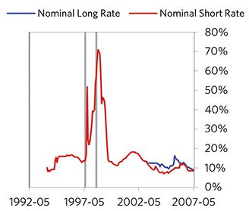

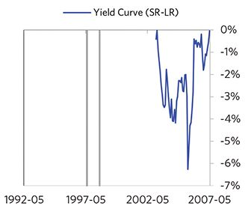

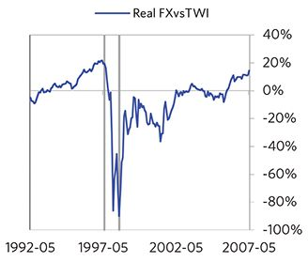

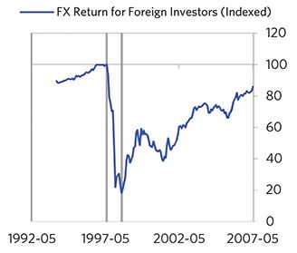

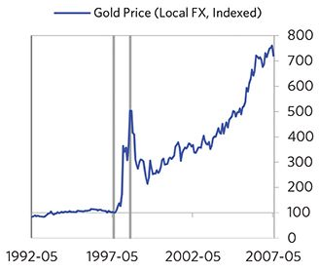

#### External Position

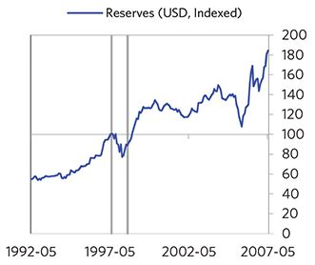

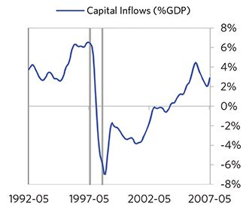

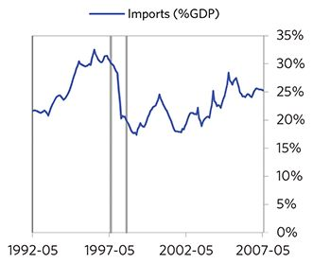

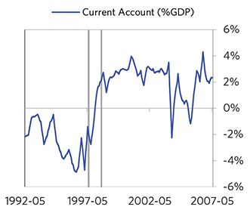

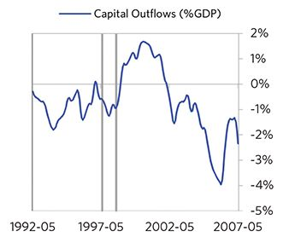

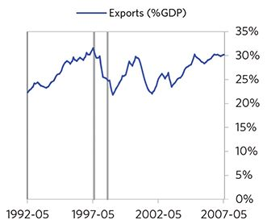

### Korea 1994–2001 Case Auto-Summary

As show in the charts below, Korea experienced a transitory inflationary deleveraging cycle between 1994 and 2001. This is also a classic example of a country “letting its currency go” in the face of external pressures, which produces some temporary inflation but ultimately gives policy makers more flexibility to set interest rates.

#### The Bubble Phase

Between 1994 and 1997, Korea experienced a bubble that was driven by a self-reinforcing cycle of unsustainably strong capital inflows, rising debt and strong growth. Debts rose by 23% of GDP during the bubble to a pre-crisis peak of 163% of GDP. In this case, a high share of the debt was in foreign currencies (27% of GDP)—leaving Korea with a large exposure to a pullback in foreign capital. During the bubble phase, investment inflows were moderately strong, averag- ing around 8% of GDP, which helped to finance a current account deficit of 3% of GDP. Aided by that rising debt and capital, growth was strong (at 8%), while levels of economic activity were high (the GDP gap peaked at 5%). Taken together, these bubble pressures and Korea’s dependence on foreign financing, combined with the weakened conditions of related countries, created an unsustainable situation.

#### The Depression Phase

Eventually the dynamic turned, producing a self-reinforcing bust and a balance of payments/currency crisis, which ran from 1997 to 1998. At its pre-crisis peak, debt service reached 42% of GDP, making Korea vulnerable to a shock—which came in the form of the 1997 Asian financial crisis. Korea suffered a fall in foreign funding (with capital inflows falling by 9% of GDP), leading to a tightening (policy makers hiked short rates by 14%) and a meaningful decline in the currency (real FX fell to -50%)—which coincided with self-reinforcing declines in GDP (falling by 8%), in stock prices (falling by 75%) and in home prices (falling by 13%). Unemployment rates increased by 6%, while currency weakness contributed to moderate inflation, peaking at 7% during the depression phase, which is low compared to other similar cases. That makes sense given that Korea had only about a quarter of the classic “risk factors” for bigger inflation spirals (with the biggest risk factor being low central bank reserves). Korea’s financial institutions also came under considerable pressure. Meanwhile, the central bank spent down its reserves to defend the currency (drawing down reserves by 24%), though it eventually abandoned its currency defense. As shown in the attribution chart to the right, even though Korea needed a deleveraging, its debt as a % GDP went up by 19% (13% annualized), in part because the currency fell (which increased the burden of foreign-denominated debt).

The gauges below are composed from a compendium of stats shown in the chart deck that follows. Note these are meant to be rough measures.

*The first two charts show gauges which measure bubble/depression conditions and tightness/easiness of money and credit. For each gauge, the difference from zero conveys the extent of the bubble while the crossing above/below zero represents the shifting into or out of the bubble.

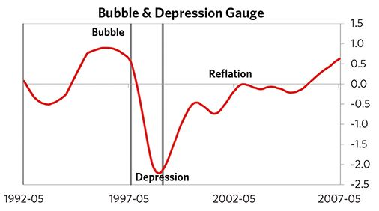

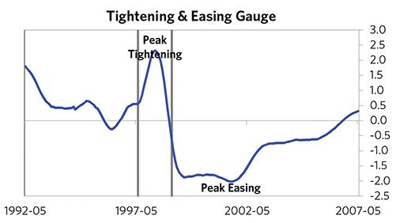

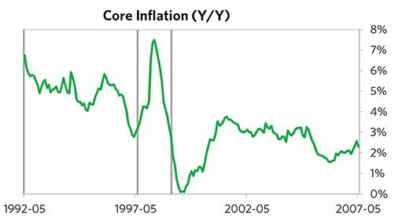

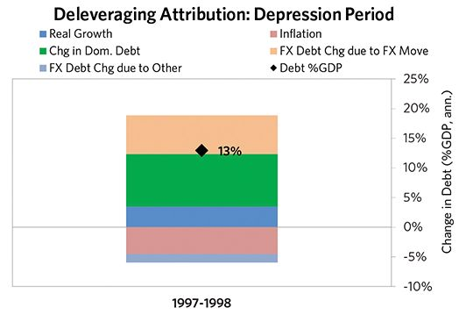

#### The Reflation Phase

A key determinant of how balance of payments/currency crises play out is how policy makers respond to adverse capital flows: whether they let their currency go and allow a tightening of financial conditions to flow through (painful but typically necessary to resolve the crisis), or print money to make up for money leaving (which can be inflationary). In this case, they abandoned the currency peg and, after a slightly shorter than average “ugly” phase, policy makers allowed enough tightening to flow through to reduce spending on imports (the current account balance improved by 7% of GDP), and make the currency more attractive to hold. Korea was very aggressive in managing its financial institutions and bad debts, pulling 7 out of 9 classic policy levers. In particular, it nationalized banks, provided liquidity, and directly purchased troubled assets. It also benefited from an IMF assistance program and enacted structural reforms designed to increase labor market flexibility. As shown in the attribution chart to the right, debt as a % of GDP fell by 25% (10% annualized) over the course of this adjustment period. The reduction in debt-to-income ratios came mostly from nominal income rising, driven primarily by higher real growth. Meanwhile, Korea’s now lower currency (with real FX bottoming at -17% during the beautiful period) set up the country for renewed competitiveness. It took 1.7 years before real GDP reached its prior peak and equity prices in USD terms recovered within 9 years.

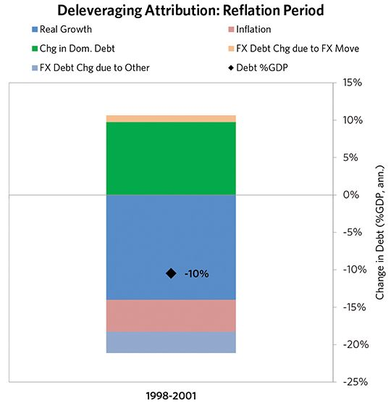

### Korea 1994–2001 Chart Deck Appendix

#### Indebtedness

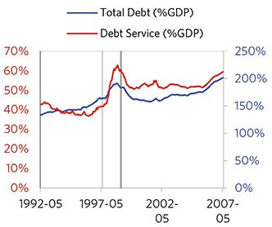

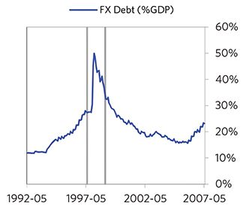

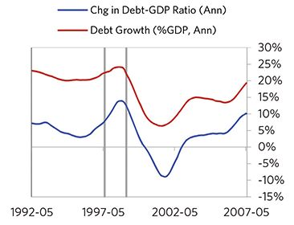

#### Monetary and Fiscal Policy

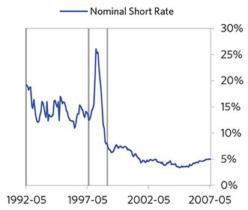

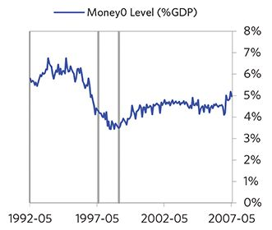

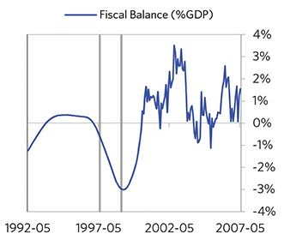

#### Economic Conditions

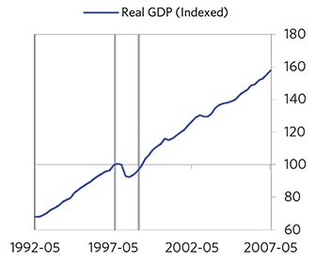

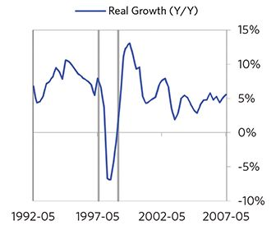

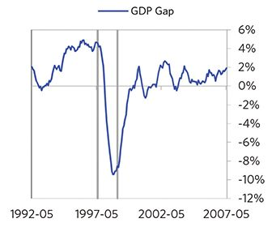

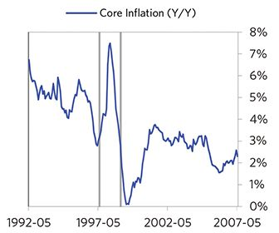

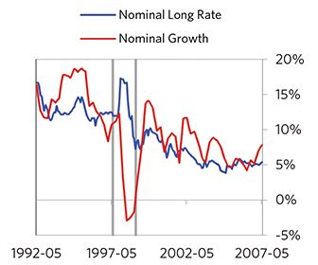

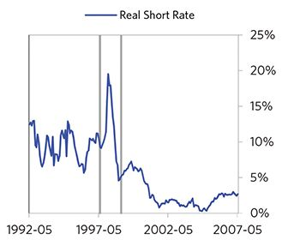

#### Markets

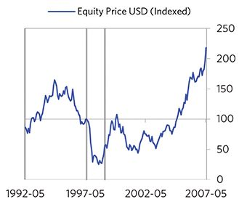

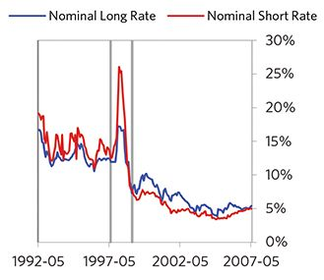

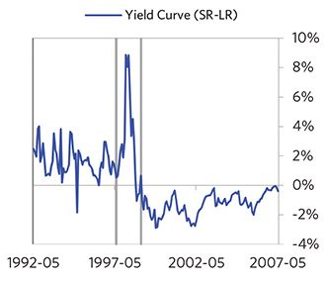

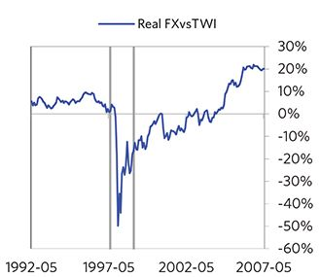

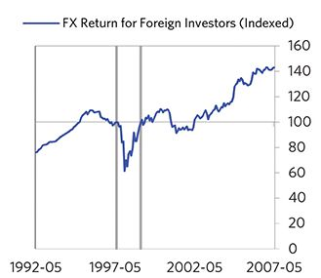

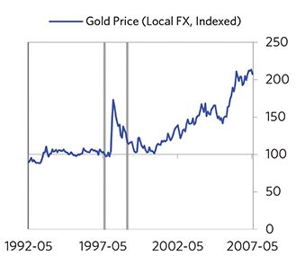

#### External Position

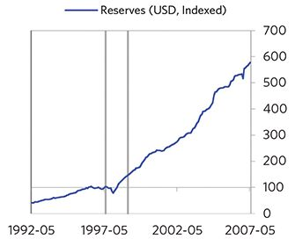

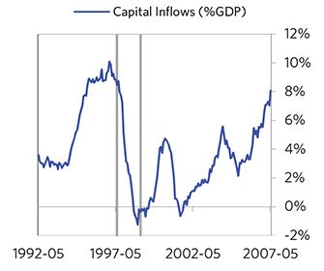

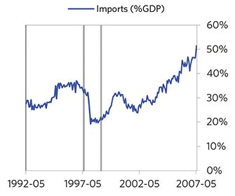

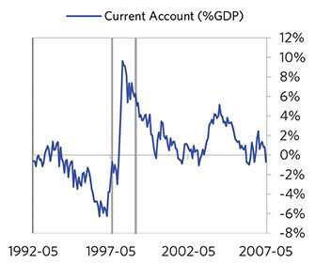

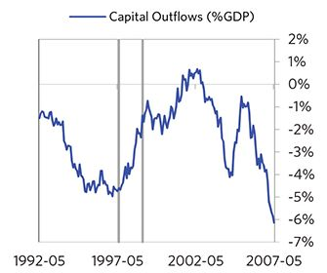

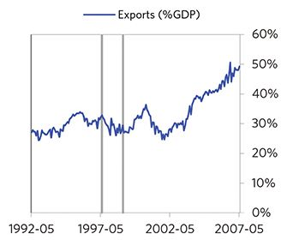

### Malaysia 1994–2001 Case Auto-Summary

As show in the charts below, Malaysia experienced a transitory inflationary deleveraging cycle between 1994 and 2001. This is also a classic example of a country “letting its currency go” in the face of external pressures, which produces some temporary inflation but ultimately gives policy makers more flexibility to set interest rates.

#### The Bubble Phase

Between 1994 and 1997, Malaysia experienced a bubble that was driven by a self-reinforcing cycle of unsustainably strong capital inflows, rising debt and strong growth. Debts rose by 53% of GDP during the bubble to a pre-crisis peak of 212% of GDP. In this case, a high share of the debt was in foreign currencies (39% of GDP)—leaving Malaysia with a large exposure to a pullback in foreign capital. During the bubble phase, investment inflows were moderately strong, averaging around 6% of GDP, which helped to finance a current account deficit of 8% of GDP. Aided by that rising debt and capital, growth was strong (at 10%), while levels of economic activity were high (the GDP gap peaked at 9%). Taken together, these bubble pressures and Malaysia’s dependence on foreign financing, combined with the weakened condi- tions of related countries, created an unsustainable situation.

#### The Depression Phase

Eventually the dynamic turned, producing a self-reinforcing bust and a balance of payments/currency crisis, which ran from 1997 to 1998. At its pre-crisis peak, debt service reached 45% of GDP, making Malaysia vulnerable to a shock—which came in the form of the 1997 Asian financial crisis. Malaysia suffered a fall in foreign funding (with capital inflows falling by 5% of GDP), leading to a tightening (policy makers hiked short rates by 4%) and a meaningful decline in the currency (real FX fell by 24%)—which coincided with self-reinforcing declines in GDP (falling by 9%), and in stock prices (falling by 83%). In addition, currency weakness contributed to rising inflation, peaking at 5% during the depression phase, which is low compared to other similar cases. That makes sense given that Malaysia had only about a quarter of the classic “risk factors” for bigger inflation spirals (with the biggest risk factor being their current account deficit). Malaysia’s financial institu- tions also came under considerable pressure. Meanwhile, the central bank spent down its reserves to defend the currency (drawing down reserves by 27%), though it eventually abandoned its currency defense. As shown in the attribution chart to the right, even though Malaysia needed a deleveraging, its debt as a % GDP went up by 10% (7% annualized), in part because the currency fell (which increased the burden of foreign-denominated debt).

The gauges below are composed from a compendium of stats shown in the chart deck that follows. Note these are meant to be rough measures.

*The first two charts show gauges which measure bubble/depression conditions and tightness/easiness of money and credit. For each gauge, the difference from zero conveys the extent of the bubble while the crossing above/below zero represents the shifting into or out of the bubble.

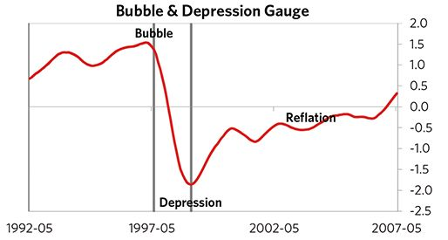

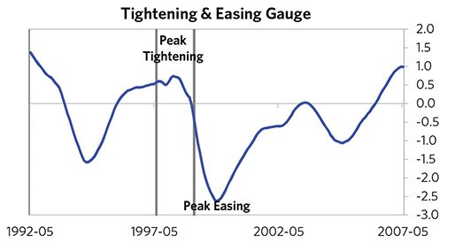

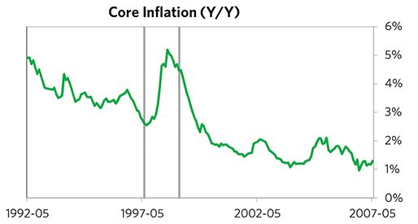

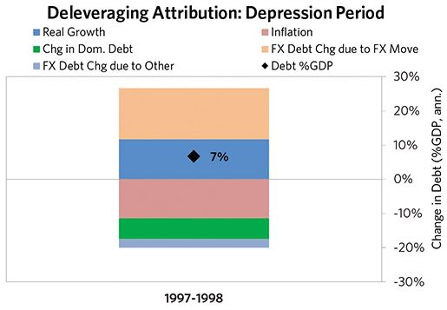

#### The Reflation Phase

A key determinant of how balance of payments/currency crises play out is how policy makers respond to adverse capital flows: whether they let their currency go and allow a tightening of financial conditions to flow through (painful but typically necessary to resolve the crisis), or print money to make up for money leaving (which can be inflationary). In this case, they abandoned the currency peg and, after a slightly shorter than average “ugly” phase, policy makers allowed enough tightening to flow through to reduce spending on imports (the current account balance improved by 19% of GDP), and make the currency more attractive to hold. Malaysia was very aggressive in managing its financial institutions and bad debts, pulling 7 out of 9 classic policy levers. In particular, it nationalized banks, provided liquidity, and directly purchased troubled assets. As shown in the attribution chart to the right, debt as a % of GDP fell by 41% (18% annualized) over the course of this adjustment period. The reduction in debt-to-income ratios came mostly from nominal income rising, driven primarily by higher real growth. Meanwhile, Malaysia’s now much lower currency (with real FX bottoming at -9% during the beautiful period) set up the country for renewed competitiveness. It took 2 years before real GDP reached its prior peak and equity prices in USD terms recovered within 14 years.

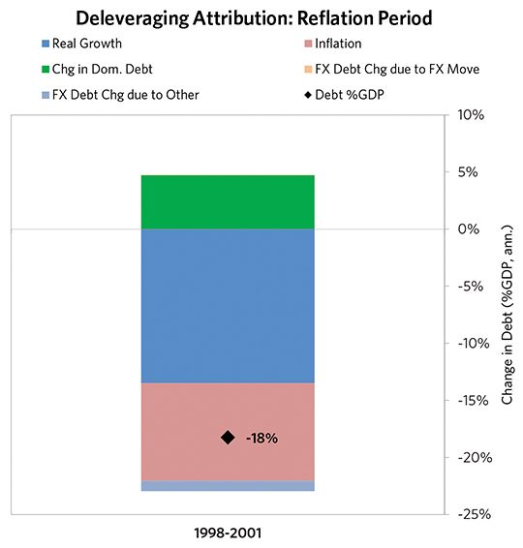

### Malaysia 1994–2001 Chart Deck Appendix

#### Indebtedness

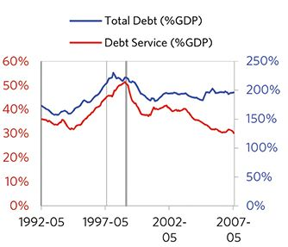

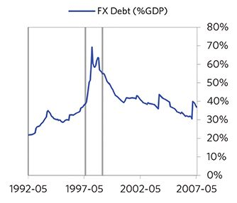

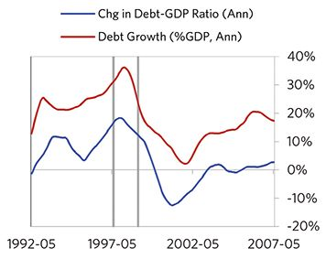

#### Monetary and Fiscal Policy

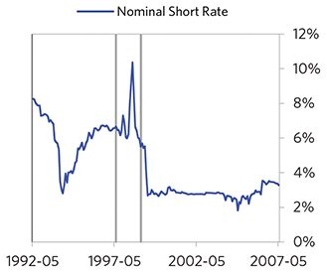

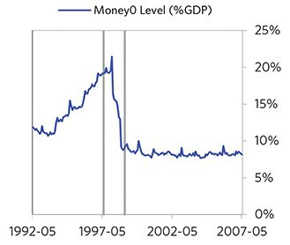

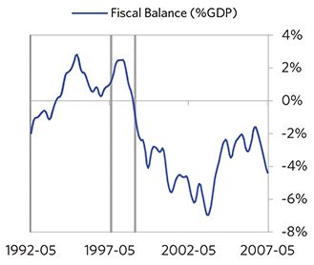

#### Economic Conditions

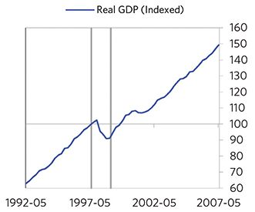

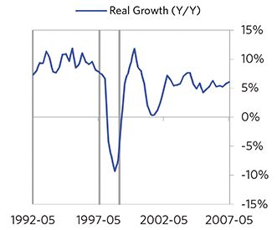

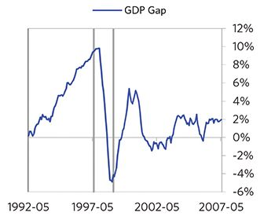

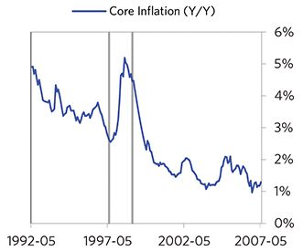

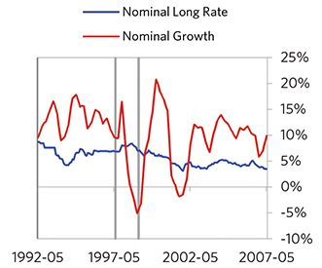

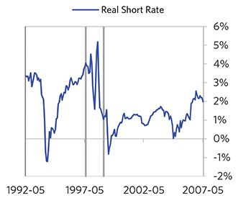

#### Markets

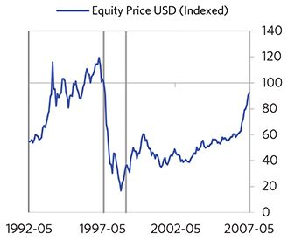

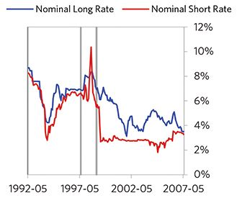

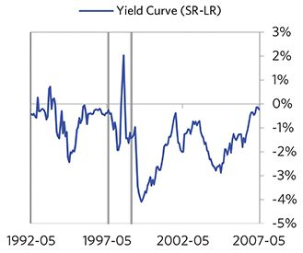

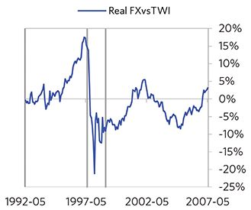

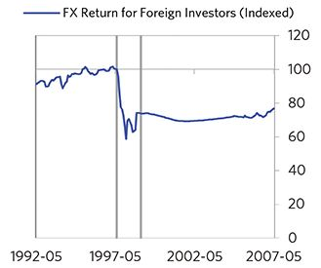

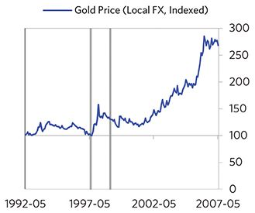

#### External Position

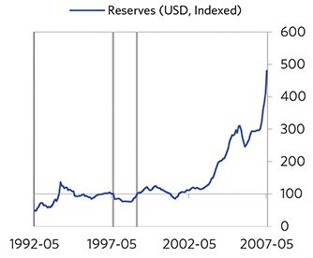

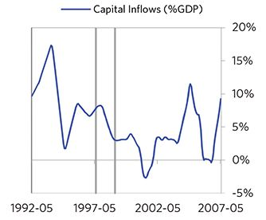

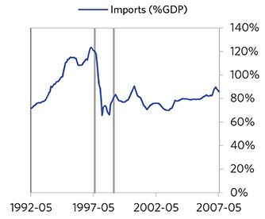

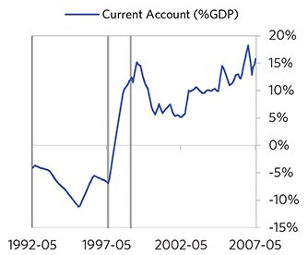

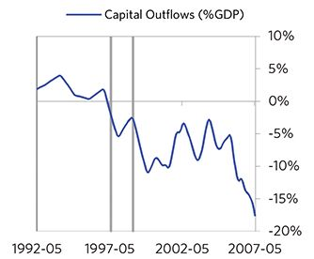

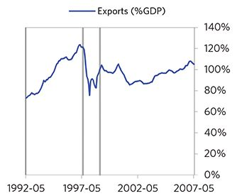

### Philippines 1994–2008 Case Auto-Summary

As show in the charts below, the Philippines experienced a transitory inflationary deleveraging cycle between 1994 and 2008. This is also a classic example of a country “letting its currency go” in the face of external pressures, which produces some temporary inflation but ultimately gives policy makers more flexibility to set interest rates.

#### The Bubble Phase

Between 1994 and 1997, the Philippines experienced a bubble that was most characterized by unsustainably strong capital inflows and strong currency returns. Debts rose by 12% of GDP during the bubble to a pre-crisis peak of 95% of GDP. In this case, a high share of the debt was in foreign currencies (51% of GDP)—leaving the Philippines with a large exposure to a pullback in foreign capital. During the bubble phase, investment inflows were strong, averaging around 12% of GDP, which helped to finance a current account deficit of 5% of GDP. Aided by that rising debt and capital, growth was strong (at 5%), while levels of economic activity were moderate (the GDP gap peaked at 2%). Furthermore, strong asset returns (equities averaged 8% annualized returns over the bubble period) encouraged more borrowing and helped to stimulate growth. Competitiveness became an issue, as the Philippines’s real FX peaked at +23%. Taken together, these bubble pressures and the Philippines’s dependence on foreign financing, combined with the weakened conditions of related countries, created an unsustainable situation.

#### The Depression Phase

Eventually the dynamic turned, producing a self-reinforcing bust and a balance of payments/currency crisis, which ran from 1997 to 1998. At its pre-crisis peak, debt service reached 25% of GDP, making the Philippines vulnerable to a shock—which came in the form of the 1997 Asian financial crisis. The Philippines suffered a fall in foreign funding (with capital inflows falling by 19% of GDP), leading to a tightening (policy makers hiked short rates by 9%) and a meaningful decline in the currency (real FX fell by 29%)—which coincided with self-reinforcing declines in GDP (falling by 3%), and in stock prices (falling by 79%). In addition, currency weakness contributed to moderate and rising inflation, peaking at 10% during the depression phase, which is low compared to other similar cases. That makes sense given that the Philippines had only about a quarter of the classic “risk factors” for bigger inflation spirals (with the biggest risk factor being low central bank reserves). The Philippines’s financial institutions also came under considerable pressure. Meanwhile, the central bank spent down its reserves to defend the currency (drawing down reserves by 60%), though it eventually abandoned its currency defense. As shown in the attribution chart to the right, even though the Philippines needed a deleveraging, its debt as a % GDP went up by 24% (15% annualized), in part because the currency fell (which increased the burden of foreign-denominated debt).

The gauges below are composed from a compendium of stats shown in the chart deck that follows. Note these are meant to be rough measures.

*The first two charts show gauges which measure bubble/depression conditions and tightness/easiness of money and credit. For each gauge, the difference from zero conveys the extent of the bubble while the crossing above/below zero represents the shifting into or out of the bubble.

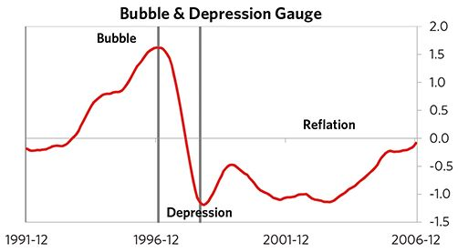

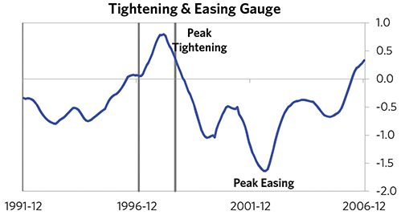

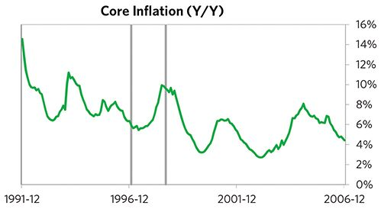

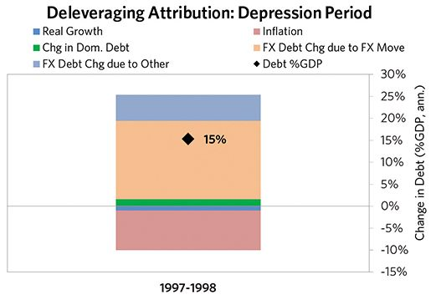

#### The Reflation Phase

A key determinant of how balance of payments/currency crises play out is how policy makers respond to adverse capital flows: whether they let their currency go and allow a tightening of financial conditions to flow through (painful but typically necessary to resolve the crisis), or print money to make up for money leaving (which can be inflationary). In this case, they abandoned the currency peg and, after a slightly shorter than average “ugly” phase, policy makers allowed enough tightening to flow through to reduce spending on imports (the current account balance improved by 11% of GDP), and make the currency more attractive to hold. The Philippines was somewhat aggressive in managing its financial institutions and bad debts, pulling 3 out of 9 classic policy levers. It also benefited from an IMF assistance program and enacted structural reforms designed to increase labor market flexibility. As shown in the attribution chart to the right, debt as a % of GDP fell by 51% (5% annualized) over the course of this adjustment period. The reduction in debt-to-income ratios came mostly from nominal income rising. Meanwhile, the Philippines’s now much lower currency (with real FX bottoming at -24% during the beautiful period) set up the country for renewed competitive- ness. In the end, the GDP contraction was brief, while equity prices in USD terms recovered within 16 years.

The crisis had a notable impact on the politics of the Philippines, as it helped set the stage for Joseph Estrada, whom many people consider a populist leader, to take power.

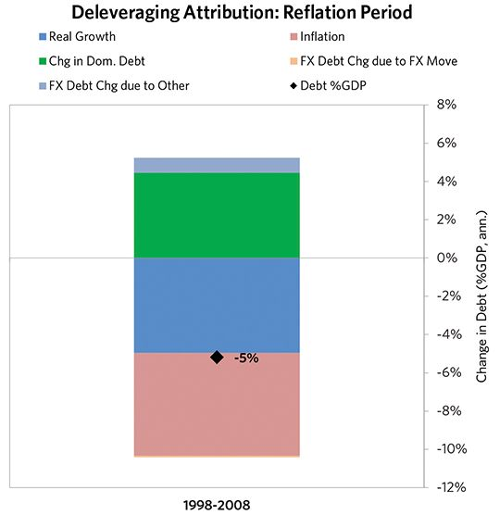

### Philippines 1994–2008 Chart Deck Appendix

#### Indebtedness

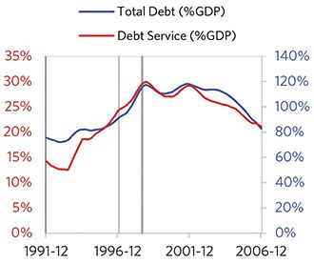

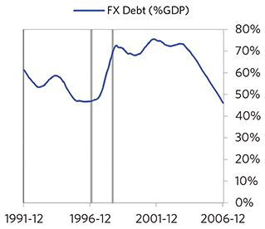

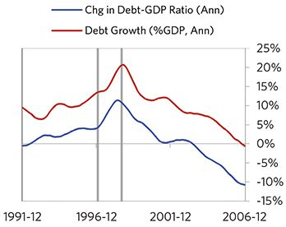

#### Monetary and Fiscal Policy

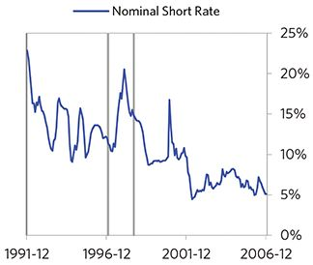

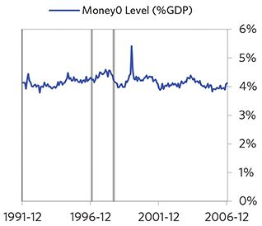

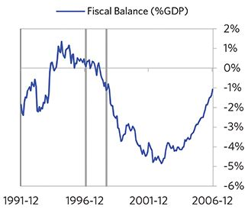

#### Economic Conditions

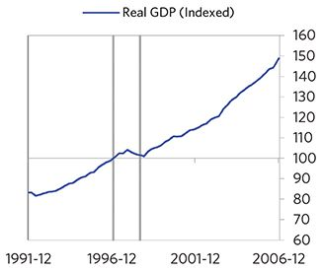

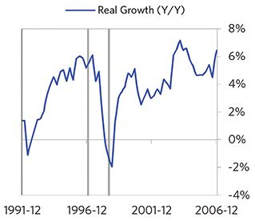

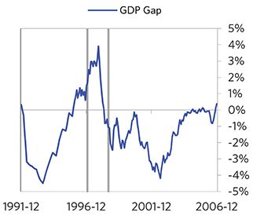

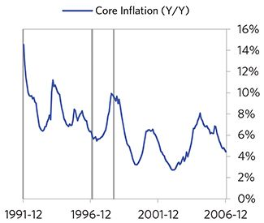

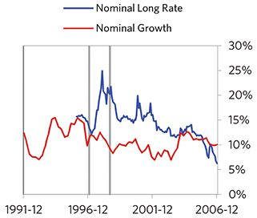

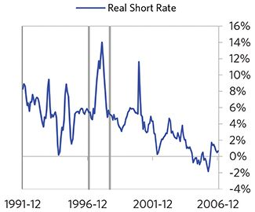

#### Markets

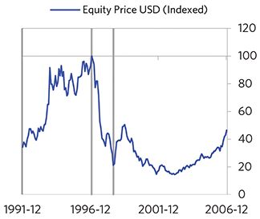

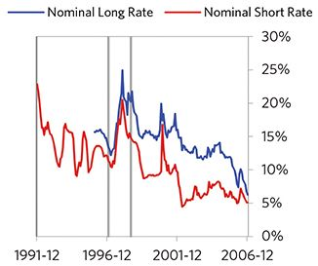

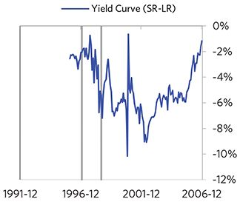

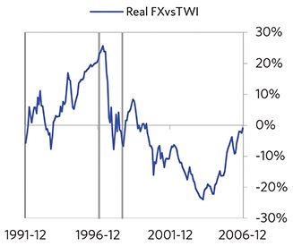

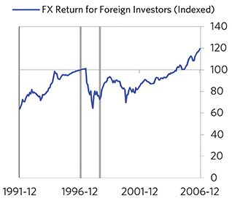

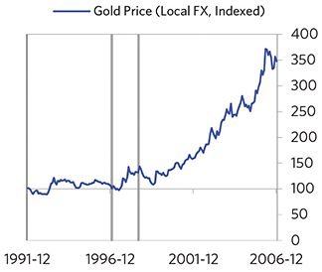

#### External Position

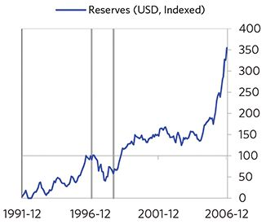

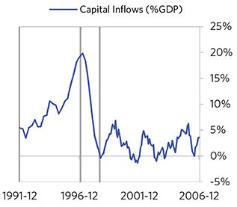

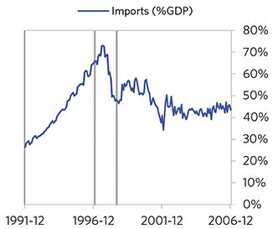

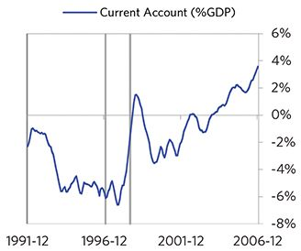

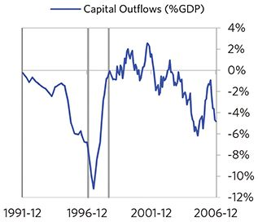

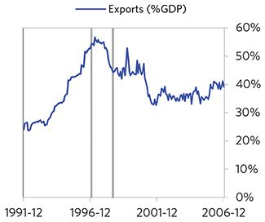

### Russia 1996–2006 Case Auto-Summary

As show in the charts below, Russia experienced a transitory inflationary deleveraging cycle between 1996 and 2006. This is also a classic example of a country “letting its currency go” in the face of external pressures, which produces some temporary inflation but ultimately gives policy makers more flexibility to set interest rates.

#### The Bubble Phase

Unlike many other cases, Russia didn’t experience a broad-based bubble in the years before the crisis, but it was tied to other countries, economies, and financial markets that were experiencing bubble-like conditions. And it did build up a substantial debt stock driven by unsustainably strong capital inflows, with debts reaching 112% of GDP prior to the crisis. In this case, a high share of the debt was in foreign currencies (38% of GDP)—leaving Russia with a large exposure to a pullback in foreign capital. Russia also became somewhat dependent on continuous foreign financing, with investment inflows averaging 5% in the years before the crisis. Ultimately, these high debts and Russia’s dependence on foreign financing, combined with the weakened conditions of related countries, created an unsustainable situation.

#### The Depression Phase

Eventually the cycle turned, producing a self-reinforcing bust and a balance of payments/currency crisis, which ran from 1997 to 1998. At its pre-crisis peak, debt service reached 90% of GDP, making Russia vulnerable to a shock—which came in the form of ripples from the 1997 Asian financial crisis and falling oil prices. Russia suffered a fall in foreign funding (with capital inflows falling by 5% of GDP), leading to a tightening (policy makers hiked short rates by more than 250%) and a meaningful decline in the currency (real FX fell by 72%)—which coincided with self-reinforcing declines in GDP (falling by 10%), and in stock prices (falling by 85%). In addition, currency weakness contributed to high and rising inflation, peaking at 91% during the depression phase, which is high compared to other similar cases. That makes sense given that Russia had around half of the classic “risk factors” for bigger inflation spirals (with the biggest risk factor being a long history of poorly-controlled inflation). Russia’s financial institutions also came under considerable pressure. Meanwhile, the central bank spent down its reserves to defend the currency (drawing down reserves by 55%), though it eventually abandoned its currency defense. As shown in the attribution chart to the right, even though Russia needed a deleveraging, its debt as a % GDP went up by 63% (58% annualized), in part because the currency fell (which increased the burden of foreign-denominated debts) and in part because the government had to borrow more in response to the crisis (with a peak fiscal deficit of 5% of GDP).

The gauges below are composed from a compendium of stats shown in the chart deck that follows. Note these are meant to be rough measures.

*The first two charts show gauges which measure bubble/depression conditions and tightness/easiness of money and credit. For each gauge, the difference from zero conveys the extent of the bubble while the crossing above/below zero represents the shifting into or out of the bubble.

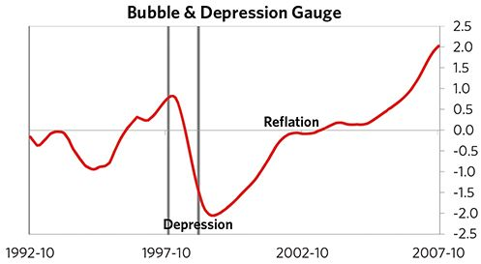

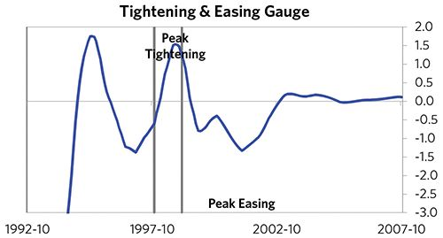

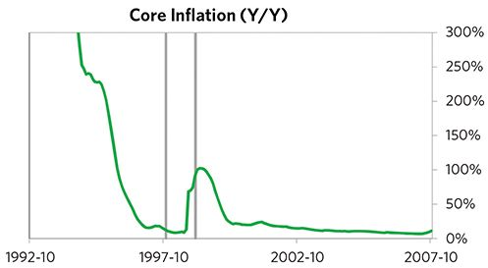

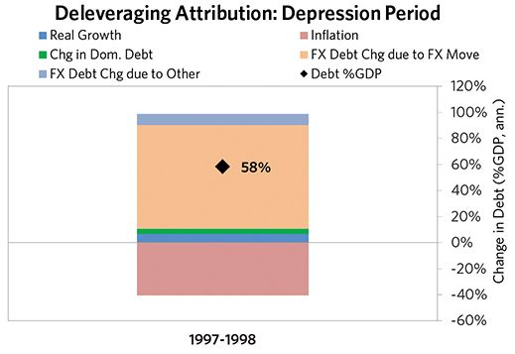

#### The Reflation Phase

A key determinant of how balance of payments/currency crises play out is how policy makers respond to adverse capital flows: whether they let their currency go and allow a tightening of financial conditions to flow through (painful but typically necessary to resolve the crisis), or print money to make up for money leaving (which can be inflationary). In this case, they abandoned the currency peg and, after a relatively short “ugly” phase, policy makers allowed enough tightening to flow through to reduce spending on imports (the current account balance improved by 8% of GDP), and make the currency more attractive to hold. Russia was very aggressive in managing its financial institutions and bad debts, pulling 6 out of 9 classic policy levers. In particular, it nationalized banks, provided liquidity, and directly purchased troubled assets. It also benefited from an IMF assistance program and enacted structural reforms designed to increase labor market flexibility. As shown in the attribution chart to the right, debt as a % of GDP fell by 119% (15% annualized) over the course of this adjustment period. The reduction in debt-to-income ratios came mostly from nominal income rising. Meanwhile, Russia’s now much lower currency (with real FX bottoming at -43% during the beautiful period) set up the country for renewed competitiveness. It took 1.8 years before real GDP reached its prior peak and equity prices in USD terms recovered within 6 years.

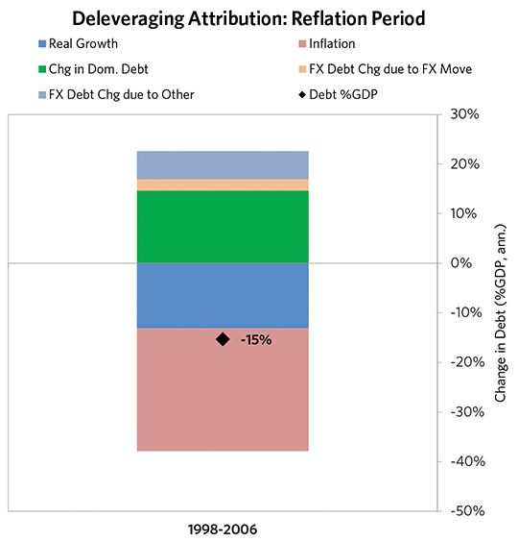

### Russia 1996–2006 Chart Deck Appendix

#### Indebtedness

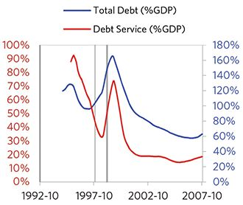

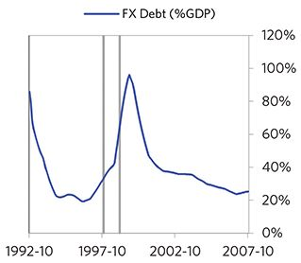

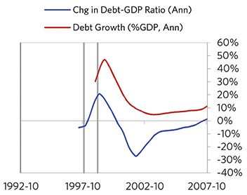

#### Monetary and Fiscal Policy

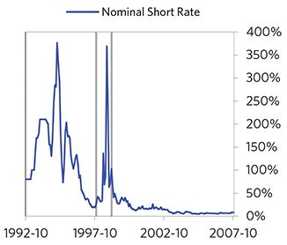

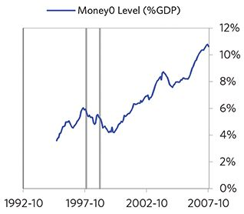

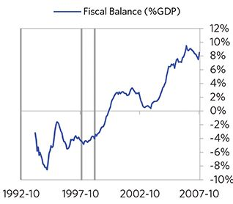

#### Economic Conditions

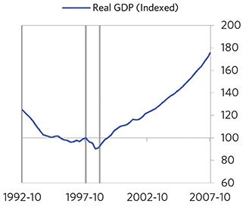

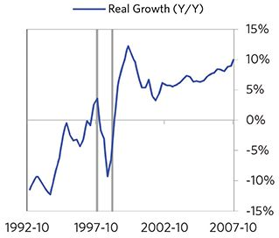

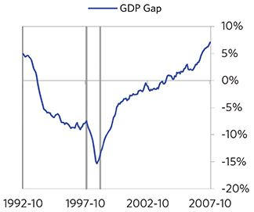

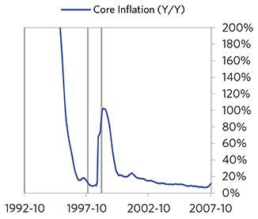

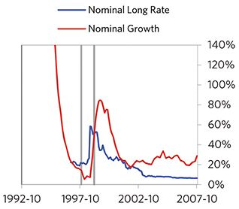

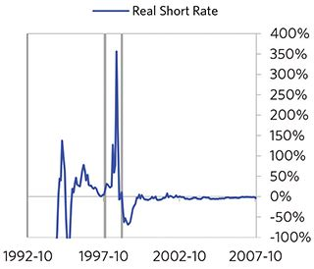

#### Markets

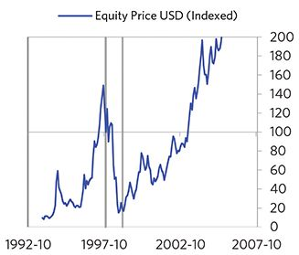

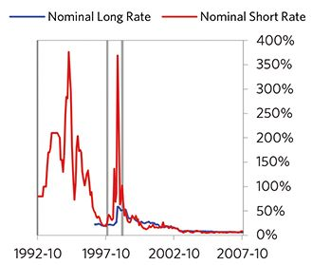

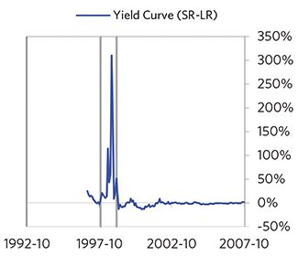

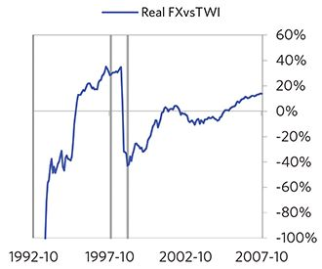

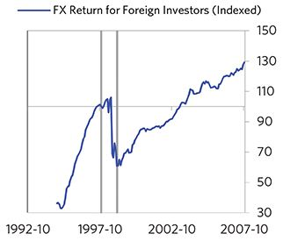

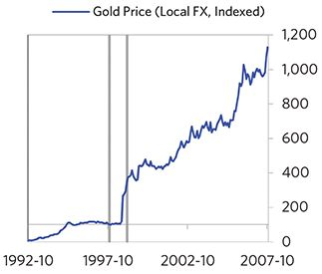

#### External Position

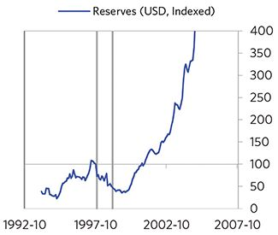

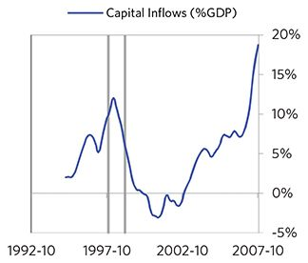

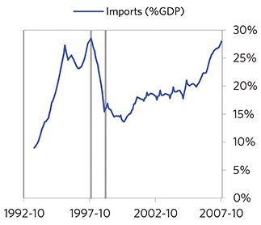

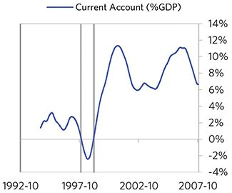

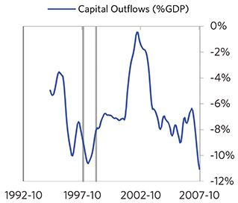

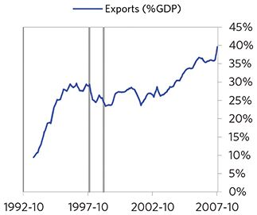

### Colombia 1995–2008 Case Auto-Summary

As show in the charts below, Colombia experienced a transitory inflationary deleveraging cycle between 1995 and 2008. This is also a classic example of a country “letting its currency go” in the face of external pressures, which produces some temporary inflation but ultimately gives policy makers more flexibility to set interest rates.

#### The Bubble Phase

Between 1995 and 1998, Colombia experienced a bubble that was driven by a self-reinforcing cycle of unsustainably strong capital inflows, rising debt, strong growth, and strong housing returns. Debts rose by 11% of GDP during the bubble to a pre-crisis peak of 58% of GDP. In this case, a high share of the debt was in foreign currencies (30% of GDP)—leaving Colombia with a large exposure to a pullback in foreign capital. During the bubble phase, investment inflows were moderately strong, averaging around 8% of GDP, which helped to finance a current account deficit of 5% of GDP. Aided by that rising debt and capital, growth was strong (at 3%), while levels of economic activity were high (the GDP gap peaked at 5%). Competitiveness became an issue, as Colombia’s real FX peaked at +16%. Taken together, these bubble pressures and Colombia’s dependence on foreign financing, combined with the weakened conditions of related countries, created an unsustainable situation.

#### The Depression Phase

Eventually the dynamic turned, producing a self-reinforcing bust and a balance of payments/currency crisis, which ran from 1998 to 2003. High debt levels left Colombia vulnerable to a shock—which came in the form of the effects of the 1997 Asian financial crisis. Colombia suffered a fall in foreign funding (with capital inflows falling by 8% of GDP), leading to a tightening (policy makers hiked short rates by 20%) and a meaningful decline in the currency (real FX fell by 45%)— which coincided with self-reinforcing declines in GDP (falling by 7%), and in stock prices (falling by 66%). Unemployment rates increased by 6%, while currency weakness contributed to moderate inflation, peaking at 20% during the depression phase, which is low compared to other similar cases. That’s true despite the fact that Colombia had around half of the classic “risk factors” for bigger inflation spirals (with the biggest risk factor being a long history of poorly-controlled inflation). Colombia’s financial institutions also came under considerable pressure. Meanwhile, the central bank spent down its reserves to defend the currency (drawing down reserves by 37%), though it eventually abandoned its currency defense. As shown in the attribution chart to the right, even though Colombia needed a deleveraging, its debt as a % GDP went up by 12% (2% annualized), in part because the currency fell (which increased the burden of foreign-denominated debts) and in part because the government had to borrow more in response to the crisis (with a peak fiscal deficit of 5% of GDP).

The gauges below are composed from a compendium of stats shown in the chart deck that follows. Note these are meant to be rough measures.

*The first two charts show gauges which measure bubble/depression conditions and tightness/easiness of money and credit. For each gauge, the difference from zero conveys the extent of the bubble while the crossing above/below zero represents the shifting into or out of the bubble.

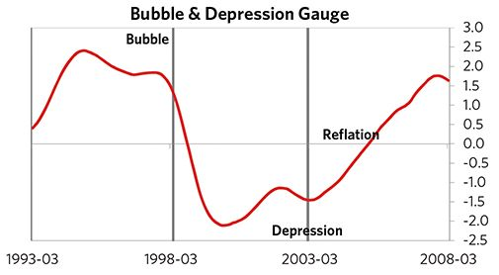

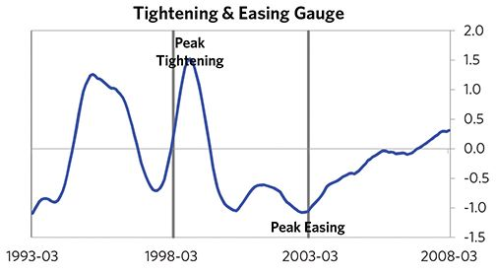

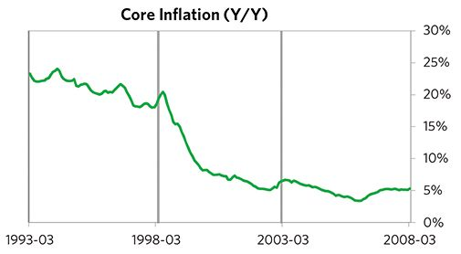

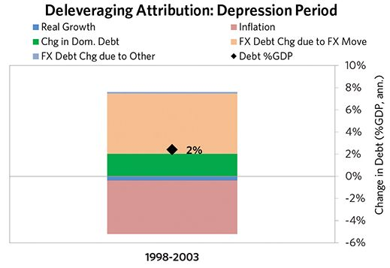

#### The Reflation Phase

A key determinant of how balance of payments/currency crises play out is how policy makers respond to adverse capital flows: whether they let their currency go and allow a tightening of financial conditions to flow through (painful but typically necessary to resolve the crisis), or print money to make up for money leaving (which can be inflationary). In this case, they abandoned the currency peg and, after a slightly longer than average “ugly” phase, policy makers allowed enough tightening to flow through to reduce spending on imports (the current account balance improved by 5% of GDP), and make the currency more attractive to hold. Colombia was very aggressive in managing its financial institutions and bad debts, pulling 6 out of 9 classic policy levers. In particular, it nationalized banks, provided liquidity, and directly purchased troubled assets. It also benefited from an IMF assistance program and enacted structural reforms designed to increase labor market flexibility. As shown in the attribution chart to the right, debt as a % of GDP fell by 16% (3% annualized) over the course of this adjustment period. The reduction in debt-to-income ratios came mostly from nominal income rising. Meanwhile, Colombia’s now much lower currency (with real FX bottoming at -29% during the beautiful period) set up the country for renewed competitiveness. It took 4 years before real GDP reached its prior peak and equity prices in USD terms recovered within 7 years.

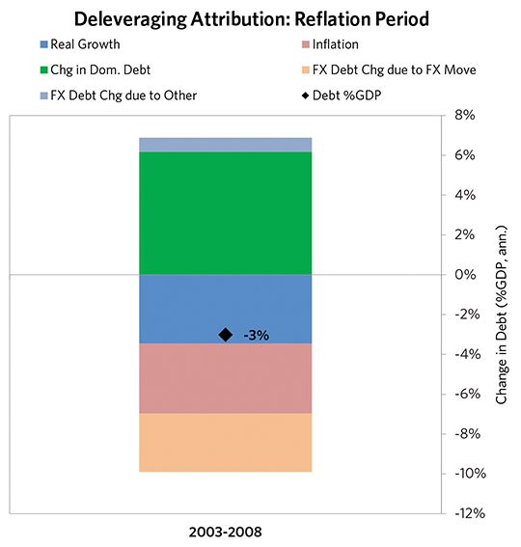

### Colombia 1995–2008 Chart Deck Appendix

#### Indebtedness

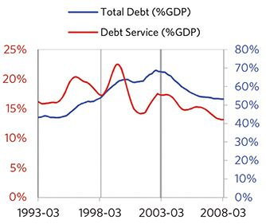

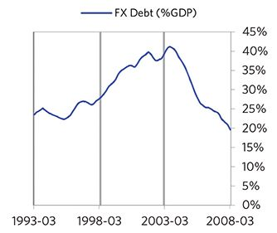

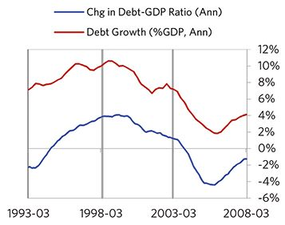

#### Monetary and Fiscal Policy

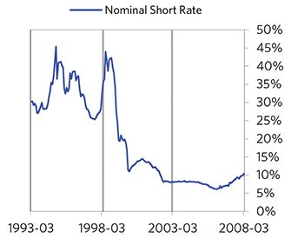

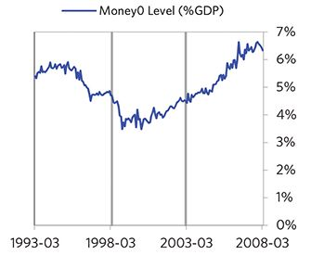

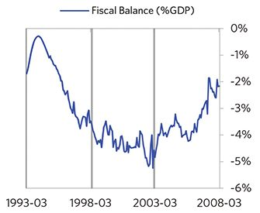

#### Economic Conditions

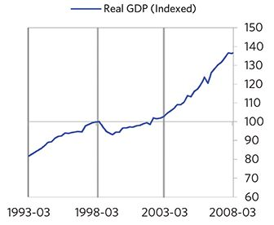

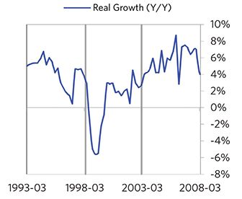

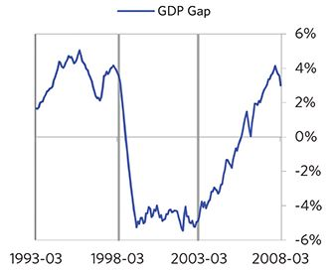

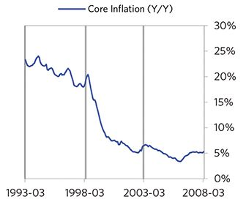

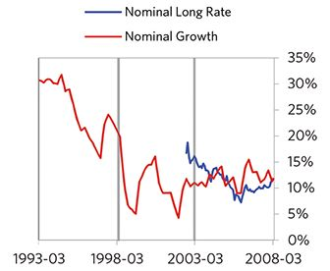

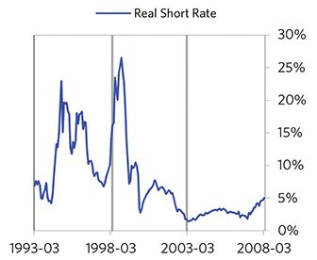

#### Markets

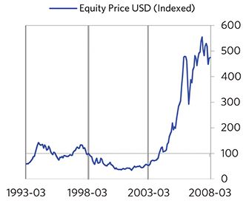

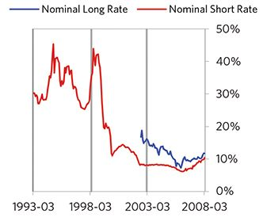

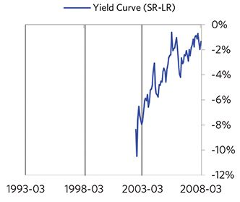

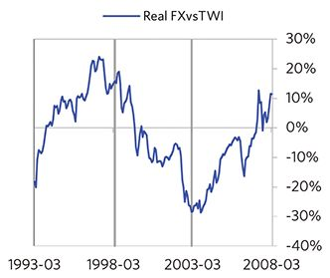

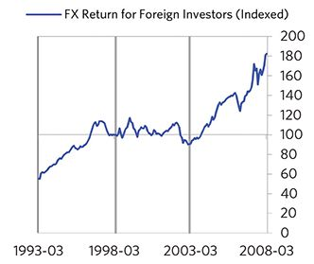

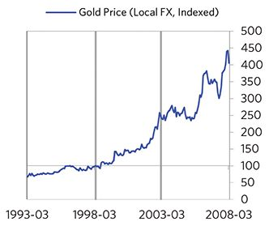

#### External Position

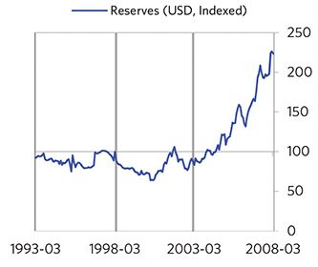

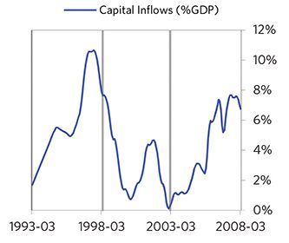

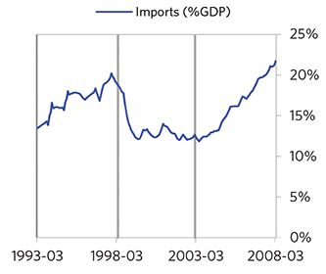

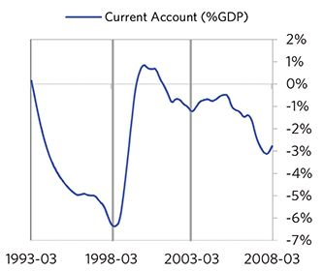

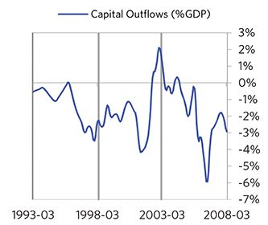

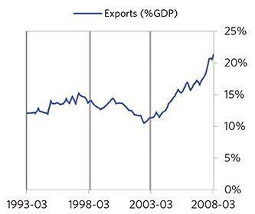

### Ecuador 1995–2009 Case Auto-Summary

As show in the charts below, Ecuador experienced a classic inflationary deleveraging cycle between 1995 and 2009.

#### The Bubble Phase

Unlike many other cases, Ecuador didn’t experience a broad-based bubble in the years before the crisis, but it was tied to other countries, economies, and financial markets that were experiencing bubble-like conditions. And it did build up a substantial debt stock, with debts reaching 85% of GDP prior to the crisis. In this case, a high share of the debt was in foreign currencies (56% of GDP)—leaving Ecuador with a large exposure to a pullback in foreign capital. Ecuador also became somewhat dependent on continuous foreign financ- ing, running a current account deficit of 4% of GDP (with investment inflows averaging 3% of GDP in the years before the crisis). Ultimately, these high debts and Ecuador’s dependence on foreign financing, combined with the weakened conditions of related countries, created an unsustainable situation.

#### The Depression Phase

Eventually the cycle turned, producing a self-reinforcing bust and a balance of payments/currency crisis, which ran from 1998 to 2000. High debt levels left Ecuador vulnerable to a shock—which came in the form of contagion from the 1997 Asian financial crisis. Ecuador suffered a fall in foreign funding (with capital inflows falling by 11% of GDP), leading to a meaningful decline in the currency (real FX fell by 60%)—which coincided with self-reinforcing declines in GDP (falling by 6%), and in stock prices (falling by 62%). Unemployment rates increased by 2%, while currency weakness contributed to high and rising inflation, peaking at 76% during the depression phase, which is high compared to other similar cases. That makes sense given that Ecuador had most of the classic “risk factors” for bigger inflation spirals (with the biggest risk factor being low real short rates). Ecuador’s financial institutions also came under considerable pressure. Meanwhile, the central bank spent down its reserves to defend the currency (drawing down reserves by 61%), though it eventually abandoned its currency defense. As shown in the attribution chart to the right, even though Ecuador needed a deleveraging, its debt as a % GDP went up by 46% (42% annualized), in part because the currency fell (which increased the burden of foreign-denominated debt).

The gauges below are composed from a compendium of stats shown in the chart deck that follows. Note these are meant to be rough measures.

*The first two charts show gauges which measure bubble/depression conditions and tightness/easiness of money and credit. For each gauge, the difference from zero conveys the extent of the bubble while the crossing above/below zero represents the shifting into or out of the bubble.

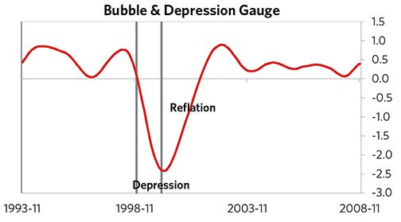

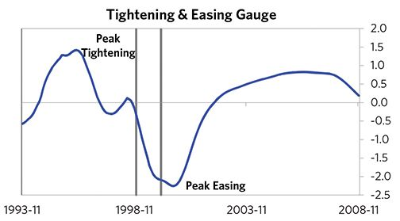

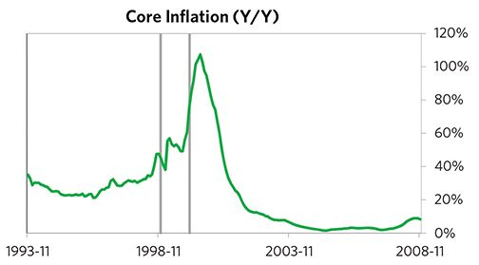

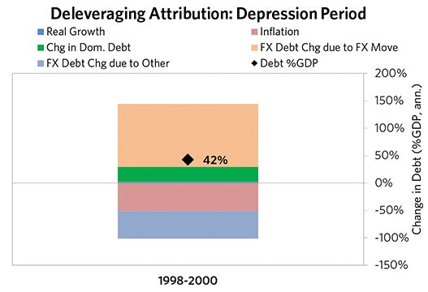

#### The Reflation Phase

A key determinant of how balance of payments/currency crises play out is how policy makers respond to adverse capital flows: whether they let their currency go and allow a tightening of financial conditions to flow through (painful but typically necessary to resolve the crisis), or print money to make up for money leaving (which can be inflationary). In this case, they abandoned the currency peg and, after a relatively short “ugly” phase, policy makers allowed enough tightening to flow through to reduce spending on imports (the current account balance improved by 11% of GDP), and make the currency more attractive to hold. Ecuador was very aggressive in managing its financial institutions and bad debts, pulling 9 out of 9 classic policy levers. In particular, it nationalized banks, provided liquidity, and directly purchased troubled assets. It also benefited from an IMF assistance program and enacted structural reforms designed to increase labor market flexibility. As shown in the attribution chart to the right, debt as a % of GDP fell by 79% (8% annualized) over the course of this adjustment period. The reduction in debt-to-income ratios came mostly from nominal income rising. Meanwhile, Ecuador’s now much lower currency (with real FX bottoming at -55% during the beautiful period) set up the country for renewed competitiveness. It took 1.8 years before real GDP reached its prior peak and equity prices in USD terms recovered within 5 years.

The crisis had a notable impact on the politics of Ecuador, as it helped set the stage for Lucio Gutierrez, whom many people consider a populist leader, to take power in 2003.

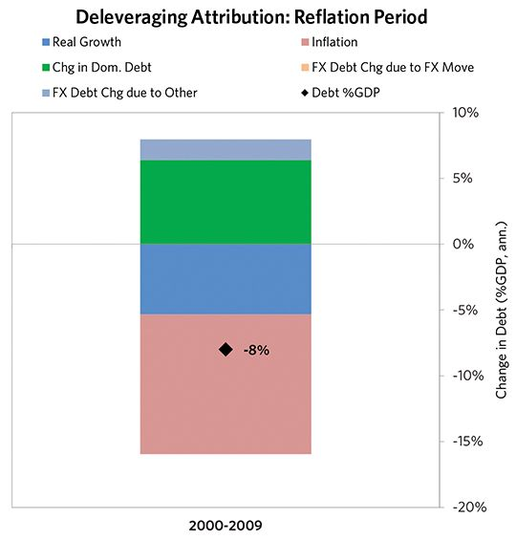

### Ecuador 1995–2009 Chart Deck Appendix

#### Indebtedness

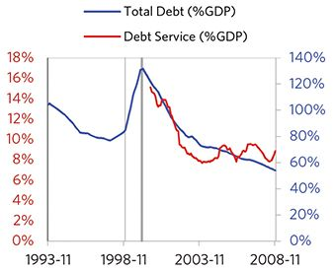

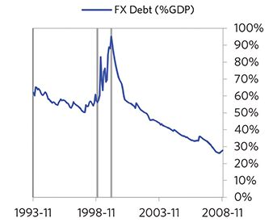

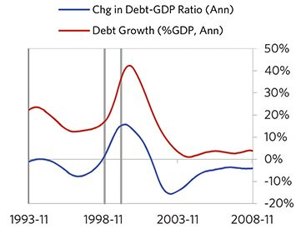

#### Monetary and Fiscal Policy

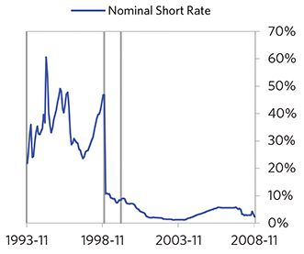

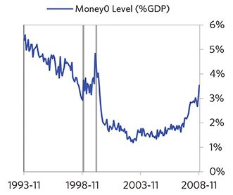

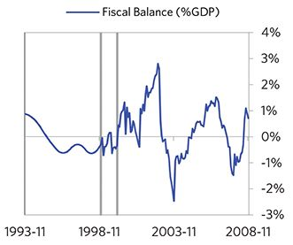

#### Economic Conditions

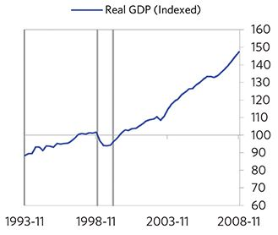

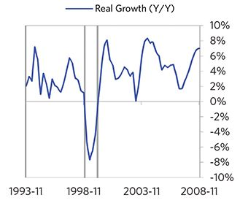

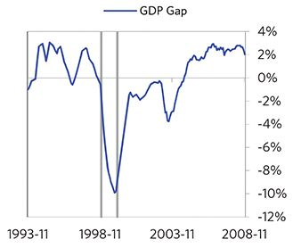

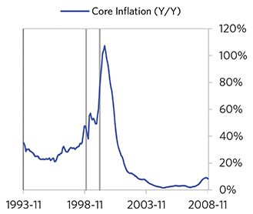

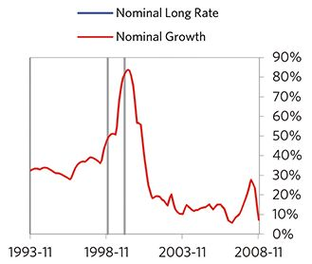

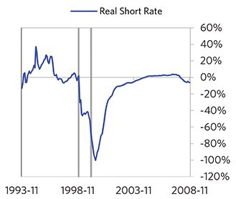

#### Markets

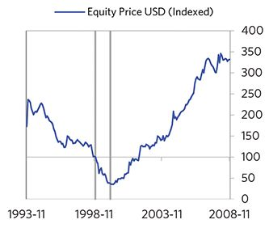

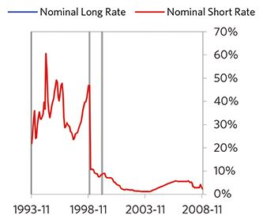

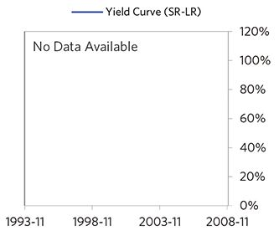

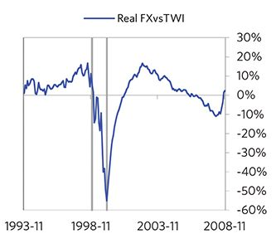

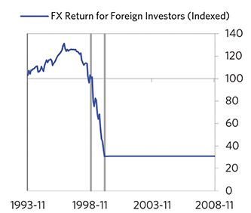

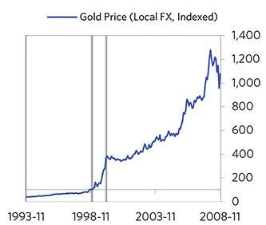

#### External Position

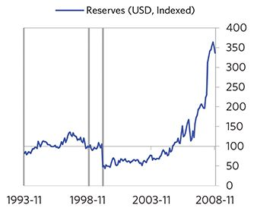

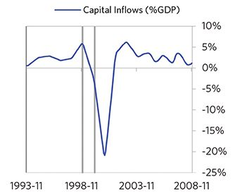

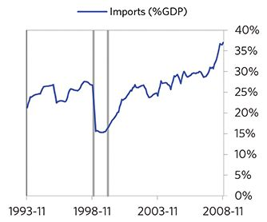

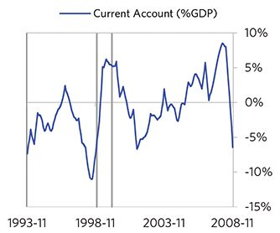

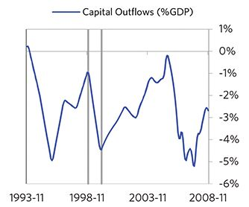

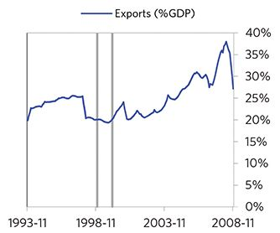

### Turkey 1997–2003 Case Auto-Summary

As show in the charts below, Turkey experienced a classic inflationary deleveraging cycle between 1997 and 2003.

#### The Bubble Phase

Between 1997 and 2000, Turkey experienced a bubble that was driven by a self-reinforcing cycle of rising debt, strong equity returns, and strong growth. Debts rose by 17% of GDP during the bubble to a pre-crisis peak of 60% of GDP. In this case, a high share of the debt was in foreign currencies (46% of GDP)—leaving Turkey with a large exposure to a pullback in foreign capital. During the bubble phase, investment inflows were low but positive, averaging around 3% of GDP. Aided by that rising debt and capital, growth was moderate (at 2%), while levels of economic activity were high (the GDP gap peaked at 9%). Furthermore, strong asset returns (equities averaged 22% annualized returns over the bubble period) encouraged more borrowing and helped to stimulate growth. Taken together, these bubble pressures and Turkey’s dependence on foreign financing created an unsustainable situation.

#### The Depression Phase

Eventually the dynamic turned, producing a self-reinforcing bust and a balance of payments/currency crisis, which ran from 2000 to 2001. At its pre-crisis peak, debt service reached 30% of GDP, making Turkey vulnerable to a shock—which came in the form of political turmoil and violence. Turkey suffered a fall in foreign funding (with capital inflows falling by 10% of GDP), leading to a tighten- ing (policy makers hiked short rates by 157%) and a meaningful decline in the currency (real FX fell by 12%)— which coincided with self-reinforcing declines in GDP (falling by 10%), and in stock prices (falling by 78%). Unemployment rates increased by 3%, while currency weakness contributed to high and rising inflation, peaking at 62% during the depression phase, which is high compared to other similar cases. That makes sense given that Turkey had most of the classic “risk factors” for bigger inflation spirals (with the biggest risk factor being a long history of poorly-controlled inflation). Turkey’s financial institutions also came under considerable pressure. Meanwhile, the central bank spent down its reserves to defend the currency (drawing down reserves by 100%), though it eventually abandoned its currency defense. As shown in the attribution chart to the right, even though Turkey needed a deleverag- ing, its debt as a % GDP went up by 9% (6% annualized), in part because the currency fell (which increased the burden of foreign-denominated debts) and in part because the government had to borrow more in response to the crisis (with a peak fiscal deficit of 11% of GDP).

The gauges below are composed from a compendium of stats shown in the chart deck that follows. Note these are meant to be rough measures.

*The first two charts show gauges which measure bubble/depression conditions and tightness/easiness of money and credit. For each gauge, the difference from zero conveys the extent of the bubble while the crossing above/below zero represents the shifting into or out of the bubble.

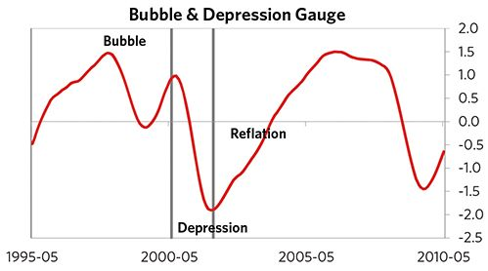

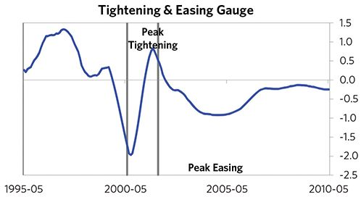

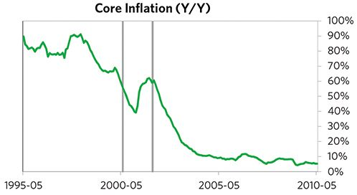

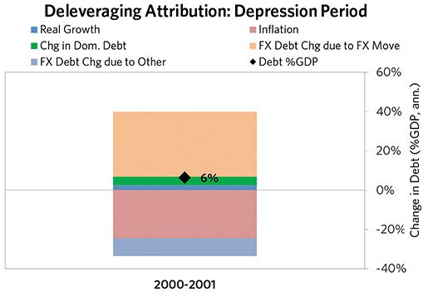

#### The Reflation Phase

A key determinant of how balance of payments/currency crises play out is how policy makers respond to adverse capital flows: whether they let their currency go and allow a tightening of financial conditions to flow through (painful but typically necessary to resolve the crisis), or print money to make up for money leaving (which can be inflationary). In this case, they abandoned the currency peg and, after a slightly shorter than average “ugly” phase, policy makers allowed enough tightening to flow through to reduce spending on imports (the current account balance improved by 5% of GDP), and make the currency more attractive to hold. Turkey was very aggressive in managing its financial institutions and bad debts, pulling 7 out of 9 classic policy levers. In particular, it nationalized banks, provided liquidity, and directly purchased troubled assets. It also benefited from an IMF assistance program and enacted structural reforms designed to increase labor market flexibility. As shown in the attribution chart to the right, debt as a % of GDP fell by 6% (3% annualized) over the course of this adjustment period. The reduction in debt-to-income ratios came mostly from nominal income rising. Meanwhile, Turkey’s now lower currency (with real FX bottoming at -18% during the beautiful period) set up the country for renewed competitiveness. It took 2 years before real GDP reached its prior peak and equity prices in USD terms recovered within 6 years.

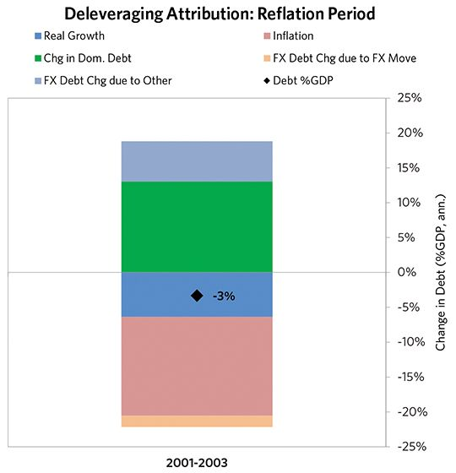

### Turkey 1997–2003 Chart Deck Appendix

#### Indebtedness

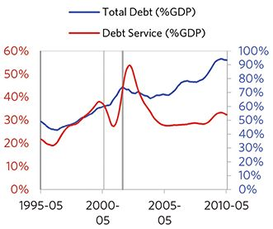

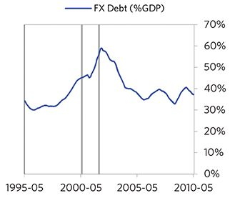

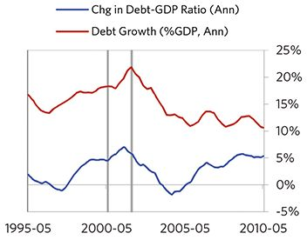

#### Monetary and Fiscal Policy

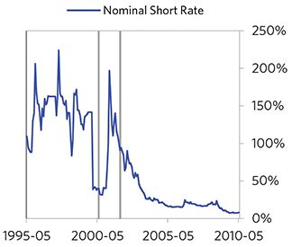

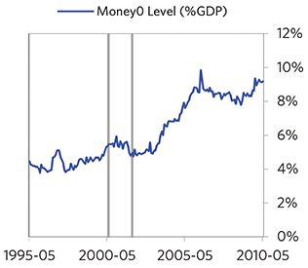

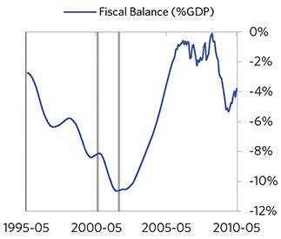

#### Economic Conditions

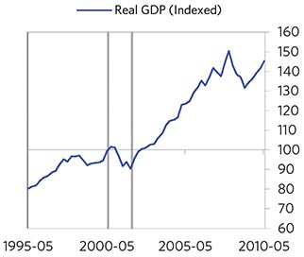

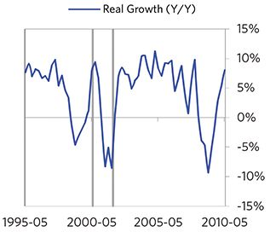

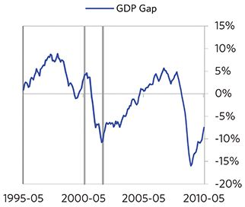

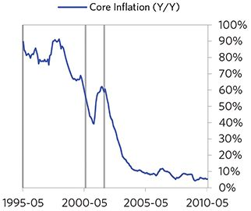

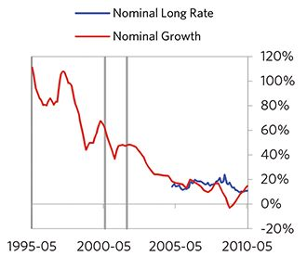

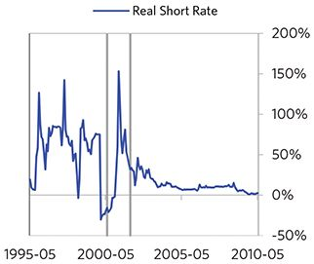

#### Markets

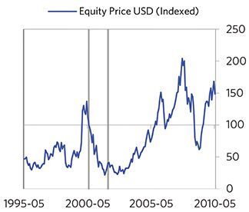

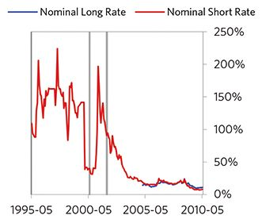

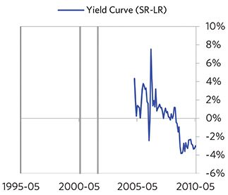

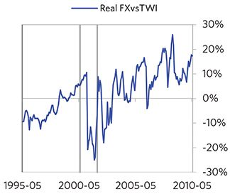

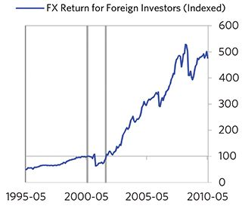

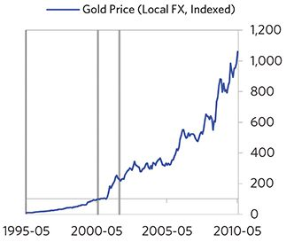

#### External Position

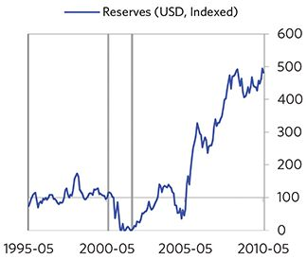

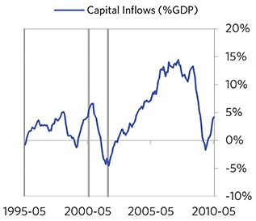

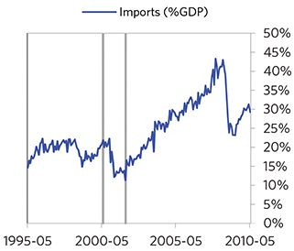

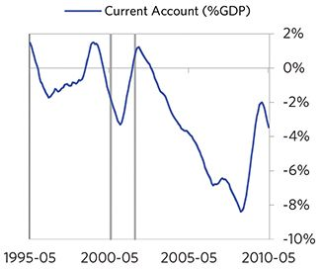

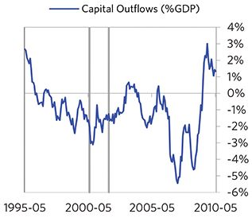

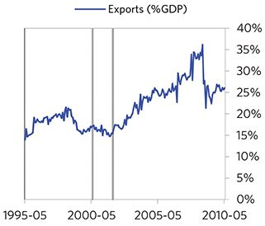

### Argentina 1998–2012 Case Auto-Summary

As show in the charts below, Argentina experienced a transitory inflationary deleveraging cycle between 1998 and 2012. This is also a classic example of a country “letting its currency go” in the face of external pressures, which produces some temporary inflation but ultimately gives policy makers more flexibility to set interest rates.

#### The Bubble Phase

Between 1998 and 2001, Argentina experienced a bubble that was most characterized by unsustainably strong capital inflows and strong currency returns. By the bubble’s end, debts had reached a pre-crisis peak of 78% of GDP. In this case, a high share of the debt was in foreign currencies (47% of GDP)—leaving Argentina with a large exposure to a pullback in foreign capital. During the bubble phase, investment inflows were strong, averaging around 11% of GDP, which helped to finance a current account deficit of 5% of GDP. Growth was weak (at 0%), while levels of economic activity were high (the GDP gap peaked at 9%). Competitiveness became an issue, as Argentina’s real FX peaked at +39%. Taken together, these bubble pressures and Argentina’s dependence on foreign financing, combined with the weakened conditions of related countries, created an unsustainable situation.

#### The Depression Phase

Eventually the dynamic turned, producing a self-reinforcing bust and a balance of payments/currency crisis, which ran from 2001 to 2002. High debt levels left Argentina vulnerable to a shock—which came in the form of ripples from the late 1990s crises in other EM countries. Argentina suffered a fall in foreign funding (with capital inflows falling by 10% of GDP), leading to a tightening (policy makers hiked short rates by 173%) and a meaningful decline in the currency (real FX fell by 77%)—which coincided with self-reinforcing declines in GDP (falling by 15%), and in stock prices (falling by 82%). Unemployment rates increased by 3%, while currency weakness contributed to high and rising inflation, peaking at 32% during the depression phase, which is normal compared to other similar cases. That makes sense given that Argentina had around half of the classic “risk factors” for bigger inflation spirals (with the biggest risk factor being a long history of poorly-controlled inflation). Argentina’s financial institutions also came under considerable pressure. Meanwhile, the central bank spent down its reserves to defend the currency (drawing down reserves by 66%), though it eventually abandoned its currency defense. As shown in the attribution chart to the right, even though Argentina needed a deleverag- ing, its debt as a % GDP went up by 118% (62% annualized), in part because the currency fell (which increased the burden of foreign-denominated debts) and in part because the govern- ment had to borrow more in response to the crisis (with a peak fiscal deficit of 4% of GDP).

The gauges below are composed from a compendium of stats shown in the chart deck that follows. Note these are meant to be rough measures.

*The first two charts show gauges which measure bubble/depression conditions and tightness/easiness of money and credit. For each gauge, the difference from zero conveys the extent of the bubble while the crossing above/below zero represents the shifting into or out of the bubble.

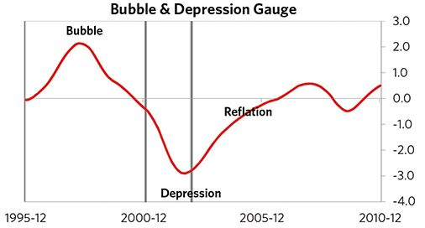

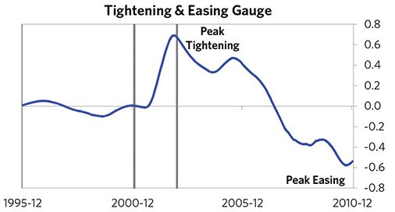

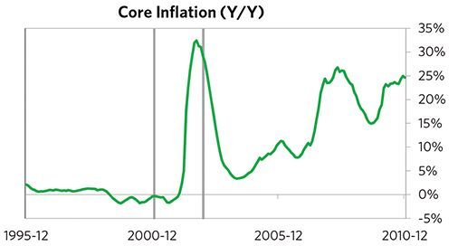

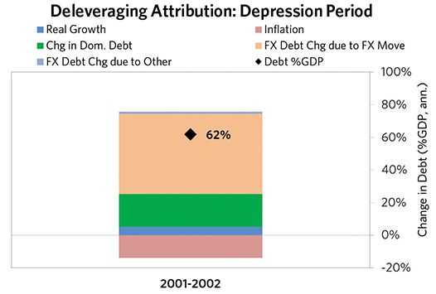

#### The Reflation Phase

A key determinant of how balance of payments/currency crises play out is how policy makers respond to adverse capital flows: whether they let their currency go and allow a tightening of financial conditions to flow through (painful but typically necessary to resolve the crisis), or print money to make up for money leaving (which can be inflationary). In this case, they abandoned the currency peg and, after a slightly shorter than average “ugly” phase, policy makers allowed enough tightening to flow through to reduce spending on imports (the current account balance improved by 7% of GDP), and make the currency more attractive to hold. Argentina was very aggressive in managing its financial institutions and bad debts, pulling 6 out of 9 classic policy levers. In particular, it nationalized banks and provided liquidity. It also benefited from an IMF assistance program and enacted structural reforms designed to increase labor market flexibility. As shown in the attribution chart to the right, debt as a % of GDP fell by 140% (15% annualized) over the course of this adjustment period. The reduction in debt-to-income ratios came mostly from nominal income rising. Meanwhile, Argentina’s now much lower currency (with real FX bottoming at -42% during the beautiful period) set up the country for renewed competitiveness. It took 5 years before real GDP reached its prior peak and equity prices in USD terms recovered within 7 years.

The crisis had a notable impact on the politics of Argentina, as it helped set the stage for Eduardo Duhalde, whom many people consider a populist leader, to take power.

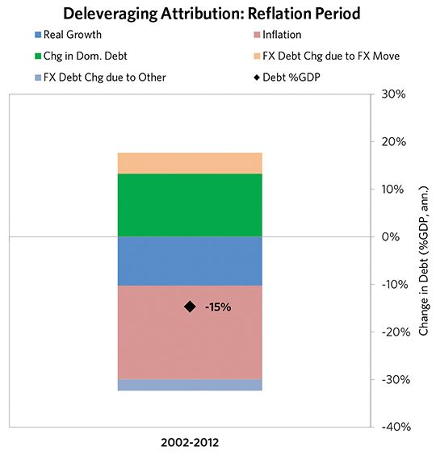

### Argentina 1998–2012 Chart Deck Appendix

#### Indebtedness

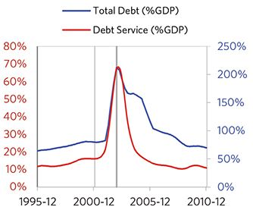

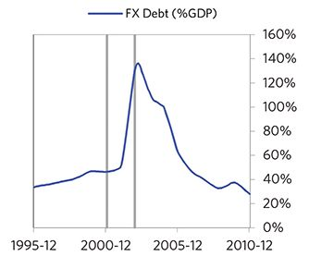

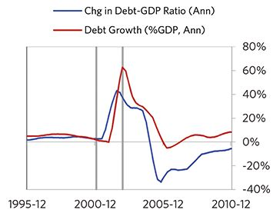

#### Monetary and Fiscal Policy

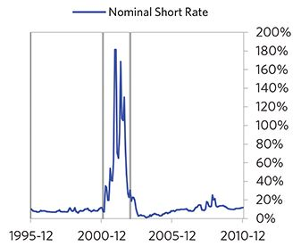

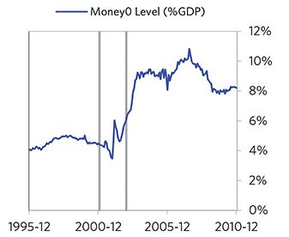

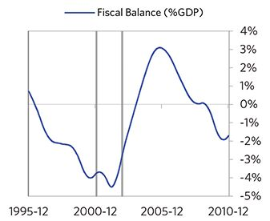

#### Economic Conditions

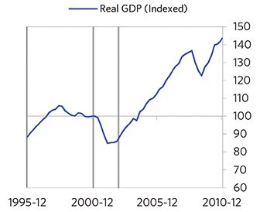

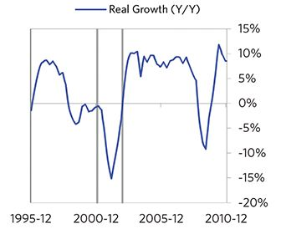

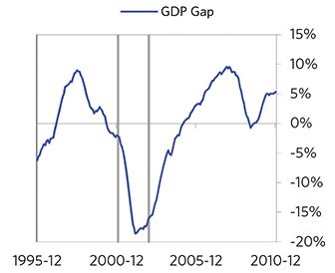

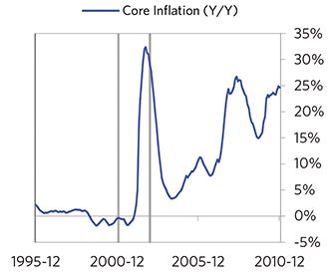

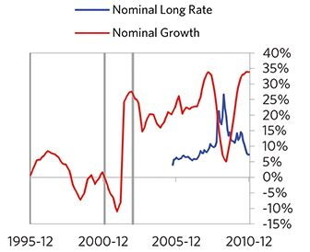

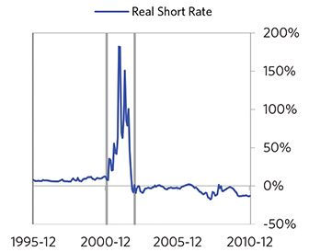

#### Markets

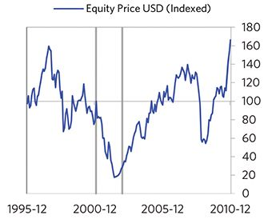

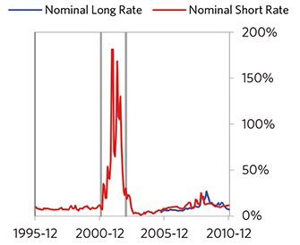

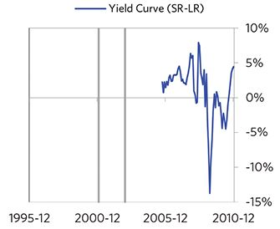

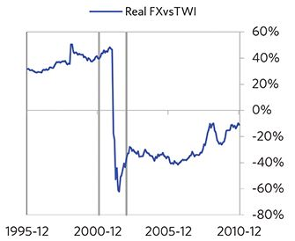

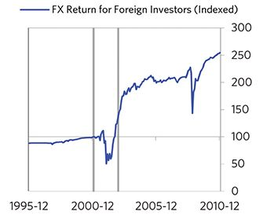

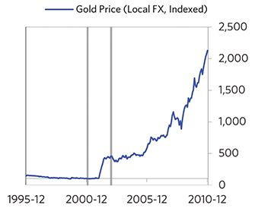

#### External Position

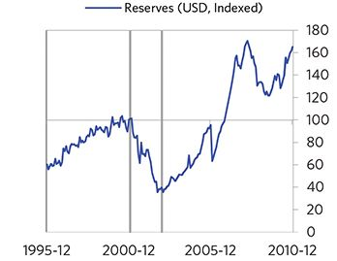

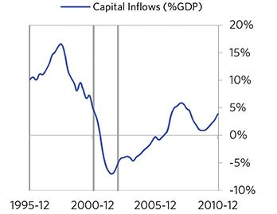

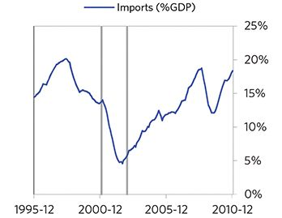

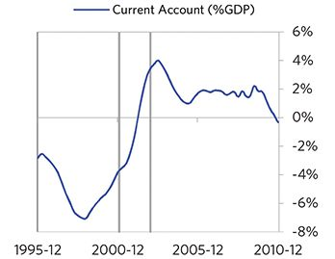

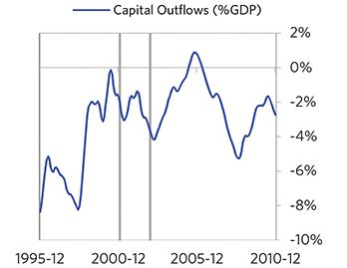

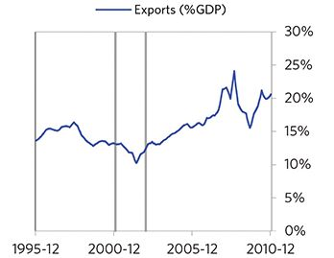

### Iceland 2005–2016 Case Auto-Summary

As show in the charts below, Iceland experienced a transitory inflationary deleveraging cycle between 2005 and 2016. This is also a classic example of a country “letting its currency go” in the face of external pressures, which produces some temporary inflation but ultimately gives policy makers more flexibility to set interest rates.

#### The Bubble Phase

Between 2005 and 2008, Iceland experienced a bubble that was driven by a self-reinforcing cycle of unsustainably strong capital inflows, rising debt, strong equity returns, and strong housing returns. Debts rose by 565% of GDP during the bubble to a pre-crisis peak of 1173% of GDP. In this case, a high share of the debt was in foreign currencies (691% of GDP)—leaving Iceland with a large exposure to a pullback in foreign capital. During the bubble phase, investment inflows were strong, averaging around 37% of GDP, which helped to finance a current account deficit of 18% of GDP. Aided by that rising debt and capital, growth was strong (at 7%). Furthermore, strong asset returns (equities averaged 12% annualized returns over the bubble period) encouraged more borrowing and helped to stimulate growth. Taken together, these bubble pressures and Iceland’s dependence on foreign financing, combined with the weakened conditions of related countries, created an unsustainable situation.

#### The Depression Phase

Eventually the dynamic turned, producing a self-reinforcing bust and a balance of payments/currency crisis, which ran from 2008 to 2010. High debt levels left Iceland vulnerable to a shock—which came in the form of the 2008 global financial crisis. Iceland suffered a fall in foreign funding (with capital inflows falling by 49% of GDP), leading to a tightening (policy makers hiked short rates by 4%) and a meaningful decline in the currency (real FX fell by 29%)—which coincided with self-reinforcing declines in GDP (falling by 11%), in stock prices (falling by 96%) and in home prices (falling by 15%). Unemployment rates increased by 5%, while currency weakness contributed to moderate inflation, peaking at 18% during the depression phase, which is low compared to other similar cases. That makes sense given that Iceland had only about a quarter of the classic “risk factors” for bigger inflation spirals (with the biggest risk factor being high foreign-denominated debts). Iceland’s financial institutions also came under considerable pressure. Meanwhile, the central bank spent down its reserves to defend the currency (drawing down reserves by 18%), though it eventually abandoned its currency defense. As shown in the attribution chart to the right, even though Iceland needed a deleveraging, its debt as a % GDP went up by 122% (46% annualized), in part because the currency fell (which increased the burden of foreign-denominated debts) and in part because the government had to borrow more in response to the crisis (with a peak fiscal deficit of 5% of GDP).

The gauges below are composed from a compendium of stats shown in the chart deck that follows. Note these are meant to be rough measures.

*The first two charts show gauges which measure bubble/depression conditions and tightness/easiness of money and credit. For each gauge, the difference from zero conveys the extent of the bubble while the crossing above/below zero represents the shifting into or out of the bubble.

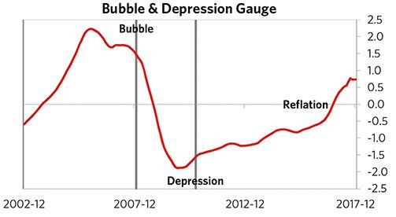

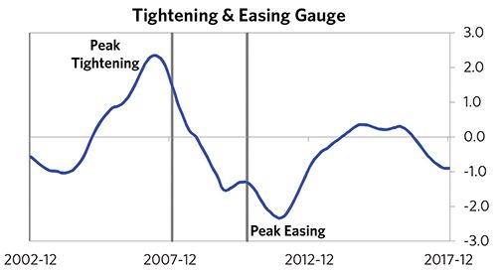

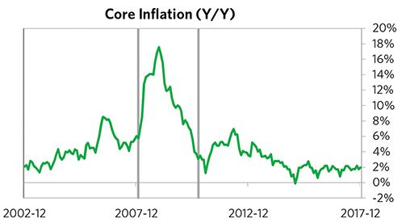

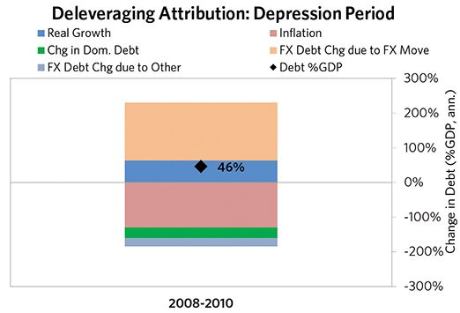

#### The Reflation Phase

A key determinant of how balance of payments/currency crises play out is how policy makers respond to adverse capital flows: whether they allow a tightening of financial conditions to flow through (painful but typically necessary to resolve the crisis), or print money to make up for money leaving (which can be inflationary). In this case, after a slightly longer than average “ugly” phase, policy makers allowed enough tightening to flow through to reduce spending on imports (the current account balance improved by 13% of GDP), and make the currency more attractive to hold. Iceland was very aggressive in managing its financial institutions and bad debts, pulling 6 out of 9 classic policy levers. In particular, it nationalized banks and provided liquidity. It also benefited from an IMF assistance program. As shown in the attribution chart to the right, debt as a % of GDP fell by 1,037% (170% annualized) over the course of this adjustment period. The reduction in debt-to-income ratios came from a balanced mix of outright debt reduction as well as rising income, driven primarily by higher real growth. Meanwhile, Iceland’s now much lower currency (with real FX bottoming at -22% during the beautiful period) set up the country for renewed competitiveness. It took 8 years before real GDP reached its prior peak, but equity prices in USD terms haven’t yet fully recovered.

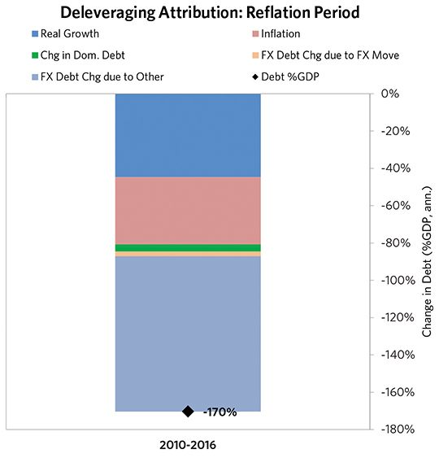

### Iceland 2005–2016 Chart Deck Appendix

#### Indebtedness

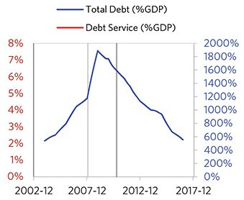

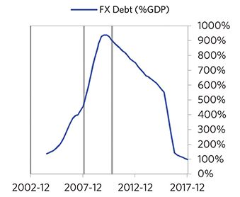

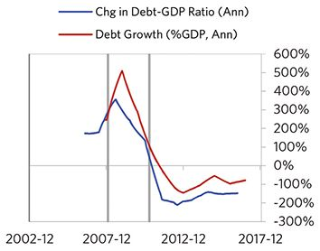

#### Monetary and Fiscal Policy

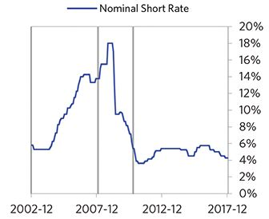

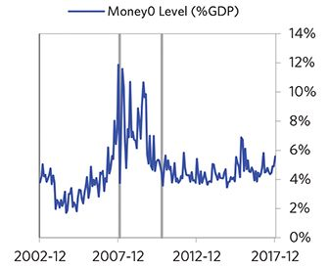

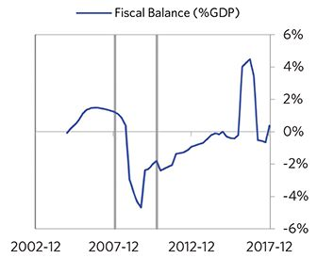

#### Economic Conditions

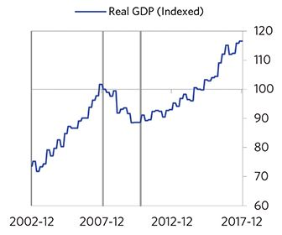

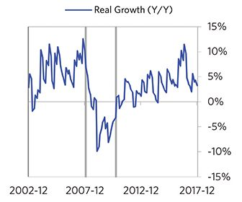

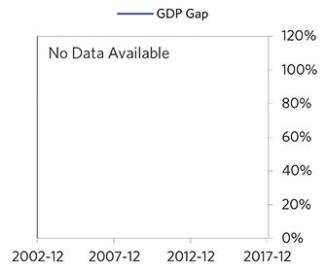

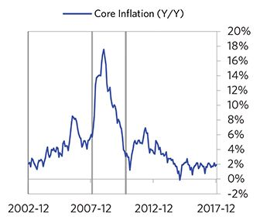

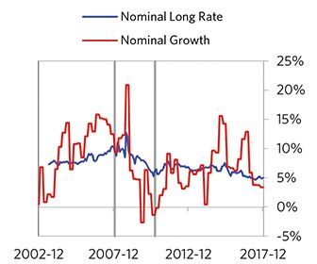

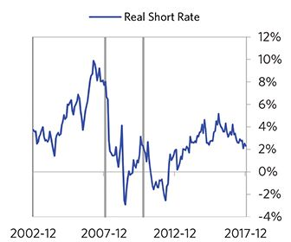

#### Markets

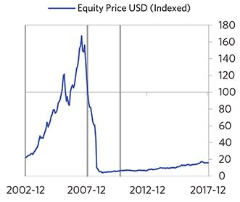

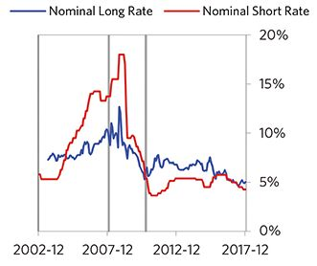

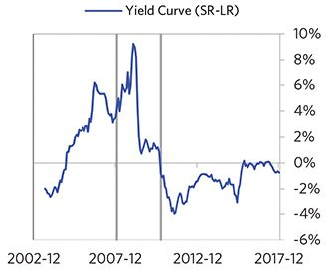

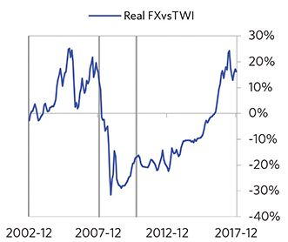

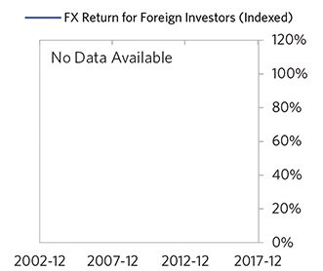

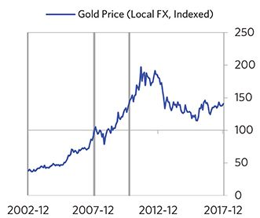

#### External Position

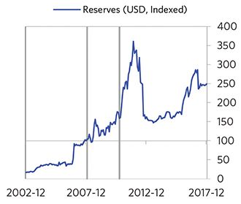

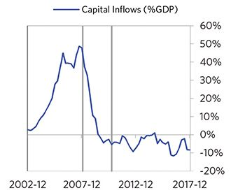

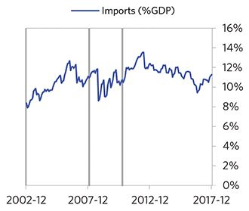

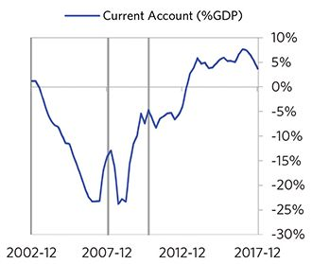

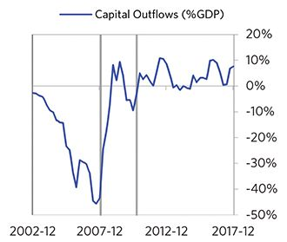

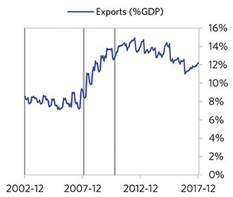

### Russia 2005–2011 Case Auto-Summary

As show in the charts below, Russia experienced a transitory inflationary deleveraging cycle between 2005 and 2011. This is also a classic example of a country “letting its currency go” in the face of external pressures, which produces some temporary inflation but ultimately gives policy makers more flexibility to set interest rates.

#### The Bubble Phase

Between 2005 and 2008, Russia experienced a bubble that was driven by a self-reinforcing cycle of unsustainably strong capital inflows, rising debt, strong growth and strong asset returns. By the bubble’s end, debts had reached a pre-crisis peak of 66% of GDP. In this case, a high share of the debt was in foreign currencies (21% of GDP)—leaving Russia with a large exposure to a pullback in foreign capital. During the bubble phase, investment inflows were strong, averaging around 10% of GDP. Aided by that rising debt and capital, growth was strong (at 8%), while levels of economic activity were high (the GDP gap peaked at 8%). Furthermore, strong asset returns (equities averaged 46% annualized returns over the bubble period) encouraged more borrowing and helped to stimulate growth. Taken together, these bubble pressures and Russia’s dependence on foreign financing, combined with the weakened conditions of related countries, created an unsustainable situation.

#### The Depression Phase

Eventually the dynamic turned, producing a self-reinforcing bust and a balance of payments/currency crisis, which ran from 2008 to 2009. High debt levels left Russia vulnerable to a shock—which came in the form of the 2008 global financial crisis and an accompanying collapse in oil prices. Russia suffered a fall in foreign funding (with capital inflows falling by 21% of GDP), leading to a tightening (policy makers hiked short rates by 19%) and a meaningful decline in the currency (real FX fell by 21%)—which coincided with self-reinforcing declines in GDP (falling by 8%), and in stock prices (falling by 71%). Unemployment rates increased by 3%, while currency weakness contributed to moderate and rising inflation, peaking at 15% during the depression phase, which is low compared to other similar cases. That makes sense given that Russia had only about a quarter of the classic “risk factors” for bigger inflation spirals (with the biggest risk factor being a long history of poorly-controlled inflation). Russia’s financial institutions also came under considerable pressure. Meanwhile, the central bank spent down its reserves to defend the currency (drawing down reserves by 44%), though it eventually abandoned its currency defense. As shown in the attribution chart to the right, even though Russia needed a deleveraging, its debt as a % GDP went up by 17% (12% annualized), in part because the currency fell (which increased the burden of foreign-denominated debt).

The gauges below are composed from a compendium of stats shown in the chart deck that follows. Note these are meant to be rough measures.

*The first two charts show gauges which measure bubble/depression conditions and tightness/easiness of money and credit. For each gauge, the difference from zero conveys the extent of the bubble while the crossing above/below zero represents the shifting into or out of the bubble.

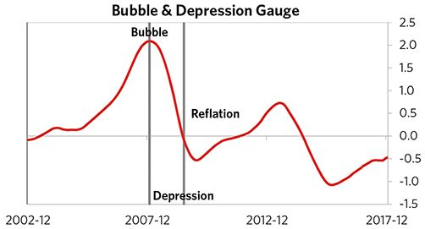

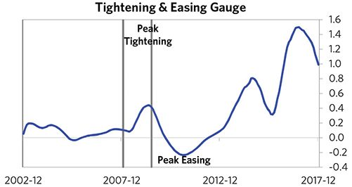

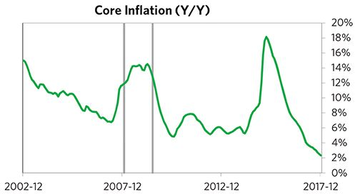

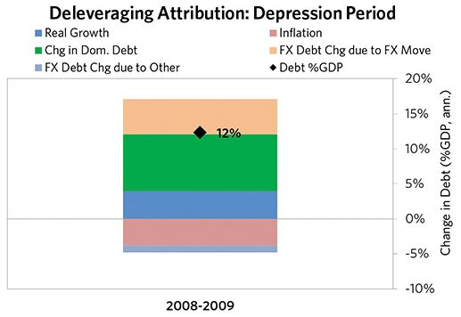

#### The Reflation Phase

A key determinant of how balance of payments/currency crises play out is how policy makers respond to adverse capital flows: whether they allow a tightening of financial conditions to flow through (painful but typically necessary to resolve the crisis), or print money to make up for money leaving (which can be inflationary). In this case, after a slightly shorter than average “ugly” phase, policy makers allowed enough tightening to flow through to make the currency more attractive to hold. Russia was aggressive in managing its financial institutions and bad debts, pulling 4 out of 9 classic policy levers. As shown in the attribution chart to the right, debt as a % of GDP fell by 14% (8% annualized) over the course of this adjustment period. The reduction in debt-to-income ratios came mostly from nominal income rising. Meanwhile, Russia’s now much lower currency (with real FX bottoming at 11% during the beautiful period) set up the country for renewed competitiveness. It took 3 years before real GDP reached its prior peak, but equity prices in USD terms haven’t yet fully recovered.

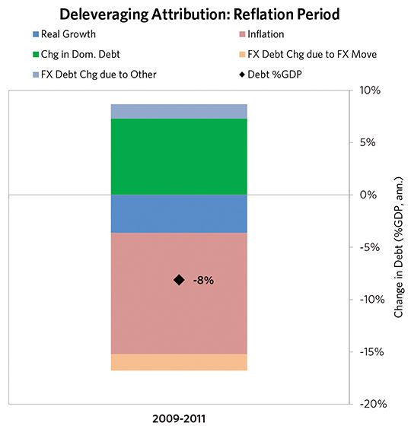

### Russia 2005–2011 Chart Deck Appendix

#### Indebtedness

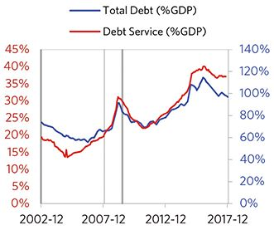

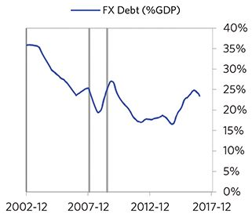

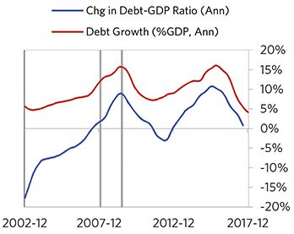

#### Monetary and Fiscal Policy

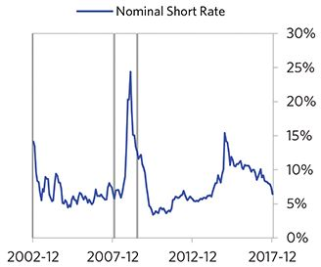

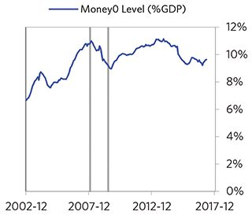

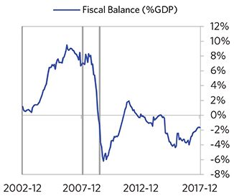

#### Economic Conditions

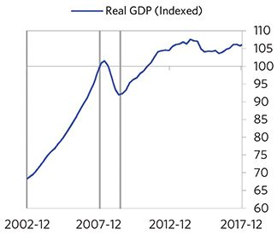

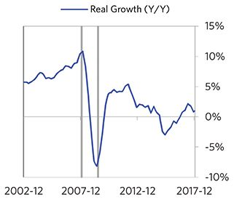

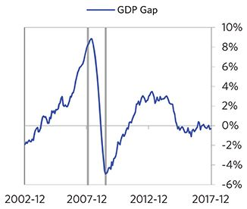

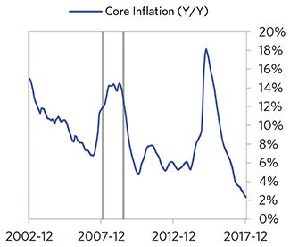

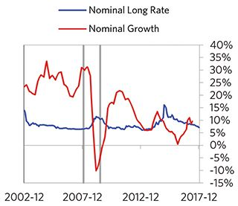

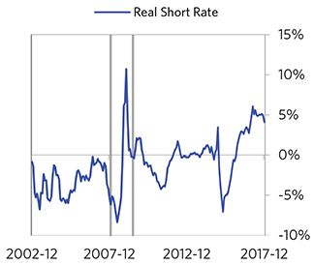

#### Markets

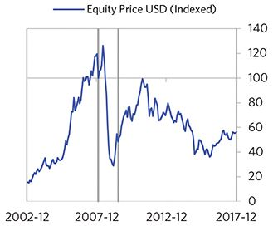

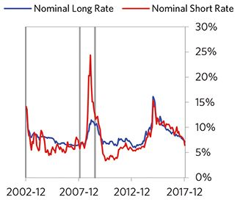

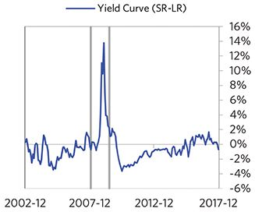

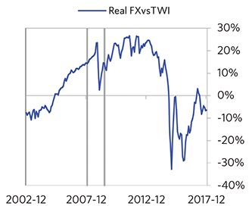

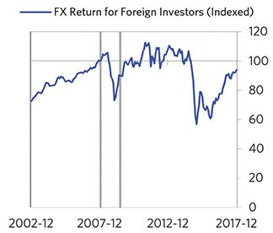

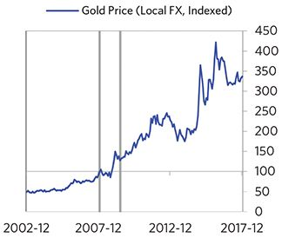

#### External Position

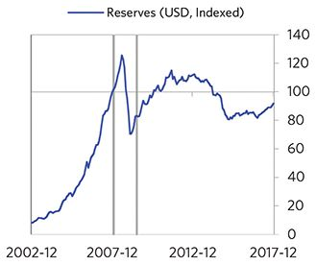

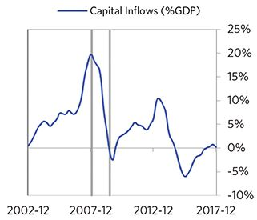

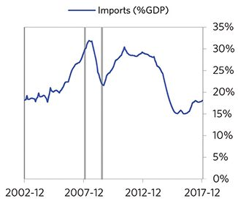

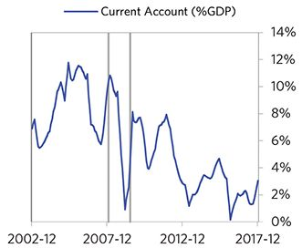

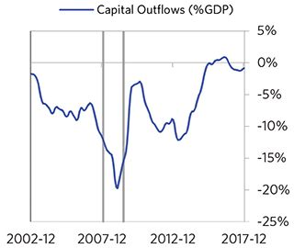

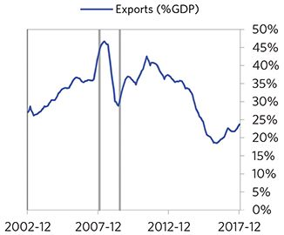

### Russia 2012–2016 Case Auto-Summary

As show in the charts below, Russia experienced a transitory inflationary deleveraging cycle between 2012 and 2016. This is also a classic example of a country “letting its currency go” in the face of external pressures, which produces some temporary inflation but ultimately gives policy makers more flexibility to set interest rates.

#### The Bubble Phase

Unlike many other cases, Russia didn’t experience a broad-based bubble in the years before the crisis, but it did build up a substantial debt stock driven by unsustainably strong capital inflows, with debts rising by 19% of GDP to a pre-crisis peak of 89% of GDP during a period of leveraging up. In this case, a high share of the debt was in foreign currencies (15% of GDP)—leaving Russia with a large exposure to a pullback in foreign capital. Russia also became somewhat dependent on continuous foreign financing, with investment inflows averaging 6% in the years before the crisis. Ultimately, these high debts and Russia’s dependence on foreign financing created an unsustainable situation.

#### The Depression Phase

Eventually the cycle turned, producing a self-reinforcing bust and a balance of payments/currency crisis, which ran from 2014 to 2016. At its pre-crisis peak, debt service reached 32% of GDP, making Russia vulnerable to a shock—which came in the form of oil price declines. Russia suffered a fall in foreign funding (with capital inflows falling by 8% of GDP), leading to a tightening (policy makers hiked short rates by 7%) and a meaningful decline in the currency (real FX fell by 30%)— which coincided with self-reinforcing declines in GDP (falling by 4%), and in stock prices (falling by 46%). In addition, currency weakness contributed to moderate inflation, peaking at 18% during the depression phase, which is low compared to other similar cases. That makes sense given that Russia had only about a quarter of the classic “risk factors” for bigger inflation spirals (with the biggest risk factor being a long history of poorly-controlled inflation). Russia’s financial institutions also came under considerable pressure. Meanwhile, the central bank spent down its reserves to defend the currency (drawing down reserves by 26%), though it eventually abandoned its currency defense. As shown in the attribution chart to the right, even though Russia needed a deleveraging, its debt as a % GDP went up by 19% (9% annualized), in part because the currency fell (which increased the burden of foreign-denominated debts) and in part because the government had to borrow more in response to the crisis (with a peak fiscal deficit of 4% of GDP).

The gauges below are composed from a compendium of stats shown in the chart deck that follows. Note these are meant to be rough measures.

*The first two charts show gauges which measure bubble/depression conditions and tightness/easiness of money and credit. For each gauge, the difference from zero conveys the extent of the bubble while the crossing above/below zero represents the shifting into or out of the bubble.

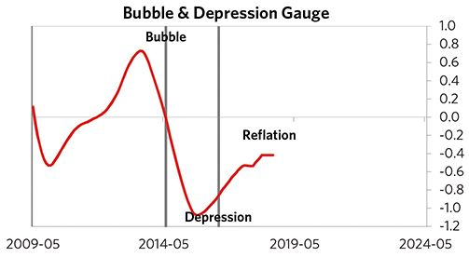

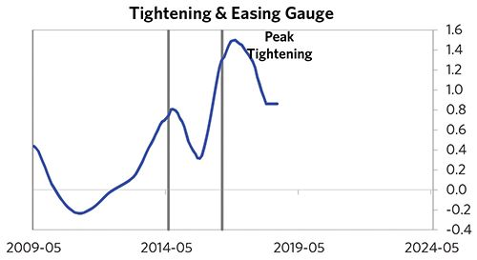

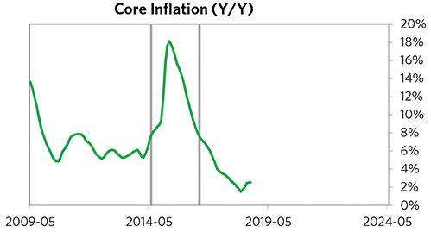

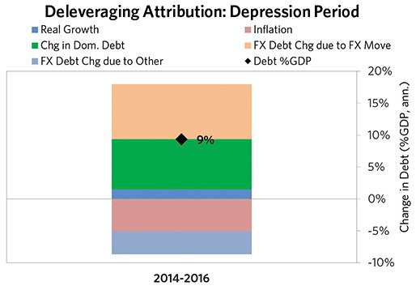

#### The Reflation Phase

A key determinant of how balance of payments/currency crises play out is how policy makers respond to adverse capital flows: whether they allow a tightening of financial conditions to flow through (painful but typically necessary to resolve the crisis), or print money to make up for money leaving (which can be inflationary). In this case, after a slightly shorter than average “ugly” phase, policy makers allowed enough tightening to flow through to make the currency more attractive to hold. Russia was aggressive in managing its financial institutions and bad debts, pulling 4 out of 9 classic policy levers. As shown in the attribution chart to the right, debt as a % of GDP fell by 7% (14% annualized) over the course of this adjustment period. The reduction in debt-to-income ratios came from a balanced mix of outright debt reduction as well as rising income. Meanwhile, Russia’s now much lower currency (with real FX bottoming at -17% during the beautiful period) set up the country for renewed competitiveness. Real GDP has not yet reached its prior peak and equity prices in USD terms haven’t yet fully recovered.

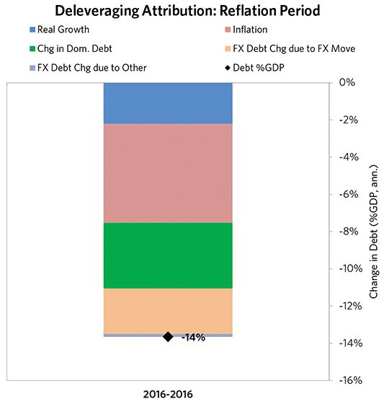

### Russia 2012–2016 Chart Deck Appendix

#### Indebtedness

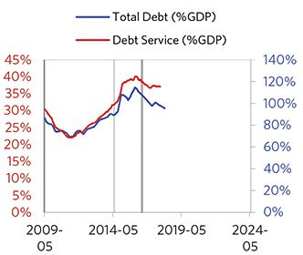

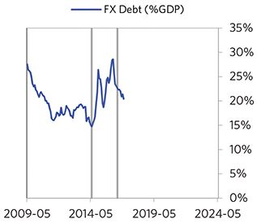

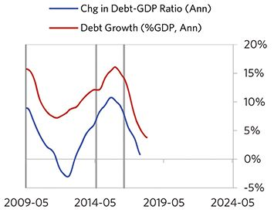

#### Monetary and Fiscal Policy

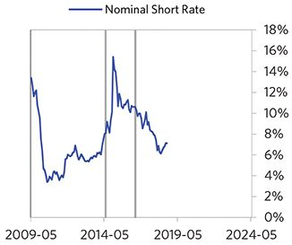

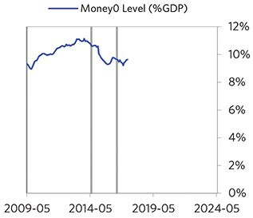

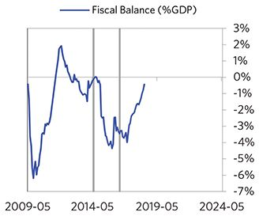

#### Economic Conditions

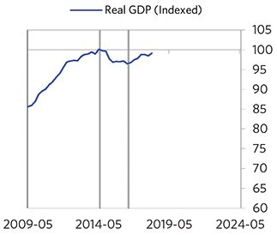

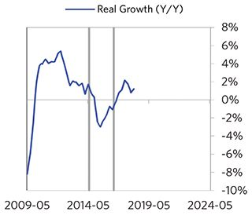

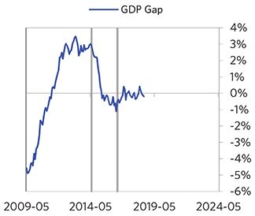

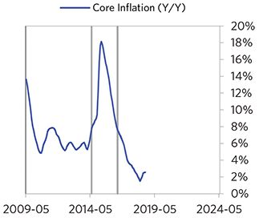

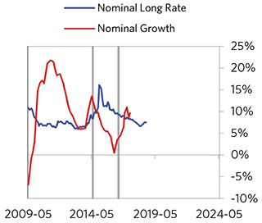

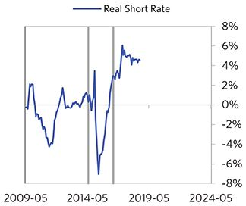

#### Markets

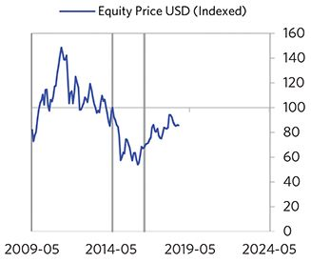

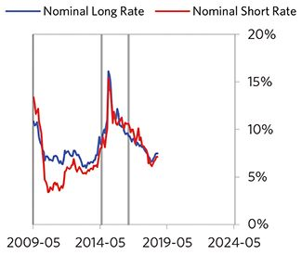

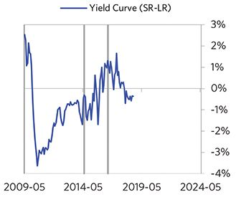

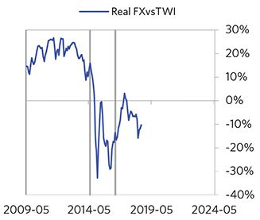

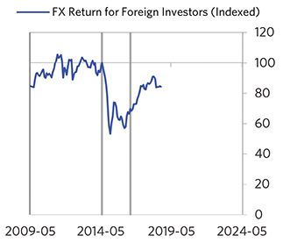

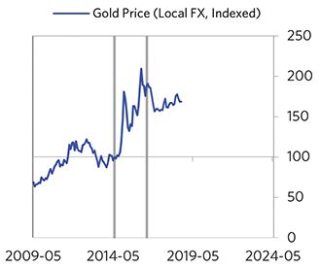

#### External Position

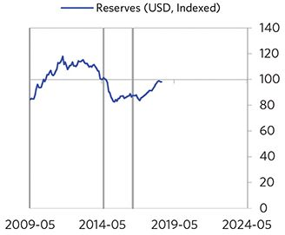

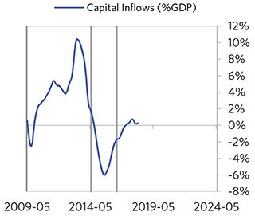

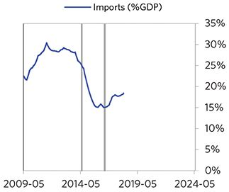

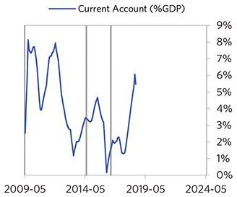

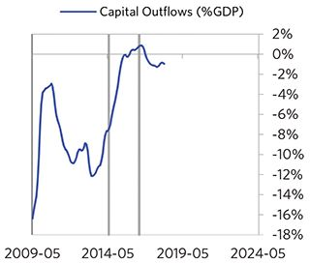

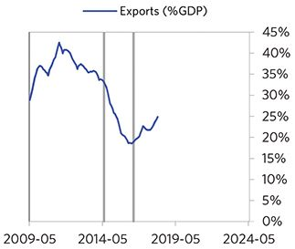

## Appendix: Macroprudential Policies

While the central bank is generally meant to provide one monetary policy for all (making money and credit broadly available through banks without deciding who gets it) and those who run fiscal policy are meant to apportion it well, macroprudential policies are tools for directing credit one way or another through the central bank’s regulatory authorities. The need for macroprudential monetary policy is created by differentiation as credit grows: There can be a bubble in one area, and a starvation of credit in another area. If policy makers want to slow down credit where bubbles are emerging, and redirect credit to other areas, macroprudential policies can shift credit in that way. For instance, a classic countercyclical macroprudential policy is to make it easier to buy a house in a housing bust (say, by forcing credit standards lower or allowing lower down payments) or to make it harder to buy a house in a housing bubble (by doing the opposite).

By directing credit through regulatory authorities, macroprudential policies can resemble fiscal policies in that they can benefit some at the expense of others. While this is generally avoided, the challenges of managing an economy through a deleveraging make macroprudential policies a really useful tool to complement monetary policy. For instance, QE often fuels pockets of frothiness in the economy, particularly in asset markets, even as the broader economy is still in recovery. In the Great Depression and during World War II, central bankers used macroprudential measures to reduce the pockets of frothiness, while keeping overall monetary policy sufficiently easy for the broader economy.

Macroprudential policies are not a new tool for monetary policy. In fact, they were a bread-and-butter tool of central banks and regulators for almost the entire period of modern monetary policy. As an illustration, the Federal Reserve has changed margin requirements for equity holdings 23 times since it was formed, typically tightening the requirement during big rallies/periods of excess in stock market credit, and easing in bear markets/depressed volumes of credit.1 While macroprudential measures became rarer from the early 1990s to mid-2000s,2 that period is the historical exception. Recently, global central banks and regulators have returned to a world where macroprudential tools are thought of as a key part of managing an economy.

The typical case (drawing on the history of macroprudential tools being used in the US)…

Occurred when shifting interest rates was losing effectiveness as a monetary policy tool.

* The economy needs further stimulation, but with interest rates at zero, further easing is limited.
* Tightening in one or more areas is needed when it’s not appropriate for the overall economy. Raising interest rates is undesirable because of the drag on growth it would cause.

Occurred when it was desirable to direct credit both to credit-starved sectors, and away from frothy assets/lending.

Involved policy makers using a combination of different types of policies at once.

* These included measures aimed at changing demand for credit:
  + Changing required loan-to-value ratios.
  + Changing required debt service-to-income ratios.
  + Changing requirements around loan maturities.
  + Changing margin requirements for buying financial assets.
  + Changing the cost of loans through interest rate subsidies/tax policy/other regulations.
* And measures aimed at changing the supply of credit:
  + Changing capital/reserve requirements for certain types of lending.
  + Changing the portfolio of assets that financial institutions are allowed to hold.
  + Changing accounting rules on different assets.
  + Supervisors of financial institutions putting pressure for certain lending behaviors.
  + Interest/lending rate ceilings and other limitations.

Saw coordination between the Federal Reserve, Congress, the executive branch, and regulatory bodies.

* During the most successful cases, different parts of the government coordinated their actions. Often, lawmakers and the executive branch armed different government bodies, including the Federal Reserve, with the tools and the leeway to manage policy.
* New institutions were set up to implement the regulations and monitor their progress.

Saw mixed success for different policies—some were more effective, while others had bad second order consequences. The most successful cases involved significant amounts of experimentation and flexibility.

* In successful cases, effective policies were frequently used for long periods of time, or expanded, and unsuccessful policies were ended, often within a matter of months.
* But policy makers have a mixed track record of quickly ending ones with distortionary second order consequences. A few were allowed to continue for years (Regulation Q, for instance).
* As the financial system has evolved, policy makers have relied on a changing set of tools as the cost/benefit trade-off of using different tools has evolved.
* When financial innovations made it easier to circumvent certain policies (e.g., new ways for investors to leverage up, new financial institutions springing up), certain policies were adapted or abandoned.

## Questions to Consider Pertaining to Macroprudential Policy

As we observe the different cases, we see different issues and questions that policy makers grapple with in implementing macroprudential policy. Below we go through these questions and then give some examples of historical debates.

Where are bubbles emerging in the economy? How confident are you that they are bubbles?

* At different points in history, policy makers have taken various approaches to dealing with bubbles.
  + In a repeat of the late 1920s, US policy was tightening in 1935–36 in part in response to rapid stock price appreciation that caused fears of a bubble. That tightening ended up being too much for the deleveraging economy to bear. The economy went back into severe recession and stocks fell 60 percent between 1937 and 1938.
  + Over the past several decades US monetary policy makers took a “mopping up” approach, with the notion that they should not be involved with pricking bubbles but rather should deal with the implications of a bubble popping on the economy.3 A key reason was the difficulty in knowing when the market is mispricing an asset. So, for example, despite some concerns in the housing market, regulators didn’t aggressively target slowing the increase of frothy mortgage lending in 2006 and earlier.

Which sectors are starved for credit? Is there a need for differentiated credit policy?

* Policy makers in the 1950s grappled with this question by trying to formalize a framework to assess when differentiated policy is necessary.4 They developed four basic tests:
  + How effective is general monetary policy in balancing the provision of credit to the economy?
  + How potentially destabilizing is the growth of the credit in the specific sector?
  + How important is credit to the growth of the specific sector?
  + How effective would it be to administer selective credit controls?

How comfortable are you picking winners and losers as part of directing credit? What are the political costs?

What policy tools will you choose to re-direct credit? Will you target demand for credit, or supply of credit, or both?

How will you measure effectiveness of the policy?

What will be the second- and third-order consequences of the policy? How will you handle them? Often, these can come years later.

* Regulation Q, which put caps on interest rates for deposits, was implemented during the Great Depression to give smaller banks a leg up. By the 1950s, it started to create substantial distortions, driving deposits into shadow banking systems.5
* Savings & Loan Associates (S&L, a small type of bank) were deregulated in the early 1980s, in part to help those institutions cope with tight monetary policy, contributed to the S&L crisis that began in the mid-1980s.6

How will you ensure policy coordination between legislators, the executive branch, and the central bank? How will you empower regulators to make changes?

* The most successful US cases represented broad coordination between different government agencies. The Second World War effort was a good example—Congress revised several laws to give the Federal Reserve the authority it needed, Roosevelt used executive orders to supplement the Fed’s efforts, etc.7
* In the most successful cases (Volcker’s time at the Fed, for instance), policy makers were given the ability to shift policy nimbly as circumstances changed. Some of the biggest issues came from low flexibility—interest rates caps were not flexibly adapted and negative second-order consequences emerged.
* Today, this remains a key question and there are differences in how different governments have vested powers. In the UK for example, much of the power for regulation and macroprudential policy has been vested in the BoE, and the Financial Policy Committee (FPC) within it. In the US, it has been vested in a number of agencies and a coordinating committee setup after the financial crisis, the Financial Stability Oversight Council (FSOC).8

## Some Historical Cases of US Macroprudential Policies

In the next few pages, we go through historical cases of US macroprudential policies from the last century. It’s a long list, so we organized them into seven categories according to the type of policy, and we go through each category chronologically. We relied on the excellent and authoritative paper, “The History of Cyclical Macroprudential Policy in the United States” by Elliott, Feldberg and Lehnert, for the below framework and historical details.

### Macroprudential Measures Aimed at Demand for Credit: Margin Requirements

The margin requirement is the amount of collateral—often cash—that investors need to provide in order to buy an investment using credit. Increasing the requirement puts downward pressure on the amount of credit used to purchase financial assets.

After attaining the ability to set margin requirements from the Securities Exchange Act of 1934, the Fed used this ability counter-cyclically.9 In practice, the Fed would increase the margin requirement when asset prices were booming and the use of credit for asset purchases was rising, and decrease it in the opposite situation.

* Specifically, Regulation T set margin requirements for brokers and Regulation U set the margin requirement for banks.
* All of the Fed’s changes to the margin requirements are shown in the chart below.
* Since 1974, the Federal Reserve mostly stopped using this lever, as the development of other ways of buying assets on credit (e.g., derivatives) made it easy for investors to side-step this requirement.

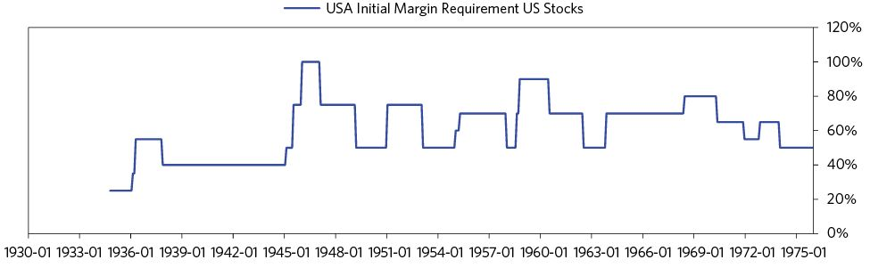

### Macroprudential Measures Aimed at Demand for Credit: Underwriting Standards

Great Depression  
 Congress created the Federal Home Loan Bank System in 1932.10 It was designed to act as a quasi-central bank for S&Ls, with the ability to provide liquidity through advances or collateralized lending. The FHLB System was also in charge of setting underwriting standards and collateral restrictions.

In 1934 Congress formed the Federal Housing Administration (FHA) to insure home loans.11 This resulted in easier underwriting standards (80 percent loan to value and 20-year maturity) for loans eligible for insurance.

* The Electric Home and Farm Authority, established in 1934, was meant to provide cheap loans for home electric appliances. These loans had <10 percent interest rate and only a 5 percent down payment, for up to 36 months. This program ended in 1942.12
* In 1935 Congress lowered the loan-to-value regulations (from 50 percent to 60 percent) and maturity restrictions (from up to 5 years to 10 years) for national banks.13
* The FHA insured up to 20 percent of loans (up to 5-year maturity) for improving residential properties from 1934-1937.14
* The FHA, in 1938, lowered standards for insurance on home loans. Mortgages with up to 90 percent loan-to-value and 25-year maturity were now eligible.15

World War II

* In 1941, President Roosevelt ordered the Federal Reserve Board to limit the use of installment credit to purchase consumer durable goods. Roosevelt wanted to direct production towards national defense rather than domestic consumption. In an executive order, he said: “liberal terms for such credit tend to stimulate demand for consumers’ durable goods, the production of which requires the materials, skills, and equipment needed for national defense.”16
  + The Federal Reserve responded by enforcing tighter underwriting on all types of consumer installment loans (known as Regulation W).17

Postwar Period

* In October 1950, the Federal Reserve Board, worried about the rise in mortgage debt, aimed to tighten housing credit. Their response was Regulation X.18
  + Regulation X was a set of loan-to-value and maturity caps on residential real estate loans that became more restrictive as loan size grew.
  + The Fed set the target of reducing housing production in 1951 by one-third of the 1950 levels.
* In response to President Truman’s requests, in 1950, the Federal Housing Administration (FHA) and Veterans Administration (VA) raised the down payment requirement by 5 percent, decreased the maximum FHA loan on single-family homes from $16,000 down to $14,000, and instituted a maximum maturity of 25 years. These were the FHA’s and VA’s first restrictive actions in their nearly 20 years of existence.19
  + Responding to a recession beginning in mid-1953 and political pressures, these measures were removed.
  + In August 1954, Congress reversed the FHA’s and VA’s actions—reducing maximum down payment requirements on FHA loans and raised the maximum FHA loan.
* By late-1954, the housing market looked increasingly frothy. However, the Fed did not want to tighten, because the economy was just recovering from a recession. Therefore the government pursued a number of macroprudential policies instead20 (listed below):
  + First: the FHA and VA raised down payment requirements and reduced maximum maturities on loans, from 30 to 25 years (these were tweaked and eventually reversed in subsequent years)
  + Second: field offices were instructed to “intensify their surveys of local housing markets, and to take coordinated steps to restrain federal underwriting of mortgages in localities where housing surpluses were found to exist.”
  + Third: the Federal Home Loan Bank Board (FHLBB) asked Federal Home Loan banks to curb extension of loan commitments to thrifts. In September 1954, they also implemented official restraints on lending by savings and loans banks.
  + Finally, the Federal Reserve Bank of New York moved to restrain mortgage warehouse lending. Mortgage warehouse lending is when commercial banks extend interim loans to finance the origination of mortgages by nonbank lenders. This had more than doubled between August 1954 and August 1955.
* The Credit Control Act, passed in 1969, gave the Federal Reserve the ability to use credit controls to target certain sectors. By targeting certain sectors, the Fed could keep overall monetary policy easy, but tighten sectors experiencing inflation.21
  + The Fed’s levers included: prescribing a “maximum rate of interest, maximum maturity, minimum periodic payment, maximum period between payments, and other specification or limitation of the terms and conditions of any extension of credit.”
  + The Credit Control Act was not used until the Volcker era.
* In 1982, Congress abolished restrictions on loan-to-value ratios and maturities for national banks.22

### Macroprudential Measures Aimed at Supply of Credit: Voluntary Guidelines Aimed at Reducing Speculative/Non-Productive Lending

In the following examples, policy makers imposed voluntary restraints or guidelines on the banks, in order to curb lending for speculative or non-productive ends.

* Congress, in 1947, encouraged banks to “restrict voluntarily their lending and investing programs.”23 This guideline was put in place after the Fed’s limits on consumer installment loans expired.
* During the Korean War, Congress enacted the Defense Production Act of 1950. This gave the Federal Reserve the authority to establish “voluntary” credit restraints.24
  + The Federal Reserve asked lenders to “screen loan applications on the basis of their [loan’s] purpose, in addition to the usual tests of credit worthiness.” The program was in place for about a year.
* In 1965, the cabinet-level Committee on the Balance of Payments recommended “voluntary” lending restraints, to be monitored by the Federal Reserve.25
  + This policy sought to reduce net capital outflows by over 15 percent from the previous year.
  + The program called for an initial 5 percent ceiling on foreign loan growth, the first time such a quantitative credit target was put in place.
  + In 1968, President Johnson passed an Executive Order which allowed the Federal Reserve to make the program mandatory. However, the Fed chose not to, citing the high voluntary participation. The programs continued until 1974.
* In 1966, the Fed prompted banks to slow business loans. At the time, business credit creation was high and inflation was rising. For banks that did not cooperate, the Fed limited their ability to borrow at the discount window. After the economy slowed, the policy was ended.26
* From March to July 1980, President Carter established the “voluntary” Special Credit Restraint Program. Under the program, banks, bank holding companies, finance companies, and foreign bank branches were asked to limit loan growth to 6-9%.27
  + From a high level, the program was designed to restrain certain types of speculative or inflationary lending, while maintaining availability of funds to small businesses, farmers, and homebuyers. Banks were encouraged to “maintain availability of funds to small business, farmers, home buyers and others without access to other forms of financing” and ensure that “credit for automobiles, home mortgage and home improvement loans should be treated normally in the light of general market conditions.”
  + Conversely, banks were encouraged to restrain credit card lending and to limit other unsecured consumer loans. The program also asked banks to limit credit used to support “essentially speculative uses of funds, including voluntary buildup of inventories by businesses beyond operating needs, or to finance transactions such as takeovers or mergers that can be reasonably postponed, that do not contribute to economic efficiency or productivity, or may be financed from other sources of funds.” Speculative lending also covered “financing of purely speculative holdings of commodities or precious metals.”
  + The Special Credit Restraint Program called for periodic reports on lending activities.
* Similar tools were used in Europe. National credit councils in France and Italy would announce which sectors they thought needed more credit or were already over-burdened, especially in the postwar period.28

### Macroprudential Measures Aimed at Supply of Credit: Reserve Requirements

* State governments instituted the first reserve requirements in the 1800s, to ensure that state-chartered banks had enough reserves (typically gold or other specie) to meet their obligations (in the form of circulating bank notes) and to meet deposit withdrawals. The National Bank Act, passed in 1863, introduced the first nationwide reserve requirements for banks.29
* Congress eased reserve requirements in the Federal Reserve Act of 1913.30 This is because, with the Federal Reserve now serving as a lender of last resort for national banks, Congress viewed reserve requirements as less critical.
* In the 1930s and afterwards, reserve requirements were again seen as a more useful counter-cyclical policy tool. In 1935, Congress gave the Federal Reserve the ability to set the reserve requirement31. In conjunction with Roosevelt’s economic recovery program in the spring of 1938, the central bank lowered reserve requirements. In the 1940s, the Federal Reserve made a series of adjustments to the reserve requirements: in 1942, reserve requirements were eased three times. During the war, the Federal Reserve held requirements steady, and following the war (in 1948) the requirements were tightened three times—back to the statutory caps. Between 1949 and 1951, the reserve requirements were adjusted nine times; the Federal Reserve eased them in 1949 and tightened them in 1951.
* During periods of tightening interest rates, the Federal Reserve also raised the reserve requirements in 1966–69, 1973, and 1979–80.32
* Eventually, new funding instruments were invented to continue lending and bypass the reserve requirement. These included commercial paper, eurodollars, repurchase agreements, and large-denomination certificates of deposits.33
* In 1969, the Federal Reserve attempted to address the loopholes that were enabling banks to skirt the reserve requirements. New bank borrowing from overseas branches was capped at 10%; this was done to stop banks from borrowing Eurodollars through their overseas branches (which were not subject to reserve requirements). Additionally, the Fed set a 10 percent limit on assets sales by banks to their overseas branches.34
  + In 1970, the limits on both borrowing from and selling assets to overseas branches were increased to 20 percent. However, in 1973, these requirements were both lowered down to 8 percent. This was the same requirement as was in place for large-denomination certificates of deposits.35
* In the late 1960s, the Federal Home Loan Bank Board (FHLBB) used reserve requirements to affect mortgage lending. The FHLBB reduced requirements when savings declined, thereby increasing liquidity in mortgage lending, and raised requirements when lending was high, or liquidity already abundant.36
* As part of the Paul Volcker’s effort to rein in inflation, the Federal Reserve increased interest rates and reserve requirements in October 1979. Reserve requirements on wholesale liabilities rose to 8 percent (wholesale liabilities included large time deposit, Eurodollar borrowings, repos with government or agency collateral backing, and federal funds borrowings).37
  + In March 1980, the reserve requirements were increased to 10%. One month later, the central bank lowered the requirements to 5 percent and eventually eliminated them entirely in July.
* The FHLBB eased the reserve requirements in 1968–69 and 1973–74, when liquidity for mortgage lending was squeezed. It had “at most a limited, positive impact on mortgage lending.”38
* In 1980, the Fed imposed unprecedented asset-based reserve requirements to reduce inflation. This fell under their control due to the 1969 Credit Control Act.39 The exact requirements were as follows:
  + All lenders were required to hold a special deposit of 15 percent on specific types of consumer credit. Money market funds were subject to the same reserve requirements. Both were later lowered to 7.5 percent.
  + Money market funds were also required to file monthly reports.
  + By August, the Fed removing all of the restrictions completely, and by the end of 1980, Congress terminated the Credit Control Act.
* The Federal Reserve lowered reserve requirements in 1990 and 1992 to promote credit availability.40
* To briefly provide some perspective from Europe, liquidity ratios and reserve requirements there have also been used as macroprudential tools. France and Italy would particularly use different reserve requirements to help direct credit—for instance, giving public banks more lenient requirements, or excluding long-term or export loans.41
* Regulators more often used some types of caps on the amount of loans, or the ability of banks to access central bank financing for lending—tools which had similar net effects of putting downward pressure on the supply of credit. For instance, until 1972 France had a “rediscount ceiling,” a cap that limited how much a financial institution could borrow from the central bank.42
* The cap often differed by sector or by type of loan, designed to encourage or discourage certain types of lending. For instance, overproduction in certain agricultural products led the Banque de France to set lending quotas in those sectors.43 Sometimes, these caps were broader, targeting all lending to corporations or households.44

### Macroprudential Measures Aimed at Supply of Credit: Interest Rate Ceilings

* In the early 1900s, states limited the interest rates a bank could offer for deposit accounts. This was part of state deposit insurance programs.45
* Under the amended Federal Reserve Act of 1927, a cap was placed on interest paid by national banks to state banks.46
* After the passage of the Banking Act of 1933, Federal Reserve was able to regulate maximum interest rates paid on time and savings deposits.47
  + In November 1933, the Fed imposed Regulation Q: a 3 percent ceiling on interest rates. After a decline in market rates, the Fed lowered this to 2.5 percent, reducing the costs for the banks.
  + Regulation Q also allowed the Fed to set maximum rates the Federal Deposit Insurance Corporation (FDIC) paid to non-member insured banks.
  + The Fed did not want to limit bank balance sheets, so it later raised the maximum rate back to 3 percent (for all savings and time deposits with maturities of six months or more). This allowed banks to attract more depositors with a higher interest rate.
  + As market rates rose again in 1960 and 1961, the Federal Reserve raised Regulation Q ceilings.
* From 1934 to 1989, the Federal Home Loan Bank Board (FHLBB) was responsible for supervising savings and loans. The FHLBB set informal ceilings on dividends paid by savings and loans, which were generally about 25-50 basis points above the Fed funds rate.48
* Under the Interest Rate Regulation Act of 1966 the FDIC and FHLBB were able to set interest rate ceilings on deposits at mutual savings banks and savings and loans. This act also allowed the Federal Reserve to set rates for specific classes of deposits.49
  + The Fed used this authority to set a 5.5 percent limit on single-maturity CDs. It also lowered the maximum interest rates paid on time deposits.
  + However, in 1973, this ceiling on CDs was removed.
* In 1978, the Fed allowed banks to issue money market certificates with floating interest rate ceilings pegged to the six-month Treasury bill. The banks were now able to issue instruments competitive with money market funds. This was a relaxation of previous Regulation Q ceilings.50
* The Depository Institutions Deregulation and Monetary Control Act in March, 1980, eliminated Regulation Q. In the end, Regulation Q was considered unsuccessful because there were many ways to get around it.51
* By 1986, the ceilings were gradually phased out.52

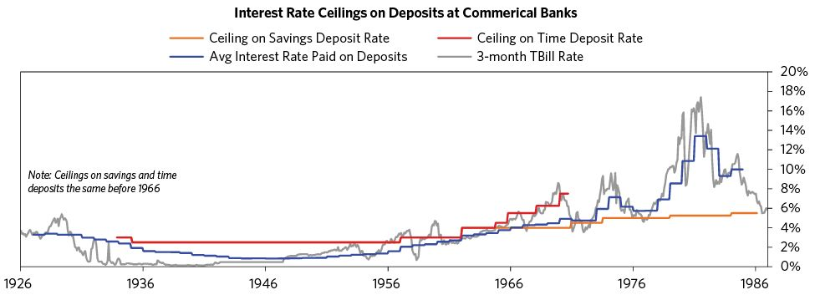

### Macroprudential Measures Aimed at Supply of Credit: Supervisory Guidance and “Direct Pressure”

Guidance to curtail lending in booms

* After WWI, the Federal Reserve wanted to direct credit towards what it deemed as productive rather than speculative uses. They used supervisors to exert “direct pressure” on the banks.53
* By the middle of 1927, policy makers were nervous about stock market speculation. In the previous year, stocks rose by almost 100 percent, and credit creation was booming. The central bank, in February of 1929, issued a statement to denounce speculation; the Fed stated it would not lend to banks that were extending credit for speculation. The Fed’s statement was largely ineffectual at stemming speculation.54
* On November 24th, 1947, supervisors of lending standards issued a statement urging for bank caution. They were concerned that there were both excessive credit creation in the economy and falling credit standards. The statement said that banks “should curtail all loans either to individuals or business for speculation in real estate, commodities or securities.”55
* Supervisors again released several statements detailing a deterioration in lending standards in the 1990s and 2000s.56
  + Specifically, in 1995 the Fed warned that examiners should watch for excessive easing in credit underwriting standards. The Fed was also concerned about the risks of a cyclical downturn in regional real estate markets. This was due to previous experiences with the S&L crisis in the 1980s.
  + In 1999, supervisors issued a statement that detailed the risks of subprime lending. They also suggested raising the capital standards for those institutions engaged in the practice. This came after several banks failed the year before, due to subprime lending losses.
  + Two years later, the agencies quantified the new capital standards. The statement suggested that banks hold between 1.5x-3x more capital against subprime loans, versus assets of a similar type.
  + In the early and mid-2000s, Federal officials made several statements that expressed concern over frothy credit growth.
  + Supervisors took further action in 2005, issuing guidance on home equity and commercial real estate lending as well as on nontraditional mortgages.
  + In 2013, the Fed and OCC tightened regulation of leveraged loans, adopting a 6x leverage limit, threatening fines.

Credit availability during busts

* In order to promote credit creation, President Roosevelt asked regulators in April, 1938 to “agree on a more liberal bank examination policy.”57
* The Treasury, along with three federal supervisors, responded by issuing a joint statement that outlined the unified treatment of loans and securities. The procedures described a move away from mark-to-market accounting for securities. They also distinguished “investment” and “speculative” securities. Investment securities were assigned one of the four highest grades from the rating agencies.
* As the S&L crisis came to an end, the administration moved to ease the credit crunch.58
  + First: in May of 1990, the OCC, Fed, and FDIC leaders urged senior bank officials to extend loans to borrowers.
  + Supervisors published a report to “clarify regulatory policies” in March 1991. The supervisors did not ease supervisory standards, despite stating that “It is possible, however, that some depository institutions may have become overly cautious in their lending practices.”
* Shortly after his election, President Clinton pursued a new credit availability initiative. The supervisors issued a concurrent joint statement, meant to encourage banks to lend.59
* Clinton’s initiatives attempted to make small business lending easier by reducing the “appraisal burden” and enhancing the appeals by bankers of examiners’ decisions.
* Supervisors, from 2007-2009, encouraged banks to lend and to work with distressed borrowers, without weakening the standards of examination.60

1. Douglas J. Elliott, Greg Feldberg, and Andreas Lehnert, “The History of Cyclical Macroprudential Policy in the United States,” Finance and Economics Discussion Series, Board of Governors of the Federal Reserve System (U.S.) 2013-29 (May 2013): 19.

2. Elliott, Feldberg, and Lehnert, 3.

3. Stanley Fischer, “Financial Sector Reform: How Far Are We?” At the Martin Feldstein Lecture, National Bureau of Economic Research, Board of Governors of the Federal Reserve System (U.S.) Speech 813 (July 2014).

4. Elliott, Feldberg, and Lehnert, 13.

5. Elliott, Feldberg, and Lehnert, 30-31.

6. Elliott, Feldberg, and Lehnert, 34.

7. Elliott, Feldberg, and Lehnert, 10.

8. Dominic Wilson, Kamakshya Trivedi, Noah Weisberger, Aleksandar Timcenko, Jose Ursua, George Cole, Hui Shan, and Julian Richers, “Beyond interest rates: Macro-prudential policies in housing markets,” Global Economics Weekly, Goldman Sachs, no. 14/16 (April 2014).

9. Elliott, Feldberg, and Lehnert, 19.

10. Elliott, Feldberg, and Lehnert, 9-10.

11. Elliott, Feldberg, and Lehnert, 10.

12. Elliott, Feldberg, and Lehnert, 10.

13. Elliott, Feldberg, and Lehnert, 9.

14. Elliott, Feldberg, and Lehnert, 9.

15. Elliott, Feldberg, and Lehnert, 9.

16. Elliott, Feldberg, and Lehnert, 10.

17. Elliott, Feldberg, and Lehnert, 11.

18. Elliott, Feldberg, and Lehnert, 13.

19. Elliott, Feldberg, and Lehnert, 13.

20. Elliott, Feldberg, and Lehnert, 14-15.

21. Elliott, Feldberg, and Lehnert, 15-16.

22. Elliott, Feldberg, and Lehnert, 17.

23. Elliott, Feldberg, and Lehnert, 21.

24. Elliott, Feldberg, and Lehnert, 21.

25. Elliott, Feldberg, and Lehnert, 22.

26. Elliott, Feldberg, and Lehnert, 23.

27. Elliott, Feldberg, and Lehnert, 23.

28. Anna Kelber and Éric Monnet, “Macroprudential policy and quantitative instruments: a European historical perspective,” Financial Stability Review, Banque de France, no. 18 (April 2014): 157.

29. Elliott, Feldberg, and Lehnert, 24.

30. Elliott, Feldberg, and Lehnert, 25.

31. Elliott, Feldberg, and Lehnert, 25.

32. Elliott, Feldberg, and Lehnert, 26-27.

33. Elliott, Feldberg, and Lehnert, 26.

34. Elliott, Feldberg, and Lehnert, 27.

35. Elliott, Feldberg, and Lehnert, 27.

36. Elliott, Feldberg, and Lehnert, 28.

37. Elliott, Feldberg, and Lehnert, 27.

38. Elliott, Feldberg, and Lehnert, 28.

39. Elliott, Feldberg, and Lehnert, 29.

40. Elliott, Feldberg, and Lehnert, 24.

41. Kelber and Monnet, 158.

42. Kelber and Monnet, 155.

43. Kelber and Monnet, 156.

44. Kelber and Monnet, 156.

45. Elliott, Feldberg, and Lehnert, 30.

46. Elliott, Feldberg, and Lehnert, 30.

47. Elliott, Feldberg, and Lehnert, 30.

48. Elliott, Feldberg, and Lehnert, 32.

49. Elliott, Feldberg, and Lehnert, 32.

50. Elliott, Feldberg, and Lehnert, 33.

51. Elliott, Feldberg, and Lehnert, 34.

52. Elliott, Feldberg, and Lehnert, 34.

53. Elliott, Feldberg, and Lehnert, 36.

54. Elliott, Feldberg, and Lehnert, 36.

55. Elliott, Feldberg, and Lehnert, 37.

56. Elliott, Feldberg, and Lehnert, 37-38.

57. Elliott, Feldberg, and Lehnert, 38.

58. Elliott, Feldberg, and Lehnert, 39.

59. Elliott, Feldberg, and Lehnert, 39.

60. Elliott, Feldberg, and Lehnert, 40.